**Circular**

03-11-2023

SMGG/2023-24/T&P/AAC/1

All IV-year students from every department will participate in a motivational workshop on **"Developing Leadership Skills"** in the Main Seminar Hall of the F-Block. The Evolution of Individuality program, led by our **Alumni**, the External Experts, is available to anyone who would like to assist them in getting placed on universities.

The details of timings and dates are given below

Date: 09.11.2023.

Timings: 9:00 A.M. to 4:00 P.M.

|  |  |
| --- | --- |
| Copy to :   1. All Departments 2. All In charges 3. Office | Principal |

|  |
| --- |
|  |

Name of the Alumni:

Date and time 09.11.2023 & 9:00 A.M. to 4:00 P.M

Venue: Seminar Hall F- Block

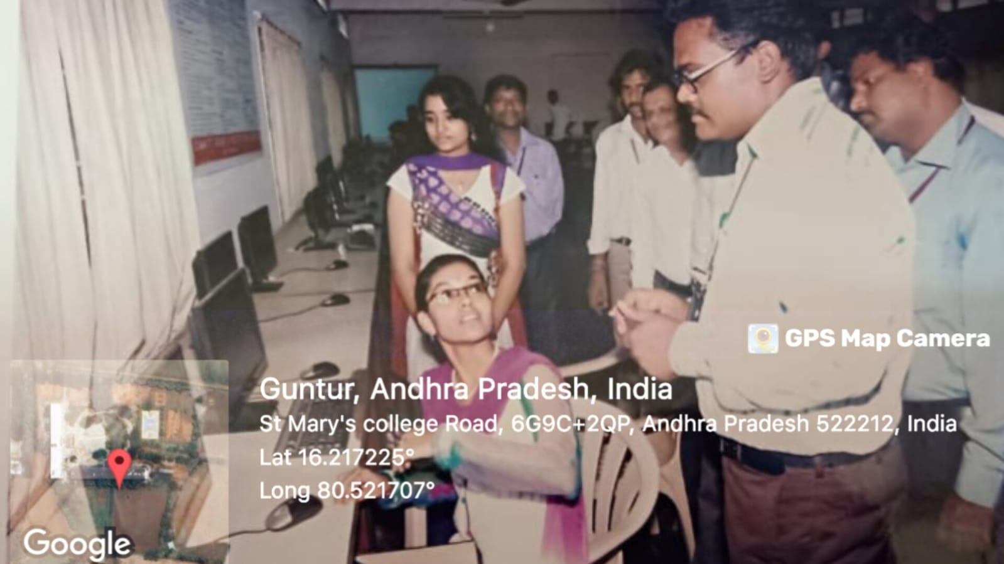

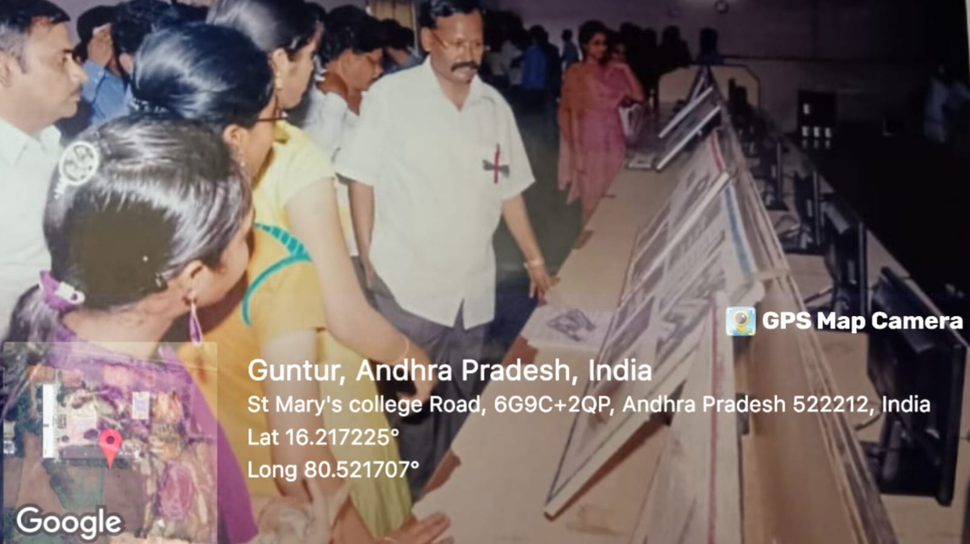

MR J.SRI RAM Alumni Batch 2017-2018 of St Mary’s Group of Institutions has given a Motivational Speech on **"Developing Leadership Skills"** and also conducted group sessions for several events.