7.1.5.1 - The institutional initiatives for greening the campus are as follows:
- Restricted entry of automobiles
- Use of Bicycles/ Battery powered vehicles
- Pedestrian Friendly pathways
- Ban on use of Plastic
- landscaping with trees and plants

Restricted entry of automobiles
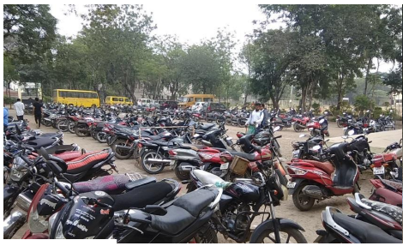
Pedestrian Friendly pathways
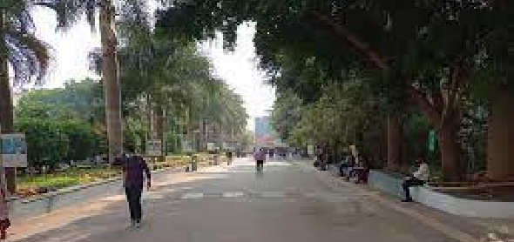

Landscaping with trees and plants
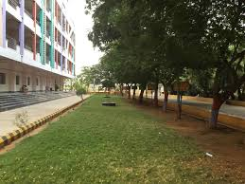
Ban on use of Plastic
