7.1.4 - Water conservation facilities available in the Institution:
- Rain water harvesting
- Bore well /Open well recharge
- Construction of tanks and bunds
- Waste water recycling
- Maintenance of water bodies and distribution system in the campus

- RAIN WATER HARVESTING
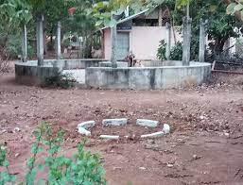

- BOREWELL / OPEN WELL RECHARGE
