UNIT IV
TRANSISTORS
4.1 INTRODUCTION
A bipolar junction transistor (BJT) is a three terminal device in which operation depends on the interaction of both majority and minority carriers and hence the name bipolar. The BJT is analogus to vacuum triode and is comparatively smaller in size. It is used i amplifier and oscillator circuits, and as a switch in digital circuits. It has wide applications in computers, satellites and other modern communication systems.
4.2 CONSTRUCTION OF BJT AND ITS SYMBOLS
The Bipolar Transistor basic construction consists of two PN-junctions producing three connecting terminals with each terminal being given a name to identify it from the other two. These three terminals are known and labelled as the Emitter ( E ), the Base ( B ) and the Collector ( C ) respectively. There are two basic types of bipolar transistor construction, PNP and NPN, which basically describes the physical arrangement of the P-type and N-type semiconductor materials from which they are made.
Transistors are three terminal active devices made from different semiconductor materials that can act as either an insulator or a conductor by the application of a small signal voltage. The transistor's ability to change between these two states enables it to have two basic functions: "switching" (digital electronics) or "amplification" (analogue electronics). Then bipolar transistors have the ability to operate within three different regions:
- 1. Active Region - the transistor operates as an amplifier and Ic = β.Ib
- 2. Saturation - the transistor is "fully-ON" operating as a switch and Ic = I(saturation)
- 3. Cut-off - the transistor is "fully-OFF" operating as a switch and Ic = 0
Bipolar Transistors are current regulating devices that control the amount of current flowing through them in proportion to the amount of biasing voltage applied to their base terminal acting like a current-controlled switch. The principle of operation of the two transistor types PNP and NPN, is exactly the same the only difference being in their biasing and the polarity of the power supply for each type(fig 1).

Bipolar Transistor Construction
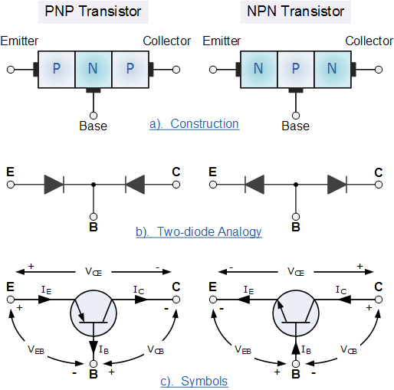
- Fig:1
The construction and circuit symbols for both the PNP and NPN bipolar transistor are given above with the arrow in the circuit symbol always showing the direction of "conventional current flow" between the base terminal and its emitter terminal. The direction of the arrow always points from the positive P-type region to the negative N-type region for both transistor types, exactly the same as for the standard diode symbol.

4.3 TRANSISTOR CURRENT COMPONENTS:

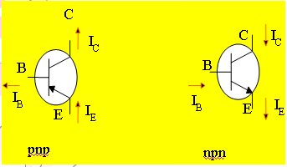
FIG 2
The above fig 2 shows the various current components, which flow across the forward biased emitter junction and reverse- biased collector junction. The emitter current I_{E} consists of hole current I_{PE} (holes crossing from emitter into base) and electron current I_{nE} (electrons crossing from base into emitter).The ratio of hole to electron currents, I_{pE /} I_{nE} , crossing the emitter junction is proportional to the ratio of the conductivity of the p material to that of the n material. In a transistor, the doping of that of the emitter is made much larger than the doping of the base. This feature ensures (in p-n-p transistor) that the emitter current consists an almost entirely of holes. Such a situation is desired since the current which results from electrons crossing the emitter junction from base to emitter does not contribute carriers, which can reach the collector.
Not all the holes crossing the emitter junction J_{E} reach the the collector junction J_{C}
Because some of them combine with the electrons in n-type base. If I_{pC} is hole current at junction J_{C} there must be a bulk recombination current ( I_{PE-} I_{pC} ) leaving the base.

Actually, electrons enter the base region through the base lead to supply those charges, which have been lost by recombination with the holes injected in to the base across J_{E.} If the emitter were open circuited so that I_{E}=0 then I_{pC} would be zero. Under these circumstances, the base and collector current I_{C} would equal the reverse saturation current I_{CO.} If I_{E}≠0 then
I_{C}= I_{CO}- I_{pC}
For a p-n-p transistor, I_{CO} consists of holes moving across J_{C from} left to right (base to collector) and electrons crossing J_{C} in opposite direction. Assumed referenced direction for I_{CO} i.e. from right to left, then for a p-n-p transistor, I_{CO is} negative. For an n-p-n transistor, I_{CO} is positive.The basic operation will be described using the pnp transistor. The operation of the pnp transistor is exactly the same if the roles played by the electron and hole are interchanged.
Applying KCL to the transistor :
I_{E} = I_{C} + I_{B}
The comprises of two components – the majority and minority carriers
I_{C} = I_{Cmajority} + I_{COminority}
I_{CO} – I_{C} current with emitter terminal open and is called leakage current
Various parameters which relate the current components is given below
Emitter efficiency:
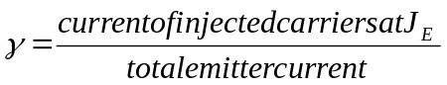
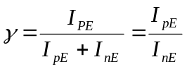
Transport Factor:
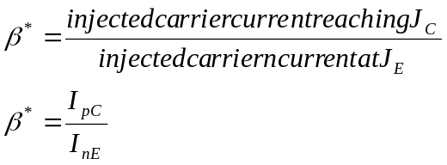
Large signal current gain:
The ratio of the negative of collector current increment to the emitter current change from zero (cut-off)to I_{E} the large signal current gain of a common base transistor.
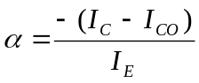
Since I_{C and} I_{E} have opposite signs, then α, as defined, is always positive. Typically numerical values of α lies in the range of 0.90 to 0.995
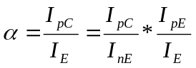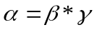
The transistor alpha is the product of the transport factor and the emitter efficiency. This statement assumes that the collector multiplication ratio 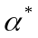is unity. 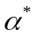is the ratio of total current crossing J_{C} to hole arriving at the junction.

4.4 Bipolar Transistor Configurations
As the Bipolar Transistor is a three terminal device, there are basically three possible ways to connect it within an electronic circuit with one terminal being common to both the input and output. Each method of connection responding differently to its input signal within a circuit as the static characteristics of the transistor vary with each circuit arrangement.
- 1. Common Base Configuration - has Voltage Gain but no Current Gain.
- 2 Common Emitter Configuration - has both Current and Voltage Gain.
- 3. Common Collector Configuration - has Current Gain but no Voltage Gain.
4.5 COMMON-BASE CONFIGURATION
Common-base terminology is derived from the fact that the : base is common to both input and output of t configuration. base is usually the terminal closest to or at ground potential. Majority carriers can cross the reverse-biased junction because the injected majority carriers will appear as minority carriers in the n-type material. All current directions will refer to conventional (hole) flow and the arrows in all electronic symbols have a direction defined by this convention.
Note that the applied biasing (voltage sources) are such as to establish current in the direction indicated for each branch.
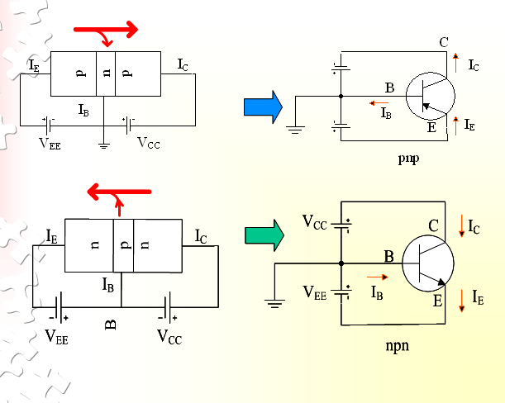
To describe the behavior of common-base amplifiers requires two set of characteristics:
- Input or driving point characteristics.
- Output or collector characteristics
The output characteristics has 3 basic regions:
- Active region –defined by the biasing arrangements
- Cutoff region – region where the collector current is 0A
- Saturation region- region of the characteristics to the left of V_{CB} = 0V
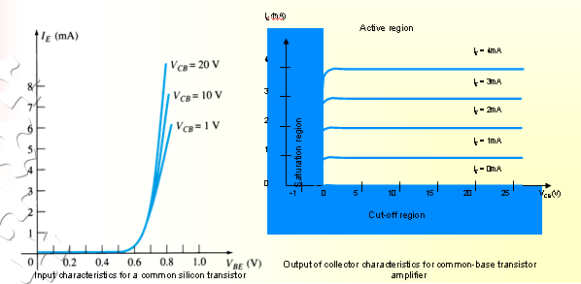

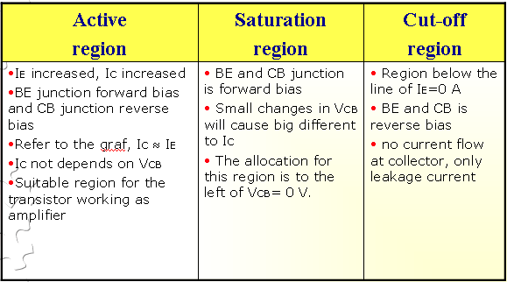
The curves (output characteristics) clearly indicate that a first approximation to the relationship between IE and IC in the active region is given by
I_{C} ≈IE
Once a transistor is in the ‘on’ state, the base-emitter voltage will be assumed to beV_{BE} = 0.7V
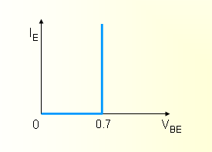
In the dc mode the level of I_{C} and I_{E} due to the majority carriers are related by a quantity called alpha α= α_{dc}
I_{C} = αI_{E} + I_{CBO}
It can then be summarize to I_{C} = αI_{E} (ignore I_{CBO} due to small value)
For ac situations where the point of operation moves on the characteristics curve, an ac alpha defined by α_{ac}
Alpha a common base current gain factor that shows the efficiency by calculating the current percent from current flow from emitter to collector. The value of α is typical from 0.9 ~ 0.998.
Biasing:Proper biasing CB configuration in active region by approximation I_{C} ≈ I_{E} (I_{B} ≈ 0 uA)
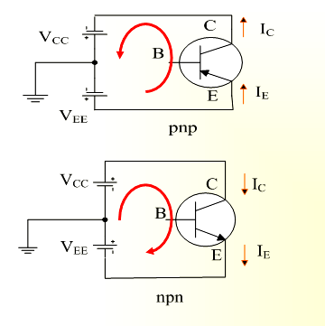

4.6 TRANSISTOR AS AN AMPLIFIER
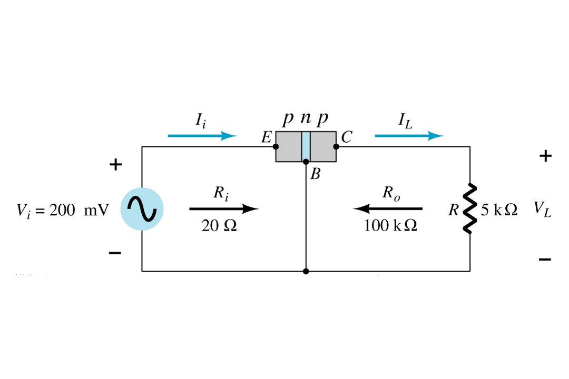
Common-Emitter Configuration
It is called common-emitter configuration since : emitter is common or reference to both input and output terminals.emitter is usually the terminal closest to or at ground potential.
Almost amplifier design is using connection of CE due to the high gain for current and voltage.
Two set of characteristics are necessary to describe the behavior for CE ;input (base terminal) and output (collector terminal) parameters.
Proper Biasing common-emitter configuration in active region
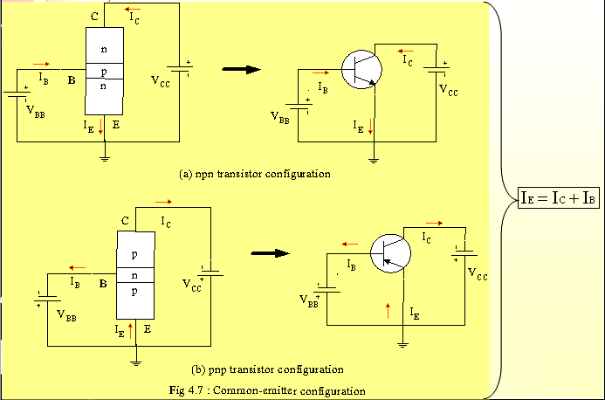

I_{B} is microamperes compared to miliamperes of I_{C}.
I_{B} will flow when V_{BE} > 0.7V for silicon and 0.3V for germanium
Before this value I_{B} is very small and no I_{B}.
Base-emitter junction is forward bias Increasing V_{CE} will reduce I_{B} for different values.

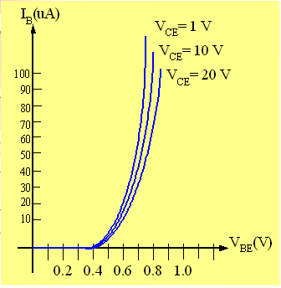

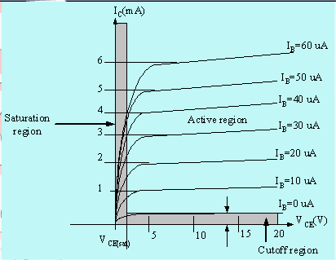
Output characteristics for acommon-emitter npn transistor
For small V_{CE} (V_{CE} < V_{CESAT}, I_{C} increase linearly with increasing of V_{CE}
V_{CE} > V_{CESAT} I_{C} not totally depends on V_{CE} à constant I_{C}
I_{B}(uA) is very small compare to I_{C} (mA). Small increase in I_{B} cause big increase in I_{C}
I_{B}=0 A à I_{CEO} occur.
Noticing the value when I_{C}=0A. There is still some value of current flows.

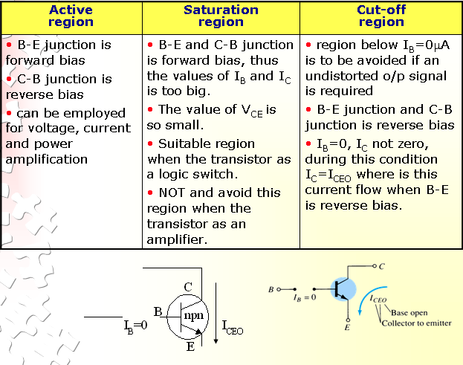
Beta (β) or amplification factor
The ratio of dc collector current (IC) to the dc base current (IB) is dc beta (βdc ) which is dc current gain where IC and IB are determined at a particular operating point, Q-point (quiescent point). It’s define by the following equation:
30 < βdc < 300 à 2N3904
On data sheet, β_{dc}=hfe with h is derived from ac hybrid equivalent cct. FE are derived from forward-current amplification and common-emitter configuration respectively.
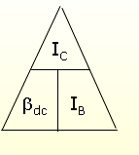

For ac conditions, an ac beta has been defined as the changes of collector current (I_{C}) compared to the changes of base current (I_{B}) where I_{C} and I_{B} are determined at operating point. On data sheet, β_{ac}=hfe It can defined by the following equation:
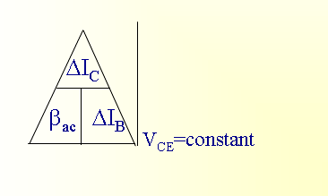

From output characteristics of commonemitter configuration, find β_{ac} and β_{dc} with an
Operating point at I_{B}=25 μA and V_{CE} =7.5V
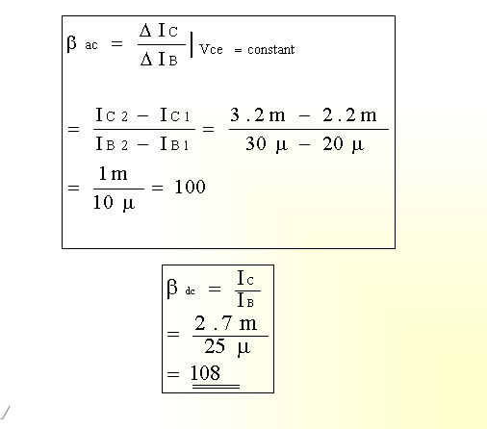
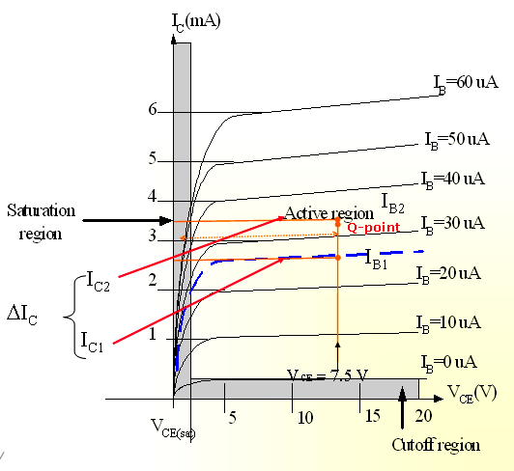

Relationship analysis between α and β
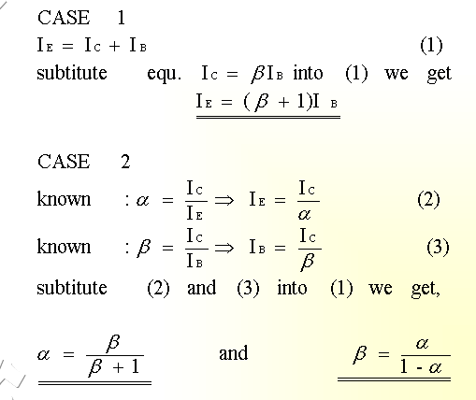
4.7 COMMON – COLLECTOR CONFIGURATION
Also called emitter-follower (EF). It is called common-emitter configuration since both the signal
source and the load share the collector terminal as a common connection point.The output voltage is obtained at emitter terminal. The input characteristic of common-collector configuration is similar with common-emitter. configuration.Common-collector circuit configuration is provided with the load resistor connected from emitter to ground.It is used primarily for impedance-matching purpose since it has high input impedance and low output impedance.
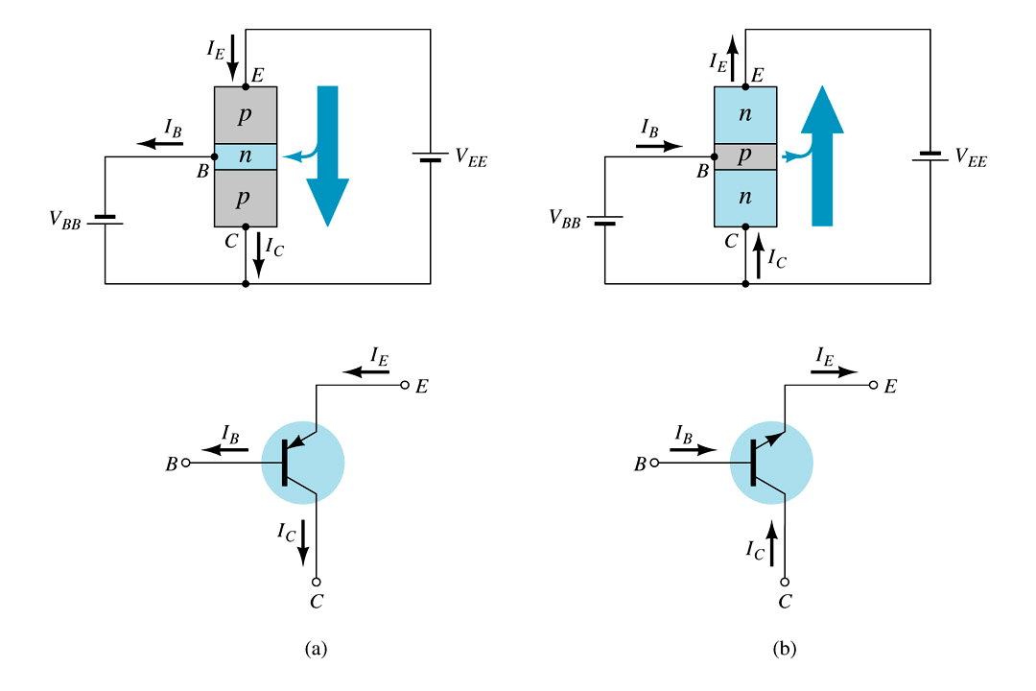

For the common-collector configuration, the output characteristics are a plot of I_{E} vs V_{CE} for a range of values of I_{B}.
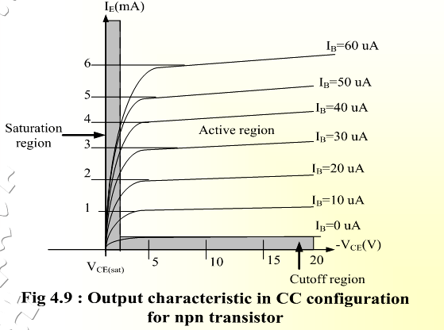

TRANSISTOR BIASING AND STABILIZATION

4.8 NEED FOR TRANSISTOR BIASING:
If the o/p signal must be a faithful reproduction of the i/p signal, the transistor must be operated in active region. That means an operating point has to be established in this region . To establish an operating point (proper values of collector current I_{c} and collector to emitter voltage V_{CE}) appropriate supply voltages and resistances must be suitably chosen in the ckt. This process of selecting proper supply voltages and resistance for obtaining desired operating point or Q point is called as biasing and the ckt used for transistor biasing is called as biasing ckt.
There are four conditions to be met by a transistor so that it acts as a faithful ampr:
- Emitter base junction must be forward biased (V_{BE}=0.7Vfor Si, 0.2V for Ge) and collector base junction must be reverse biased for all levels of i/p signal.
- V_{ce} voltage should not fall below V_{CE (sat)} (0.3V for Si, 0.1V for Ge) for any part of the i/p signal. For V_{CE} less than V_{CE (sat)} the collector base junction is not probably reverse biased.
- The value of the signal I_{c} when no signal is applied should be at least equal to the max. collector current t due to signal alone.
- Max. rating of the transistor I_{c(max)}, V_{CE (max)} and P_{D(max)} should not be exceeded at any value of i/p signal.
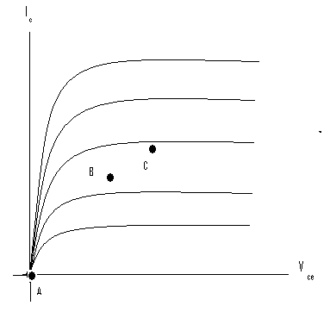 fig1
I_{C(max)} P_{D(max)}
P_{D(max)} P_{D(max)}
V_{ce(sat)} P_{D(max)}

4.9 DC LOAD LINE:
Referring to the biasing circuit of fig 4.2a, the values of V_{CC} and R_{C} are fixed and Ic and V_{CE} are dependent on R_{B}.
Applying Kirchhoff’s voltage law to the collector circuit in fig. 4.2a, we get
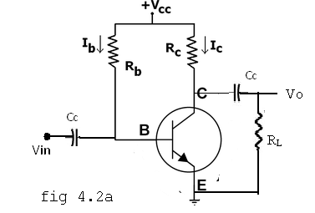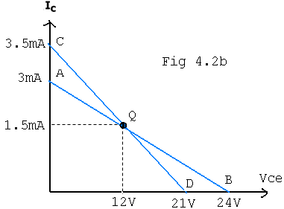
The straight line represented by AB in fig4.2b is called the dc load line. The coordinates of the end point A are obtained by substituting V_{CE} =0 in the above equation. Then . Therefore The coordinates of A are V_{CE} =0 and .
The coordinates of B are obtained by substituting Ic=0 in the above equation. Then Vce = Vcc. Therefore the coordinates of B are V_{CE} =Vcc and Ic=0. Thus the dc load line AB can be drawn if the values of Rc and Vcc are known.
As shown in the fig4.2b, the optimum POINT IS LOCATED AT THE MID POINT OF THE MIDWAY BETWEEN a AND b. In order to get faithful amplification, the Q point must be well within the active region of the transistor.
Even though the Q point is fixed properly, it is very important to ensure that the operating point remains stable where it is originally fixed. If the Q point shifts nearer to either A or B, the output voltage and current get clipped, thereby o/p signal is distorted.
In practice, the Q-point tends to shift its position due to any or all of the following three main factors.
- Reverse saturation current, Ico, which doubles for every 10ºC raise in temperature
- Base emitter Voltage ,VBE, which decreases by 2.5 mV per ºC
- Transistor current gain, h_{FE} or β which increases with temperature.
.4.10 AC LOAD LINE:
After drawing the dc load line, the operating point Q is properly located at the center of the dc load line. This operating point is chosen under zero input signal condition of the circuit. Hence the ac load line should also pas through the operating point Q. The effective ac load resistance R_{ac}, is a combination of R_{C} parallel to R_{L} i.e. ||. So the slope of the ac load line CQD will be 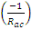. To draw the ac load line, two end points, I.e. V_{CE(max)} and I_{C(max)} when the signal is applied are required.
, which locates point D on the Vce axis.
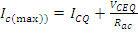, which locates the point C on the I_{C} axis.
By joining points c and D, ac load line CD is constructed. As R_{C} > R_{ac}, The dc load line is less steep than ac load line.
4.11 STABILITY FACTOR (S):
The rise of temperature results in increase in the value of transistor gain β and the leakage current Ico. So, I_{C} also increases which results in a shift in operating point. Therefore, The biasing network should be provided with thermal stability. Maintenance of the operating point is specified by S, which indicates the degree of change in operating point due to change in temperature.
The extent to which I_{C} is stabilized with varying I_{C} is measured by a stability factor S
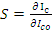 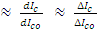 ,
For CE configuration
Differentiate the above equation w.r.t I_{C} , We get
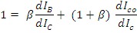
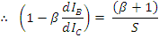
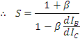
S should be small to have better thermal stability.
Stability factor S’ and S’’:
S’ is defined as the rate of change of I_{C} with V_{BE}, keeping I_{C} and V_{BE} constant.
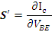
S’’ is defined as the rate of change of I_{C} with β, keeping I_{CO} and V_{BE} constant.
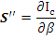

4.12 METHODS OF TRANSISTOR BIASING:

1) Fixed bias (base bias)
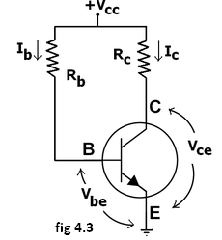
This form of biasing is also called base bias. In the fig 4.3 shown, the single power source (for example, a battery) is used for both collector and base of a transistor, although separate batteries can also be used.
In the given circuit,
V_{cc} = I_{B}R_{B} + V_{be}
Therefore, I_{B} = (V_{cc} - V_{be})/R_{B}
Since the equation is independent of current I_{C}R, dI_{B/}/dI_{C}R =0 and the stability factor is given by the equation….. reduces to
S=1+β
Since β is a large quantity, this is very poor biasing circuit. Therefore in practice the circuit is not used for biasing.
For a given transistor, V_{be} does not vary significantly during use. As V_{cc} is of fixed value, on selection of R_{B}, the base current I_{B} is fixed. Therefore this type is called fixed bias type of circuit.
Also for given circuit, V_{cc} = I_{C}R_{C} + V_{ce}
Therefore, V_{ce} = V_{cc} - I_{C}R_{C}
Merits:
- It is simple to shift the operating point anywhere in the active region by merely changing the base resistor (R_{B}).
- A very small number of components are required.
Demerits:
- The collector current does not remain constant with variation in temperature or power supply voltage. Therefore the operating point is unstable.
- Changes in V_{be} will change I_{B} and thus cause R_{E} to change. This in turn will alter the gain of the stage.
- When the transistor is replaced with another one, considerable change in the value of β can be expected. Due to this change the operating point will shift.
2) EMITTER-FEEDBACK BIAS:
The emitter feedback bias circuit is shown in the fig 4.4. The fixed bias circuit is modified by attaching an external resistor to the emitter. This resistor introduces negative feedback that stabilizes the Q-point. From Kirchhoff's voltage law, the voltage across the base resistor is
V_{Rb} = V_{CC} - I_{e}R_{e} - V_{be}.
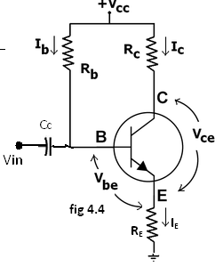
From Ohm's law, the base current is
I_{b} = V_{Rb} / R_{b}.
The way feedback controls the bias point is as follows. If V_{be} is held constant and temperature increases, emitter current increases. However, a larger I_{e} increases the emitter voltage V_{e} = I_{e}R_{e}, which in turn reduces the voltage V_{Rb} across the base resistor. A lower base-resistor voltage drop reduces the base current, which results in less collector current because I_{c} = ß I_{B}. Collector current and emitter current are related by I_{c} = α I_{e} with α ≈ 1, so increase in emitter current with temperature is opposed, and operating point is kept stable.
Similarly, if the transistor is replaced by another, there may be a change in I_{C} (corresponding to change in β-value, for example). By similar process as above, the change is negated and operating point kept stable.
For the given circuit,
I_{B} = (V_{CC} - V_{be})/(R_{B} + (β+1)R_{E}).
Merits:
The circuit has the tendency to stabilize operating point against changes in temperature and β-value.
Demerits:
- In this circuit, to keep I_{C} independent of β the following condition must be met:
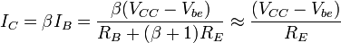
which is approximately the case if ( β + 1 )R_{E} >> R_{B}.
- As β-value is fixed for a given transistor, this relation can be satisfied either by keeping R_{E} very large, or making R_{B} very low.
- If R_{E} is of large value, high V_{CC} is necessary. This increases cost as well as precautions necessary while handling.
- If R_{B} is low, a separate low voltage supply should be used in the base circuit. Using two supplies of different voltages is impractical.
- In addition to the above, R_{E} causes ac feedback which reduces the voltage gain of the amplifier.

  - COLLECTOR TO BASE BIAS OR COLLECTOR FEED-BACK BIAS:
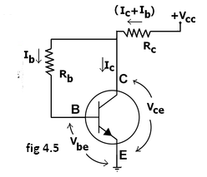
This configuration shown in fig 4.5 employs negative feedback to prevent thermal runaway and stabilize the operating point. In this form of biasing, the base resistor R_{B} is connected to the collector instead of connecting it to the DC source V_{cc}. So any thermal runaway will induce a voltage drop across the R_{C} resistor that will throttle the transistor's base current.
From Kirchhoff's voltage law, the voltage across the base resistor R_{b} is
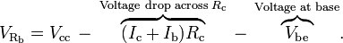
By the Ebers–Moll model, I_{c} = βI_{b}, and so
From Ohm's law, the base current , and so
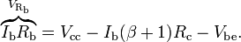
Hence, the base current I_{b} is
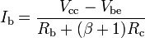
If V_{be} is held constant and temperature increases, then the collector current I_{c} increases. However, a larger I_{c} causes the voltage drop across resistor R_{c} to increase, which in turn reduces the voltage across the base resistor R_{b}. A lower base-resistor voltage drop reduces the base current I_{b}, which results in less collector current I_{c}. Because an increase in collector current with temperature is opposed, the operating point is kept stable.
Merits:
- Circuit stabilizes the operating point against variations in temperature and β (i.e. replacement of transistor)
Demerits:
- In this circuit, to keep I_{c} independent of β, the following condition must be met:
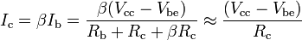
which is the case when
- As β-value is fixed (and generally unknown) for a given transistor, this relation can be satisfied either by keeping R_{c} fairly large or making R_{b} very low.
- If R_{c} is large, a high V_{cc} is necessary, which increases cost as well as precautions necessary while handling.
- If R_{b} is low, the reverse bias of the collector–base region is small, which limits the range of collector voltage swing that leaves the transistor in active mode.
- The resistor R_{b} causes an AC feedback, reducing the voltage gain of the amplifier. This undesirable effect is a trade-off for greater Q-point stability.
Usage: The feedback also decreases the input impedance of the amplifier as seen from the base, which can be advantageous. Due to the gain reduction from feedback, this biasing form is used only when the trade-off for stability is warranted.

  - COLLECTOR –EMITTER FEEDBACK BIAS:
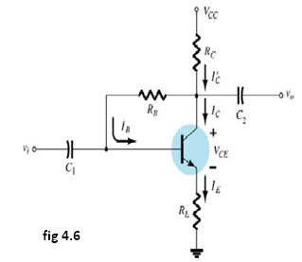
The above fig4.6 shows the collector –emitter feedback bias circuit that can be obtained by applying both the collector feedback and emitter feedback. Here the collector feedback is provided by connecting a resistance RB from the collector to the base and emitter feedback is provided by connecting an emitter Re from emitter to ground. Both feed backs are used to control collector current and base current IB in the opposite direction to increase the stability as compared to the previous biasing circuits.
  - VOLTAGE DIVIDER BIAS OR SELF BIAS OR EMITTER BIAS:
The voltage divider as shown in the fig 4.7 is formed using external resistors R₁ and R₂. The voltage across R₂ forward biases the emitter junction. By proper selection of resistors R₁ and R₂, the operating point of the transistor can be made independent of β. In this circuit, the voltage divider holds the base voltage fixed independent of base current provided the divider current is large compared to the base current. However, even with a fixed base voltage, collector current varies with temperature (for example) so an emitter resistor is added to stabilize the Q-point, similar to the above circuits with emitter resistor.
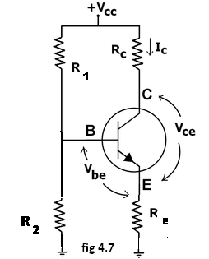
In this circuit the base voltage is given by:
voltage across 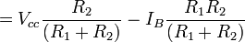
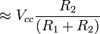provided .
Also
For the given circuit,
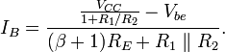
Let the current in resistor R1 is I1 and this is divided into two parts – current through base and resistor R2. Since the base current is very small so for all practical purpose it is assumed that I1 also flows through R2, so we have
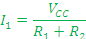
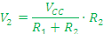
Applying KVL in the circuit, we have
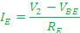
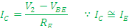
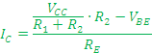
It is apparent from above expression that the collector current is independent of ? thus the stability is excellent. In all practical cases the value of VBE is quite small in comparison to the V2, so it can be ignored in the above expression so the collector current is almost independent of the transistor parameters thus this arrangement provides excellent stability.
Again applying KVL in collector circuit, we have
The resistor RE provides stability to the circuit. If the current through the collector rises, the voltage across the resistor RE also rises. This will cause VCE to increase as the voltage V2 is independent of collector current. This decreases the base current, thus collector current increases to its former value.
Stability factor for such circuit arrangement is given by
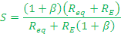
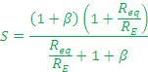
If Req/RE is very small compared to 1, it can be ignored in the above expression thus we have
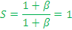
Which is excellent since it is the smallest possible value for the stability. In actual practice the value of stability factor is around 8-10, since Req/RE cannot be ignored as compared to 1.
Merits:
- Unlike above circuits, only one dc supply is necessary.
- Operating point is almost independent of β variation.
- Operating point stabilized against shift in temperature.
Demerits:
- In this circuit, to keep I_{C} independent of β the following condition must be met:
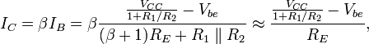
which is approximately the case if
where R₁ || R₂ denotes the equivalent resistance of R₁ and R₂ connected in parallel.
4.13 BIAS COMPENSATION USING DIODE AND TRANSISTOR:
The various biasing circuits considered use some type of negative feedback to stabilize the operation point. Also, diodes, thermistors and sensistors can be used to compensate for variations in current.

DIODE COMPENSATION:
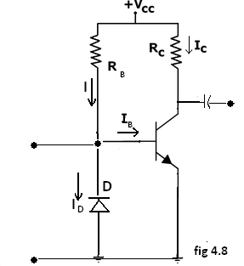
The following fig4.8 shows a transistor amplifier with a diode D connected across the base-emitter junction for compensation of change in collector saturation current I_{CO}. The diode is of the same material as the transistor and it is reverse biased by e the emitter-base junction voltage V_{BE}, allowing the diode reverse saturation current I_{O} to flow through diode D. The base current I_{B}=I-I_{O}.
As long as temperature is constant, diode D operates as a resistor. As the temperature increases, I_{CO} of the transistor increases. Hence, to compensate for this, the base current I_{B} should be decreased.
The increase in temperature will also cause the leakage current I_{O} through D to increase and thereby decrease the base current I_{B}. This is the required action to keep Ic constant.
This type of bias compensation does not need a change in Ic to effect the change in I_{C}, as both I_{O} and I_{CO} can track almost equally according to the change in temperature.
THERMISTOR COMPENSATION:
The following fig4.9 a thermistor R_{T}, having a negative temperature coefficient is connected in parallel with R₂. The resistance of thermistor decreases exponentially with increase of temperature. An increase of temperature will decrease the base voltage V_{BE}, reducing I_{B} and I_{C}.
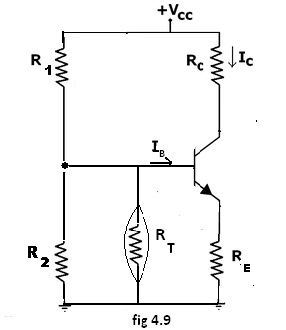
SENSISTOR COMPENSATION:
In the following fig4.10 shown a sensistor Rs having a positive temperature coefficient is connected across R₁ or R_{E}. Rs increases with temperature. As the temperature increases, the equivalent resistance of the parallel combination of R1 and Rs also increases and hence V_{BE} decreases, reducing I_{B} and Ic. This reduced Ic compensates for increased Ic caused by the increase in V_{BE}, I_{CO} and β due to temperature.
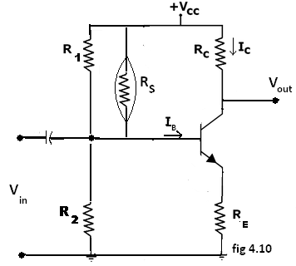

4.14 THERMAL RUNAWAY AND THERMAL STABILITY:
THERMAL RUNAWAY:
The collector current for the CE circuit is given by The three variables in the equation, β, , and increases with rise in temperature. In particular, the reverse saturation current or leakage current changes greatly with temperature. Specifically it doubles for every 10ºC rise in temperature. The collector current causes the collector base junction temperature to rise which in turn, increase , as a result will increase still further, which will further rise the temperature at the collector base junction. This process will become cumulative leading at the collector base junction. This process will become cumulative leading to “thermal runaway”. Consequently, the ratings of the transistor are exceeded which may destroy the transistor itself.
The collector is made larger in size than the emitter in order to help the heat developed at the collector junction. However if the circuit is designed such that the base current is made to decrease automatically with rise in temperature, then the decrease in will compensate for increase in the , keeping almost constant.
THERMAL RESISTANCE
Consider transistor used in a circuit where the ambient temperature of the air around the transistor is T_{A}ºC and the temperature of the collector-base junction of the transistor is T_{J}ºC.
Due to heating within the transistor T_{J} is higher than T_{A}. As the temperature difference T_{J}- T_{A} is greater, the power dissipated in the transistor, P_{D} will be greater, i.e, T_{J}- T_{A} P_{D}
The equation can be written as T_{J}- T_{A} P_{D}., where is the constant of proportionality and is called the Thermal resistance. Rearranging the above equation = T_{J}- T_{A} /P_{D}. Hence is measured in ºC/W which may be as small as 0.2 ºC/W for a high power transistor that has an efficient heat sink or up to 1000ºC/W for small signal, low power transistor which have no cooling provision.
As Θ represents total thermal resistance from a transistor junction to the ambient temperature, it is referred to as Θ_{J-A}. However, for power transistors, thermal resistance is given form junction to case, Θ_{J-C}.
The amount resistance from junction to ambience is considered to consist of 2 parts.
Θ_{J-A} = Θ_{J-C} - Θ_{C-A}.
Which indicates the heat dissipated in the junction must make its way to the surrounding air through two series paths from junction to case and from case to air. Hence the power dissipated.
P_{D} = (T_{J}- T_{A}Θ _{J-A}
=(T_{J}- T_{A}Θ _{J-C} + Θ _{C-A})
Θ_{J-C} is determined by the type of manufacture of the transistor and how it is located I the case, but Θ_{C-A} is determined by the surface area of the case or flange and its contact with air. If the effective surface area of the transistor case could be increased, the resistance to heat flows, or could be increased Θ_{C-A}, could be decreased. This can be achieved by the use of a heat sink.
The heat sink is a relatively large, finned, usually black metallic heat conducting device in close contact with transistor case or flange. Many versions of heat sink exist depending upon the shape and size of the transistor. Larger the heat sink smaller is the thermal resistance Θ_{HS-A}.
This thermal resistance is not added to Θ_{C-A} in series, but is instead in parallel with it and if
Θ_{HS-A} is much less than Θ_{C-A}, then Θ_{C-A} will be reduced significantly, thereby improving the dissipation capability of the transistor. Thus
Θ _{J-A}=Θ _{J-C} + Θ _{C-A}|| Θ_{HS-A}.

4.15 CONDITION FOR THERMAL STABILITY:
For preventing thermal runaway, the required condition I the rate at which the heat is released at the collector junction should not exceed the rate at which the heat can be dissipated under steady state condition. Hence the condition to be satisfied to avoid thermal runaway is given by
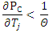
If the circuit is properly designed, then the transistor cannot runaway below a specified ambient temperature or even under any conditions.
In the self biased circuit the transistor is biased in the active region. The power generated at the junction without any signal is
Let us assume that the quiescent collector and the emitter currents are equal. Then
………………….(1)
The condition to prevent thermal runaway can be written as
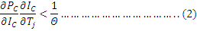
As Θ and are positive, should be negative in order to satisfy the above condition.
Differentiating equation (1) w.r.t we get
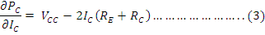
Hence to avoid thermal runaway it is necessary that
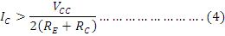
SinceVCE=VCC-IC(RE+RC) then eq(4) implies that VCE<VCC/2. IF the inequality of eq(4) is not satisfied and VCE<VCC/2, then from eq(3), is positive., and the corresponding eq(2) should be satisfied. Other wise thermal runaway will occur.
4.16 TRANSISTOR HYBRID MODEL:
The hybrid model for a transistor amplifier can be derived as follow:
Let us consider CE configuration as show in fig. 3. The variables, i_{B}, i_{C} ,v_{C}, and v_{B} represent total instantaneous currents and voltages i_{B} and v_{C} can be taken as independent variables and v_{B}, I_{C} as dependent variables.
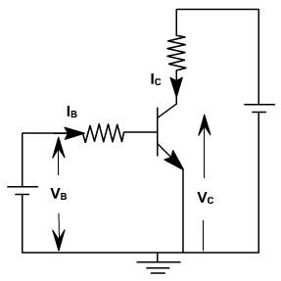
Fig. 3
V_{B} = f1 (i_{B} ,v_{C} )
I_{C} = f2 (i_{B} ,v_{C}).
Using Taylor 's series expression, and neglecting higher order terms we obtain.
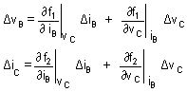
The partial derivatives are taken keeping the collector voltage or base current constant. The Δ v_{B}, Δ v_{C}, Δ i_{B}, Δ i_{C} represent the small signal (incremental) base and collector current and voltage and can be represented as v_{B}, i_{C,} i_{B} ,v_{C}
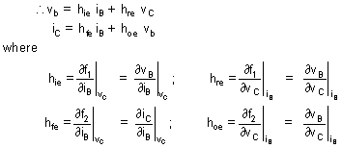
The model for CE configuration is shown in fig. 4.
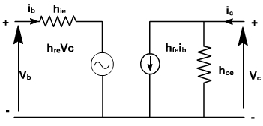
Fig. 4
4.17 ANALYSIS OF A TRANSISTOR AMPLIFIER USING H-PARAMETERS:
To form a transistor amplifier it is only necessary to connect an external load and signal source as indicated in fig. 1 and to bias the transistor properly.
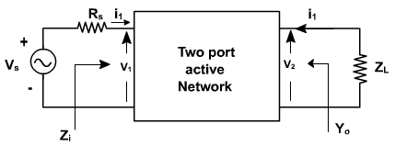
Fig. 1
Consider the two-port network of CE amplifier. R_{S} is the source resistance and Z_{L} is the load impedence h-parameters are assumed to be constant over the operating range. The ac equivalent circuit is shown in fig. 2. (Phasor notations are used assuming sinusoidal voltage input). The quantities of interest are the current gain, input impedence, voltage gain, and output impedence.
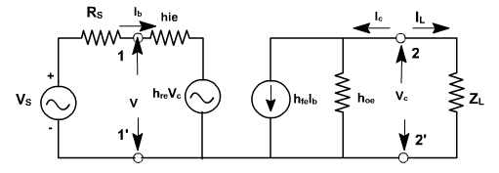
Fig. 2
1.3.1 Current gain:
For the transistor amplifier stage, A_{i} is defined as the ratio of output to input currents.
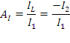
1.3.2 Input impedence:
The impedence looking into the amplifier input terminals ( 1,1' ) is the input impedence Z_{i} 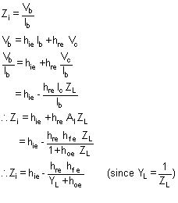
1.3.3 Voltage gain:
The ratio of output voltage to input voltage gives the gain of the transistors.
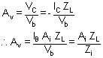
1.3.4 Output Admittance:
It is defined as
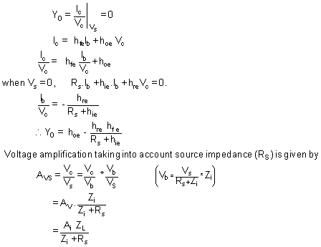
A_{v} is the voltage gain for an ideal voltage source (R_{v} = 0).
Consider input source to be a current source I_{S} in parallel with a resistance R_{S} as shown in fig. 3.
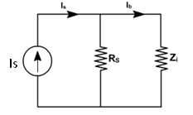 Fig. 3
In this case, overall current gain A_{IS} is defined as


