UNIT-V
INTRODUCTION TO ACCOUNTING

Introduction:
Accounting has rightly been termed as the language of business the basic function of language is to serve as a means of communication. Accounting was practiced in India thousand years ago and there is a clear evidence for this. Accounting in India is now a fast developing discipline. The two premier accounting institutes in India are chartered accountants of India and the Institute of cost and works accountants of India are making continuous and substantial contributions.
Definition:
- According to “ American Institute of certified public Accountants” (AICPA) the art of recording, classifying and summarizing in a significant manner and in terms of many transactions and events, which are in part at least, of a financial character and interpreting the results there of.
- According to Smith and Ashburn “Accounting is a means of measuring and reporting the results of economic activities.
- According to R.N Anthony “Accounting system is a means of collecting, summarizing, analyzing and reporting in monetary terms, the information about the business”.
According to Professor G.A. Lee the accounting system has two stages. The first stage is Book keeping, second stage is accounting.
- Book Keeping: It involves the chronological records of financial transactions in a set of books in a systematic manner.
- Accounting: It is concerned with the maintenance of accounts giving stress to the design of the system of records, the preparation of reports based on the recorded data and the interpretation of the reports.
Classification of accounting principles: Accounting principles can be broadly classified in to two categories:
- Accounting Concepts.
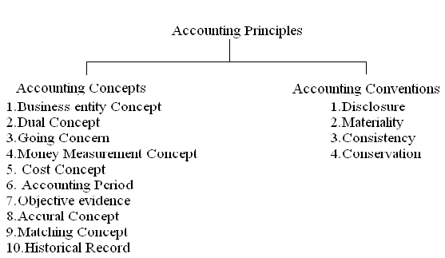
- Accounting Conventions

Accounting Concepts:
- Business Entity Concept: It implies that the business is different from the persons who own it. If the owner takes any cash or goods from the business, the drawings account is Debited and cash or goods account is credited.

- Dual Aspect Concept: This concept throws on the point that each transaction has two fold affect the receiving of the benefit and giving of the benefit. The receiving aspect is termed as debit, where the giving aspect as Credit. For each debit there will be a credit.
Eg: If we purchase furniture for Rs 5,000, we receive furniture on one hand and give Rs 5000 on the other hand.

- Going Concern Concept: It is assumed that the business will continue for a long time with this assumption fixed assets are recorded in the books at their original cost.

- Money measurement Concept: While recording the business transactions we do not record them in terms of Kilograms, Quintals, Meters, Liters etc. we record them in a common denomination so as to see that they become homogeneous and meaningful, money does this function. Hence recording is done in terms of standard currency of the country.

- Objectives Evidence Concept: According to this concept all accounting transaction should be evidenced and supported by objective documents. The documents include invoices, receipts cash memos etc.

- Cost Concept: All the transactions will be recorded at cash in the books. At the end of every year the accountant shows the reduced value of the asset, after providing for depreciation.
- Accounting Period Concept: It is the period by a business concern for maintaining accounts to know profit/loss. Usually one year will be the accounting period starting from 1st April and ending 31st March(Financial Year) or 1st January to December 31st (Calendar year).

- Accrual Concept: The accrual system is a method where by revenues and expenses are identified with specific periods of time like a Month, Half year or a year. It implies recording of revenues and expenses of a particular accounting period.
If there is an excess of revenues over expenses is called “Income”, if the expenses is more than revenue it is “Loss”.

- Matching Cost Concept: According to these principles, the expenses incurred in an accounting period should be matched with the revenues recognized in that period.

- Historical Record Concept: The accountant shows only those transactions which have actually taken place and not those which may take place in future. All transactions in accounting are to be recorded in the books in chronological (proper) order. This means the preparation of a historical record for all transactions.
Accounting Conventions:
- Full Disclosure Concept: This concept with the convention that all information which is of material importance should be disclosed in the accounting statements. The companies Act 1956 makes it compulsory to provide all the information in the prescribed form. The accounting reports should disclose full and fair information to the proprietors, creditors, investors and others.

- Materiality Concept: Under this concept the trader records important facts about the commercial activities in the form of financial statements. If any unimportant information is to be given for the sake of clarity, it will be given as foot notes.

- Consistency Concept: It is used in the preparation of various accounts should be followed in the years to come. Eg: A Company may adopt straight line method, written down value method, or any other method of providing depreciation on fixed assets.

- Conservatism Concept: This Convention warns the trader not to take unrealized income into account. The practice of valuing stock at cost or Market price, whichever is in Vogue (General Liking) this policy is a playing safe?
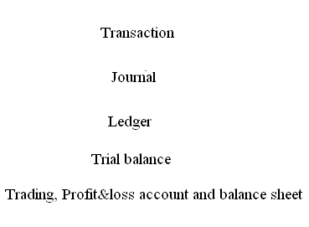
Accounting Cycle: The Accounting cycle can be generated as follows:

Classification of Accounts: All business transactions are broadly classified into three categories:
- Relating to persons.
- Relating to property (Assets).
- Relating to income and expenses.
These three classes of accounts are maintained for recording all business transactions. They are
- Personal Accounts (A/c)
- Real Accounts (A/c)
- Nominal Accounts (A/c)
Personal Account: Accounts which show transactions with persons are called “Personal Accounts”. A Separate account is kept in the name of each person for recording the benefits.
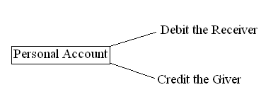
Eg: Krishna A/c, Gopal A/c, etc
Real Accounts: Accounts relating to properties or assets are known as Real Accounts. Every business needs assets such as machinery, Furniture etc for running its activities. A separate account is maintained for each asset owned by the business. If the asset coming into the business is treated as “Debit”, going outside of the business is treated as “Credit”.
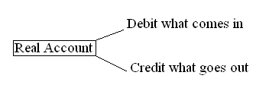

Nominal Account: Accounts relating to expenses, losses, incomes and gains are known as Nominal accounts. If any expenses or losses generated it is treated as Debit, any income or gains is treated as Credit.
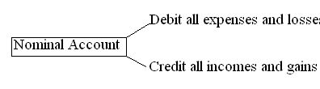

Journal: The word journal is derived from the Latin word “Journo”, which means a day. Therefore journal means a day book where day to day business transactions are recorded in a proper order.
Journal is treated as the books of original entry or first entry. All the business transactions are first entered in this book, later posted in the ledger.
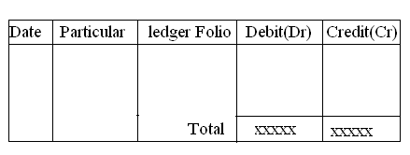

RATIO ANALYSIS
Introduction:
Analysis of Financial statements is an interpretation of financial results. Financial analysis through ratio is the process of in identifying the financial strengths and weakness of the firm by properly establishing relationships by means of ratio between the item of the profit and loss account and the Balance sheet.
Ratio Analysis is the most widely used tool of financial analysis. A ratio indicates a quantitative relationship which is used for a qualified judgment and decision making. The relationship between two accounting figures is known as accounting ratio. Ratio may be compared with the previous year or base year ratios of the same firm. Ratio analysis is useful to share holders, creditors and all other parties who are connected with the concern.
Ratio’s are among the best known and most widely used tools of financial analysis. Ratio is defined as “the indicated of two mathematical expressions”.
Importance
- Ratio act as an index of efficiency of a concern.
- Ratio serves as an instrument of management control.
- They are useful in evaluating performance.
- They facilitate and help in forecasting future events.
- They help management to take corrective action.
- They facilitate intra and inter firm comparison.
Limitations:
- The financial ratios are generally calculated from the historical financial statements. The concerned parties of a concern are interested in the concern future than its past.
- The comparison of the ratios of two companies becomes difficult and meaningless when they are operating in different situation.
- The interpretation and comparison of ratios are also tendered invalid by the changing value of money (Inflation).
Types of Ratios:
Several ratios can be calculated from the accounting data contained in financial statements. From the accounting point of view they can be classified into:
- Ratio Calculated from profit and loss account.
- Ratio calculated from the Balance sheet.
On the other hand from the point of view of financial analyst or financial manager, the ratios can be categorized on the basis of liquidity, Solvency, operational efficiency and Profitability.
- Liquidity ratio: It provides test to measure the ability of the corporation to cover its short term obligations out of its short term resources. Two commonly used liquidity ratios are current ratio and quick ratio.
- Current Ratio: It expresses the relationship between current assets and current liabilities. It is also called as working capital ratio. The ratio is calculated by using the following formula

Current ratio = current assets/current liabilities
Where
Current assets: cash in hand, cash at bank, debtors, bills receivable, stock, prepaid expenses, short term investments etc.
Current Liabilities: Creditors, bills payable, outstanding exp, bank O.D, incomes received in advance, short term loan etc.
The firm is said to be comfortable in its liquidity position if the current ratio is 2:1
2. Quick Ratio: It is also called “Acid test ratio”. It measures the firm’s ability to convert its current assets quickly in cash in order to meet its current liabilities.
Quick Ratio = Quick Assets/current Liabilities
Where Quick assets = Current assets – (Stock +prepaid expenses).
- Activity Ratios: Activity ratios express how active the firm is in terms of selling its stocks, collecting its receivables and paying its creditors. these are three types:
- Inventory turnover
- Debtors turn over
- Creditors turn over
Inventory turnover ratios: It is also called stock turnover ratio. It indicates the number of times the average stock is being sold during a given accounting period. It establishes the relation between the cost of goods sold during a given period and the average amount of inventory turnover ratio, the better is the performance of the firm in selling its stocks. The inventory are converted into sales and then to cash.
Inventory turnover ratio = Cost of goods sold/Average Inventory
(Or) Credit sales/Average Stock
Where cost of goods sold = sales – Gross profit.
Average Inventory = opening stock + closing stock/2
Inventory holding period = 365 days/inventory turnover ratio.

Debtor’s turnover ratio: It reveals the number of times the average debtors are collected during a given accounting period.
Debtor’s turnover ratio = Credit sales/average debtors
Average Debtors = opening debtors + closing debtors/2
Debtors collection period = 365days/debtors turnover ratio.

Creditor’s turnover ratio: It reveals the number of times the average creditors are paid during a given accounting period.
Creditors turnover ratio = Credit purchases/average creditors
Average Creditors = opening Creditors + Closing Creditors/2
Creditors payment period = 365days/Creditors turnover ratio.
- Capital Structure Ratios (Leverage ratio): It is defined as the financial ratio which focuses on the long term solvency of the firm. The following are the capital structure ratio:
- Debt – equity ratio
- Interest coverage ratio
- Proprietors fund ratio
Debt-equity ratio: It is the ratio between outsider’s funds (debt) and insider’s funds (equity). This is used to measure the firm’s obligations to creditors in relation to the owner’s funds. It should be in the formation of 1:1. In other word for every rupee of debt, there should be one rupee worth internal funds.
Debt-equity: Debt/Equity (Or) Outsiders funds/Insiders or Share holder’s funds
Debt or outsiders funds = Debentures, bonds, long term loans.
Equity or share holders funds = Share capital (equity, preference), reserves both general and specific, retained earnings.
Interest Coverage Ratio: It is calculated to judge the firms capacity to pay the interest on debt it borrows. It gives an idea of the extent the firms earnings may contract before it is unable to pay interest payments out of current earnings.
It is very important ratio for the financial institutions to judge the ability of the borrower to service the loan from the current year’s profit. The higher ratio indicates that the company has no problems in paying interest.
Interest coverage ratio = Net profit before Interest and taxes (EBIT)/Fixed interest charges.
Proprietors fund ratio: This establishes the relationship between proprietor’s funds and the total assets.
Proprietors funds to total assets ratios = Proprietors funds /Total assets*100
Proprietors funds = equity share, preference share, general reserve, employee provident funds, profit and loss a/c.
- Profitability Ratio: It throws light on the firm is organizing it s activities in a profitable manner. The firm should generate enough profits not only to meet the expectations of the owners, but also to finance the expansion activity.
- Gross profit ratio
- Net profit ratio
- Operating ratio
- Earnings per share
- Price/earnings ratio
- Working capital ratio
- Fixed assets turnover ratio.
Gross profit ratio: Gross profit ratio is the ratio between gross profits to sales during a given period; it is expressed in terms of percentage. Gross profit is the difference between the net sales and the cost of goods sold.
Gross profit Ratio = Gross profit/sales*100
Net profit ratio: Net profit ratio is the ratio between net profits after taxes and net sales.
Net profit ratio = Net sales /Net profit after tax*100 (or)
Net profit/Sales*100
Operating ratio: It is the ratio between “cost of goods sold + operating exp and the net sales” the higher the operating ratio, lower is profit.
Operating ratio = operating exp + cost of goods sold/net sales*100
Operating exp: Administrative exp + selling and distribution exp
Earnings per share: EPS is the relationship between net profits and the number of shares outstanding at the end of the given period.
EPS = net profit/No: of shares
Price/ earnings ratio: This is the share price divided by the earnings per share.
Price / earnings ratio = Market price per share/Earnings per share
Working capital turnover ratio: This ratio measures the relationship between working capital and sales. The ratio shows the number of times the working capital results in sales.
W.C.T.R = sales or cost of sales/working capital
Fixed assets turnover ratio: Fixed assets are used in the business for producing goods to be sold. The effective utilization of fixed assets will result in increased production and reduced cost.
Fixed assets turnover ratio = Sales or Cost of sales/Fixed assets

Limitations of the ratios:
- False results
- Limited comparability
- Price level changes effect ratios
- Price level changes make ratio analysis difficult.

FUNDS FLOW STATEMENT

Steps for Preparing Funds Flow Statement:
The steps involved in preparing the statement are as follows:
- Determine the change (increase or decrease) in working capital.by making statement of
Changes in working capital
2. Determine the adjustments account to be made to net income.
3. For each non-current account on the balance sheet, establish the increase or decrease in that account. Analyze the change to decide whether it is a source (increase) or use (decrease) of working capital.
4. Be sure the total of all sources including those from operations minus the total of all uses equals the change found in working capital in Step 1.

Format of Funds Flow Statement:
A funds flow statement can be prepared in statement form or ‘T’ form.
Both the formats are given below:

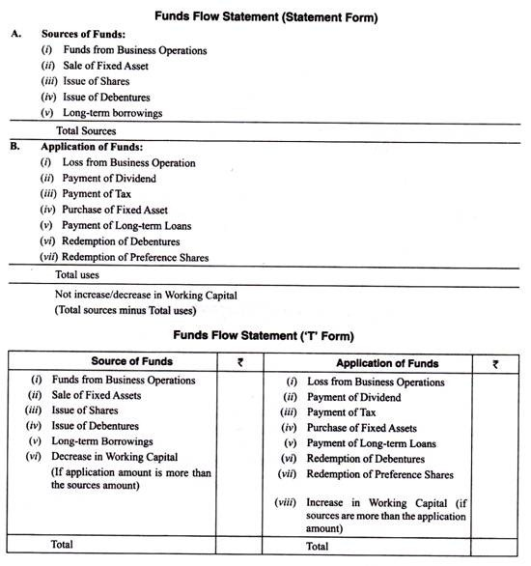
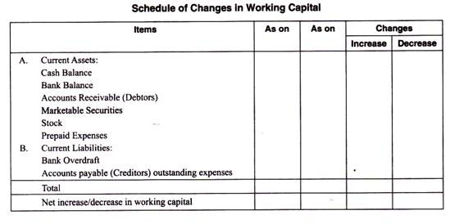

CASH FLOW STATEMENT
The official name for the cash flow statement is the statement of cash flows. We will use both names throughout AccountingCoach.com.
The statement of cash flows is one of the main financial statements. (The other financial statements are the balance sheet, income statement, and statement of stockholders' equity.)
The cash flow statement reports the cash generated and used during the time interval specified in its heading. The period of time that the statement covers is chosen by the company. For example, the heading may state "For the Three Months Ended December 31, 2014" or "The Fiscal Year Ended September 30, 2014".
The cash flow statement organizes and reports the cash generated and used in the following categories:

