UNIT-III
INTRODUCTION MARKETS, THEORIES OF THE FIRM AND PRICING POLICIES
Introduction:
Market constitutes an important phase in the economic activity. All the goods and services that are produced need to be sold to the consumer for a price. Market primarily provides possession utility for the goods and services. In other words “the sellers sell the goods to the buyer and thus transfer the ownership of the goods.
Definition: It is defined as it is a place or point at which buyer and sellers negotiate their exchange of well defined products or services. It was referred to as a public place in a village or town where provisions and other objects where brought for sale. Based on the locations, markets are classified as rural, urban, national or world markets.
Size of Market: The size of market depends on many factors such as nature of products, nature of their demand, tastes and preferences of the customers, their income level, state of technology, extent of infrastructure namely telecommunications and information technology.
Market Structure: Market structure refers to the characteristics of a market that influence the behavior and performance of firms that sell in that market.
The structure of market is based on its following features:
- The degree of seller Concentration: This refers to the number of sellers and their market share for a given product or service in the market.

- The degree of buyer concentration: This refers to the number of buyers and their extent of purchases of a given product or service in the market.

- The degree of product differentiation: This refers to the extent by which the product of each trader is differentiated from that of the other. Product differentiation can take several forms as varieties, brands all of which are sufficiently similar to distinguish them as a group, from other products eg: cars

- The conditions of entry into the market: There could be certain restrictions to enter or exit from the markets. The degree with which one can enter the market or exit from the markets also determines the market structure.

Types of Competition
Based on the degree of competition, the market can be divided into
- Perfect market Competition
- Imperfect market Competition
PERFECT MARKET COMPETITION
A market in which all firms in an industry are price takers and in which there is freedom of entry into and exit from the industry. The business motive of the entire firm under perfect competition is profit maximization. Each firm seeks to maximize its profit. The market with perfect conditions is known as perfect market.
Features: The following are features of perfect competition. In other words these are the assumptions underlying perfect markets:
- Large number of buyers and sellers: There should be significantly large number of buyers and sellers in the market. The number should be so large that it should not make any difference in terms of price or quantity supplied even if one enters the market or one leaves the market.
- Homogenous products or services: The products and services of each seller should be homogeneous. They cannot be differentiated from that of one another. It makes no difference to the buyer whether he buys from firm X or firm Z.
- Freedom to enter or exit the market: There is no restriction on the part of the buyer and sellers to enter the market or leave the market. There should not be any barriers. The buyer can enter the market or leave the market whenever they want.
- Perfect information available to the buyer and sellers: Each buyer and seller has total knowledge of the prices prevailing in the market at every given point of time, quantity supplied, costs, demand, nature of product and other relevant information. There is no need for any advertisement expenditure as the buyer and sellers are fully informed.
- Each firm is a price taker: An individual firm can alter its rate of production or sales without significantly affecting the market price of the product. A firm in a perfect market cannot influence the market through its own individual actions.
- Perfect Mobility of factors of production: There should not be any restrictions on the utilization of factors of production such as Land, Labour, and Capital so on. In other words whenever capital or labour is required it should instantly be made available.
Price Output Determination In Case Of Perfect Competition
The price and output of the firm are determined under perfect competition, based on Demand and Supply, at which price demand and supply’s are interest the seller will follow that price.

Price | Demand | Supply
60 | 20,000 | 30,000
50 | 25,000 | 25,000
40 | 30,000 | 20,000
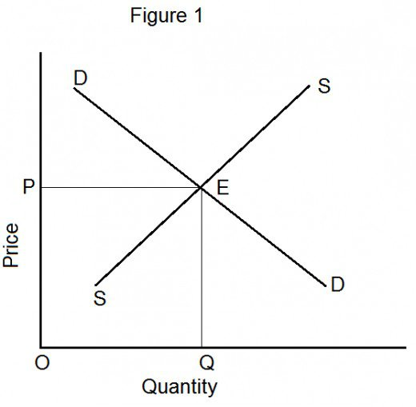

Equilibrium in Perfect competitive market
- MR = MC
- MC Curve cuts MR Curve from below.
- AR > AC

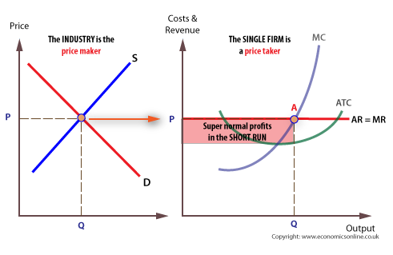

IMPERFECT COMPETITION
A Competition is said to be imperfect when it is not perfect. In other words when any or most of the above conditions do not exist in a given market. It is referred to as imperfect market. Based on the number of buyers and sellers, the imperfect markets are classified as explained below. The structure of market varies as below.
The various imperfect competitions are:
- Monopoly
- Monopolistic Competition
- Oligopoly
- Duopoly
MONOPOLY
Monopoly refers to a situation where a single firm is in a position to control either supply or price of a particular product/services. In monopoly the seller have rights to fix the price as he like.
Monopoly can be interpreted in to two ways. When there is a sole supplier it is a case of a pure monopoly. In this case, the firm and the industry are one and the same. E.g.: RBI is the sole supplier of currency notes in India. Another way is the firm supplying a half of the total market may have a greater market power, if the rest of the market is shared by a number of small firms, when the remaining firms are equally big it may face competition from the other firms.
FEATURES OF MONOPOLY
- Single seller and large number of buyers
- There is no close substitute goods
- Price maker
- In monopoly there is no difference between company and industry
- In monopoly restrictions are more
- Demand is inelastic
- In monopoly the seller control both price and supply
Price and output determination under monopoly
In monopoly price and output determination is based on elasticity of demand, where elasticity of demand is greater than one

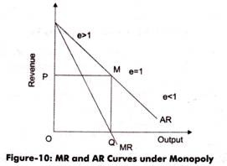

Equilibrium in Monopoly market
In the case of monopoly the marginal revenue (MR) is always less than the average revenue (AR) because of discounts or concessions.
- MR = MC
- MC Curve cuts MR Curve from below.
- AR > AC

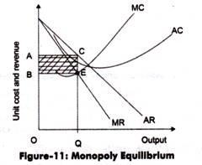

MONOPOLISTIC COMPETITION
When large number of seller produces differentiated products, monopolistic is said to exist. A product is said to be differentiated when its important features vary.
Eg: For “cameras”, the important features include Zoom lenses, focal length, memory, size of the camera, flash, safety, digital day and so on. The products with better features are differentiated from the others and they can be sold at higher prices. NIKON, KODAK, YASHICA and so on are the leading players among the many in market.
- Large Number of Buyers and Sellers:
- Product Differentiation:
- Selling Cost:
- Lack of Perfect Knowledge:
- Less Mobility:
- More Elastic Demand:

Price determination under monopolistic competition:
Under monopolistic competition, the firm will be in equilibrium position when marginal revenue is equal to marginal cost. So long the marginal revenue is greater than marginal cost, the seller will find it profitable to expand his output, and if the MR is less than MC, it is obvious he will reduce his output where the MR is equal to MC. In short run, therefore, the firm will be in equilibrium when it is maximising profits, i.e., when MR = MC.

(a) Short Run Equilibrium: Short run equilibrium is illustrated in the following diagram:

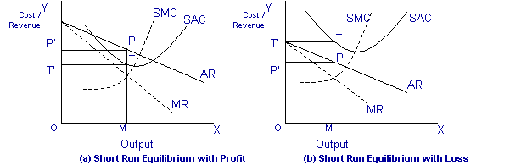

In the above diagram, the short run average cost is MT and short run average revenue is MP. Since the AR curve is above the AC curve, therefore, the profit is shown as PT. PT is the supernormal profit per unit of output. Total supernormal profit will be measured by multiplying the supernormal profit to the total output, i.e. PT × OM or PTT’P’ as shown in figure (a). The firm may also incur losses in the short run if it is facing AR curve below the AC curve. In figure (b) MP is less than MT and TP is the loss per unit of output. Total loss will be measured by multiplying loss per unit of output to the total output, i.e., TP × OM or TPP’T’.
b) Long Run Equilibrium: Under monopolistic competition, the supernormal profit in the long run is disappeared as new firms are entered into the industry. As the new firms are entered into the industry, the demand curve or AR curve will shift to the left, and therefore, the supernormal profit will be competed away and the firms will be earning normal profits. If in the short run firms are suffering from losses, then in the long run some firms will leave the industry so that remaining firms are earning normal profits.

The AR curve in the long run will be more elastic, since a large number of substitutes will be available in the long run. Therefore, in the long run, equilibrium is established when firms are earning only normal profits. Now profits are normal only when AR = AC. It is further illustrated in the following diagram:

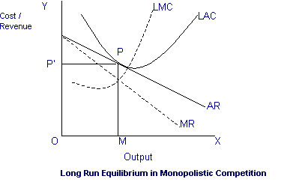

OLIGOPOLY
Oligopoly is a situation where a few large firms compete against each other and there is an element of interdependence in the decision making of these firms. Another variety of imperfect competition is oligopoly. If there is competition among a few sellers. Oligopoly is said to exist.
Eg: 1.Car manufacturing companies such as Maruthi Suzuki, Hindustan Motors, and Toyota so on. 2. News papers (such as The Hindu, Indian Express, and Times of India).
Features of Oligopoly: In order to distinguish oligopoly from other types of market situations, it is essential to understand the main features of oligopoly. These are the following:

- An industry which is dominated by a few firms.
- Interdependence of firms, firms will be affected by how other firms set price and output.
- Barriers to entry, but less than monopoly.
- Differentiated products, advertising is often important.
- Oligopoly is the most common market structure.

Kinky Demand model in oligopoly: The kinked demand curve was first used by Paul M.Sweezy to explain price rigidity. The assumption behind this theory of kinked demand is that each oligopolistic will act and react in a way that keeps conditions tolerable for all members of the industry. Such a situation is almost likely to occur where products are quite similar and therefore their prices are also the same.

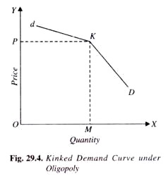
In oligopoly one firm is going to decrease the price then other firms are also going to decrease the price, why because large competition is going on among the firms.
OLIGOPSONY
If there are number of buyers, oligopsony is said to exist. There are a few news papers publishing companies in India and all these buy news print from the government of India. There are quite a good number of Computer assembly operators who buy the computer components on wholesale basis.
MONOPSONY
Based on the number of buyers and sellers, the structure of market varies as outlined below. “Poly refers to seller and “Psony” means buyer. Monopsony means that if there is only one buyer, monopsony market is said to exist. Food Corporation of India is the only government organization that purchases the agricultural products such as rice and so on
DUOPOLY
If there are two sellers, then duopoly is said to exist. If Pepsi and Coke are the two companies in soft drinks this market is called Duopoly.
DUOPSONY
If there are two buyers, Duopsony is said to exist.
PRICING METHODS
Fixation of the price for the product is very important. Most often discounts, concessions offered at the time of purchase. Sometimes certain schemes are introduced.
In consideration of pricing “Under pricing will result in losses and over pricing will make the customer run away. So in order to determine the pricing, objectives, methods, policies and procedures are implemented. Pricing new products and services is relatively a difficult task. Because, there is no prior information or guidelines available to fix the price.
Pricing objectives: It refers to the general and specific objectives. The various objectives are:
- To maximize profits.
- To increase sales.
- To increase market share.
- To satisfy customers and to meet the competition.
Pricing policy: The firm has to implement the pricing policies, when it deals in multiple products. This policy may explain how to handle about the price levels of the products.
Pricing Methods:
- Cost based pricing methods.
- Competition oriented pricing.
- Strategy based pricing.
- Demand oriented pricing.

Cost Based Pricing: These are two types
Cost Plus pricing: This is also called as “Mark up” pricing. The average cost at normal capacity of output is ascertained and then a conventional margin of profits is added to the cost to arrive at the price.
This method is suitable where the costs keep fluctuating from time to time. It is commonly followed in departmental stores and other retail shops. Sometimes it may be very difficult to find the selling price in advance due to complexity of the nature of the project.
Marginal Cost pricing: In Marginal Cost pricing, selling pricing is fixed in such a way that it covers fully the variables or marginal cost and contributes towards recovery of fixed costs fully or partly depending up on the market situations.
In stiff competition, marginal cost offers a guide line or boundary line, how the selling prices are lowered. This is also called Break- Even Pricing or Target profit pricing.
Competition Oriented Pricing: The pricing is a very complex task. The price of a product is set based on the competition charges for a similar product. These are various types mainly:
Sealed Bid Pricing: This method is more popular in tenders and contracts. Each contracting firm quotes its price in a sealed cover called “Tender”. All the tenders are opened on a scheduled date and the person, who quotes the lowest price, is awarded the contract. Any price quoted less than the marginal price results in loss.
Going rate pricing: The price charged by the firm is in tune with the price charged in the industry as a whole. When one wants to buy and sell gold, the prevailing market rate at a given point of time is taken as the basis to determine the price. Normally the market leaders keep announcing the prevailing prices at a given point of time based on demand and supply positions.

Demand based pricing methods: Demand-based pricing, also known as customer-based pricing, is any pricing method that uses consumer demand - based on perceived value - as the central element. These include:
Price discrimination: Price discrimination is the practice of charging a different price for the same good or service.
Perceived value pricing: Value-based price (also value optimized pricing) is a pricing strategy which setsprices primarily, but not exclusively, in the value, perceived or estimated, to the customer rather than on the cost of the product or historical prices.
Strategy Based Pricing: The various types of pricing are
Market Skimming: when the product is introduced for the first time in the market, the company follows this method. Under this method the company fixes High price for the product. The main idea is to change the customer maximum possible. This strategy is mostly found in case of technological products. Eg: when Sony introduces a particular TV model, it fixes a very high price.
Penetration price: This is exactly opposite to the market skimming method. The price of the product is fixed at low price that the company can increase its market share. The company attains profits with increasing volumes and increase in market share. The companies believe that it is necessary to dominate the market in the long run than making profits in the short run.
Two-Part Pricing: The firms with market power can enhance profits by the strategy of two part pricing. Under this strategy, a firm charges a fixed fee for the right to purchase its goods, plus a per unit charges for each unit purchased.
Entertainment houses such as Country clubs, Golf courses, and health clubs can adopt this strategy. They charge a fixed initiation fee plus a charge per month or per visit to use the facilities.
Peak Load pricing: During seasonal period when demand is likely to be higher a firm may enhance profits by peak load pricing. The firm’s philosophy is to charge a higher price during peak times. Where the demand during the peak times is so high that all customers cannot be accommodated at the same price due to capacity constraints.

