UNIT-II
PRODUCTION AND COST ANALYSIS
Production Function
Production is the result of the combinations of factors for the creation of values and utility to the corresponding commodities. The factors of production are namely Land, Labour, Capital, Organization and Technology.
Outputs
Processing
Inputs

Meaning: production is an activity that transforms inputs into outputs.
Definition: According to Michael R Baye defines production function as “that function which defines the maximum amount of output that can be produced with a given set of inputs.
Production Function: The function for the production is stated as:
Q = f{L_{1,} L_{2,} C, O, T}
Where Q = Quantity of Production, F = Relation between Inputs and Outputs, L₁ = land, L₂= Labour, C = Capital, O = Organization, T = Technology.
The level of output of a firm can be increases in to two ways:
1. By increasing only one factor and keeping the other factors constant.
2. By increasing all factors of Production.
LAW OF VARIABLE PROPORTION
The Law of variable proportion deals with the first way. It explains the relationship between the production and factors of production in the short period. This law explain the output increases when one factor is changed, keeping other factors constant.
According to this law three types of returns will be occurred.
In the Initial stage the proportionate change in the output is greater than the Proportionate change in the inputs. This is called “Increasing Return”. In the second stage the rate of change in the output is equal to the rate of change in the inputs then it is treated as “Constant Return”. In the third stage the rate of change in the output is less than the rate of change in the inputs then it is known as “Diminishing Return”. When the proportionate change in output is more than the inputs, the Marginal products may become Negative, then it is known as Negative Return to scale.
Definition: According to the “Marshall” An increase in capital and labour applied in the cultivation of land causes, in general a less than proportionate increase in the amount of producers raised, unless it happens to coincide with an improvement in the arts of agriculture.
Tabular Representation of the Law: This law can be explaining with the help of an example. A farmer has 5 acre of Land and he wants to increase the output, for this reason he increases the no: of workers. Only keeping other factors constant, at the same time there may be changes in Total Products, Average products, Marginal Products are shown in the following table:
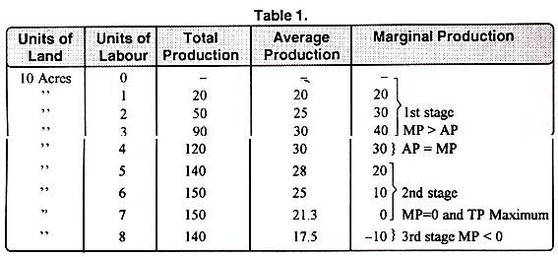

Total Product (TP =AP*Q): It refers to the total amount of output obtains by employing the workers on a plot of land. Average Product is multiplies by the number of workers then we get Total Product.
Average product (AP = TP/Q): It refers to the product of each worker it is divided by the quantity with respect of total product.
Marginal Product: (∆TP/∆Q): It refers to the additional products from the use of an additional worker.
In the above table of the first Stage we find the total product, Average product and marginal products are increased. In the incremental stage Marginal Product is greater than the Average product. In the second stage both average product and marginal product are equal. Hence in the third stage of the 8th worker the total product reaches the maximum level at the same time Marginal product becomes negative, and the Average product was gradually decreases.
Diagrammatic representation of the Law: The law of Diminishing returns was explained with the help of following diagram given below:

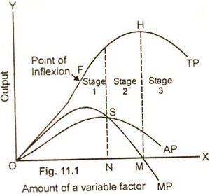

In the above diagram the variable factor i.e. workers or labour are shown on X- axis and the output is shown on Y- axis. “TPC” is total Product Curve, “APC” is the Average product curve, “MPC” is the Marginal Product curve. In this diagram at point S Average product and Marginal Product are equal, that is the end of the First Stage. At point P Total product reaches the maximum level at the same time at point R Marginal products becomes zero, that is the end of the second stage. In the third stage Total product Decreases and the marginal product becomes negative.
Production will not be stopped in the first stage, because in this stage the increasing returns operates .In the same way the producer will not continue in the third because Negative returns is operating.
Assumptions:
- All units of the variables factors are homogeneous
- It assumes there is short run situation
- All units of the variable factors are having the same efficiency
- The production is measured in terms of physical units.
Applicability of the law: According to “Classical Economists” the law of diminishing returns was applicable to agriculture sector only. Because land is a fixed factor, we cannot able to change the supply of land. If we want to increase the production in the agriculture sector, we have to increase either labour or capital. If we employed more no: of workers on the same piece of land. After a particular point the Marginal product will be decreases, hence diminishing returns may occur. But according to “Modern economists” the law of diminishing returns is applicable to not only in the agriculture sector but also in the industrial sector like Mining, Fisheries, and other sectors.
ISOQUANTS
An isoquant is a curve representing the various combinations of two inputs that produce the same amount of output. It is also known as isoproduct curve, Equal- product curve or production in difference curve.
“Iso” means Equal “Quant” means Quantity. Isoquant means that the quantities throughout a given isoquant are equal. The different pairs of labour and capital result in the same output have the following tabular from:
Labour (units) | Capital (units) | Output (units)
1 | 5 | 10
2 | 4 | 10
3 | 3 | 10
4 | 2 | 10
5 | 1 | 10

It will be seen that output is the same either by employing 4L+1C or 5L+0C and so on.
By drawing the graphical representation of isoquant or production function with two variables. one can derive the isoquant tracing all the combinations of the two factors of production that yield the same output. An isoquant is defined as the curve passing through the plotted points representing all the combinations of the two factors of production which will produce a given output.
For each level of output there will be a different isoquant. “When the whole array of isoquants is represented on a graph it is called “isoquant map”. The isoquant graph is as follows.

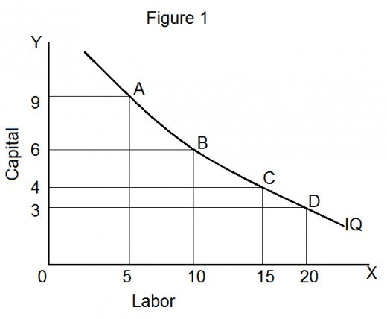

Feature of an isoquant:
- Down ward sloping: isoquant are down ward sloping curve, because if one input increases the other one reduces. There is no question of increase in both the inputs to yield a given output. A degree of substitution is assumed between the factors of production.
- Convex to Origin: Isoquant are convex to the origin. It is because the input factors are not perfect substitutes. One put factors can be substituted but other input factor in a “diminishing marginal rate”.
- Do not intersect: Two iso products do not intersect with each other, because each of these denotes a particular level of output. If the manufacturer wants to operate at a higher level of output, he has to switch over to another isoquant with a higher level of output and vice-versa.
- Do not touch axes: The isoquant touches neither X-axis, nor Y-axis as both inputs are required to produce a given product.
Types of isoquants:
Isoqunat assume different shapes depending up on the degree of substitutability of inputs under consideration
- Linear Isoquant
- Right angle Isoquant
- Convex isoquant
- Smooth convex isoquant

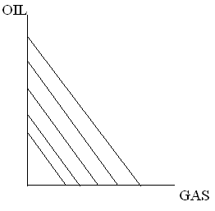
- Linear Isoquant: here there is a perfect substitutability of combined inputs to have a same desired level of output.
Eg: a power plant equipped to burn either oil or gas, various amounts of electric power can be produced by burning gas only, oil only or various amounts of each. Gas and oil are perfect substitute here. Hence the isoquants are straight lines.
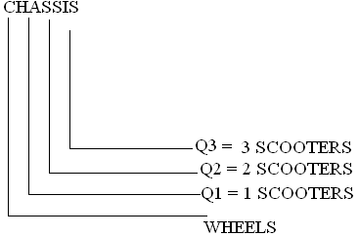
- Non linear isoquant: here there is not having perfect substitution between the inputs to have a same desired output.
E.g.: Exactly two wheels and one frame are required to produce a bicycle (scooter) and in no way can wheels be substituted for frame or vice versa. Likewise, two wheels and one chassis are required for a scooter. This is also known as “Leontief isoquant” or “Input-output isoquant”.

MARGINAL RATE OF TECHNICAL SUBSTITUTIONS (MRTS)
The Marginal Rate of Technical Substitution refers to the rate at which one input factor is substituted with the other to attain a given level of output. In other words the lesser units of one input must be compensated by increasing amounts of another input to produce the same level of output.
MRTS = Change in one input
Change in another input
= ∆K/∆L
∆K = Change in Capital
∆L = Change in Labour

RETURNS TO SCALE
Production is the result of various factors of production. The level of output can be increased into two ways:
- By increasing only one factor and keeping other factors are constant.
- By increasing all factors of production.

The law of variable proportion deals with the first cases. It explains how the output increases when one factor is changed on the other hand the “Law of returns “to scale is deals with the second way. It shows that how the output changes when all factors of production changed in the long period.

Labour | Capital | % Increase in Labour and Capital | Total out put | % Increase in out put | Returns to scale
1 | 100 | - | 100 | - | Increasing Returns to scale
2 | 200 | 100 | 220 | 120
3 | 300 | 50 | 350 | 59
4 | 400 | 33.33 | 500 | 42.9
5 | 500 | 25 | 625 | 25 | Constant Returns to scale
6 | 600 | 20 | 750 | 20
7 | 700 | 16.66 | 860 | 14.66 | Decreasing Returns to scale
8 | 800 | 14.24 | 940 | 9.3
9 | 900 | 12.29 | 1000 | 6.4

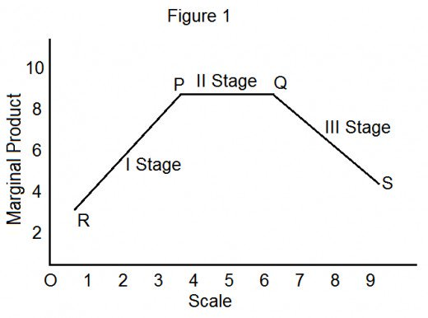

When all factors are increased we find three stages in the production they are:
- Increasing Returns to Scale
- Constant Return to Scale
- Diminishing Returns to Scale

- Increasing Return to Scale: When an increase in the factors of production causes a more than proportionate increases in the output. It is called increasing return to scale. In other words increasing returns to scale refers to that “the rate of change in the output is greater than the rate of change in input”.
Numerically it was represented as ∆P > ∆F
P F
∆P =Change in production
P
∆F =Change in factors of production.
F
2. Constant Return to Scale: Increasing returns to scale will not be continuing in definitely. After a certain stage the advantages and disadvantages of a large scale production are equal and we get the constant returns to scale.
In this stage “the rate of change in output is equal to the rate of change in the inputs”. Symbolically represented as ∆P ₌ ∆F
P F
The numerically value of constant returns to scale is always equal to one. If the inputs are doubled, the output will also be doubled.
3. Diminishing Return to Scale: In the stage the “rate of change in the output is less than the rate of change in input”. It was represented as ∆P < ∆F
P F
The numerical value of diminishing returns is less than one. When inputs are doubled, the output cannot be doubled. In this stage the advantages of large scale of Production are dominated by the disadvantages of production.
There are some other reasons for diminishing returns:
- Lack of proper control
- Inefficiency of Management
- Storage of raw materials
- Lack of Proper division of labour

ECONOMIES OF SCALE
The economies of scale result because of increase in the scale of production. “Alfred Marshall” divides the economies of scale into two groups:
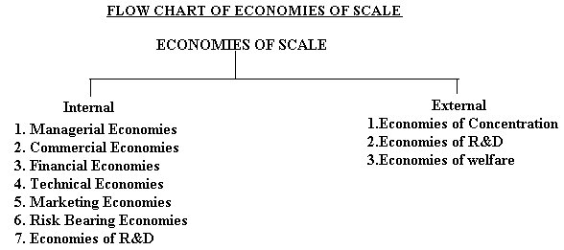

Internal Economies of Scale: It refers to the economies in production costs which accrue to the firm alone, when it expands its output. The internal economies occur as a result of increase in the scale of production.
- Managerial Economies: As the firm expands the firm needs qualified managerial personnel to handle each of its function marketing, finance, production, human resource and others in a professional way. Specialization ensures minimum wastage and lowers the cost of production in the long run.
- Commercial Economies: The transactions of buying and selling raw materials and other operating supplies such as spares and soon will be rapid and the volume of each transaction also grows as the firm grows. There could be cheaper savings in the procurement, transportation and storage costs will leads to lower costs and increased profits.
- Financial Economies: There could be cheaper facilities from the financial institutions to meet the capital expenditure or working capital requirements. A larger firm has larger assets to give security to the financial institutions which can consider reducing the rate of interest on loans.
- Technical Economies: Increase in the scale of production follows when there is sophisticated technology available and the firm is in a position to hire qualified technical manpower to make use of it.
- Marketing Economies: As the firm grows larger and larger it can afford to maintain a full fledged marketing department independently, to handle the issue related to design of customer survey’s, advertising, Materials, promotion campaign, handling of scales and marketing staff, launching a new product and soon.
- Risk Bearing Economies: As there is growth in the size of the firm, there is increase in the risk also. Sharing the risk with the insurance companies is the first priority for any firm. The firm can insure its machinery and other assets against the hazards of fire, thefts and other risks. The larger firms can spread their risk so that they do not keep all their eggs in one basket; they purchase raw materials from different sources. They more often deal in more than one product to offset the losses by the profit from the sale of others.
- Economies of research and Development: Large organizations such as Dr. Reddy’s Labs, Hindustan lever spend heavily on research and development and bring out several innovative products only such firms with a strong R & D base can cope with competition globally.
External Economies of Scale: It refers to all firms in the industry of growth of the industry as a whole or because of growth of ancillary industries. External economies benefits all the firms in the industry as the industry expands. This will lead to lowering the cost of production and thereby increasing the profitability. The external economies can be grouped under three types.
- Economies of Concentration: Because all the firms are located at one place, it is likely that there is better infrastructure in terms of approach roads, transportation facilities such as railways lines, banking and communications facilities and soon.
- Economies of R&D: All the firms can pool resources together to finance research and development activities and thus share the benefits of research. There could be a common facility to share journals, newspapers and other available reference material of common interest.
- Economies of Welfare: There could be common facilities such as canteen, industrial housing, community halls, schools and colleges, employment bureau, hospitals and soon, which can be used in common by the employee in the welfare industry.
Diseconomies of Scale: Diseconomies are mostly managerial in nature. Problems of planning, coordination, communication and control may become increasingly complex as the firm grows in size resulting in increasing average cost per unit. Sometimes the firm may also collapse.
Diseconomies of scale are said to result when an increase in the scale of production leads to a higher cost per unit. All inputs increase by 10 % but the production increases by only 5%. Expansion of a firm beyond a particular limit may leads to diseconomies of scale.
Similarly when the industrial estates are booming with activity, industry as a whole expands and there is keen competition for inputs and other operating supplies. As a result the price on inputs and other factors of production such as skilled labour rise substantially. This leads to diseconomies as a result of the expansion of the industry.

ISOCOSTS (BUDGETING)
Isoquants show that any desired level of output can be produced by a number of different combinations of inputs. But our task is to determine the specific combinations of inputs a producer should select.
To attain the highest possible level of output for a given level of cost or the lowest possible cost for producing any given level of output. The firm needs some information regarding the prices of inputs and the amount of resources availability with the firm produce output.
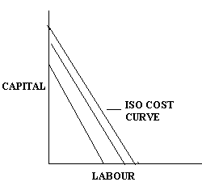
“Isocost” cost refers to the cost curve that represents the combinations of inputs that will cost the producer the same amount of money. In other words, each isocost denotes a particular level of total cost for a given level of production. If the level of production changes, the total cost changes and thus the isocost curve moves upwards and vice versa.
Meaning: “The different possible combinations of inputs which the firm can buy with the help of its possible resources (given input prices) are represented as Isocost line.
Eg: Suppose that the firm wishes to spend 50,000/- on a particular process which involve two inputs Labour and Capital. Let the price of labour Rs 100 per unit and Capital 200Rs per unit with Rs50, 000. The firm can buy either 500 units of labour or 250 units of capital or their combinations which fully exhausts Rs50, 000. A straight line joining 250 units of capital with 500 units of labour will pass through all such combinations capital and labour which the firm can buy with its outlay of 50,000. Such line is called isocost line.

Algebraically the isocost can be expressed as E =P_{L} L +P _{C} C
Where E = Total budget for the inputs like labour and capital
P_{L} P _{C =} Price of labour and capital
L and C = Quantity of labour and capital.

LEAST COST COMBINATION OF INPUTS
The manufacturing has to produce at lower costs to attain higher profits. The isocost and isoquants can be used to determine the inputs usage that minimizes the cost of Production.
When a firm’s expenditure increase on inputs it would lead to a parallel shift isocost lines each isocost line gives a new tangency point and therefore a new equilibrium point. If we join these equilibrium points we get a curve known as a “Expansion Path”.
The points of tangency P,Q, and R on each of the isoquant curves represents the least cost combinations of inputs yielding maximum level of outputs. Any output lower or higher than this will result in higher cost of production.
COBB-DOUGLASPRODUCTION FUNCTION
Cobb and Douglas put forth a production function relating output in American Manufacturing industries from 1899 – 1922 to labour and capital inputs. They used the following formula:
P = b Lª C^{1-a}
Where P is total output
L = the index of employment of labour in manufacturing
C = Index of fixed capital in manufacturing.
The exponents “a and1-a” are the elasticity of production these measures the percentage response of output to percentage changes in labour and capital respectively.
P = 1.01 L^{0.75} C^{0.25}
R² = 0.9409.
The production functions shows that one percentage change in labour inputs, capital remaining the same is associated with a 0.75 percentage change in output, similarly one percentage change in capital, labour remaining the same is associated with a 0.25 percentage change in output . The coefficient of determinations (R²) means that 94 % of the variations on the dependent variables (P) were accounted for by the variations in the independent variable (L and C)
Thus Cobb Douglas production function was based on macro level study, it has been very useful for interpreting economic results.
LEONTIEF PRODUCTION FUNCTION OR FIXED PROPORTIONS PRODUCTION FUNCTION
It is a production function that implies the factors of production will be used in fixed (technologically pre-determined) proportions, as there is no substitutability between factors.
For the simple case of a good that is produced with two inputs, the function is of the form
Q= Min (Z₁ /a, Z₂ /b

where q is the quantity of output produced, z₁ and z₂ are the utilized quantities of input 1 and input 2 respectively, and a and b are technologically determined constants.
Example: Suppose that the intermediate goods "tires" and "steering wheels" are used in the production of automobiles (for simplicity of the example, to the exclusion of anything else). Then in the above formula q refers to the number of automobiles produced, z₁ refers to the number of tires used, and z₂ refers to the number of steering wheels used. Assuming each car is produced with 4 tires and 1 steering wheel, the Leontief production function is
Number of cars = Min{¼ times the number of tires, 1 times the number of steering wheels}.

COST ANALYSIS
Introduction:
The Managerial economist is concerned with making Managerial decisions. Different business proposals are evaluates of their costs and revenues.
Concept and Nature of Cost: Cost refers to the expenditure incurred to produce a particular product or service. All costs involve a sacrifice of some kind or other or acquire some benefits.
Eg: I want to eat food; I should be prepared to sacrifice Money. Costs may be monetary or non monetary, tangible or intangible, determined subjectively or objectively. Social costs such as pollution, noise or traffic congestion to the cost concept.
The cost of production normally includes the cost of raw materials, labour and other expenses. These are called Total cost (TC). This is compared with the total revenues (TR) realized on the sale of the products manufactured. The difference between total revenues and total cost is known as Profit (P)
Profit (p) = TR-TC
In decision making Cost refers needs to be analyzed and understood in a wider perspective. Though the data for studying the costs is obtained from the financial records, these need to be supplemented by specific details. The costs as reported by financial accounts are more suited to the legal and financial purpose for which they are designs. But financial records cannot provide all the necessary information about costs.
An understanding of the meaning of various cost concepts is essential for clear business thinking. They facilitate clear understanding of the management problem and also of the concept of cost that is relevant to it.
Opportunity Cost:
Opportunity cost refers to the earning / profits that are foregone from alternatives ventures by using given limited facilities for a particular purpose. They represent only the sacrificed alternatives. So they are never recorded in the books of accounts. These costs must be considered for decision making.
Opportunity cost refers to the “cost for the next best alternatives foregone”. We have scarce resources and all these have alternative uses. Where there is an alternative, there is an opportunity to reinvest the resources. In other words if there are no alternatives there are no opportunity costs.
Eg: If the firm owns land there is no cost of using the land (i.e rent) in the firms account. But the firm has an opportunity cost of using this land, which is equivalent to the rent foregone by not letting the land out on rent.
Explicit vs Implicit costs:
The costs of using resources in production involve both explicit costs. It is also called as out-of-Pocket cost and other non cash costs called Implicit costs entered in the books of accounts. Explicit costs involve payment of cash. The rent for the land lord, wages for the laborer, interest paid are the explicit cost. Other examples of explicit costs are:
.Cost of raw material, Salaries, Power charges, Rent of business, insurance premium
Implicit Costs: These are also called imputed costs do not involve payment of cash as they are not actually incurred. They do not take the form of cash outlays, nor outlays, nor they do not appear in the accounting system. Eg: wages of labour rendered by the entrepreneur himself, Interest on capital supplied by him.
Out-of-Pocket costs: The costs that involve an immediate outflow of cash. These are spent in the day- to-day life of the business, such as purchase of raw material, payment of salaries interest on loans and so on. Out of pocket costs are also called explicit costs because they are incurred in reality.
Fixed cost vs Variable cost: Economists often divide costs into two main groups they are fixed cost and Variable cost. Fixed costs are that part of the total cost of the firm which does not vary with output. Eg: Expenditure depreciation rent of land and building, property taxes etc. If the period under consideration is long enough to allow the necessary adjustments in the capacity of the firm. The fixed costs no longer remain fixed.
Variable Costs: It directly dependent on the volume of output or service variable costs increase but not necessarily in the same proportion as the increase in output. The degree of proportionality between the variable cost and output depends up on the utilization of fixed facilities and resources during the process of production.
BREAK EVEN ANALYSIS (BEP)/ COST VOLUME PROFIT ANALYSIS (CVP)
Introduction:
Break even analysis refers to analysis of the breakeven point. The BEP is defined as a no profit or no loss point. It is necessary to determine the BEP when there is neither profit nor loss. It is important because it denoted the minimum volume of production to be undertaken to avoid losses.
In other words BEP refers to the point where total cost is equal to total revenues
BEP equal to TC=TR. It is points of no profit no loss. Break even analysis is defined of costs and their possible impact on revenues and volume of the firm. Hence it is also called the Cost-Volume-Profit Analysis. A firm is said to attain the BEP when its total revenue is equal to total cost (TR=TC).
Total cost comprises fixed cost and variable cost. The significant variables on which the BEP is based are fixed cost, variable cost and Total Revenues.
Break Even Chart: The graphical representation of breakeven point in a breakeven chart is Output is shown on Horizontal axis and Revenues on Vertical axis.
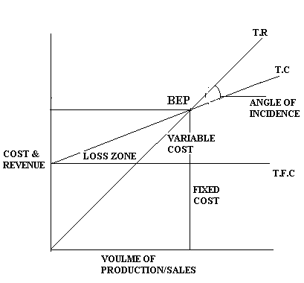

- TC = Total variable cost (TVC) + Total Fixed Cost (TFC).
- The variable cost line is drawn first. It varies proportionately with volume of production and sales.
- The total cost line is derived by adding total fixed cost line to the total variable cost line. The total cost line is parallel to variable cost line.
- The total revenue line starts from zero point and increase along with the volume of sales intersecting total cost line at point BEP.
- The zone below BEP is loss zone and above is BEP profit zone.
- OP is the quantity produced/ sold at OC. The cost/price at BEP.
- The angle formed at BEP that is the point of intersection of total revenues and total cost is called “Angle of Incidence”.
- The larger the angle of incidence, the higher is the quantum of profit. Once the fixed costs are absorbed.
Applications of Breakeven Analysis:
- Make or Buy Decision: The manager is confronted with “Make or Buy” decision. The necessary components or spare parts, where the consumption is larger making may be economical.
- Choosing a product mix when there is a limiting factor: It is very likely that the company may be dealing in more than one product and company wants to know, in view of the limited plant capacity.
- Drop or Add Decision: It is common that the firm keep on adding new products to their product range, while dropping the old ones to keep space with the changing demand. In this process we proposed to be dropped, saves the firm from the losses then |Break even analysis helps in such decisions.
Assumptions of Break Even Analysis
- Cost perfectly classified fixed and variable
- Selling price does not change with volume of sales simply price discounts are not allowed
- Assume all the produced goods are sold in the market ie No of units produced equals to No of units sold.
- Only one product is available for sale if multi product firm , the product mix does not change.
Significance of Break Even Analysis:
- To ascertain the profit on a particular level of sales volume or a\ given capacity of production.
- To calculate sales required to earn a particular desired level of profit.
- To compare the product line, sales area, method of sale for individual company.
- To compare the efficiency of the different firms.
- To decide whether to add a particular product to the existing product line or drop one from it.
- To decide to “Make or Buy” a given component or spare part.
- To decide what promotion mix will yield optimum sales.

Limitations of BEA:
- Breakeven point is based on fixed cost, variable cost and total revenue a change in one variable is going to affect the BEP.
- All costs cannot be classified into fixed and variable costs.
- It is based on fixed cost concept and hence holds good only in the short run.
- Constant selling price is not true.
- No importance is given to opening and closing stocks.
Margin of Safety: It is the excess of sales over the break even sales. It can be expressed in percentage or in absolute sales amount. A large margin of safety indicates the soundness of the business. The formula for the margin of safety is:
MOS = Actual sales (present sales – break even sales)
MOS = Net Profit/P/V Ratio.

