UNIT-VI

SYLLABUS: Color image processing: color fundamentals, color models, pseudo color image processing, basics of full color image processing, color transformations, smoothing and sharpening. Image segmentation based on color, noise in color images, color image compression.

color fundamentals.

Color of an object is determined by the nature of the light reflected from it. When a beam of sunlight passes through a glass prism, the emerging beam of light is not white but consists instead of a continuous spectrum of colors ranging from violet at one end to red at the other. As Fig. 5.1.1 shows, the color spectrum may be divided into six broad regions: violet, blue, green, yellow, orange, and red. When viewed in full color (Fig. 5.1.2), no color in the spectrum ends abruptly, but rather each color blends smoothly into the next.
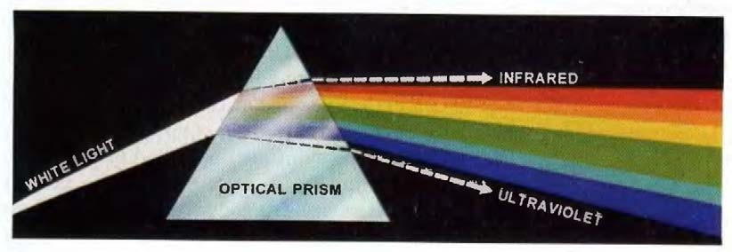
Fig. 5.1.1 Color spectrum seen by passing white light through a prism.

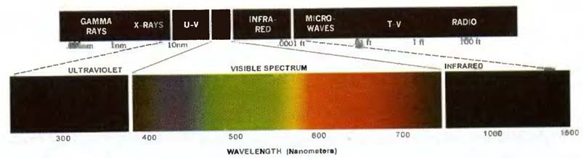
Fig. 5.1.2 Wavelengths comprising the visible range of the electromagnetic spectrum.

As illustrated in Fig. 5.1.2, visible light is composed of a relatively narrow band of frequencies in the electromagnetic spectrum. A body that reflects light that is balanced in all visible wavelengths appears white to the observer. However, a body that favors reflectance in a limited range of the visible spectrum exhibits some shades of color. For example, green objects reflect light with wavelengths primarily in the 500 to 570 nm range while absorbing most of the energy at other wavelengths.
Characterization of light is central to the science of color. If the light is achromatic (void of color), its only attribute is its intensity, or amount. Achromatic light is what viewers see on a black and white television set Three basic quantities are used to describe the quality of a chromatic light source: radiance, luminance, and brightness.

Radiance:

Radiance is the total amount of energy that flows from the light source, and it is usually measured in watts (W).

Luminance:

Luminance, measured in lumens (lm), gives a measure of the amount of energy an observer perceives from a light source. For example, light emitted from a source operating in the far infrared region of the spectrum could have significant energy (radiance), but an observer would hardly perceive it; its luminance would be almost zero.

Brightness:

Brightness is a subjective descriptor that is practically impossible to measure. It embodies the achromatic notion of intensity and is one of the key factors in describing color sensation.
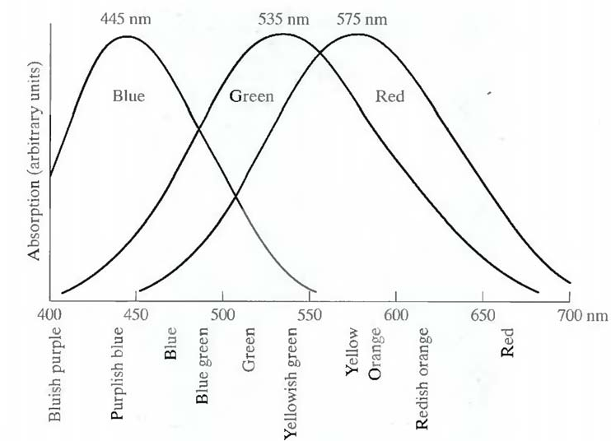
Fig. 5.1.3 Absorption of light by the red, green, and blue cones in the human eye as a function of wavelength.
Cones are the sensors in the eye responsible for color vision. Detailed experimental evidence has established that the 6 to 7 million cones in the human eye can be divided into three principal sensing categories, corresponding roughly to red, green, and blue. Approximately 65%

of all cones are sensitive to red light, 33% are sensitive to green light, and only about 2% are sensitive to blue (but the blue cones are the most sensitive). Figure 5.1.3 shows average experimental curves detailing the absorption of light by the red, green, and blue cones in the eye. Due to these absorption characteristics of the human eye, colors arc seen as variable combinations of the so- called primary colors red (R), green (G), and blue (B).
The primary colors can be added to produce the secondary colors of light --magenta (red plus blue), cyan (green plus blue), and yellow (red plus green). Mixing the three primaries, or a secondary with its opposite primary color, in the right intensities produces white light.
The characteristics generally used to distinguish one color from another are brightness, hue, and saturation. Brightness embodies the chromatic notion of intensity. Hue is an attribute associated with the dominant wavelength in a mixture of light waves. Hue represents dominant color as perceived by an observer. Saturation refers to the relative purity or the amount of white light mixed with a hue. The pure spectrum colors are fully saturated. Colors such as pink (red and white) and lavender (violet and white) are less saturated, with the degree of saturation being inversely proportional to the amount of white light-added.
Hue and saturation taken together are called chromaticity, and. therefore, a color may be characterized by its brightness and chromaticity.

RGB color model.

The purpose of a color model (also called color space or color system) is to facilitate the specification of colors in some standard, generally accepted way. In essence, a color model is a specification of a coordinate system and a subspace within that system where each color is represented by a single point.

The RGB Color Model:

In the RGB model, each color appears in its primary spectral components of red, green, and blue. This model is based on a Cartesian coordinate system. The color subspace of interest is the cube shown in Fig. 5.2, in which RGB values are at three corners; cyan, magenta, and yellow are at three other corners; black is at the origin; and white is at the corner farthest from the origin. In this model, the gray scale (points of equal RGB values) extends from black to white along the line joining these two points. The different colors in this model arc points on or inside the cube, and are defined by vectors extending from the origin. For convenience, the assumption is that all color values have been normalized so that the cube shown in Fig. 5.2 is the unit cube. That is, all values of R, G. and B are assumed to be in the range [0, 1].

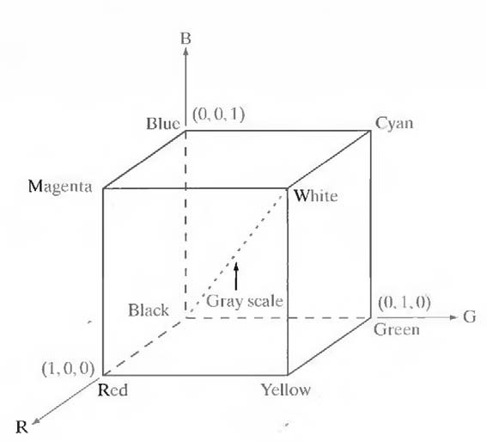

Fig. 5.2 Schematic of the RGB color cube.

Images represented in the RGB color model consist of three component images, one for each primary color. When fed into an RGB monitor, these three images combine on the phosphor screen to produce a composite color image. The number of bits used to represent each pixel in RGB space is called the pixel depth.
Consider an RGB image in which each of the red, green, and blue images is an 8-bit image. Under these conditions each RGB color pixel [that is, a triplet of values (R, G, B)] is said to have a depth of 24 bits C image planes times the number of bits per plane). The term full-color image is used often to denote a 24-bit RGB color image. The total number of colors in a 24-bit RGB image is (2⁸)³ = 16,777,216.
RGB is ideal for image color generation (as in image capture by a color camera or image display in a monitor screen), but its use for color description is much more limited.

CMY color model.

Cyan, magenta, and yellow are the secondary colors of light or, alternatively, the primary colors of pigments. For example, when a surface coated with cyan pigment is illuminated with white light, no red light is reflected from the surface. That is, cyan subtracts red light from reflected white light, which itself is composed of equal amounts of red, green, and blue light.
Most devices that deposit colored pigments on paper, such as color printers and copiers, require CMY data input or perform an RGB to CMY conversion internally. This conversion is performed using the simple operation (1) where, again, the assumption is that all color values

have been normalized to the range [0, 1]. Equation (1) demonstrates that light reflected from a surface coated with pure cyan does not contain red (that is, C = 1 — R in the equation).
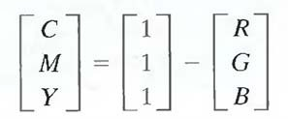 (1)
Similarly, pure magenta does not reflect green, and pure yellow does not reflect blue. Equation (1) also reveals that RGB values can be obtained easily from a set of CMY values by subtracting the individual CMY values from 1. As indicated earlier, in image processing this color model is used in connection with generating hardcopy output, so the inverse operation from CMY to RGB generally is of little practical interest.
Equal amounts of the pigment primaries, cyan, magenta, and yellow should produce black. In practice, combining these colors for printing produces a muddy-looking black.

HSI color model.

When humans view a color object, we describe it by its hue, saturation, and brightness. Hue is a color attribute that describes a pure color (pure yellow, orange, or red), whereas saturation gives a measure of the degree to which a pure color is diluted by white light. Brightness is a subjective descriptor that is practically impossible to measure. It embodies the achromatic notion of intensity and is one of the key factors in describing color sensation.
Intensity (gray level) is a most useful descriptor of monochromatic images. This quantity definitely is measurable and easily interpretable. The HSI (hue, saturation, intensity) color model, decouples the intensity component from the color-carrying information (hue and saturation) in a color image. As a result, the HSI model is an ideal tool for developing image processing algorithms based on color descriptions that are natural and intuitive to humans.
In Fig 5.4 the primary colors are separated by 120°. The secondary colors are 60° from the primaries, which means that the angle between secondaries is also 120°. Figure 5.4(b) shows the same hexagonal shape and an arbitrary color point (shown as a dot).The hue of the point is determined by an angle from some reference point. Usually (but not always) an angle of 0° from the red axis designates 0 hue, and the hue increases counterclockwise from there. The saturation (distance from the vertical axis) is the length of the vector from the origin to the point. Note that the origin is defined by the intersection of the color plane with the vertical intensity axis. The important components of the HSI color space are the vertical intensity axis, the length of the vector to a color point, and the angle this vector makes with the red axis.

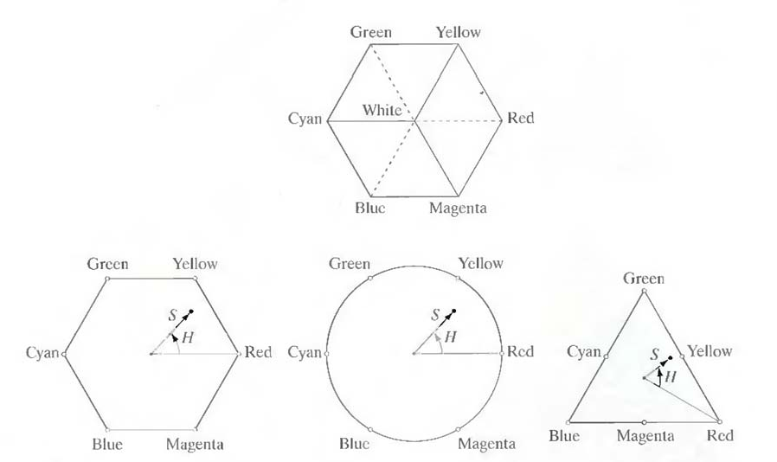

Fig 5.4 Hue and saturation in the HSI color model.

conversion from RGB color model to HSI color model.

Given an image in RGB color format, the H component of each RGB pixel is obtained using the equation

(1)

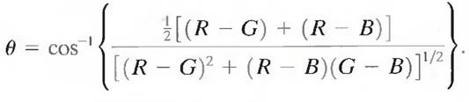
With

The saturation component is given by
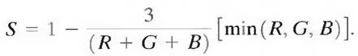

Finally, the intensity component is given by
(2)

(3)

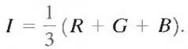
(4)

It is assumed that the RGB values have been normalized to the range [0, 1] and that angle θ is measured with respect to the red axis of the HST space. Hue can be normalized to the range [0, 1] by dividing by 360° all values resulting from Eq. (1). The other two HSI components already are in this range if the given RGB values are in the interval [0, 1].

conversion from HSI color model to RGB color model.

Given values of HSI in the interval [0,1 ], one can find the corresponding RGB values in the same range. The applicable equations depend on the values of H. There are three sectors of interest, corresponding to the 120° intervals in the separation of primaries.\

RG sector (0º ≤ H <120°):
When H is in this sector, the RGB components are given by the equations

B = I (1 – S) G = 3 I – (R + B)
R = I [1 + (S * cos H/ cos(60º – H)]

GB sector (120º ≤ H < 240º):
If the given value of H is in this sector, first subtract 120° from it.

H = H - 120⁰

Then the RGB components are

R = I (1 – S)

B = 3 I – (R + G)

G = I [1 + (S * cos H/ cos(60º – H)]
BR sector (240º ≤ H ≤ 360º):

If H is in this range, subtract 240º from it

H = H - 240⁰

Then the RGB components are

G = I (1 – S)

R = 3 I – (B + G)

B = I [1 + (S * cos H/ cos(60º – H)]

pseudocolor image processing.

Pseudocolor (also called false color) image processing consists of assigning colors to gray values based on a specified criterion. The term pseudo or false color is used to differentiate the process of assigning colors to monochrome images from the processes associated with true color images. The process of gray level to color transformations is known as pseudocolor image processing.
The two techniques used for pseudocolor image processing are,

- Intensity Slicing

- Gray Level to Color Transformation

Intensity Slicing:

The technique of intensity (sometimes called density) slicing and color coding is one of the simplest examples of pseudocolor image processing. If an image is interpreted as a 3-D function (intensity versus spatial coordinates), the method can be viewed as one of placing planes parallel to the coordinate plane of the image; each plane then "slices" the function in the area of intersection. Figure 5.8 shows an example of using a plane at f(x, y) = l_{i} to slice the image function into two levels.
If a different color is assigned to each side of the plane shown in Fig. 5.8, any pixel whose gray level is above the plane will be coded with one color, and any pixel below the plane will be coded with the other. Levels that lie on the plane itself may be arbitrarily assigned one of the two colors. The result is a two-color image whose relative appearance can be controlled by moving the slicing plane up and down the gray-level axis.
In general, the technique may be summarized as follows. Let [0, L - 1 ] represent the gray scale, let level l_{o} represent black [f(x, y) = 0], and level l_{L} ₋ ₁ represent white [f(x, y) = L - 1 ]. Suppose that P planes perpendicular to the intensity axis are defined at levels l₁, l₂,….,l_{p.}. Then, assuming that 0 < P < L – 1, the P planes partition the gray scale into P + 1 intervals, V₁, V₂,...,
V_{p} + 1. Gray-level to color assignments are made according to the relation

f(x, y) = c_{k} if f(x, y) є V_{k}
where c_{k} is the color associated with the kth intensity interval V_{k} defined by the partitioning planes at l = k - 1 and l = k.

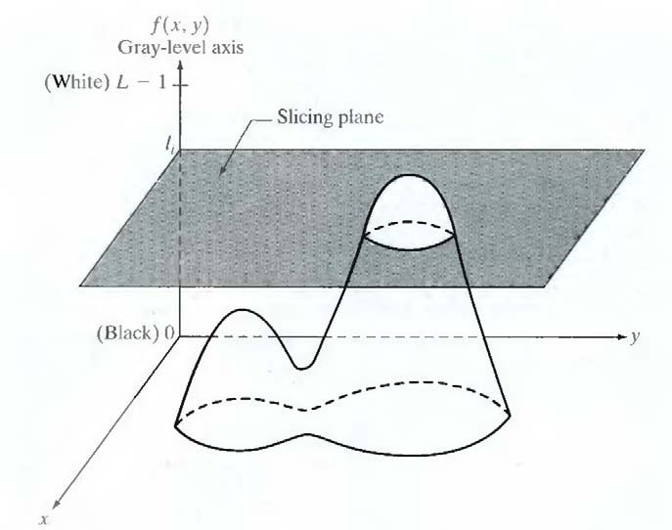

Fig 5.8.1 Geometric interpretation of the intensity-slicing technique.

The idea of planes is useful primarily for a geometric interpretation of the intensity- slicing technique. Figure 5.8.2 shows an alternative representation that defines the same mapping as in Fig. 5.8.1. According to the mapping function shown in Fig. 5.8.2, any input gray level is assigned one of two colors, depending on whether it is above or below the value of l_{i} When more levels are used, the mapping function takes on a staircase form.
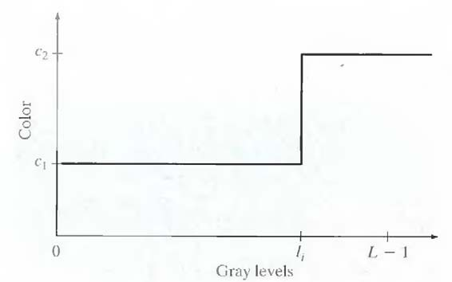
Fig 5.8.2 An alternative representation of the intensity-slicing technique.

Gray Level to Color Transformation:

The idea underlying this approach is to perform three independent transformations on the gray level of any input pixel. The three results are then fed separately into the red, green, and blue channels of a color television monitor. This method produces a composite image whose color content is modulated by the nature of the transformation functions. Note that these are transformations on the gray-level values of an image and are not functions of position.
In intensity slicing, piecewise linear functions of the gray levels are used to generate colors. On the other hand, this method can be based on smooth, nonlinear functions, which, as might be expected, gives the technique considerable flexibility.
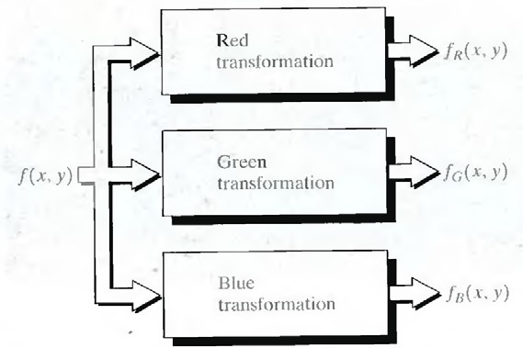
Fig. 5.8.3 Functional block diagram for pseudocolor image processing.

The output of each transformation is a composite image.

full color image processing.

Full-color image processing approaches fall into two major categories. In the first category, each component image is processed individually and then form a composite processed color image from the individually processed components. In the second category, one works with color pixels directly. Because full-color images have at least three components, color pixels really are vectors. For example, in the RGB system, each color point can be interpreted as a vector extending from the origin to that point in the RGB coordinate system.
Let c represent an arbitrary vector in RGB color space:

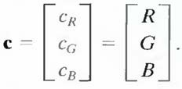
(1)

This equation indicates that the components of c are simply the RGB components of a color image at a point. If the color components are a function of coordinates (x, y) by using the notation
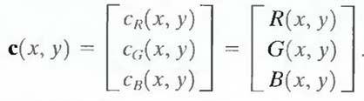 (2)
For an image of size M X N, there are MN such vectors, c(x, y), for x = 0,1, 2,...,M- l; y = 0,1,2,...,N- 1.
It is important to keep clearly in mind that Eq. (2) depicts a vector whose components are spatial variables in x and y.
In order for per-color-component and vector-based processing to be equivalent, two conditions have to be satisfied: First, the process has to be applicable to both vectors and scalars. Second, the operation on each component of a vector must be independent of the other components.
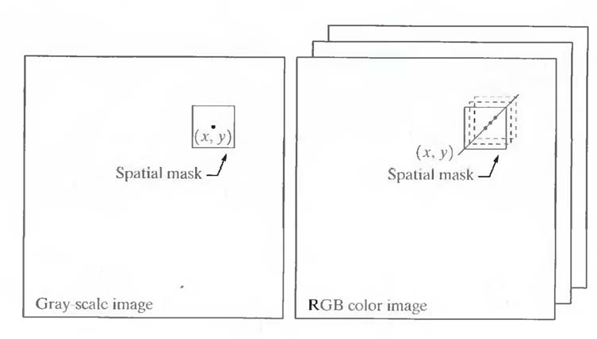
Fig 9 Spatial masks for gray-scale and RGB color images.

Fig 9 shows neighborhood spatial processing of gray-scale and full-color images. Suppose that the process is neighborhood averaging. In Fig. 9(a), averaging would be

accomplished by summing the gray levels of all the pixels in the neighborhood and dividing by the total number of pixels in the neighborhood. In Fig. 9(b), averaging would be done by summing all the vectors in the neighborhood and dividing each component by the total number of vectors in the neighborhood. But each component of the average vector is the sum of the pixels in the image corresponding to that component, which is the same as the result that would be obtained if the averaging were done on a per-color-component basis and then the vector was formed.

color segmentation process.

Segmentation is a process that partitions an image into regions and partitioning an image into regions based on color is known as color segmentation.

Segmentation in HSI Color Space:

If anybody want to segment an image based on color, and in addition, to carry out the process on individual planes, it is natural to think first of the HSI space because color is conveniently represented in the hue image. Typically, saturation is used as a masking image in order to isolate further regions of interest in the hue image. The intensity image is used less frequently for segmentation of color images because it carries no color information.

Segmentation in RGB Vector Space:

Although, working in HSI space is more intuitive, segmentation is one area in which better results generally are obtained by using RGB color vectors. The approach is straightforward. Suppose that the objective is to segment objects of a specified color range in an RGB image. Given a set of sample color points representative of the colors of interest, we obtain an estimate of the "average" color that we wish to segment. Let this average color be denoted by the RGB vector a. The objective of segmentation is to classify each RGB pixel in a given image as having a color in the specified range or not. In order to perform this comparison, it is necessary to have a measure of similarity. One of the simplest measures is the Euclidean distance. Let z denote an arbitrary point in RGB space. z is similar to a if the distance between them is less than a specified threshold, D_{o}. The Euclidean distance between z and a is given by
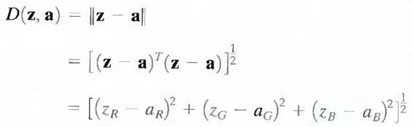

where the subscripts R, G, and B, denote the RGB components of vectors a and z .The locus of points such that D(z, a) ≤ Do is a solid sphere of radius D_{o}.
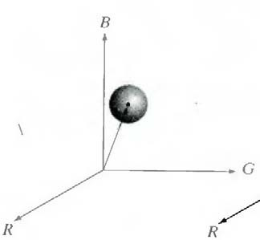
Points contained within or on the surface of the sphere satisfy the specified color criterion; points outside the sphere do not. Coding these two sets of points in the image with, say, black and white, produces a binary segmented image.
A useful generalization of previous equation is a distance measure of the form

D (z, a) = [(z-a) ^{T} C⁻¹ (z-a)] ^{1/2}
where C is the covariance matrix1 of the samples representative of the color to be segmented. The above equation represents an ellipse with color points such that D(z, a ) ≤ D_{o}.

