UNIT-I
INTRODUCTION
Syllabus:
Origin of digital image processing, uses of digital image processing, fundamental steps in digital image processing, components of an image processing system ,digital image fundamentals, elements of visual perception, light and electromagnetic spectrum, image sensing and acquisition, image sampling and quantization, some basic relationships between pixels, an introduction to the mathematical tools used in digital image processing.
IMAGE TRANSFORMS, Need for Image Transforms, Spatial Frequencies in Image Processing Introduction to Fourier transform, Discrete Fourier Transforms, Properties of 2-D Fourier Transform,Fast Fourier Transform & its algorithm, Walsh Transform,Hadamard Transform, Discrete Cosine and Sine Transform, Haar Transform Slant Transform,SVD and KLTransform,Hotelling Transform
Introduction to Image Processing

An image may be defined as a two-dimensional function, f(x, y), where x and y are spatial (plane) coordinates, and the amplitude of f at any pair of coordinates (x, y) is called the intensity or gray level of the image at that point. When x, y, and the amplitude values of f are all finite, discrete quantities, we call the image a digital image. The field of digital image processing refers to processing digital images by means of a digital computer. Note that a digital image is composed of a finite number of elements, each of which has a particular location and value. These elements are referred to as picture elements, image elements, pels, and pixels. Pixel is the term most widely used to denote the elements of a digital image.

Vision is the most advanced of our senses, so it is not surprising that images play the single most important role in human perception. However, unlike humans, who are limited to the visual band of the electromagnetic (EM) spectrum, imaging machines cover almost the entire EM spectrum, ranging from gamma to radio waves. They can operate on images generated by sources that humans are not accustomed to associating with images. These include ultra-sound, electron microscopy, and computer-generated images. Thus, digital image processing encompasses a wide and varied field of applications. There is no general agreement among authors regarding where image processing stops and other related areas, such as image analysis and computer vision, start. Sometimes a distinction is made by defining image processing as a discipline in which both the input and output of a process are images. We believe this to be a limiting and somewhat artificial boundary. For example, under this definition, even the trivial task of computing the average intensity of an image (which yields a single number) would not be considered an image processing operation. On the other hand, there are fields such as computer vision whose ultimate goal is to use computers to emulate human vision, including learning and being able to make inferences and take actions based on visual inputs. This area itself is a branch of artificial intelligence (AI) whose objective is to emulate human intelligence. The field of AI is in its earliest stages of infancy in terms of development, with progress having been much slower than originally anticipated. The area of image analysis (also called image understanding) is in between image processing and computer vision.

There are no clear-cut boundaries in the continuum from image processing at one end to computer vision at the other. However, one useful paradigm is to consider three types of computerized processes in this continuum: low-, mid-, and high-level processes. Low- level processes involve primitive operations such as image preprocessing to reduce noise, contrast enhancement, and image sharpening. A low-level process is characterized by the fact that both its inputs and outputs are images. Mid-level processing on images involves tasks such as segmentation (partitioning an image into regions or objects), description of those objects to reduce them to a form suitable for computer processing, and classification (recognition) of individual objects. A mid-level process is characterized by the fact that its inputs generally are images, but its outputs are attributes extracted from those images (e.g., edges, contours, and the identity of individual objects). Finally, higher-level processing involves “making sense” of an ensemble of recognized objects, as in image analysis, and, at the far end of the continuum, performing the cognitive functions normally associated with vision and, in addition, encompasses processes that extract attributes from images, up to and including the recognition of individual objects. As a simple illustration to clarify these concepts, consider the area of automated analysis of text. The processes of acquiring an image of the area containing the text, preprocessing that image, extracting (segmenting) the individual characters, describing the characters in a form suitable for computer processing, and recognizing those individual characters are in the scope of what we call digital image processing.

Representing Digital Images:

We will use two principal ways to represent digital images. Assume that an image f(x, y) is sampled so that the resulting digital image has M rows and N columns. The values of the coordinates (x, y) now become discrete quantities. For notational clarity and convenience, we shall use integer values for these discrete coordinates. Thus, the values of the coordinates at the origin are (x, y) = (0, 0). The next coordinate values along the first row of the image are represented as (x, y) = (0, 1). It is important to keep in mind that the notation (0, 1) is used to signify the second sample along the first row. It does not mean that these are the actual values of physical coordinates when the image was sampled. Figure 1 shows the coordinate convention used.

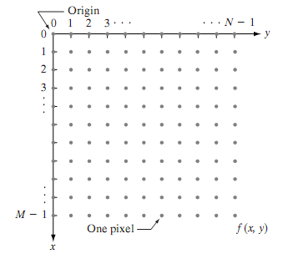

Fig 1 Coordinate convention used to represent digital images

The notation introduced in the preceding paragraph allows us to write the complete M*N digital image in the following compact matrix form:

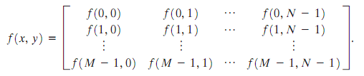

The right side of this equation is by definition a digital image. Each element of this matrix array is called an image element, picture element, pixel, or pel.

Fundamental steps in Digital Image Processing

Fundamental Steps in Digital Image Processing:

Image acquisition is the first process shown in Fig. 1.2 Note that acquisition could be as simple as being given an image that is already in digital form. Generally, the image acquisition stage involves preprocessing, such as scaling.

Image enhancement is among the simplest and most appealing areas of digital image processing. Basically, the idea behind enhancement techniques is to bring out detail that is obscured, or simply to highlight certain features of interest in an image. A familiar example of enhancement is when we increase the contrast of an image because “it looks better.” It is important to keep in mind that enhancement is a very subjective area of image processing.

Image restoration is an area that also deals with improving the appearance of an image. However, unlike enhancement, which is subjective, image restoration is objective, in the sense that restoration techniques tend to be based on mathematical or probabilistic models of image degradation. Enhancement, on the other hand, is based on human subjective preferences regarding what constitutes a “good” enhancement result.

Color image processing is an area that has been gaining in importance because of the significant increase in the use of digital images over the Internet.

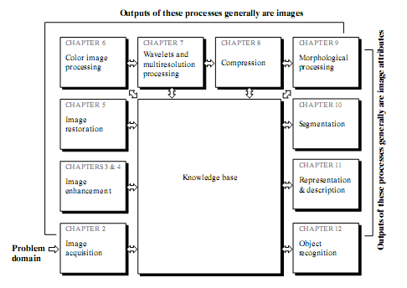

Fig.1.2 Fundamental steps in Digital Image Processing

Wavelets are the foundation for representing images in various degrees of resolution. Compression, as the name implies, deals with techniques for reducing the storage required to save an image, or the bandwidth required to transmit it. Although storage technology has improved significantly over the past decade, the same cannot be said for transmission capacity. This is true particularly in uses of the Internet, which are characterized by significant pictorial content. Image compression is familiar (perhaps inadvertently) to most users of computers in the form of image file extensions, such as the jpg file extension used in the JPEG (Joint Photographic Experts Group) image compression standard.

Morphological processing deals with tools for extracting image components that are useful in the representation and description of shape.

Segmentation procedures partition an image into its constituent parts or objects. In general, autonomous segmentation is one of the most difficult tasks in digital image processing. A rugged segmentation procedure brings the process a long way toward successful solution of imaging problems that require objects to be identified individually. On the other hand, weak or erratic segmentation algorithms almost always guarantee eventual failure. In general, the more accurate the segmentation, the more likely recognition is to succeed.

Representation and description almost always follow the output of a segmentation stage, which usually is raw pixel data, constituting either the boundary of a region (i.e., the set of pixels separating one image region from another) or all the points in the region itself. In either case, converting the data to a form suitable for computer processing is necessary. The first decision that must be made is whether the data should be represented as a boundary or as a complete region. Boundary representation is appropriate when the focus is on external shape characteristics, such as corners and inflections. Regional representation is appropriate when the focus is on internal properties, such as texture or skeletal shape. In some applications, these representations complement each other. Choosing a representation is only part of the solution for transforming raw data into a form suitable for subsequent computer processing. A method must also be specified for describing the data so that features of interest are highlighted. Description, also called feature selection, deals with extracting attributes that result in some quantitative information of interest or are basic for differentiating one class of objects from another.

Recognition is the process that assigns a label (e.g., “vehicle”) to an object based on its descriptors. We conclude our coverage of digital image processing with the development of methods for recognition of individual objects.

Components of an Image Processing System

Components of an Image Processing System:

As recently as the mid-1980s, numerous models of image processing systems being sold throughout the world were rather substantial peripheral devices that attached to equally substantial host computers. Late in the 1980s and early in the 1990s, the market shifted to image processing hardware in the form of single boards designed to be compatible with industry standard buses and to fit into engineering workstation cabinets and personal computers. In addition to lowering costs, this market shift also served as a catalyst for a significant number of new companies whose specialty is the development of software written specifically for image processing.

Although large-scale image processing systems still are being sold for massive imaging applications, such as processing of satellite images, the trend continues toward miniaturizing and blending of general-purpose small computers with specialized image processing hardware. Figure 3 shows the basic components comprising a typical general-purpose system used for digital image processing. The function of each component is discussed in the following paragraphs, starting with image sensing.

With reference to sensing, two elements are required to acquire digital images. The first is a physical device that is sensitive to the energy radiated by the object we wish to image. The second, called a digitizer, is a device for converting the output of the physical sensing device into

digital form. For instance, in a digital video camera, the sensors produce an electrical output proportional to light intensity. The digitizer converts these outputs to digital data.

Specialized image processing hardware usually consists of the digitizer just mentioned, plus hardware that performs other primitive operations, such as an arithmetic logic unit (ALU), which performs arithmetic and logical operations in parallel on entire images. One example of how an ALU is used is in averaging images as quickly as they are digitized, for the purpose of noise reduction. This type of hardware sometimes is called a front-end subsystem, and its most distinguishing characteristic is speed. In other words, this unit performs functions that require fast data throughputs (e.g., digitizing and averaging video images at 30 framess) that the typical main computer cannot handle.

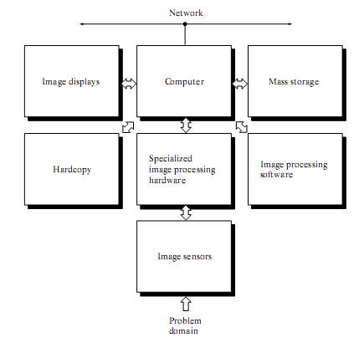

Fig.1.3 Components of a general purpose Image Processing System

The computer in an image processing system is a general-purpose computer and can range from a PC to a supercomputer. In dedicated applications, sometimes specially designed computers are used to achieve a required level of performance, but our interest here is on general-purpose
image processing systems. In these systems, almost any well-equipped PC-type machine is suitable for offline image processing tasks.

Software for image processing consists of specialized modules that perform specific tasks. A well-designed package also includes the capability for the user to write code that, as a minimum, utilizes the specialized modules. More sophisticated software packages allow the integration of those modules and general-purpose software commands from at least one computer language.

Mass storage capability is a must in image processing applications. An image of size 1024*1024 pixels, in which the intensity of each pixel is an 8-bit quantity, requires one megabyte of storage space if the image is not compressed. When dealing with thousands, or even millions, of images, providing adequate storage in an image processing system can be a challenge. Digital storage for image processing applications falls into three principal categories: (1) short-term storage for use during processing, (2) on-line storage for relatively fast re-call, and (3) archival storage, characterized by infrequent access. Storage is measured in bytes (eight bits), Kbytes (one thousand bytes), Mbytes (one million bytes), Gbytes (meaning giga, or one billion, bytes), and Tbytes (meaning tera, or one trillion, bytes). One method of providing short-term storage is computer memory. Another is by specialized boards, called frame buffers, that store one or more images and can be accessed rapidly, usually at video rates (e.g., at 30 complete images per second).The latter method allows virtually instantaneous image zoom, as well as scroll (vertical shifts) and pan (horizontal shifts). Frame buffers usually are housed in the specialized image processing hardware unit shown in Fig.3.Online storage generally takes the form of magnetic disks or optical-media storage. The key factor characterizing on-line storage is frequent access to the stored data. Finally, archival storage is characterized by massive storage requirements but infrequent need for access. Magnetic tapes and optical disks housed in “jukeboxes” are the usual media for archival applications.

Image displays in use today are mainly color (preferably flat screen) TV monitors. Monitors are driven by the outputs of image and graphics display cards that are an integral part of the computer system. Seldom are there requirements for image display applications that cannot be met by display cards available commercially as part of the computer system. In some cases, it is necessary to have stereo displays, and these are implemented in the form of headgear containing two small displays embedded in goggles worn by the user.

Hardcopy devices for recording images include laser printers, film cameras, heat-sensitive devices, inkjet units, and digital units, such as optical and CD-ROM disks. Film provides the highest possible resolution, but paper is the obvious medium of choice for written material. For presentations, images are displayed on film transparencies or in a digital medium if image projection equipment is used. The latter approach is gaining acceptance as the standard for image presentations.

Networking is almost a default function in any computer system in use today. Because of the large amount of data inherent in image processing applications, the key consideration in image transmission is bandwidth. In dedicated networks, this typically is not a problem, but communications with remote sites via the Internet are not always as efficient. Fortunately, this situation is improving quickly as a result of optical fiber and other broadband technologies.

Elements of visual perception.

Elements of Visual Perception:

Although the digital image processing field is built on a foundation of mathematical and probabilistic formulations, human intuition and analysis play a central role in the choice of one technique versus another, and this choice often is made based on subjective, visual judgments.

(1) Structure of the Human Eye:

Figure 1.4 shows a simplified horizontal cross section of the human eye. The eye is nearly a sphere, with an average diameter of approximately 20 mm. Three membranes enclose the eye: the cornea and sclera outer cover; the choroid; and the retina. The cornea is a tough, transparent tissue that covers the anterior surface of the eye. Continuous with the cornea, the sclera is an opaque membrane that encloses the remainder of the optic globe. The choroid lies directly below the sclera. This membrane contains a network of blood vessels that serve as the major source of nutrition to the eye. Even superficial injury to the choroid, often not deemed serious, can lead to severe eye damage as a result of inflammation that restricts blood flow. The choroid coat is heavily pigmented and hence helps to reduce the amount of extraneous light entering the eye and the backscatter within the optical globe. At its anterior extreme, the choroid is divided into the ciliary body and the iris diaphragm. The latter contracts or expands to control the amount of light that enters the eye. The central opening of the iris (the pupil) varies in diameter from approximately 2 to 8 mm. The front of the iris contains the visible pigment of the eye, whereas the back contains a black pigment.

The lens is made up of concentric layers of fibrous cells and is suspended by fibers that attach to the ciliary body. It contains 60 to 70%water, about 6%fat, and more protein than any other tissue in the eye. The lens is colored by a slightly yellow pigmentation that increases with age. In extreme cases, excessive clouding of the lens, caused by the affliction commonly referred to as cataracts, can lead to poor color discrimination and loss of clear vision. The lens absorbs approximately 8% of the visible light spectrum, with relatively higher absorption at shorter wavelengths. Both infrared and ultraviolet light are absorbed appreciably by proteins within the lens structure and, in excessive amounts, can damage the eye.

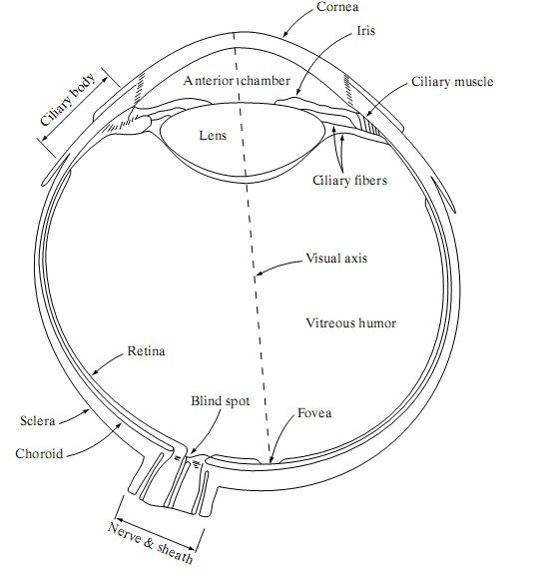

Fig. 1.4 Simplified diagram of a cross section of the human eye.

The innermost membrane of the eye is the retina, which lines the inside of the wall’s entire posterior portion. When the eye is properly focused, light from an object outside the eye is imaged on the retina. Pattern vision is afforded by the distribution of discrete light receptors over the surface of the retina. There are two classes of receptors: cones and rods. The cones in each eye number between 6 and 7 million. They are located primarily in the central portion of the

retina, called the fovea, and are highly sensitive to color. Humans can resolve fine details with these cones largely because each one is connected to its own nerve end. Muscles controlling the eye rotate the eyeball until the image of an object of interest falls on the fovea. Cone vision is called photopic or bright-light vision. The number of rods is much larger: Some 75 to 150 million are distributed over the retinal surface. The larger area of distribution and the fact that several rods are connected to a single nerve end reduce the amount of detail discernible by these receptors. Rods serve to give a general, overall picture of the field of view. They are not involved in color vision and are sensitive to low levels of illumination. For example, objects that appear brightly colored in daylight when seen by moonlight appear as colorless forms because only the rods are stimulated. This phenomenon is known as scotopic or dim-light vision.

(2) Image Formation in the Eye:

The principal difference between the lens of the eye and an ordinary optical lens is that the former is flexible. As illustrated in Fig. 1.4, the radius of curvature of the anterior surface of the lens is greater than the radius of its posterior surface. The shape of the lens is controlled by tension in the fibers of the ciliary body. To focus on distant objects, the controlling muscles cause the lens to be relatively flattened. Similarly, these muscles allow the lens to become thicker in order to focus on objects near the eye. The distance between the center of the lens and the retina (called the focal length) varies from approximately 17 mm to about 14 mm, as the refractive power of the lens increases from its minimum to its maximum. When the eye

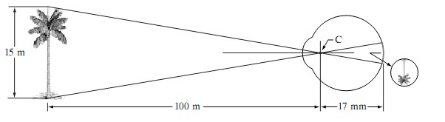

Fig. 1.5. Graphical representation of the eye looking at a palm tree Point C is the optical center of the lens.

focuses on an object farther away than about 3 m, the lens exhibits its lowest refractive power. When the eye focuses on a nearby object, the lens is most strongly refractive. This information

makes it easy to calculate the size of the retinal image of any object. In Fig. 1.5, for example, the observer is looking at a tree 15 m high at a distance of 100 m. If h is the height in mm of that object in the retinal image, the geometry of Fig. 1.5 yields 15/100=h/17 or h=2.55mm. The retinal image is reflected primarily in the area of the fovea. Perception then takes place by the relative excitation of light receptors, which transform radiant energy into electrical impulses that are ultimately decoded by the brain.

(3)Brightness Adaptation and Discrimination:

Because digital images are displayed as a discrete set of intensities, the eye’s ability to discriminate between different intensity levels is an important consideration in presenting image- processing results. The range of light intensity levels to which the human visual system can adapt is enormous—on the order of 1010—from the scotopic threshold to the glare limit. Experimental evidence indicates that subjective brightness (intensity as perceived by the human visual system)
is a logarithmic function of the light intensity incident on the eye. Figure 4.3, a plot of light intensity versus subjective brightness, illustrates this characteristic. The long solid curve represents the range of intensities to which the visual system can adapt. In photopic vision alone, the range is about 106. The transition from scotopic to photopic vision is gradual over the approximate range from 0.001 to 0.1 millilambert (–3 to –1 mL in the log scale), as the double branches of the adaptation curve in this range show.

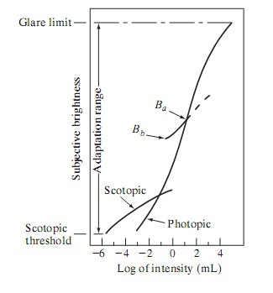

Fig.1.6. Range of Subjective brightness sensations showing a particular adaptation level.

The essential point in interpreting the impressive dynamic range depicted in Fig.1.6 is that the visual system cannot operate over such a range simultaneously. Rather, it accomplishes this large variation by changes in its overall sensitivity, a phenomenon known as brightness adaptation. The total range of distinct intensity levels it can discriminate simultaneously is rather small when compared with the total adaptation range. For any given set of conditions, the current sensitivity level of the visual system is called the brightness adaptation level, which may correspond, for example, to brightness Ba in Fig. 1.6. The short intersecting curve represents the range of subjective brightness that the eye can perceive when adapted to this level. This range is rather restricted, having a level Bb at and below which all stimuli are perceived as indistinguishable blacks. The upper (dashed) portion of the curve is not actually restricted but, if extended too far, loses its meaning because much higher intensities would simply raise the adaptation level higher than Ba.

Process of image acquisition.

Image Sensing and Acquisition:

The types of images in which we are interested are generated by the combination of an “illumination” source and the reflection or absorption of energy from that source by the elements of the “scene” being imaged. We enclose illumination and scene in quotes to emphasize the fact that they are considerably more general than the familiar situation in which a visible light source illuminates a common everyday 3-D (three-dimensional) scene. For example, the illumination may originate from a source of electromagnetic energy such as radar, infrared, or X-ray energy. But, as noted earlier, it could originate from less traditional sources, such as ultrasound or even a computer-generated illumination pattern.

Similarly, the scene elements could be familiar objects, but they can just as easily be molecules, buried rock formations, or a human brain. We could even image a source, such as acquiring images of the sun. Depending on the nature of the source, illumination energy is reflected from, or transmitted through, objects. An example in the first category is light reflected from a planar surface. An example in the second category is when X-rays pass through a patient’s body for the purpose of generating a diagnostic X-ray film. In some applications, the reflected or transmitted energy is focused onto a photo converter (e.g., a phosphor screen), which converts the energy into visible light. Electron microscopy and some applications of gamma imaging use this approach.

Figure 1.7 shows the three principal sensor arrangements used to transform illumination energy into digital images. The idea is simple: Incoming energy is transformed into a voltage by the combination of input electrical power and sensor material that is responsive to the particular type of energy being detected. The output voltage waveform is the response of the sensor(s), and a digital quantity is obtained from each sensor by digitizing its response.

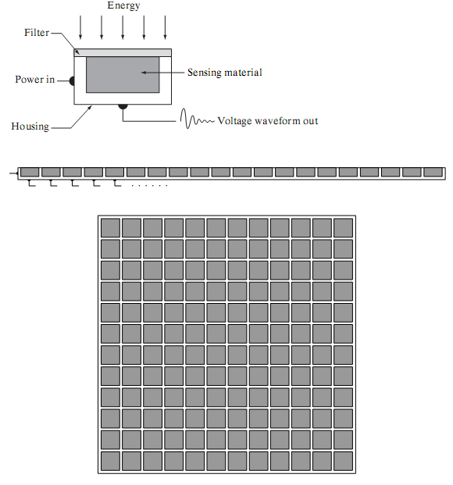

Fig. 1.7 (a) Single imaging Sensor (b) Line sensor (c) Array sensor

(1)Image Acquisition Using a Single Sensor:

Figure 1.7 (a) shows the components of a single sensor. Perhaps the most familiar sensor of this type is the photodiode, which is constructed of silicon materials and whose output voltage waveform is proportional to light. The use of a filter in front of a sensor improves selectivity. For example, a green (pass) filter in front of a light sensor favors light in the green band of the color

spectrum. As a consequence, the sensor output will be stronger for green light than for other components in the visible spectrum.

In order to generate a 2-D image using a single sensor, there has to be relative displacements in both the x- and y-directions between the sensor and the area to be imaged. Figure 1.8 shows an arrangement used in high-precision scanning, where a film negative is mounted onto a drum whose mechanical rotation provides displacement in one dimension. The single sensor is mounted on a lead screw that provides motion in the perpendicular direction. Since mechanical motion can be controlled with high precision, this method is an inexpensive (but slow) way to obtain high-resolution images. Other similar mechanical arrangements use a flat bed, with the sensor moving in two linear directions. These types of mechanical digitizers sometimes are referred to as microdensitometer.

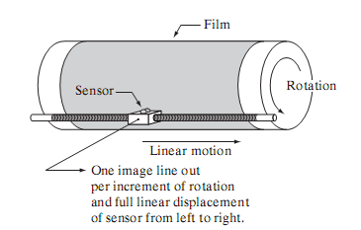

Fig. 1.8 Combining a single sensor with motion to generate a 2-D image

(2) Image Acquisition Using Sensor Strips:

A geometry that is used much more frequently than single sensors consists of an in-line arrangement of sensors in the form of a sensor strip, as Fig. 1.7 (b) shows. The strip provides imaging elements in one direction. Motion perpendicular to the strip provides imaging in the other direction, as shown in Fig. 1.9 (a).This is the type of arrangement used in most flat bed scanners. Sensing devices with 4000 or more in-line sensors are possible. In-line sensors are used routinely in airborne imaging applications, in which the imaging system is mounted on an aircraft that flies at a constant altitude and speed over the geographical area to be imaged. One- dimensional imaging sensor strips that respond to various bands of the electromagnetic spectrum are mounted perpendicular to the direction of flight. The imaging strip gives one line of an image

at a time, and the motion of the strip completes the other dimension of a two-dimensional image. Lenses or other focusing schemes are used to project the area to be scanned onto the sensors.

Sensor strips mounted in a ring configuration are used in medical and industrial imaging to obtain cross-sectional (“slice”) images of 3-D objects, as Fig. 1.9 (b) shows. A rotating X-ray source provides illumination and the portion of the sensors opposite the source collect the X-ray energy that pass through the object (the sensors obviously have to be sensitive to X-ray energy).This is the basis for medical and industrial computerized axial tomography (CAT). It is important to note that the output of the sensors must be processed by reconstruction algorithms whose objective is to transform the sensed data into meaningful cross-sectional images.

In other words, images are not obtained directly from the sensors by motion alone; they require extensive processing. A 3-D digital volume consisting of stacked images is generated as the object is moved in a direction perpendicular to the sensor ring. Other modalities of imaging based on the CAT principle include magnetic resonance imaging (MRI) and positron emission tomography (PET).The illumination sources, sensors, and types of images are different, but conceptually they are very similar to the basic imaging approach shown in Fig. 1.9 (b).

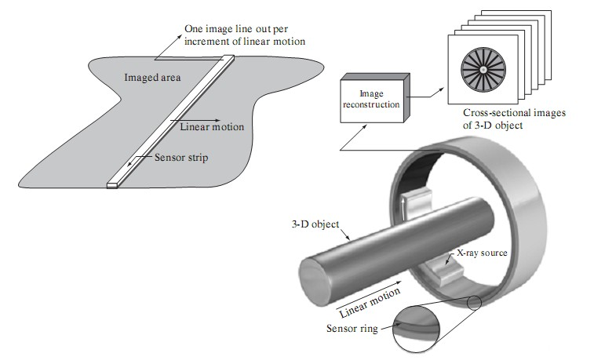

Fig. 1.9 (a) Image acquisition using a linear sensor strip (b) Image acquisition using a circular sensor strip.

(3) Image Acquisition Using Sensor Arrays:
Figure 1.7 (c) shows individual sensors arranged in the form of a 2-D array. Numerous electromagnetic and some ultrasonic sensing devices frequently are arranged in an array format. This is also the predominant arrangement found in digital cameras. A typical sensor for these cameras is a CCD array, which can be manufactured with a broad range of sensing properties and can be packaged in rugged arrays of 4000 * 4000 elements or more. CCD sensors are used widely in digital cameras and other light sensing instruments. The response of each sensor is proportional to the integral of the light energy projected onto the surface of the sensor, a property that is used in astronomical and other applications requiring low noise images. Noise reduction is achieved by letting the sensor integrate the input light signal over minutes or even hours. Since the sensor array shown in Fig. 1.10(c) is two dimensional, its key advantage is that a complete image can be obtained by focusing the energy pattern onto the surface of the array. The principal manner in which array sensors are used is shown in Fig.1.10. This figure shows the energy from an illumination source being reflected from a scene element, but, as mentioned at the beginning of this section, the energy also could be transmitted through the scene elements. The first function performed by the imaging system shown in Fig. 1.10(c) is to collect the incoming energy and focus it onto an image plane. If the illumination is light, the front end of the imaging system is a lens, which projects the viewed scene onto the lens focal plane, as Fig. 1.10(d) shows. The sensor array, which is coincident with the focal plane, produces outputs proportional to the integral of the light received at each sensor. Digital and analog circuitry sweep these outputs and converts them to a video signal, which is then digitized by another section of the imaging system. The output is a digital image, as shown diagrammatically in Fig. 1.10 (e).
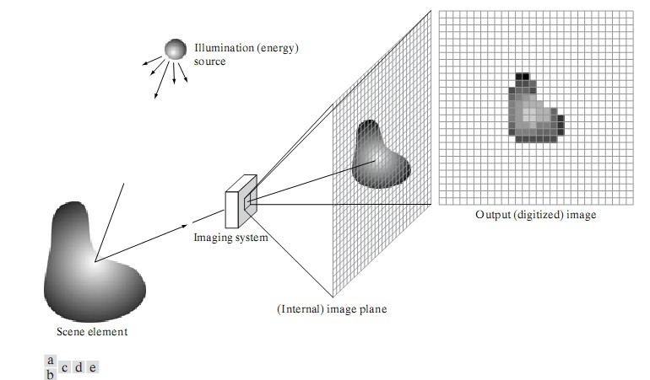

Fig. 1.10 An example of the digital image acquisition process (a) Energy (“illumination”) source (b) An element of a scene (c) Imaging system (d) Projection of the scene onto the image plane (e) Digitized image

Image sampling and quantization process.

Image Sampling and Quantization:

The output of most sensors is a continuous voltage waveform whose amplitude and spatial behavior are related to the physical phenomenon being sensed. To create a digital image, we need to convert the continuous sensed data into digital form. This involves two processes: sampling and quantization.

Basic Concepts in Sampling and Quantization:

The basic idea behind sampling and quantization is illustrated in Fig.1.11 Figure 1.11(a) shows a continuous image, f(x, y), that we want to convert to digital form. An image may be continuous with respect to the x- and y-coordinates, and also in amplitude. To convert it to digital form, we have to sample the function in both coordinates and in amplitude. Digitizing the coordinate values is called sampling. Digitizing the amplitude values is called quantization.

The one-dimensional function shown in Fig.1.11 (b) is a plot of amplitude (gray level) values of the continuous image along the line segment AB in Fig. 1.11(a).The random variations are due to image noise. To sample this function, we take equally spaced samples along line AB, as shown in Fig.1.11(c). The location of each sample is given by a vertical tick mark in the bottom part of the figure. The samples are shown as small white squares superimposed on the function. The set of these discrete locations gives the sampled function. However, the values of the samples still span (vertically) a continuous range of gray-level values. In order to form a digital function, the gray-level values also must be converted (quantized) into discrete quantities. The right side of Fig.1.11(c) shows the gray-level scale divided into eight discrete levels, ranging from black to white. The vertical tick marks indicate the specific value assigned to each of the eight gray levels. The continuous gray levels are quantized simply by assigning one of the eight discrete gray levels to each sample. The assignment is made depending on the vertical proximity of a sample to a vertical tick mark. The digital samples resulting from both sampling and quantization are shown in Fig.1.11 (d). Starting at the top of the image and carrying out this procedure line by line produces a two-dimensional digital image.

Sampling in the manner just described assumes that we have a continuous image in both coordinate directions as well as in amplitude. In practice, the method of sampling is determined by the sensor arrangement used to generate the image. When an image is generated by a single

sensing element combined with mechanical motion, as in Fig. 1.10, the output of the sensor is quantized in the manner described above. However, sampling is accomplished by selecting the number of individual mechanical increments at which we activate the sensor to collect data. Mechanical motion can be made very exact so, in principle; there is almost no limit as to how fine we can sample an image. However, practical limits are established by imperfections in the optics used to focus on the

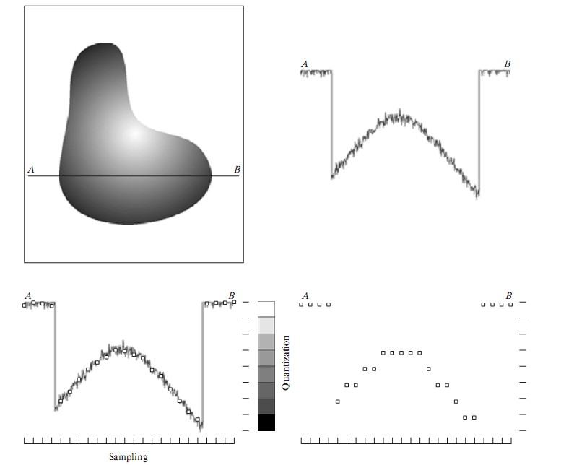

Fig.1.11 Generating a digital image (a) Continuous image (b) A scan line from A to Bin the continuous image, used to illustrate the concepts of sampling and quantization (c) Sampling and quantization. (d) Digital scan line

sensor an illumination spot that is inconsistent with the fine resolution achievable with mechanical displacements. When a sensing strip is used for image acquisition, the number of sensors in the strip establishes the sampling limitations in one image direction. Mechanical motion in the other direction can be controlled more accurately, but it makes little sense to try to achieve sampling density in one direction that exceeds the sampling limits established by the number of sensors in the other. Quantization of the sensor outputs completes the process of generating a digital image.

When a sensing array is used for image acquisition, there is no motion and the number of sensors in the array establishes the limits of sampling in both directions. Figure 1.12 illustrates this concept. Figure 1.12 (a) shows a continuous image projected onto the plane of an array sensor. Figure 1.12 (b) shows the image after sampling and quantization. Clearly, the quality of a digital image is determined to a large degree by the number of samples and discrete gray levels used in sampling and quantization.

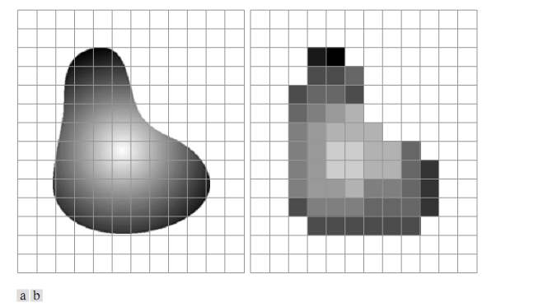

Fig.1.12. (a) Continuous image projected onto a sensor array (b) Result of image sampling and quantization.

Spatial and Gray-Level Resolution:

Sampling is the principal factor determining the spatial resolution of an image. Basically, spatial resolution is the smallest discernible detail in an image. Suppose that we construct a chart with vertical lines of width W, with the space between the lines also having width W.A line pair consists of one such line and its adjacent space. Thus, the width of a line pair is 2W, and there are 1/2Wline pairs per unit distance. A widely used definition of resolution is simply the smallest number of discernible line pairs per unit distance; for example, 100 line pairs per millimeter. Gray-level resolution similarly refers to the smallest discernible change in gray level. We have considerable discretion regarding the number of samples used to generate a digital image, but this is not true for the number of gray levels. Due to hardware considerations, the number of gray levels is usually an integer power of 2.

The most common number is 8 bits, with 16 bits being used in some applications where enhancement of specific gray-level ranges is necessary. Sometimes we find systems that can digitize the gray levels of an image with 10 or 12 bit of accuracy, but these are the exception rather than the rule. When an actual measure of physical resolution relating pixels and the level of detail they resolve in the original scene are not necessary, it is not uncommon to refer to an L- level digital image of size M*N as having a spatial resolution of M*N pixels and a gray-level resolution of L levels.

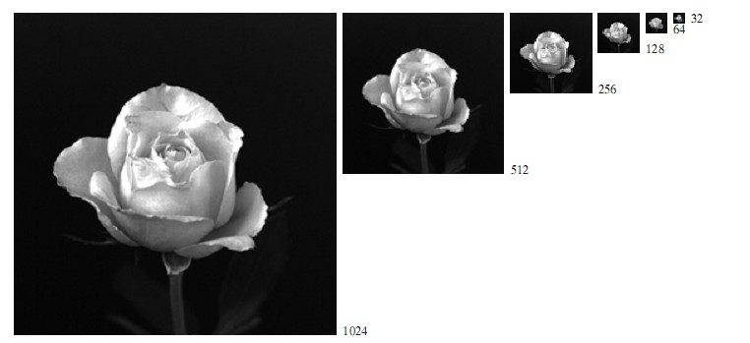

Fig.1.13 A 1024*1024, 8-bit image sub-sampled down to size 32*32 pixels The number of allowable gray levels was kept at 256.

The subsampling was accomplished by deleting the appropriate number of rows and columns from the original image. For example, the 512*512 image was obtained by deleting every other row and column from the 1024*1024 image. The 256*256 image was generated by deleting every other row and column in the 512*512 image, and so on. The number of allowed gray levels was kept at 256. These images show the dimensional proportions between various sampling densities, but their size differences make it difficult to see the effects resulting from a reduction in the number of samples. The simplest way to compare these effects is to bring all the subsampled images up to size 1024*1024 by row and column pixel replication. The results are shown in Fig. 1.14 (b) through (f). Fig.1.14 (a) is the same 1024*1024, 256-level image shown in Fig.1.14; it is repeated to facilitate comparisons.

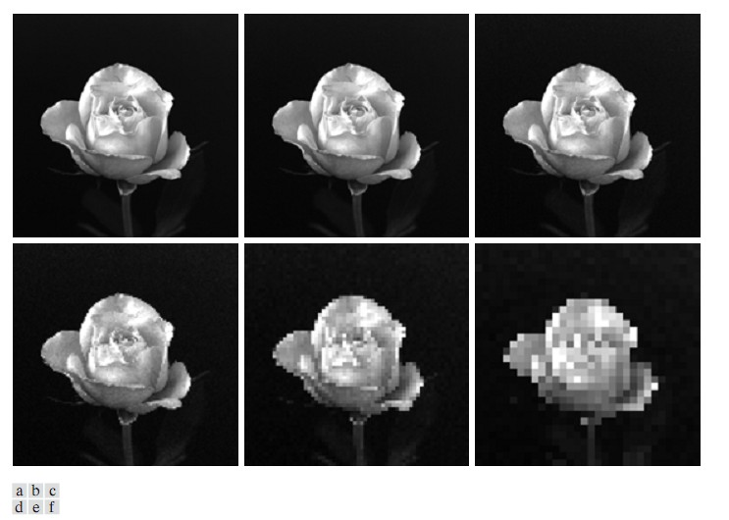

Fig. 1.14 (a) 1024*1024, 8-bit image (b) 512*512 image resampled into 1024*1024 pixels by row and column duplication (c) through (f) 256*256, 128*128, 64*64, and 32*32 images resampled into 1024*1024 pixels

Compare Fig. 1.14(a) with the 512*512 image in Fig. 1.14(b) and note that it is virtually impossible to tell these two images apart. The level of detail lost is simply too fine to be seen on the printed page at the scale in which these images are shown. Next, the 256*256 image in Fig. 1.14(c) shows a very slight fine checkerboard pattern in the borders between flower petals and the black back- ground. A slightly more pronounced graininess throughout the image also is beginning to appear. These effects are much more visible in the 128*128 image in Fig. 1.14(d), and they become pronounced in the 64*64 and 32*32 images in Fig. 1.14 (e) and (f), respectively.

In the next example, we keep the number of samples constant and reduce the number of gray levels from 256 to 2, in integer powers of 2. Fig.1.15 (a) is a 452*374 CAT projection image, displayed with k=8 (256 gray levels). Images such as this are obtained by fixing the X-ray source in one position, thus producing a 2-D image in any desired direction. Projection images are used as guides to set up the parameters for a CAT scanner, including tilt, number of slices, and range. Fig.1.15 (b) through (h) were obtained by reducing the number of bits from k=7 to k=1 while keeping the spatial resolution constant at 452*374 pixels. The 256-, 128-, and 64-level images are visually identical for all practical purposes. The 32-level image shown in Fig.1.15 (d), however, has an almost imperceptible set of very fine ridge like structures in areas of smooth gray levels (particularly in the skull).This effect, caused by the use of an insufficient number of gray levels in smooth areas of a digital image, is called false contouring, so called because the ridges resemble topographic contours in a map. False contouring generally is quite visible in images displayed using 16 or less uniformly spaced gray levels, as the images in Figs. 1.15(e) through (h) show.

Digital Image Processing Unit-1

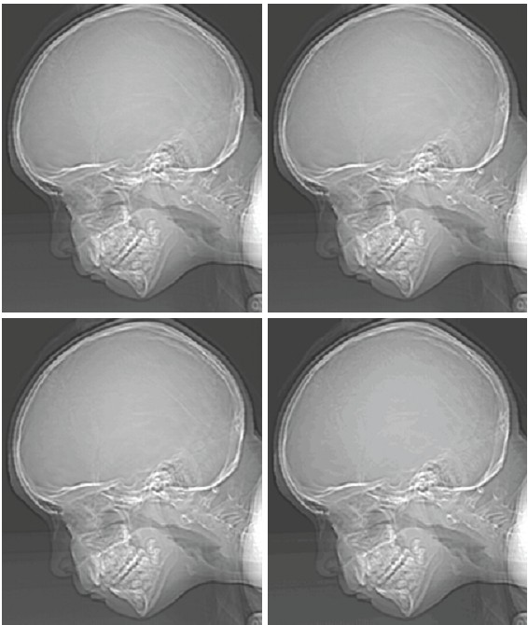

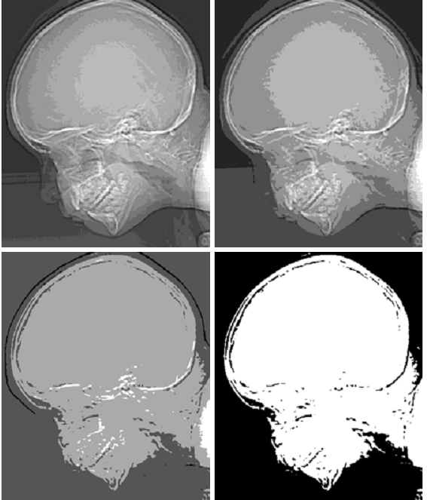

Fig. 1.15 (a) 452*374, 256-level image (b)–(d) Image displayed in 128, 64, and 32 gray levels, while keeping the spatial resolution constant (e)–(g) Image displayed in 16, 8, 4, and 2 gray levels.

As a very rough rule of thumb, and assuming powers of 2 for convenience, images of size
256*256 pixels and 64 gray levels are about the smallest images that can be expected to be reasonably free of objectionable sampling checker-boards and false contouring.

The results in Examples 7.2 and 7.3 illustrate the effects produced on image quality by varying N and k independently. However, these results only partially answer the question of how varying N and k affect images because we have not considered yet any relationships that might exist between these two parameters.

An early study by Huang [1965] attempted to quantify experimentally the effects on image quality produced by varying N and k simultaneously. The experiment consisted of a set of subjective tests. Images similar to those shown in Fig.7.4 were used. The woman’s face is representative of an image with relatively little detail; the picture of the cameraman contains an intermediate amount of detail; and the crowd picture contains, by comparison, a large amount of detail. Sets of these three types of images were generated by varying N and k, and observers were then asked to rank them according to their subjective quality. Results were summarized in the form of so-called isopreference curves in the Nk-plane (Fig.7.5 shows average isopreference curves representative of curves corresponding to the images shown in Fig. 7.4).Each point in the Nk-plane represents an image having values of N and k equal to the coordinates of that point.

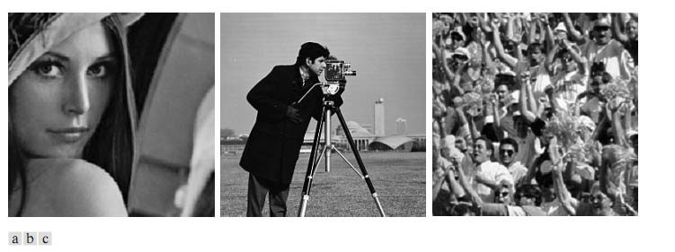

Fig.7.4 (a) Image with a low level of detail (b) Image with a medium level of detail (c) Image with a relatively large amount of detail

Points lying on an isopreference curve correspond to images of equal subjective quality. It was found in the course of the experiments that the isopreference curves tended to shift right and upward, but their shapes in each of the three image categories were similar to those shown in

Fig. 7.5. This is not unexpected, since a shift up and right in the curves simply means larger values for N and k, which implies better picture quality.

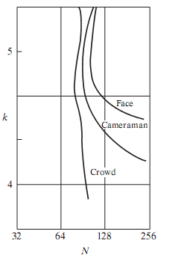

Fig.7.5. Representative isopreference curves for the three types of images in Fig.7.4

The key point of interest in the context of the present discussion is that isopreference curves tend to become more vertical as the detail in the image increases. This result suggests that for images with a large amount of detail only a few gray levels may be needed. For example, the isopreference curve in Fig.7.5 corresponding to the crowd is nearly vertical. This indicates that, for a fixed value of N, the perceived quality for this type of image is nearly independent of the number of gray levels used. It is also of interest to note that perceived quality in the other two image categories remained the same in some intervals in which the spatial resolution was increased, but the number of gray levels actually decreased. The most likely reason for this result is that a decrease in k tends to increase the apparent contrast of an image, a visual effect that humans often perceive as improved quality in an image.

Aliasing and Moire patterns.

Aliasing and Moiré Patterns:

Functions whose area under the curve is finite can be represented in terms of sines and cosines of various frequencies. The sine/cosine component with the highest frequency determines the highest “frequency content” of the function. Suppose that this highest frequency is finite and that the function is of unlimited duration (these functions are called band-limited functions).Then, the Shannon sampling theorem [Brace well (1995)] tells us that, if the function is sampled at a rate equal to or greater than twice its highest frequency, it is possible to recover completely the original function from its samples. If the function is undersampled, then a phenomenon called aliasing corrupts the sampled image. The corruption is in the form of additional frequency components being introduced into the sampled function. These are called aliased frequencies. Note that the sampling rate in images is the number of samples taken (in both spatial directions) per unit distance.

As it turns out, except for a special case discussed in the following paragraph, it is impossible to satisfy the sampling theorem in practice. We can only work with sampled data that are finite in duration. We can model the process of converting a function of unlimited duration into a function of finite duration simply by multiplying the unlimited function by a “gating function” that is valued 1 for some interval and 0 elsewhere. Unfortunately, this function itself has frequency components that extend to infinity. Thus, the very act of limiting the duration of a band-limited function causes it to cease being band limited, which causes it to violate the key condition of the sampling theorem. The principal approach for reducing the aliasing effects on an image is to reduce its high-frequency components by blurring the image prior to sampling. However, aliasing is always present in a sampled image. The effect of aliased frequencies can be seen under the right conditions in the form of so called Moiré patterns.

There is one special case of significant importance in which a function of infinite duration can be sampled over a finite interval without violating the sampling theorem. When a function is periodic, it may be sampled at a rate equal to or exceeding twice its highest frequency and it is possible to recover the function from its samples provided that the sampling captures exactly an integer number of periods of the function. This special case allows us to illustrate vividly the Moiré effect. Figure 8 shows two identical periodic patterns of equally spaced vertical bars, rotated in opposite directions and then superimposed on each other by multiplying the two images. A Moiré pattern, caused by a breakup of the periodicity, is seen in Fig.8 as a 2-D sinusoidal (aliased) waveform (which looks like a corrugated tin roof) running in a vertical direction. A similar pattern can appear when images are digitized (e.g., scanned) from a printed page, which consists of periodic ink dots.

Fig.8. Illustration of the Moiré pattern effect

Basic relationships and distance measures between pixels in a digital image.

Neighbors of a Pixel:

A pixel p at coordinates (x, y) has four horizontal and vertical neighbors whose coordinates are given by (x+1, y), (x-1, y), (x, y+1), (x, y-1). This set of pixels, called the 4-neighbors of p, is denoted by N4 (p). Each pixel is a unit distance from (x, y), and some of the neighbors of p lie outside the digital image if (x, y) is on the border of the image.

The four diagonal neighbors of p have coordinates (x+1, y+1), (x+1, y-1), (x-1, y+1), (x-1, y-1) and are denoted by ND (p). These points, together with the 4-neighbors, are called the 8- neighbors of p, denoted by N8 (p). As before, some of the points in ND (p) and N8 (p) fall outside the image if (x, y) is on the border of the image.

Connectivity:

Connectivity between pixels is a fundamental concept that simplifies the definition of numerous digital image concepts, such as regions and boundaries. To establish if two pixels are connected, it must be determined if they are neighbors and if their gray levels satisfy a specified criterion of similarity (say, if their gray levels are equal). For instance, in a binary image with values 0 and 1, two pixels may be 4-neighbors, but they are said to be connected only if they have the same value.

Let V be the set of gray-level values used to define adjacency. In a binary image, V={1} if we are referring to adjacency of pixels with value 1. In a grayscale image, the idea is the same, but set V typically contains more elements. For example, in the adjacency of pixels with a range of possible gray-level values 0 to 255, set V could be any subset of these 256 values. We consider three types of adjacency:

(a) 4-adjacency. Two pixels p and q with values from V are 4-adjacent if q is in the set N4 (p). (b) 8-adjacency. Two pixels p and q with values from V are 8-adjacent if q is in the set N8 (p). (c) m-adjacency (mixed adjacency).Two pixels p and q with values from V are m-adjacent if (i) q is in N4 (p), or
(ii) q is in ND (p) and the set has no pixels whose values are from V.

Mixed adjacency is a modification of 8-adjacency. It is introduced to eliminate the ambiguities that often arise when 8-adjacency is used. For example, consider the pixel arrangement shown in Fig.9 (a) for V= {1}.The three pixels at the top of Fig.9 (b) show multiple (ambiguous) 8- adjacency, as indicated by the dashed lines. This ambiguity is removed by using m-adjacency, as shown in Fig. 9 (c).Two image subsets S1 and S2 are adjacent if some pixel in S1 is adjacent to some pixel in S2. It is understood here and in the following definitions that adjacent means 4-, 8-
, or m-adjacent. A (digital) path (or curve) from pixel p with coordinates (x, y) to pixel q with coordinates (s, t) is a sequence of distinct pixels with coordinates

where and pixels are adjacent for . In this case, n is the length of the path. If (xo, yo) = (xn, yn), the path is a closed path. We can define 4-, 8-, or m-paths depending on the type of adjacency specified. For example, the paths shown in Fig. 9 (b) between the northeast and southeast points are 8-paths, and the path in Fig. 9 (c) is an m-path. Note the absence of ambiguity in the m-path. Let S represent a subset of pixels in an image. Two pixels p and q are said to be connected in S if there

exists a path between them consisting entirely of pixels in S. For any pixel p in S, the set of pixels that are connected to it in S is called a connected component of S. If it only has one connected component, then set S is called a connected set.

Let R be a subset of pixels in an image. We call R a region of the image if R is a connected set. The boundary (also called border or contour) of a region R is the set of pixels in the region that have one or more neighbors that are not in R. If R happens to be an entire image (which we recall is a rectangular set of pixels), then its boundary is defined as the set of pixels in the first and last rows and columns of the image. This extra definition is required because an image has no neighbors beyond its border. Normally, when we refer to a region, we are referring to a subset

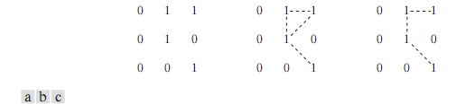

Fig.9 (a) Arrangement of pixels; (b) pixels that are 8-adjacent (shown dashed) to the center pixel; (c) m-adjacency

of an image, and any pixels in the boundary of the region that happen to coincide with the border of the image are included implicitly as part of the region boundary.

Distance Measures:

For pixels p, q, and z, with coordinates (x, y), (s, t), and (v, w), respectively, D is a distance function or metric if

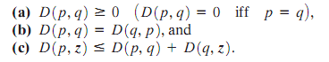

The Euclidean distance between p and q is defined as

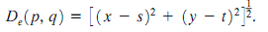

For this distance measure, the pixels having a distance less than or equal to some value r from(x, y) are the points contained in a disk of radius r centered at (x, y).

The D4 distance (also called city-block distance) between p and q is defined as

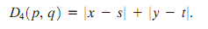

In this case, the pixels having a D4 distance from (x, y) less than or equal to some value r form a diamond centered at (x, y). For example, the pixels with D4 distance ≤ 2 from (x, y) (the center point) form the following contours of constant distance:

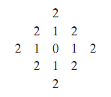

The pixels with D4 =1 are the 4-neighbors of (x, y).

The D8 distance (also called chessboard distance) between p and q is defined as

In this case, the pixels with D8 distance from(x, y) less than or equal to some value r form a square centered at (x, y). For example, the pixels with D8 distance ≤ 2 from(x, y) (the center point) form the following contours of constant distance:

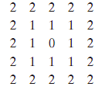

The pixels with D8=1 are the 8-neighbors of (x, y). Note that the D4 and D8 distances between p and q are independent of any paths that might exist between the points because these distances involve only the coordinates of the points. If we elect to consider m-adjacency, however, the Dm distance between two points is defined as the shortest m-path between the points. In this case, the distance between two pixels will depend on the values of the pixels along the path, as well as the values of their neighbors. For instance, consider the following arrangement of pixels and assume that p, p2 , and p4 have value 1 and that p1 and p3 can have a value of 0 or 1:

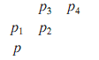

Suppose that we consider adjacency of pixels valued 1 (i.e. = {1}). If p1 and p3 are 0, the length of the shortest m-path (the Dm distance) between p and p4 is 2. If p1 is 1, then p2 and p will no longer be m-adjacent (see the definition of m-adjacency) and the length of the shortest m-path becomes 3 (the path goes through the points pp1p2p4). Similar comments apply if p3 is 1 (and p1 is 0); in this case, the length of the shortest m-path also is 3. Finally, if both p1 and p3 are 1 the length of the shortest m-path between p and p4 is 4. In this case, the path goes through the sequence of points pp1p2p3p4.

Perspective image transformation.

A perspective transformation (also called an imaging transformation) projects 3D points onto a plane. Perspective transformations play a central role in image processing because they provide an approximation to the manner in which an image is formed by viewing a 3D world. These transformations are fundamentally different, because they are nonlinear in that they involve division by coordinate values.

Figure 10 shows a model of the image formation process. The camera coordinate system (x, y, z) has the image plane coincident with the xy plane and the optical axis (established by the center of the lens) along the z axis. Thus the center of the image plane is at the origin, and the centre of the lens is at coordinates (0.0, λ). If the camera is in focus for distant objects, λ is the focal length of the lens. Here the assumption is that the camera coordinate system is aligned with the world coordinate system (X, Y, Z).

Let (X, Y, Z) be the world coordinates of any point in a 3-D scene, as shown in the Fig. 10. We assume throughout the following discussion that Z> λ; that is all points of interest lie in front of the lens. The first step is to obtain a relationship that gives the coordinates (x, y) of the projection of the point (X. Y, Z) onto the image plane. This is easily accomplished by the use of similar
triangles. With reference to Fig. 10,

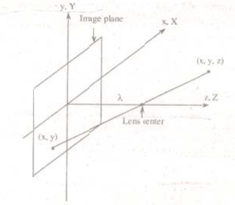

Fig.10 Basic model of the imaging process The camera coordinate system (x, y, z) is aligned with the world coordinate system (X, Y, Z)

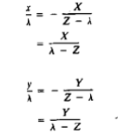

Where the negative signs in front of X and Y indicate that image points are actually inverted, as the geometry of Fig.10 shows.
The image-plane coordinates of the projected 3-D point follow directly from above equations

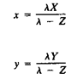

These equations are nonlinear because they involve division by the variable Z. Although we could use them directly as shown, it is often convenient to express them in linear matrix form, for rotation, translation and scaling. This is easily accomplished by using homogeneous coordinates.
The homogeneous coordinates of a point with Cartesian coordinates (X, Y, Z) are defined as (kX, kY, kZ. k), where k is an arbitrary, nonzero constant. Clearly, conversion of homogeneous coordinates back to Cartesian coordinates is accomplished by dividing the first three homogeneous coordinates by the fourth. A point in the Cartesian world coordinate system may be expressed in vector form as

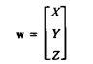

and its homogeneous counterpart is

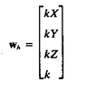

If we define the perspective transformation matrix as

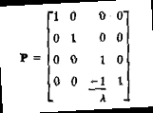

The product Pwh yields a vector denoted ch
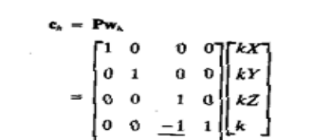

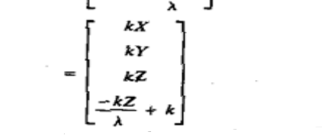

The element of ch is the camera coordinates in homogeneous form. As indicated, these coordinates can be converted to Cartesian form by dividing each of the first three components of ch by the fourth. Thus the Cartesian of any point in the camera coordinate system are given in vector form by

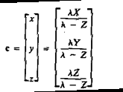

The first two components of c are the (x, y) coordinates in the image plane of a projected 3-D point (X, Y, Z). The third component is of no interest in terms of the model in Fig. 10. As shown next, this component acts as a free variable in the inverse perspective transformation

The inverse perspective transformation maps an image point back into 3-D.

Where P-1 is

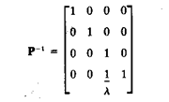

Suppose that an image point has coordinates (xo, yo, 0), where the 0 in the z location simply indicates that the image plane is located at z = 0. This point may be expressed in homogeneous vector form as

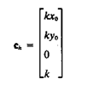

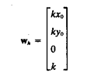

or, in Cartesian coordinates

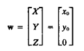

This result obviously is unexpected because it gives Z = 0 for any 3-D point. The problem here is caused by mapping a 3-D scene onto the image plane, which is a many-to-one transformation. The image point (x0, y0) corresponds to the set of collinear 3-D points that lie on the line passing through (xo, yo, 0) and (0, 0, λ). The equation of this line in the world coordinate system; that is,

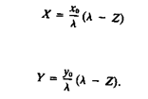

Equations above show that unless something is known about the 3-D point that generated an image point (for example, its Z coordinate) it is not possible to completely recover the 3-D point from its image. This observation, which certainly is not unexpected, can be used to formulate the inverse perspective transformation by using the z component of ch as a free variable instead of 0. Thus, by letting

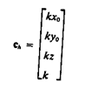

It thus follows

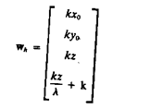

which upon conversion to Cartesian coordinate gives

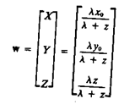

In other words, treating z as a free variable yields the equations

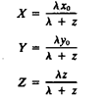

Solving for z in terms of Z in the last equation and substituting in the first two expressions yields

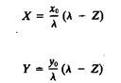

which agrees with the observation that revering a 3-D point from its image by means of the inverse perspective transformation requires knowledge of at least one of the world coordinates of the point.

IMAGE TRANSFORMS

Syllabus:
Origin of digital image processing, uses of digital image processing, fundamental steps in digital image processing, components of an image processing system ,digital image fundamentals, elements of visual perception, light and electromagnetic spectrum, image sensing and acquisition, image sampling and quantization, some basic relationships between pixels, an introduction to the mathematical tools used in digital image processing.

Outcomes:
Students will be able to
- Understand the fundamental steps digital image processing
- Understand the mathematical tools used in digital image processing

Fourier Transform and its inverse.

Let f(x) be a continuous function of a real variable x. The Fourier transform of f(x) is defined by the equation

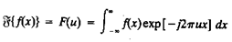

Where j = √-1

Given F(u), f(x) can be obtained by using the inverse Fourier transform

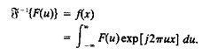

The Fourier transform exists if f(x) is continuous and integrable and F(u) is integrable. The Fourier transform of a real function, is generally complex,
F(u) = R(u) + jI(u)

Where R(u) and I(u) are the real and imiginary components of F(u). F(u) can be expressed in exponential form as

F(u) = │F(u)│ejØ(u)

where

│F(u)│ = [R2(u) + I2(u)]1/2

and

Ø (u, v) = tan-1[ I (u, v)/R (u, v) ]

The magnitude function |F (u)| is called the Fourier Spectrum of f(x) and Φ(u) its phase angle. The variable u appearing in the Fourier transform is called the frequency variable.

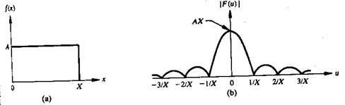

Fig 1 A simple function and its Fourier spectrum

The Fourier transform can be easily extended to a function f(x, y) of two variables. If f(x, y) is continuous and integrable and F(u,v) is integrable, following Fourier transform pair exists

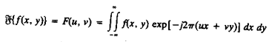

and
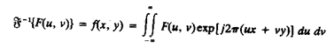

\

Where u, v are the frequency variables

The Fourier spectrum, phase, are

│F(u, v)│ = [R2(u, v) + I2(u, v )]1/2

Ø(u, v) = tan-1[ I(u, v)/R(u, v) ]

2. Define discrete Fourier transform and its inverse.

The discrete Fourier transform pair that applies to sampled function is given by,

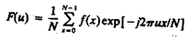 (1) For u = 0, 1, 2 . . . . , N-1, and

(2)
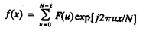

For x = 0, 1, 2 . . . ., N-1.

In the two variable case the discrete Fourier transform pair is

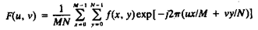

For u = 0, 1, 2 . . . , M-1, v = 0, 1, 2 . . . , N - 1, and

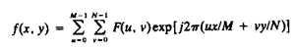

For x = 0, 1, 2 . . . , M-1, y = 0, 1, 2 . . . , N-1.

If M = N, then discrete Fourier transform pair is

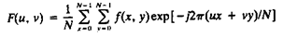

For u, v = 0, 1, 2 . . . , N – 1, and

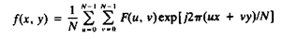

For x, y = 0, 1, 2 . . . , N – 1

Separability property of 2D-DFT.

The separability property of 2D-DFT states that, the discrete Fourier transform pair can be expressed in the separable forms. i.e. ,

(1)
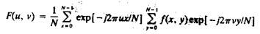

For u, v = 0, 1, 2 . . . , N – 1, and

(2)
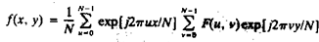

For x, y = 0, 1, 2 . . . , N – 1

The principal advantage of the separability property is that F(u,v) or f(x,y) can be obtained in two steps by successive applications of the 1-D Fourier transform or its inverse. This advantage becomes evident if equation (1) is expressed in the form

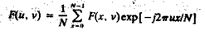 (3) Where,

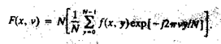(4)

For each value of x, the expression inside the brackets in eq(4) is a 1-D transform, with frequency values v = 0, 1, . . . , N-1. Therefore the 2-D function f(x, v) is obtained by taking a transform along each row of f(x, y) and multiplying the result by N. The desired result, F(u, v), is then obtained by taking a transform along each column of F(x, v), as indicated by eq(3)

Translation property.

The translation properties of the Fourier transform pair are

(1)

and

(2)
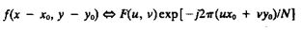

Where the double arrow indicates the correspondence between a function and its Fourier
Transform,

Equation (1) shows that multiplying f(x, y) by the indicated exponential term and taking the transform of the product results in a shift of the origin of the frequency plane to the point (uo, vo).

Consider the equation (1) with uo = vo = N/2 or

exp[j2Π(uox + voy)/N] = ejΠ(x + y)

= (-1)(x + y)

and

f(x, y)(-1)x +y Ù F(u – N/2, v – N/2)

Thus the origin of the Fourier transform of f(x, y) can be moved to the center of its corresponding N x N frequency square simply by multiplying f(x, y) by (-1)x+y . In the one variable case this shift reduces to multiplication of f(x) by the term (-1)x. Note from equation (2) that a shift in f(x, y) does not affect the magnitude of its Fourier transform as,

Distributivity and scaling property. Distributivity:
From the definition of the continuous or discrete transform pair,

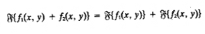

and, in general,

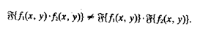

In other words, the Fourier transform and its inverse are distributive over addition but not over multiplication.

Scaling:

For two scalars a and b,

af (x, y) Ù aF(u, v)

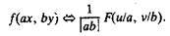

Principle of Hotelling transforms.
Hotelling transform:
The basic principle of hotelling transform is the statistical properties of vector representation. Consider a population of random vectors of the form,

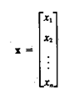

And the mean vector of the population is defined as the expected value of x i.e., mx = E{x}
The suffix m represents that the mean is associated with the population of x vectors. The
expected value of a vector or matrix is obtained by taking the expected value of each elememt. The covariance matrix Cx in terms of x and mx is given as

Cx = E{(x-mx) (x-mx)T}

T denotes the transpose operation. Since, x is n dimensional, {(x-mx) (x-mx)T} will be of n x n dimension. The covariance matrix is real and symmetric. If elements xi and xj are uncorrelated, their covariance is zero and, therefore, cij = cji = 0.

For M vector samples from a random population, the mean vector and covariance matrix can be approximated from the samples by

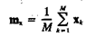

and

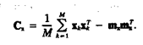

Slant transform.

The Slant transform matrix of order N x N is the recursive expression Sn is given by

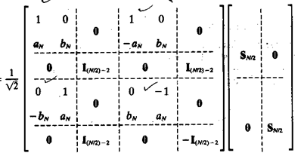

Where Im is the identity matrix of order M x M, and

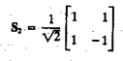

The coefficients are

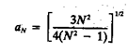

and

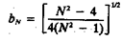

The slant transform for N = 4 will be

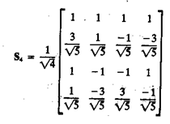
Properties of Slant transform

(i) The slant transform is real and orthogonal.

S = S*

S-1 = ST

(ii) The slant transform is fast, it can be implemented in (N log2N) operations on an N x 1 vector. (iii) The energy deal for images in this transform is rated in very good to excellent range.
(iv) The mean vectors for slant transform matrix S are not sequentially ordered for n ≥ 3.

Discrete cosine transform.

The 1-D discrete cosine transform is defined as

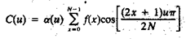

For u = 0, 1, 2, . . , N-1. Similarly the inverse DCT is defined as

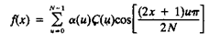

For u = 0, 1, 2, . . , N-1

Where α is

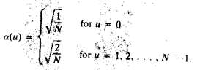

The corresponding 2-D DCT pair is

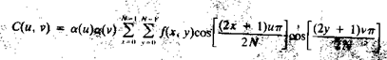

For u, v = 0, 1, 2, . . , N-1, and

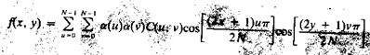

For x, y= 0, 1, 2, . . , N-1

Haar transform.

The Haar transform is based on the Haar functions, hk(z), which are defined over the continuous, closed interval z ε [0, 1], and for k = 0, 1, 2 . . . , N-1, where N = 2n. The first step in generating the Haar transform is to note that the integer k can be decomposed uniquely as

k = 2p + q - 1

where 0 ≤ p ≤ n-1, q = 0 or 1 for p = 0, and 1 ≤ q ≤ 2p for p ≠ 0. For example, if N = 4, k, q, p have following values

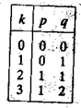

The Haar functions are defined as

for z ε [0, 1] ……. (1)
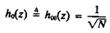

and

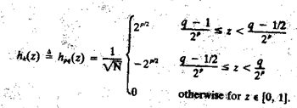

These results allow derivation of Haar transformation matrices of order N x N by formation of the ith row of a Haar matrix from elements oh hi(z) for z = 0/N, 1/N, . . . , (N-1)/N. For instance, when N = 2, the first row of the 2 x 2 Haar matrix is computed by using ho(z) with z = 0/2, 1/2. From equation (1) , ho(z) is equal to 1/, independent of z, so the first row of the matrix has two
identical 1/ elements. Similarly row is computed. The 2 x 2 Haar matrix is

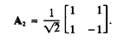

Similarly matrix for N = 4 is

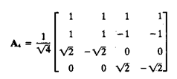

Properties of Haar transform:

1. The Haar transform is real and orthogonal.

2. The Haar transform is very fast. It can implement O(n) operations on an N x 1 vector.

3. The mean vectors of the Haar matrix are sequentially ordered.

4. It has a poor energy deal for images.

Hadamard transform.

1-D forward kernel for hadamard transform is

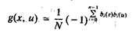

Expression for the 1-D forward Hadamard transform is

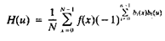

Where N = 2n and u has values in the range 0, 1, . . . , N-1.

1-D inverse kernel for hadamard transform is

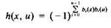

Expression for the 1-D inverse Hadamard transform is

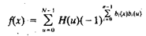

The 2-D kernels are given by the relations

and

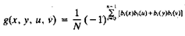

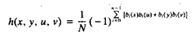

2-D Hadamard transform pair is given by following equations

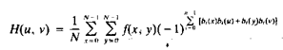

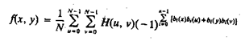

Values of the 1-D hadamard transform kernel for N = 8 is

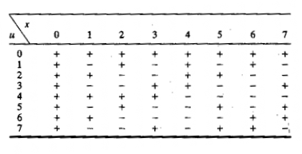

The Hadamard matrix of lowest order N = 2 is

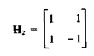

If HN represents the matrix of order N, the recursive relationship is given by

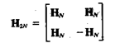

Where H2N is the Hadamard matrix of order 2N and N = 2n

Walsh transform.

The discrete Walsh transform of a function f (x), denoted W(u), is given by

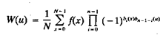

Walsh transform kernel is symmetric matrix having orthogonal rows and columns. These properties, which hold in general, lead to an inverse kernel given by

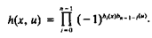

Thus the inverse Walsh transform is given by

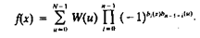

The 2-D forward and inverse Walsh kernels are given by

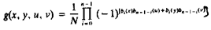

and

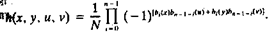

Thus the forward and inverse Walsh transforms for 2-D are given by

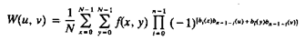

and

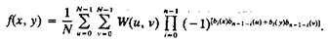

The Walsh Transform kernels are seperable and symmetric, because

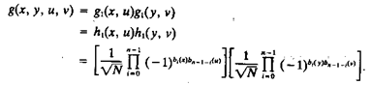

Values of the 1-D walsh transform kernel for N = 8 is

