Mechanical Vibrations

A mass m is suspended at the end of a spring, its weight stretches the spring by a length L to reach a static state (the equilibrium position of the system). Let u(t) denote the displacement, as a function of time, of the mass relative to its equilibrium position. Recall that the textbook’s convention is that downward is positive. Therefore, u > 0 means the spring is stretched beyond its equilibrium length, while u < 0 means that the spring is compressed. The mass is then assumed to be set in motion (by any one of several means).

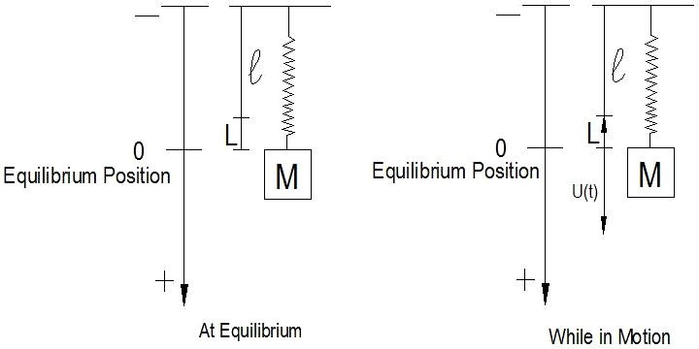

The equations that govern a mass-spring system

At equilibrium: (by Hooke’s Law)
mg = kL

While in motion:
m u″ + γ u′ + k u = F(t)

This is a second order linear differential equation with constant coefficients. It usually comes with two initial conditions: u(t₀) = u₀, and u′(t₀) = u′₀.

Summary of terms:

u(t) = displacement of the mass relative to its equilibrium position.
m = mass (m > 0)
γ = damping constant (γ ≥ 0)
k = spring (Hooke’s) constant (k > 0)
g = gravitational constant
L = elongation of the spring caused by the weight F(t) = Externally applied forcing function, if any u(t₀) = initial displacement of the mass
u′(t₀) = initial velocity of the mass

Undamped Free Vibration (γ = 0, F(t) = 0)

The simplest mechanical vibration equation occurs when γ = 0, F(t) = 0.
This is the undamped free vibration. The motion equation is

m u″ + k u = 0.
k
m

The characteristic equation is mr² + k = 0. Its solutions are The general solution is then
r = ± i .

u(t) = C₁ cos ω0 t + C₂ sin ω0 t.

Where is called the natural frequency of the system. It is the
k
m
0
ω =

frequency at which the system tends to oscillate in the absence of any damping. A motion of this type is called simple harmonic motion. It is a perpetual, sinusoidal, motion.

Comment: Just like everywhere else in calculus, the angle is measured in radians, and the (angular) frequency is given in radians per second. The frequency is not given in hertz (which measures the number of cycles or revolutions per second). Instead, their relation is: 2π radians/sec = 1 hertz.

The (natural) period of the oscillation is given by (seconds).
ω 0
T = 2π

To get a clearer picture of how this solution behaves, we can simplify it with trig identities and rewrite it as

u(t) = R cos (ω₀ t − δ).
The displacement is oscillating steadily with constant amplitude of oscillation

.
2
1
2
R = C 2 + C

The angle δ is the phase or phase angle of displacement. It measures how much u(t) lags (when δ > 0), or leads (when δ < 0) relative to cos(ω₀ t), which has a peak at t = 0. The phase angle satisfies the relation

.
tan δ = C2
C1

More explicitly, it is calculated by:

δ = tan−1 C2
C1

, if C₁

> 0,

δ = tan−1 C2
C1
+ π , if C₁

< 0,

δ = π

2

, if C₁

= 0 and C₂

> 0,

δ = − π

2

, if C₁

= 0 and C₂

< 0,

The angle is undefined if C₁ = C₂ = 0.

An example of simple harmonic motion:

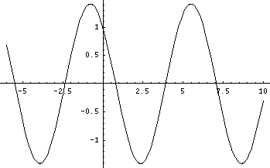

Graph of u(t) = cos(t) − sin(t)
Amplitude: R = 2
Phase angle: δ = −π/4

Damped Free Vibration (γ > 0, F(t) = 0)

When damping is present (as it realistically always is) the motion equation of the unforced mass-spring system becomes

m u″ + γ u′ + k u = 0.

Where m, γ, k are all positive constants. The characteristic equation is m r² + γ r + k = 0. Its solution(s) will be either negative real numbers, or complex numbers with negative real parts. The displacement u(t) behaves differently depending on the size of γ relative to m and k. There are three possible classes of behaviors based on the possible types of root(s) of the characteristic polynomial.

Case I. Two distinct (negative) real roots

When γ² > 4mk, there are two distinct real roots, both are negative. The displacement is in the form
.
2
1
2
r t
1
r t
u(t) = C e + C e

A mass-spring system with such type displacement function is called overdamped. Note that the system does not oscillate; it has no periodic components in the solution. In fact, depending on the initial conditions the mass of an overdamped mass-spring system might or might not cross over its equilibrium position. But it could cross the equilibrium position at most once.

Figures: Displacement of an Overdamped system

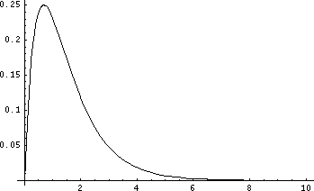

Graph of u(t) = e^{−t} − e^{−2t}

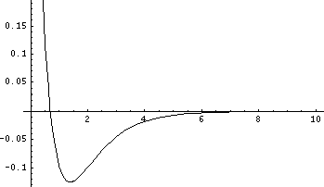

Graph of u(t) = − e^{−t} + 2e^{−2t}

Case II. One repeated (negative) real root

− γ
When γ² = 4mk, there is one (repeated) real root. It is negative: r = 2m . The displacement is in the form
u(t) = C₁ e ^{rt} + C₂ t e ^{rt}.

A system exhibits this behavior is called critically damped. That is, the damping coefficient γ is just large enough to prevent oscillation. As can be seen, this system does not oscillate, either. Just like the overdamped case, the mass could cross its equilibrium position at most one time.

Comment: The value γ² = 4mk → γ =

is called critical damping. It
2 mk

is the threshold level below which damping would be too small to prevent the system from oscillating.

Figures: Displacement of a Critically Damped system

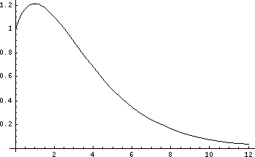

Graph of u(t) = e^{−t} / ² + t e⁻ ^{t} / ²

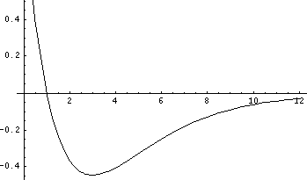

Graph of u(t) = e^{−t} / ² − t e⁻ ^{t} / ²

Case III. Two complex conjugate roots

When γ² < 4mk, there are two complex conjugate roots, where their common real part, λ, is always negative. The displacement is in the form
u(t) = C₁ e ^{λt} cos µ t + C₂ e ^{λt} sin µ t.

A system exhibits this behavior is called underdamped. The name means that the damping is small compares to m and k, and as a result vibrations will occur. The system oscillates (note the sinusoidal components in the solution). The displacement function can be rewritten as

u(t) = R e^{λ} ^{t}cos (µ t − δ).
The formulas for R and δ are the same as in the previous (undamped free vibration) section. The displacement function is oscillating, but the amplitude of oscillation, R e ^{λ} ^{t}, is decaying exponentially. For all particular solutions (except the zero solution that corresponds to the initial conditions u(t₀) = 0, u′( t₀) = 0), the mass crosses its equilibrium position infinitely often.

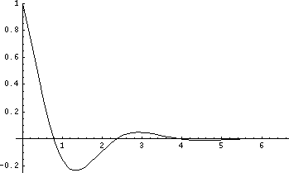

Damped oscillation: u(t) = e^{−t} cos(2t)

The displacement of an underdamped mass-spring system is a quasi-periodic function (that is, it shows periodic-like motion, but it is not truly periodic because its amplitude is ever decreasing so it does not exactly repeat itself). It is oscillating at quasi-frequency, which is µ radians per second. (It’s just the frequency of the sinusoidal components of the displacement.) The peak-
μ
q
T = 2π

to-peak time of the oscillation is the quasi-period: (seconds).

In addition to cause the amplitude to gradually decay to zero, damping has another, more subtle, effect on the oscillating motion: It immediately decreases the quasi-frequency and, therefore, lengthens the quasi-period (compare to the natural frequency and natural period of an undamped system). The larger the damping constant γ, the smaller quasi-frequency and the longer the quasi-period become. Eventually, at the critical damping
4mk

threshold, when γ =
, the quasi-frequency vanishes and the

displacement becomes aperiodic (becoming instead a critically damped system).

Note that in all 3 cases of damped free vibration, the displacement function tends to zero as t → ∞. This behavior makes perfect sense from a conservation of energy point-of-view: while the system is in motion, the damping wastes away whatever energy the system has started out with, but there is no forcing function to supply the system with additional energy.
Consequently, eventually the motion comes to a halt.

Example: A mass of 1 kg stretches a spring 0.1 m. The system has a damping constant of γ = 14. At t = 0, the mass is pulled down 2 m and released with an upward velocity of 3.5 m/s. Find the displacement function. What are the system’s quasi-frequency and quasi-period?

m = 1, γ = 14, L = 0.1;
mg = 9.8 = kL = 0.1 k → 98 = k.

The motion equation is u″ + 14 u′ + 98 u = 0, and the initial conditions are u(0) = 2, u′(0) = −3.5.

The roots of characteristic polynomial are r = −7 ± 7i:

u(t) = C₁ e ⁻⁷ ^{t} cos 7 t + C₂ e ⁻⁷ ^{t} sin 7 t
Therefore, the quasi-frequency is 7 (rad/sec) and the quasi-period is

T = 2π
q 7
(seconds).

Apply the initial condition and we get C₁ = 2, and C₂ = 3/2. Hence
u(t) = 2e ^{−7t} cos 7 t + 1.5e ^{−7t} sin 7 t.

Summary: the Effects of Damping on an Unforced Mass-Spring System

Consider a mass-spring system undergoing free vibration (i.e. without a forcing function) described by the equation:

m u″ + γ u′ + k u = 0, m > 0, k > 0.

The behavior of the system is determined by the magnitude of the damping coefficient γ relative to m and k.

- Undamped system (when γ = 0)

Displacement: u(t) = C₁ cos ω₀ t + C₂ sin ω₀ t

Oscillation: Yes, periodic (at natural frequencyω 0 = )
k
m

Notes: Steady oscillation with constant amplitude R = .
C 2 + C 2
1
2
- Underdamped system (when 0 < γ² < 4mk) Displacement: u(t) = C₁ e ^{λ} ^{t} cos µ t + C₂ e ^{λ} ^{t} sin µ t
Oscillation: Yes, quasi-periodic (at quasi-frequency µ)
Notes: Exponentially-decaying oscillation

- Critically Damped system (when γ² = 4mk) Displacement: u(t) = C₁ e ^{rt} + C₂ t e ^{rt} Oscillation: No

- Overdamped system (when γ² > 4mk)

Displacement:
u(t) = C er1 t
- C2
er2 t

Oscillation: No
1

Mechanical Vibrations, F(t) = 0
γ

Overdamped
γ² > 4mk
No Oscillation,
DAMPING INCREASES
Displacement: u(t)= C₁ e ^{r}1 t + C₂ e ^{r}2 t , Mass crosses equilibrium at most once.

Critically Damped
γ² = 4mk

No Oscillation

rt rt

Displacement: u(t)= C1 e + C2 te
Mass crosses equilibrium at most once.

Underdamped
γ² < 4mk
System oscillates with amplitude decreasing exponentially overtime,
Displacement: u(t)= C₁e^{λt}cos µt + C₂ e^{λt}sin µt,
Oscillation quasi periodic: T_{q} = 2π/µ

γ=0 ry
© 2008 Zacha
Undamped
γ = 0, Displacement: u(t)= C₁ cos ω₀t + C₂ sin ω₀t
S Tseng
Natural frequency: ω₀ = , Steady oscillation with constant amplitude

B-3 - 14

Forced Vibrations

Undamped Forced Vibration (γ = 0, F(t) ≠ 0)

Now let us introduce a nonzero forcing function into the mass-spring system.
To keep things simple, let damping coefficient γ = 0. The motion equation is

m u″ + k u = F(t).

In particular, we are most interested in the cases where F(t) is a periodic function. Without the losses of generality, let us assume that the forcing function is some multiple of cosine:

m u″ + k u = F₀ cos ωt.
This is a nonhomogeneous linear equation with the complementary solution

u_{c}(t) = C₁ cos ω₀ t + C₂ sin ω₀ t.
The form of the particular solution that the displacement function will have depends on the value of the forcing function’s frequency, ω.

Case I. When ω ≠ ω₀
If ω ≠ ω₀ then the form of the particular solution corresponding to the forcing function is
Y = A cos ωt + B sin ωt.

Solving for A and B using the method of Undetermined Coefficients, we find

that
Y =
m(ω
F0
2 − ω 2 )
0
cosωt .

Therefore, the general solution of the displacement function is

u(t) = C1
cosω 0
t + C2
sin ω 0 t +

m(ω
F0
2 − ω 2 )
0
cosω t .

An interesting instance of such a forced vibration occurs when the initial conditions are u(0) = 0, and u′(0) = 0. Applying the initial conditions to the general solution and we get

C = − F0

, and C

= 0.

1 m(ω 2 − ω 2 ) ²
0

Thus,
0
u(t) =

m(ω

F0
2 − ω 2 )
0

(cosω t − cosω t ) .

Again, a clearer picture of the behavior of this solution can be obtained by rewriting it, using the identity:
sin(A) sin(B) = [cos(A − B) − cos(A + B)] / 2.

The displacement becomes
.
(ω 0 + ω )t 2
⎥ sin
⎦
2
0
(ω 0 − ω )t ⎤
sin
2F0
⎢⎣ m(ω 2 − ω 2 )
⎡
u(t) = ⎢

The behavior exhibited by this function is that the higher-frequency, of (ω₀ + ω) / 2, sine curve sees its amplitude of oscillation modified by its lower-frequency, of (ω₀ − ω) / 2, counterpart.

This type of behavior, where an oscillating motion’s own amplitude shows periodic variation, is called a beat. The quantity ω_{b} = | ω₀ – ω | is called the beat frequency. It can be derived by dividing 2π by the distance between

adjacent zeros of
sin (ω 0 − ω ) t .
2

An example of beat:

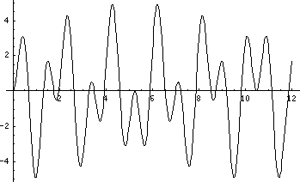

Graph of u(t) = 5 sin(1.8t) sin(4.8t)

Case II. When ω = ω₀
If the periodic forcing function has the same frequency as the natural frequency, that is ω = ω₀, then the form of the particular solution becomes

Y = A t cos ω₀ t + B t sin ω₀ t.
Use the method of Undetermined Coefficients we can find that

A = 0, and
B = F 0
2mω 0
.

The general solution is, therefore,
0
0
t sin ω t
F0
2mω
0
2
0
1
u(t) = C cos ω t + C sin ω t +
.

The first two terms in the solution, as seen previously, could be combined to become a cosine term u(t) = R cos (ω₀ t − δ), of steady oscillation. The third term, however, is a sinusoidal wave whose amplitude increases proportionally with elapsed time. This phenomenon is called resonance.

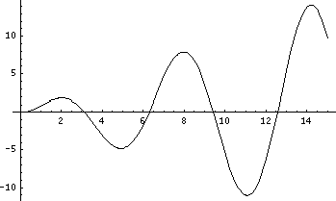

Resonance: graph of u(t) = t sin(t)

Technically, true resonance only occurs if all of the conditions below are satisfied:
- There is no damping: γ = 0,

- A periodic forcing function is present, and

- The frequency of the forcing function exactly matches the natural frequency of the mass-spring system.

However, similar behaviors, of unexpectedly large amplitude of oscillation due to a fairly low-strength forcing function occur when damping is present but is very small, and/or when the frequency of forcing function is very close to the natural frequency of the system.

Exercises B-3.1:

1 – 4 Solve the following initial value problems, and determine the natural frequency, amplitude and phase angle of each solution.
1. u″ + u = 0, | u(0) = 5, | u′(0) = −5.
2. u″ + 25u = 0, | u(0) = −2, | u′(0) = 10 3 .
3. u″ + 100u = 0, | u(0) = 3, | u′(0) = 0.
4. 4u″ + u = 0, | u(0) = −5, | u′(0) = −5.

5 – 10 Solve the following initial value problems. For each problem, determine whether the system is under-, over-, or critically damped.
5. u″ + 6u′ + 9u = 0, | u(0) = 1, | u′(0) = 1.
6. u″ + 4u′ + 3u = 0, | u(0) = 0, | u′(0) = −4.
7. u″ + 6u′ + 10u = 0, | u(0) = −2, | u′(0) = 9.
8. u″ + 2u′ + 17u = 0, | u(0) = 6, | u′(0) = −2.
9. 4u″ + 9u′ + 2u = 0, | u(0) = 3, | u′(0) = 1.
10. 3u″ + 24u′ + 48u = 0, | u(0) = −5, | u′(0) = 6.

- Consider a mass-spring system described by the equation
2u″ + 3u′ + k u = 0. Give the value(s) of k for which the system is under-, over-, and critically damped.

- Consider a mass-spring system described by the equation
4u″ + γu′ + 36u = 0. Give the value(s) of γ for which the system is under-, over-, and critically damped.

- One of the equations below describes a mass-spring system undergoing resonance. Identify the equation, and find its general solution.
(i.) u″ + 9u = 2cos 9t (ii.) u″ + 4u′ + 4u = 3sin 2t (iii.) 4u″ + 16u = 7cos 2t

- Find the value(s) of k, such that the mass-spring system described by each of the equations below is undergoing resonance.
  - 8u″ + k u = 5sin 6t (b) 3u″ + k u = −π cos t

Answers B-3.1:
1. u = 5cos t − 5sin t, ω₀ = 1, R = 5 , δ = −π / 4
2
2. u = −2cos 5t + 2 3 sin 5t, ω₀ = 5, R = 4, δ = 2π / 3
3. u = 3cos 10t, ω₀ = 10, R = 3, δ = 0
5

4. u = −5cos t / 2 − 10sin t / 2, ω₀ = 1 / 2, R =
- u = e ^{−3t} + 4t e ^{−3t}, critically damped
- u = 2e ^{−3t} − 2e ^{−t}, overdamped
- u = −2e ⁻³ ^{t} cos t + 3e ⁻³ ^{t} sin t, underdamped
- u = 6e ⁻ ^{t} cos 4t + e ⁻ ^{t} sin 4t, underdamped
- u = 4e ^{−t} / ⁴ − e ^{−2t}, overdamped
- u = −5e ^{−4t} − 14t e ^{−4t}, critically damped
5 , δ = π + tan⁻¹ 2

- Overdamped if 0 < k < 9 / 8, critically damped if k = 9 / 8, underdamped if k > 9 / 8.
- Underdamped if 0 < γ < 24, critically damped if γ = 24, overdamped if
γ > 24. When γ = 0, the system is undamped (rather than underdamped).

- (iii),
u = C1
cos 2t + C2
sin 2t + 7
16
t sin 2 t

14. (a) k = 288 (b) k = 3

