UNIT - 6
Jet Propulsion System
It is the propulsion of a jet aircraft (or) Rocket engines which do not use atmospheric air other missiles by the reaction of jet coming out with high velocity. The jet propulsion in used when the oxygen is obtained from the surrounding atmosphere.
Jet propulsion is based on Newton’s second and third low of motion. Newton’s second law states that ‘the range of momentum in any direction is proportional to the force acting in that direction’. Newton’s third low states that for every action there is an equal and opposite reaction.
In propulsion momentum is imparted to a mass of fluid in such a manner that the reaction of the imparted momentum furnishes a propulsive force. The jet aircraft draws in air and expels it to the rear at a markedly increased velocity; the rocket greatly changes the velocity of its fuel which it ejects rearward in the form of products of combustion. In each case the action of accelerating the mass of fluid in a given direction created a reaction in the opposite direction in the form of a propulsive
force. The magnitude of this propulsive force is defined as thrust.
The jet propulsion engines are classified basically as to their method of operation. The two main categories of jet propulsion engines are the atmospheric jet engines and the rockets. The atmospheric jet engines require oxygen from the atmospheric air for the combustion of fuel. As a result, their performance depends to a great degree on the forward speed of the engine and upon the atmospheric pressure and temperature.
Types of Jet Propulsion System

The jet propulsion engines are classified basically as to their method of operation. The two main categories of jet propulsion engines are the atmospheric jet engines and the rockets. The atmospheric jet engines require oxygen from the atmospheric air for the combustion of fuel. As a result, their performance depends to a great degree on the forward speed of the engine and upon the atmospheric pressure and temperature.

The rocket engine differs from the atmospheric jet engines in that the entire mass of jet is generated from the propellants carried within the engine, i.e., the rocket engine carries its own oxidant for the combustion of the fuel and is therefore, independent of the atmospheric air. The performance of this type of power plant is independent of the forward speed and affected to a maximum of about 10% by changes in altitude.

1 Air Breathing Engines
Air breathing engines can further be classified as follows:
1.Reciprocating engines (Air screw)
2. Gas Turbine engines
- Turbojet
- Turbojet with after burner (also known as turbo ramjet, turbojet with tail pipe burning and turbojet with reheater)
- Turboprop (also known as propjet).
3. Athodyds (Aero Thermodynamics Ducts)
- Steady combustion system, continuous air flow – Ramjet (also known as Lorin tube)
- Intermittent combustion system, intermittent air flow – Pulse jet (also known as aero pulse, resojet, Schmidt tube and intermittent jet).
The reciprocating engine develops its thrust by accelerating the air with the help of a propeller driven by it, the exhaust of engine imparting almost negligible amount of thrust to that developed by the propeller.
The turbojet, turbojet with afterburner and turboprop are modified simple open cycle gas turbine engines. The turbojet engine consists of an open cycle gas turbine engine (compressor, combustion chamber and turbine) with an entrance air diffuser added in front of the compressor and an exit nozzle added aft of the turbine. The turbojet with afterburner is a turbojet engine with a reheater added to the engine so the extended tail pipe acts as a combustion chamber. The turboprop is a turbojet engine with extra turbine stages, a reduction gear train and a propeller added to the engine. Approximately 80 to 905 of the thrust of the turboprop is produced by acceleration of the air outside the engine by the propeller and about 10 to 20% of the thrust is produced by the jet exit of the exhaust gases. The ramjet and the pulsejet are athodyds, i.e., a straight duct type of jet engine without compressor and turbine wheels.
2 Rocket Engines
The necessary energy and momentum which must be imparted to a propellant as it is expelled from the engine to produce a thrust can be given in many ways. Chemical, nuclear or solar energy can be used and the momentum can be imparted by electrostatic or electromagnetic force.
Chemical rockets depend up on the burning of the propellant inside the combustion chamber and expanding it through a nozzle to obtain thrust. The propellant may be solid, liquid, gas or hybrid.
The vast store of atomic energy is utilized incase of nuclear propulsion. Radioactive decay or Fission or Fusion can be used to increase the energy of the propellant.
In electrical rockets electrical energy from a separate energy source is used and the propellant is accelerated by expanding in a nozzle or by electrostatic or electromagnetic forces.
In solar rockets solar energy is used to propel spacecraft.
The Ramjet Engine
The ramjet engine is an air breathing engine which operates on the same principle as the turbojet engine. Its basic operating cycle is similar to that of the turbojet. It compresses the incoming air by ram pressure, adds the heat energy to velocity and produces thrust. By converting kinetic energy of the incoming air into pressure, the ramjet is able to operate without a mechanical compressor. Therefore the engine requires no moving parts and is mechanically the simplest type of jet engine which has been devised. Since it depends on the velocity of the incoming air for the needed compression, the ramjet will not operate statistically. For this reason it requires a turbojet or rocket assist to accelerate it to operating speed.
At supersonic speeds the ramjet engine is capable of producing very high thrust with high efficiency. This characteristic makes it quite useful on high speed aircraft and missiles, where its great power and low weight make flight possible in regions where it would be impossible with any other power plant except the rocket. Ramjets have also been used at subsonic speeds where their low cost and light weight could be used to advantage.
Principle of Operation:
The ramjet consists of a diffuser, fuel injector, flame holder, combustion chamber and exit nozzle (Ref figure 9). The air taken in by the diffuser is compressed in two stages.
The external compression takes place takes place because the bulk of the approaching engine forces the air to change its course. Further compression is accomplished in the diverging section of the ramjet diffuser. Fuel is injected into and mixed with air in the diffuser. The flame holder provides a low velocity region favourable to flame propagation, and the fuel-air mixture recirculates within this sheltered area and ignites the fresh charge as it passes the edge of the flame holder. The burning gases then pass through the combustion chamber, increasing in temperature and therefore in volume. Because the volume of air increases, it must speed up to get out of the way off the fresh charge following behind it, and a further increase in velocity occurs as the air is squeezed out through the exit nozzle. The thrust produced by the engine is proportional to this increase in velocity.
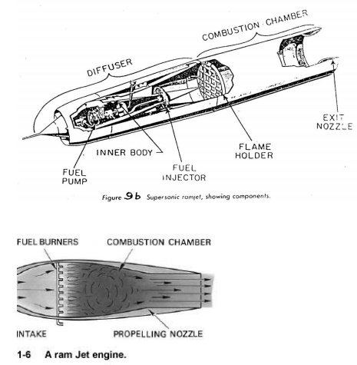
Advantages
Ø Ramjet is very simple and does not have any moving part. It is very cheap and requires almost no maintenance.
Ø Since turbine is not used the maximum temperature which can be allowed in ramjet is very high, about 2000 ⁰C as compared to about 1000 ⁰C in turbojets.
This allows a greater thrust to be obtained by burning fuel at A/F ratio of about 15.1 which gives higher temperatures.
Ø The SFC is better than turbojet engines at high speed and high altitudes.
Ø There seems to be no upper limit to the flight speed of the ramjet.
Disadvantages
Ø Since the compression of air is obtained by virtue of its speed relative to the engine, the take-off thrust is zero and it is not possible to start a ramjet without an external launching device.
Ø The engine heavily relies on the diffuser and it is very difficult to design a diffuser which will give good pressure recovery over a wide range of speeds.

Ø Due to high air speed, the combustion chamber requires flame holder to stabilise the combustion.

Ø At very high temperature of about 2000⁰ C dissociation of products of
combustion occurs which will reduce the efficiency of the plant if not recovered in nozzle during expansion.
Application:
Ø Due to its high thrust at high operational speed, it is widely used in high speed aircrafts and missiles.
Ø Subsonic ramjets are used in target weapons, in conjunction with turbojets or rockets for getting the starting torque.
Pulse Jet Engine
The pulse jet engine is an intermittent, compressor less aerodynamic power plant, with few or none of the mechanical features of conventional aviation power plants. In its simplest form, the operation of the pulse jet depends only on the properties of atmospheric air, a fuel, a shaped tube and some type of flow-check valve, and not on the interposition of pistons, impellers, blades or other mechanical part whose geometry and motion are controllable. The pulse jet differs from other types of air breathing engines, in that the air flow through it is intermittent. It can produce static thrust.
Operations:
During starting compressed air is forced into the inlet which opens the spring loaded flapper valves. In practice this may done by blowing compressed air though the valve box or by the motion of the engine through the air. The air that enters the engine passes by the fuel injector and is mixed with the fuel(Fig. A)

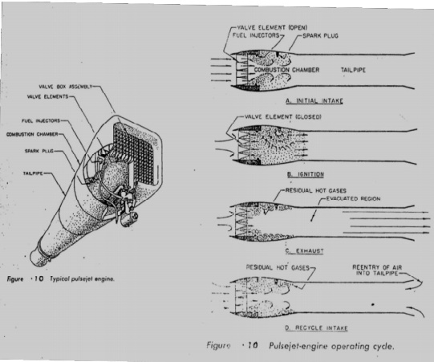
When the fuel-air mixture reaches the proper proportion to burn, it is ignited by a spark plug. The burning takes place with explosive force, thus causing a very rapid rise in pressure, the increase in pressure forces the flapper valves shut and propels the charge of burned gases out of the tail pipe, as in B of the figure.
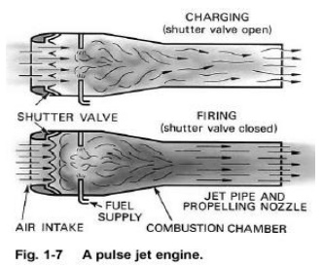
The momentum of the gases leaving the tailpipe causes the air to continue t flow out even after the pressure within the engine has reached atmospheric pressure. The pressure within the engine is therefore evacuated to below atmosphere, part C in figure.

After the pressure has reached its lowest point, atmospheric pressure (and the ram pressure if the engine is in flight) forces air into the engine through the flapper valves. At the same time, air will also be drawn in through tailpipe, since the pressure within the tailpipe is low and has nothing to prevent the entry of air, At this point, part D in figure, the engine is ready to begin another cycle. The fequency of cycles depends upon the duct shape and working temperature in V-1 rocket it was about 40 c/s which corresponds to about 2400 rpm of a two stroke reciprocating engine.
Once the engine operation has become established, the spark plug is no longer necessary. The reignition between each cycle is accomplished when the fresh charge of fuel and air is ignited by some residual flame which is left over from the preceding cycle. The air flow which reenters the tailpipe is important from both the engine operation and thrust stadpoints. Experiments have shown that the amount of air which flows into the tailpipe can be several times as much as that which flows into the inlet. This mass flow of air increases the thrust of the engine by providing additional mass for the explosion pressure to work on. It also increases the pressure within the engine at the beginning of each explosion cycle, resulting in a more efficient burning process. Reentry of air into the tailpipe is made more difficult as the airspeed surrounding the engine increases. The thrust of the engine, therefore, tends to decrease with speed. As the speed increases, the amount of reentering air flow decreases to the point where the internal pressure is eventually too low to support combustion and the engine will no longer operate.

Characteristics :
The chief advantages of the pulse jet are its simplicity, light weight, low cost and good zero speed thrust characteristic. Its particular disadvantages are its 650-800 km/h. operating speed limit, rather limited altitude range and somewhat unpredictable valve life.
One interesting and sometimes objectionable, feature of the pulse jet engine is the sound it makes when in operation. The sound is a series of loud reports caused by the firing of the individual charges of fuel and air in the combustion chamber. The frequency of the reports depends upon the length of the engine form the inlet valves to the end of the tailpipe and upon the temperature of the gases within the engine. The resulting sound is a continuous, loud, and vibratory note that can usually be heard for several kilometers.
The pulse jet has low thermal efficiency. In early designs the efficiency obtained was about 2 to 3% with a total flight life of 30 to 60 minutes. The maximum operating speed is seriously limited by tow factors: (i) It is possible to design a good diffuser at high speeds. (ii) The fiepper valves, the only mechanical part in the pulse jet, also have certain natural frequency and if resonance with the cycle frequency occurs then the valve may remain open and no compression will take place. Also, as the speed increases it is difficult for air to flow back. This reduces total compression pressure as well as the mass flow of air which results in inefficient combustion and lower thrust. The reduction in thrust and efficiency is quite sharp as the speed increases.
Advantages :
Ø This is very simple device only next to ramjet and is light in weight. It requires very small and occasional maintenance.
Unlike ramjet, it has ¬ it does not need a static thrust because of the compressed air starting, thus device for initial propulsion. The static thrust is even more than the cruise thrust.
Ø It can run on an almost any type of liquid fuel without much effect on the performance. It can also operate on gaseous fuel with little modifications.
Ø Pulse jet is relatively cheap.
Disadvantages :
Ø 1.The biggest disadvantage is very short life of flapper valve and high rates of fuel consumption. The SFC is as high as that of ramjet.
Ø The speed of the pulse jet is limited within a very narrow range of about 650-800 km/h because of the limitations in the aerodynamic design of an efficient diffuser suitable for a wide range.
Ø The high degree of vibrations due to intermittent nature of the cycle and the buzzing noise has made it suitable for pilotless crafts only.
Ø It has lower propulsive efficiency that turbojet engine.
Ø The operational range of the pulse jet is limited in altitude range.
Applications:
- German V-1 buzz bomb,
- American Helicopter company’s Jet Jeep Helicopter,
- Auxiliary power plant for sail planes.
The Turbojet Engine
The turbojet engine consists of diffuser which shows down the entrance air and thereby compresses it, a slows down the entrance air and thereby compresses it, a simple open cycle gas turbine and an exist gas into kinetic energy. The increased velocity, of air thereby produces thrust.
Figure 2 shows the basic arrangement of the diffuser, compressor, combustion chamber, turbine and the exhaust nozzle of a turbojet engine. Of the total pressure rise of air, a part is obtained by the rain compression in the diffuser and rest in the compressor. The diffuser converts kinetic energy of the air into pressure energy. In the ideal diffuser, the air is diffused isentopically down to zero velocity. In the actual diffuser the process is irreversible adiabatic and the air leaves the diffuser at a velocity between 60 and 120 m/s
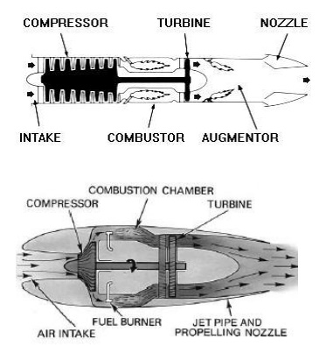

The centrifugal compressor gives a pressure ratio of about 4:1 to 5:1 in a single stage and usually a double-sided rotor is used. The turbojet using centrifugal compressor has a short and sturdy appearance. The advantages of centrifugal compressor are high durability, ease of manufacture and low cost and good operation under adverse conditions such as icing and when sand and small foreign particles are inhaled in the inlet duct. The primary disadvantage is the lack of straight-through airflow. Air leaves compressor in radial direction and ducting with the attendant pressure losses is necessary to change the direction. The axial flow is more efficient than the centrifugal type and gives the turbojet a long slim, streamlined appearance. The engine diameter is reduced which results in low aircraft drag. A multistage axial flow compressor can develop a pressure ratio as high as 6:1 or more. The air handled by it is more than that handled by a centrifugal compressor of the same diameter.
A variation of the axial compressor, the twin-spool (dual spool, split spool or coaxial) compressor has two or more sections, each revolving at or near the optimum speed for its pressure ratio and volume of air. A very high-pressure ratio of about 9:1 to 13:1 is obtained. The use of high-pressure ratio gives very good specific fuel consumption and is necessary for thrust ratings in the region of 50000 N or greater.
In the combustion chamber heat is added to the compressed air nearly at constant pressure. The three types being ‘can’, ‘annular’ and ‘can-annular’ (ref.fig.3). In the can type individual burners, or cans, are mounted in a circle around the engine axis with each one receiving air through its own cylindrical shroud. One of the main disadvantages of can type burners is that they do not make the best use of available space and this results in a large diameter engine. On the other hand, the burners are individually removable for inspection and air-fuel patterns are easier to control than in annular designs. The annular burner is essentially a single chamber made of concentric cylinders mounted co-axially about the engine axis. This arrangement makes more complete use of available space, has low pressure loss, fits well with the axial compressor and turbine and form a technical viewpoint has the highest efficiency, but has a disadvantage in that structural problems may arise due to the large diameter, thin-wall cylinder required with this type of chamber. The problem is more severe for larger engines. There is also some disadvantage in that the entire combustor must be removable from the engine for inspection and repairs. The can- annular design also makes good use of available space, but employs a number of individually replaceable cylindrical inner liners that receive air through a common annular housing for good control of fuel and air flow patterns. The can-annular arrangement has the added advantage of greater structural stability and lower pressure loss than that of the can type.
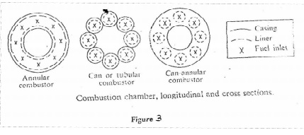
The heated air then expands through the turbine thereby increasing its velocity while losing pressure. The turbine extracts enough energy to drive the compressor and the necessary auxiliary equipments. Turbines of the impulse, reaction and a combination of both types are used. In general, it may be stated that those engines of relatively low thrust and simple design employ the impulse type, while those of large thrust employ the reaction and combination types.
The hot gas is then expended through the exit nozzle and the energy of the hot gas is converted into as much kinetic energy as is possible. This change in velocity of the air passing through the engine multiplied by the mass flow of the air is the change of momentum, which produces thrust. The nozzle can be a fixed jet or a variable area nozzle. The variable area nozzle permits the turbojet to operate at maximum efficiency over a wide range of power output. Clamshell, Finger or Iris, Centre plug with movable shroud, annular ring, annular ring with movable shroud are the various types of variable area nozzle for turbojet engines. The advantage of variable area nozzle is the increased cost, weight and complexity of the exhaust system.
The needs and demands being fulfilled by the turbojet engine are
Ø Low specific weight – ¼ to ½ of the reciprocating engine
Ø Relative simplicity – no unbalanced forces or reciprocating engine
Ø Small frontal area, reduced air cooling problem- less than ¼ th the frontal area of the reciprocating engine giving a large decrease in nacelle drag and consequently giving a greater available excess thrust or power, particularly at high speeds.

Ø Not restricted in power output - engines can be built with greatly increased power output over that of the reciprocating engine without the accompanying disadvantages.
Ø Higher speeds can be obtained – not restricted by a propeller to speeds below 800 km/h.

The Turbofan Engine

The turboprop is limited to mach number of about 0.7 because of the sharp decrease in propeller efficiency encountered above that mach number. However, the turboprop concept of increasing mass flow rate without producing an excessive increment in exhaust velocity is valid at any mach number and the use of a ducted fan combined with a jet turbine provides more economical operation at mach numbers close to unity than does the simple jet turbine. If a duct or shroud is placed around a jet engine and air is pumped through the annular passage by means of one or more sets of compressor blades, the resulting engine is called a turbofan, and is capable of producing (under proper conditions) somewhat better thrust specific fuel consumption characteristics than the turbojet itself. Basically, the air passing through the fan bypasses the combustion process but has energy added to it by the compressor fan, so that a sizable mass flow can be shunted through the fan. The air which bypasses the combustion process leaves the engine with a lower amount of internal energy and a lower exhaust speed than the jet exhaust. Yet, the thrust is not decreased since the turbofan can pump more air per unit time than a conventional jet at subsonic speeds. Accordingly, the average exhaust velocity of the turbofan (averaging the turbine flow and the bypass flow) can be made smaller at a given flight speed than that of a comparable turbojet and greater efficiency can be obtained. In turbofan engine the fan cannot be designed for all compressor ratios which is efficient at all mach numbers, thus, the turbofan is efficient over a rather limited range of speeds. Within this speed range, however, its improved cruise economy makes it a desirable unit for jet transport aircraft.
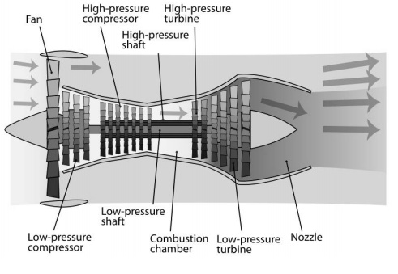
The turbofan engine has a duct enclosed fan mounted at the front or rear of the engine and driven either mechanically geared down or at the same speed as the compressor, or by an independent turbine located to the rear of the compressor drive turbine (Ref. Figure 7). There are two methods of handling the fan air. Either the fan can exit separately from the primary engine air, or it can be ducted back to mix with the primary engine’s air at the rear. If the fan air is ducted to the rear, the total fan pressure must be higher than the static pressure in the primary engine’s exhaust, or air will not flow. Similarly, the static fan discharge pressure must be less than the total pressure the primary engine’s exhaust, or the turbine will not be able to extract the energy required to drive the compressor and fan. By closing down the area of flow of the fan duct, the static pressure can be reduced and the dynamic pressure is increased.
The efficiency of the fan engine is increased over that of the pure jet by converting more of the fuel energy into pressure energy rather than the kinetic energy of a high velocity exhaust gas stream. The fan produces additional force or thrust without increasing fuel flow. As in the turboprop primary engine exhaust gas velocities and pressures are low because of the extra turbine stages needed to drive the fan, and as a result this makes the turbofan engine much quieter. One fundamental difference between the turbofan and the turboprop engine is that the air flow through the fan is controlled by design so that the air velocity relative to the fan blades is unaffected by the aircraft’s speed. This eliminates the loss in operational efficiency at high air speeds which limits the maximum air speed of propeller driven aircraft.
Fan engines show a definite superiority over the pure jet engines at speeds below Mach 1. The increased frontal area of the fan presents a problem for high- speed aircraft which, of course require small frontal areas. At high speeds air can be offset at least partially by burning fuel in the fan discharge air. This would expand the gas, and in order to keep the fan discharge air at the same pressure, the area of the fan jet nozzle is increased. This action results in an increase in gross thrust due to an increase in pressure times an area (PA), and an increase in gross thrust specific fuel consumption.
Nozzle and diffuser efficiencies
In ideal case, flow through nozzle and diffuser is isentropic. But in actual case, friction exists and affects in following ways:
i) Reduces the enthalpy drop reduces the final velocity of steam iii) Increases the final dryness fraction iv) Increases specific volume of the fluid v) Decreases the mass flow rate
Nozzle performance
The isentropic operating conditions are very easy to determine. Frictional losses in the nozzle can be accounted by several methods.
(1) Direct information on the entropy change could be given although this is usually not available.
(2) Some times equivalents information is provided in the form of stagnation pressure ratio. Normally nozzle performance is indicated by efficiency parameter defined as
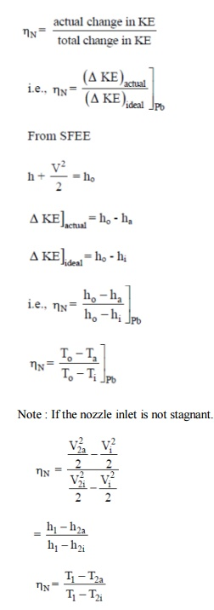
Rocket Propulsion
In the section about the rocket equation we explored some of the issues surrounding the performance of a whole rocket. What we didn’t explore was the heart of the rocket, the motor. In this section we’ll look at the design of motors, the factors which affect the performance of motors, and some of the practical limitations of motor design. The first part of this section is necessarily descriptive as the chemistry, thermodynamics and maths associated with motor design are beyond the target audience of this website.
General Principles of a Rocket Motor
In a rocket motor a chemical reaction is used to generate hot gas in a confined space called the combustion chamber. The chamber has a single exit through a constriction called the throat. The pressure of the hot gas is higher than the surrounding atmosphere, thus the gas flows out through the constriction and is accelerated.
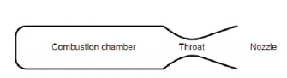
Propellants
The chemical reaction in model rocket motors is referred to as an “exothermal redox” reaction. The term “exothermal” means that the reaction gives off heat, and in the case of rocket motors this heat is mainly absorbed by the propellants raising their temperature.
The term “redox” means that it is an oxidation/reduction reaction, in other words one of the chemicals transfers oxygen atoms to another during the reaction. The two chemicals are called the oxidising agent and the reducing agent.
The most popular rocket motors are black powder motors, where the oxidising agent is saltpetre and the reducing agents are sulphur and carbon. Other motors include Potassium or ammonium perchlorate as the oxidising agent and mixtures of hydrocarbons and fine powdered metals as the reducing agents. Other chemicals are often added such as retardants to slow down the rate of burn, binding agents to hold the fuel together (often these are the hydrocarbons used in the reaction), or chemicals to colour the flame or smoke for effects. In hybrid motors a gaseous oxidiser, nitrous oxide, reacts with a hydrocarbon, such as a plastic, to produce the hot gas.
Energy Conversion
This reaction releases energy in the form of heat, and by confining the gas within the combustion chamber we give it energy due to its pressure. We refer to the energy of this hot pressurised gas as its “enthalpy”. By releasing the gas through the throat the rocket motor turns the enthalpy of the gas into a flow of the gas with kinetic energy. It is this release of energy which powers the rocket. So the energy undergoes Two conversions:
Ø Chemical energy to enthalpy
Ø Enthalpy to kinetic energy
The conversion from chemical energy to enthalpy takes place in the combustion chamber. To obtain the maximum enthalpy it is clearly important to have a reaction which releases lots of heat and generates lots of high energy molecules of gas to maximise pressure here is clearly a limit to the temperature & pressure, as the combustion chamber may melt or split if these are too high. The designer has a limitation placed on his choice of reagents in that the reaction must not heat the combustion chamber to a point where it is damaged, nor must the pressure exceed that which the chamber can survive.
Changing enthalpy to kinetic energy takes place in the throat and the nozzle. Our mass of hot gas flows into the throat, accelerating as the throat converges. If we reduce the chameter of the throat enough, the flow will accelerate to the speed of sound, at which pint something unexpected occurs. As the flow diverges into the nozzle it continues to accelerate beyond the speed of sound, the increase in velocity depending on the increase in area. This type of nozzle is called a De Laval nozzle.
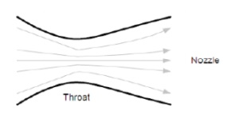
Kinetic energy of a body:
If we consider a small volume of gas, it will have a very low mass. As we accelerate this gas it gains kinetic energy proportional to the square of the velocity, so if we double the velocity we get four times the kinetic energy. The velocity of the supersonic flow increases proportional to the increase in area of the nozzle, thus the kinetic energy increases by the fourth power of the increase in nozzle diameter. Thus doubling the nozzle diameter increases the kinetic energy by 16 times! The De Laval nozzle make rocket motors possible, as only such high velocity flows can generate the energy required to accelerate a rocket.
In model rockets the reaction is chemical generally short lived, a few seconds at most, sothe amount of heat transferred to the structural parts of the motor is limited. Also, the liner of the motor casing acts to insulate the casing from the rapid rise in temperature which would result from a reaction in direct contact with the metal casing. Model rocket motors also run at quite low pressure, well below the limits if the motor casing, further protecting the casing. It can be seen that the enthalpy of a model rocket motor is thus quite low. In large launch vehicles such as Ariane, the pressure and temperature are high, the burn may last several minutes, and the mass budget for the designer is very tight. Designing motors for these purposes is highly complex.
Thrust
The basic principles of a rocket motor are relatively straightforward to understand. In rocketry the motor exists to accelerate the rocket, and thus it has to develop a force called “thrust”. One of several definitions of force is that: Force = rate of change of momentum If we ignore (for a few paragraphs) any external effects we can say that the thrust is entirely due to the momentum of the propellant, a force called the “momentum thrust”. If we denote the thrust as F and the momentum as P, then mathematically:
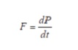
Sometimes for mathematical clarity we us the notation of P with a dot on top to denote the first derivative of P, and with 2 dots for the second derivative. Thus, in this new notation:
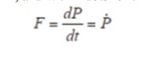
You may also recall from the section on the rocket equation that momentum is the product of the mass and velocity. Thus we can say that the momentum of the flow from the nozzle of the rocket has a momentum:
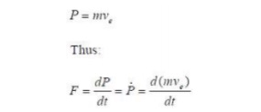
If the exhaust velocity remains constant, which is a reasonable assumption, we arrive at the equation:
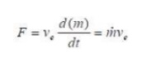

The term “m-dot” is known as the mass flow rate, in other words the rate at which mass is ejected through the nozzle in kg/sec. In other words this is the rate at which the rocket burns fuel. This is an interesting relationship, which can be expressed in words as: Momentum
Thrust = mass flow rate x exhaust velocity
Flow expansion
The propellant is accelerated into the atmosphere. As it leaves the nozzle the propellant has an exit pressure Pexit and enters an atmosphere which has a pressure Patm. The transition from one pressure to the other cannot happen instantaneously as any pressure difference will cause a flow of high pressure fluid into the low pressure region.
So the force (a component of thrust called “pressure thrust”) depends on the pressure difference and the area
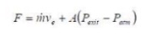
Types of Rocket Engines
Rocket or rocket vehicle is a missile, spacecraft, aircraft or other vehicle which obtains thrust from a rocket engine. In all rockets, the exhaust is formed entirely from propellants carried within the rocket before use. Rocket engines work by action and reaction. Rocket engines push rockets forwards simply by throwing their exhaust backwards extremely fast.
Rockets for military and recreational uses date back to the 13th century. Significant scientific, interplanetary and industrial use did not occur until the 20th century, when rocketry was the enabling technology of the Space Age, including setting foot on the moon.
Rockets are used for fireworks, weaponry, ejection seats, launch vehicles for artificial satellites, human spaceflight and exploration of other planets. While comparatively inefficient for low speed use, they are very lightweight and powerful, capable of generating large accelerations and of attaining extremely high speeds with reasonable efficiency.
Chemical rockets are the most common type of rocket and they typically create their exhaust by the combustion of rocket propellant. Chemical rockets store a large amount of energy in an easily released form, and can be very dangerous. However, careful design, testing, construction and use minimize risks.
Rocket vehicles are often constructed in the archetypal tall thin "rocket" shape that takes off vertically, but there are actually many different types of rockets including, tiny models such as balloon rockets, water rockets, skyrockets or small solid rockets that can be purchased at a hobby store missiles space rockets such as the enormous Saturn V used for the Apollo program rocket cars rocket bike, rocket powered aircraft (including rocket assisted takeoff of conventional aircraft- JATO), rocket sleds rocket trains rocket torpedos, rocket powered jet packs, rapid escape systems such as ejection seats and launch escape systems space probes
Propellants:
A propellant is a material that is used to move ("propel") an object. The material is usually expelled by gas pressure through a nozzle. The pressure may be from a compressed gas, or a gas produced by a chemical reaction. The exhaust material may be a gas, liquid, plasma, or, before the chemical reaction, a solid, liquid or gelled. Common chemical propellants consist of a fuel; like gasoline, jet fuel, rocket fuel, and an oxidizer. Propellant used for propulsion Technically, the word propellant is the general name for chemicals used to create thrust.
For vehicles, the term propellant refers only to chemicals that are stored within the vehicle prior to use, and excludes atmospheric gas or other material that may be collected in operation.
Amongst the English-speaking laymen, used to having fuels propel vehicles on Earth, the word fuel is inappropriately used. In Germany, the word Treibstoff—literally "drive-stuff"—is used; in France, the word ergols is used; it has the same Greek roots as hypergolic, a term used in English for propellants which combine spontaneously and do not have to be set ablaze by auxiliary ignition system.
In rockets, the most common combinations are bipropellants, which use two chemicals, a fuel and an oxidiser. There is the possibility of a tripropellant combination, which takes advantage of the ability of substances with smaller atoms to attain a greater exhaust velocity, and hence propulsive efficiency, at a given temperature. Although not used in practice, the most developed tripropellant systems involves adding a third propellant tank containing liquid hydrogen to do this.
Solid propellant
In ballistics and pyrotechnics, a propellant is a generic name for chemicals used for propelling projectiles from guns and other firearms. Propellants are usually made from low explosive materials, but may include high explosive chemical ingredients that are diluted and burned in a controlled way (deflagration) rather than detonation. The controlled burning of the propellant composition usually produces thrust by gas pressure and can accelerate a projectile, rocket, or other vehicle. In this sense, common or well known propellants include, for firearms, artillery and solid propellant rockets: Gun propellants, such as:
Ø Gunpowder (black powder)
Ø Nitrocellulose-based powders
Ø Cordite
Ø Ballistite
Ø Smokeless powders
Composite propellants made from a solid oxidizer such as ammonium perchlorate or ammonium nitrate, a rubber such as HTPB, or PBAN (may be replaced by energetic polymers such as polyglycidyl nitrate or polyvinyl nitrate for extra energy) , optional high explosive fuels (again, for extra energy) such as RDX or nitroglycerin, and usually a powdered metal fuel such as aluminum.
Some amateur propellants use potassium nitrate, combined with sugar, epoxy, or other fuels / binder compounds.
Potassium perchlorate has been used as an oxidizer, paired with asphalt, epoxy, and other binders.
Grain
Propellants are used in forms called grains. A grain is any individual particle of propellant regardless of the size or shape. The shape and size of a propellant grain determines the burn time, amount of gas and rate produced from the burning propellant and consequently thrust vs time profile.
There are three types of burns that can be achieved with different grains.
Ø Progressive Burn:
Usually a grain with multiple perforations or a star cut in the center providing a lot of surface area.
Ø Digressive Burn
Usually a solid grain in the shape of a cylinder or sphere.
Ø Neutral Burn
Usually a single perforation; as outside surface decreases the inside surface increases at the same rate.
Composition
There are four different types of solid propellant compositions:
Single Based Propellant:
A single based propellant has nitrocellulose as its chief explosives ingredient. Stabilizers and other additives are used to control the chemical stability and enhance the propellant’s properties.
Double Based Propellant:
Double based propellants consist of nitrocellulose with nitroglycerin or other liquid organic nitrate explosives added. Stabilizers and other additives are used also. Nitroglycerin reduces smoke and increases the energy output. Double based propellants are used in small arms, cannons, mortars and rockets.
Triple Based Propellant
Triple based propellants consist of nitrocellulose, nitroquanidine, nitroglycerin or other liquid organic nitrate explosives. Triple based propellants are used in cannons.
Composite
Composites contain no nitrocellulose, nitroglycerin, nitroquanidine or any other organic nitrate. Composites usually consist of a fuel such as metallic aluminum, a binder such as synthetic rubber, and an oxidizer such as ammonium perchlorate. Composite propellants are used in large rocket motors.
Liquid propellant
Common propellant combinations used for liquid propellant rockets include:
Ø Red fuming nitric acid (RFNA) and kerosene or RP-1
Ø RFNA and Unsymmetrical dimethyl hydrazine (UDMH) Dinitrogen tetroxide and UDMH, MMH and/or hydrazine Liquid oxygen and kerosene or RP-1
Ø Liquid oxygen and liquid hydrogen
Ø Liquid oxygen and ethanol
Ø Hydrogen peroxide and alcohol or RP-1
Ø Chlorine pentafluoride and hydrazine
Common monopropellant used for liquid rocket engines include:
Ø Hydrogen peroxide
Ø Hydrazine
Ø Red fuming nitric acid (RFNA)
Introducing propellant into a combustion chamber
Rocket propellant is mass that is stored, usually in some form of propellant tank, prior to being ejected from a rocket engine in the form of a fluid jet to produce thrust.
Chemical rocket propellants are most commonly used, which undergo exothermic chemical reactions which produce hot gas which is used by a rocket for propulsive purposes. Alternatively, a chemically inert reaction mass can be heated using a high- energy power source via a heat exchanger, and then no combustion chamber is used.
A solid rocket motor:
Solid rocket propellants are prepared as a mixture of fuel and oxidizing components called 'grain' and the propellant storage casing effectively becomes the combustion chamber. Liquid-fueled rockets typically pump separate fuel and oxidiser components into the combustion chamber, where they mix and burn. Hybrid rocket engines use a combination of solid and liquid or gaseous propellants. Both liquid and hybrid rockets use injectors to introduce the propellant into the chamber. These are often an array of simple jets- holes through which the propellant escapes under pressure; but sometimes may be more complex spray nozzles. When two or more propellants are injected the jets usually deliberately collide the propellants as this breaks up the flow into smaller droplets that burn more easily.
Rocket Ignition
Rocket fuels, hypergolic or otherwise, must be mixed in the right quantities to have a controlled rate of production of hot gas. A hard start indicates that the quantity of combustible propellant that entered the combustion chamber prior to ignition was too large. The result is an excessive spike of pressure, possibly leading to structural failure or even an explosion (sometimes facetiously referred to as "spontaneous disassembly").
Avoiding hard starts involves careful timing of the ignition relative to valve timing or varying the mixture ratio so as to limit the maximum pressure that can occur or simply ensuring an adequate ignition source is present well prior to propellant entering the chamber.
Explosions from hard starts often cannot happen with purely gaseous propellants, since the amount of the gas present in the chamber is limited by the injector area relative to the throat area, and for practical designs propellant mass escapes too quickly to be an issue.
A famous example of a hard start was the explosion of Wernher von Braun's "1W" engine during a demonstration to General Dornberger on December 21, 1932. Delayed ignition allowed the chamber to fill with alcohol and liquid oxygen, which exploded violently. Shrapnel was embedded in the walls, but nobody was hit.
Rocket Combution: Combustion chamber
For chemical rockets the combustion chamber is typically just a cylinder, and flame holders are rarely used. The dimensions of the cylinder are such that the propellant is able to combust thoroughly; different propellants require different combustion chamber sizes for this to occur. This leads to a number called L
L = Vc/At where:Vc is the volume of the chamber
At is the area of the throat, L* is typically in the range of 25–60 inches (0.63–1.5 m).
The combination of temperatures and pressures typically reached in a combustion chamber is usually extreme by any standards. Unlike in air-breathing jet engines, no atmospheric nitrogen is present to dilute and cool the combustion, and the temperature can reach true stoichiometric. This, in combination with the high pressures, means that the rate of heat conduction through the walls is very high.
Rocket nozzles
Typical temperatures (T) and pressures (p) and speeds (v) in a De Laval Nozzle. The large bell or cone shaped expansion nozzle gives a rocket engine its characteristic shape.
In rockets the hot gas produced in the combustion chamber is permitted to escape from the combustion chamber through an opening (the "throat"), within a high expansion-ratio 'de Laval' nozzle.
Provided sufficient pressure is provided to the nozzle (about 2.5-3x above ambient pressure) the nozzle chokes and a supersonic jet is formed, dramatically accelerating the gas, converting most of the thermal energy into kinetic energy.
The exhaust speeds vary, depending on the expansion ratio the nozzle is designed to give, but exhaust speeds as high as ten times the speed of sound of sea level air are not uncommon.
Rocket thrust is caused by pressures acting in the combustion chamber and nozzle. From Newton's third law, equal and opposite pressures act on the exhaust, and this accelerates it to high speeds.
About half of the rocket engine's thrust comes from the unbalanced pressures inside the combustion chamber and the rest comes from the pressures acting against the inside of the nozzle (see diagram). As the gas expands (adiabatically) the pressure against the nozzle's walls forces the rocket engine in one direction while accelerating the gas in the other.
Propellant efficiency
For a rocket engine to be propellant efficient, it is important that the maximum pressures possible be created on the walls of the chamber and nozzle by a specific amount of propellant; as this is the source of the thrust. This can be achieved by all of: Heating the propellant to as high a temperature as possible (using a high energy fuel, containing hydrogen and carbon and sometimes metals such as aluminium, or even using nuclear energy)
Using a low specific density gas (as hydrogen rich as possible). Using propellants which are, or decompose to, simple molecules with few degrees of freedom to maximize translational velocity. Since all of these things minimise the mass of the propellant used, and since pressure is proportional to the mass of propellant present to be accelerated as it pushes on the engine, and since from Newton's third law the pressure that acts on the engine also reciprocally acts on the propellant, it turns out that for any given engine the speed that the propellant leaves the chamber is unaffected by the chamber pressure (although the thrust is proportional). However, speed is significantly affected by all three of the above factors and the exhaust speed is an excellent measure of the engine propellant efficiency. This is termed exhaust velocity, and after allowance is made for factors that can reduce it, the effective exhaust velocity is one of the most important parameters of a rocket engine (although weight, cost, ease of manufacture etc. are usually also very important). For aerodynamic reasons the flow goes sonic ("chokes") at the narrowest part of the nozzle, the 'throat'. Since the speed of sound in gases increases with the square root of temperature, the use of hot exhaust gas greatly improves performance. By comparison, at room temperature the speed of sound in air is about 340 m/s while the speed of sound in the hot gas of a rocket engine can be over 1700 m/s; much of this performance is due to the higher temperature, but additionally rocket propellants are chosen to be of low molecular mass, and this also gives a higher velocity compared to air.
Expansion in the rocket nozzle then further multiplies the speed, typically between 1.5 and 2 times, giving a highly collimated hypersonic exhaust jet. The speed increase of a rocket nozzle is mostly determined by its area expansion ratio—the ratio of the area of the throat to the area at the exit, but detailed properties of the gas are also important. Larger ratio nozzles are more massive but are able to extract more heat from the combustion gases, increasing the exhaust velocity.
Nozzle efficiency is affected by operation in the atmosphere because atmospheric pressure changes with altitude; but due to the supersonic speeds of the gas exiting from a rocket engine, the pressure of the jet may be either below or above ambient, and equilibrium between the two is not reached at all altitudes (See Diagram).
Back pressure and optimal expansion
For optimal performance the pressure of the gas at the end of the nozzle should just equal the ambient pressure: if the exhaust's pressure is lower than the ambient pressure, then the vehicle will be slowed by the difference in pressure between the top of the engine and the exit; on the other hand, if the exhaust's pressure is higher, then exhaust pressure that could have been converted into thrust is not converted, and energy is wasted.
To maintain this ideal of equality between the exhaust's exit pressure and the ambient pressure, the diameter of the nozzle would need to increase with altitude, giving the pressure a longer nozzle to act on (and reducing the exit pressure and temperature). This increase is difficult to arrange in a lightweight fashion, although is routinely done with other forms of jet engines. In rocketry a lightweight compromise nozzle is generally used and some reduction in atmospheric performance occurs when used at other than the 'design altitude' or when throttled. To improve on this, various exotic nozzle designs such as the plug nozzle, stepped nozzles, the expanding nozzle and the aerospike have been proposed, each providing some way to adapt to changing ambient air pressure and each allowing the gas to expand further against the nozzle, giving extra thrust at higher altitudes.
When exhausting into a sufficiently low ambient pressure (vacuum) several issues arise. One is the sheer weight of the nozzle- beyond a certain point, for a particular vehicle, the extra weight of the nozzle outweighs any performance gained. Secondly, as the exhaust gases adiabatically expand within the nozzle they cool, and eventually some of the chemicals can freeze, producing 'snow' within the jet. This causes instabilities in the jet and must be avoided.
On a De Laval nozzle, exhaust gas flow detachment will occur in a grossly over-expanded nozzle. As the detachment point will not be uniform around the axis of the engine, a side force may be imparted to the engine. This side force may change over time and result in control problems with the launch vehicle.
Thrust vectoring
Many engines require the overall thrust to change direction over the length of the burn. A number of different ways to achieve this have been flown: The entire engine is mounted on a hinge or gimbal and any propellant feeds reach the engine via low pressure flexible pipes or rotary couplings.
Just the combustion chamber and nozzle is gimbled, the pumps are fixed, and high pressure feeds attach to the engine multiple engines (often canted at slight angles) are deployed but throttled to give the overall vector that is required, giving only a very small penalty fixed engines with vernier thrusters high temperature vanes held in the exhaust that can be tilted to deflect the jet
Overall rocket engine performance
Rocket technology can combine very high thrust (meganewtons), very high exhaust speeds (around 10 times the speed of sound in air at sea level) and very high thrust/weight ratios (>100) simultaneously as well as being able to operate outside the atmosphere, and while permitting the use of low pressure and hence lightweight tanks and structure.
Rockets can be further optimised to even more extreme performance along one or more of these axes at the expense of the others.
Specific impulse:
The most important metric for the efficiency of a rocket engine is impulse per unit of propellant, this is called specific impulse (usually written Isp). This is either measured as a speed (the effective exhaust velocity Ve in metres/second or ft/s) or as a time (seconds).
An engine that gives a large specific impulse is normally highly desirable. The specific impulse that can be achieved is primarily a function of the propellant mix (and ultimately would limit the specific impulse), but practical limits on chamber pressures and the nozzle expansion ratios reduce the performance that can be achieved. Space flight: Spaceflight is the act of travelling into or through outer space. Spaceflight can occur with spacecraft which may, or may not, have humans on board. Examples of human spaceflight include the Russian Soyuz program, the U.S. Space shuttle program, as well as the ongoing International Space Station. Examples of unmanned spaceflight include space probes which leave Earth's orbit, as well as satellites in orbit around Earth, such as communication satellites.
Effectiv Speed Ratio
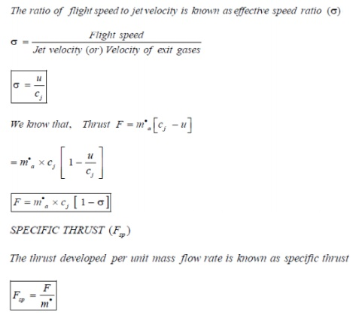
Thrust Specific Fuel Consumption (TSFC)
The fuel consumption rate per unit thrust is known as Thrust Specific Fuel Consumption
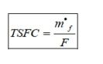
Specific Impulse (I_{sp} )
The thrust developed per unit weight flow rate is known as specific impulse
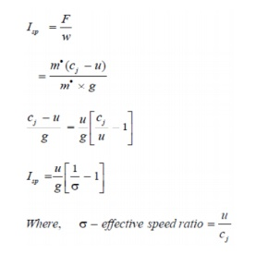
propulsive efficiency:
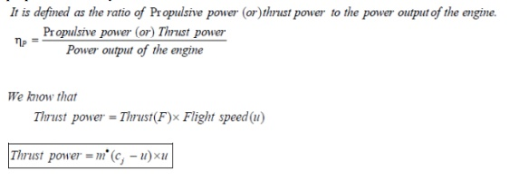
At the outlet of the engine , the power is
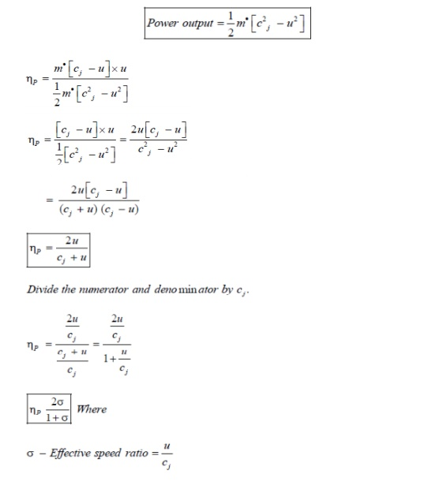
Thermal Efficiency
It is defined as the ratio of power output of the engine to the power input to the engine.
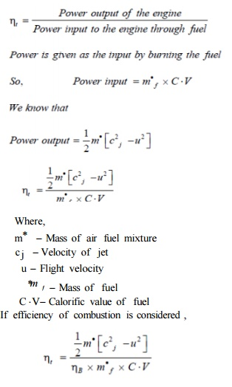
Where,
m Mass of air fuel mixture
c j Velocity of jet
u Flight velocity
fuel
m f Mass of
C V Calorific value of fuel
If efficiency of combustion is considered ,

Overall Efficiency
It is defined as the ratio of propulsive power to the power input to the engine.
