UNIT – 4 Steam Condensers
Elements of a condensing plant, Types of condensers, Comparison of jet and surface condensers, Condenser vacuum, Sources of air leakage & its disadvantages, Vacuum efficiency, Condenser efficiency

- Steam Condenser: It is a device or an appliance in which steam condenses and heat released by steam is absorbed by water.

Elements of a steam condensing plant:

  - Condense: It is a closed vessel is which steam is condensed. The steam gives up heat energy to coolant (which is water) during the process of condensation.

  - Condensate pump: It is a pump, which removes condensate (i.e. condensed steam) from the condenser to the hot well.

  - Hot well: It is a sump between the condenser and boiler, which receives condensate pumped by the condensate pump.

  - Boiler feed pump: It is a pump, which pumps the condensate from the hot well to the , boiler. This is done by increasing the pressure of condensate above the boiler pressure.

  - Air extraction pump: It is a pump which extracts (i.e. removes) air from the condenser.

  - Cooling tower: It is a tower used for cooling the water which is discharged from the condenser.
  - Cooling water pump: It is a pump, which circulates the cooling water through the condenser.
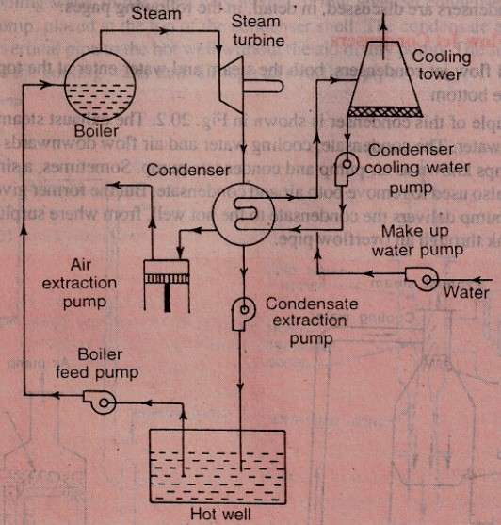

Classification of Condensers

- Jet condensers • Surface condenser

- Jet Condensers: The exhaust steam and water come in direct contact with each other and temperature of the condensate is the same as that of cooling water leaving the condenser. The cooling water is usually sprayed into the exhaust steam to cause, rapid condensation.

- Surface Condensers: The exhaust steam and water do not come into direct contact. The steam passes over the outer surface of tubes through which a supply of cooling water is maintained.

STEAM CONDESERS

Jet Condensers Surface Condensers
Parallel flow Counter flow Ejector flow Down-flow Central-flow Inverted-flow Regenerative Evaporative

- Parallel- Flow Type of Jet Condenser: The exhaust steam and cooling water find their entry at the top of the condenser and then flow downwards and condensate and water are finally collected at the bottom.

- Counter- Flow Type jet Condenser: The steam and cooling water enter the condenser from opposite directions. Generally, the exhaust steam travels in upward direction and meets the cooling water which flows downwards.
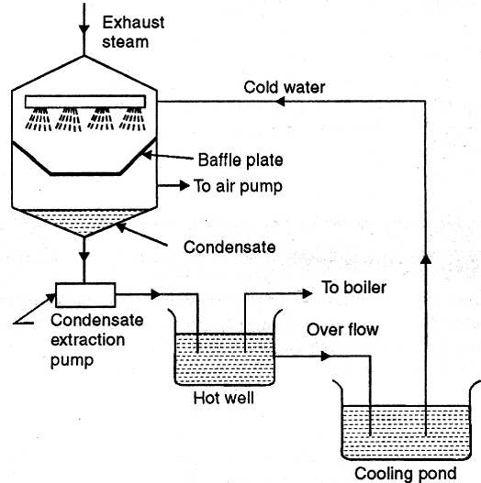
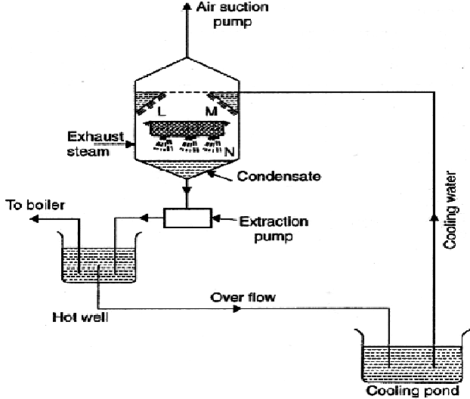
Fig. Parallel flow type condenser Fig. Low level counter flow type condenser

  - Low Level Jet Condenser (Counter-Flow Type Jet Condenser): Figure Shows, L, M and N are the perforated trays which break up water into jets. The steam moving upwards comes in contact with water and gets condensed.

The condensate and water mixture is sent to the hot well by means of an extraction pump and the air is removed by an air suction pump provided at the top of the condenser.

  - High Level Jet Condenser (Counter-Flow Type Jet Condenser): It is also called barometric condenser. In this type the shell is placed at a height about 10.363 meters above hot well and thus the necessity of providing an extraction pump can be obviated. However provision of own injection pump has to be made if water under pressure is not available.

- Ejector Condenser Flow Type Jet Condenser: Here the exhaust steam and cooling water mix in hollow truncated cones. Due to this decreased pressure exhaust steam along with associated air is drawn through the truncated cones and finally lead to diverging cone.

In the diverging cone, a portion of kinetic energy gets converted into pressure energy which is more than the atmospheric so that condensate consisting of condensed steam, cooling water and air is discharged into the hot well. The exhaust steam inlet is provided with a non-return valve which does not allow the water from hot well to rush back to the engine in case a failure of cooling water supply to condenser.

- Down-Flow Type: The cooling water enters the shell at the lower half section and after traveling through the upper half section comes out through the outlet. The exhaust steam entering shell from the top flows down over the tubes and gets condensed and is finally removed by an extraction pump. Due to the fact that steam flows in a direction right angle to the direction of flow of water, it is also called cross-surface condenser.

- Central Flow Type: In this type of condenser, the suction pipe of the air extraction pump is located in the centre of the tubes which results in radial flow of the steam. The better contact between the outer surface of the tubes and steam is ensured; due to large passages the pressure drop of steam is reduced.

- Evaporative Type: The principle of this condenser is that when a limited quantity of water is available, its quantity needed to condense the steam can be reduced by causing the circulating water to evaporate under a small partial pressure.

The exhaust steam enters at the top through gilled pipes. The water pump sprays water on the pipes and descending water condenses the steam. The water which is not evaporated falls into the open tank (cooling pond) under the condenser from which it can be drawn by circulating water pump and used over again.

The evaporative condenser is placed in open air and finds its application in small size plants.

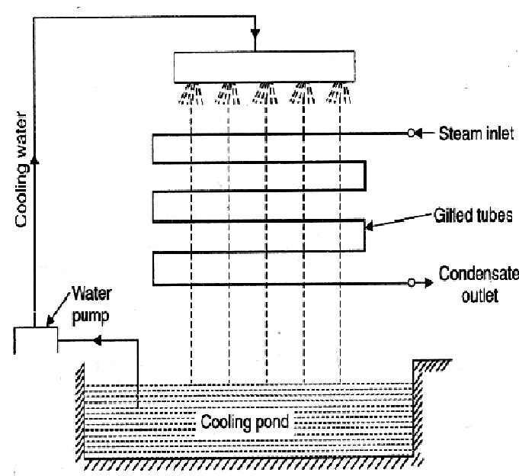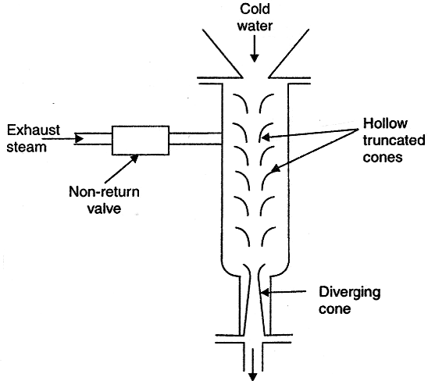
Fig. Evaporative Type Fig. Ejector flow type condenser
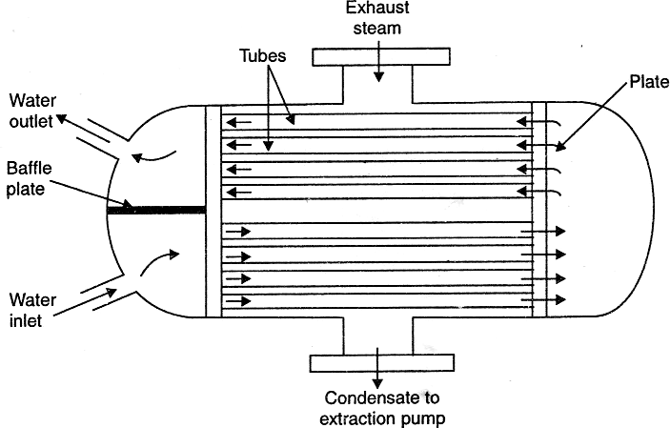
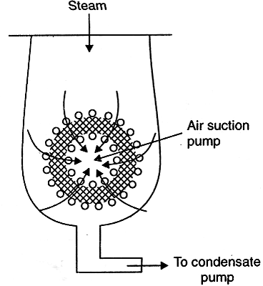
Fig. Down-Flow Type Fig. Central Flow Type

- Inverted Flow Type: This type of condenser has the air suction at the top; the steam after entering at the bottom rises up and then again flows down to the bottom of the condenser, by following a path near the outer surface of the condenser. The condensate extraction pump is at the bottom.

- Regenerative Type: This type is applied to condensers adopting a regenerative method of heating of the condensate. After leaving the tube nest, the condensate is passed through the entering exhaust steam from the steam engine or turbine thus raising the temperature of the condensate, for use as feed water for the boiler.

Comparison Between Jet And Surface Condensers
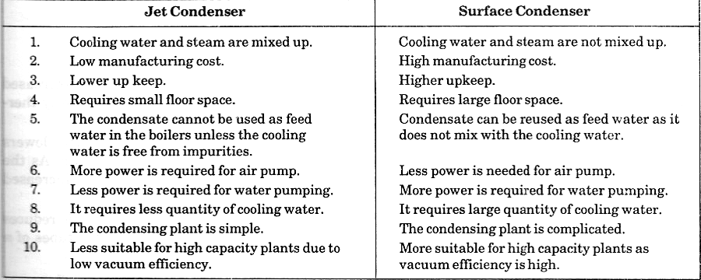

- Mixture of Air and Steam (Dalton's Law of Partial Pressures):

It states "The pressure of the mixture of air and steam is equal to the sum of the pressures, which each constituent would exert, if it occupied the same space by itself" Mathematically, pressure in the condenser containing mixture of air and steam,

Pc=Pa + Ps

Where, Pc = Pressure in condenser Pa = Partial pressure of air and, Ps = Partial pressure of steam

Measurement of Vacuum in a Condenser:

  - Vacuum: The difference between the atmospheric pressure and the absolute pressure.

In the study of condensers, the vacuum is generally converted to correspond with a standard atmospheric pressure, which is taken as the barometric pressure of 760 mm of mercury (Hg). Mathematically, vacuum gauge reading corrected to standard barometer or in other words:

Corrected vacuum in the condenser = 760 - (Barometer reading - Vacuum gauge reading) Note: We know that; Atmospheric pressure = 760 mm of Hg = 1.013 bar
.'. 1 mm of Hg = 1.013/760 = O.00133 bar = 133 N/m2 (. ‘. 1 bar = 105 N/m2)

- Vacuum Efficiency: The minimum absolute pressure (also called ideal pressure) at the steam inlet of a condenser is the pressure corresponding to the temperature of the condensed steam. The corresponding vacuum (called ideal vacuum) is the maximum vacuum that can be obtained in a condensing plant, with no air present at that temperature. The pressure in the actual condenser is greater than the ideal pressure by an amount equal to the pressure of air present in the condenser. The ratio of the actual vacuum to the ideal vacuum is known as vacuum efficiency. Mathematically, vacuum efficiency
η = Actual Vacuum / Ideal Vacuum

Where, η = Vacuum efficiency
Actual vacuum = Barometric pressure - Actual pressure And Ideal vacuum = Barometric pressure - Ideal pressure

Condenser Efficiency

It is defined as the ratio of the difference between the outlet and inlet temperatures of cooling water to the difference between the temperature corresponding to the vacuum in the condenser and inlet temperature of cooling water, i.e.,
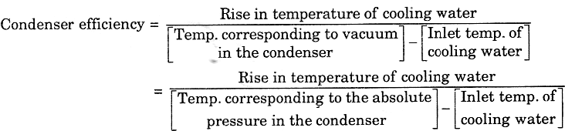

Sources of air into the condensers:

- The dissolved air in the feed water enters into the boiler, which in turn enters into the condenser with the exhaust steam.
- The air leaks into the condenser, through various joints, due to high vacuum pressure in the condenser.
- In case of jet condensers, dissolved air with the injection water enters into the condenser.

Effects of Air Leakage:

- It reduces the vacuum pressure in the condenser.
- Since air is a poor heat conductor, particularly at low densities, it reduces the rate of heat transmission.
- It requires a larger air pump. Moreover, an increased power is required to drive the pump.

Cooling Towers

In a cooling tower water is made to trickle down drop by drop so that it comes in contact with the air moving in the opposite direction. As a result of this some water is evaporated and is taken away with air. In evaporation, the heat is taken away from the bulk of water, which is thus cooled.

Types of Cooling Tower
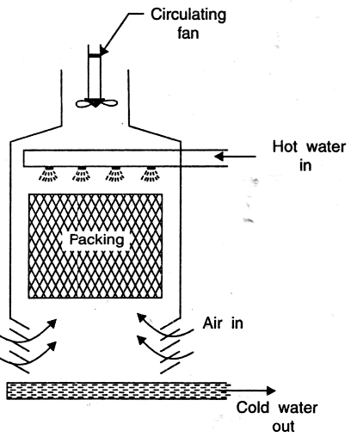
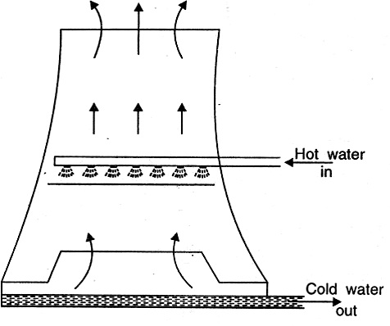
Fig. Natural draught cooling tower Fig. Forced draught cooling tower

Student Notes:

