UNIT 4

MONOSTABLE MULTIVIBRATOR

4.1 MONOSTABLE MULTIVIBRATOR
As the name indicates, a monostable multivibrator has got only one permanent stable state, the other state being quasi stable. Under quiescent conditions, the monostable multivibrator will be in its stable state only. A triggering signal is required to induce a transition from the stable state to the quasi stable state. nce triggered properly the circuit may remain in its quasi stable state for a time which is very long compared with the time of transition between the states, and after that it will return to its original state. No external triggering signal is required to induce this reverse transition. In a monostable multivibrator one coupling element is a resistor and another coupling element is a capacitor.
When triggered, since the circuit returns to its original state by itself after a time T, it is known as a one- shot, a single-step, or a univibrator. Since it generates a rectangular waveform which can be used to gate other circuits, it is also called a gating circuit. Furthermore, since it generates a fast transition at a predetermin6d time T after the input trigger, it is also referred to as a delay circuit. The monostable multivibrator may be a collector-coupled one, or an emitter-coupled one.
THE COLLECTOR COUPLED MONOSTABLE MULTIVIBRATOR
Figure 4.41 shows the circuit diagram of a collector-to-base coupled (simply called collector- coupled) monostable multivibrator using n-p-n transistors. The collector of Q2 is coupled to the base of Qi by a resistor R} (dc coupling) and the collector of Qt is coupled to the base of Q2 by a capacitor C (ac coupling). Ci is the commutating capacitor introduced to increase the speed of operation. The base of Qi is connected to -VBB through a resistor R2, to ensure that Q! is cut off under quiescent conditions. The

base of Q2 is connected to VCc through R to ensure that Q2 is ON under quiescent conditions. In fact, R
may be returned to even a small positive voltage but connecting it to Vcc is advantageous.
The circuit parameters are selected such that under quiescent conditions, the monostable multivibrator finds itself in its permanent stable state with Q2ON (i.e. in saturation) and Q! OFF (i.e. in cut-off)- The multivibrator may be induced to make a transition out of its stable state by the application of a negative trigger at the base of Q2 or at the collector of Q|. Since the triggering signal is applied to only one device and not to both the devices simultaneously, unsymmetrical triggering is employed.
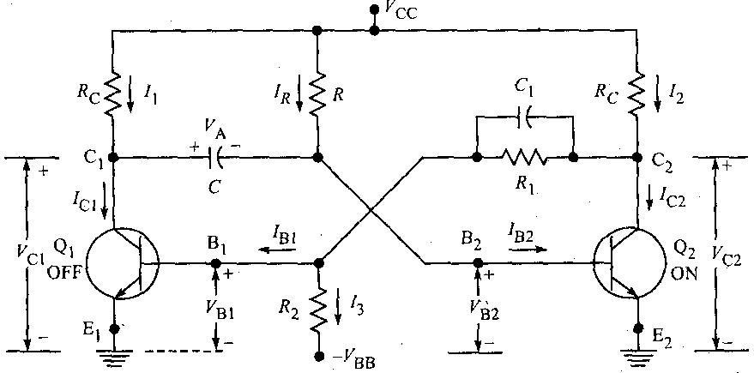
When a negative signal is applied at the base of Q2 at t ~ 0, due to regenerative action Q2 goes to OFF state and Qi goes to ON state. When Q, is ON, a current /i flows through its Rc and hence its collector voltage drops suddenly by I\RC This drop will be instantaneously

Figure 4.41 Circuit diagram of a collector-coupled monostable multivibrator.
transmitted through the coupling capacitor C to the base of Q2. So at t = 0+, the base voltage of Q2 is
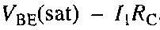
The circuit cannot remain in this state for a long time (it stays in this state only for a finite time T) because when Qt conducts, the coupling capacitor C charges from Vcc through the conducting transistor Qi and
hence the potential at the base of Q2 rises exponentially with a time constant 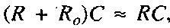 where R0 is the conducting transistor output impedance including the resistance Rc. When it passes the
cut-in voltage Vy of Q2 (at a time t = T), a regenerative action takes place turning Q| OFF and eventually returning the multivibrator to its initial stable state.
The transition from the stable state to the quasi-stable state takes place at t = 0, and the reverse transition
from the quasi-stable state to the stable state takes place at t = T. The time T for which the circuit is in its quasi-stable state is also referred to as the delay time, and also as the gate width, pulse width, or pulse duration. The delay time may be varied by varying the time constant t(= RC).

Expression for the gate width T of a monostable multivibrator neglecting the reverse saturation current /CBO
Figure 4.42(a) shows the waveform at the base of transistor Q2 of the monostable multivibrator shown in Figure 4.41.
For t < 0, Q2 is ON and so vB2 = VBE(sat). At t = 0, a negative signal applied brings Q2 to OFF state and Q[ into saturation. A current /| flows through Rc of Qt and hence vci drops abruptly by /|7? c volts and so vB2 also drops by I\RC instantaneously. So at t - 0, vB2 = VBE(sat) - I}RC. For t > 0, the capacitor charges with a time constant RC, and hence the base voltage of Q2 rises exponentially towards VCc with the same
time constant. At t = T, when this base voltage rises to the cut-in voltage level Vy of the transistor, Q2 goes to ON state, and Qj to OFF state and the pulse ends.

In the interval 0 < t < 7", the base voltage of Q2, i.e. vB2 is given by
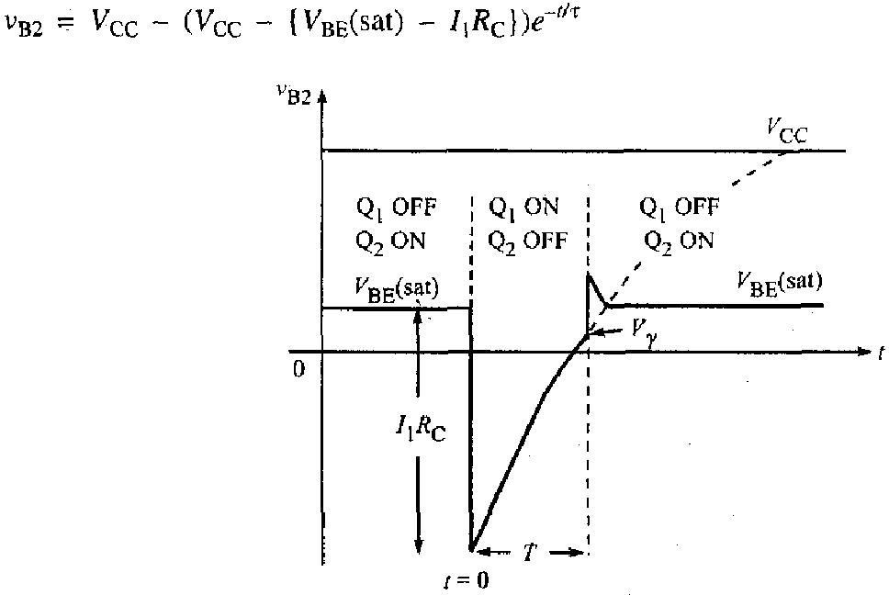
Figure 4.42(a) Voltage variation at the base of Q2 during the quasi-stable state (neglecting /cuoX

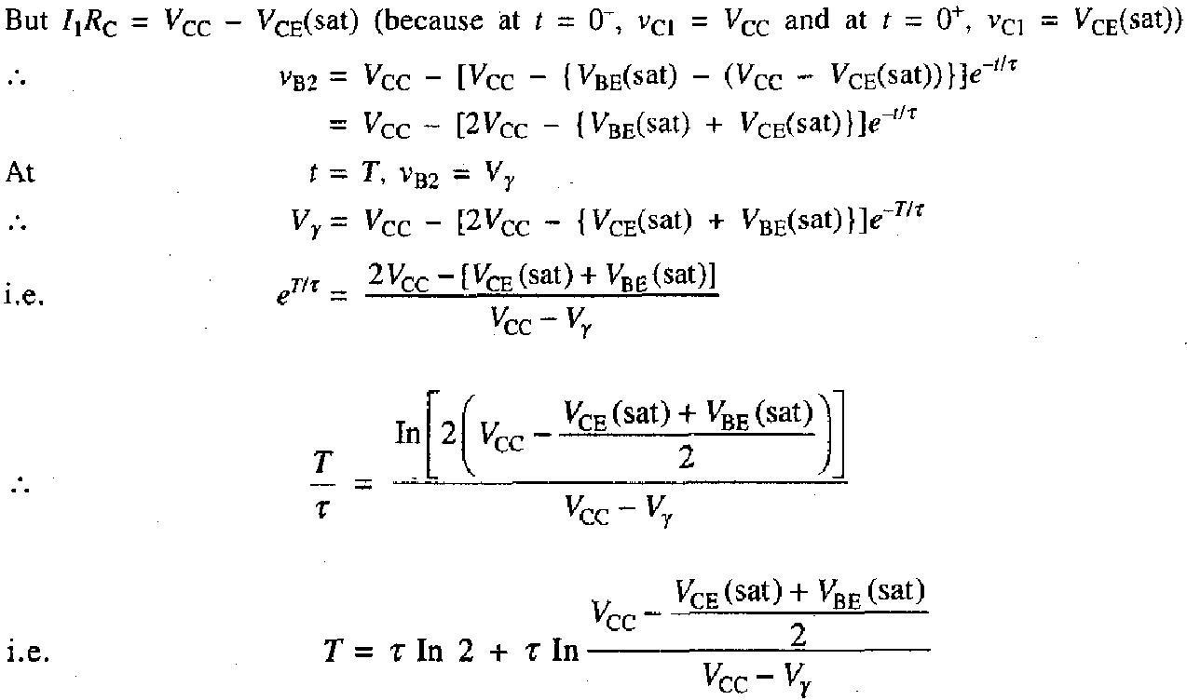

Normally for a transistor, at room temperature, the cut-in voltage is the average of the saturation junction

voltages for either Ge or Si transistors, i.e. 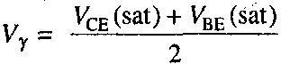
Neglecting the second term in the expression for T
but for a transistor in saturation Ra « R.
Gate width, T = 0.693KC
The larger the Vcc is, compared to the saturation junction voltages, the more accura the result is.
The gate width can be made very stable (almost independent of transistor characteristic supply voltages, and resistance values) if Ql is driven into saturation during the quasi-stab state.
Expression for the gate width of a monostable multivibrator considering th
reverse saturation current /CBO
In the derivation of the expression for gate width T above, we neglected the effect of tt reverse saturation current /CBO on the gate width T. In fact, as the temperature increases, tt reverse saturation current increases and the gate width decreases.
In the quasi-stable state when Q2 is OFF, /CBO flows out of its base through R to th supply Vcc. Hence
the base of Q2 will be not at Vcc but at Vcc + /CBO^> ^ C *s disconnect from the junction of the base of Q2 with the resistor R. It therefore appears that the capacitt C in effect charges through R from a source Vcc + /CBO^- See Figure 4.42(b).

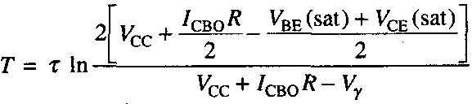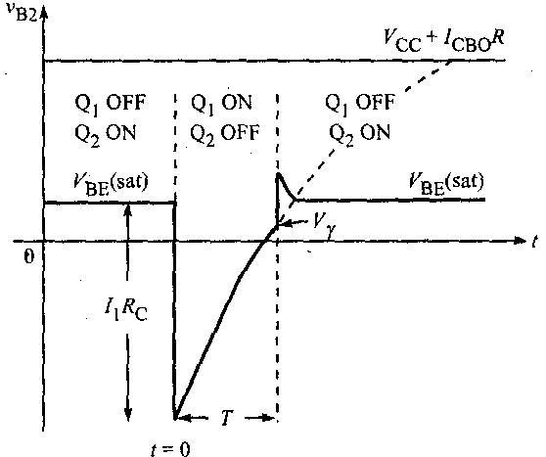

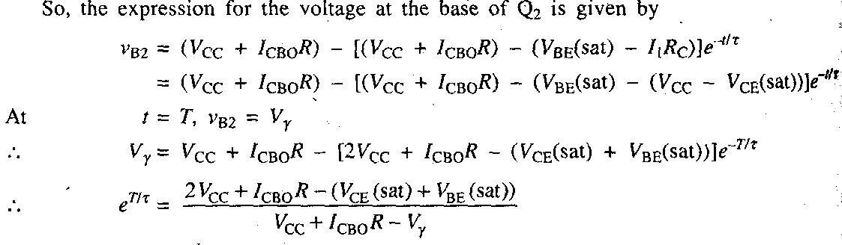
Figure 4.42(b) Voltage variation at the base of Q2 during the quasirstable state (considering
Neglecting the junction voltages and the cut-in voltage of the transistor,
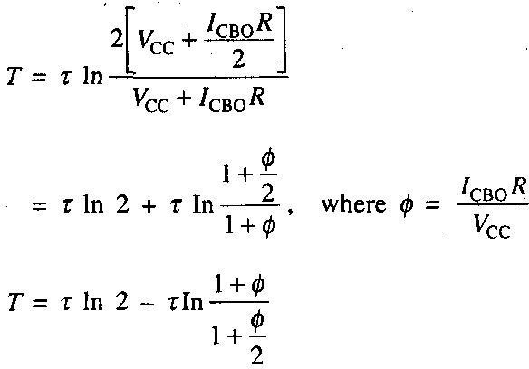
Since /_{C}BO increases with temperature, we can conclude that the delay time T decreases as temperature increases.
Waveforms of the collector-coupled monostable multivibrator
The waveforms at the collectors and bases of both the transistors Q] and Q2 of the monostable multivibrator of Figure 4.41 are shown in Figure 4.44.

The triggering signal is applied at t = 0, and the reverse transition occurs at t = T.

The stable state. For t < 0, the monostable circuit is in its stable state with Q2 ON and Q, OFF. Since Q2 is ON, the^ase voltage of Q2 is vB2 = VBE2(sat) and the collector voltage of Q2 is vC2 = VCE2(sat). Since Q, is OFF, there is no current in Rc of Q! and its base voltage must be negative. Hence the voltage at the collector of Q| is, vC1 = VCC
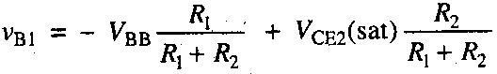
and the voltage at the base of Q] using the superposition theorem is
The quasi-stable state. A negative triggering signal applied at t = 0 brings Q2 to OFF state and Qi to ON state.
A current /, flows in tfc of Q]. So, the collector voltage of Qj drops suddenly by I}RC volts. Since the
voltage across the coupling capacitor C cannot change instantaneously, the voltage at the base of Q2 also drops by /itfc, where I{RC = Vcc -VcE2(sat)- Since Qi is ON,
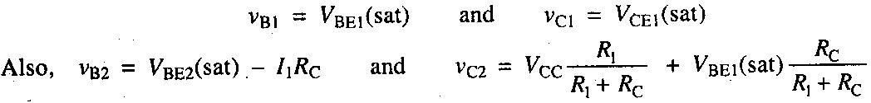
In the interval 0 < t < T, the voltages VGI, VBI and Vc2 remain constant at their values at f = 0, but the voltage at the base of. Q2, i.e. vB2 rises exponentially towards Vcc with a time constant, t - RC, until at t
= T, vB2 reaches the cut-in voltage Vx of the transistor.
Waveforms for t > T. At / = 7*1", reverse transition -takes place. Q2 conducts and Qi is cut-off. The collector voltage of Q2 and the base voltage of Qi return to their voltage levels for / < 0. The voltage vcl
now rises abruptly since Qt is OFF. This increase in voltage is transmitted to the base of Q2 and drives Q2 heavily into saturation. Hence an overshoot develops in vB2 at t = 7**", which decays as the capacitor recharges because of the base current. The magnitude of the base current may be calculated as follows. Replace the input circuit of Q2 by the base spreading resistance rBB in series with the voltage VsE(sat) as
shown in Figure 4.43. Let 7B be the base current at t = 1*. The current in R may be neglected compared to /'B.
From Figure 4.43,

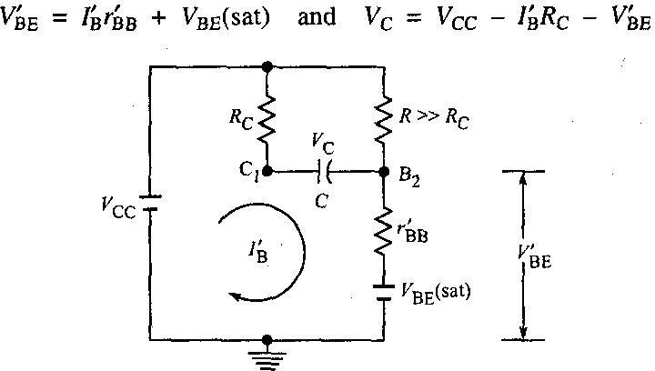

Figure 4.43 Equivalent circuit for calculating the overshoot at base 62 of Q3.
The jumps in voltages at B2 and C| are, respectively, given by
Since C] and B2 are connected by a capacitor C and since the voltage across the capacitts cannot change instantaneously, these two discontinuous voltage changes 5 and 5' must bl equal.
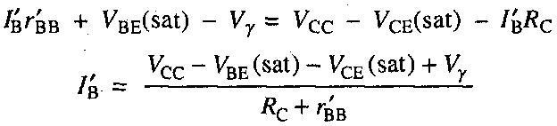
Equating them,
vB2 and vcl decay to their steady-state values with a time constant 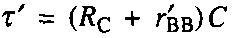
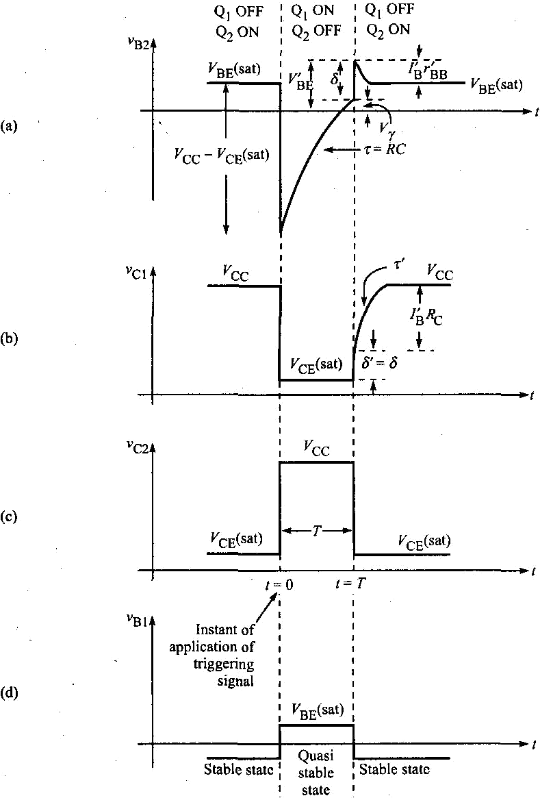

Figure 4.44 Waveforms at the collectors and bases of the collector-coupled monostable multivibrator. (a) at the base of Q2, (b) at the collector of Qt, (c) at the collector of Q2, and (d) at the base o
4.2 ASTABLE MULTIVIBRATOR
As the name indicates an astable multivibrator is a multivibrator with no permanent stable state. Both of its states are quasi stable only. It cannot remain in any one of its states indefinitely and keeps on oscillating between its two quasi stable states the moment it is connected to the supply. It remains in each of its two quasi stable states for only a short designed interval of time and then goes to the other quasi stable state. No triggering signal is required. Both the coupling elements are capacitors (ac coupling) and hence both the states are quasi stable. It is a free running multivibrator. It generates square waves. It is used as a master oscillator.
There are two types of astable multivibrators:
- Collector-coupled astable multivibrator
- Emitter-coupled astable multivibrator
THE COLLECTOR-COUPLED ASTABLE MULTIVIBRATOR
Figure 4.53 shows the circuit diagram of a collector-coupled astable multivibrator using n-p-n transistors. The collectors of both the transistors Qj and Q2 are connected to the bases
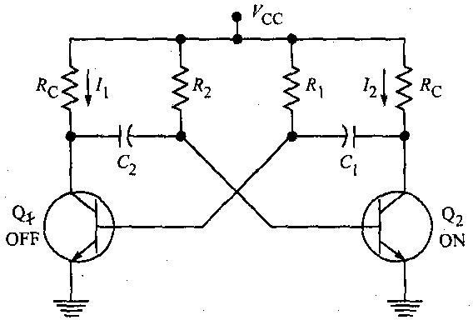

Figure 4.53 A collector-coupled astable multivibrator.
of the other transistors through the coupling capacitors Cs and C2. Since both are ac couplings, neither transistor can remain permanently at cut-off. Instead, the circuit has two quasi-stable states, and it makes periodic transitions between these states. Hence it is used as a master oscillator. No triggering signal is required for this multivibrator. The component values are selected such that, the moment it is connected to the supply, due to supply transients one transistor will go into saturation and the other into cut-off, and also due to capacitive couplings it keeps on-oscillating between its two quasi stable states.
The waveforms at the bases and collectors for the astable multivibrator, are shown in Figure 4.54. Let us say at t = 0, Q2 goes to ON state and Q] to OFF state. So, for t < 0, Q2 was OFF and Qi was ON. Hence

for t < 0, vB2 is negative, vC2 = Vcc, VB! = VBE(sat) and vcj = VCE(sat). The capacitor C2 charges from Vcc through R2 and vB2 rises exponentially towards V cc. At t = 0, vB2 reaches the cut-in voltage Vy and Q2 conducts. As Q2 conducts, its collector voltage Vc2 drops by /2/?c - ^cc ~ VcE(saO- This drop in vc2 is
transmitted to the base of Qj through the coupling capacitor C2 and hence vB1 also falls by /2/?c- Qi goes to OFF state. So, VB] = VBE(sat) - /2tfc, and its collector voltage vcl rises towards VCc- This rise in vc] is coupled through the coupling capacitor C2 to the base of Q2, causing an overshoot § in vB2 and the abrupt rise by the same amount 8 in VCL as shown in Figure 4.51(c). Now since Q2 is ON, C\ charges from Vcc through Rlt and hence VB] rises exponentially. At t = 7"], when VB! rises to VY, Qi conducts and due to regenerative action Qi goes into saturation and Q2 to cut-off. Now, for t > T\, the coupling capacitor C2 charges from Vcc through R2 and at / = 7", + 7"2, when vB2 rises to the cut-in voltage Vr, Q2
conducts and due to regenerative feedback Q2 goes to ON state and Q| to OFF state. The cycle of events repeats and the circuit keeps on oscillating between its two quasi-stable states. Hence the output is a square wave. It is called a square wave generator or square wave oscillator or relaxation oscillator. It is a free running oscillator.
Expression for the frequency of oscillation of an astable multivibrator
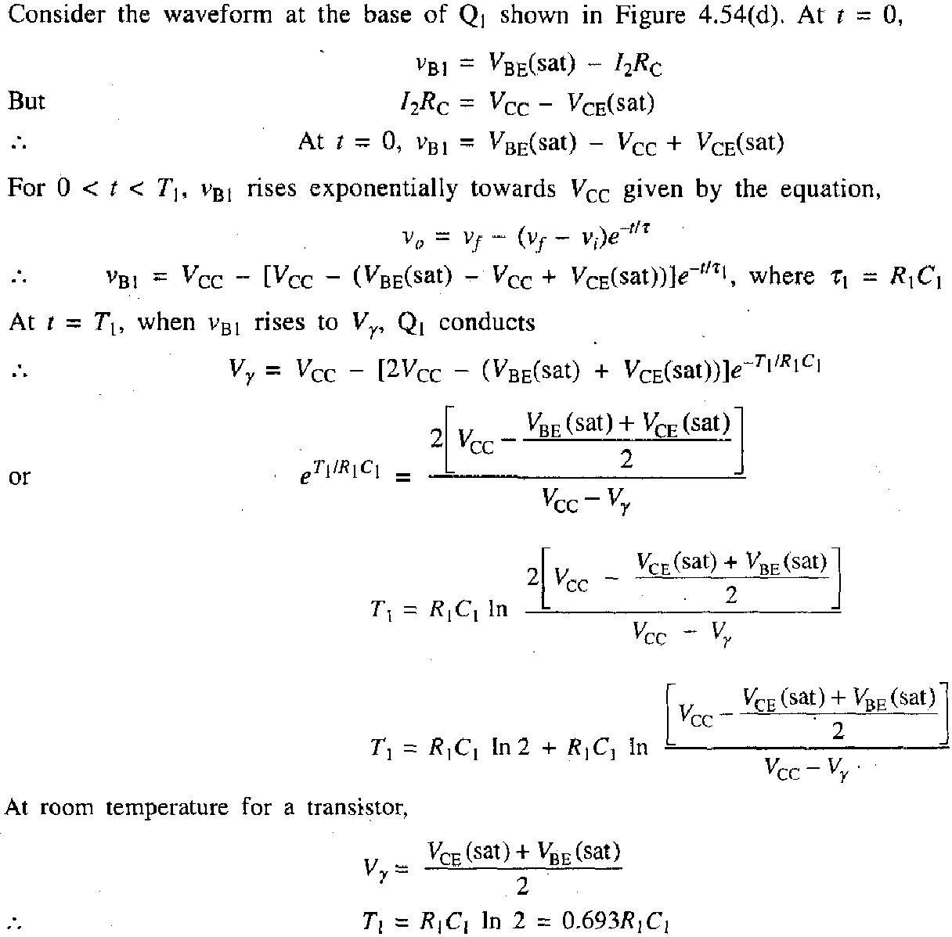

On similar lines considering the waveform of Figure 4.54(b), we can show that the time T2 for which Q2 is
OFF and Qj is ON is given by The period of the waveform, The frequency of oscillation,
If R{ = R2 = R, and Cs = C2 = C, then TI = T2 = 772

The frequency of oscillation may be varied over the range from cycles to mega cycles by varying RC. It is also possible to vary the frequency electrically by connecting R\ and R2 to an auxiliary voltage source V (the collector supply remains +VCC) and then varying this voltage V.
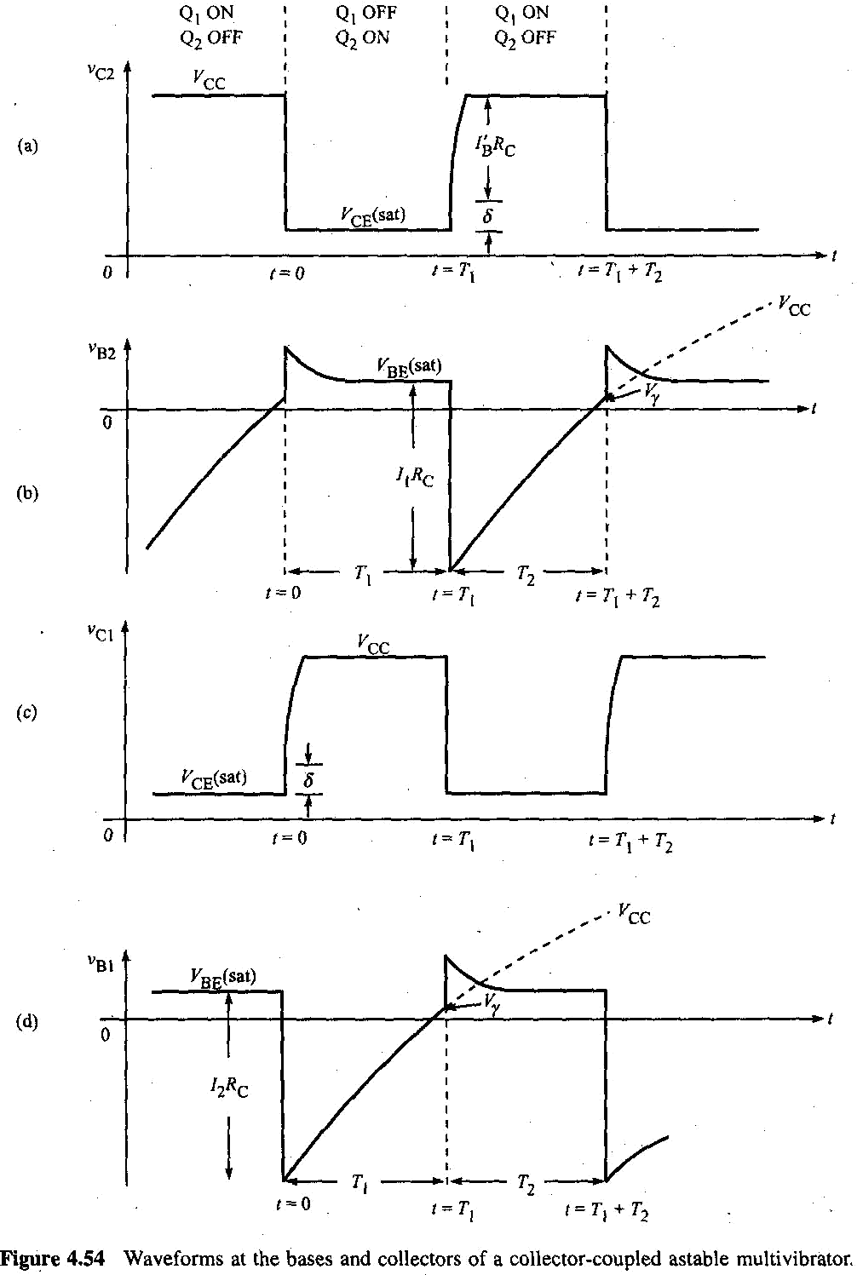

4.3 THE EMITTER-COUPLED ASTABLE MULTIVIBRATOR
An emitter-coupled astable multivibrator may be obtained by using three power supplies or a single power supply.
Figure 4.63 shows the circuit diagram of a free-running emitter coupled multivibrator using n-p-n transistors. Figure 4.64 shows its waveforms. Three power supplies are indicated for the sake of simplifying the analysis. A more practical circuit using a single supply is indicated in Figure 4.65. Let us assume that the circuit operates in such a manner that Qi switches between cut-off and saturation and
Q2 switches between cut-off and its active region.

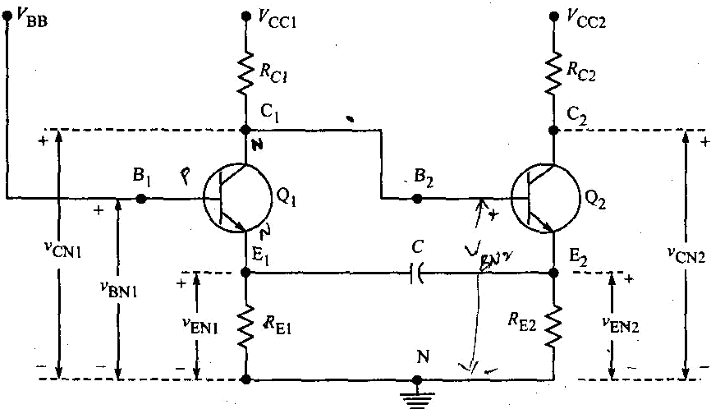
Figure 4.63 The astable emitter-coupled multivibrator.
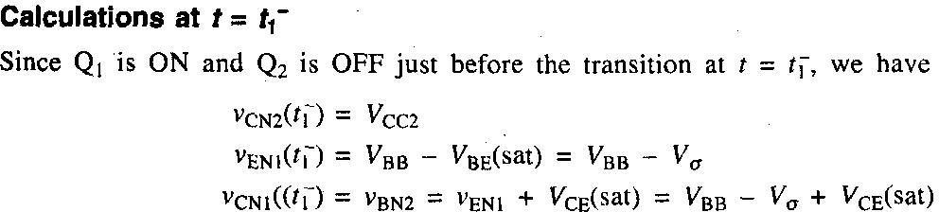
During the interval preceding t = t\, the capacitor C charges from a fixed voltage ^BB ~ V0 through the resistor RE2. All circuit voltages remain constant except vEN2, which falls asymptotically towards zero.
The transistor Q2 will begin to conduct when vEN2 falls to
Calculations at f = tf
When Q2 conducts, vEN2 and vEN1 rise. As vENi rises, Q] comes out of saturation and vCN1 (= vBN2) also increases, causing a further increase in the current in Q2. Because of this regenerative action, Qi is driven OFF and Q2 is driven into its active region where its base-to-emitter voltage is VBE2, its base current is /B2 and its collector current is /C2. From Figure 4.64, we see that after transition, at t = rf.

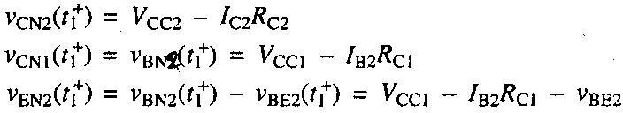

At t\ there is an abrupt change Vp in vEN2.
Because of the capacitive coupling between emitters there must also be the same discontinuity VD
in VENI. Hence,
Neglecting junction voltages and /B2^ci compared with VCCi
The period
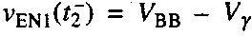
The interval T\ when Q2 conducts and Qi is OFF ends at t = t2- The transistor Qt will turn ON when the base-to-emitter voltage reaches the cut-in value Vy or when VENi reaches the voltage

Since the base voltage of Qi is fixed, then to carry the transistor from the cut-in point to
saturation the emitter must drop. However this drop S is small, since S = Va~ Vr= 0.2 V. Because the emitters are capacitively coupled there will be an identical jump S in vEN2, After / = t2, in the interval T2, conditions are the same as they were for t < t\.
Therefore, the cycle of events described above is repeated and the circuit behaves as
an astable multivibrator.
From Figure 4.64(a), we see that the voltage VENI starts at V\ at t = t\ and falls to
*^BB - Vj,at f = t2. Since this decay is exponential with a time constant #E|C and approaches zero asymptotically,

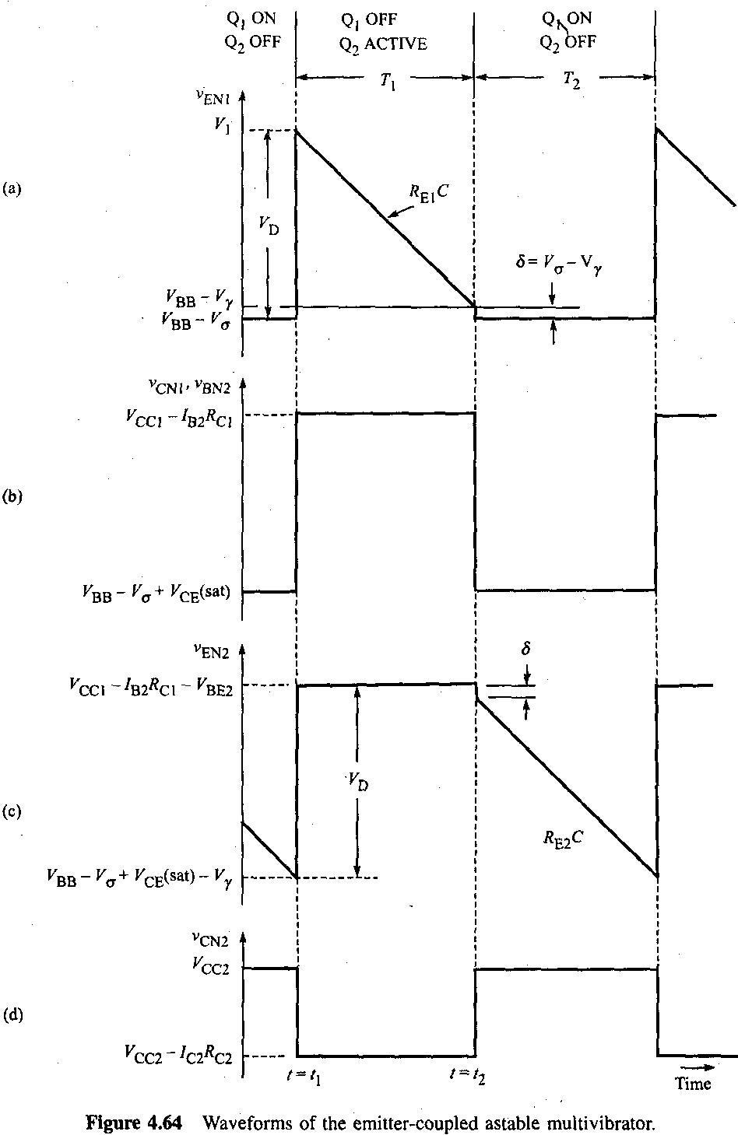

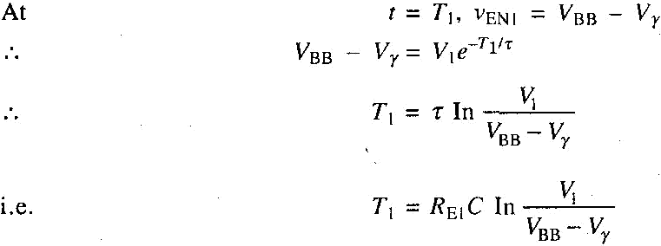
Assuming that the supply voltages are large compared with the junction voltages and assuming also that
/B2^Ei « ^ccb we find 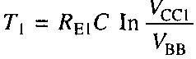
Subject to the same approximations, T2 is given by 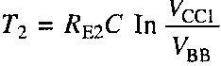

If VCC| and VBB are arranged to be proportional to one another, then the frequency is independent of the supply voltages.
When QJ is OFF, its collector-to-ground voltage is approximately VCC1 and equals the base-to-ground voltage of Q2. Since it is desired that Q2 be in its active region, then VBN2 should be less than VCN2 or VCC[
< VCC2. Since Qj is to be driven into saturation, then its base voltage may be almost as large as its collector supply voltage. However, to avoid driving Q\ too deeply into saturation it is better to arrange that VBB < VCC1, A circuit which uses a single supply and which satisfies the requirements that VBB be
proportional to Vca and that VBB < VCC1 < VCC2 is shown in Figure 4.65. Since C' is a bypass capacitor intended to maintain VBB constant, it is not involved in the operation of the circuit. We assume that /?! and RI are small enough so that the voltage VBB at the junction of R} and R2 remains normally constant
during the entire cycle of operations of the multivibrator. Using Thevenin's theorem we see that the
circuit of Figure 4.65 is of the same form as that of Figure 4.63 with VCc2 ~ ^cc a°d with
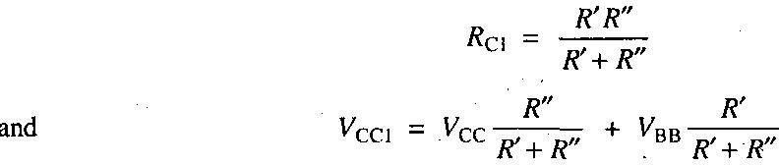
The advantages and disadvantages of the emitter-coupled astable multivibrator over the collector-coupled astable multivibrator are given below:
Advantages
- It is inherently self-starting.
- The collector of Q2 where the output is taken may be loaded heavily even capacitively.
- The output is free of recovery transients.
- Because it has an isolated input at the base of Qi, synchronization is convenient.
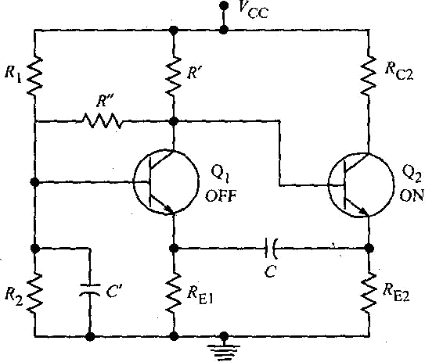
- Frequency adjustment is convenient because only one capacitor is used.

Disadvantages
Figure 4.65 The emitter-coupled multivibrator.

- This circuit is more difficult to adjust for proper operating conditions.
- This circuit cannot be operated with T\ and T2 widely different.
- This circuit uses more components than does the collector-coupled circuit.

