UNIT –III

SWITCHING CHARACTERISTICS OF DEVICES
---------------------------------------------------------------------------------------

3.1JUNCTION DIODE—SWITCHING TIMES

Diode forward recovery time
When a diode is driven from the: reverse-biased condition to the forward-biased condition or in the opposite direction, the diode response is accompanied by a transient, and an interval of time elapses before the diode recovers to its steady state. The nature of the forward recovery transient depends on the magnitude of the current being driven through the diode and the rise time of the driving signal.
Consider the voltage which develops across the diode when the input is a current source
supplying a step current Iv as shown in Figure 3,1 (a). If the current amplitude is comparable to or larger than the diode rated current, and if the rise time of the current step is small enough, then the waveform of the voltage which appears across the diode is shown in Figure 3.1(b). The overshoot results from the fact that initially the diode acts not as a p-n junction diffusion device but as a resistor, tn the steady-state condition, the current which flows through the diode is a diffusion current which results from the gradient in the density of minority carriers. If the current is large enough, then there will also be an ohmic drop across the diode. The ohmic drop is initially very large, for immediately after the application of the current, the holes, say, will npn have time to diffuse very far into the n-side in order to build up a minority carrier density. Therefore except near the junction, there will be no minority charge to establish a density gradient, and the current flow through the mechanism of diffusion will not be possible. Indeed, an electric field will be required to achieve current flow by exerting force on the majority carriers. This electric field gives rise to the ohmic drop. With the passage of time, however, the ohmic drop will decrease as more and more minority carriers become available from the junction, and current by diffusion takes over.

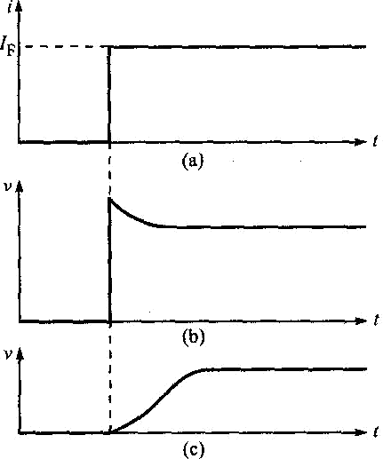
Figure 3.1(aj Input step current to a diode, (b) diode voltage when the current is large, arid
(c) diode voltage when the current is small.
The magnitude of the overshoot will increase as the magnitude of the input current increases. At large current amplitudes, the diode behaves as a combination of a resistor and an inductor. At low currents the diode is representable by a parallel resistor-capacitor combination. At intermediate currents, the diode behaves as a resistor, inductor, and capacitor circuit and oscillations may be produced.
The forward recovery time ffr, for a specified rise time of the input current is the time difference between the 10% point of the diode voltage and the time when this voltage reaches and remains within 10% of its final value. The forward recovery time does not usually
constitute a serious problem.

Diode reverse recovery time
When an external voltage is impressed across a junction in the direction that reverse biases it, very little current called the reverse saturation current flows. This current is because of the minority carriers.
The density of minority carriers in the neighbourhood of the junction in the steady state is shown in Figure 3.2(a). Here the levels pnl) and n are the thermal equilibrium values of the minority carrier densities on the two sides of the junction in the absence of an externally
impressed voltage. When a reverse voltage is applied, the density of minority carriers is shown
by the solid Sines marked pn and np. Away from the junction, the minority carrier density remains unaltered, but as these carriers approach the junction they are rapidly swept across and the density of minority carriers diminishes to zero at the junction. The reverse saturation current which flows is small because the density of thermally generated minority carriers is very small.

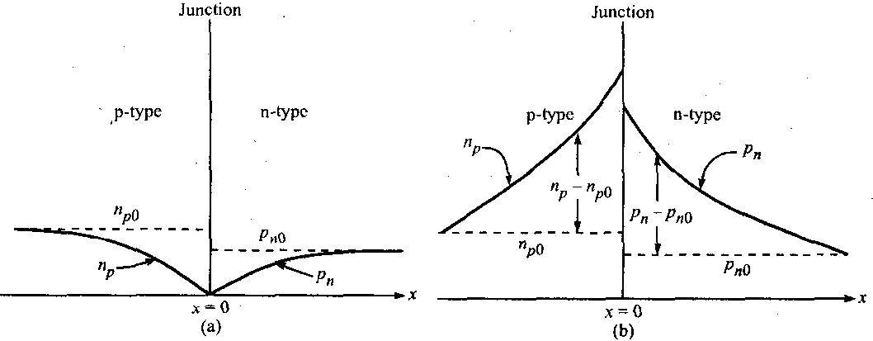
Figure 3.2 Minority-carrier density distribution as a function of the distance x from a junction;
(a) a reverse-biased junction and (b) a forward-biased junction.
When the external voltage forward biases the junction, the steady-state density of minority carriers is as shown in Figure 3.2(b). The injected or excess hole density is (pn - pnQ) and the excess electron density is (np - npQ).
In a diode circuit which has been carrying current in the forward direction, if the external voltage
is suddenly reversed, the diode current will not immediately fall to its steady-state reverse value. The current cannot attain its steady-state value until the minority carrier distribution changes the form in Figure 3.2(b) to the distribution shown in Figure 3.2(a). Until such time as the injected
or excess minority carrier density pn - pnQ (or np -np0) drops nominally to zero, the diode will continue to conduct easily and the current will be determined by the external resistance in the diode circuit.

Storage and transition times
The sequence of events which occurs when a conducting diode is reverse biased is shown in Figure 3.3. The input voltage shown in Figure 3.3(b) is applied to a diode circuit shown in
Figure 3.3(a). Up to t = t\, v, = Vf. The resistance RL is assumed large so that the drop across RL
is large compared with the drop across the diode.
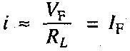
At the time t ~ t[, the input voltage reverses abruptly to the value V; = - VR, the current reverses,
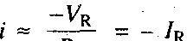 until the time t - t2. At t ~ t^ as shown in Figure 3.3(c), the injected minority carrier density at the junction drops to zero, that is, the minority carrier density reaches its equilibrium state.
If the diode ohmic resistance is RA, then at time t\, the diode voltage falls slightly by [(VF + VR)] but does not reverse as shown in Figure 3.3(e). At t = ?2 when the excess minority carriers in the immediate neighbourhood of the junction have been swept back across the junction, the diode

voltage begins to reverse as shown in Figure 3.3(e) and the magnitude of the diode current begins to decrease as shown in Figure 3.3(d). The interval from t\ to t2 for the minority charge to become zero is called the storage time ts. The time which elapses between r2 and the time when the diode has
nominally recovered is called the transition time tt. The recovery interval will be completed when the minority carriers which are at some distance from the junction have diffused to the junction, crossed it and then, in addition, the junction transition capacitance across the reverse-biased junction has
charged through RL to the voltage -VR as shown in Figure 3.3(e).
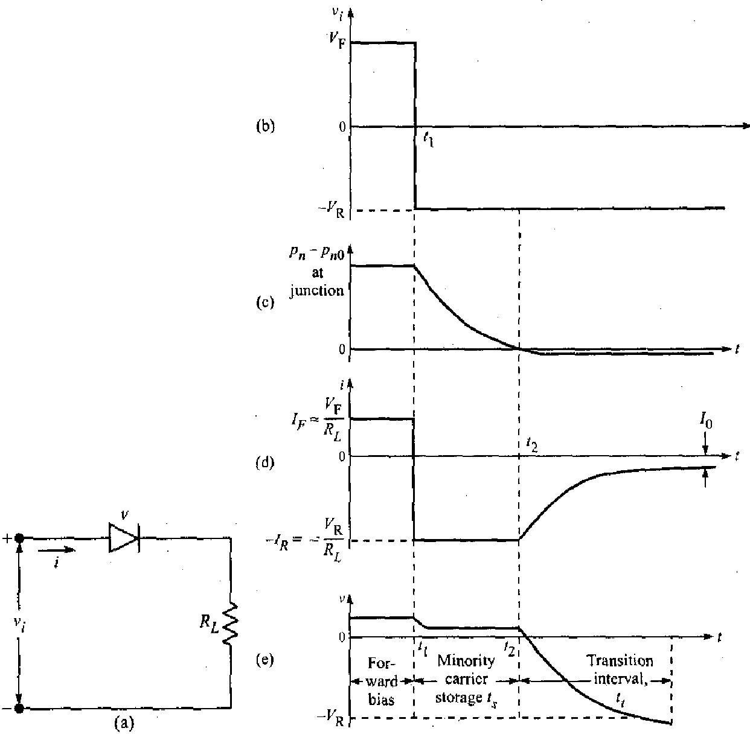
Figure 3.3 The waveform in (b) is applied to the diode circuit in (a), (c) the excess carrier density at the junction, (d) the diode current, and (e) the diode voltage.

3.2PIECE-WISE LINEAR DIODE CHARACTERISTICS
A large-signal approximation which often leads to a sufficiently accurate engineering solution is the piece-wise linear representation. The piece-wise linear approximation for a
semiconductor diode characteristic is shown in Figure 3.4. The breakdown is at Vy, which is

called the offset or threshold voltage. The diode behaves like an open-circuit if v < Vr The characteristic shows a constant incremental resistance r =dvldi if v > Vr Here r is called the forward resistance. The static resistance Rf = Vγ is not constant and is not useful.
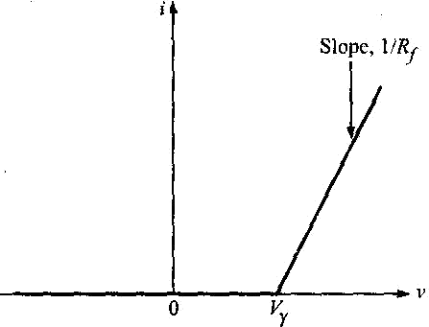

Figure 3.4 The piece-wise linear characteristic of a diode.
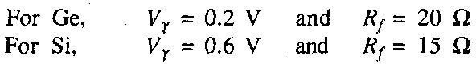
The numerical values of Vy and Rf to be used depend upon the type of diode and the contemplated voltage and current swings. Typically: For current swings from cut-off to 10 mA

For current swings up to 50 mA
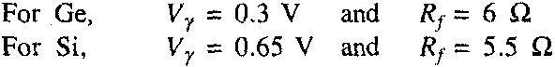
3.3TRANSISTOR AS A SWITCH
A transistor can be used as a switch. It has three regions of operation. When both emitter^ base and collector-base junctions are reverse biased, the transistor operates in the cut-o! region and it acts as an open switch. When the emitter base junction is forward biased and the collector base junction is reverse biased, it operates in the active region and acts as auf amplifier. When both the emitter-base and collector-base junctions are forward biased, it! operates in the saturation region and acts as a closed switch. When the transistor is switched! from cut-off to saturation and from saturation to cut-off with negligible active region, thej transistor is operated as a switch. When the transistor is in saturation, junction voltages are'i very small but the operating currents are large. When the transistor is in cut-off, the currents* are zero (except small leakage current) but the junction voltages are large.
In Figure 3.6 the transistor Q can be used to connect and disconnect the load RL from the source Vcc When Q is saturated it is like a closed switch from collector to emitter and when Q is cut- off it is like an open switch from collector to emitter.

Referring to the output characteristics shown in Figure 3.6(b), the region below the IB =
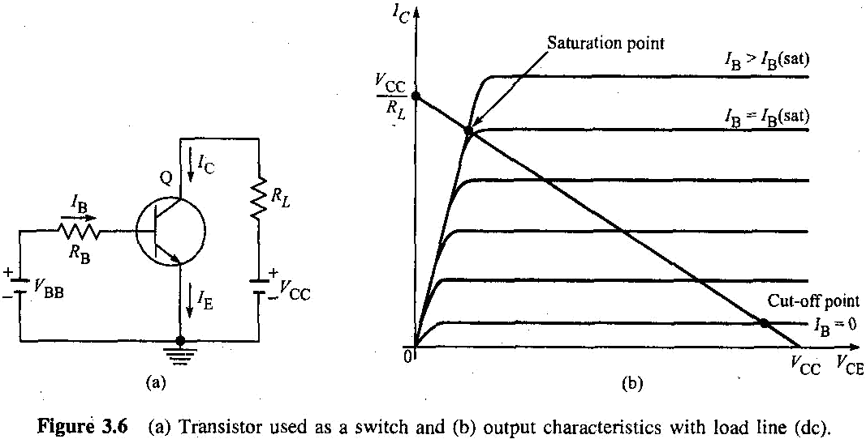
0 curve is the cut-off region. The intersection of the load line with IB = 0 curve is the cut-off point. At this point, the base current is zero and the collector current is negligible. The emitter diode comes out of forward bias and the normal transistor action is lost, i.e, VCE(cut-off) = Vcc. The transistor appears like an open switch.

The intersection of the load line with the IB - Ie(sat) curve is called the saturation point. At this
point, the base current is IB(sat) and the collector current is maximum. 'At saturation, the collector diode comes out of cut-off and again the normal transistor action is lost, i.e. Ic(sat) = Vcc/RL.Ie(sat) represents the minimum base current required to bring the transistor into
saturation. For 0 < IB < IB(sat), the transistor operates in the active region. If the base current is
greater than IB(sat), the collector current approximately equals VCC/IC and the transistor appears like a closed switch.

3.4 TRANSISTOR SWITCHING TIMES
When the transistor acts as a switch, it is either in cut-off or in saturation. To consider the behaviour of the transistor as it makes transition from one state to the other, consider the circuit shown in Figure 3,7(a) driven by the pulse waveform shown in Figure 3.7(b). The pulse
waveform makes transitions between the voltage levels V2 and V1. At V2 the transistor is at cut- off and at V the transistor is in saturation. The input waveform v; is applied between the base and the emitter through a resistor RB.

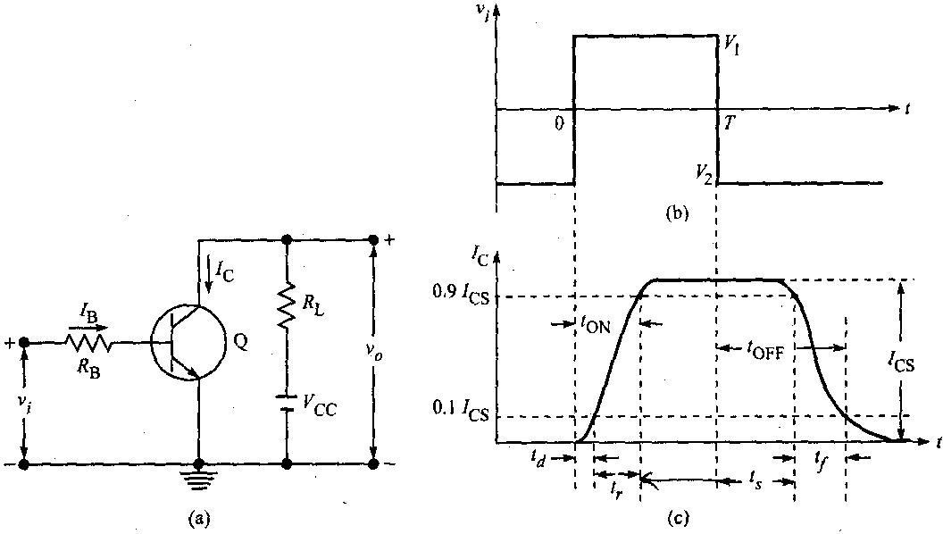
Figure 3.7 (a) Transistor as a switch, (b) input waveform, and (c) the response of collector current versus time.
The response of the collector current ic to the input waveform, together with its time relationship to the waveform is shown in Figure 3.7(c), The collector current does not immediately respond to the input signal. Instead there is a delay, and the time that elapses during this delay, together with the time required for the current to rise to 10% of its maximum
(saturation) value (ICs = Vcc/Rc) is called the delay time td. The current waveform has a nonzero rise time fr, which is the rise time required for the current to rise from 10% to 90% of Ics- The total turn-on time TON is the sum of the delay time and the rise time, i.e. TON = td + tr.
When the input signal returns to its initial state, the collector current again fails to respond
immediately. The interval which elapses between the transition of the input waveform and the time when /c has dropped to 90% of /Cs is called the storage time ts. The storage interval is followed by the fall time ly, which is the time required for 7C to fall from 90% to 10% of Ics-
The turn-off time ^OFF is defined as the sum of the storage and fall times, i.e. TOFF = tr + tf We shall now consider the physical reasons for the existence of each of these times.

The delay time
There are three factors that contribute to the delay time. First there is a delay which results from the fact that, when the driving signal is applied to the transistor input, a non-zero time is required to charge up the junction capacitance so that the transistor may be brought, from cut-off to the active region. Second, even when the transistor has been brought to the point where minority carriers have begun to cross the emitter junction into the base, a nonzero time is required before these carriers can cross the base region to the collector junction and be recorded as collector current. Finally, a nonzero time is required before the collector current can rise to

10% of its maximum value. Rise time and fall time The rise time and fall time are due to the fact that, if a base current step is used to saturate the transistor or to return it from saturation into cut- off, the collector current must traverse the active region. The collector current increases or decreases along an exponential curve. Storage time The failure of the transistor to respond to the
trailing edge of the driving pulse for the time interval ts, results from the fact that a transistor in saturation has a saturation charge of excess minority carriers stored in the base. The transistor cannot respond until the saturation excess charge has been removed.

3.5 MULTIVIBRATORS
Multi means many; vibrator means oscillator. A circuit which can oscillate at a number of frequencies is called a multivibrator. Basically there are three types of multivibrators:
- Bistable multivibrator
- Monostable multivibrator
- Astable multivibrator
Each of these multivibrators has two states. As the names indicate, a bistable multivibrator has got two stable states, a monostable multivibrator has got only one stable state (the other state being quasi stable) and the astable multivibrator has got no stable state (both the states being quasi stable). The stable state of a multivibrator is the state in which the device can stay permanently. Only when a proper external triggering signal is applied, it will change its state. Quasi stable state means temporarily stable state. The device cannot stay permanently in this state. After a predetermined time, the device will automatically come out of the quasi stable state.
In this chapter we will discuss multivibrators with two-stage regenerative amplifiers. They have two cross-coupled inverters, i.e. the output of the first stage is coupled to the input of the second stage and the output of the second stage is coupled to the input of the first stage. In bistable circuits both the coupling elements are resistors (i.e. both are dc couplings). In monostable circuits, one coupling element is a capacitor (ac coupling) and the other coupling element is a resistor (dc coupling) In astable multivibrators both the coupling elements are capacitors (i.e. both are ac couplings).
A bistable multivibrator requires a triggering signal to change from one stable state to another. It requires another triggering signal for the reverse transition. A monostable multivibrator requires a triggering signal to change from the stable state to the quasi stable state but no triggering signal is required for the reverse transition, i.e. to bring it from the quasi stable state to the stable state. The astable multivibrator does not require any triggering signal at all. It

keeps changing from one quasi stable state to another quasi stable state on its own the moment it is connected to the supply.
A bistable multivibrator is the basic memory element. It is used to perform many digital operations such as counting and storing of binary data. It also finds extensive applications in the generation and processing of pulse type waveforms. The monostable multivibrator finds extensive applications in pulse circuits. Mostly it is used as a gating circuit or a delay circuit. The astable circuit is used as a master oscillator to generate square waves. It is often a basic source of fast waveforms. It is a free running oscillator. It is called a square wave generator. It is also termed a relaxation oscillator.

3.6 BISTABLE MULTIVIBRATOR
A bistable multivibrator is a multivibrator which can exist indefinitely in either of its two stable states and which can be induced to make an abrupt transition from one state to the other by means of external excitation. In a bistable multivibrator both the coupling elements are resistors (dc coupling). The bistable multivibrator is also called a multi, Eccles-Jordan circuit (after its inventors), trigger circuit, scale-of-two toggle circuit, flip-flop, and binary. There are two types of bistable multivibrators:
- Collector coupled bistable multivibrator
- Emitter coupled bistable multivibrator
There are two types of collector-coupled bistable multivibrators:
- Fixed-bias bistable multivibrator
- Self-bias bistable multivibrator
A FIXED-BIAS BISTABLE MULTIVIBRATOR
Figure 4.1 shows the circuit diagram of a fixed-bias bistable multivibrator using transistors (inverters). Note, that the output of each amplifier is direct coupled to the input of the
other amplifier. In one of the stable states, transistor Q[ is ON (i.e. in saturation) and Q2 is OFF
(i.e. in cut-off), and in the other stable state Qj is OFF and Q2 is ON. Even though the circuit is symmetrical, it is not possible for the circuit to remain in a stable state with both the transistors conducting (i.e. both operating in the active region) simultaneously and carrying equal currents. The reason is that if we assume that both the transistors are biased equally and are carrying equal
currents /[ and 72 and suppose there is a minute fluctuation in the current 1\~—let us say it increases by a small amount—then the voltage at the collector of Qi decreases. This will result in a decrease in voltage at the base of Q2. So Q2 conducts less and /2 decreases and hence the

potential at the collector of Q2 increases. This results in an increase in the base potential of Qi. So, Qi conducts still more and /[ is further increased and the potential at the collector of Qt is further reduced, and so on. So, the current I\ keeps on increasing and the current /2 keeps on
decreasing till Q( goes into saturation and Q2 goes into cut-off. This action takes place because of the regenerative feedback incorporated into the circuit and will occur only if the loop gain is greater than one.A stable state of a binary is one in which the voltages and currents satisfy the Kirchhoff's laws and are consistent with the device characteristics and in which, in addition, the
condition of the loop gain being less than unity is satisfied.
The condition with respect to loop gain will certainly be satisfied, if either of the two devices is below cut-off or if either device is in saturation. But normally the circuit is designed such that in a stable state one transistor is in saturation and the other one is ir cut-off, because if one transistor is biased to be in cut-off and the other one to be in active region, as the temperature changes or the devices age and the device parameters vary, the quiescent point changes and the quiescent output voltage may also change appreciably Sometimes the drift may be so much that the device operating in the active region may gc into cut-off, and with both the devices in cut-off the circuit will be useless.

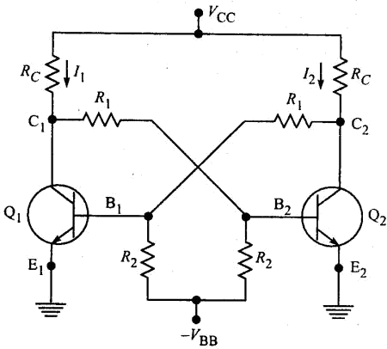

Selection of components in the fixed-bias bistable multivibrator
In the fixed-bias binary shown in Figure 4.1., nearly the full supply voltage Vcc will appear across the transistor that is OFF. Since this supply voltage Vcc is to be reasonably smaller
than the collector breakdown voltage SVce. Vcc *s restricted to a maximum of a few tens of
volts. Under saturation conditions the collector current Ic is maximum. Hence RC must be chosen so that this value of 7C (= VCC/^G) does not exceed the maximum permissible limit. The

values of R\, /?2 and VBB must be selected such that in one stat>le state the base current is large enough to drive the transistor into saturation whereas in the second stable state the emitter junction must be below cut-off. The signal at a collector called the output swing Vw is the
change in collector voltage resulting from a transistor going from one state to the other, i.e. Vw
= VCi - ^C2- If the loading caused by RI can be neglected, then the collector voltage of the OFF transistor is Vcc. Since the collector saturation voltage is few tenths of a volt, then the swing Vw
= Vcc, independently of RQ- The component values, the supply voltages and the values of /CBO,
h^, VBE(sat), and VCE(sat) are sufficient for the analysis of transistor binary circuits.

Loading
The bistable multivibrator may be used to drive other circuits and hence at one or both the collectors there are shunting loads, which are not shown in Figure 4.1. These loads reduce the
magnitude of the collector voltage VC1 of the OFF transistor. This will result in reduction of the
output voltage swing. A reduced VC[ will decrease 7B2 and it is possible that Q2 may not be driven into saturation- Hence the flip-flop circuit components must be chosen such that under the heaviest load, which the binary drives, one- transistor remains in saturation while the other is in
cut-off. Since the resistor Rl also loads the OFF transistor, to reduce loading, the value of R]
should be as large as possible compared to the value of Rc. But to ensure a loop gain in excess of unity during the transition between the states, R^ should be selected such that For some applications, the loading varies with the operation being performed. In such cases, the extent to which a transistor is driven into saturation is variable. A constant output swing V\v = V, arid a
constant base saturation current IB2 can be obtained by clamping the collectors to an auxiliary
voltage V < Vcc through the diodes DI and D2 as indicated in Figure 4.2. As Qi cuts OFF, its collector voltage rises and when it reaches V, the "collector catching diode" D| conducts and clamps the output to V.

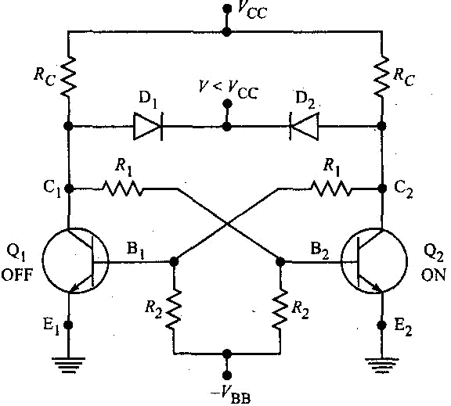

Transistor as an ON-OFF switch
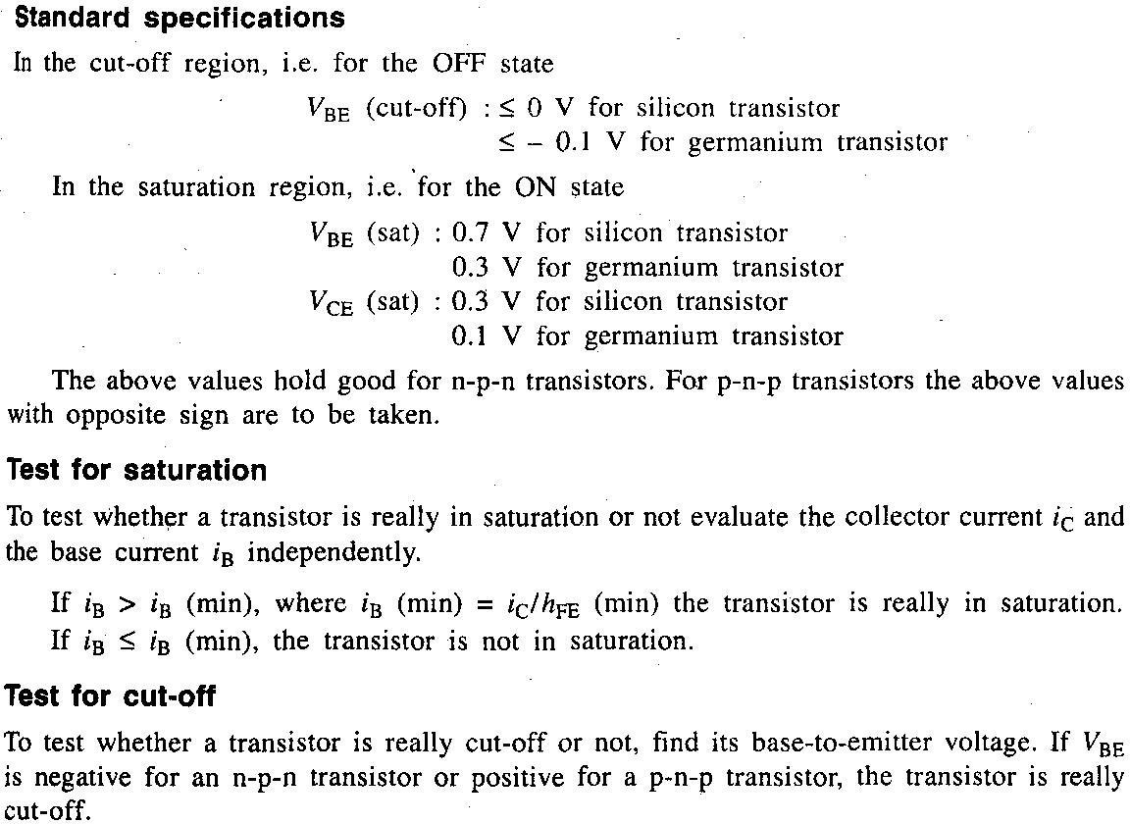
In digital circuits transistors operate either in the cut-off region or in the saturation region. Specially designed transistors called switching transistors with negligible active region are used. In the cut-off region the transistor does not conduct and acts as a open switch. In the saturation region the transistor conducts heavily and acts as a closed switch-In a binary which uses two cross-coupled transistors, each of the transistors is alternately cut-off and driven into saturation. Because of regenerative feedback provided both the transistors cannot be.ON or both cannot be OFF simultaneously. When one transistor is ON, the other is OFF and vice versa.

3.7 THE EMITTER-COUPLED BINARY (THE SCHMITT TRIGGER CIRCUIT)

Figure 4.29 shows the circuit diagram of an emitter-coupled bistable multivibrator using n-p-n transistors. Quite commonly it is called Schmin trigger after the inventor of its vacuum-tube version. It differs from the basic collector-coupled binary in that the coupling from the output of the second stage to the input of the first stage is missing and the feedback is obtained now through a
common emitter resistor RE. It is a bistable circuit and the existence of only two stable states results form the fact that positive feedback is incorporated into the circuit, and from the further fact that the loop gain of the circuit is greater than unity. There are several ways to adjust the loop gain. One way of
adjusting the loop gain is.by varying /?C1. Suppose RC] is selected such that the loop gain is less than unity. When fl cl is small, regeneration is not possible.
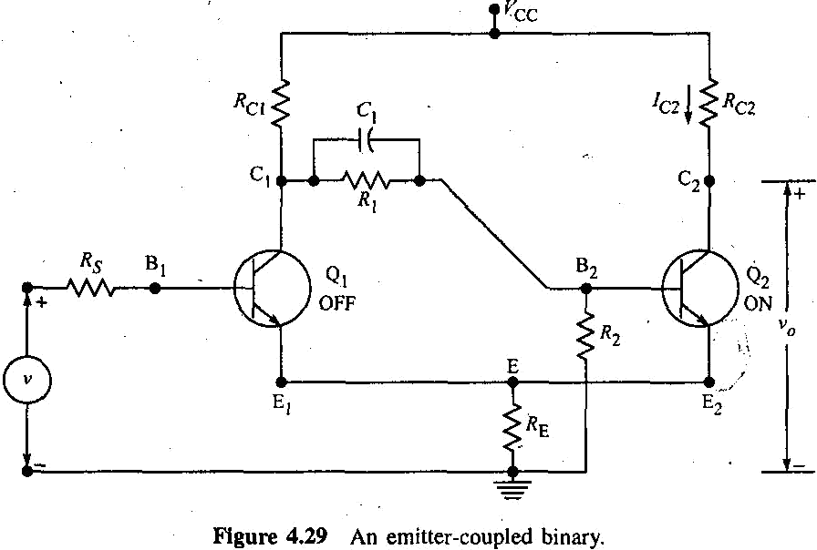
For the circuit of Figure 4.29, under quiescent conditions Qi is OFF and Q2 is ON because it gets the required base drive from VCc through RCi and /?j. So the output voltage

is at its lower level. With Q2 conducting, there will be a voltage drop across RE -7B2)/?E> and this will elevate the emitter of Q\. As the input v is increased from zero, the circuit will not respond until Qi reaches the cut-in point (at v = Vt). Until then the output remains at its lower level. With Oj conducting (for v > V|) the circuit will amplify because Q2 is already conducting and since the gain
Av</Av is positive, the output will rise in response to the rise in input. As v continues to rise, Ct and hence B2 continue to fall and E2 continues to rise. Therefore a value of v will be reached at which Qa is turned OFF. At this point v0 = VCc and the output remains constant at this value of Vcc, even if the input is further increased. A plot of va versus v is shown in Figure 4.30(a) for loop gain < 1.

Suppose the loop gain is increased by increasing the resistance Rci. Such a change will have negligible effect on the cut-in point V| of Qj. However in the region of amplification (i.e. for v > V{) the amplifier gain Av</Av will increase and so the slope of the rising portion of the plot in Figure 4.30(a) will be steeper. This increase in slope with increase in loop gain continues until at a loop gain of unity where the circuit has just become regenerative the slope will become infinite. And finally when the loop gain becomes greater than unity, the- slope becomes negative and the plot of va versus v assumes the S shape shown in Figure 4.30(b).
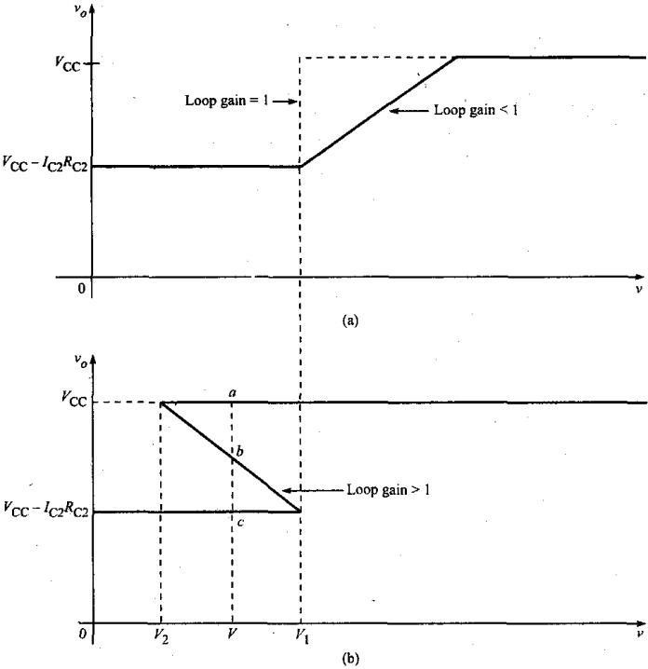
Figure 4.30 Response of emitter-coupled binary for (a) loop gain < 1 and (b) loop gain > 1.
The behaviour of the circuit may be described by using this S curve. As v rises from zero voltage, v0 will remain at its lower level (= VCc ~ 'c2 ^ca) unt*l v reaches V\. (This value of v = V, at which the transistor
Qi just enters into conduction is called the upper triggering point, UTP.) As v exceeds V} the output will make an abrupt .transition to its higher level (= Vcc). For v > Vh Qj is ON and Q2 is OFF. Similarly if v is initially greater than V], then as v is decreased, the output will remain at its upper level until v attains a definite level V2 at which point the circuit makes an abrupt transition to its lower level. For v < ^2> Qi is
OFF and Q2 is ON. (This value of v = V2 at which the transistor Q2 resumes conduction is called the lower triggering point, LTP.) This circuit exhibits hysteresis, that is, to effect a transition in one direction we must first pass beyond the voltage at which the reverse transition took place.
A vertical line drawn at v = V which lies between V2 and Vi intersects the S curve at three points a, b
and c. The upper and lower points a and c are points of stable equilibrium.
The S curve is a plot of values which satisfy Kirchhoff's laws and which are consistent with the transistor characteristics. At v = V, the circuit will be at a or c, depending on the direction of approach of v towards

V. When v = V in the range between V2 and V|, the Schmitt circuit is in one of its two possible stable states and hence is a bistable circuit.
Applications of Schmitt trigger circuit
Schmitt trigger is also a bistable multivibrator. Hence it can be used in applications where a normal binary is used. However for applications where the circuit is to be triggered back-and-forth between stable states, the normal binary is preferred because of its symmetry. Since the base of Q] is not involved in regenerative switching, the Schmitt trigger is preferred for applications in which the advantage of this free terminal can be taken. The resistance KC2 m me output circuit of Q2 is not required for the operation of the binary. Hence this resistance may be selected over a wide range to obtain different output signal amplitudes.
A most important application of the Schmitt trigger is its use as an amplitude comparator to mark the instant at which an arbitrary waveform attains a particular reference level. As input v rises to Vi or falls to V2, the circuit makes a fast regenerative transfer to its other state.
Another important application of the Schmitt trigger is as a squaring circuit. It can convert a sine wave into a square wave. In fact, any slowly varying input waveform can be converted into a square wave with faster leading and trailing edges as shown in Figure 4.31, if the input has large enough excursions to
carry the input beyond the limits of the hysteresis range, VH = V\ - V2.
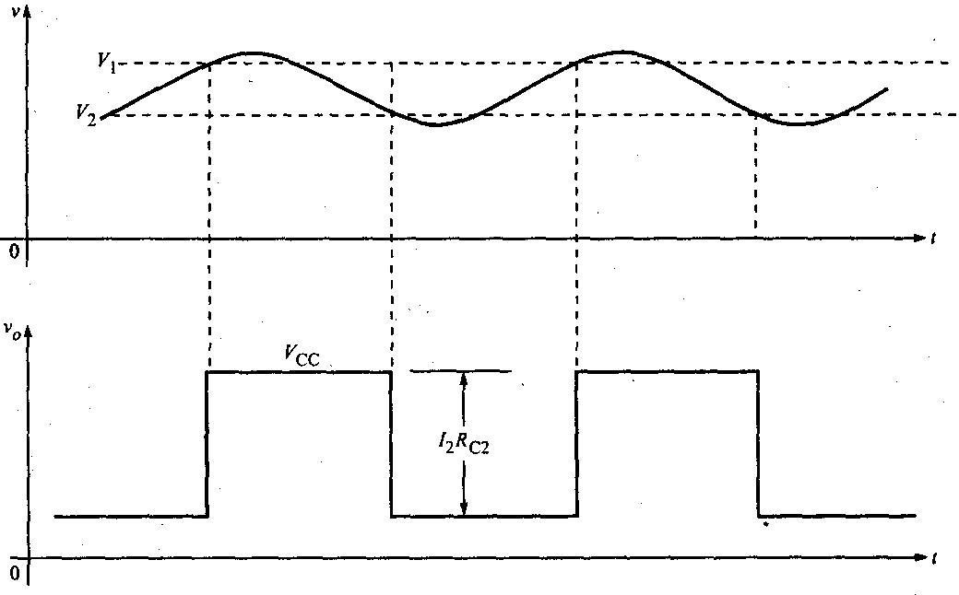
Figure 4.31 Response of the emitter-coupled binary to an arbitrary input waveform.
In another important application, the Schmitt trigger circuit is triggered between its two stable states by alternate positive and negative pulses. If the input is biased at a voltage V between V2 and V\ and if a
positive pulse of amplitude greater than V\ - V is coupled to the input, then Qj will conduct and Q2 will be OFF. If now a negative pulse of amplitude larger than V - V2 is coupled to the input, the circuit will be triggered back to the state where Qj is OFF and Q2 is ON.
Hysteresis

If the amplitude of the periodic input signal is large compared with the hysteresis range VH, then the hysteresis of the Schmitt trigger is not a matter of concern. In some applications, a large hysteresis range will not allow the circuit to function properly.
Hysteresis may be eliminated by adjusting the loop gain of the circuit to unity. Such an adjustment may be made in a number of ways:
- The loop gain may be increased or decreased by increasing or decreasing the resistance
^ci-
- The loop gain may be increased or decreased by adding a resistance /?E1 in series
with the emitter of Qi, or by adding a resistance 7?^ in series with the emitter of Q2 and then decreasing or increasing REl and RE2. Since /?C1 and RE] are in series with Qi, these resistors will have no effect on the circuit when Qi is OFF. Therefore, these resistors will not change V\ but may be used to move V2 closer to or coincident with V\. Similarly, RE2 will affect V\ but not V2.
- The loop gain may also be varied by varying the ratio R[/(Ri + /?2). Such an adjustment will change both V\ and V2.
- The loop gain may be increased by increasing the value of R$.
If /?E1 or RE2 is larger than the value required to give zero hysteresis, then the gain will be less than unity and the circuit will not change state. So, usually RE\ or /?E2 is chosen so that a small amount of hysteresis remains in order to ensure that the loop gain is greater than unity.
Vi is independent of Rs but V2 depends on R$ and increases with an increase in the value of Rs. So for a large value of Rs it is possible for V2 to be equal to V\, Hysteresis is thus eliminated and the gain is unity.
If Rs exceeds this critical value, the loop gain falls below unity and the circuit cannot bs triggered. If Rs
is too small, the speed of operation of the circuit is reduced.
Derivation of expression for UTP
The upper triggering point UTP is defined as the input voltage Vl at which the transistor Qi just enters into conduction. To calculate Vb we have to first find the current in Q2 when Q! just enters into conduction. For this we have to find the Thevenin's equivalent voltage V and the Thevenin's equivalent resistance tfB at the base of Q2, where
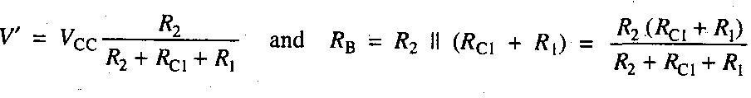
It is possible for Q2 to be in its active region or to be in saturation. Assuming that Q2 is in its active region

In the circuit shown in Figure 4.32, to calculate V\, we replace Vcc, KCI> ^i anc* ^2 of Figure 4.29 by V
and RB at the base of Q2.
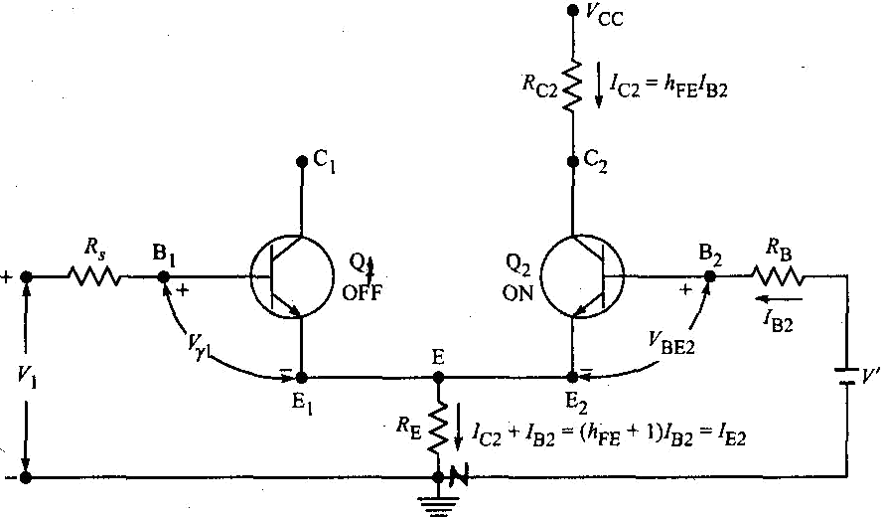
Figure 4.32 The equivalent circuit of Figure 4.29 with Q| just at cut-in.
Writing KVL around the base loop of Q2,
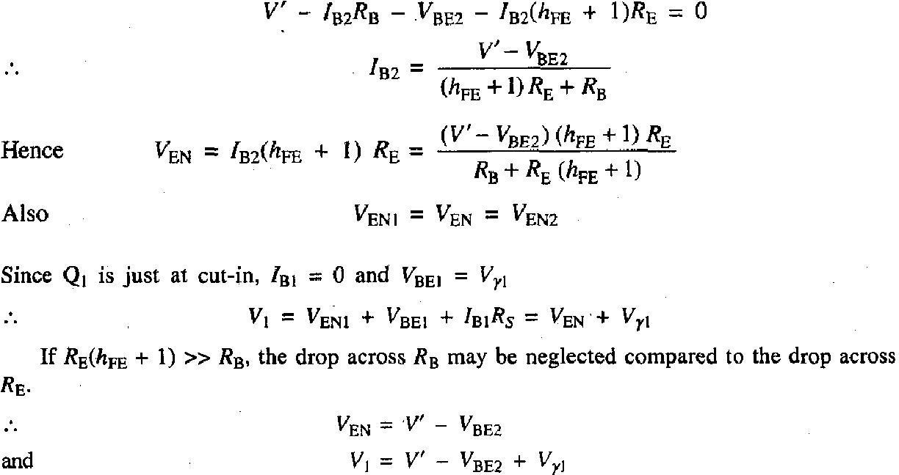

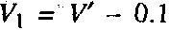
Since VyJ is the voltage from base to emitter at cut-in where the loop gain just exceeds unity, it differs from VBE2 in the active region by only 0.1 V for either Ge or Si.
This indicates that V, may be made almost independent of h^, of the emitter resistance RE, of the temperature and of whether or not a silicon or germanium transistor is used. Hence the discriminator level Vt is stable with transistor replacement, ageing, temperature changes, provided that (/IPE + l)/?E »
RB and that V" » 0.1. Since V depends on Vcc, RCI, R\ and R2, where stability is required it is necessary that a stable supply and stable resistors are selected.
Derivation of expression for LTP

The lower triggering point LTP is defined as the input voltage V2 at which the transistor Q2 resumes conduction. Vi can be calculated from the circuit shown in Figure 4.33 which is obtained by replacing Vcc, J?C1, RI and R2 of Figure 4.29 by Thevenin's equivalent voltage VTH and Thevenin's equivalent resistance R at the collector of Q(, where
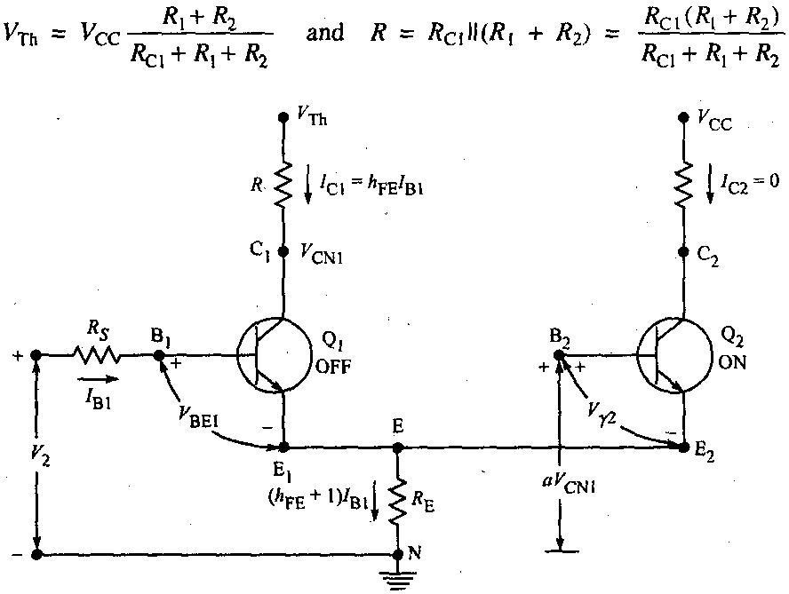

Figure 433 The equivalent circuit of Figure 4.29 when Q2 just resumes conduction.
The voltage ratio from the collector of Qi to the base of Q2 is 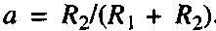 Figure 4.33, the input signal to Qi is decreasing, and when it reaches V2 then Q2 comes out of cut-off.
Writing KVL around the base circuit of Q2,
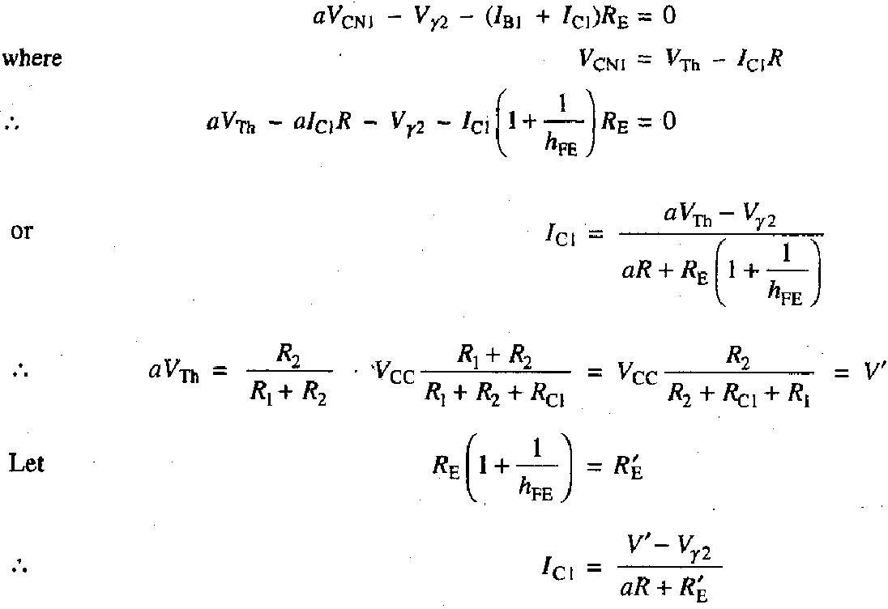

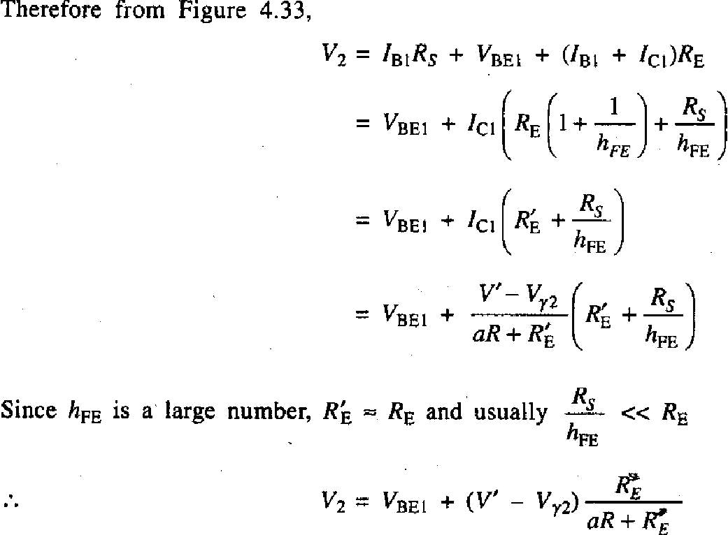

Since VBE| is higher for silicon than germanium, the LTP Va is a few tenths of a volt higher for a Schmitt trigger using silicon transistors than for one using germanium transistors.

