UNIT – I PRECESSION

Introduction
‘Gyre’ is a Greek word, meaning ‘circular motion’ and Gyration means the whirling motion. A gyroscope is a spatial mechanism which is generally employed for the study of precessional motion of a rotary body. Gyroscope finds applications in gyrocompass, used in aircraft, naval ship, control system of missiles and space shuttle. The gyroscopic effect is also felt on the automotive vehicles while negotiating aturn.
A gyroscope consists of a rotor mounted in the inner gimbal. The inner gimbal is mounted in the outer gimbal which itself is mounted on a fixed frame as shown in Fig.. When the rotor spins about X-axis with angular velocity ω rad/s and the inner gimbal precesses (rotates) about Y-axis, the spatial mechanism is forced to turn about Z-axis other than its own axis of rotation, and the gyroscopic effect is thus setup. The resistance to this motion is called gyroscopiceffect.
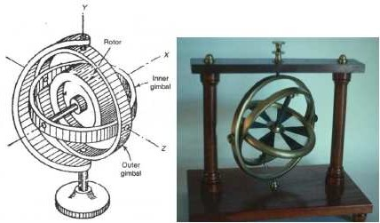

ANGULAR MOTION

A rigid body, (Fig.) spinning at a constant angular velocity ω rad/s about a spin axis through the mass centre. The angular momentum ‘H’ of the spinning body is represented by a vector whose magnitude is ‘Iω’. I represents the mass amount of inertia of the rotor about the axis ofspin.

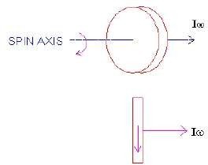

The direction of the angular momentum can be found from the right hand screw rule or the right hand thumb rule. Accordingly, if the fingers of the right hand are bent in the direction of rotation of rotor, then the thumb indicates the direction ofmomentum.

GYROSCOPIC COUPLE

Consider a rotary body of mass m having radius of gyration k mounted on the shaft supported at two bearings. Let the rotor spins (rotates) about X-axis with constant angular velocity ω rad/s. The X-axis is, therefore, called spin axis, Y-axis, precession axis and Z-axis, the couple or torque axis (Fig.).
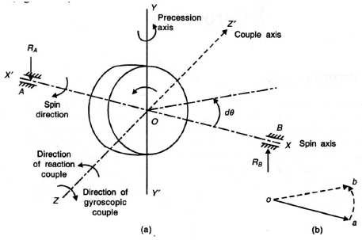
The angular momentum of the rotating mass is given by,

H = mk2 ω = Iω
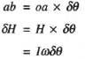
Now, suppose the shaft axis (X-axis) precesses through a small angle δθ about Y-axis in the plane XOZ, then the angular momentum varies from H to H + δH, where δH is the change in the angular momentum, represented by vector ab [Figure 15.2(b)]. For the small value of angle of rotation 50, we can write
However, the rate of change of angular momentum is:
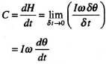

C = Iωωp

Direction of Spin vector, Precession vector and Couple/Torque vector with forced precession
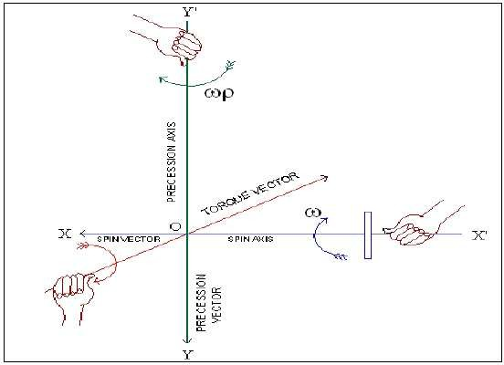
To determine the direction of spin, precession and torque/couple vector, right hand screw rule or right hand rule is used. The fingers represent the rotation of the disc and the thumb shows the direction of the spin, precession and torque vector (Fig.).

The method of determining the direction of couple/torque vector is as follows

Case (i):
Consider a rotor rotating in anticlockwise direction when seen from the right (Fig.5 and Fig. 6), and to precess the spin axis about precession axis in clockwise and anticlockwise direction when seen from top. Then, to determine the active/reactive gyroscopic couple vector, the following procedure isused.
  - Turn the spin vector through 900 in the direction of precession on the XOZplane
  - The turned spin vector will then correspond to the direction of active gyroscopic couple/torquevector
  - The reactive gyroscopic couple/torque vector is taken opposite to active gyro vector direction
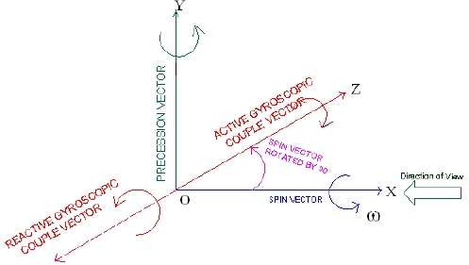
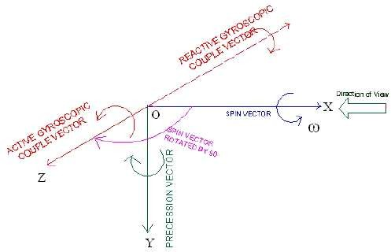

Case (ii):
Consider a rotor rotating in clockwise direction when seen from the right (Fig.7 and Fig. 8), and to precess the spin axis about precession axis in clockwise and anticlockwise direction when seen from top. Then, to determine the active/reactive gyroscopic couplevector,
  - Turn the spin vector through 900 in the direction of precession on the XOZplane
  - The turned spin vector will then correspond to the direction of active gyroscopic couple/torquevector
  - The reactive gyroscopic couple/torque vector is taken opposite to active gyro vector direction
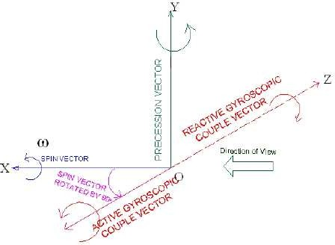

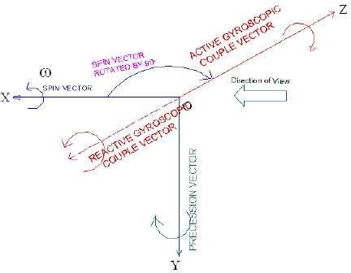

The resisting couple/ reactive couple will act in the direction opposite to that of the gyroscopic couple. This means that, whenever the axis of spin changes its direction, a gyroscopic couple is applied to it through the bearing which supports the spinning axis.

GYROSCOPIC EFFECT ON SHIP
Gyroscope is used for stabilization and directional control of a ship sailing in the rough sea. A ship, while navigating in the rough sea, may experience the following three different types ofmotion:
- Steering—The turning of ship in a curve while movingforward
- Pitching—The movement of the ship up and down from horizontal position in a vertical plane about transverseaxis
- Rolling—Sideway motion of the ship about longitudinalaxis
For stabilization of a ship against any of the above motion, the major requirement is that the gyroscope shall be made to precess in such a way that reaction couple exerted by the rotor opposes the disturbing couple which may act on theframe.
Ship Terminology
- Bow – It is the fore end ofship
- Stern – It is the rear end ofship
- Starboard – It is the right hand side of the ship looking in the direction ofmotion
- Port – It is the left hand side of the ship looking in the direction ofmotion
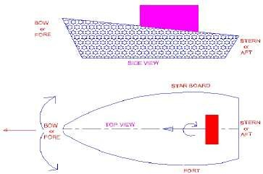

Consider a gyro-rotor mounted on the ship along longitudinal axis (X-axis) as shown in Fig.10 and rotate in clockwise direction when viewed from rear end of the ship. The angular speed of the rotor is ω rad/s. The direction of angular momentum vector oa, based on direction of rotation of rotor, is decided using right hand thumb rule as discussed earlier. The gyroscopic effect during the three types of motion of ship isdiscussed.
Gyroscopic effect on Steering ofship
- Left turn with clockwiserotor
When ship takes a left turn and the rotor rotates in clockwise direction viewed from stern, the gyroscopic couple act on the ship is analyzed in the followingway.
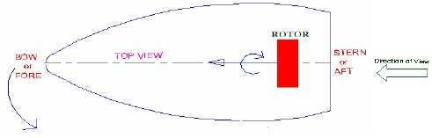

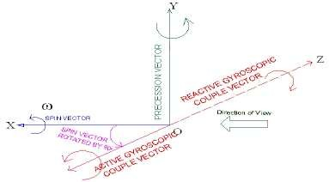

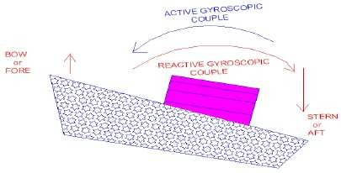

Note that, always reactive gyroscopic couple is considered for analysis. From the above analysis (Fig.), the couple acts over the ship between stern and bow. This reaction couple tends to raise the front end (bow) and lower the rear end (stern) of theship.

- Right turn with clockwiserotor
When ship takes a right turn and the rotor rotates in clockwise direction viewed from stern, the gyroscopic couple acts on the ship is analyzed (Fig 14). Again, the couple acts in vertical plane, means between stern and bow. Now the reaction couple tends to lower the bow of the ship and raise thestern.
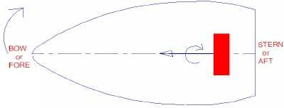

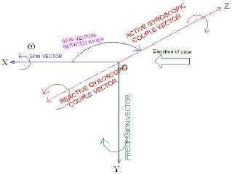

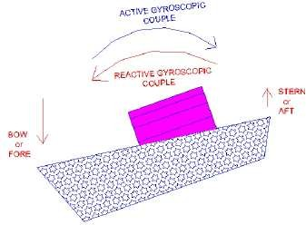

- Left turn with anticlockwiserotor
When ship takes a left turn and the rotor rotates in anticlockwise direction viewed from stern, the gyroscopic couple act on the ship is analyzed in the following way (Fig.).
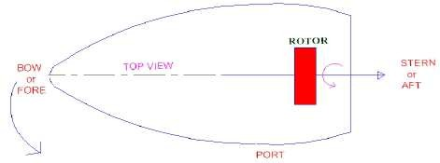
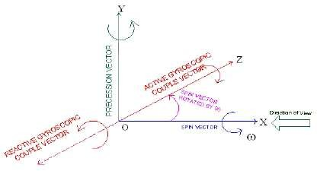
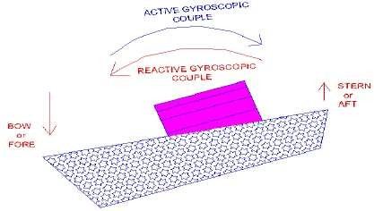

The couple acts over the ship is between stern and bow. This reaction couple tends to press or dip the front end (bow) and raise the rear end (stern) of theship.

- Right turn with anticlockwiserotor
When ship takes a right turn and the rotor rotates in anticlockwise direction viewed from stern, the gyroscopic couple act on the ship is according to Fig 20. Now, the reaction couple tends to raise the bow of the ship and dip thestern
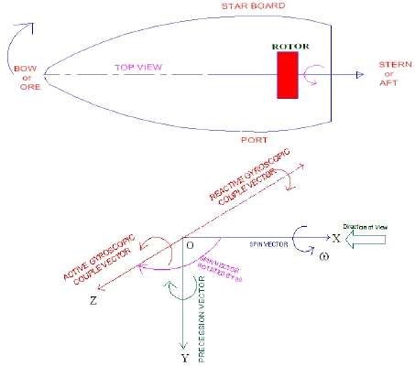
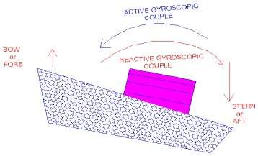

Gyroscopic effect on Pitching of ship
The pitching motion of a ship generally occurs due to waves which can be approximated as sine wave. During pitching, the ship moves up and down from the horizontal position in vertical plane (Fig.)
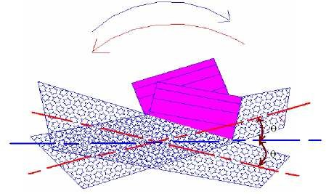
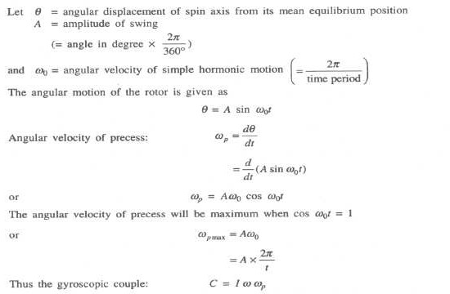

Consider a rotor mounted along the longitudinal axis and rotates in clockwise direction when seen from the rear end of the ship. The direction of momentum for this condition is shown byvectorox(Fig.24).Whentheshipmovesupthehorizontalpositioninverticalplanebyan

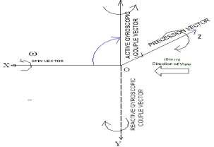
angle δθfrom the axis of spin, the rotor axis (X-axis) processes about Z- axis in XY-plane and for this case Z-axis becomes precession axis. The gyroscopic couple acts in anticlockwise direction about Y-axis and the reaction couple acts in opposite direction, i.e. in clockwise direction, which tends to move towards right side (Fig.25). However, when the ship pitches down the axis of spin, the direction of reaction couple is reversed and the ship turns towards left side(Fig.)

. 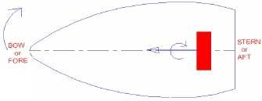

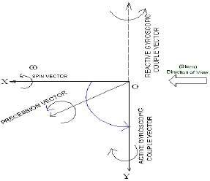
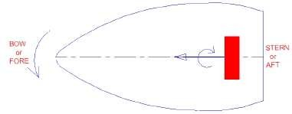
Similarly, for the anticlockwise direction of the rotor viewed from the rear end (Stern) of the ship, the analysis may be done.

Gyroscopic effect on Rolling of ship.
The axis of the rotor of a ship is mounted along the longitudinal axis of ship and therefore, there is no precession of this axis. Thus, no effect of gyroscopic couple on the ship frame is formed when the shiprolls

Gyroscopic Effect on Aeroplane
Aeroplanes are subjected to gyroscopic effect when it taking off, landing and negotiating left or right turn in the air.
Let
ω = Angular velocity of the engine rotating parts in rad/s, m = Mass of the engine and propeller in kg,
rW= Radius of gyration in m,
I = Mass moment of inertia of engine and propeller in kg m2, V = Linear velocity of the aeroplane in m/s,
R = Radius of curvature in m,
ωp=Angular velocity of precession =v/R rad/s
Gyroscopic couple acting on the aero plane = C = I ωωp

Let us analyze the effect of gyroscopic couple acting on the body of the aero plane for various conditions.

Case (i): PROPELLER rotates in CLOCKWISE direction when seen from rear end and Aeroplane turns towards LEFT
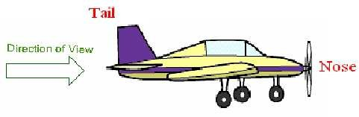

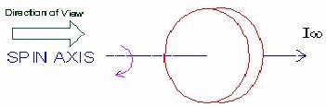

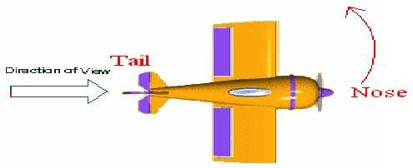

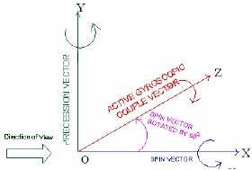

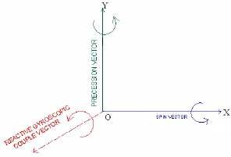

According to the analysis, the reactive gyroscopic couple tends to dip the tail and raise the nose ofaeroplane.
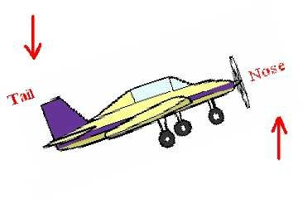
Case (ii): PROPELLER rotates in CLOCKWISE direction when seen from rear end and Aeroplane turns towardsRIGHT
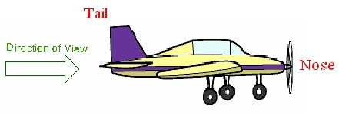

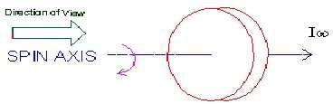

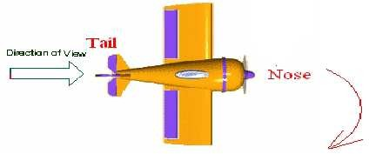

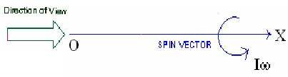

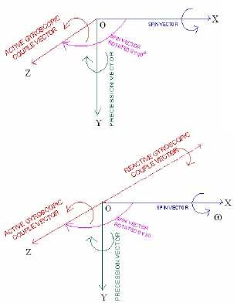

According to the analysis, the reactive gyroscopic couple tends to raise the tail and dip the nose ofaeroplane.
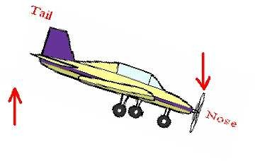
Case (iii): PROPELLER rotates in ANTICLOCKWISE direction when seen from rear end and Aeroplane turns towards LEFT
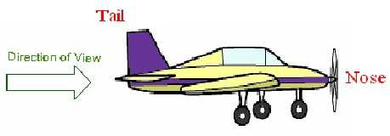
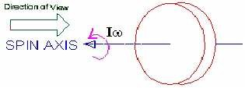
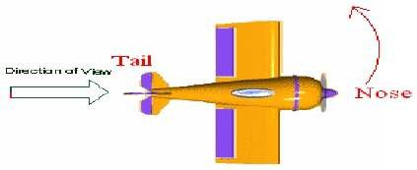

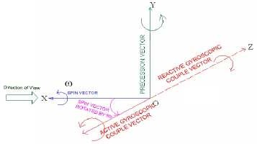
The analysis indicates, the reactive gyroscopic couple tends to raise the tail and dip the nose of aeroplane.
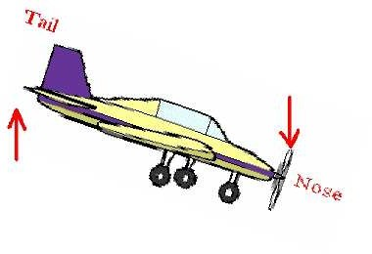
Case (iv): PROPELLER rotates in ANTICLOCKWISE direction when seen from rear end and Aeroplane turns towards RIGHT
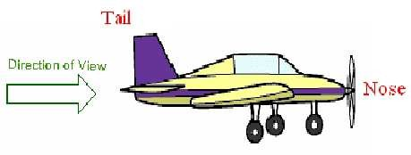

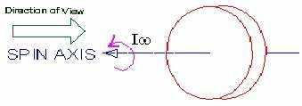

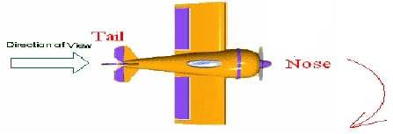

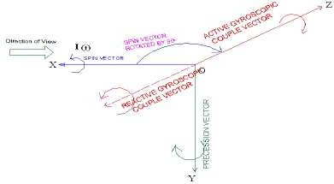

The analysis shows, the reactive gyroscopic couple tends to raise the tail and dip the nose of aeroplane.

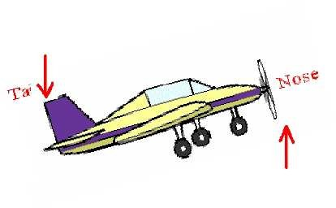
Case (v): PROPELLER rotates in CLOCKWISE direction when seen from rear end and Aeroplane takes off or nose moveupwards
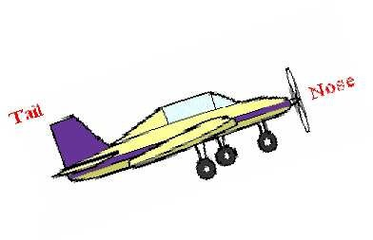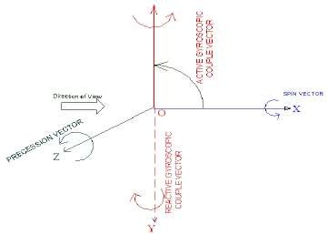

The analysis show, the reactive gyroscopic couple tends to turn the nose of aeroplane toward right
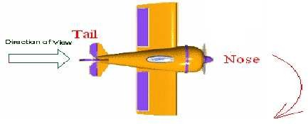
Case (vi): PROPELLER rotates in CLOCKWISE direction when seen from rear end and Aeroplane is landing or nose movedownwards

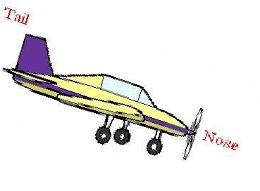

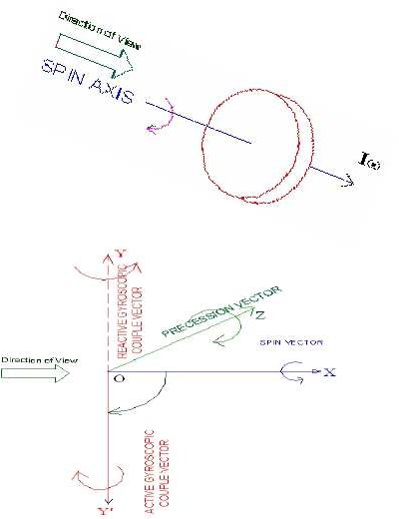
The reactive gyroscopic couple tends to turn the nose of aeroplane toward left
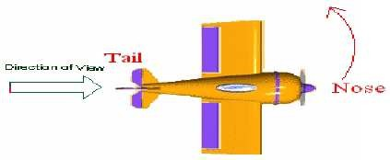

Case (vii): PROPELLER rotates in ANTICLOCKWISE direction when seen from rear end and Aeroplane takes off or nose move upwards
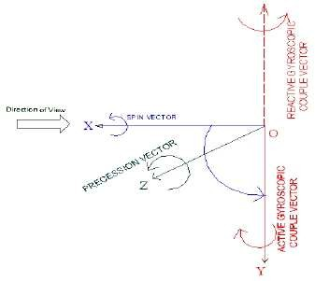
The reactive gyroscopic couple tends to turn the nose of aeroplane toward left

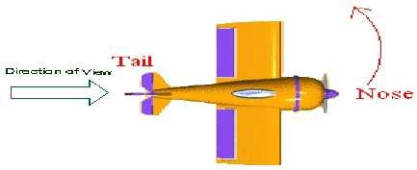

Case (viii): PROPELLER rotates in ANTICLOCKWISE direction when seen from rear end and Aeroplane is landing or nose move downwards
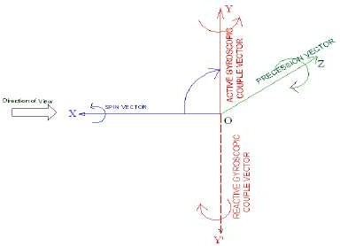

The analysis show, the reactive gyroscopic couple tends to turn the nose of aeroplane toward right

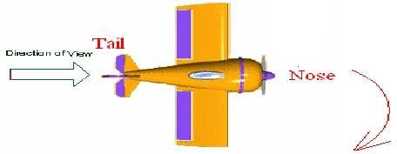

Stability of Automotive Vehicle
A vehicle running on the road is said to be stable when no wheel is supposed to leave the road surface. In other words, the resultant reactions by the road surface on wheels should act in upward direction. For a moving vehicle, one of the reaction is due to gyroscopic couple produced by the rotating wheels and rotating parts of the engine. Let us discuss stability of two and four wheeled vehicles when negotiating a curve/turn.

Stability of Two Wheeler negotiating a turn
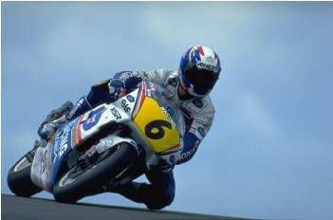
Fig shows a two wheeler vehicle taking left turn over a curved path. The vehicle is inclined to the vertical for equilibrium by an angle θ known as angle of heel.

Let
m = Mass of the vehicle and its rider in kg,
W = Weight of the vehicle and its rider in newtons = m.g, h = Height of the centre of gravity of the vehicle and rider, rW= Radius of thewheels,
R = Radius of track or curvature,
IW = Mass moment of inertia of each wheel,
IE = Mass moment of inertia of the rotating parts of the engine,
ωW= Angular velocity of the wheels,
ωE= Angular velocity of the engine rotating parts,
G = Gear ratio = ωE/ ωW,

v = Linear velocity of the vehicle = ωW× rW,
θ = Angle of heel. It is inclination of the vehicle to the vertical for equilibrium
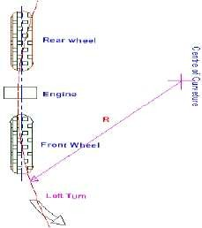

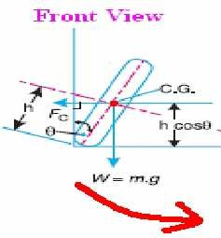
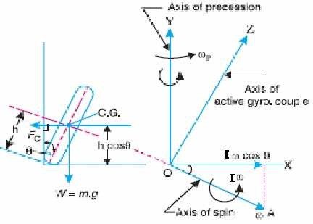

Let us consider the effect of the gyroscopic couple and centrifugal couple on the wheels.

- Effect of GyroscopicCouple
Weknowthat, V = ωW×rW
ωE= G .ωW or
Angular momentum due to wheels = 2 IwωW
Angular momentum due to engine and transmission = IE ωE
Total angular momentum (I xω) = 2 IwωWIEωE

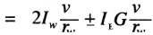
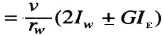

Velocity of precession = ωp
It is observed that, when the wheels move over the curved path, the vehicle is always inclined at an angle θ with the vertical plane as shown in Fig… This angle is known as ‘angle of heel’. In other words, the axis of spin is inclined to the horizontal at an angle θ , as shown in Fig.73 Thus, the angular momentum vector I ω due to spin is represented by OA inclined to OX atanangleθ. But,theprecessionaxisisinvertical.Therefore,thespinvectorisresolvedalongOX.

Gyroscopic Couple,

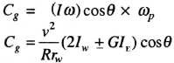

Note: When the engine is rotating in the same direction as that of wheels, then the positive sign is used in the above equation. However, if the engine rotates in opposite direction to wheels, then negative sign isused.

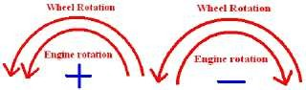
The gyroscopic couple will act over the vehicle outwards i.e., in the anticlockwise direction when seen from the front of the two wheeler. This couple tends to overturn/topple the vehicle in the outward direction as shown inFig…

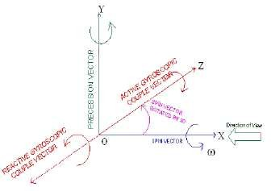
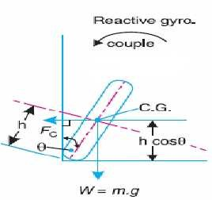

- Effect of CentrifugalCouple

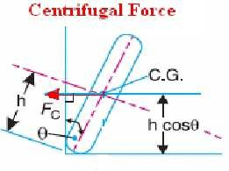

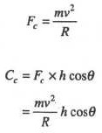
Centrifugal force,

Centrifugal Couple

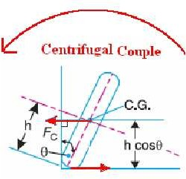
The Centrifugal couple will act over the two wheeler outwards i.e., in the anticlockwise direction when seen from the front of the two wheeler. This couple tends to overturn/topple the vehicle in the outward direction as shown in Fig.

Therefore, the total Over turning couple: C = Cg + Cc

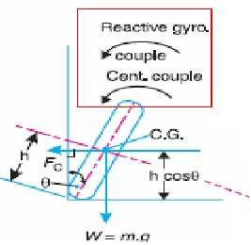

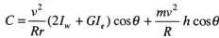
For the vehicle to be in equilibrium, overturning couple should be equal to balancing couple acting in clockwise direction due to the weight of the vehicle and rider.
C = mgh sinθ

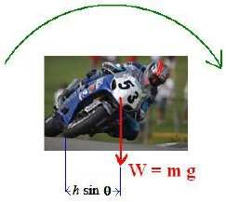
For the stability, overturning couple must be equal to balancing couple,
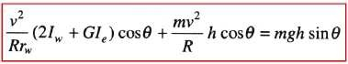
Therefore, from the above equation, the value of angle of heel (θ) may be determined, so that the vehicle does not skid. Also, for the given value of θ, the maximum vehicle speed in the turn with out skid may be determined.

Stability of Four Wheeled Vehicle negotiating a turn.
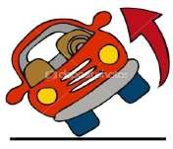

Consider a four wheels automotive vehicle as shown in Figure 82. The engine is mounted at the rear with its crank shaft parallel to the rear axle. The centre of gravity of the vehicle lies vertically above the ground where total weight of the vehicle is assumed to be acted upon.

Let
m = Mass of the vehicle (kg)
W = Weight of the vehicle (N) = m.g,
h = Height of the centre of gravity of the vehicle (m)
rW= Radius of the wheels (m)
R = Radius of track or curvature (m)
IW = Mass moment of inertia of each wheel (kg-m2)
IE = Mass moment of inertia of the rotating parts of the engine (kg-m2)
ωW= Angular velocity of the wheels (rad/s) ωE= Angular velocity of the engine (rad/s) G = Gear ratio = ωE/ ωW,
v = Linear velocity of the vehicle (m/s)= ωW× rW,
x = Wheel track (m) b = Wheel base (m)

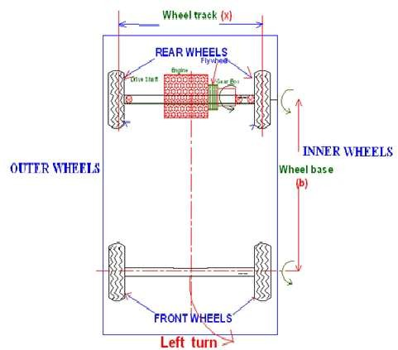

- Reaction due to weight ofVehicle
Weight of the vehicle. Assuming that weight of the vehicle (mg) is equally distributed over four wheels. Therefore, the force on each wheel acting downward is mg/4 and the reaction by the road surface on the wheel acts in upward direction.
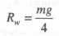

- Effect of Gyroscopic couple due toWheel
Gyroscopic couple due to four wheels is,
Cw= 4 Iwωωp
- Effect of Gyroscopic Couple due toEngine
Gyroscopic couple due to rotating parts of the engine
CE = IE ωωp = IE G ωωp

Therefore, Total gyroscopic couple:
Cg = Cw+ CE= ωωp (4IW ± IEG)
When the wheels and rotating parts of the engine rotate in the same direction, then positive sign is used in the above equation. Otherwise negative sign should beconsidered.
Assuming that the vehicle takes a left turn, the reaction gyroscopic couple on the vehicle acts between outer and inner wheels.
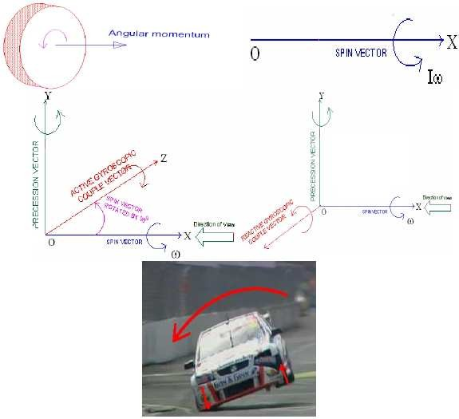

This gyroscopic couple tends to press the outer wheels and lift the inner wheels

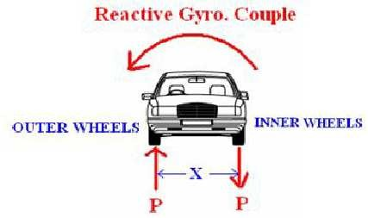
Due to the reactive gyroscopic couple, vertical reactions on the road surface will be produced. The reaction will be vertically upwords on the outer wheels and vertically downwords on the inner wheels. Let the magnitude of this reaction at the two outer and inner wheels be P Newtons, then,
P x X = Cg
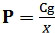
Road reaction on each outer/Inner wheel,
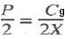

(iii)Effect of Centrifugal Couple
When a vehicle moves on a curved path, a centrifugal force acts on the vehicle in outward direction through the centre of gravity of the vehicle( Fig…)
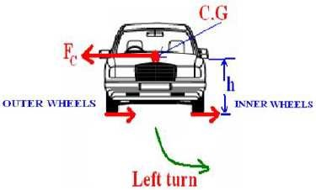

Centrifugal force,
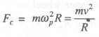
This force forms a Centrifugal couple.
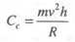
This centrifugal couple tends to press the outer and lift the inner
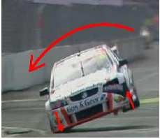
Due to the centrifugal couple, vertical reactions on the road surface will be produced. The reaction will be vertically upwords on the outer wheels and vertically downwords on the inner wheels. Let the magnitude of this reaction at the two outer and inner wheels be F Newtons, then,
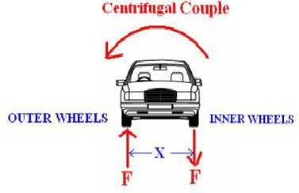

Road reaction on each outer/Inner wheel,
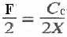

The reactions on the outer/inner wheels are as follows,
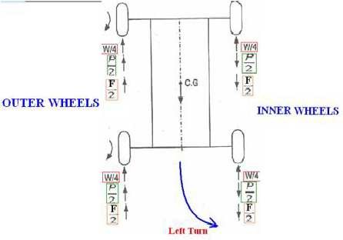
Total vertical reaction at each outerwheels

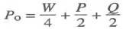
Total vertical reaction at each innerwheels
