Abrasive Processes

Abrasive machining processes can be divided into two categories based on how the grains are applied to the workpiece.

In bonded abrasive processes, the particles are held together within a matrix, and their combined shape determines the geometry of the finished workpiece. For example, in grinding the particles are bonded together in a wheel. As the grinding wheel is fed into the part, its shape is transferred onto the workpiece.

In loose abrasive processes, there is no structure connecting the grains. They may be applied without lubrication as dry powder, or they may be mixed with a lubricant to form a slurry. Since the grains can move independently, they must be forced into the workpiece with another object like a polishing cloth or a lapping plate.

Common abrasive processes are listed below.

Fixed (bonded) abrasive processes

• Grinding
€
• Honing, superfinishing
€
• Tape finishing, abrasive belt machining
€
• Buffing, brushing
€
• Abrasive sawing, Diamond wire cutting, Wire saw
€
• Sanding

Loose abrasive processes

• Polishing
€
• Lapping
€
• Abrasive flow machining (AFM)
€
• Hydro-erosive grinding
€
• Water-jet cutting
€
• Abrasive blasting
€
• Mass finishing,
Grinding Wheels

A grinding wheel is an expendable wheel that is composed of an abrasive compound used for various grinding (abrasive cutting) and abrasive machining operations. They are used in grinding machines.

The wheels are generally made from a matrix of coarse particles pressed and bonded together to form a solid, circular shape. Various profiles and cross sections are available depending on the intended usage for the wheel. They may also be made from a solid steel or aluminium disc with particles bonded to the surface.
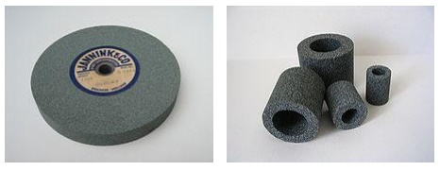
The manufacture of these wheels is a precise and tightly controlled process, due not only to the inherent safety risks of a spinning disc, but also the composition and uniformity required to prevent that disc from exploding due to the high stresses produced on rotation.

There are five characteristics of a cutting wheel: material, grain size, wheel grade, grain spacing, and bond type. They will be indicated by codes on the wheel's label.

Abrasive Grain, the actual abrasive, is selected according to the hardness of the material being cut.

• Aluminum Oxide (A)
€
• Silicon Carbide (S)
€
• Ceramic (C)
€
• Diamond (D, MD, SD)
€
• Cubic Boron Nitride (B)

Grinding wheels with diamond or Cubic Boron Nitride (CBN) grains are called superabrasives. Grinding wheels with Aluminum Oxide (corundum), Silicon Carbide or Ceramic grains are called conventional abrasives.

Grain size, from 8 (coarsest) 1200 (finest), determines the physical size of the abrasive grains in the wheel. A larger grain will cut freely, allowing fast cutting but poor surface finish. Ultra-fine grain sizes are for precision finish work.

Wheel grade, from A (soft) to Z (hard), determines how tightly the bond holds the abrasive. Grade affects almost all considerations of grinding, such as wheel speed, coolant flow, maximum and minimum feed rates, and grinding depth.
Grain spacing, or structure, from 1 (densest) to 16 (least dense). Density is the ratio of bond and abrasive to air space. A less-dense wheel will cut freely, and has a large effect on surface finish. It is also able to take a deeper or wider cut with less coolant, as the chip clearance on the wheel is greater.

Wheel bond, how the wheel holds the abrasives, affects finish, coolant, and minimum/maximum wheel speed.

• Vitrified (V)
€
• Resinoid (B)
€
• Silicate (S)

• Shellac (E)
€
• Rubber (R)
€
• Metal (M)
€
• Oxychloride (O)
Types of Grinding Processes

Straight wheel
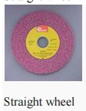
Straight wheel

To the right is an image of a straight wheel. These are by far the most common style of wheel and can be found on bench or pedestal grinders. They are used on the periphery only and therefore produce a slightly concave surface (hollow ground) on the part. This can be used to advantage on many tools such as chisels.

Straight Wheels are generally used for cylindrical, centreless, and surface grinding operations. Wheels of this form vary greatly in size, the diameter and width of face naturally depending upon the class of work for which is used and the size and power of the grinding machine.

Cylinder or wheel ring

Cylinder wheels provide a long, wide surface with no center mounting support (hollow). They can be very large, up to 12" in width. They are used only in vertical or horizontal spindle grinders. Cylinder or wheel ring is used for producing flat surfaces, the grinding being done with the end face of the wheel.

Tapered wheel

A straight wheel that tapers outward towards the center of the wheel. This arrangement is stronger than straight wheels and can accept higher lateral loads. Tapered face straight wheel is primarily used for grinding thread, gear teeth etc.

Straight cup

Straight cup wheels are an alternative to cup wheels in tool and cutter grinders, where having an additional radial grinding surface is beneficial.

Dish cup

A very shallow cup-style grinding wheel. The thinness allows grinding in slots and crevices. It is used primarily in cutter grinding and jig grinding.

Saucer wheel

A special grinding profile that is used to grind milling cutters and twist drills. It is most common in non-machining areas, as saw filers use saucer wheels in the maintenance of saw blades.

Diamond wheels
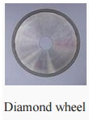
Diamond wheel

Diamond wheels are grinding wheels with industrial diamonds bonded to the periphery.

They are used for grinding extremely hard materials such as carbide cutting tips, gemstones or concrete. The saw pictured to the right is a slitting saw and is designed for slicing hard materials, typically gemstones.

Mounted points

Mounted points are small grinding wheels bonded onto a mandrel. Diamond mounted points are tiny diamond rasps for use in a jig grinder doing profiling work in hard material. Resin and vitrified bonded mounted points with conventional grains are used for deburring applications, especially in the foundry industry.

Cut off wheels

Cut off wheels, also known as parting wheels, are self-sharpening wheels that are thin in width and often have radial fibres reinforcing them. They are often used in the construction industry for cutting reinforcement bars (rebar), protruding bolts or anything that needs quick removal or trimming. Most handymen would recognise an angle grinder and the discs they use.

Cylindrical grinding
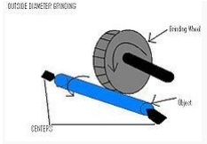
Cylindrical grinding

The cylindrical grinder is a type of grinding machine used to shape the outside of an object. The cylindrical grinder can work on a variety of shapes; however the object must have a central axis of rotation. This includes but is not limited to such shapes as a cylinder, an ellipse, a cam, or a crankshaft.
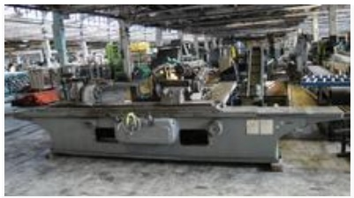

Cylindrical grinding is define d as having four essential actions:

1. The work (object) musst be constantly rotating

2. The grinding wheel m ust be constantly rotating

3. The grinding wheel is fed towards and away from the work

4. Either the work or the grinding wheel is traversed with respect to th e other.

While the majority of cylindri cal grinders employ all four movements, there are grinders that only employ three of the four actions.

There are five different types of cylindrical grinding: outside diameter (O D) grinding, inside diameter (ID) grinding, plunge grinding, creep feed grinding, and centerles s grinding.
A basic overview of Outside Diameter Cylindrical Grinding. The Curve d Arrows refer to direction of rotation

Grinding Wheels

A grinding wheel is an expendable wheel that is composed of an abrasive compound used for various grinding (abrasive cutting) and abrasive machining operations. They are used in grinding machines.

The wheels are generally made from a matrix of coarse particles pressed and bonded together to form a solid, circular shape. Various profiles and cross sections are available depending on the intended usage for the wheel. They may also be made from a solid steel or aluminium disc with particles bonded to the surface.
Outside Diameter Grinding

OD grinding is grinding occurring on external surface of an object between the centers. The centers are end units with a p oint that allow the object to be rotated. The grinding wheel is also being rotated in the sa me direction when it comes in contact with the object. This effectively means the two surfaces will be moving opposite directions when contact is made which allows for a smoother o peration and less chance of a jam up.

Plunge grinding

A form of OD grinding, ho wever the major difference is that the grinding wheel makes continuous contact with a sing le point of the object instead of traversing the object.

Creep feed grinding

Creep Feed is a form of grinding where a full depth of cut is removed in a single pass of the wheel. Successful operation of this technique can reduce manufacturing time by 50%, but often the grinding machine being used must be designed specifically for this purpose. This form occurs in both cylindrical and Surface Grinding.

Surface Grinding
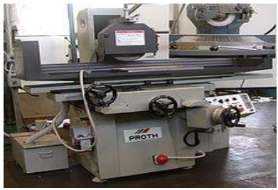
Surface grinding is used to produce a smooth finish on flat surfaces. It is a widely used abrasive machining process in which a spinning wheel covered in rough particles (grinding wheel) cuts chips of metallic or nonmetallic substance from a workpiece, making a face of it flat or smooth.

Surface grinding is the most common of the grinding operations. It is a finishing process that uses a rotating abrasive wheel to smooth the flat surface of metallic or nonmetallic materials to give them a more refined look or to attain a desired surface for a functional purpose.

The surface grinder is composed of an abrasive wheel, a workholding device known as a chuck, and a reciprocating or rotary table. The chuck holds the material in place while it is being worked on. It can do this one of two ways: ferromagnetic pieces are held in place by a magnetic chuck, while non-ferromagnetic and nonmetallic pieces are held in place by vacuum or mechanical means. A machine vise (made from ferromagnetic steel or cast iron) placed on the magnetic chuck can be used to hold non-ferromagnetic workpieces if only a magnetic chuck is available.

Factors to consider in surface grinding are the material of the grinding wheel and the material of the piece being worked on.

Typical workpiece materials include cast iron and mild steel. These two materials don't tend to clog the grinding wheel while being processed. Other materials are aluminum, stainless steel, brass and some plastics. When grinding at high temperatures, the material tends to become weakened and is more inclined to corrode. This can also result in a loss of magnetism in materials where this is applicable.

The grinding wheel is not limited to a cylindrical shape and can have a myriad of options that are useful in transferring different geometries to the object being worked on. Straight wheels can be dressed by the operator to produce custom geometries. When surface grinding an object, one must keep in mind that the shape of the wheel will be transferred to the material of the object like a mirror image.

Spark out is a term used when precision values are sought and literally means "until the sparks are out (no more)". It involves passing the workpiece under the wheel, without resetting the depth of cut, more than once and generally multiple times. This ensures that any inconsistencies in the machine or workpiece are eliminated.

A surface grinder is a machine tool used to provide precision ground surfaces, either to a critical size or for the surface finish.

The typical precision of a surface grinder depends on the type and usage, however +/-0.002 mm (+/- 0.0001") should be achievable on most surface grinders.

The machine consists of a table that traverses both longitudinally and across the face of the wheel. The longitudinal feed is usually powered by hydraulics, as may the cross feed, however any mixture of hand, electrical or hydraulic may be used depending on the ultimate usage of the machine (i.e.: production, workshop, cost). The grinding wheel rotates in the spindle head and is also adjustable for height, by any of the methods described previously. Modern surface grinders are semi-automated, depth of cut and spark-out may be preset as to the number of passes and, once set up, the machining process requires very little operator intervention.

Depending on the workpiece material, the work is generally held by the use of a magnetic chuck. This may be either an electromagnetic chuck, or a manually operated, permanent magnet type chuck; both types are shown in the first image.

The machine has provision for the application of coolant as well as the extraction of metal dust (metal and grinding particles).
Types of surface grinders

Horizontal-spindle (peripheral) surface grinders. The periphery (flat edge) of the wheel is in contact with the workpiece, producing the flat surface. Peripheral grinding is used in high-precision work on simple flat surfaces; tapers or angled surfaces; slots; flat surfaces next to shoulders; recessed surfaces; and profiles.

Vertical-spindle (wheel-face) grinders. The face of a wheel (cup, cylinder, disc, or segmental wheel) is used on the flat surface. Wheel-face grinding is often used for fast material removal, but some machines can accomplish high-precision work. The workpiece is held on a reciprocating table, which can be varied according to the task, or a rotary-table machine, with continuous or indexed rotation. Indexing allows loading or unloading one station while grinding operations are being performed on another.

Disc grinders and double-disc grinders. Disc grinding is similar to surface grinding, but with a larger contact area between disc and workpiece. Disc grinders are available in both vertical and horizontal spindle types. Double disc grinders work both sides of a workpiece simultaneously. Disc grinders are capable of achieving especially fine tolerances.

Centerless grinding and Internal Grinding
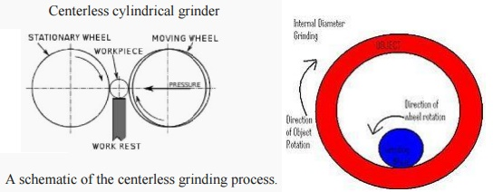

Centerless grinding

Centerless cylindrical grinder
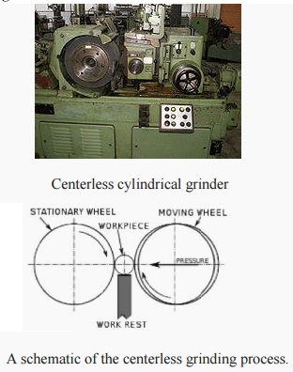 A schematic of the centerless grinding process.
Centerless grinding is a form of grinding where there is no collet or pair of centers holding the object in place. Instead, th ere is a regulating wheel positioned on the o pposite side of the object to the grinding wheel. A work rest keeps the object at the appropriate height but has no bearing on its rotary speed. The workblade is angled slightly towa rds the regulating wheel, with the workpiece c enterline above the centerlines of the regul ating and grinding wheel; this means that high spots do not tend to generate corresponding o pposite low spots, and hence the roundness of parts can be improved. Centerless grinding is much easier to combine with automatic load ing procedures than centered grinding; thr oughfeed grinding, where the regulating wheel is held at a slight angle to the part so that ther e is a force feeding the part through the grinder, i s particularly efficient.

Internal Grinding
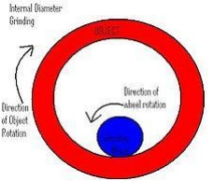

A basic overview of Internal Diameter Cylindrical Grinding. The Curve d Arrows refer to direction of rotation.

ID grinding is grinding occurring on the inside of an object. The grinding wheel is always smaller than the width of the object. The object is held in place by a collet, which also rotates the object in place. Just as with OD grinding, the grinding wheel and the object rotated in opposite directions giving reversed direction contact of the two surfaces where the grinding occurs.
Concepts of surface Integrity

Surface integrity is the surface condition of a workpiece after being modified by a manufacturing process. The surface integrity of a workpiece or item changes the material's properties. The consequences of changes to surface integrity are a mechanical engineering design problem, but the preservation of those properties are a manufacturing consideration.

Surface integrity can have a great impact on a parts function; for example, Inconel 718 can have a fatigue limit as high as 540 MPa (78,000 psi) after a gentlegrinding or as low as 150 MPa (22,000 psi) after electrical discharge machining (EDM).

There are two aspects to surface integrity: topography characteristics and surface layer characteristics. The topography is made up of surface roughness, waviness, errors of form, and flaws. The surface layer characteristics that can change through processing are: plastic deformation, residual stresses, cracks, hardness, overaging, phase changes, recrystallization, intergranular attack, and hydrogen embrittlement. When a traditional manufacturing process is used, such as machining, the surface layer sustains local plastic deformation.

The processes that affect surface integrity can be conveniently broken up into three classes: traditional processes, non-traditional processes, and finishing treatments. Traditional processes are defined as processes where the tool contacts the workpiece surface; for example: grinding, turning, and machining. These processes will only damage the surface integrity if the improper parameters are used, such as dull tools, too high feed speeds, improper coolant or lubrication, or incorrect grinding wheel hardness. Nontraditional processes are defined as processes where the tool does not contact the workpiece; examples of this type of process include EDM, electrochemical machining, and chemical milling. These processes will produce different surface integrity depending on how the processes are controlled; for instance, they can leave a stress-free surface, a remelted surface, or excessive surface roughness. Finishing treatments are defined as processes that negate surface finishes imparted by traditional and non-traditional processes or improve the surface integrity. For example, compressive residual stress can be enhanced via peening or roller burnishing or the recast layer left by EDMing can be removed via chemical milling.

Finishing treatments can affect the workpiece surface in a wide variety of manners. Some clean and/or remove defects, such as scratches, pores, burrs, flash, or blemishes. Other processes improve or modify the surface appearance by improving smoothness, texture, or color. They can also improve corrosion resistance,wear resistance, and/or reduce friction. Coatings are another type of finishing treatment that may be used to plate an expensive or scarce material onto a less expensive base material.

Variables

Manufacturing processes have five main variables: the workpiece, the tool, the machine tool, the environment, and process variables. All of these variables can affect the surface integrity of the workpiece by producing:

• High temperatures involved in various machining processes
€
• Plastic deformation in the workpiece (residual stresses)
€
• Surface geometry (roughness, cracks, distortion)
€
• Chemical reactions, especially between the tool and the workpiece

Broaching Machines

Broaching machines are relatively simple as they only have to move the broach in a linear motion at a predetermined speed and provide a means for handling the broach automatically. Most machines are hydraulic, but a few specialty machines are mechanically driven. The machines are distinguished by whether their motion is horizontal or vertical. The choice of machine is primarily dictated by the stroke required. Vertical broaching machines rarely have a stroke longer than 60 in (1.5 m).
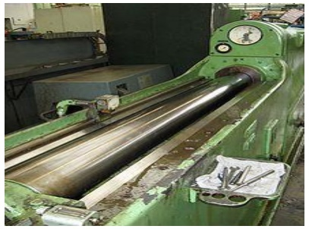

Vertical broaching machines can be designed for push broaching, pull-down broaching, pull-up broaching, or surface broaching. Push broaching machines are similar to an arbor press with a guided ram; typical capacities are 5 to 50 tons. The two ram pull-down machine is the most common type of broaching machine. This style machine has the rams under the table. Pull-up machines have the ram above the table; they usually have more than one ram. Most surface broaching is done on a vertical machine.
€
• Horizontal broaching machines are designed for pull broaching, surface broaching, continuous broaching, and rotary broaching. Pull style machines are basically vertical machines laid on the side with a longer stroke. Surface style machines hold the broach stationary while the workpieces are clamped into fixtures that are mounted on a conveyor system. Continuous style machines are similar to the surface style machines except adapted for internal broaching.
€
• Horizontal machines used to be much more common than vertical machines, however today they represent just 10% of all broaching machines purchased. Vertical machines are more popular because they take up less space.

Push Type Broaching Machine
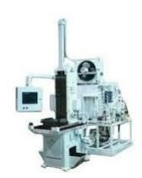

vertical internal push-down: Vertical push-down machines are often nothing more than general-purpose hydraulic presses with special fixtures. They are available with capacities of 2 to 25 tons, strokes up to 36" and speeds as high as 40 FPM. In some cases, universal machines have been designed which combine as many as three different broaching operations, such as push, pull, and surface, simply through the addition of special fixtures.

Pull Type Broaching Machine
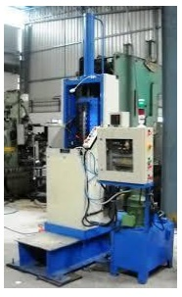
Vertical internal pull-up: The pull-up type, in which the workpiece is placed below the

worktable, was the first to be introduced. Its principal use is in broaching round and irregular

shaped holes. Pull-up machines are now furnished with pulling capacities of 6 to 50 tons,

strokes up to 72", and broaching speeds of 30 FPM. Larger machines are available; some

have electro-mechanical drives for greater broaching speed and higher productivity.

Vertical internal pull-down: The more sophisticated pull-down machines, in which the work

is placed on top of the table, were developed later than the pull-up type. These pull-down

machines are capable of holding internal shapes to closer tolerances by means of locating

fixtures on top of the worktable. Machines come with pulling capacities of 2 to 75 tons, 30"

to 110" strokes, and speeds of up to 80 FPM.

Surface broaches

The broaches used to remove material from an external surface are commonly known as surface broaches. Such broaches are passed over the workpiece surface to be cut, or the workpiece passes over the tool on horizontal, vertical or chain machines to produce flat or contoured surfaces.

While some surface broaches are of solid construction, most are of built-up design, with sections, inserts or indexable tool bits that are assembled end-to-end in a broach holder or sub holder. The holder fits on the machine slide and provides rigid alignment and support.
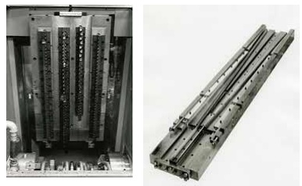
Continuous Chain Broaching

Continuous chain, or simply chain broaching refers to the type of machine that is used to broach a piece part.

Chain broaching is oriented towards high volume production, and is an extremely fast and efficient operation. However, because the fixtures used to hold the piece parts are mounted on chains that are driven by sprockets, it is difficult to hold extremely close tolerances. This process is suitable for high-volume, external cutting.
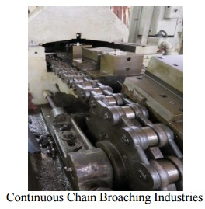
Continuous Chain Broaching Industries

• Biomedical
• Electronics
• Defense

A chain broaching machine resembles a very long tunnel, through which passes a series of holding fixtures, or cars. Piece parts are loaded, usually automatically, into the cars, which themselves are mounted on, and carried through the tunnel by a very large continuous chain. The broach tooling is mounted on the inside walls of the tunnel, and this tooling cuts the piece part as it passes through the tunnel. Contact us today to learn more.

Important Questions and Answers: Abrasive Process and Broaching
ABRASIVE PROCESS AND BROACHING

1. What is broaching?

Broaching is a processes of machining a surface with a special multipoint cutting tool called ' broach' which has successively higher cutting edges in a fixed path.

2.Indicate any two specification of a broaching machine?

1.Maximum length of stroke in mm

2.Maximum force developed by the slide in tones

3.What are the advantages and limitation of broaching?

Advantages:

1.Roughing, semi finishing & finishing cuts are completed in one pass of the broach 2.Broaching can be used for either external or internal surface finish

Limitation:

1.High initial cost of the broach tool compare to other tools

2.Job work or batch work is not advisable due to the high tool cost.

4.What are the different operations that can be performed on a broaching machine?

1.Broaching splines

2.Broaching a key way

5.What are the advantages of gear planning process?

Any given module can be cut using a single cutter.

The rate of production is higher when compared to forced cutter method. It is a simple flexible and accurate method of generating gears.

6.What are the limitations of gear hobbing?

1.Internal gears cannot be generated.

2.Hobbing process cannot be applied very near to shoulders

7.State the purpose of grinding?

1.To remove small amount of metal from work pieces & finish then to close tolerances.
2.To obtain the better surface finish.

The machining accuracy of holes produce by this machine tool lies with in a range of 0.0025 mm.

8. Define the term “grade” used in grinding wheel?

Grade or hardness indicates the strength with which the bonding material holds the abrasive grain in the grinding wheel.
9. What is meant by dressing &truing?

The process of loading &breaking away the glazed surface so that new sharp abrasive particles are again present to work for efficient cutting is called dressing.

Truing is a process of trimming the cutting surface of the wheel to run true with the axis.

10. What is process of lapping?

Lapping is a surface finishing process used for producing geometrically accurate flat, cylindrical &spherical surfaces.

11.What are the three types dividing heads?

1.Plain or simple.

2.Universal.

3.Optical

12.What are the other forming methods for manufacturing gears?

1.Gear cutting by single point form tool. 2.Gear cutting by shear speed shaping process. 3.Gear broaching.

4.Template method.

13.List the gear generating process?

1.Gear shaping process.

2.Gear planning process.

3.Gear hobbing process.

14.Mention the applications of gear shaping process?

1.Gear shaping used for generating both internal & external spur gears. 2.Helical gears can

also be generated using special attachments.

15.What are the limitations of gear hobbing?

1.Internal gears cannot be generated.

2.Hobbing process cannot be applied very near to shoulders.

16.What are the advantages of gear planning process?

1.Any given model can be cut using a single cutter.

2.It is a simple flexible &accurate method of generating gears.

17.List the various gear finishing processes?

1.Gear shaving. 2. Gear burnishing.

2.Gear grinding. 4.Gear lapping.

18. How the centre less grinder operates?

The centre less grinder operates with two wheels as the cutting wheel, to remove the excess stock and a regulating wheel which is used to control the speed of rotation of the work and the rate of feed.

19. What are the advantages of centre les grinding?

The work pieces are suppressed through the wheels

No tendency for chatter and deflection of the work piece. Easy size control of the work.

No need of chucking or mounting of the work piece.

20. What is honing?

Honing ids also a surface finishing process like grinding, which uses a “hon” tool that consists of stones to abrade the metals.

21. What is meant by polishing?

Polishing is the surface finishing operation performed by a polishing wheel, for the purpose of removing appreciable metal to take out scratches, hole marks, Pits and other defects from rough surfaces.

22. What is meant by buffing?

Buffing is used give much high lustrous, reflective finish that can not be obtained by polishing. The buffing process consists of applying a very fine abrasive with rotating wheel.

