Fluid Properties and Flow Characteristics
FLUID PROPERTIES AND FLOW CHARACTERISTICS

PRE REQUEST DISCUSSION

This page broadly deal with units and dimensions, properties of fluids and applications of control volume of continuity equation, energy equation, and momentum equation.

Man’s desire for knowledge of fluid phenomena began with his problems of watersupply, irrigation, navigation, and waterpower.

Matter exists in two states; the solid and the fluid, the fluid state being commonly divided into the liquid and gaseous states. Solids differ from liquids and liquids from gases in the spacing and latitude of motion of their molecules, these variables being large in a gas, smaller in a liquid, and extremely small in a solid. Thus it follows that intermolecular cohesive forces are large in a solid, smaller in a liquid, and extremely small in a gas.
DIFFERENCES BETWEEN SOLIDS AND FLUIDS

The differences between the behaviors of solids and fluids under an applied force are as follows:

i. For a solid, the strain is a function of the applied stress, providing that the elastic limit is not exceeded. For a fluid, the rate of strain is proportional to the applied stress.

ii. The strain in a solid is independent of the time over which the force is applied and, if the elastic limit is not exceeded, the deformation disappears when the force is removed. A fluid continues to flow as long as the force is applied and will not recover its original form when the force is removed.

FLUID MECHANICS

Fluid mechanics is that branch of science which deals with the behavior of fluids (liquids or gases) at rest as well as in motion. Thus this branch of science deals with the static, kinematics and dynamic aspects of fluids. The study of fluids at rest is called fluid statics. The study of fluids in motion, where pressure forces are not considered, is called fluid kinematics and if the pressure forces are also considered for the fluids in motion, that branch of science is called fluid dynamics.
UNITS AND DIMENSIONS

The word dimensions are used to describe basic concepts like mass, length, time, temperature and force.Units are the means of expressing the value of the dimension quantitatively or numerically.

Example - Kilogram, Metre, Second, Kelvin, Celcius.
The four examples are the fundamental units; other derived units are
Density = mass per unit volume = kg/m3
Force = mass x acceleration = kg.m/s2 = Newton or N
Pressure = force per unit area = N/m2 =Pascal or Pa
Other unit is‘ bar’ ,
where 1 bar =1 X105 Pa =100 Kpa = 0.1 Mpa
Work = force x distance = Newton x metre = N.m==J or Joule
Power = work done per unit time= J/s = Watt or W
Term Dimension Unit
Area L*L m2
Volume L*L*L m3
Velocity L* T-1 m/s
Acceleration L*T-2 m/s2
Force M*L*T-2 N
Pressure M*L-1*T-2 N/m2 = Pa
Work M*L2*T-2 Nm = J
Power M*L2*T-3 J/s = W
Density M*L-3 kg/m3
Viscosity M*L-1*T-1 kg/ms = N s/m2
Surface Tension M*T-1 N/m
Quantity Representative symbol Dimensions
Angular velocity ω t-1
Area A L2
Density ρ M/L3
Force F ML/t2
Kinematic viscosity ν L2/t
Linear velocity V L/t
Linear acceleration A L/t2
Mass flow rate m. M/t

Power P ML2/t3
Pressure P M/Lt2
Sonic velocity C L/t
Shear stress τ M/Lt2
Surface tension σ M/t2
Viscosity μ M/Lt
Volume V L3
Dimensions:
Dimensions of the primary quantities:

Fundamental dimension : Symbol

Length L
Mass M
Time T
Temperature T
Dimensions of derived quantities can be expressed in terms of the fundamental dimensions.
1.SYSTEM OF UNITS

1. CGS Units

2. FPS Units

3. MKS Units

4. SI Units
FLUID PROPERTIES

1 Density or Mass density:

Density or mass density of a fluid is defined as the ratio of the mass of a fluid to its volume. Thus mass per unit volume of a is called density.

2. Specific weight or weight density:

Specific weight or weight density of a fluid is the ratio between the weight of a fluid to its volume. The weight per unit volume of a fluid is called weight density.

3. Specific Volume:

Specific volume of a fluid is defined as the volume of a fluid occupied by a unit mass orvolume per unit mass of a fluid

4.Specific Gravity:

Specific gravity is defined as the ratio of the weight density of a fluid to the weight density of a standard fluid.
VISCOSITY

Viscosity is defined as the property of a fluid which offers resistance to the

movement of one layer of fluid over adjacent layer of the fluid. When two layers of a fluid, a distance ‘dy’ apart, move one over the other at different velocities, say u

and u+du as shown in figure. The viscosity together with relative velocity causes a shear stress acting between the fluid layers

The top layer causes a shear stress on the adjacent lower layer while the lower layer causes a shear stress on the adjacent top layer. This shear stress is proportional to the rate of change of velocity with respect to y.
VAPOUR PRESSURE

The pressure at which a liquid will boil is called its vapor pressure. This pressure is a function 3 of temperature (vapor pressure increases with temperature). In this context we usually think about the temperature at which boiling occurs. For example, water boils at 100oC at sea-level atmospheric pressure (1 atm abs). However, in terms of vapor pressure, we can say that by increasing the temperature of water at sea level to 100 oC, we increase the vapor pressure to the point at which it is equal to the atmospheric pressure (1 atm abs), so that boiling occurs. It is easy to visualize that boiling can also occur in water at temperatures much below 100oC if the pressure in the water is reduced to its vapor pressure. For example, the vapor pressure of water at 10oC is 0.01 atm.
1.CAVITATION

Cavitation(flashing of the liquid into vapour) takes place when very low pressures are produced at certain locations of a flowing liquid. Cavitation results in the formation of vapour pockets or cavities which are carried away from the point of origin and collapse at the high pressure zone.
COMPRESSIBILITY

Compressibility is the reciprocal of the bulk modulus of elasticity, K which is defined as the ratio of compressive stress to volumetric strain.

Compressibility is given by = 1/K

SURFACE TENSION

Surface tension is defined as the tensile force acting on the surface of a liquid in contact with a gas or on the surface between two two immiscible liquids such that the contact surface behaves like a membrane under tension.
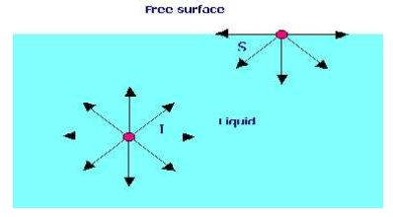
1.A soap bubble 50 mm in diameter contains a pressure (in excess of atmospheric) of 2 bar. Find the surface tension in the soap film.

Data:

Radius of soap bubble (r) = 25 mm = 0.025 m Δp = 2 Bar = 2 x 105 N/m2

Formula:
Pressure inside a soap bubble and surface tension (σ) are related by, Δp = 4σ/r
Calculations:
σ = Δpr/4 = 2 x 105 x 0.025/4 = 1250 N/m

CAPILLARITY

Capillarity is defined as a phenomenon of rise or fall of a liquid surface in a small tube relative to the adjacent general level of liquid when the tube is held vertically in the liquid. The rise of liquid surface is known as capillary rise while the fall of the liquid surface is known as capillary depression.
It is expressed in terms of cm or mm of liquid. Its value depends upon the specific weight of the liquid, diameter of the tube and surface tension of the liquid.
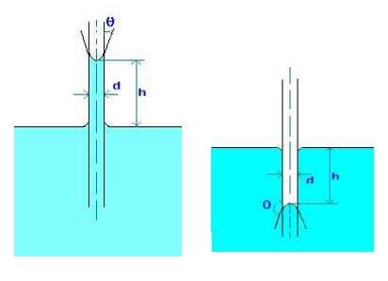
1.Water has a surface tension of 0.4 N/m. In a 3 mm diameter vertical tube if the liquid rises 6 mm above the liquid outside the tube, calculate the contact angle.

Data:

Surface tension (σ)€= 0.4 N/m

Dia of tube (d) = 3 mm = 0.003 m

Capillary rise (h) = 6 mm = 0.006 m

Formula:

Capillary rise due to surface tension is given by

h = 4 cos(θ)/(ρgd), where θ is the contact angle.

Calculations:

cos(θ) = hρgd/(4σ) = 0.006 x 1000 x 9.812 x 0.003 / (4 x 0.4) = 0.11

Therfore, contact angle θ = 83.7o
CONCEPT OF CONTROL VOLUME

A specified large number of fluid and thermal devices have mass flow in and out of a system called as control volume.

1.CONTINUITY EQUATION

Concepts

The continuity equation is governed from the principle of conservation of mass.It states that the mass of fluid flowing through the pipe at the cross-section remains constants,if there is no fluid is added or removed from the pipe.

Let us make the mass balance for a fluid element as shown below: (an open-faced cube)
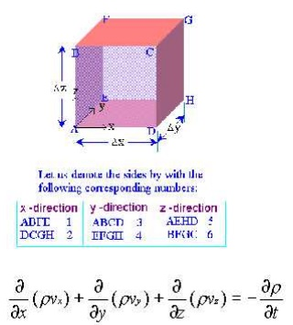
This is the continuity equation for every point in a fluid flow whether steady or unsteady , compressible or incompressible.

For steady, incompressible flow, the density ρ€is constant and the equation simplifies to
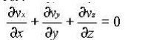
For two dimensional incompressible flow this will simplify still further to
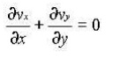
2 EULER'S EQUATION OF MOTION
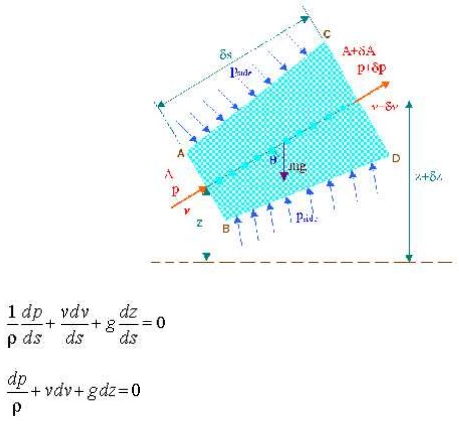
This is known as Euler's equation, giving, in differential form the relationship between p, v, ρand elevation z, along a streamline for steady flow.
3 BERNOULLI EQUATION

Concepts

Bernoulli’s Equation relates velocity, pressure and elevation changes of a fluid in motion. Itmay be stated as follows “ In an ideal incompressible fluid when the flow is steady and

continuous the sum of pressure energy, kinetic energy and potential energy is constant along streamline”
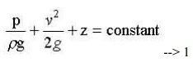
This is the basic from of Bernoulli equation for steady incompressible inviscid flows. It may be written for any two points 1 and 2 on the same streamline as
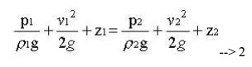
The contstant of Bernoulli equation, can be named as total head (ho) has different values on different streamlines.
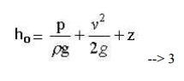
The total head may be regarded as the sum of the piezometric head h* = p/ρg + z and the kinetic head v2/2g.

Bernoullie equation is arrived from the following assumptions:

1. Steady flow - common assumption applicable to many flows.

2. Incompressible flow - acceptable if the flow Mach number is less than 0.3.
3. Frictionless flow - very restrictive; solid walls introduce friction effects.

4. Valid for flow along a single streamline; i.e., different streamlines may have different ho.

5. No shaft work - no pump or turbines on the streamline.
6. No transfer of heat - either added or removed.

Range of validity of the Bernoulli Equation:

Bernoulli equation is valid along any streamline in any steady, inviscid, incompressible flow. There are no restrictions on the shape of the streamline or on the geometry of the overall flow. The equation is valid for flow in one, two or three dimensions.

Modifications on Bernoulli equation:

Bernoulli equation can be corrected and used in the following form for real cases.
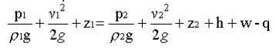
APPLICATIONS

1.Venturimeter.

2.Orificemeter

3.Pitot Tube

MOMENTUM EQUATION

Net force acting on fluid in the direction of x=Rate of change of momentum in x direction

=Mass per sec×Change in velocity

p1A1-p2A2×cos θ-Fx=ρQ(v2cosθ-v1)

Fx=ρQ(v1-v2cosθ)-p2A2cosθ+p1A1

Similarlt,the momentum in y-direction is -p2A2sinθ+Fy=ρQ(v2sinθ-0)

Fy=ρQv2sinθ+p2A2 sinθ

Resultant force acting on the bend,
Fr=√Fx²+Fy²
GLOSSARY

Quantity : Unit

Mass in Kilogram : Kg
Length in Meter : M
Time in Second : s or as sec
Temperature in Kelvin : K
Mole : gmol or simply as mol

Derived quantities:

Quantity : Unit

Force in Newton (1 N = 1 kg.m/s2) : N
Pressure in Pascal (1 Pa = 1 N/m2) : N/m2
Work, energy in Joule ( 1 J = 1 N.m) : J
Power in Watt (1 W = 1 J/s) : W
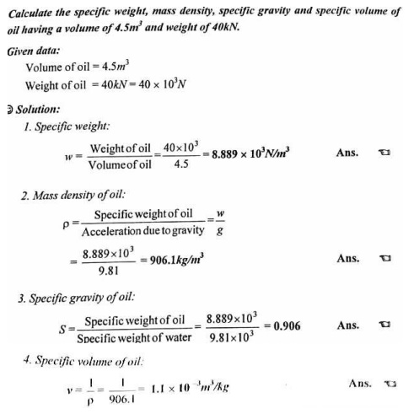

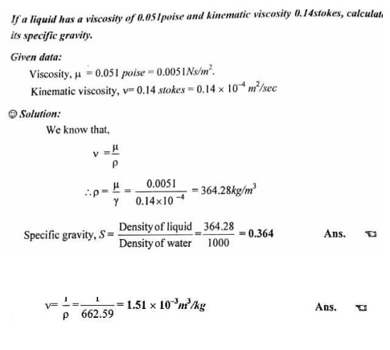
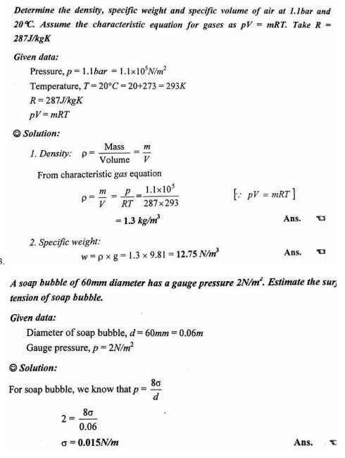
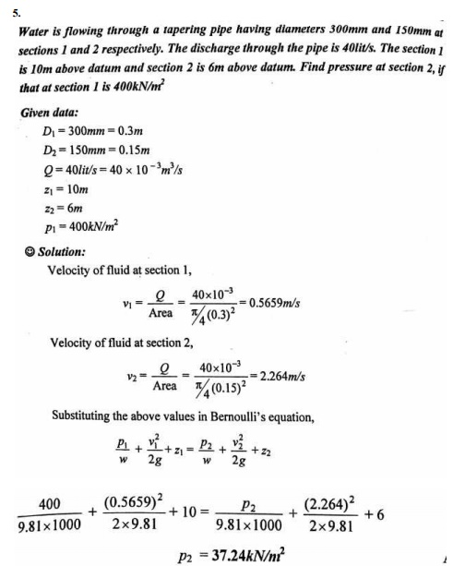
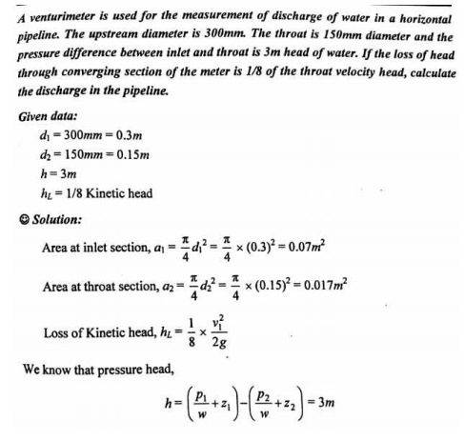
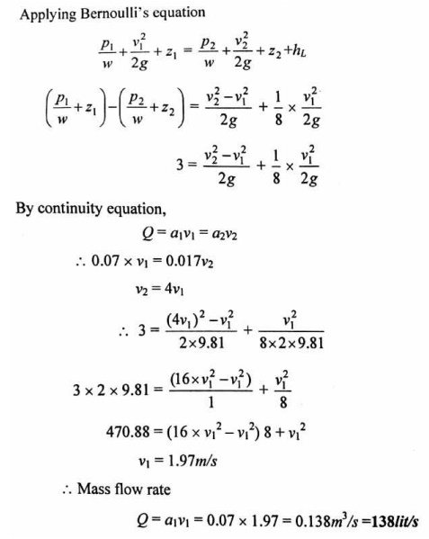
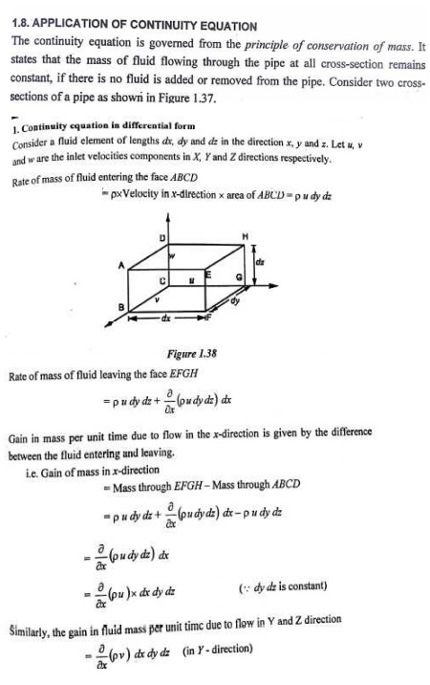
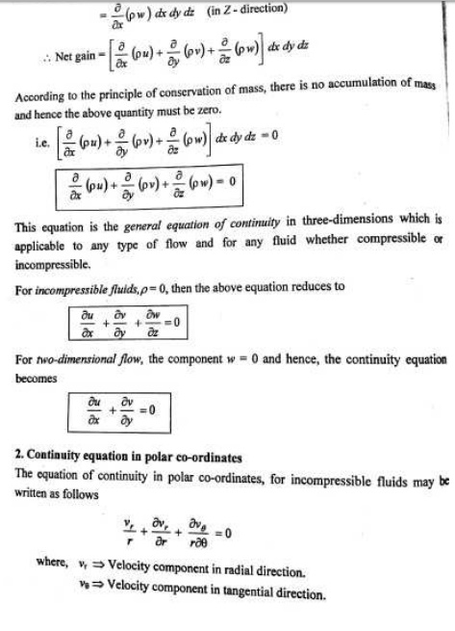
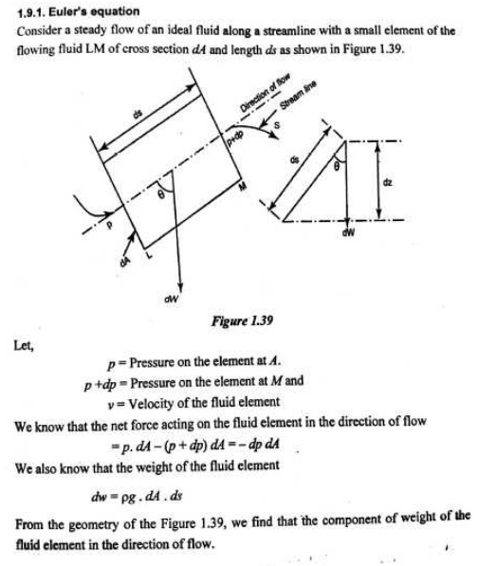
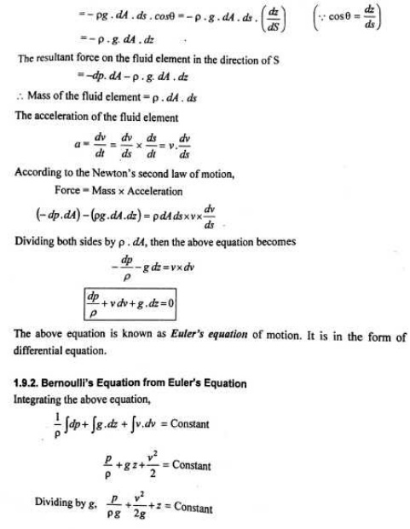
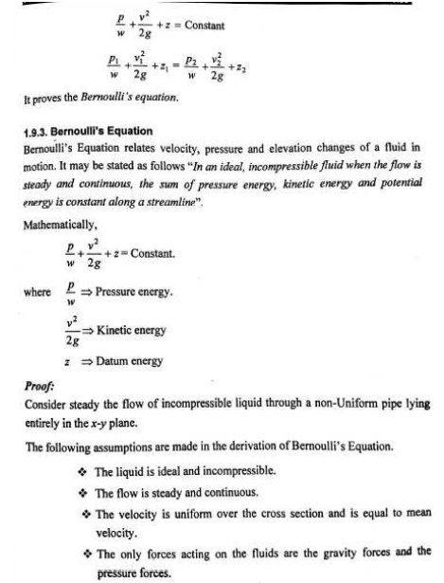
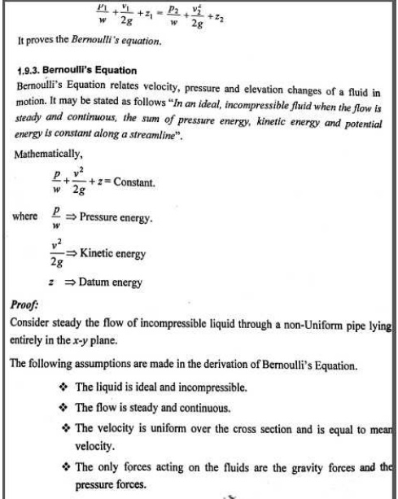
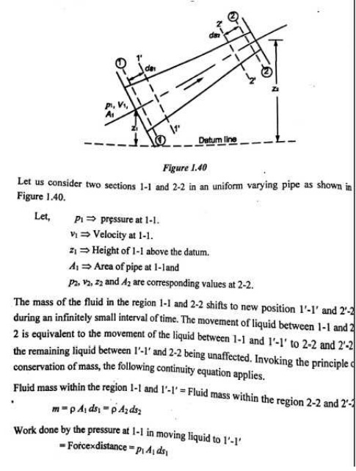
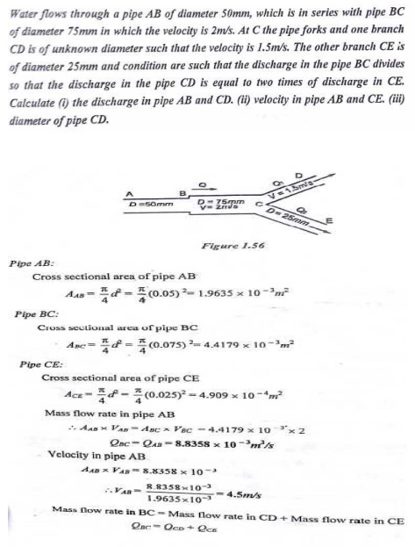
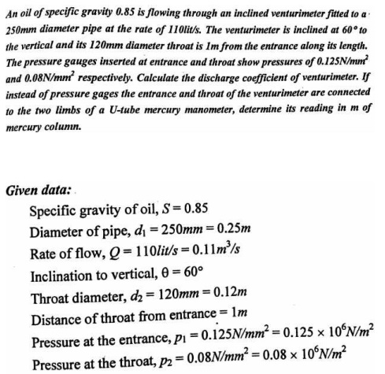
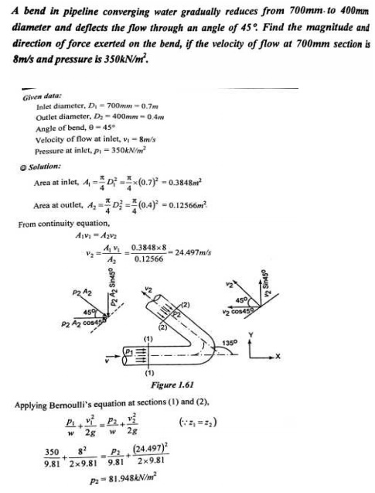
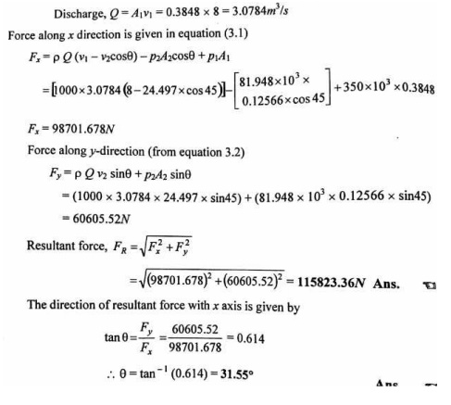

Important Answers and Solved Problems: Fluid Properties and Flow Characteristics
1. Define fluids.

Fluid may be defined as a substance which is capable of flowing. It has no definite shape of its own, but confirms to the shape of the containing vessel.

2. What are the properties of ideal fluid?

Ideal fluids have following properties i)It is incompressible

ii) It has zero viscosity
iii) Shear force is zero

3. What are the properties of real fluid?

Real fluids have following properties i)It is compressible

ii) They are viscous in nature
iii) Shear force exists always in such fluids.

4. Explain the Density

Density or mass density is defined as the ratio of the mass of the fluid to its volume. Thus mass per unit volume of a fluid is called density. It is denoted by the symbol (ρ).
Density = Mass of the fluid (kg) / Volume of the fluid (m3)
5. Explain the Specific weight or weight density

Specific weight or weight density of a fluid is the ratio between the weight of a fluid to its volume. Thus weight per uint volume of a fluid is called weight density and is denoted by the symbol (W).

(W) = Weight of the fluid / Volume of fluid
= Mass x Acceleration due to gravity / Volume of fluid
W = pg
6. Explain the Specific volume

Specific volume of a fluid is defined as the volume of the fluid occupied by a unit Mass or volume per unit mass of a fluid is called specific volume.
Specific volume = Volume / Mass = m3 /kg = l/p
7. Explain the Specific gravity

Specific gravity is defined as the ratio of weight density of a fluid to the weight density of a standard fluid. For liquid, standard fluid is water and for gases, it is air.

Specific gravity = Weight density of any liquid or gas Weight / density of standard liquid or gas
8.Define Viscosity.

It is defined as the property of a liquid due to which it offers resistance to the movement of one layer of liquid over another adjacent layer.

9. Define kinematic viscosity.
It is defined as the ratio of dynamic viscosity to mass density. (m²/sec)

10. Define Relative or Specific viscosity.

It is the ratio of dynamic viscosity of fluid to dynamic viscosity of water at 20°C.

11. State Newton's law of viscosity and give examples.

Newton's law states that the shear stress ( ) on a fluid element layer is directly proportional to the rate of shear strain. The constant of proportionality is called co-

efficient of viscosity.
r = μ du / dy

12. Give the importance of viscosity on fluid motion and its effect on temperature.

Viscosity is the property of a fluid which offers resistance to the movement of one layer of fluid over another adjacent layer of the fluid. The viscosity is an important property which offers the fluid motion.

The viscosity of liquid decreases with increase in temperature and for gas it Increases with increase in temperature.
13. Explain the Newtonian fluid
The fluid which obeys the Newton's law of viscosity i.e., the shear stress is directly

proportional to the rate of shear strain, is called Newtonian
fluid. r = μ du / dy
14. Explain the Non-Newtonian fluid

The fluids which does not obey the Newton's law of viscosity i.e., the shear stress is not directly proportional to the ratio of shear strain, is called non-Newtonian fluid.

15. Define compressibility.

Compressibility is the reciprocal of bulk modulus of elasticity, k which is defined as the ratio of compressive stress to volume strain.
k = Increase of pressure / Volume strain
Compressibility = 1 / k = Volume of strain / Increase of pressure
16. Define surface tension.

Surface tension is defined as the tensile force acting on the surface of a liquid in Contact with a gas or on the surface between two immiscible liquids such that contact surface behaves like a membrane under tension.

17. Define Capillarity.
Capillary is a phenomenon of rise or fall of liquid surface relative to the adjacent general level of liquid.

18. What is cohesion and adhesion in fluids?

Cohesion is due to the force of attraction between the molecules of the same liquid. Adhesion is due to the force of attraction between the molecules of two different Liquids or between the molecules of the liquid and molecules of the solid boundary surface.

19. State momentum of momentum equation?

It states that the resulting torque acting on a rotating fluid is equal to the rate of change of moment of momentum.

20. What is momentum equation

It is based on the law of conservation of momentum or on the momentum principle It states that,the net force acting on a fluid mass is equal to the change in momentum of flow per unit time in that direction.

21. What is Euler's equation of motion

This is the equation of motion in which forces due to gravity and pressure are taken into consideration. This is derived by considering the motion of a fluid element along a stream line.

22. What is venturi meter?

Venturi meter is a device for measuring the rate of fluid flow of a flowing fluid through a pipe. It consisits of three parts.

a. A short converging part b. Throat c.Diverging part. It is based on the principle of Bernoalli's equation.

23. What is an orifice meter?

Orifice meter is the device used for measuring the rate of flow of a fluid through a pipe. it is a cheaper device as compared to venturi meter. it also works on the priniciple as that of venturi meter. It consists of a flat circular plate which has a circular sharp edged hole called orifice.

24. What is a pitot tube?

Pitot tube is a device for measuring the velocity of a flow at any point in a pipe or a channel. It is based on the principle that if the velocity of flow at a point becomes zero, the pressure there is increased due to the conversion of kinetic energy into pressure energy.
. What are the types of fluid flow?

Steady & unsteady fluid flow Uniform & Non-uniform flow
One dimensional, two-dimensional & three-dimensional flows Rotational & Irrotational flow
25. State the application of Bernouillie’s equation ?

It has the application on the following measuring devices.
1.Orifice meter.

2.Venturimeter.
3.Pitot tube.

