Shapers

Shaping is performed on a machine tool called a shaper. The major components of a shaper are the ram, which has the tool post with cutting tool mounted on its face, and a worktable, which holds the part and accomplishes the feed motion.

A shaper is a type of machine tool that uses linear relative motion between the workpiece and a single-point cutting tool tomachine a linear toolpath. Its cut is analogous to that of a lathe, except that it is (archetypally) linear instead of helical. (Adding axes of motion can yield helical toolpaths, as also done in helical planing.) A shaper is analogous to a planer, but smaller, and with the cutter riding a ram that moves above a stationary workpiece, rather than the entire workpiece moving beneath the cutter. The ram is moved back and forth typically by a crank inside the column; hydraulically actuated shapers also exist.
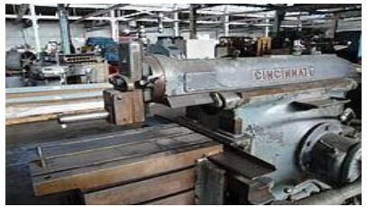

Types of Shapers

Shapers are mainly classified as standard, draw-cut, horizontal, universal, vertical, geared, crank, hydraulic, contour and traveling head.[1] The horizontal arrangement is the most common. Vertical shapers are generally fitted with a rotary table to enable curved surfaces to be machined (same idea as in helical planing). The vertical shaper is essentially the same thing as a slotter (slotting machine), although technically a distinction can be made if one defines a true vertical shaper as a machine whose slide can be moved from the vertical. A slotter is fixed in the vertical plane.

Small shapers have been successfully made to operate by hand power. As size increases, the mass of the machine and its power requirements increase, and it becomes necessary to use a motor or other supply of mechanical power. This motor drives a mechanical arrangement (using a pinion gear, bull gear, and crank, or a chain over sprockets) or a hydraulic motor that supplies the necessary movement via hydraulic cylinders.

The workpiece mounts on a rigid, box-shaped table in front of the machine. The height of the table can be adjusted to suit this workpiece, and the table can traverse sideways underneath the reciprocating tool, which is mounted on the ram. Table motion may be controlled manually, but is usually advanced by an automatic feed mechanism acting on the feedscrew.
The ram slides back and forth above the work. At the front end of the ram is a vertical tool slide that may be adjusted to either side of the vertical plane along the stroke axis. This tool-slide holds the clapper box and toolpost, from which the tool can be positioned to cut a straight, flat surface on the top of the workpiece. The tool-slide permits feeding the tool downwards to deepen a cut. This adjustability, coupled with the use of specialized cutters and toolholders, enable the operator to cut internal and external gear tooth profiles, splines, dovetails, and keyways.

The most common use is to machine straight, flat surfaces, but with ingenuity and some accessories a wide range of work can be done. Other examples of its use are:
Keyways in the boss of a pulley or gear can be machined without resorting to a dedicated broaching setup.
€
• Dovetail slides
€
• Internal splines and gear teeth.
€
• Keyway, spline, and gear tooth cutting in blind holes
€
• Cam drums with toolpaths of the type that in CNC milling terms would require 4- or 5-axis contouring or turn-mill cylindrical interpolation
€
• It is even possible to obviate wire EDM work in some cases. Starting from a drilled or cored hole, a shaper with a boring-bar type tool can cut internal features that don't lend themselves to milling or boring (such as irregularly shaped holes with tight corners).

Drilling and Reaming

Drilling and reaming operations
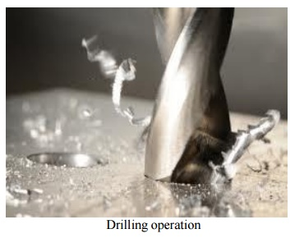

Drilling is used to drill a round blind or through hole in a solid material. If the hole is larger than ~30 mm, its a good idea to drill a smaller pilot hole before core drilling the final one. For holes larger than ~50 mm, three-step drilling is recommended; v Core drilling is used to increase the diameter of an existing hole; v Step drilling is used to drill a stepped (multi-diameter) hole in a solid material;
Counterboring provides a stepped hole again but with flat and perpendicular relative to hole axis face. The hole is used to seat internal hexagonal bolt heads;

Countersinking is similar to counterboring, except that the step is conical for flat head screws:

Reaming provides a better tolerance and surface finish to an initially drilled hole. Reaming slightly increases the hole diameter. The tool is called reamer;

Center drilling is used to drill a starting hole to precisely define the location for subsequent drilling. The tool is called center drill. A center drill has a thick shaft and very short flutes. It is therefore very stiff and will not walk as the hole is getting started;

Gun drilling is a specific operation to drill holes with very large length-to-diameter ratio up to L/D ~300. There are several modifications of this operation but in all cases cutting fluid is delivered directly to the cutting zone internally through the drill to cool and lubricate the cutting edges, and to remove the chips (see Section 5.6 Cutting Fluids);

Drills and Reamers
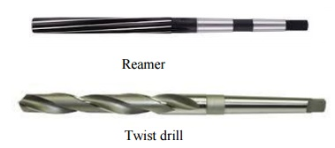

The twist drill does most of the cutting with the tip of the bit. It has two flutes to carry the chips up from the cutting edges to the top of the hole where they are cast off. The standard drill geometry

The typical helix angle of a general purpose twist drill is 18~30 degree, while the point angle (which equals two times the major cutting edge angle, see page 101) for the same drill is 118deg.

Some standard drill types are,
straight shank: this type has a cylindrical shank and is held in a chuck;

taper shank: his type is held directly in the drilling machine spindle.

Reamers

The reamer has similar geometry. The difference in geometry between a reamer and a twist drill are:

The reamer contains four to eight straight or helical flutes, respectively cutting edges.

The tip is very short and does not contain any cutting edges.

Boring

Boring is a process of producing circular internal profiles on a hole made by drilling or another process. It uses single point cutting tool called a boring bar. In boring, the boring bar can be rotated, or the workpart can be rotated. Machine tools which rotate the boring bar against a stationary workpiece are called boring machines (also boring mills). Boring can be accomplished on a turning machine with a stationary boring bar positioned in the tool post and rotating workpiece held in the lathe chuck as illustrated in the figure. In this section, we will consider only boring on boring machines.
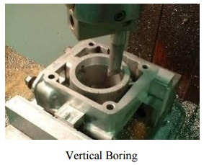
Boring machines

Boring machines can be horizontal or vertical according to the orientation of the axis of rotation of the machine spindle. In horizontal boring operation, boring bar is mounted in a tool slide, which position is adjusted relative to the spindle face plate to machine different diameters. The boring bar must be supported on the other end when boring long and small-diameter holes. A vertical boring mill is used for large, heavy work parts with diameters up to 12 m. The typical boring mill can position and feed several cutting tools simultaneously. The work part is mounted on a rotating worktable.

Cutting tool for boring

The typical boring bar is shown in the figure. When boring with a rotating tool, size is controlled by changing the radial position of the tool slide, which holds the boring bar, with respect to the spindle axis of rotation. For finishing machining, the boring bar is additionally mounted in an adjustable boring head for more precise control of the bar radial position.
Tapping

A tap cuts a thread on the inside surface of a hole, creating a female surface which functions like a nut. The three taps in the image illustrate the basic types commonly used by most machinists:
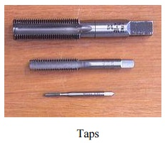
Bottoming tap or plug taps

The tap illustrated in the top of the image has a continuous cutting edge with almost no taper
— between 1 and 1.5 threads of taper is typical. This feature enables a bottoming tap to cut threads to the bottom of a blind hole. A bottoming tap is usually used to cut threads in a hole that has already been partially threaded using one of the more tapered types of tap; the tapered end ("tap chamfer") of a bottoming tap is too short to successfully start into an unthreaded hole. In the US, they are commonly known as bottoming taps, but in Australia and Britain they are also known as plug taps.

Intermediate tap, second tap, or plug tap

The tap illustrated in the middle of the image has tapered cutting edges, which assist in aligning and starting the tap into an untapped hole. The number of tapered threads typically ranges from 3 to 5.Plug taps are the most commonly used type of tap.[citation needed] In the US, they are commonly known as plug taps, whereas in Australia and Britain they are commonly known as second taps.

1.Define cutting ratio of the shaper.

The ratio between the cutting stroke time and the return stroke time is called as cutting

ratio.

Cutting stroke time

Cutting ratio m= Return stroke time

2. Mention any four shaper specifications.

1.Maximum stroke length. 2.mechanism.

3.Power of the motor. 4.Speed and feed available.

3. How the planer differs from a shaper?

Planer- The work piece reciprocates while the tool is Stationary. Shaper – The tool reciprocates while the work Stationary.

4. What is the main difference made in divided table planer?

The working principle is similar to that of a planer. But it has two reciprocating table. In that one table is working with work the other is loaded and unloaded

5. What is gang drilling machine?

More number of single spindle with essential speed and feed are mounted side by side on one base and have common work table, is known as the gang- drilling machine.
6. What is the use of a tapping tool?

A tap is a tool which is used for making internal threads in a machined component.

7. What are the applications of boring?

The boring machine is designed for machining large and heavy work piece in mass production work of engine frame, Cylinder, machine housing etc.

8. What is the main difference between boring bar and boring tool?
Boring bar:

The tool which is having single point cutting edge known as boring bar. Boring tool:

The tool which is having multi point cutting edge known as boring tool.

9. How omniversal milling machine differs from universal milling machines?

This is a modified form of a milling machine It is provided with two spindles, one of which is in the horizontal plane while the other is carried by a universal swiveling head.

10.What are the advantages of up milling processes?

1.It does not require a backlash eliminator.

2.Safer operation due to separating forces between cutter and work.

3.Less wear on feed screw and nut due to the absence of pre loaded.

4.Milled surface does not have built up edge.
11.What is meant by plain or slab milling?

Plain or Lab milling is the operation of producing flat horizontal surface parallel to the axis of the cutter using a plain or slab milling cutter.

1. What is meant by the term indexing?

Indexing is the process of dividing the periphery of a job in to equal number of divisions.

13.What are the three types dividing heads?

1.Plain or simple dividing head.

2.Universal dividing head.

3.Optical dividing head.

14.What is cam milling?

Cam milling is the operation of producing cams in a milling machine by the use of a universal dividing head and a vertical milling attachment.
15. List the advantages and limitations of thread milling.

Advantages;

1.the threads will be smoother and more accurate than those cut in a lathe. 2.Threads can be cut closer to shoulders of work piece.

3.It is a faster method.

4.It is more efficient than cutting threads in a lathe. Limitations:

1.It is Difficult to produce internal threads.

2.Threads milling cannot be used for making thread with more than 30 helix angle.
16.List the various types of planners?

1.Double housing

2.Open side planer

3.Pit planer

4.Edge planer

5.Divided table planer

17.Name the various parts of a double housing planer?

1.Bed

2.Table

3.Columns 4.Cross rail 5.Tool head

