DIMENSIONAL ANALYSIS

PRE REQUEST DISCUSSION

This Page deals with dimensional analysis,models and similitude,and application of dimensionless parameters.

Many important engineering problems cannot be solved completely by theoretical or mathematical methods. Problems of this type are especially common in fluid-flow, heat-flow, and diffusional operations. One method of attacking a problem for which no mathematical equation can be derived is that of empirical experimentations.

For example, the pressure loss from friction in a long, round, straight, smooth pipe depends on all these variables: the length and diameter of the pipe, the flow rate of the liquid, and the density and viscosity of the liquid. If any one of these variables is changed, the pressure drop also changes. The empirical method of obtaining an equation relating these factors to pressure drop requires that the effect of each separate variable be determined in turn by systematically varying that variable while keep all others constant. The procedure is laborious, and is difficult to organize or correlate the results so obtained into a useful relationship for calculations.

There exists a method intermediate between formal mathematical development and a completely empirical study. It is based on the fact that if a theoretical equation does exist among the variables affecting a physical process, that equation must be dimensionally homogeneous. Because of this requirement it is possible to group many factors into a smaller number of dimensionless groups of variables. The groups themselves rather than the separate factors appear in the final equation.

Concepts

Dimensional analysis drastically simplifies the task of fitting experimental data to design equations where a completely mathematical treatment is not possible; it is also useful in checking the consistency of the units in equations, in converting units, and in the scale-up of data obtained in physical models to predict the performance of full-scale model. The method is based on the concept of dimension and the use ofdimensional formulas.

Dimensional analysis does not yield a numerical equation, and experiment is required to complete the solution of the problem. The result of a dimensional analysis is valuable in pointing a way to correlations of experimental data suitable for engineering use.

METHODS OF DIMENSIONAL ANALYSIS

If the number of variables involved in a physical phenomenon are known, then the relation among the variables can be determined by the following two methods.

1.Rayleigh’s method

2. Buckingham’s π theorem

1Rayleigh’s method

This method is used for determining the expression for a variable which depends upon maximum three or four variables only. If the number of independent variables becomes more than four then it is very difficult to find the expression for the dependent variable.

2 Buckingham’s π theorem.

If there are n variables (independent and dependent variables) in a physical

phenomenon and if these variables contain m fundamental dimensions (M, L, T), then the variables are arranged into (n-m) dimensionless numbers. Each term is called Buckingham’s

π theorem.

Applications

❖ It is used to justify the dependency of one variable with the other.
❖ Usually this type of situation occurs in structures and hydraulic machines.
▪
❖ To solve this problem efficiently, an excellent tool is identified called dimensional analysis.
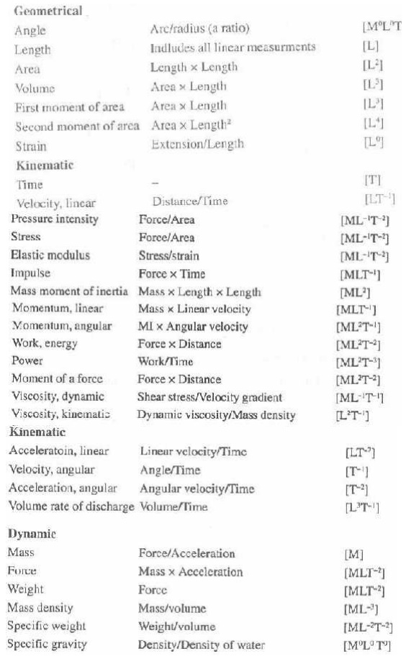
SMILITUDE –TYPES OF SIMILARITIES

Similitude is defined as the similarity between the model and its prototype in every respect, which means that the model and prototype are completely similar. Three types of similarities must exist between the model and prototype.

Concepts

Whenever it is necessary to perform tests on a model to obtain information that cannot be obtained by analytical means alone, the rules of similitude must be applied. Similitude is the theory and art of predicting prototype performance from model observations

1. Geometric similarity refers to linear dimensions. Two vessels of different sizes are geometrically similar if the ratios of the corresponding dimensions on the two scales are the same. If photographs of two vessels are completely super-impossible, they are geometrically similar.

2.Kinematic similarity refers to motion and requires geometric similarity and the same ratio of velocities for the corresponding positions in the vessels.

3.Dynamic similarity concerns forces and requires all force ratios for corresponding positions to be equal in kinematically similar vessels.

SIGNIFICANCE

The requirement for similitude of flow between model and prototype is that the significant dimensionless parameters must be equal for model and prototype

DIMENSIONLESS PARAMETERS

Since the inertia force is always present in a fluid flow, its ratio with each of the other forces provides a dimensionless number.

1. Reynold’s number
2. Froud’s number
3. Euler’s number
4. Weber’s number
5. Mach’s number

Applications of dimensionless parameters

1. Reynold’s model law
2. Froud’s model law
3. Euler’s model law
4. Weber’s model law
5. Mach’s model law

Important Dimensionless Numbers in Fluid Mechanics:
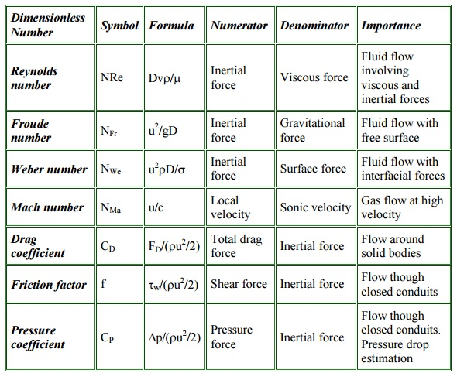
MODEL ANALYSIS.

PRE REQUEST DISCUSSION

Present engineering practice makes use of model tests more frequently than most people realize. For example, whenever a new airplane is designed, tests are made not only on the general scale model but also on various components of the plane. Numerous tests are made on individual wing sections as well as on the engine pods and tail sections

Models of automobiles and high-speed trains are also tested in wind tunnels to predict the drag and flow patterns for the prototype. Information derived from these model studies often indicates potential problems that can be corrected before prototype is built, thereby saving considerable time and expense in development of the prototype.
Concepts

Much time, mony and energy goes into the design construction and eradication of hydraulic structures and machines.

To minimize the chances of failure, it is always desired that the tests to be performed on small size models of the structures or machines. The model is the small scale replica of the actual structure or machine. The actual structure or machine is Called prototype.

Applictions

1. Civil engineering structures such as dams, canals etc.
2. Design of harbor, ships and submarines
3. Aero planes, rockets and machines.

4. Marine engineers make extensive tests on model shop hulls to predict the drag of the ships

GLOSSARY

The three friction factor problems:

The friction factor relates six parameters of the flow:

1. Pipe diameter
2. Average velocity
3. Fluid density
4. Fluid viscosity
5. Pipe roughness
6. The frictional losses per unit mass.

Therefore, given any five of these, we can use the friction-factor charts to find the sixth.

Most often, instead of being interested in the average velocity, we are interested in the volumetric flow rate Q = (π/4)D²V
The three most common types of problems are the following: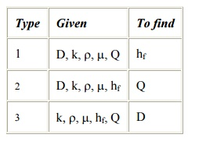
Generally, type 1 can be solved directly, where as types 2 and 3 require simple trial and error.

Three fundamental problems which are commonly encountered in pipe-flow calculations: Constants: rho, mu, g, L

1. Given D, and v or Q, compute the pressure drop. (pressure-drop problem)
2. Given D, delP, compute velocity or flow rate (flow-rate problem)
3. Given Q, delP, compute the diameter D of the pipe (sizing problem)
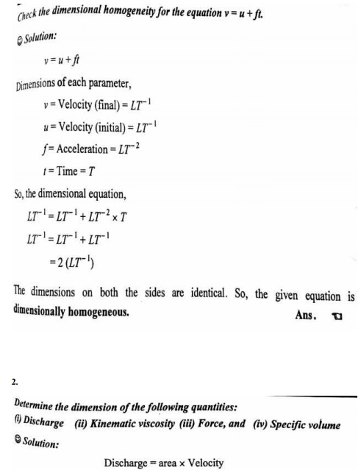
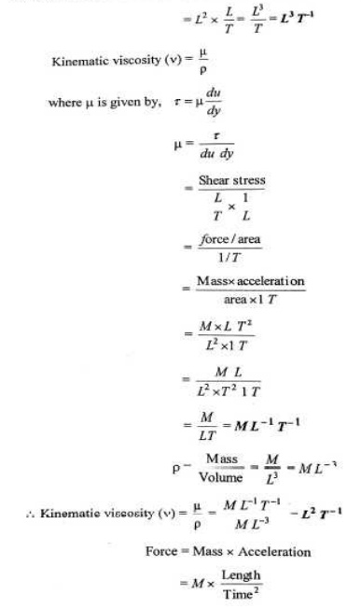
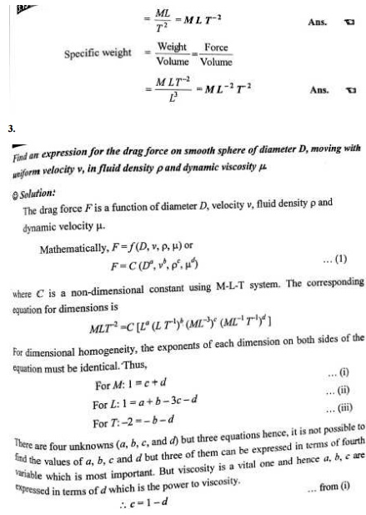
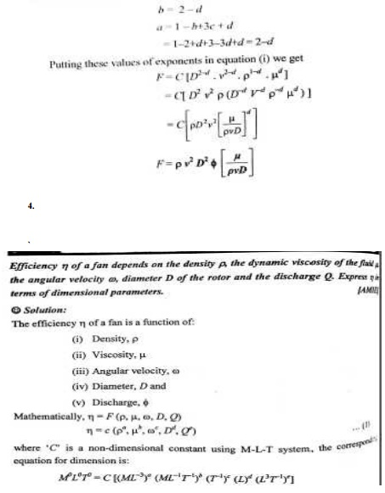
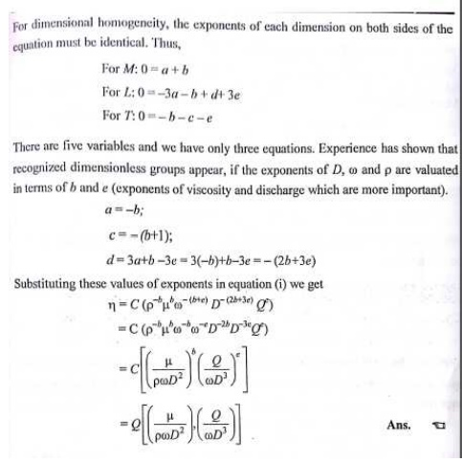
1. Define viscosity (u).

Viscosity is defined as the property of a fluid which offers resistance to the movement of one layer of fluid over another adjacent layer of the fluid.Viscosity is also defined as the shear stress required to produce unit rate of shear strain.

2. Define kinematic viscosity.

Kniematic viscosity is defined as the ratio between the dynamic viscosity and density of fluid. It is denoted by μ.

3. What is minor energy loss in pipes?

The loss of head or energy due to friction in a pipe is known as major loss while loss of energy due to change of velocity of fluid in magnitude or direction is called minor loss of energy. These include,

a. Loss of head due to sudden enlargement.
b. Loss of head due to sudden contraction.
c. Loss of head at entrance to a pipe.
d. Loss of head at exit of a pipe.
e. Loss of head due to an obstruction in a pipe.
f. Loss of head due to bend in a pipe.
g. Loss of head in various pipe fittings.

4. What is total energy line?

Total energy line is defined as the line which gives the sum of pressure head, datum head and kinetic head of a flowing fluid in a pipe with respect to some reference line. It is also defined as the line which is obtained by joining the tops of all vertical ordinates showing sum of the pressure head and kinetic head from the centre of the pipe.

5. What is hydraulic gradient line?

Hydraulic gradient line gives the sum of (p/w+z) with reference to datum line. Hence hydraulic gradient line is obtained by subtracting v2 / 2g from total energy line.

6. What is meant by pipes in series?

When pipes of different lengths and different diameters are connected end to end, pipes are called in series or compound pipe. The rate of flow through each pipe connected in series is same.

7. What is meant by pipes in parallel?

When the pipes are connected in parallel, the loss of head in each pipe is same. The rate of flow in main pipe is equal to the sum of rate of flow in each pipe, connected in parallel.

8. What is boundary layer and boundary layer theory?

When a solid body immersed in the flowing fluid, the variation of velocity from zero to free stream velocity in the direction normal to boundary takes place in a narrow region in the vicinity of solid boundary. This narrow region of fluid is called boundary layer. The theory dealing with boundary layer flow is called boundary layer theory.

9. What is turbulent boundary layer?

If the length of the plate is more then the distance x, the thickness of boundary layer will go on increasing in the downstream direction. Then laminar boundary becomes unstable and motion of fluid within it, is disturbed and irregular which leads to a transition from laminar to turbulent boundary layer.

10. What is boundary layer thickness?

Boundary layer thickness (S) is defined as the distance from boundary of the solid body measured in y-direction to the point where the velocity of fluid is approximately equal to 0.99 times the free steam (v) velocity of fluid.

11. Define displacement thickness

Displacement thickness (S*) is defined as the distances, measured perpendicular to the boundary of the solid body, by which the boundary should be displaced to compensate for the reduction inflow rate on account of boundary layer formation.

12. What is momentum thickness?

Momentum thickness (0) is defined as the distance, measured perpendicular to the boundary of the solid body, by which the boundary should be displaced to compensate for the reduction in momentum of flowing fluid on account of boundary layer formation.

13.Mention the general characteristics of laminar flow.

• There is a shear stress between fluid layers

• ‘No slip’ at the boundary

• The flow is rotational

• There is a continuous dissipation of energy due to viscous shear

14. What is Hagen poiseuille’s formula ?
P1-P2 / pg = h f = 32 µ UL / _gD²

The expression is known as Hagen poiseuille formula .
Where P1-P2 / _g = Loss of pressure head U = Average velocity
µ = Coefficient of viscosity D = Diameter of pipe

L = Length of pipe

15.What are the factors influencing the frictional loss in pipe flow ?
Frictional resistance for the turbulent flow is

i. Proportional to vn where v varies from 1.5 to 2.0 . ii. Proportional to the density of fluid .

iii. Proportional to the area of surface in contact . iv. Independent of pressure .

v. Depend on the nature of the surface in contact .

16. What is the expression for head loss due to friction in Darcy formula ?

hf = 4fLV² / 2gD
Where f = Coefficient of friction in pipe L = Length of the pipe

D = Diameter of pipe V = velocity of the fluid

17. What do you understand by the terms

a) major energy losses , b) minor energy losses Major energy losses : -

This loss due to friction and it is calculated by Darcy weis bach formula and chezy’s formula .

Minor energy losses :- This is due to

h. Sudden expansion in pipe .ii. Sudden contraction in pipe . iii. Bend in pipe .iv. Due to obstruction in pipe .

18. Give an expression for loss of head due to sudden enlargement of the pipe :

he = (V1-V2)² /2g
Wherehe = Loss of head due to sudden enlargement of pipe . V1 = Velocity of flow at section 1-1

V2 = Velocity of flow at section 2-2

19.Give an expression for loss of head due to sudden contraction : hc =0.5 V²/2g
Where hc = Loss of head due to sudden contraction . V = Velocity at outlet of pipe.

20. Give an expression for loss of head at the entrance of the pipe hi =0.5V2/2g
where hi = Loss of head at entrance of pipe .

V = Velocity of liquid at inlet and outlet of the pipe .

21. What is sypon ? Where it is used: _

Sypon is along bend pipe which is used to transfer liquid from a reservoir at a higher elevation to another reservoir at a lower level .

Uses of sypon : -
1. To carry water from one reservoir to another reservoir separated by a hill ridge .
2. To empty a channel not provided with any outlet sluice .

