TURNING MACHINES

Center Lathes

A lathe is a machine tool that rotates the work piece against a tool whose position it controls. The spindle is the part of the lathe that rotates. Various work holding attachments such as three jaw chucks, collets, and centers can be held in the spindle. The spindle is driven by an electric motor through a system of belt drives and gear trains. Spindle rotational speed is controlled by varying the geometry of the drive train.

The tailstock can be used to support the end of the workpiece with a center, or to hold tools for drilling, reaming, threading, or cutting tapers. It can be adjusted in position along the ways to accommodate different length workpieces. The tailstock barrel can be fed along the axis of rotation with the tailstock hand wheel.

The carriage controls and supports the cutting tool. It consists of:

A saddle that slides along the ways;

An apron that controls the feed mechanisms;

A cross slide that controls transverse motion of the tool (toward or away from the operator);

A tool compound that adjusts to permit angular tool movement; v a tool post that holds the cutting tools.
This machine tool is manually operated that is why it requires skilled operators. Suitable for low and medium production and for repair works.

There are two tool feed mechanism in the engine lathes. These cause the cutting tool to move when engaged.

The lead screw will cause the apron and cutting tool to advance quickly. This is used for cutting threads, and for moving the tool quickly.

The feed rod will move the apron and cutting tool slowly forward. This is largely used for most of the turning operations.

Work is held in the lathe with a number of methods.

Between two centers. The work piece is driven by a device called a dog; the method is suitable for parts with high length-to-diameter ratio.

There are a number of different lathe designs, and some of the most popular are discussed here.
Centre lathe
The basic, simplest and most versatile lathe.

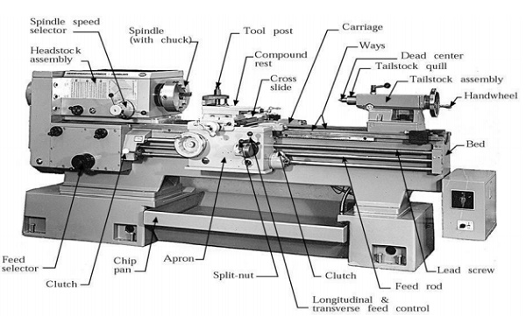

A 3 jaw self-centering chuck is used for most operations on cylindrical work parts. For parts with high length-to-diameter ratio the part is supported by center on the other end.

Collet consists of tubular bushing with longitudinal slits. Collets are used to grasp and hold bar stock. A collet of exact diameter is required to match any bar stock diameter.

A face plate is a device used to grasp parts with irregular shapes:

Taper turning methods
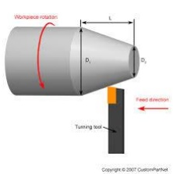

A taper is a conical shape. Tapers can be cut with lathes quite easily. There are some common methods for turning tapers on an center lathe,

Using a form tool: This type of tool is specifically designed for one cut, at a certain taper angle. The tool is plunged at one location, and never moved along the lathe slides. v Compound Slide

Method: The compound slide is set to travel at half of the taper angle. The tool is then fed across the work by hand, cutting the taper as it goes. v Off-Set Tail Stock: In this method the normal rotating part of the lathe still drives the workpiece (mounted between centres), but the centre at the tailstock is offset towards/away from the cutting tool. Then, as the cutting tool passes over, the part is cut in a conical shape. This method is limited to small tapers over long lengths. The tailstock offset h is defined by

h = L sinα, where L is the length of work piece, and α is the half of the taper angle.

Thread cutting methods
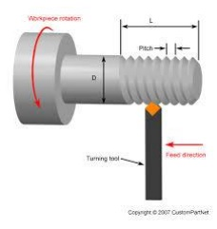
Different possibilities are available to produce a thread on a lathe. Threads are cut using lathes by advancing the cutting tool at a feed exactly equal to the thread pitch. The single-point cutting tool cuts in a helical band, which is actually a thread. The procedure calls for correct settings of the machine, and also that the helix be restarted at the same location each time if multiple passes are required to cut the entire depth of thread. The tool point must be ground so that it has the same profile as the thread to be cut.

Another possibility is to cut threads by means of a thread die (external threads), or a tap (internal threads). These operations are generally performed manually for small thread diameters.
Special Attachments

Unless a workpiece has a taper machined onto it which perfectly matches the internal taper in the spindle, or has threads which perfectly match the external threads on the spindle (two conditions which rarely exist), an accessory must be used to mount a workpiece to the spindle.

A workpiece may be bolted or screwed to a faceplate, a large, flat disk that mounts to the spindle. In the alternative, faceplate dogs may be used to secure the work to the faceplate.

A workpiece may be mounted on a mandrel, or circular work clamped in a three- or four-jaw chuck. For irregular shaped workpieces it is usual to use a four jaw (independent moving jaws) chuck. These holding devices mount directly to the Lathe headstock spindle.

In precision work, and in some classes of repetition work, cylindrical work pieces are usually held in a collet inserted into the spindle and secured either by a draw-bar, or by a collet closing cap on the spindle. Suitable collets may also be used to mount square or hexagonal work pieces. In precision tool making work such collets are usually of the draw-in variety, where, as the collet is tightened, the work piece moves slightly back into the headstock, whereas for most repetition work the dead length variety is preferred, as this ensures that the position of the workpiece does not move as the collet is tightened.

A soft work piece (e.g., wood) may be pinched between centers by using a spur drive at the headstock, which bites into the wood and imparts torque to it.
Machining time

Machining time is the time when a machine is actually processing something. Generally, machining time is the term used when there is a reduction in material or removing some undesirable parts of a material. For example, in a drill press, machining time is when the cutting edge is actually moving forward and making a hole. Machine time is used in other situations, such as when a machine installs screws in a case automatically.

One of the important aspects in manufacturing calculation is how to find and calculate the machining time in a machining operation. Generally, machining is family of processes or operations in which excess material is removed from a starting work piece by a sharp cutting tool so the remaining part has the desired geometry and the required shape. The most common machining operations can be classified into four types: turning, milling, drilling and lathe work.

Calculate Time for Turning
Capstan versus turret
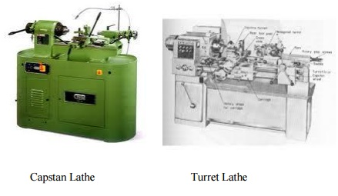

The term "capstan lathe" overlaps in sense with the term "turret lathe" to a large extent. In many times and places, it has been understood to be synonymous with "turret lathe". In other times and places it has been held in technical contradistinction to "turret lathe", with the difference being in whether the turret's slide is fixed to the bed (ram-type turret) or slides on the bed's ways (saddle-type turret). The difference in terminology is mostly a matter of United Kingdom and Common wealth usage versus United States usage. American usage tends to call them all "turret lathes".

The word "capstan" could logically seem to refer to the turret itself, and to have been inspired by the nauticalcapstan. A lathe turret with tools mounted in it can very much resemble a nautical capstan full of handspikes.This interpretation would lead Americans to treat "capstan" as a synonym of "turret" and "capstan lathe" as a synonym of "turret lathe". However, the multi-spoked handles that the operator uses to advance the slide are also called capstans, and they themselves also resemble the nautical capstan.

No distinction between "turret lathe" and "capstan lathe" persists upon translation from English into other languages. Most translations involve the term "revolver", and serve to translate either of the English terms.

The words "turret" and "tower", the former being a diminutive of the latter, come ultimately from the Latin "turris", which means "tower", and the use of "turret" both to refer to lathe turrets and to refer to gun turrets seems certainly to have been inspired by its earlier connection to the turrets of fortified buildings and to siege towers. The history of the rook in chess is connected to the same history, with the French word for rook, tour, meaning "tower".

It is an interesting coincidence that the word "tour" in French can mean both "lathe" and "tower", with the first sense coming ultimately from Latin "tornus", "lathe", and the second sense coming ultimately from Latin "turris", "tower". "Tour revolver", "tour tourelle", and "tour tourelle revolver" are various ways to say "turret lathe" in French.

Semi-automatic

Sometimes machines similar to those above, but with power feeds and automatic turret-indexing at the end of the return stroke, are called "semi-automatic turret lathes". This nomenclature distinction is blurry and not consistently observed. The term "turret lathe" encompasses them all. During the 1860s, when semi-automatic turret lathes were developed, they were sometimes called "automatic". What we today would call "automatics", that is, fully automatic machines, had not been developed yet. During that era both manual and semi-automatic turret lathes were sometimes called "screw machines", although we today reserve that term for fully automatic machines.

Automatic

During the 1870s through 1890s, the mechanically automated "automatic" turret lathe was developed and disseminated. These machines can execute many part-cutting cycles without human intervention. Thus the duties of the operator, which were already greatly reduced by the manual turret lathe, were even further reduced, and productivity increased. These machines use cams to automate the sliding and indexing of the turret and the opening and closing of the chuck. Thus, they execute the part-cutting cycle somewhat analogously to the way in which an elaborate cuckoo clock performs an automated theater show. Small- to medium-sized automatic turret lathes are usually called "screw machines" or "automatic screw machines", while larger ones are usually called "automatic chucking lathes", "automatic chuckers", or "chuckers".

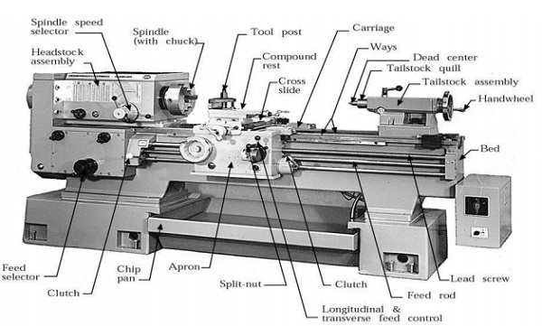

Special Attachments

Unless a workpiece has a taper machined onto it which perfectly matches the internal taper in the spindle, or has threads which perfectly match the external threads on the spindle (two conditions which rarely exist), an accessory must be used to mount a workpiece to the spindle.

A workpiece may be bolted or screwed to a faceplate, a large, flat disk that mounts to the spindle. In the alternative, faceplate dogs may be used to secure the work to the faceplate.

A workpiece may be mounted on a mandrel, or circular work clamped in a three- or four-jaw chuck. For irregular shaped workpieces it is usual to use a four jaw (independent moving jaws) chuck. These holding devices mount directly to the Lathe headstock spindle.

In precision work, and in some classes of repetition work, cylindrical workpieces are usually held in a collet inserted into the spindle and secured either by a draw-bar, or by a collet closing cap on the spindle. Suitable collets may also be used to mount square or hexagonal workpieces. In precision tool making work such collets are usually of the draw-in variety, where, as the collet is tightened, the workpiece moves slightly back into the headstock, whereas for most repetition work the dead length variety is preferred, as this ensures that the position of the workpiece does not move as the collet is tightened.

A soft workpiece (e.g., wood) may be pinched between centers by using a spur drive at the headstock, which bites into the wood and imparts torque to it.

TURNING MACHINES

1. What is a Lathe?
Lathe is a machine tool which removes the metal from a piece of work to the required shape and size.

2. What are the uses of headstock?
Headstock carries a hollow spindle with nose to hold the work piece. To Mount the driving and speed changing mechanisms.

3. What is an apron?
The integral part of several gears, levers and clutches mounted with the saddle for moving the carriage along with lead screw while thread cutting.

4. What are the advantages semi-automatic lathes?
Production time is minimized Accuracy will be high. Production rate is increased.

5. List any four work holding devices.
1. Chucks. 2. Centres. 3. Faceplates. 4.Angle Plate.

6. Compare the advantages of turret lathe over capstan lathe
Heavier and Larger workpiece chucking can be done. More rigid, hence it withstands heavy cuts.

7.Name any four tool holding devices used in capstan and turret lathe.
Multiple cutter holders. Offset cutter holder.
Sliding cutter holder. Knee tool holder.

8. What are the four types of tool post?
1. Single screw 2. Open side
3. Four bolt 4. Four way

9. List any four types of lathe?
1. Engine lathe 2. Bench lathe
Semi automatic 3. Tool room lathe 4. Lathe

5.Automatic lathe
10.What is a semi-automatic lathe?

The lathe in which all the machining operations are performed automatically and loading and unloading of work piece, coolant on or off is performed manually

11.State the various feed mechanisms used for obtaining automatic feed?

1.Tumbler gear mechanism

2.Quick change gearbox

3.Tumbler gear- Quick change gearbox

4.Apron mechanism

12.What are the different operations performed on the lathe?

Centering, straight turning, rough turning, finish turning, shoulder turning, facing, chamfering, knurling, etc.

13. Define the term ‘Conicity’?

The ratio of the difference in diameters of tapers its length k= D-dd-smaller dia

D-larger dia

l-length of the work piece

14.State the purpose of providing lead cam in single spindle automatic screw cutting machine?

The turret slide travel is controlled by a lead cam. The lead cam gives a slow forward and fast return movement to the turret slide.

15.What are the advantages of sliding head automatic lathes?

The advantages of a sliding head automatic lathe is that long slender work pieces can be machined with very good surface finish, accuracy and concentricity in sliding head automatic lathes.

