THEORY OF METAL CUTTING

Definitions

Machining: Term applied to all material-removal processes

Metal cutting: The process in which a thin layer of excess metal (chip) is removed by a wedge-shaped single-point or multipoint cutting tool with defined geometry from a work piece, through a process of extensive plastic deformation

MECHANICS OF CHIP FORMATION

The cutting itself is a process of extensive plastic deformation to form a chip that is removed afterward. The basic mechanism of chip formation is essentially the same for all machining operations. Assuming that the cutting action is continuous, we can develop so-called continuous model of cutting process.
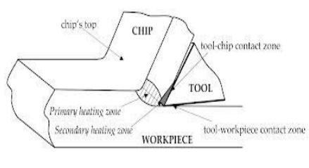
The cutting model shown above is oversimplified. In reality, chip formation occurs not in a plane but in so-called primary and secondary shear zones, the first one between the cut and chip, and the second one along the cutting tool face.

Single-point cutting tool,

As distinguished from other cutting tools such as a The cutting edge is ground to suit a particular machining operation and may be re sharpened or reshaped as needed. The ground tool bit is held rigidly by a tool holder while it is cutting.

Back Rake is to help control the direction of the chip, which naturally curves into the work due to the difference in length from the outer and inner parts of the cut. It also helps counteract the pressure against the tool from the work by pulling the tool into the work.

Side Rake along with back rake controls the chip flow and partly counteracts the resistance of the work to the movement of the cutter and can be optimized to suit the particular material being cut. Brass for example requires a back and side rake of 0 degrees while aluminum uses a back rake of 35 degrees and a side rake of 15 degrees. Nose Radius makes the finish of the cut smoother as it can overlap the previous cut and eliminate the peaks and valleys that a pointed tool produces. Having a radius also strengthens the tip, a sharp point being quite fragile.
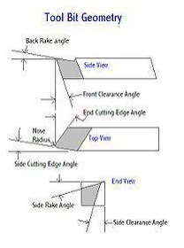
All the other angles are for clearance in order that no part of the tool besides the actual cutting edge can touch the work. The front clearance angle is usually 8 degrees while the side clearance angle is 10-15 degrees and partly depends on the rate of feed expected.

Minimum angles which do the job required are advisable because the tool gets weaker as the edge gets keener due to the lessening support behind the edge and the reduced ability to absorb heat generated by cutting.

The Rake angles on the top of the tool need not be precise in order to cut but to cut efficiently there will be an optimum angle for back and side rake.
Forces in machining

If you make a free body analysis of the chip, forces acting on the chip would be as follows.

At cutting tool side due to motion of chip against tool there will be a frictional force and a normal force to support that. At material side thickness of the metal increases while it flows from uncut to cut portion. This thickness increase is due to inter planar slip between different metal layers. There should be a shear force (Fs) to support this phenomenon. According to shear plane theory this metal layer slip happens at single plane called shear plane. So shear force acts on shear plane. Angle of shear plane can approximately determined using shear plane theory analysis. It is as follows $φ={45}^{0 }+\frac{α}{2}-\frac{β}{2}$
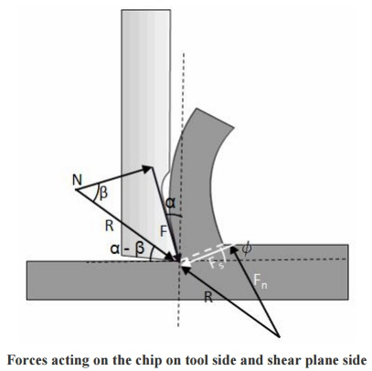
Forces acting on the chip on tool side and shear plane side

Shear force on shear plane can be determined using shear strain rate and properties of material. A normal force (Fn) is also present perpendicular to shear plane. The resultant force

(R) at cutting tool side and metal side should balance each other in order to make the chip in equilibrium. Direction of resultant force, R is determined as shown in Figure.
Types of chip

There are three types of chips that are commonly produced in cutting,

Discontinuous chips

Continuous chips

Continuous chips with built up edge

A discontinuous chip comes off as small chunks or particles. When we get this chip it may indicate,

Brittle work material

Small or negative rake angles

Coarse feeds and low speeds

A continuous chip looks like a long ribbon with a smooth shining surface. This chip type may indicate,

Ductile work materials

Large positive rake angles

Fine feeds and high speeds

Continuous chips with a built up edge still look like a long ribbon, but the surface is no longer smooth and shining. Under some circumstances (low cutting speeds of ~0.5 m/s, small or negative rake angles),
Work materials like mild steel, aluminum, cast iron, etc., tend to develop so-called built-up edge, a very hardened layer of work material attached to the tool face, which tends to act as a cutting edge itself replacing the real cutting tool edge. The built-up edge tends to grow until it reaches a critical size (~0.3 mm) and then passes off with the chip, leaving small fragments on the machining surface. Chip will break free and cutting forces are smaller, but the effects is a rough machined surface. The built-up edge disappears at high cutting speeds.

Chip control

Discontinuous chips are generally desired because

They are less dangerous for the operator

Do not cause damage to workpiece surface and machine tool

Can be easily removed from the work zone

Can be easily handled and disposed after machining.

There are three principle methods to produce the favorable discontinuous chip:

Proper selection of cutting conditions

Use of chip breakers

Change in the work material properties
Chip breaker

Chip break and chip curl may be promoted by use of a so-called chip breaker. There are two types of chip breakers

External type, an inclined obstruction clamped to the tool face

Integral type, a groove ground into the tool face or bulges formed onto the tool face
Cutting tool nomenclature
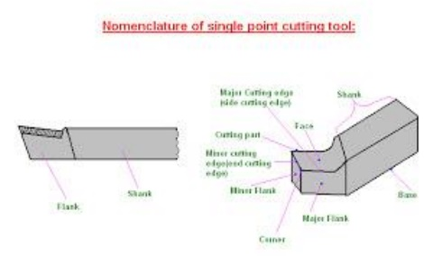
Back Rake is to help control the direction of the chip, which naturally curves into the work due to the difference in length from the outer and inner parts of the cut. It also helps counteract the pressure against the tool from the work by pulling the tool into the work.

Side Rake along with back rake controls the chip flow and partly counteracts the resistance of the work to the movement of the cutter and can be optimized to suit the particular material being cut. Brass for example requires a back and side rake of 0 degrees while aluminum uses a back rake of 35 degrees and a side rake of 15 degrees.

Nose Radius makes the finish of the cut smoother as it can overlap the previous cut and eliminate the peaks and valleys that a pointed tool produces. Having a radius also strengthens the tip, a sharp point being quite fragile.

All the other angles are for clearance in order that no part of the tool besides the actual cutting edge can touch the work. The front clearance angle is usually 8 degrees while the side clearance angle is 10-15 degrees and partly depends on the rate of feed expected.

Minimum angles which do the job required are advisable because the tool gets weaker as the edge gets keener due to the lessening support behind the edge and the reduced ability to absorb heat generated by cutting.

The Rake angles on the top of the tool need not be precise in order to cut but to cut efficiently there will be an optimum angle for back and side rake.

Orthogonal metal cutting
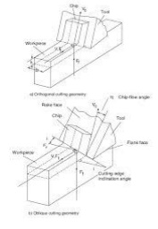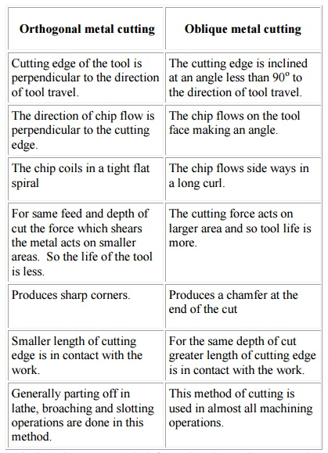
Orthogonal metal cutting

Cutting edge of the tool is perpendicular to the direction of tool travel.

The direction of chip flow is perpendicular to the cutting edge.

The chip coils in a tight flat spiral

For same feed and depth of cut the force which shears the metal acts on smaller areas. So the life of the tool is less.

Produces sharp corners.

Smaller length of cutting edge is in contact with the work.

Generally parting off in lathe, broaching and slotting operations are done in this method.

Oblique metal cutting

The cutting edge is inclined at an angle less than 90o to the direction of tool travel.

The chip flows on the tool face making an angle.

The chip flows side ways in a long curl.

The cutting force acts on larger area and so tool life is more.

Produces a chamfer at the end of the cut

For the same depth of cut greater length of cutting edge is in contact with the work.

This method of cutting is used in almost all machining operations.
Depending on whether the stress and deformation in cutting occur in a plane (two-dimensional case) or in the space (three-dimensional case), we consider two principle types of cutting:
Orthogonal cutting the cutting edge is straight and is set in a position that is perpendicular to the direction of primary motion. This allows us to deal with stresses and strains that act in a plane.

Oblique cutting the cutting edge is set at an angle.

According to the number of active cutting edges engaged in cutting, we distinguish again two types of cutting:

Single-point cutting the cutting tool has only one major cutting edge

Examples: turning, shaping, boring

Multipoint cutting the cutting tool has more than one major cutting edge

Examples: drilling, milling, broaching, reaming. Abrasive machining is by definition a process of multipoint cutting.
Cutting conditions

Each machining operation is characterized by cutting conditions, which comprises a set of three elements:

Cutting velocity: The traveling velocity of the tool relative to the work piece. It is measured in m/s or m/min.

Depth of cut: The axial projection of the length of the active cutting tool edge, measured in mm. In orthogonal cutting it is equal to the actual width of cut.

Feed: The relative movement of the tool in order to process the entire surface of the work piece. In orthogonal cutting it is equal to the thickness of cut and is measured in mm.

Thermal aspects

In cutting, nearly all of energy dissipated in plastic deformation is converted into heat that in turn raises the temperature in the cutting zone. Since the heat generation is closely related to the plastic deformation and friction, we can specify three main sources of heat when cutting,

Plastic deformation by shearing in the primary shear zone

Plastic deformation by shearing and friction on the cutting face

Friction between chip and tool on the tool flank

Heat is mostly dissipated by,

The discarded chip carries away about 60~80% of the total heat

The workpiece acts as a heat sink drawing away 10~20% heat
The cutting tool will also draw away ~10% heat

If coolant is used in cutting, the heat drawn away by the chip can be as big as 90% of the total heat dissipated. Knowledge of the cutting temperature is important because it:

Affects the wear of the cutting tool. Cutting temperature is the primary factor affecting the cutting tool wear can induce thermal damage to the machined surface. High surface temperatures promote the process of oxidation of the machined surface. The oxidation layer has worse mechanical properties than the base material, which may result in shorter service life. Causes dimensional errors in the machined surface. The cutting tool elongates as a result of the increased temperature, and the position of the cutting tool edge shifts toward the machined surface, resulting in a dimensional error of about 0.01~0.02 mm. Since the processes of thermal generation, dissipation, and solid body thermal deformation are all transient, some time is required to achieve a steady-state condition

Cutting temperature determination

Cutting temperature is either measured in the real machining process, or predicted in the machining process design. The mean temperature along the tool face is measured directly by means of different thermocouple techniques, or indirectly by measuring the infrared radiation, or examination of change in the tool material microstructure or micro hardness induced by temperature. Some recent indirect methods are based on the examination of the temper color of a chip, and on the use of thermo sensitive paints.

There are no simple reliable methods of measuring the temperature field. Therefore, predictive approaches must be relied on to obtain the mean cutting temperature and temperature field in the chip, tool and work piece.

For cutting temperature prediction, several approaches are used:

Analytical methods: there are several analytical methods to predict the mean temperature. The interested readers are encouraged to read more specific texts, which present in detail these methods. Due to the complex nature of the metal cutting process, the analytical methods are typically restricted to the case of orthogonal cutting.

Numerical methods: These methods are usually based on the finite element modeling of metal cutting. The numerical methods, even though more complex than the analytical approaches, allow for prediction not only of the mean cutting temperature along the tool face but also the temperature field in orthogonal and oblique cutting.

Cutting tool materials

Requirements

The cutting tool materials must possess a number of important properties to avoid excessive wear, fracture failure and high temperatures in cutting, the following characteristics are essential for cutting materials to withstand the heavy conditions of the cutting process and to produce high quality and economical parts:
Hardness at elevated temperatures (so-called hot hardness) so that hardness and strength of the tool edge are maintained in high cutting temperatures:

Toughness: ability of the material to absorb energy without failing. Cutting if often accompanied by impact forces especially if cutting is interrupted, and cutting tool may fail very soon if it is not strong enough.

Wear resistance: although there is a strong correlation between hot hardness and wear resistance, later depends on more than just hot hardness. Other important characteristics include surface finish on the tool, chemical inertness of the tool material with respect to the work material, and thermal conductivity of the tool material, which affects the maximum value of the cutting temperature at tool-chip interface.

Cutting tool materials

Carbon Steels

It is the oldest of tool material. The carbon content is 0.6~1.5% with small quantities of silicon, Chromium, manganese, and vanadium to refine grain size. Maximum hardness is about HRC 62. This material has low wear resistance and low hot hardness. The use of these materials now is very limited.

High-speed steel (HSS)

First produced in 1900s. They are highly alloyed with vanadium, cobalt, molybdenum, tungsten and Chromium added to increase hot hardness and wear resistance. Can be hardened to various depths by appropriate heat treating up to cold hardness in the range of HRC 63-65. The cobalt component give the material a hot hardness value much greater than carbon steels. The high toughness and good wear resistance make HSS suitable for all type of cutting tools with complex shapes for relatively low to medium cutting speeds. The most widely used tool material today for taps, drills, reamers, gear tools, end cutters, slitting, broaches, etc.

Cemented Carbides

Introduced in the 1930s. These are the most important tool materials today because of their high hot hardness and wear resistance. The main disadvantage of cemented carbides is their low toughness. These materials are produced by powder metallurgy methods, sintering grains of tungsten carbide (WC) in a cobalt (Co) matrix (it provides toughness). There may be other carbides in the mixture, such as titanium carbide (TiC) and/or tantalum carbide (TaC) in addition to WC.

Ceramics

Ceramic materials are composed primarily of fine-grained, high-purity aluminum oxide (Al2O3), pressed and sintered with no binder. Two types are available:

White, or cold-pressed ceramics, which consists of only Al2O3 cold pressed into inserts and sintered at high temperature.

Black, or hot-pressed ceramics, commonly known as cermets (from ceramics and metal). This material consists of 70% Al2O3 and 30% TiC. Both materials have very high wear resistance but low toughness; therefore they are suitable only for continuous operations such as finishing turning of cast iron and steel at very high speeds. There is no occurrence of built-up edge, and coolants are not required.

Cubic boron nitride (CBN) and synthetic diamonds
Diamond is the hardest substance ever known of all materials. It is used as a coating material in its polycrystalline form, or as a single-crystal diamond tool for special applications, such as mirror finishing of non-ferrous materials. Next to diamond, CBN is the hardest tool material. CBN is used mainly as coating material because it is very brittle. In spite of diamond, CBN is suitable for cutting ferrous materials.

Tool wear and tool life

The life of a cutting tool can be terminated by a number of means, although they fall broadly into two main categories:

Gradual wearing of certain regions of the face and flank of the cutting tool, and abrupt tool failure. Considering the more desirable case Œ the life of a cutting tool is therefore determined by the amount of wear that has occurred on the tool profile and which reduces the efficiency of cutting to an unacceptable level, or eventually causes tool failure. When the tool wear reaches an initially accepted amount, there are two options,

To resharpen the tool on a tool grinder, or

To replace the tool with a new one.

This second possibility applies in two cases,

When the resource for tool resharpening is exhausted. or

The tool does not allow for resharpening, e.g. in case of the indexable carbide inserts

Wear zones

Gradual wear occurs at three principal locations on a cutting tool. Accordingly, three main types of tool wear can be distinguished,

Crater wear
Flank wear

Corner wear

Crater wear: consists of a concave section on the tool face formed by the action of the chip sliding on the surface. Crater wear affects the mechanics of the process increasing the actual rake angle of the cutting tool and consequently, making cutting easier. At the same time, the crater wear weakens the tool wedge and increases the possibility for tool breakage. In general, crater wear is of a relatively small concern.

Flank wear: occurs on the tool flank as a result of friction between the machined surface of the workpiece and the tool flank. Flank wear appears in the form of so-called wear land and is measured by the width of this wear land, VB, Flank wear affects to the great extend the mechanics of cutting. Cutting forces increase significantly with flank wear. If the amount of flank wear exceeds some critical value (VB > 0.5~0.6 mm), the excessive cutting force may cause tool failure.
Corner wear: occurs on the tool corner. Can be considered as a part of the wear land and respectively flank wear since there is no distinguished boundary between the corner wear and flank wear land. We consider corner wear as a separate wear type because of its importance for the precision of machining. Corner wear actually shortens the cutting tool thus increasing gradually the dimension of machined surface and introducing a significant dimensional error in machining, which can reach values of about 0.03~0.05 mm.

Tool life

Tool wear is a time dependent process. As cutting proceeds, the amount of tool wear increases gradually. But tool wear must not be allowed to go beyond a certain limit in order to avoid tool failure. The most important wear type from the process point of view is the flank wear, therefore the parameter which has to be controlled is the width of flank wear land, VB. This parameter must not exceed an initially set safe limit, which is about 0.4 mm for carbide cutting tools. The safe limit is referred to as allowable wear land (wear criterion),

. The cutting time required for the cutting tool to develop a flank wear land of width is called tool life, T, a fundamental parameter in machining. The general relationship of VB versus cutting time is shown in the figure (so-called wear curve). Although the wear curve shown is for flank wear, a similar relationship occurs for other wear types. The figure shows also how to define the tool life T for a given wear criterion VBk
Parameters, which affect the rate of tool wear, are

Cutting conditions (cutting speed V, feed f, depth of cut d)

Cutting tool geometry (tool orthogonal rake angle)

Properties of work material

Surface finish

The machining processes generate a wide variety of surface textures. Surface texture consists of the repetitive and/or random deviations from the ideal smooth surface. These deviations are

Roughness: small, finely spaced surface irregularities (micro irregularities)

Waviness: surface irregularities of grater spacing (macro irregularities)

Lay: predominant direction of surface texture

Three main factors make the surface roughness the most important of these parameters:

Fatigue life: the service life of a component under cyclic stress (fatigue life) is much shorter if the surface roughness is high

Bearing properties: a perfectly smooth surface is not a good bearing because it cannot maintain a lubricating film.
Wear: high surface roughness will result in more intensive surface wear in friction.

Surface finish is evaluated quantitatively by the average roughness height, Ra

Roughness control
Factors, influencing surface roughness in machining are

Tool geometry (major cutting edge angle and tool corner radius),

Cutting conditions (cutting velocity and feed), and

Work material properties (hardness).

The influence of the other process parameters is outlined below:

Increasing the tool rake angle generally improves surface finish

Higher work material hardness results in better surface finish

Tool material has minor effect on surface finish.

Cutting fluids affect the surface finish changing cutting temperature and as a result the built-up edge formation.

Cutting fluids

Cutting fluid (coolant) is any liquid or gas that is applied to the chip and/or cutting tool to improve cutting performance. A very few cutting operations are performed dry, i.e., without the application of cutting fluids. Generally, it is essential that cutting fluids be applied to all machining operations.

Cutting fluids serve three principle functions:

To remove heat in cutting: the effective cooling action of the cutting fluid depends on the method of application, type of the cutting fluid, the fluid flow rate and pressure. The most effective cooling is provided by mist application combined with flooding. Application of fluids to the tool flank, especially under pressure, ensures better cooling that typical application to the chip but is less convenient.

To lubricate the chip-tool interface: cutting fluids penetrate the tool-chip interface improving lubrication between the chip and tool and reducing the friction forces and temperatures.

To wash away chips: this action is applicable to small, discontinuous chips only. Special devices are subsequently needed to separate chips from cutting fluids.

Methods of application

Manual application
Application of a fluid from a can manually by the operator. It is not acceptable even in job-shop situations except for tapping and some other operations where cutting speeds are very low and friction is a problem. In this case, cutting fluids are used as lubricants.

Flooding
In flooding, a steady stream of fluid is directed at the chip or tool-workpiece interface. Most machine tools are equipped with a recirculating system that incorporates filters for cleaning of cutting fluids. Cutting fluids are applied to the chip although better cooling is obtained by applying it to the flank face under pressure

Coolant-fed tooling

Some tools, especially drills for deep drilling, are provided with axial holes through the body of the tool so that the cutting fluid can be pumped directly to the tool cutting edge.

Mist applications

Fluid droplets suspended in air provide effective cooling by evaporation of the fluid. Mist application in general is not as effective as flooding, but can deliver cutting fluid to inaccessible areas that cannot be reached by conventional flooding.

Types of cutting fluid

Cutting Oils

Cutting oils are cutting fluids based on mineral or fatty oil mixtures. Chemical additives like sulphur improve oil lubricant capabilities. Areas of application depend on the properties of the particular oil but commonly, cutting oils are used for heavy cutting operations on tough steels.
Soluble Oils

The most common, cheap and effective form of cutting fluids consisting of oil droplets suspended in water in a typical ratio water to oil 30:1. Emulsifying agents are also added to promote stability of emulsion. For heavy-duty work, extreme pressure additives are used. Oil emulsions are typically used for aluminum and cooper alloys.

Chemical fluids

These cutting fluids consist of chemical diluted in water. They possess good flushing and cooling abilities. Tend to form more stable emulsions but may have harmful effects to the skin.

Environmental issues

Cutting fluids become contaminated with garbage, small chips, bacteria, etc., over time. Alternative ways of dealing with the problem of contamination are:

Replace the cutting fluid at least twice per month,

Machine without cutting fluids (dry cutting),
Use a filtration system to continuously clean the cutting fluid.

Disposed cutting fluids must be collected and reclaimed. There are a number of methods of reclaiming cutting fluids removed from working area. Systems used range from simple settlement tanks to complex filtration and purification systems. Chips are emptied from the skips into a pulverizer and progress to centrifugal separators to become a scrap material. Neat oil after separation can be processed and returned, after cleaning and sterilizing to destroy bacteria.
Machinability

Machinability is a term indicating how the work material responds to the cutting process. In the most general case good machinability means that material is cut with good surface finish, long tool life, low force and power requirements, and low cost.

Machinability of different materials

Steels Leaded steels: lead acts as a solid lubricant in cutting to improve considerably machinability.

Resulphurized steels: sulphur forms inclusions that act as stress raisers in the chip formation zone thus increasing machinability.

Difficult-to-cut steels: a group of steels of low machinability, such as stainless steels, high manganese steels, precipitation-hardening steels.

Other metals

Aluminum: easy-to-cut material except for some cast aluminum alloys with silicon content that may be abrasive.

Cast iron: gray cast iron is generally easy-to-cut material, but some modifications and alloys are abrasive or very hard and may cause various problems in cutting.

Cooper-based alloys: easy to machine metals. Bronzes are more difficult to machine than brass.

Selection of cutting conditions

For each machining operation, a proper set of cutting conditions must be selected during the process planning. Decision must be made about all three elements of cutting conditions,

Depth of cut

Feed
Cutting speed

There are two types of machining operations:

Roughing operations: the primary objective of any roughing operation is to remove as much as possible material from the work piece for as short as possible machining time. In roughing operation, quality of machining is of a minor concern.
Finishing operations: the purpose of a finishing operation is to achieve the final shape, dimensional precision, and surface finish of the machined part. Here, the quality is of major importance. Selection of cutting conditions is made with respect to the type of machining operation. Cutting conditions should be decided in the order depth of cut - feed - cutting speed.
THEORY OF METAL CUTTING

1. Define Metal Cutting .

Metal cutting or machining is the process of by removing unwanted material from a block of metal in the form of chips.

2. What are the important characteristics of materials used for cutting tools?

High red hardness High wear resistance

Low frictional co- efficient
High toughness

High thermal conductivity.

3. How do you define tool life?

The time period between two consecutive resharpening, with which the cuts the material effectively is called as tool life.

4. What is tool signature?

The various angles of tools are mentioned in a numerical number in particular order. That is known as tool signature.

5. What is the effect of back rack angle and mention the types?

Back rake angle of tool is increases the strength of cutting tool and cutting action. It can be classified in to two types.

1. Negative Rake angle.

2. Positive rake angle.
6. Explain the nose radius?

Joining of side and end cutting edges by means of small radius in order to increase the tool life and better surface finish on the work piece.

7. What are all conditions for using positive rake angle?

1. To machine the work hardened materials.

2. To machine low strength ferrous and non-ferrous metals.

3. To machine long shaft of small diameters.

4. To machine the metal blow recommended cutting speeds.

5. Using small machine tools with low horsepower.

8. Define the orthogonal and oblique cutting.

Orthogonal cutting: The cutting edge of tool is perpendicular to the work piece axis. Oblique cutting: The cutting edge is inclined at an acute angle with normal to the cutting velocity vector is called oblique cutting process.

9. What are the favorable factors for discontinuous chip formation?

Maching of brittle materials. Small rake angle

Higher depth of cut Low cutting speeds

Excess cutting fluid.

Cutting ductile materials with low speed and small rake angle of the tool.
10. What are the favorable factors for continuous chip formation?

Small rake angle Low cutting speed

Strong adhesion between chip and tool face. Coarse feed

Insufficient cutting fluid. Large uncut thickness.

11. Define machineability of metal.

Machine ability is defined as the ease with which a material can be satisfactorily machined.

Life of the tool before tool failure or resharpening.

12. What is shear plane?

The material of work piece is stressed beyond its yield point under the compressive force. This causes the material to deform plastically and shear off. The plastic floe takes place in a localized region is called shear plane.

13. What is chip and mention its different types?

The sheared material begins to along the cutting tool face in the form of small pieces is called chip. The chips are mainly classified into three types.

a. Continuous chip.

b. Discontinuous chip.

c. Continuous chip with built up edge.
14. Write the factors affecting the tool life or Write the Taylor’s tool life equation.

Taylor’s equation VT n = C

i. Cutting speed

ii. Feed and Depth of cut. iii.Tool Geometry

iv.Tool material

v. Type of Cutting Fluid

vi.Work material

vii.Rigidity of the Machine tool.

15. Define “Side relief” and “End relief” angle.

Side relief angle: It is the angle between the portion of the side flank immediately below the side cutting edge and a line perpendicular to the base of the tool, and measured at right angle to the side flank.

End relief angle: It is the angle between the portion of the end flank immediately below the end cutting edge and a line perpendicular to the base of the tool, and measured at right angle to the angle.

16. What are the importance of Nose Radius?

Nose radius is favorable to long tool life and good surface finish. A sharp point on the end of a tool is highly stressed, Short lived and leaves a groove in the path of cut. There is an improvement in surface finish and permissible cutting speed as nose radius is increased from zero value.

17. What are the differences between orthogonal cutting and oblique cutting?
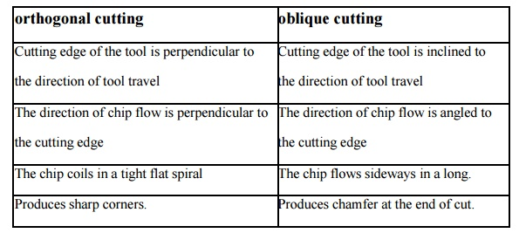

orthogonal cutting
Cutting edge of the tool is perpendicular to the direction of tool travel
The direction of chip flow is perpendicular to the cutting edge
The chip coils in a tight flat spiral
Produces sharp corners.

oblique cutting
Cutting edge of the tool is inclined to the direction of tool travel
The direction of chip flow is angled to the cutting edge
The chip flows sideways in a long.
Produces chamfer at the end of cut.

