INTRODUCTION

Since the world’s resources of material and energy are getting progressively, by necessity, there is growing involvement in studies of wear on a global basis. Wear of sliding components result in reduced mechanical efficiency and an irretrievable loss of material in the form of wear debris. Wear at the interface between moving particles is a normal characteristic of machine operation. The kind and rate of wear depend on the machine type. Lubrication is provided between the moving surface to minimize the wear but during operations millions minute wear particles entering the lubricating oil. These particles are in suspension in the oil, larger particles may be trapped by filter while others generally too small to be removed, remain in suspension in the circulating oil.

Condition based monitoring has, in the past, been referred to as an art, when quite clearly it is a science, and despites the cost of machine, surprisingly little attention has been devoted to this science from the viewpoint of understanding and modeling failure mechanisms and the study of probability to failure. Predictive maintenance technique has now become common exercises as they maximize the machine availability time and minimize the cost of maintenance, since the machine can be stopped just before as impending problem in an other wise healthy machine

Fault detection using vibration analysis is difficult in very low speed – high load noisy machines. In the case of slow speed bearing the vibration generated by damaged components is very low, usually close to the floor noise and difficult to identify. In these situations, Wear Debris Analysis has proven useful in providing supporting evidence on the bearing or gear status. It also provides information on the wear mechanism, which is involved.

WEAR MECHANISMS AND PARTICLES

Sliding adhesive wear particles are found in most lubricating oils. They are an indication of normal wear. They are produced in large numbers when one metal surface moves across another. The particles are seen as thin asymmetrical flakes of metals with highly polished surfaces.
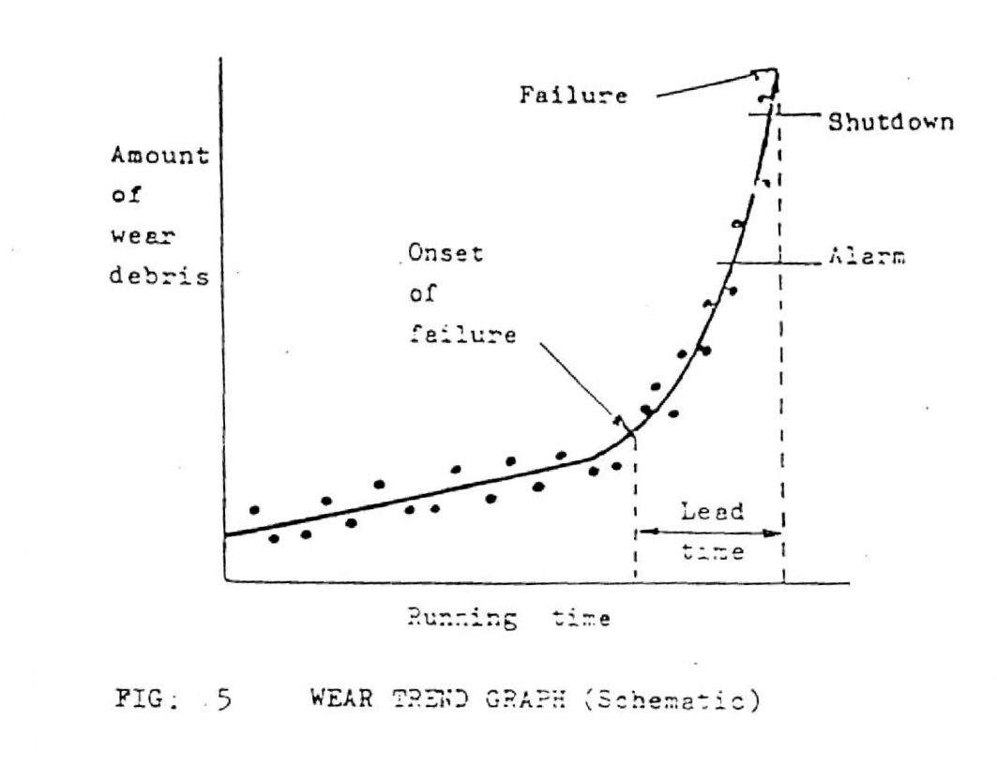

Cutting abrasive wear produces another particle type. These particles resemble most of all shavings from a metal shop. E.g.: Spiral, loops and threads.
These presences of a few of these particles are not significant, but if there are several hundred, it is an indication of serious cutting wear. A sudden dramatic increase in the quantity of cutting particles indicates that the break down is imminent.

SURFACE FATIGUE

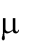
A consequence of periodic stresses with very high local tension in the surface, which occurs, with the meshing of years. These wear mechanisms give plate particles a rough surface and an irregular perimeter. Small particles often develop in connection with roller bearings. Refer table 1.

TYPE OF COMPONENT | TYPICAL EXAMPLE | NATURE OF WEAR DEBRIS ASSOCOATED WITH FAILURE
Loaded, moving components in which load is concentrated in a non confirmed contact | Rolling bearings, gear teeth, cams and tappets | Ferrous particles of various size and shapes
Loaded, moving components in which load is concentrated in a small area | Piston rings and cylinders splines, gear couplings | Ferrous flakes less than 150 m across, and fine iron or iron oxide particles
Loaded, moving components with the load spread over a large area | Plain bearings, pistons and cylinders | Usually very small and ferrous and non- ferrous flakes and particles, bearing fatigue can give rise to larger flakes

WEAR METALS

Wear metals are caused by the relative motion between metallic parts. The motion is accompanied by friction and wear on the surfaces, which are in contact with one another. The metal particles are rubbed off due to friction and enter the lubricating oil, the degree of wear can be evaluated as being normal or abnormal. The wear metals have the same chemical composition as the components from which they come, and type of wear metal can provide information on which part being worn. Increased quantities of iron are common, since many parts are composed of iron, while an increase in

content of less common metals such as silver can often indicate precisely which component is being worn abnormally.
The size and shape of wear material will differentiate between the following wear mechanisms.

►Rubbing

►Surface Fatigue

►Corrosion

►Sliding

►Cutting

The particle material will pin point to the source and therefore deteriorating component- wearing race, rolling element or cage, rubbing scales, gear teeth etc.

Spheres

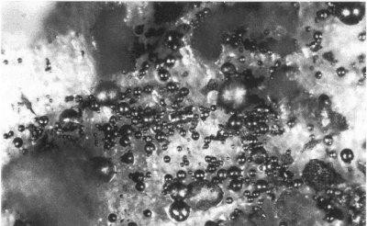

SPHERES

Spherical particles can be heat generated if there is insufficient lubrication or there is a depletion of extreme pressure additives in high load or high stress conditions. Spheres are also produced by fatigue (cavitation erosion) of rolling element bearings. Fatigue spherical particles formed

within bearing fatigue cracks range in size from 1 to 10 microns. A marked increase in spherical particles indicates possible equipment distress.

Dark Metallo-Oxides

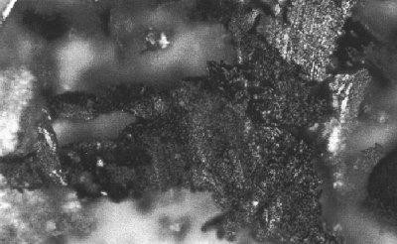

These particles are also heat generated and may indicate lubricant starvation. They appear as darkened, rough particles in varying degrees of oxidation, in contrast to rubbing wear platelets which appear in silver/grey shades

Wear Particles

For systems, which operate normally, wear metals are produces at constant rate. This rate is the same for all normally operating systems of the same type.
The theoretical curve showing the concentration of wear metals as a function of time for a close system without oil consumption is shown in figure.

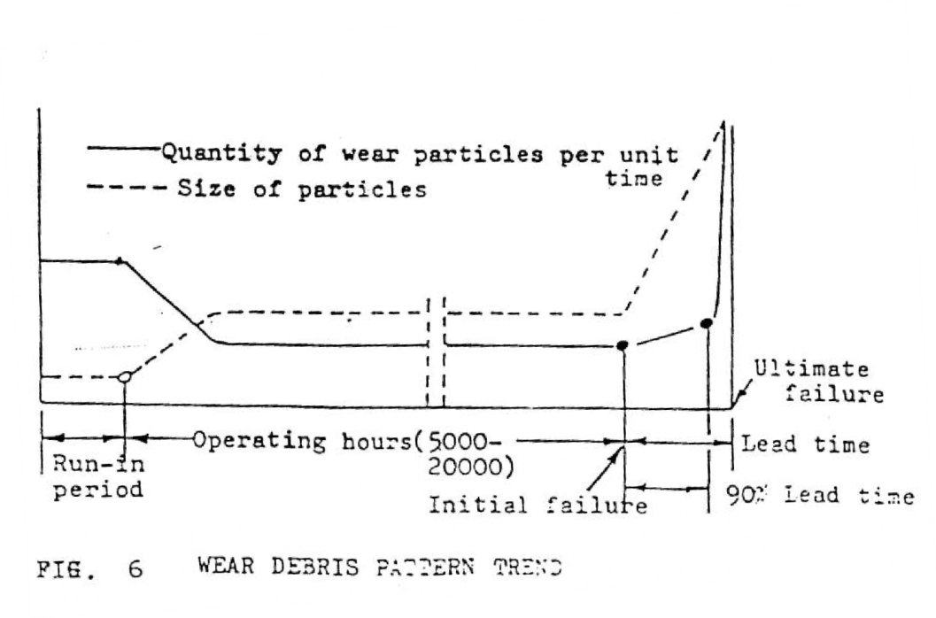

TYPES OF WEAR PARTICLES

There are six basic particles type generated through the wear process. These include ferrous and non-ferrous particles and comprise of:

- Normal Rubbing Wear

Rubbing wear particles are generated because of normal sliding wear in a machine and result from exploitation of particles of the shear mixed layer. Rubbing wear particles consists of flat platelets, generally 5 microns or smaller, although they might range up to 15 microns depending upon equipment associations. There should be little or no visible texturing of the surface and thickness should be 1 micron or less

- Cutting Wear Particles

Cutting wear particles are generated as result of one surface penetrating another. There are two ways of generating this effect.

- A relatively hard component can become misaligned or fractured resulting in hard, sharp edge penetrating a soft surface. The particle generated this way is coarse and large, averaging 2-5 microns wide and 25-100 microns long.
- Hard abrasive particles in the lubrication, either as contaminants such as sand or wear debris from another part of this system, may become embedded in soft wear surface(two body abrasion) such as Lead/Tin alloy bearing. The abrasive particles protrude from the soft wear surface and penetrating the opposing wear surface. The maximum size of cutting wear particles generated in this way is proportional to the size of abrasive particles in the lubricant. Very fine wire-like particles can be generated with thickness as low as 25 microns.

Cutting wear particles are abnormal. Their presence and quantity should be carefully monitored. If the majority of the cutting particles in a system are a few micrometers long and a fraction of a micrometers wide the presence of particulate contaminants should be suspected. If a system shows increased quantity of large (50 microns long) cutting wear particles, a component failure is potentially imminent.

- Spherical Particles

These particles are generated in the bearing cracks. If generates their presence gives an improved warning of impending trouble as they are detectable before any spalling occurs. Rolling fatigue generates few spheres over 5 microns in diameter while the sphere generated by welding, grinding and corrosion are frequently over 10 microns in diameter.
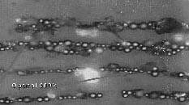

- Severe Sliding

Severe sliding wear particles are identified by parallel on their surfaces. They are generally larger than 15 microns, with the length-to-width thickness ratio falling between
5-30 microns. Severe sliding wear particles sometimes show evidence of temper colors, which may change the appearance of the particle after heat treatment.

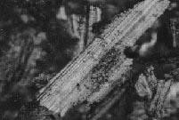

- Bearing Wear Particles

These distinct particle types have been associated with rolling bearing fatigues.

- Fatigue spall particles constitute actual removal from the metal surface with a pit or a crack is propagated. These particles reach a maximum size of 100 microns during the microspalling process. Fatigues spalls are generally are flat with a major dimension-to-thickness ratio of 10 to 1. They have a smooth surface and a random, irregularity shape circumference.
- Laminar particles are very thin free metal particles with frequent occurrence of holes. They range between 20 to 50 microns in major diameter with a thickness ratio of 30:1. These particles are formed by the passage of wear particles through a rolling contact. Laminar particles may be generated throughout the life of a bearing.

- Gear Wear

Two types of wear have been associated with gear wear:

- Pitch line fatigue particles from a gear pitch line have much in common with rolling-element bearing fatigue particles. They generally have a smooth surface and frequently irregularly shaped. Depending upon the gear design, the particles usually have a major dimension-to thickness ration between 4:1 and 10:1. The chunkier particles results from tensile stresses on the gear surfaces causing the fatigue cracks to propagate deeper into the gear tooth prior to spalling.

- Scuffing or scoring particles are caused by too high a load and / or speed. These particles tend to have a rough surface and jagged circumference. Even small particles may
be discerned from rubbing wear by there characteristics. Some of the large particles have striations on their surface indicating a sliding contact. Because of the thermal nature of
scuffing, quantities of oxides are usually present and same of particles may show evidence of partial oxidation that is tan or blue temper colors.

Contaminant particles are generally considered the single most significant cause of abnormal component wear. The wear initiated by contaminants generally induces the

formation of larger particles, with the formation rate being dependent on the filteration efficiency of the system. In fact, once a particle is generated and moves with the lubricant, it is technically a contaminant.

SIGNIFICANT OIL CONTAMINENTS

Lubricating oil used in engine may possibly include concentration of such elements as iron chromium, copper, lead, tin, antimony, borated silver, silicon. A list of common contaminants and their possible origins is given in table 2.

CONTAMINENT | SOURCES
1.Aluminium | Pistons, bearings
2. Boron | Coolant leak
3. Copper | Bearings, bushings, washers etc.
4. Iron | Piston rings, ball and roller bearings
5. Lead | Bearings, bushings

Iron concentration usually rises as a consequence of higher wear rate of cylinder liners or piston rings (or of piston where these are of ferrous materials). A common cause is that of piston rings stuck in their grooves with consequent blow-by of combustion gases and burning of the oil film adding to scuffing and piston seizure.

Iron and silicon together in high concentration suggests linear and ring wear from dust in the intake air. This could be caused by inefficient or chocked air filters. Air filter filled relatively low in the body of a vehicle may choke and allow direct to enter.
Copper and lead concentration in an engine fitted with copper – lead bearings suggests incident failure of one or more bearings. Copper and tin increased could be caused by high wear of bronze and bushes.

Antimony in some engines might indicate a rise or copper content from crankshaft or camshaft bearings.

Chromates are used in some engines coating water to suppress corrosion, their presence in lubrication oils indicates that cooling water has leaked into the crankcase(this effect can be masked in an engine fitted with chrome-plated piston rings and cylinder lines)

Solver in contaminated oil results from the wear of plating, bearings and silver soldered fittings.

USED OIL CONTAMINATION – TIME TRENDS

The quantity of each contaminant reflects the extent of surface wear of the components of a machine under normal conditions; wear rate is small and uniform so that oil contamination collects slowly. As large surface defects develop, abnormal wear occurs and contamination increases. A curve typical of the change of the iron concentration with time as shown in fig.
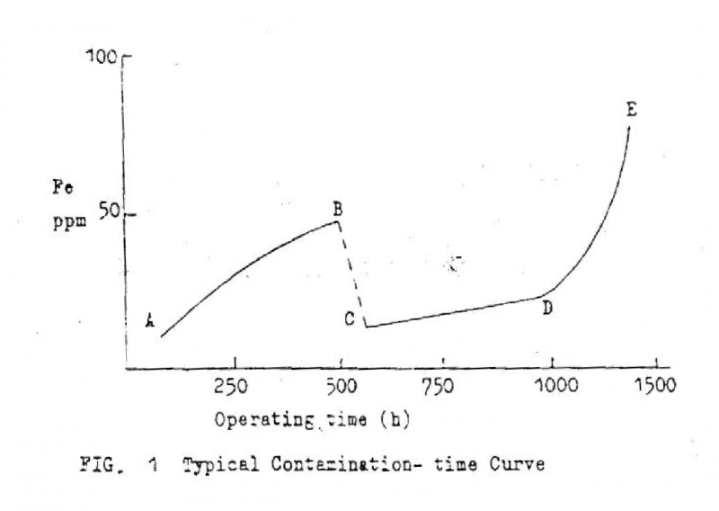

Initially, when the machinery is now or recently overheated, a sharp rise in metallic concentration occurs from A to B as the parts wear in. Once this phase is completed, the concentration should remain steady, the oil shouls then be changed. Some residual wear metal products remain from the old oil and circulate in the new oil following the oil

change at c, with normal functioning the metallic concentration would be expected to increase slowly as by C-D. If abnormal conditions arise, the concentration may increase by D-F.

The physical analysis of the wear debris that has been generated by the deterioration of the moving parts within the system. A diagnosis of the wear mechanisms and extent of the damage to components is made using the following parameters.

The test package includes:

Wear index: A measurement of the amount of ferrous wear within a system.
Particle Quantifier Index (PQ): A measurement of the wear debris filtered from the used oil.
Magnetic Separation Index (Mag I): A measurement of ferrous wear debris magnetically separated from other debris.
Contamination Index (Contamin): A measurement of the amount of metallic contamination. Average Size: The average size of the particle size of the wear debris.
Maximum Size: The maximum particle size of the wear debris.
Density Index (Density): A measurement of the density of the largest wear particles.

Particle Type: The wear particle classification according to the size and shape used to determine the mechanism of wear.

WEAR PROCESS MONITORING TECHNIQUES

The method of wear process can be classified into three main types, which are shown in fig.

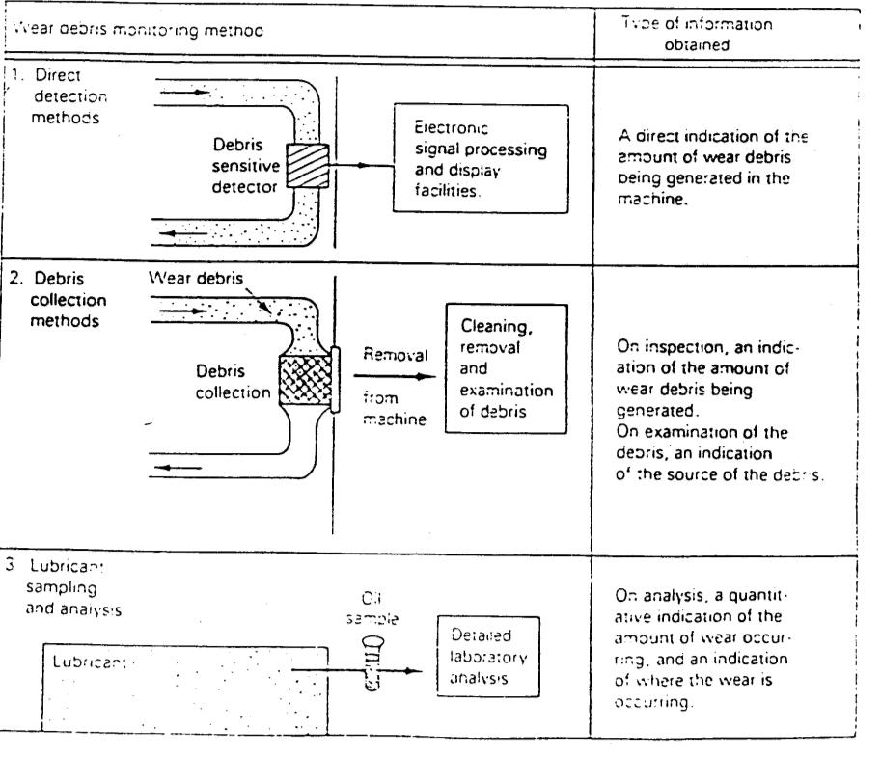

Direct detection method:

Wear debris in the lubricant is detected in the machine by arranging for the oil flow through a device, which is sensitive to the presence of debris.

Debris collection methods:

Wear debris is collected in a device, fitted to the machine which is convenient to remove, so that the debris can be extracted for examination.

Lubricant Sample Analysis:

A sample of lubricant is extracted from the machine and analyzed for wear debris contamination.

These methods are normally used to monitor the conditions of components lubricated by a circulatory oil system.

When applying a wear debris monitoring method to any machine for the first time there is an initial learning period required, partly to gain experience in using the

equipment, but mainly to establish wear debris characteristic levels which indicate normal and incipient failure conditions. This learning period can take up to 2 Yrs. During this
time it will also be necessary to establish the inspection and sampling intervals for intermittent monitoring methods such as debris collection and lubricant sampling. This time interval will depend on the application but fortnightly or monthly is probably a reasonable choice for an industrial application in the absence of more precise guidance.

Debris collection and lubricant sampling can also indicate the nature of the wear problem and engineers carrying out monitoring need to be given a regular feedback of information on the accuracy of their diagnosis. They must therefore either see the components of thin machines when they are stripped for overhaul, or atleast be given

precise data on their condition.

Direct Debris Collection Method

Wear debris is collected in a device, fitted to the machine, which is convenient to removed so that the debris can be extracted.
Existing Filter system

Filtration is widely used to remove harmful particles from oil. The simplest method of debris monitoring is to extend such an approach by carefully collecting and checking the contents of machine’s oil filtration system at regular intervals
Special Filters

These collects all particles down to the mesh size of the filter. The complete filter unit can usually be extracted from it’s housing without breaking any pipe connections and the machine need not be stopped. If a bi-pass- valve is fitted. To collect all particles the filter should be fitted in the oil system immediately downstream of the components being monitored. These are mainly used for detecting non- ferrous debris not collected by magnetic plugs often they are used in conjunction with these.

Debris Collection Method

Magnetic Plugs

As it is an “on-line” control method, magnetic plugs are used in oil-lubricated machines. The monitoring equipment is mounted directly in the lubricating system of the machine. The underlining principle is that the Ferro-magnetic particles in the oil are attracted by the magnetic plugs. The magnetic plugs or chip detectors are usually of the self-closing type which prevent oil loss during removal. This method only detect ferrous material.

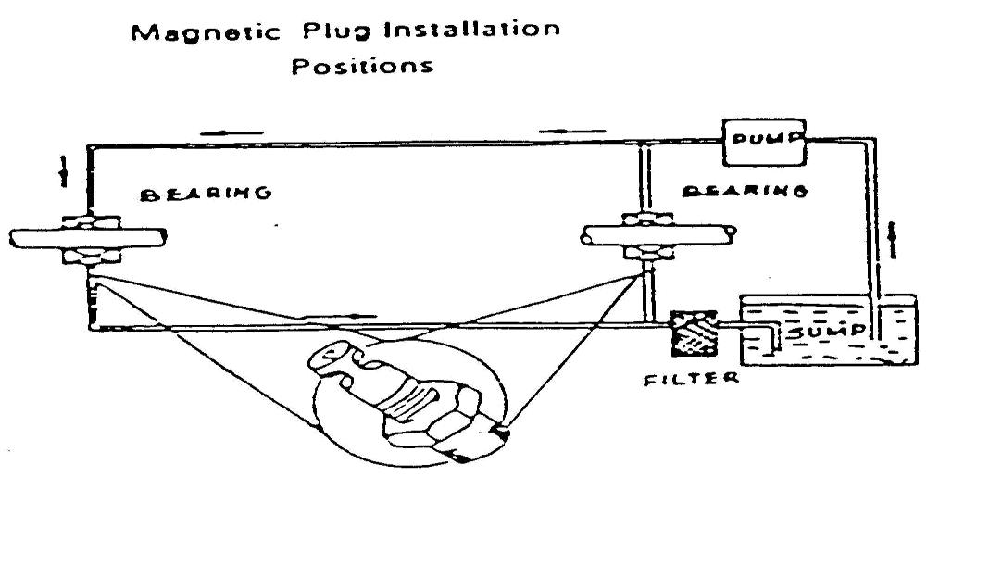

The quantity of particles collected depends upon the path of the oil flow and the placement of the plugs are therefore placed so that they provide a maximum amount of information about wear(particle production) of the critical parts. Regular examination and evaluation of the coating of the plug allows one to eliminate the quantity and size of the particles, as it often follows a typical “bath-tub” curve. By means of such a graph it is possible to identify appropriate times for the performance of preventive maintenance.

This technique supplements the two other oil monitoring methods. The magnetic plugs captures particles from about 100mm and upwards, ie, a large number of particles are detected which would not normally be recorded by means of ferrography.
The magnetic plug is thus in a position to capture the large flakes which are formed due to the break down of the surfaces by fatigue. The magnetic plug is therefore, used particularly in connection with the monitoring of the gear boxes and bearings. A

scattering of black particle fragments (whiskers) is seen. An unacceptable coating is visible. This indicates abnormal wear. An unacceptable coating can be characterized by the following conditions.
☞ Large individual fragments

☞ Pieces which can be identified as flakes from a bearing

☞ Flat fragments

☞ A large number of whiskers

☞ Particularly long whiskers

Magnetic plugs are used in the modern aircraft engines where particle sizes are in the order of 0.2-1 µm are found.
Direct debris collection methods

  - Optical oil turbidity monitor

  - Electrically conducting filters

  - Inductive detection methods

  - Capacitive detection methods

Lubricant Sample Analysis

A sample of lubricant is extracted from a machine and analyzed for wear debris contamination.
There are two most widely used methods. They are:

- Spectrometric oil analysis program (SOAP)

- Ferrography

These methods are normally used to monitor the conditions of components lubricated by a circulating oil system. Two main lubricating sample analysis methods are:
- Analysis of the sample to determine the concentration of the chemical elements it contains.
- Analysis of the sample to determine the amount, size and shape of contaminant particles contained in it.

SOAP

It is a maintenance tool which is used to check the condition of the oil lubricated mechanical systems(Examples: Motors, Gear boxes, Hydraulic systems). The systems can be kept under surveillance without dismantling them. Abnormally worn compounds can be localized and replaced before a

catastrophic failure occurs. The quantity and type of wear metals in sample of lubricating oil is determined. The quantity can indicate something about the magnitude of the wear and the type of wear metals can reveal which component is wearing out.
- Emission Spectroscopy

An emission spectrometer is an optical instrument where the sample is “burned” is in a spark between two electrodes. The energy is absorbed by the metal in the sample, and they emit light with wavelengths, which are characteristic for each element in the sample. The intensity of light is proportional to the concentration of the metal in the sample.

- Atomic Absorption Spectroscopy

In this, the sample is burned in a gas flame, where the metal compounds are transferred into atoms that can absorb light at wavelengths, which can characteristic for each metal. If one wishes e.g. to determine the quantity of fuel copper, then light with a wavelength characteristic for copper is send through the flame, where the copper atoms absorb a part of light . The quantity of absorbed light is proportional with the quantity of copper in the sample.
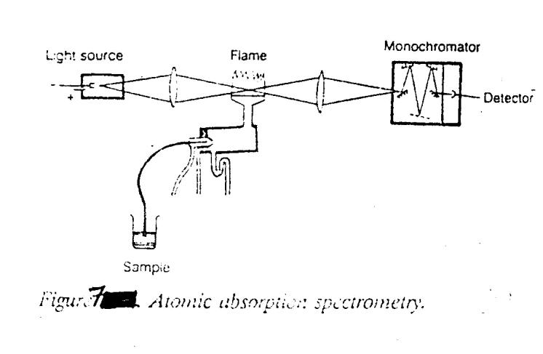

Only particle under certain size can be measured, which is of the order of 0-10µm. With emission spectroscopy somewhat larger particles can be measured.

Limitations:-

Users of the SOAP claim that they find that a large proportion of the defects which would lead to the breakdown. This method provides no indication of:
  - Large particles (E.g. bearings can breakdown due to few large particles)

  - Defects which occurs quickly (E.g. due to the lack of lubricating oil or due to bearings which burn up)

  - Defects where no wear metals are formed.(E.g. breakdown due to metal fatigue).

Applications:-

  - It is used in situation s where breakdowns are catastrophic or expensive.

  - It is widely used in the military services.

  - In US, it is used by the Air force, Navy and the Army.

  - It is used for many civil aviation companies.

Ferrography

It is a technique which is based upon the systematic collection of oil samples from an oil- lubricated machines. The method identifies, isolate and classify wear particles from machine parts. A magnetic field is used to sort the wear particles in the flowing oil. This technique was used successfully to monitor the condition of military aitcraft engines, gear boxes and transmissions.

Three of the major type of equipments used in wear particle analysis are the

Direct –Reading(DR) ferrorgraphy, the analytical ferrograph system and ferrorgram scanner.

Registraion of the quantity of “large” and “small” wear particles is used to monitor the development of process between checks. Abnormal wear is revealed when there is a change in distribution of the particles called wear index of the oil.

FerroGraph Analysis Apparatus:-

Here the particles are separated on a treated object glass where due to its displacement in a special magnetic field( with a very high field gradiation) causes the particle should be sorted according to size. The largest particles are deposited first while smaller ones travel farther with the flowing oil. The density i.e. the concentration of particles at a single location on the ferrogram, is measured with a optical densitometer by allowing light to pass through it.

The wear index S_{A} = A ²-A ² is obtained by the comparison of the density A of the large particles and the density A_{S} of the small particles.
L S L

- DR Ferrography

This is a quick method for which direct reading of the index S_{D} can be achieved in about 5 minutes.

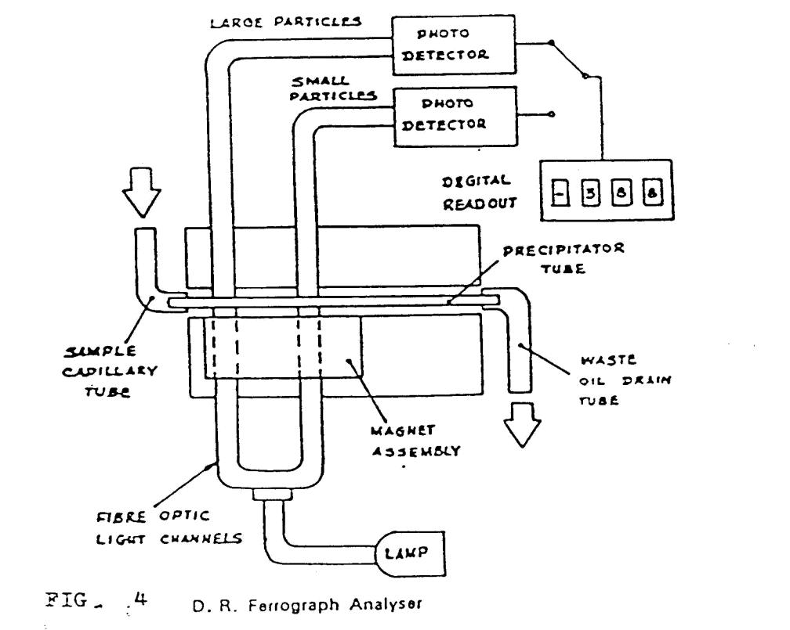

In this apparatus, a controlled flow of oil passes through a calibrated glass tube which is mounted in a specially designed magnetic field. The separation causes the particles to be sorted by the size of the bottom of the tube.

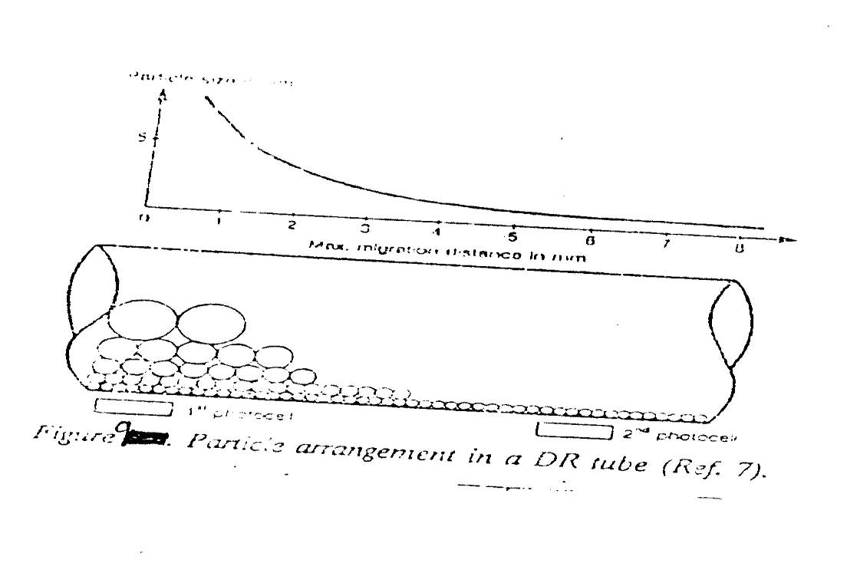

The apparatus uses photocells to convert the measured light intensities attained by passing light to the tube to electric signals. The measured region of the apparatus is 0 -190 DR units, where maximum value is 190 DR corresponding to the cases where the bottom of the tube is completely covered with metal particles.

Density at two fixed measuring points in the tube are used corresponding to the densities of large and small particles. D_{L} and D_{S} respectively.. The sum of D_{L} and D_{S} is termed the total wear and the difference D_{L} – D_{S} is termed as abnormality wear. The wear index S_{D}=D ² – D_{S}²
L

Areas of Application:-

The ferrographic DR measurement provides a warning of an incipient failure earlier than the standardized spectrometric method.

- The Analytical Ferrograph

Additional information about a wear sample, can be obtained with the Analytical Ferrograph system, instruments that can provide a permanent record of the sample, as well as analytical information. The Analytical Ferrograph is used to prepare a Ferrogram -- a fixed slide of wear particles for microscopic examination and photographic documentation. The Ferrogram is an important predictive tool, since it provides an identification of the characteristic wear pattern of specific pieces of equipment. After the particles have deposited on the Ferrogram, a wash is used to flush away the oil or water-based lubricant. After the wash fluid evaporates, the wear particles remain permanently attached to the glass substrate and are ready for microscopic examination.

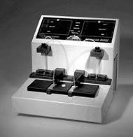

Ferrogram Maker Instrument

Wear-Debris analysis made easy
The EDAX Eagle Micro-Probe EDXRF system provides a fast and simple method for the component identification of wear-debris particles.
EDAX has led the way in the development and supply of elemental analysis instrumentation based on the method of energy-dispersive (X-ray) spectrometry (EDS). The EDS method utilizes the simple spectral information produced as a result of electron transitions deep within an atom. These X-ray spectra (so called because of their energy/

wavelength) obtained from a sample under investigation within a suitable analysis instrument, provide unique information about the type and quantity of the elements present. EDAX introduced the first commercially available EDS system for electron microscopy applications
The EDS technique is a familiar elemental analysis attachment to a scanning electron microscope (SEM) where electrons are used as the primary energy source to excite the X-ray spectra. SEM- EDS methods are used for wear-particle analysis for both their morphological and compositional properties, and are particularly useful where the study of very small particles (approximately five microns or less) is necessary. On the other hand, the radiation output from an X-ray tube may also be employed as an energy source. The resultant benefits for systems using an X-ray energy source include greatly simplified specimen handling/presentation needs, less sophisticated instrumentation, simpler and faster operation and lower cost. Such a standalone system is called an energy-dispersive X-ray fluorescence spectrometer (EDXRF), of which the EDAX Eagle is a specialised example.

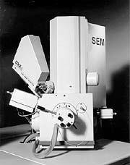
The EDS technique is a familiar elemental analysis attachment to a scanning electron microscope

Ease of analysis:-

The magnetic plugs are degreased prior to the transfer of the debris on to a clear sticky tape (the traditional method used for debris archiving and/or optical examination). Without the need for any further sample preparation, the tape/debris is presented to the spectrometer for analysis where, in typically less than two minutes, its analysis may be obtained. Also the measured spectrum can be compared (using spectral pattern-recognition methods) to stored reference spectra of the monitored assembly's component parts and hence to identify the component that has worn or been damaged.

CONCLUSION

The wear debris monitoring method access the nature of the particles generated when components wear.
They can indicate exact nature of the machine problem

The methods of wear debris analysis used as an indication of machine conditions are:

  - indication from the amount of debris present
  - indication from the size distribution of debris
  - indication from the physical form of debris
  - application of chemical analysis of debris

REFERANCES:

- VENKATRAMAN.A, SENTHILVELAN.T, “WINTER SCHOOL ON RECENT TRENDS IN DIAGNOSTIC MAINTENANCE”.
- PRABHU.B.S, “WORKSHOP ON PLANT ENGGINEERING AND INDUSTRIAL TRIBOLOGY”.

