Vibration Measurement for Rotatory Machines
Importance of maintenance practices

Vibration Measurement for Rotatory Machines ABSTRACT
This thesis work was done in cooperation with Hi-Tekno Engineering and consulting office. The purpose of this thesis was to demonstrate the impor- tance of vibration measurements in modern day production systems. The aim was to explain how vibration measurements are performed in the field and what kind of machinery diagnosis can be achieved.

Effective maintenance services in the production systems of today are vital for any company as to the profitability figures. Vibration measurements give the user a clear picture of the machines condition, by this is easier to plan the maintenance schedule, focusing the resources only on those ma- chines that have signs of failures.

A vibration analysis is about the art of looking for changes in the vibration pattern, and then relating those changes back to the machines mechanical design. The level of vibration and the pattern of the vibration tell us some- thing about the internal condition of the rotating component. The vibration pattern can tell us if the machine is out of balance or out of alignment. Al- so faults with the rolling elements and coupling problems can be detected.

The practical work in this project was conducted in Karkkila at the heating system plant of the municipality. I measured the vibration levels for the flue gas fan. The flue gas fan removes the gases generated in the combus- tion boilers, after which they have passed through a filter and are directed back into the atmosphere. The outcome demonstrated that there was a bearing problem in the flue gas fan and it was starting to develop.

Keywords Measurements, Maintenance, Vibration, Diagnosis.

Pages 52 p.

CONTENTS

- INTRODUCTION 1
- MAINTENANCE 2
Failures 3
Importance of vibration analysis 3
Maintenance practices 3
Types of maintenance practice 4
Break down maintenance 4
Preventive maintenance 5
Predictive maintenance 7
Proactive maintenance 8
- MAINTENACE IN MODERN PRODUCTION 9
Operational reliability 9
Machine reliability 10
Maintainability 10
Maintenace reliability 10
Operational reliability measurement 10
Overall Equipment Effectiveness (OEE) 12
- MAINTENANCE: ECONOMIC IMPACT 13
Maintenance: The new approach 13
Life cycle production 13
- CONDITION MONITORING 15
Types of condition monitoring 15
Vibration analysis 15
Oil analysis 17
Wear particles analysis 17
Infrared thermography 18
Condition monitoring: Today 18
- FUNDAMENTALS OF VIBRATION 19
Spectrum 21
Forcing frequencies 22
Overall readings of signals 23
Signal analysis 23
- MEASURING VIBRATION 25
Types of sensors 25
Displacement sensors 25
Velocity sensors 27
Accelerometers 27
- VIBRATION ANALYSIS 29
Detection 29
Alarm limits 29
Fixed alarm limits 30
Calculated alarm limits 31
Analysing vibration data 31
Root cause Analysis 32
Verification 32
- PRACTICAL WORK 33
Type of machine 33
Performing the measurements 34
Evaluating the data 35
Summary 36
- MACHINERY FAULT DIAGNOSIS 39
Imbalance 39
Causes for Imbalance 40
Misalignment 40
Parallel misalignment 41
Angular misalignment 41
Causes for misalignment 41
Looseness 42
Rotating looseness 42
Rolling element bearing faults 43
Pump Faults 44
Fan faults 44
- CONCLUSION 45
SOURCES 46

INTRODUCTION

In summer of 2011 I started to work for Hi-Teckno Engineering and a consulting office. During that time my task was to do maintenance work for centrifugal fans at energy plants and paper mills all around Finland. Because the core business of the company was vibration measurements, I started to become familiar with the technology. After this work experience I realized the importance of vibration measurements for maintenance ser- vices in industries.

In this day when manufacturers increase their operational profits they as- sume in the first place that this is because of a good marketing plan. But they forget that an effective maintenance budget is the fact that keeps them on top of the game.

This thesis work will explain all the common maintenance practices used by industries in our days and their economical advantages. The main focus of the thesis is to demonstrate the importance of vibration analysis as a tool to be included in maintenance plans. How vibration measurements are performed in a real world scenario is also part of the thesis.

Of all the parameters that can be measured in the industry, not one of them contains as much information as the vibration analysis. The vibration analysis is one of the most important tests for understanding what is hap- pening in a machine. The level of vibration and the pattern of the vibration tell us something about the internal condition of the rotating component. The vibration pattern can tell us if the machine is out of balance or out of alignment. Also faults with rolling elements and coupling problems can be detected through vibration analysis.

When performing vibration measurements there are four phases involved: detecting if a problem exists, performing an analysis to diagnose the sever- ity of the problem, determining why the problem took place and verifying that the problem is solved once the machine is repaired.

If we can interpret the data obtained from the vibration analysis in a cor- rect way and perhaps change the way the machine is operated or main- tained, the machine will become more reliable in the future making the overall process more profitable.

MAINTENANCE
Maintenance can be described as fixing or replacing something that is broken. Also is defined as performing routine actions in order to keep a machine running or preventing any further problem.

Maintenance includes:

  - Operation: Process control, use of machines, small component changes
  - Keeping machine running: Cleaning, lubrication, monitoring
  - Logistics: Selection, procurement and delivery of resources
  - Improvement: Without changing the object's original action
  - Changes: Changes to the original function
  - Factory service: e.g. security, fire protection, sanitation, waste- and snow removal
(PSK_6201,2011, 5-9.)

Scandinavian plants are top class in the world today. For example, the Finnish nuclear power plant of Teollisuuden Voima Oy at Olkiluoto has remained throughout its lifetime the world’s number one, that is to say the World Champion. The plants in Scandinavia and in Europe generally are well maintained and the operational reliability as well as the environ- mental aspects are continuously developed. Visitors from different parts of the world have confirmed this fact. The key success factors are the top class maintenance tradition and maintenance know-how. (Scandinavian Center for Maintenance Management Finland RY and Management Sys- tems Oy, 1998, 5-6.)

An evaluation completed in 1996 in the energy industry concluded that operations and maintenance have tremendous concealed potential. At pre- sent, companies specialised in operations and maintenance services cover 15 percent of the European maintenance market. This figure is estimated to rise to between 60 and 80 percent during the next 10 years. (Scandina- vian Center for Maintenance Management Finland rY and Management Systems Oy, 1998, 5-6.)

Maintenance skills are not only for professionals in maintenance work, but they apply to the entire company as a strategic decision.

Failures

Why do we perform maintenance services? “Failure” is the answer. When a machine does not perform a required function as a result of an incident, this can be described as a failure. In most of the cases failures can be an- ticipated through a good maintenance plan, but the possibility of unpre- dictable critical failures is always present.

Common reasons for failures:

    - Equipment is not used in the right way
    - Too much focus on repairing instead of checking and analyzing
    - The operating conditions are not optimal
    - The design does not adequately take into account the actual use or the conditions of use
    - Equipment operators detect symptomatic defects, but they don’t take any action or reports.
(Touru 2011, lectures)

How to prepare for failures?
    - Continuous monitoring
    - Redundancy
    - Preventive maintenance
    - Scheduled services

Importance of vibration analysis

Vibration measurements give us the information needed to understand why problems have occurred. If we can interpret the data obtained in a correct way and perhaps change the way a machine is operated or main- tained, the machine will become more reliable in the future making the overall process more profitable.

Therefore by including vibration measurements into our maintenance plan we can save money and in most of the cases improve the product quality.

Maintenance practices

In the past (1940-1950) the philosophy of many companies was just to keep “the plant running” forgetting all kinds of maintenance procedures. In case a machine failed, they were repaired or just replaced by new ones. Management staff did not pay attention to improving the reliability of the eqipment.

With time this philosophy changed. Second generation machines (1960- 1970) had their own maintenance plans but at the time computer where very slow. Between the years 1980-2000 manufacturers stared to realize the importance of reliability for any machine produced.

During the last ten years we have seen a radical change in the industry. Companies have begun to recognize that it is worth the investment of time and money to change maintenance practices and work to improve equip- ment reliability. Great cost savings have been realized by this approach, often termed “precision maintenance” or “proactive maintenance”. (Mo- bius Institute 2005, 3-4.)

Modern technologies enable us to achieve the following facts:

    - High-speed operation of control systems. Effective use of machine his- torical data.
    - Smart sensors enable new kinds of measurement methods and mea- surements not previously possible.
    - Runtime monitoring. Use of the target is reliable. When the sensors in- dicate that the activity is different from the normal (warning/alarm). We can assume that somewhere there is a problem and can start correc- tive actions.
    - More attention to quality, safety, environmental friendliness. Availabili- ty management and production optimization have an increasing role in maintenance.
(Touru 2011, lectures)

Types of maintenance practice

In general there are four types of maintenance in use: break down mainte- nance, preventive maintenance, proactive maintenance and predictive maintenance.

Break down maintenance

During the 1950’s this was a common practice. The idea was to let the machine run until it fails. But this practice can lead to very high mainte- nance costs because a production stop and overtime labor are needed in order to reduce production downtime.

By adopting this practice the overall safety of the plant is reduced dra- matically. Workers are exposed to physical injuries, something that in to- day’s standards is not allowed.

Advantages of break down maintenance:
      - Any costs related to preventive maintenance

Disadvantages of break down maintenance:
      - Unpredictable downtime
      - Loss in production
      - Very high repairing costs

Preventive maintenance

Also known as calendar-based maintenance. A Manufacturer designs equipment with a determined lifetime. With time machines get old and the probability of failures increases, so companies should perform mainte- nance service before the machine needs it. By doing this you extend the lifetime of the machine.

When companies adopt this practice a challenge emerges. They need to balance the risk against the costs. If they leave the machine without main- tenance for too long the machine may fail. On the other hand performing maintenance too early becomes expensive in labour and production.

From my point of view the assumption of “probability of failure” is the key element for preventive maintenance . For a period of time the risk of failures remains slow. At some point in the future the risk of failure in- creases due to the fact that parts begin to wear and fatigue.

What is important to mention is that there is a high probability of failures when machines are new due to parts installed incorrectly or poor lubrica- tion. If we try to put this in a graph we would have to combine the esti- mated lifetime versus the probable lifetime. Figure 1 is a good example of a case like this. The first and last zone represents a high failure risk and the middle zone is the period of running smoothly.

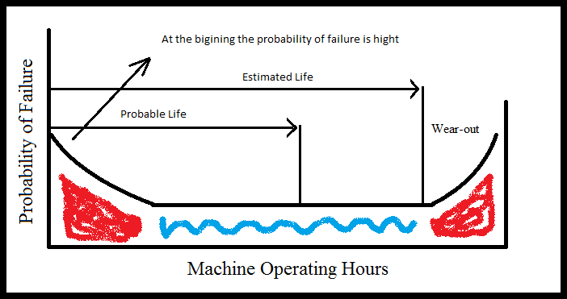

Figure 1 Probability of failure for machines

Thus, the plan should be to schedule any maintenance service within the machines probable life period. But in reality we cannot calculate this time frame or even guess how quickly the machine will fail in the wear-out stage.
A study was performed some years ago (by United Airlines) to examine exactly how the probability of failure changes over time. Two important facts came out of the study:

      - The first one was that the curve does not always follow the “bath- tub” shape portrayed thus far. In fact, the shape accounted for only 6% of the machines. In most cases (68%) the shape was flat after the initial infant mortality period.

      - The second point (which explains the flat curve) was that only 11% of the failures were age related, while 89% were random (Figure 2). That means that they were as likely to fail after two months as they were in 22 months. Therefore, the concept of ca- lendar-based maintenance was flawed. (Mobius Institute 2005, 6.)

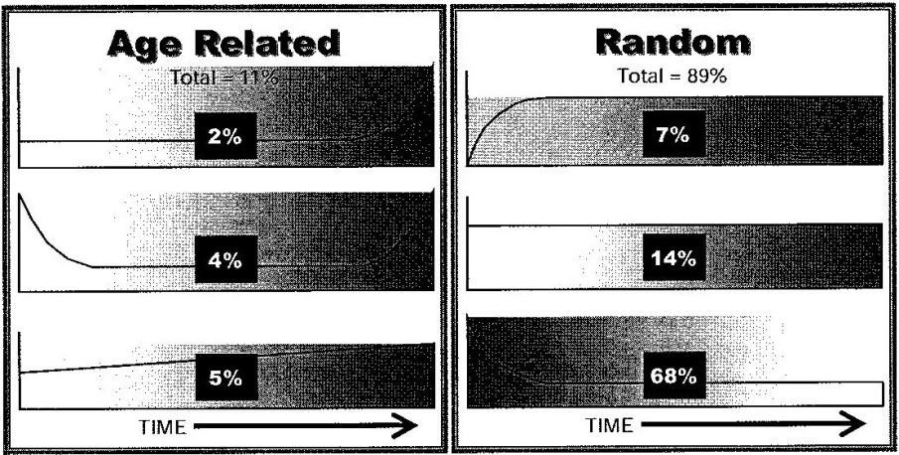
The experience tells us that usually a machine gives us some signs before it fails. The sign can be a sound, change in vibration, decrees in perform- ance or a change in energy consumption. All this information guides us into predictive maintenance.

Figure 2 Conclusions of the United Airlines study concerning “probability of failure”. (Mobius Institute 2005, 6.)

Advantages of preventive maintenance:

      - Maintenance is well planned and performed at a favourable time.
      - There is a considerable cut in machinery failure problems.
      - Interruptions in production are reduced.

Disadvantages of preventive maintenance

      - The possibility of “repairing” machines when there is no problem is higher.
      - There are still “unexpected” breakdowns.

Predictive maintenance

In case of the maintenance of the fan we can detect some warning signs before it breaks down. The vibration level and pattern will change. So, the task is to monitor the machine constantly and if we find any abnormal data, we can plan the required maintenance service before the risk of fail- ure is too high. The main benefit is that maintenance costs are reduced and the downtime becomes zero.

But in reality the theory does not apply 100%. For example in big factories such as paper mills it is difficult and very expensive to monitor every sin- gle machine.

The art of predictive maintenance is to monitor the machine with the ap- propriate technologies, frequently enough to detect the anticipated failure modes. Not unexpectedly, this is a financial issue. You must balance the financial interest against a risk of failure. You must choose the correct technologies, and the correct monitoring rate. This may mean that you im- plement a “run to failure” philosophy on some machines, because it is not economically justified to perform the condition monitoring. You may need to balance risk against cost, and perform minimal monitoring on other ma- chines. At the other end of the spectrum, however, you may install perma- nent monitoring systems, designed to keep a 24 hours watch on your criti- cal machines. (Mobius Institute 2005, 8-9.)

My conclusion is that companies need to change the way they purchase, operate and maintain their machines in order to have more reliable ma- chinery.

Advantages of predictive maintenance:

      - Replacement parts are ordered only when needed
      - Maintenance service is performed only when favourable
      - Provides more efficient operation
      - Unexpected downtime is reduced Disadvantage of predictive maintenance:
      - High costs in : operation, employees and technology systems
      - Extension of the machines life is not guaranteed.

Proactive maintenance

This type of maintenance is all about finding the real reason for any fault and not simply replacing old parts with new parts.

The process involves a deep analysis of all the condition monitoring re- cords for example vibration measurements of the last 4 years or simple is- sues as the purchasing process. Sometimes we do not buy the suitable equipment for our machines.

We need to take into consideration machine alignment and balance. These two factors are the best ways to increase the lifetime of any machine.

In order to adopt a proactive maintenance plan the philosophy of the em- ployees involved in the process must change. Management should use new technologies in order to increase the company’s profits and skilled techni- cians should perform detailed investigations of any failure and always purchase the highest quality parts available in the market. The figure 3 ex- plains the relation between management, technology and the organisation.
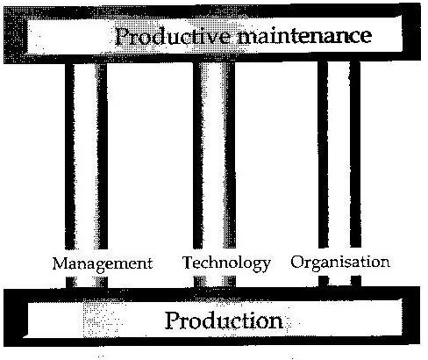
Figure 3 Life Cycle Profit concept corners stones. (Scandinavian Center for Mainte- nance Management Finland rY and Management Systems Oy, 1998, 5-6.)

Advantages of proactive maintenance

      - Machinery lifetime is extended
      - Reliability is improved
      - Reduced Downtime Disadvantages of proactive maintenance
      - Employees with additional skills are required
      - Requires a change in philosophy from the management (this can also be an advantage )
      - Costs in instrumentation and services

MAINTENACE IN MODERN PRODUCTION
Based on my experience I can say that maintenance issues can not be treated as just “simple technical issues”. Maintenance matters are always financial and involve the organisation and the administration of the com- pany.

Today’s companies struggle under great pressures for profitability and productivity. During the past few years the focus has been on investing more resources in order to improve competitiveness. The competition is tough and every day new high technology companies are established.

Scandinavia belongs to the highest industrial cost area, in many cases la- bour costs are very high compared to others competing countries. Compa- nies must be able to compete in other areas of the production process and in economical operations.

One of the most important parts of this work is to improve maintenance. By applying a good maintenance program, the quality of our product will increase and the overall operational reliability of the production will grow. Maintenance gives us an accurate production reliability that is essential for increased capacity and to improve the quality.

Operational reliability

Reliability is the ability of the machine to perform a required function un- der specified conditions of the required period. It includes: installation, construction, structural maintainability and service. The higher the opera- tional reliability the better the system can deliver the required performance for the whole plant or single machine. Operational reliability is dependent partially on: technical systems and maintenance systems (figure3).

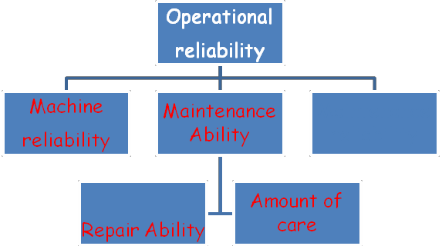

Figure 4 Operational reliability model.

For example in oil refineries were production runs continuously the de- mand on the systems operational reliability is very high.

In this case the use of redundancy is very practical, because two similar devices are installed to perform the same job but one of them only works as a backup device when the first one fails. By doing this the overall plant reliability increase 100%.

Machine reliability

Machine reliability is a quality of the technical system that determines how machines will perform (failure risk ) in a desired function for a given time. In general reliability is reduced when we have more complicated systems or components.

Maintainability

Ability of an item under given conditions of use, to be retained in, or res- tored to, a state in which it can perform a required function, when mainten- ance is performed under given conditions and using stated procedures and resources. (PSK_6201:2011, 8)

Maintenance reliability

Maintenance reliability is a quality of the maintenance resources which is achieved through sensible division of resources amongst varying resources type. This resources division results in appropriate organizational and pur- chasing agreement practices. The cost of achieving a specific level of maintenance reliability depend on the targeted operational reliability and maintainability of the maintenance object. (Scandinavian Center for Main- tenance Management Finland RY and Management Systems Oy, 1998, 24.)

Operational reliability measurement

The Process Industry Standards Centre’s standard PSK 6201 is used as the time definition of operational reliability measurements.

Operational reliability can be measured using different methods. Depend- ing on the type of performance evaluation, different indicators can be used.

The dependability indicators (figure 5) are Factors intended to asses, measure and determine the reliability, maintainability or maintenance sup- portability of an item. (PSK_6201:2011, 8, 9, 10)

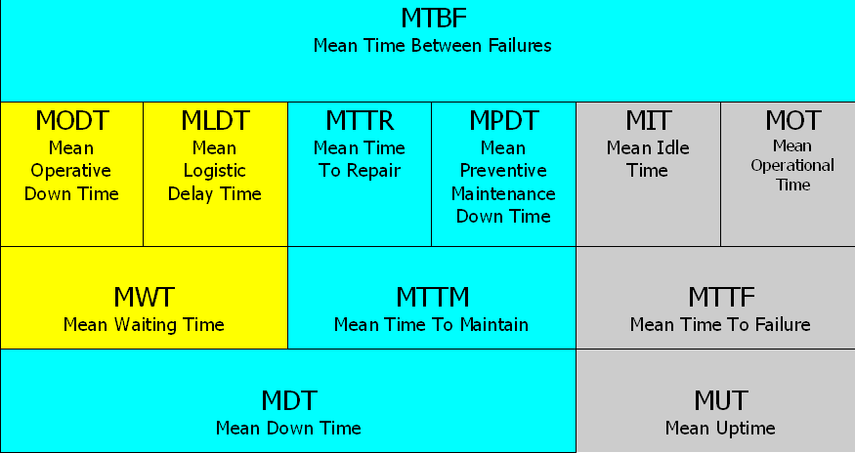First failure First Fixed Second Failure

Figure 5: PSK 6201: (time definition)

The goal of any maintenance plan should be to increase the overall ma- chine effectiveness. This operation involves three factors: Availability, performance rate and quality rate.

- Availability (A=Availability %) is the operational reliability mea- surement figure:

A= Achieved run rime MTTF Total run time MTTF + MTR + MWT
A= 200 = 88%
200+18+7
MTTF=200 machine hours MTTR=23 machine hours MWT= 8 machine hours
Example:
A machine has the following run information:

- Performance rate (N) is the ratio of actual output to maximum out- put during the operating time. The performance rate can be calcu- lated, for example, with the below formula (PSK_6201:2011, 7):

N = Output Nominal production capacity x operating time

- Quality rate (L) determines the share of saleable or processable output of the total output. The quality rate r can be calculated, for example, with the below formula (PSK_6201:2011, 7):

L = Output – Rejected Output Output

Overall Equipment Effectiveness (OEE)

The following OEE model is sued to calculate how much product a com- pany can produce.
OEE=A*S*Q= 89.4%
A=Avaliability P=Performance rate Q=quality rate
- Example: Calculate OEE.

A company has a machine tool, which have the following values: A = 95 %, S = 96 % and Q = 98 %.

MAINTENANCE: ECONOMIC IMPACT
Traditionally maintenance is handle from a technical point were techni- cians must have a good training level or many years of experience. Often the efficiency of maintenance is judge by the speed that workers repair failures and not by the ability to avoid them. Maintenance never shouldn’t be seen as a “necessary evil” that only increase costs and reduce profitabil- ity.

During the last 15 year the philosophy has change, Maintenance budget have increase to improve production and companies have made efforts to move from unplanned operations to planned and systematic activities.

Maintenance: The new approach

Companies have made efforts to increase the quality level in production but at the same time the process become very vulnerable to failures. In this scenario maintenance becomes a priority, so that consequences of failures can be avoided and in some cases eliminated. Maintenance have a direct influence in improving profitability, so it can’t be counted as a simple “cost”.

Well planned maintenance resources, as well as purchased professional services, may be viewed as tools for production capacity refinement that increases its life cycle and improve performance values (Scandinavian Center for Maintenance Management Finland RY and Management Sys- tems Oy, 1998, 29.)

Life cycle production

The LCP concept evaluate the effects of maintenance in the company as a whole and divide the cost is direct and indirect. A ineffective maintenance system increase indirect maintenance cost while well functioning mainten- ance reduce them.

Also the LCP concept evaluate how much the changes made in mainten- ance affects the production and the overall maintenance budget of the company. During this phase managers of production and maintenance units should work together and implement the same strategy of correctly research all cost involve in the process before prosecuting the project.

Direct maintenance costs:
- workers
- External supplier of services
- Replacement parts

Indirect maintenance costs:
- Losses due to maintenance (interruption of production)
- Overtime payments
- Equipment rental

In conclusion the aim of any maintenance plan should be to reduce as much as possible indirect maintenance costs in order to improve profits.

Advantages of LCP analysis:

- Gain a greater readiness at an early stage to realize and prevent problems from occurring.
- Gain more precise information for failure measurement and repair.
- The equipment operators are more committed to the project work, which in itself creates a larger knowledge base for decision making as well as increases motivation
(Scandinavian Center for Maintenance Management Finland RY and Management Systems Oy, 1998, 36.)

CONDITION MONITORING
We can describe condition monitoring as the art of monitoring the condi- tion of any machinery understanding if the health is stable or if it is deteri- orating. How that information is used as part of the maintenance decision making process, make the difference with “predictive maintenance”.

The goal of condition monitoring is to increase profitability by reducing downtime, avoid secondary damage and improve the safety. Also through appropriate monitoring machines will reach its design life cycle and the return on investment will increase.

We can apply condition monitoring in our life when we go to the doctor for some tests. The doctor will check our blood, listen our heart and check our blood pressure. In the case of rotating machinery we can check the motor current, we can test the lubricant and measure the temperature of the bearings. After all we will get a better picture of the equipment health.

To get a better result of the condition monitoring we need to compare pre- vious results against the new data. For example when the doctor discover that we have a high blood pressure, he will be interested to know what is has been for the past moths and also he will monitor it closely over the next few month.

Types of condition monitoring

We can divide condition monitoring in four parts:
- Vibration Analysis
- Oil Analysis
- Wear particle Analysis
- Infrared Thermography

Vibration analysis

The level of vibration that machines like pumps, fans, turbines and com- pressors present, will tell us the internal condition of all rotating compo- nents.
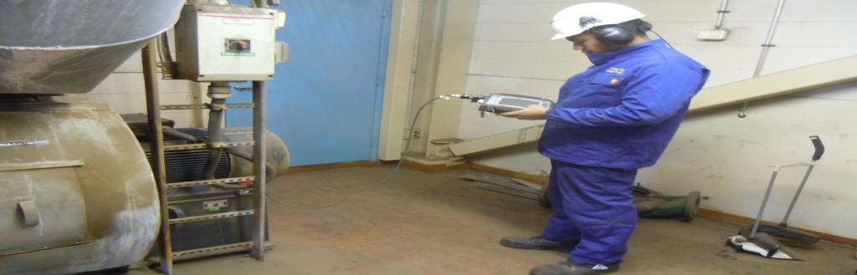
Figure 5 Vibration measurement being perfomed in the field.

Using electronic instruments to measure vibration we can see if those le- vels have increase and detect if there is any problem.

Through the vibration pattern we can find out:

      - If the machine is out of balance
      - If the machine is out of alignment
      - Problems with rolling elements (bearings)
      - Belt and coupling problems
      - Broken rotor bars
      - Soft foot
      - Electrical Faults

The basic procedure to perform vibration analysis involves six steps:

      - First: The portable data collector uses a sensor to measure the vi- bration pattern. This sensor should be mounted on the machine, always close to the vibration source.

      - Second: When the sensor is in place a sample of the vibration is collected. Normally the data collected is taken back to the office and transferred to a computer for further analysis. In the majority of the cases the vibration measurement is collected in few minutes, if the machine present serious problems the vibration measure- ments can take all night long. In case that the machine is located in a remote area, sensors will be mounted permanently on the ma- chine, and the control room will have the task of monitoring. Al- ways permanent sensors are mounted in critical machines only.

      - Third: Once the data is downloaded to the computer the task is to detect if there is any problem with the machine. The user should compare the vibrations levels to a set of alarm limits that are al- ready specify by the first vibration measurement performed to the machine when it was new. At this point is the user responsibility to determined a possible problem with the machine.

      - Fourth: Analysis of the data is the most important step. The user should study the vibration spectrum and time waveform. By view- ing trend and comparisons of previous data it’s possible to know what is wrong with the machine and how severe is the problem. At the end a report to the maintenance office should be send with a list of recommend actions if something is wrong with the machine.
−
      - Fifth: With the vibration measurements in hand the user can per- form a critical root cause analysis and determined the cause of the problem in first place. This step is very difficult to perform be- cause a lot of experience is needed to have a clear picture of the problem.

      - Sixth: In this last step the user performs new measurements to cer- tificate that the problem is solve once the machine is repaired.

Oil analysis

Good lubrication is vital when it comes to rotating machinery. Through lubricants we can reduce the wear of the surfaces that are moving relative- ly close to each other. But very often incorrect lubricants is used or per- fectly good lubricant is changed unnecessarily. Also there is a economic problem because the lubricant is very expensive to buy.

So, to achieve a good control of your lubricants the user should perform some tests (spectroscopic analysis) on the oil and grease. The test will tell you if there is a high percent of contaminants and if the lubricant still able to perform its job.

The user should be careful when using spectometers (device used to per- form the test). Most of them are not able to detect actual wear particles.
And in other cases machinery still fail, when oil tests said that everything was clear.

Wear particles analysis

Ferrographic wear particle analysis is a machine condition analysis tech- nology that is applied to lubricated equipment. Its provide an accurate in- sight into the condition of a machine’s lubricated components by examin- ing particles suspended in the lubricant (Mobius Institute 2005, 17.)

By trending the size, concentration, shape, and composition of particles contained in systematically collected lubricant samples, abnormal wear- related conditions can be identified at an early stage (Mobius Institute 2005, 17.)

We can said that the wear complement analysis complement the vibration analysis because it provide the user with an earlier fault detection.

Benefits of wear particle analysis:

      - Is a powerful technique for non-intrusive examination of the oil- wetted parts of a machine.
      - Detect particles from 1 micron to 350 microns
      - Analysis based on particle shape, composition, size distribution, and concentration.
      - Determine operation wear modes within the machine, resulting in specific maintenance recommendations
      - (Mobius Institute 2005, 17.)

Infrared thermograph

Using infrared guns to test the temperature at a point on the ma- chine is very popular in these days. The user should use the infra- red imagine to compare with the normal operating temperature and detect if there is any big change that can lead to a big problem. fig- ure 6 is a representation of infrared guns.
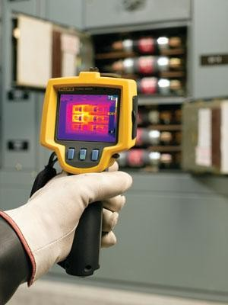

Figure 6 Infrared Termogram made by fluke

Condition monitoring: Today

    - The use of automated diagnostic systems is increasing. this involve integration between condition monitoring and process monitoring

    - Online monitoring systems and automated diagnostics systems are gaining popularity.

    - The internet: Nothing mentioned before can be done without inter- net.

    - Technicians had become multi skilled: Dealing with many differ- ent technologies

    - Groups and vendors are working on standards for sharing data

FUNDAMENTALS OF VIBRATION
Vibration can be described as the mechanical oscillation about an equilib- rium point. In case that you are measuring vibration from the bearing of a machine, you are measuring the response of the bearing housing to the forces generated inside the machine. Those forces relate to all of the rotat- ing elements: the shaft, the balls in the bearing, and the blades on the fan, plus the vibration coming from the process and surrounding machines (Mobius Institute 2005, 21).

In the vibration analysis the user will see:
- If the machine is out of balance
- If the components are not aligned accurately
- If the machine is not bolted down properly
- If there is problems with Bearings
- If there is Gearbox problems

Internal forces like unbalance, misalignment, a bent shaft, looseness or electrical problem will make the machine to vibrate. Even if the machine has no load and is well balanced vibration is present.

But of course when measuring vibration there is not a general pattern that tells how the vibration should looks like. The important part is to check for changes in patterns and comparing them with old measurements patterns (measurements of the same machine).

For example: if we take a brand new fan and turned on, probably you won’t feel very high vibration. But when you attach some weight to one of the blades (metal coin) the fan becomes unbalanced (Figure 7). In this case is obvious that the coin is the source of the vibration.

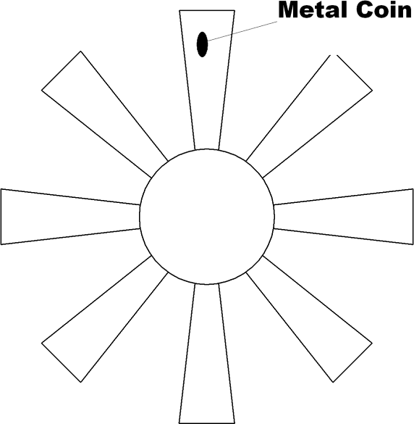

Figure 7 Representation of fan blades with a mass attached in a specific point.

From figure 7 we can determine that the maximum peak of the curve hap- pen when the coin is at the top and the minimum peek occurs when the coin is at the bottom (All this assuming that the fan is running full speed). Figure 8 represent the sine wave signal generated by the fan when is run- ning.
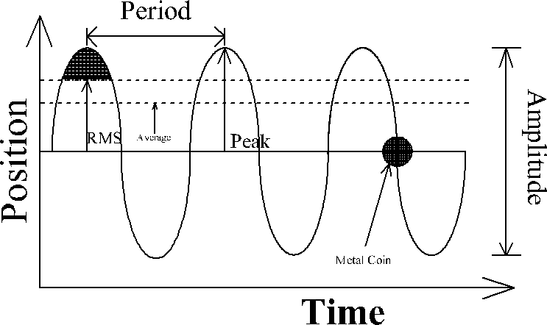
Figure 8 Sine wave generated by the fan.

This is exactly the same that you would get if you perform vibration measurements for the fan and analyze the signal in the computer using a analyzer screen. The sine wave is a representation of how the instantane- ous vibration is changing over time.

The previous example will generate (plot) a sine wave that enable us to understand the following concepts: Period, Frequency, Amplitude, Peak- to-Peak and Peak.

- Amplitude: The amplitude will tell the severity of the vibration de- termined by the height of the cycles.

- Peak to Peak: is the amount that we measure from the top of the peak through the button. In this sine wave (figure 6) the peak to peak value is exactly twice the peak value, but in a real vibration measurement this value may be bigger or smaller.

- Period (s): time between two peeks. In this case the fan is rotating once per second so the period is one second.

- Frequency (Hz): Number of oscillation in a determined period. So, if we divide 1 cycle (oscillation) by the period (1s) we will get the frequency of 1Hz.

- Peak: is the amount we measure from zero to the top of the peak.

Spectrum

When analysing vibration measurement spectrum is a concept that the user needs to understand. I will explain it with a example.

If we take a fan of 8 blades and next to the blades we put in place a plastic card in such a way that it only touches the end of the blades when the fan is running. The card will generate a vibration that is 8 times the speed of the fan. In this case the frequency is 8Hz and the amplitude is just 1 (fig- ure 9).

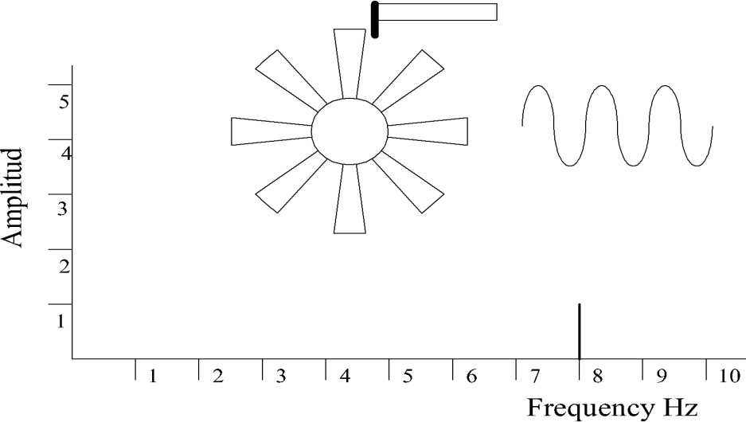

Figure 9 Plastic card barely touching the blades.

If now we place the card in such a way that makes bigger contact with blades, the height of the 8Hz line will increase (figure 10).

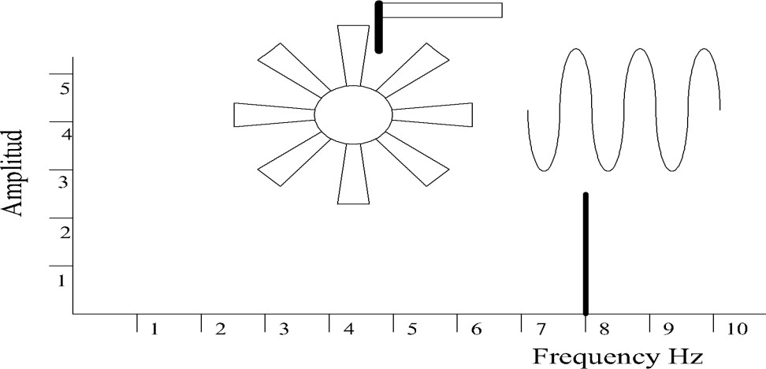

Figure 10 Plastic card making greater contact with the blades

So, we can see that our graph will change accordingly to the vibration source. The frequency or the amplitude will change and in some cases both. This is what is spectrum all about, breaking the time waveform in all of its elements (infinitive number of individual pure signals) and deter- mine the frequency and amplitude of those parts.

When measuring vibration, the frequency can be represented by and abso- lute value Hertz (Hz) or CPM (cycles per minute).

Forcing frequencies

The spectrum is based on the rotating elements of the machine. The num- ber of frequencies that the user expects in a spectrum will increase de- pending on the machine.

The forcing frequency is calculated as the speed of the shaft multiplied by a number of elements.

In this next example (Figure 11) the priority is to measure the frequency in a rotating impeller. We need to take into consideration that there are more forcing frequencies involve: motor shaft speed, cooling fan (8 blades) and the impeller itself (12 vanes).

The running speed of the fan is 2000 CPM so if the cooling fan has 8 blades, the forcing frequency is 8 times the running speed (16,000 CPM). The forcing frequency of the impeller is 24000 CPM because it has 12 vanes. Forcing frequencies are very important when it comes to machinery fault diagnosis. The calculations enable us to predict where peaks will ap- pear in the spectrum.
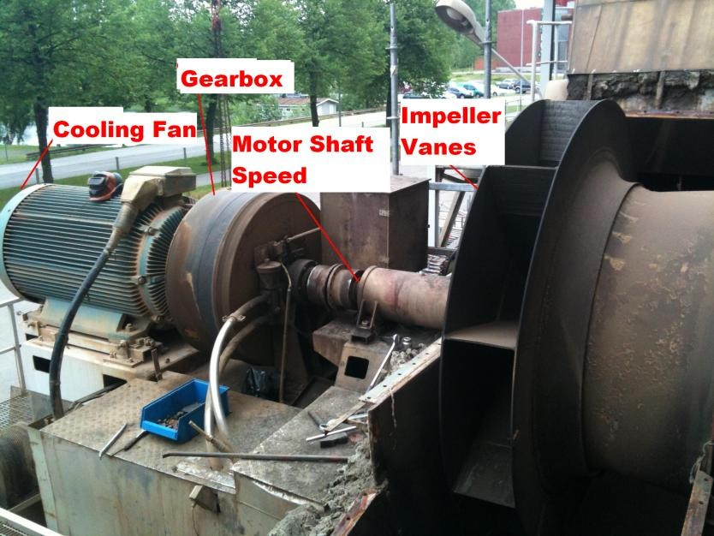

Figure 11 Representation of different vibration sources.

Also we need to take into consideration components like gearboxes (if there is one present) because they will also generate new frequencies and more important, it change the speed of the output shaft.

For example the gearbox showed in the picture 9 has a pinion input of 12 teeth and the output pinion has 24, then the output shaft will rotate at half the speed of the input shaft (2:1). Our fan (input shaft) rotates at 2000 CPM, so the output will turn at 1000 CPM. That means that our impeller now will rotate at 12 000 CPM ( 12 times the speed of the motor) and the speed of the cooling fan will remains the same because the motor speed has not change.

Overall readings of signals

Some people may not use the time waveform or spectrum data because they consider them to complicated to analyse. In the past those people consider that the RMS (Root Mean Square Amplitude) level of the signal was an “overall indication” of the machine health. When the RMS of the vibration increases, it was an indication that the condition of the machine will become worse. Also the peak level was used to describe the machines condition.

Most condition monitoring systems offer the option of an RMS reading that can be trended. The value is either calculated from the waveform or spectrum, or there is an actual chip in the data collector that derives the RMS level of a dynamic signal (Mobius Institute 2005, 28).

At the end of the day the RMS and peak level are just a detection tool and not and analysis tool. You must analyse the spectrum, time waveform or other available date in order to elaborate an accurate report of the machin- ery health.

Today most systems suppliers will offer you a variety of parameters that can be trended and is up to the user to select witch one fulfil their re- quirements.

Signal analysis

Usually companies have a very strict schedule when it comes to collect vi- bration measurements data. The most important machines will be tested every two months and less important machines once every four months.
Companies always give priority to critical machines. When reviewing the data (spectrum and time waveforms) the most common faults that the user will find are: Imbalance, misalignment, looseness and bearing faults.

The most common practice when analysing the data is to compare new measurements with old measurements and watch any change in level or time waveform, if there is then the user should act. The figure 12 shows a comparison of a vibration from different dates using a trend diagram from day cero (when machine was new) until day 2000 (5 years after).
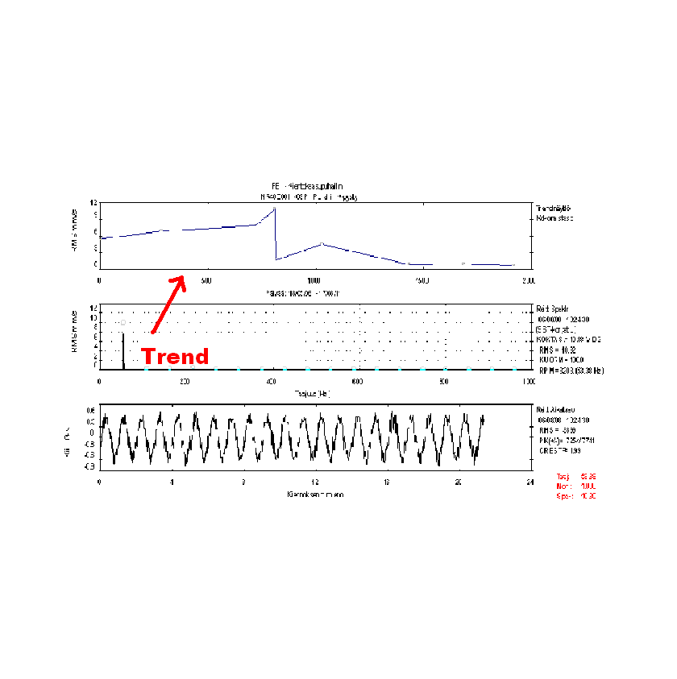

Figure 12 Comparation of vibration for same machine.

MEASURING VIBRATION

The vibration tells us about the forces inside the machine. To take advan- tage of this information a sensor ( also called transducer) is needed to con- vert the vibration into an electrical signal that we can process and store.

Collection good data is the most important part of the vibration analysis. The user should use the right sensor (mounted correctly as last time) and at the same time the test should be perform the same way every time, this means that the machine is running the same way as last time (previous vi- bration test) .Depending on the machine speed or bearing type the user should select between displacement sensor, velocity sensor and accelera- tion sensors. Annual calibration for this sensors is highly recommended by manufacturers.

Before performing any vibration test the user should carefully study the machine and identify the best location for the sensor. Also aspect like op- erating temperature or presence of water should be considered.

Types of sensors

As I mention earlier there are three types of sensors. The user should un- derstand the difference between acceleration, velocity and displacement sensors and know witch one to use depending on the measurement.

Displacement sensors

This type of sensors are permanently mounted because they measure the relative movement between the shaft and the tip of the sensor. Monitoring systems use this sensors in bearing machines such as turbines, large pumps and large fans. Usually the user is able to connect the portable data con- nector to the dynamic output to perform spectrum and trend analysis.
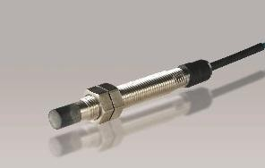

Figure 13 Displacement sensor.

Displacement sensors are also known as non-contact probes and commer- cially as proximity probes and its compound by three components: a prove, a driver, and a cable between them.

The principle of operation is very simple. A voltage is supplied to the driver that produces an RF signal. That signal is transmitted through the cable to the probe. A coil inside the probetip acts as an antenna and radi- ates the high frequency energy into the gap – its sets up a magnetic field. Any conductive material within the magnetic field absorbs the energy (Mobius Institute 2005, 64.)

The absorption of the field causes the output of the probe to decrease in proportion to the gap distance. So as the distance to the shaft changes dy- namically, so does the output signal. there is also a DC voltage propor- tional to the average gap distance. The DC gap signal is also used in moni- toring systems to determine where the shaft is located relative to the bear- ing. (Mobius Institute 2005, 64.)

The driver then acts as a “demodulator” and detector and has two outputs. the dynamic output produces the time waveform, from which we derive the spectrum and overall level (Mobius Institute 2005, 64.)

Usually the sensor is installed on the machine 90 degrees apart. By doing this the user see how the shaft is moving within the bearing. Orbit dia- grams are used to display this movement and therefore cracks in the shaft, imbalance or misalignment can be detect.

Advantages

      - Very low frequency response (to 0 Hz)
      - If they are installed correctly rehabilitee is 100%
      - It measures the actual relative displacement of the shaft with the bearings.

Disadvantages

      - They are very expensive and can’t be used for high frequency measurements
      - The calibration depends on the shaft material ( different materials absorb the energy at different rates)

Applications

      - They are useful as a key pharos for dynamic balancing and analy- sis (key phasor is a reference signal proportional to running speed)

      - Used for low speed machines. Typically below 10 Hz

Units

      - The units are mils pk-pk or microns pk-pk. (1 mil = .001”)

Velocity sensors

The electrodynamic velocity sensor is basically a suspended magnet mounted between a spring and a damper (a coil surrounds the magnet). When the case of the sensor vibrates the magnet inside remains stationary because of the inertia. So, there is a movement of the magnet between the coil that generates electricity proportional to the velocity of the mass.

Advantages

      - the output signal is very powerful
      - External power is not needed
      - It can operates in high temperatures environments

Disadvantages

      - These types of sensors are quite large
      - Because moving parts are involve, internal wear can shorten its life

Applications

These types of sensors are not longer used. Instead accelerometers that are internally integrated to velocity are more common used as velocity sen- sors.

Units

Usually units are mm/sec rms or in/sec

Accelerometers

When it comes to vibration analysis accelometers are the most common types of sensors used (figure 14). In the market there are many different types of accelometers but the most common is the internally amplified piezoelectric.

The charge output generated by the sensor is proportional to the force and therefore acceleration. In this case an amplifier is needed to convert that charge output into a voltage output (the amplifier is powered by the data collector).

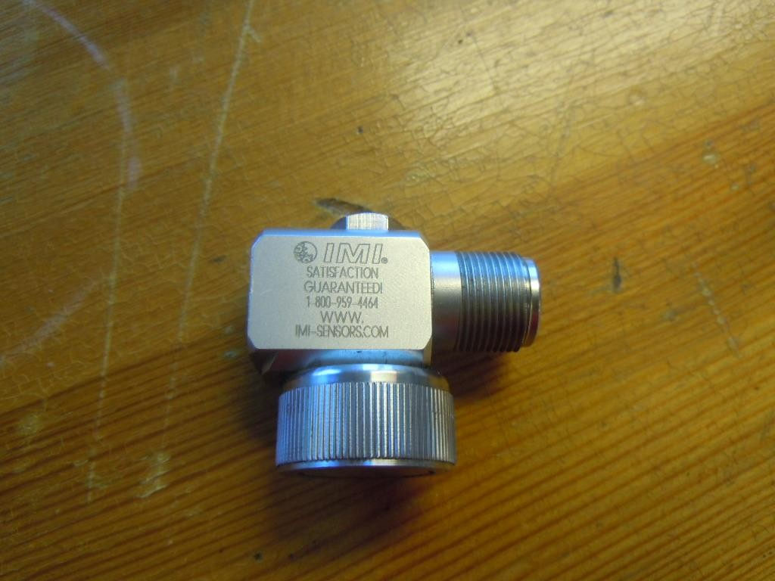

Figure 14 Accelerometer

During the measurements with the data collector the user have to take into account the settling time. When an internally amplified piezoelectric acce- lometers is connected to the power source it will takes a few second to stabilize. This means that the data obtained during this time will be con- taminated. Because of this there should be a time delay set inside the data collector to assure the accuracy of the measurement.

In a real scenario the user may drop the sensor on a hard surface and the sensitivity is compromised. It’s a good idea to calibrate the sensor at least twice in a year.

Advantages
      - A wide frequency and amplitude range
      - These types of sensors are very stable and maintain calibration for a long time

Disadvantages
      - There could be some limitations due to the internal amplifier

Applications

All portable data collectors are supplied with an accelerometer. They are available for a wide variety of environments and machine.

Units

      - G rms or adB

VIBRATION ANALYSIS

In this step the user will focus on reviewing the vibration data obtained from the measurements in order to determine witch machine have prob- lems, what is wrong with the machine and most important what should be done. Some artificial intelligence software may help the user to analyse the data but is through experience and cooperation from other colleagues that that a good report can be achieve.

After finishing the data collection process probably the user will end up with megabytes of data (waveforms, bearing measurements, spectra etc) to be analyse. When doing vibration analysis the user should not miss any problem with the machine. Because of this the vibration analysis is di- vided in four steps: Detection, Analysis, Root Cause, and Verification.

Detection

This process is all about finding out the nature and severity of the prob- lem. Typically the user get comfortable in the office and start displaying in the computer the measurements of each machine. This method may be very slow and tedious.

New technologies like automation give the user a different approach. A software would examine all the new vibration data and compare them to previous readings and generate a list of machines that are in risk of fail- ures, always taking in consideration the alarm limits. The result usually is presented as a percentage increase.

Alarm limits

When doing vibration measurements and after collecting new data the first question to ask is, what levels should be? Or at what point a recommenda- tion that a repair is needed should be done.

There are two ways to set a reference alarm level to compare against. The first is to utilize published alarm limits and the second is to perform calcu- lations to derive the alarm limit.

Fixed alarm limits

The standard ISO 10816 offers some guidance when evaluation the sever- ity of the vibration (figure 11) using the RMS as reference.

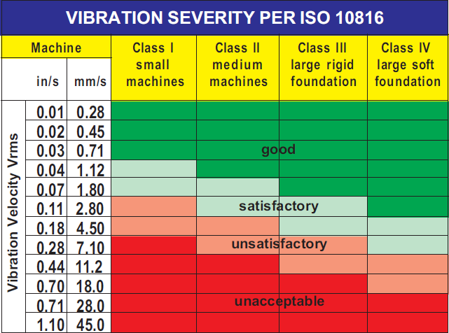

Figure 15 ISO standard number 10816 Severity Chart

      - Class 1 : Small machines, especially production electrical motors up to 15 kw

      - Class 2: Electrical motors from 15 kw up to 75 kw without special foundation

      - Class 3: Large machines on heavy foundations

      - Class 4: Largest machines and turbo machines with special founda- tion

Calculated alarm limits

Based on previous readings the user can calculate what the limit should be rather than using the fixed limits.

When new machines are put into operation is better to use fixed alarm lim- its. Later on when enough time has past (6 months) the vibration levels wont change more than 15% , so the user should consider the machine condition as stable and those vibration levels will become the vibration levels parameters.

Also is very important that the first ever set of vibration data collected from the machine are used as a baseline. In the future when a problem comes the baseline would become the vibration measurements reference that represents how the machine should vibrate.

When setting alarm limits the user should take into consideration the speed variation of the machine. For example the same machine could have different running speeds in summer and winter. In this case the alarm limit will adapt new levels because of the change in running conditions.

Analysing vibration data

Sometimes the vibration alarm limits may not be accurate or there is a change in speed/load and the user is force to make a deep investigation of the vibration measurements. During this analysis (investigation) there is a set of steps that the user should fallow in order to understand what’s really going on.

The first action is to look at the trends. They will show is there has been an increase of vibration levels over the time and if the vibration level will reach or exceed the alarm limits in the future.

Later on the user should have a clear understanding of the harmonics, how to detect and analyse them. For example looseness in machinery can be detected through harmonics.

Sideband is a very important data to look for when analysing vibration measurements. They are the result of an amplitude modulation between two signals. In the spectrum sidebands will look like evenly spaced peaks cantered around another peak. In conclusion sidebands are very important when it comes to study rolling elements like bearings.

At the end of the day vibration analysis relies heavily in comparison be- tween current measurements and older measurements. If the user under- stands the changes he or she will have a clear picture of the problem.

Root cause Analysis

Root cause analysis is the ability to detect a fault and diagnose the severity and nature of the problem. So rather than just fixing the problems the user spends time investigating the real cause of the failure in other to avoid the same problem in the future.

Verification

After the problem is detected and fixed the machine is returned to service. But in this situation there is a quite high probability of failure soon after repair because of parts installed incorrectly or poor lubrication. So after the machine is put in to service the user should take new set of vibration measurements to verify that there is any indication of new problems.

PRACTICAL WORK
The practical work of this thesis consists of describing how to perform vi- bration levels in the field. I visited the heating plant of the municipality of Karkkila located in Southern Finland to perform vibration measurements on their flue gas fan.
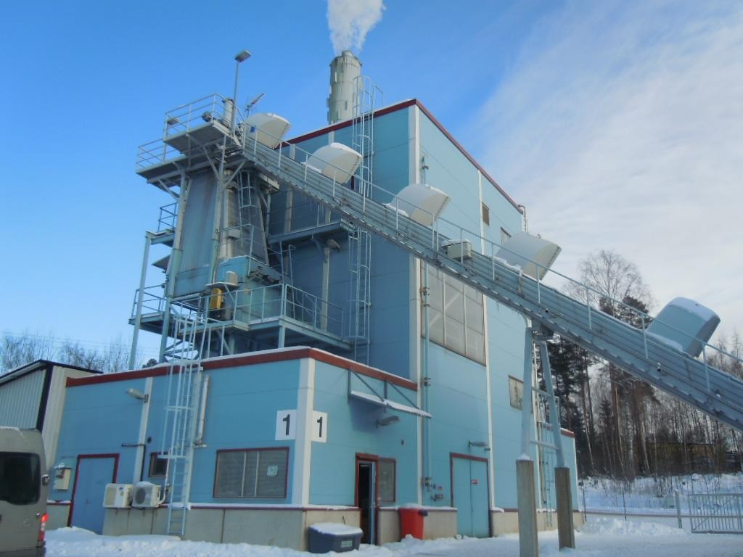

Figure 16 Heating Plant in Karkkila

Type of machine

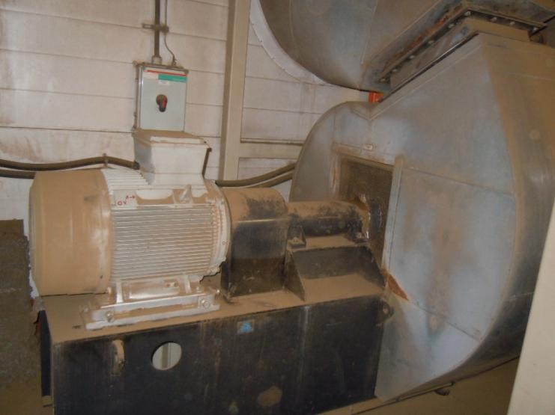
For the vibration measurement I selected the flue gas fan of the plant. The flue gas fan removes the gases generated in the combustion boilers, after which they pass through the filter and are directed back into the atmos- phere.

Figure 17 Flue gas fan in Karkkila

Performing the measurements

To perform the vibration measurements a portable data collector was used. It only took around three minutes to go through this process (Figure 19).

The CSI 2130 Machinery Health Analyzer can quickly and accurately identify developing faults in the rotating machinery, and then get to the root cause of the problem so that this can be fixed once and for all (Figure 18). Simple to use, the CSI 2130 allows maintenance personnel to monitor more machines in less time, and focus their efforts on developing faults instead of chasing the next breakdown. (Emerson.com/products)

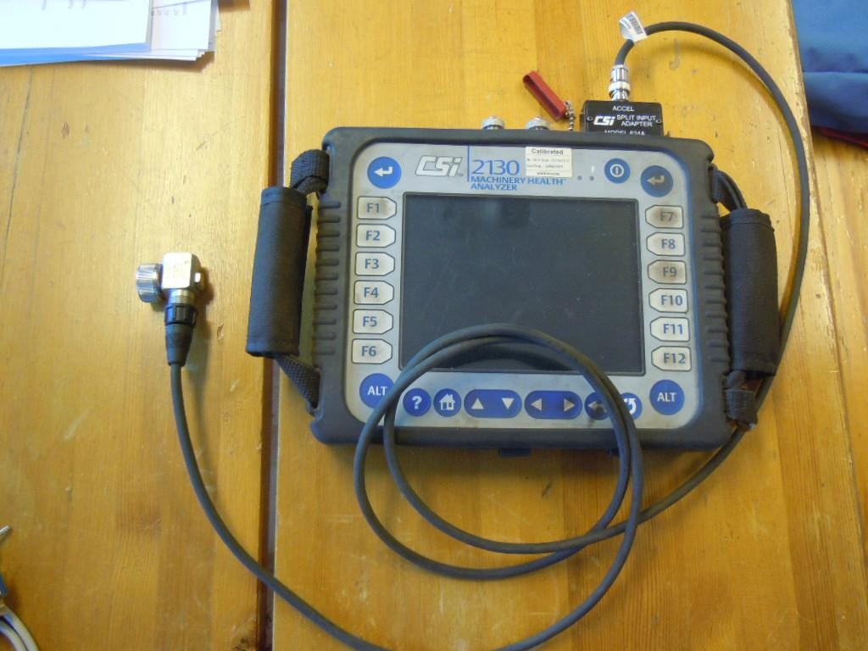

Figure 18 CSi 2130 Machinery health analyzer

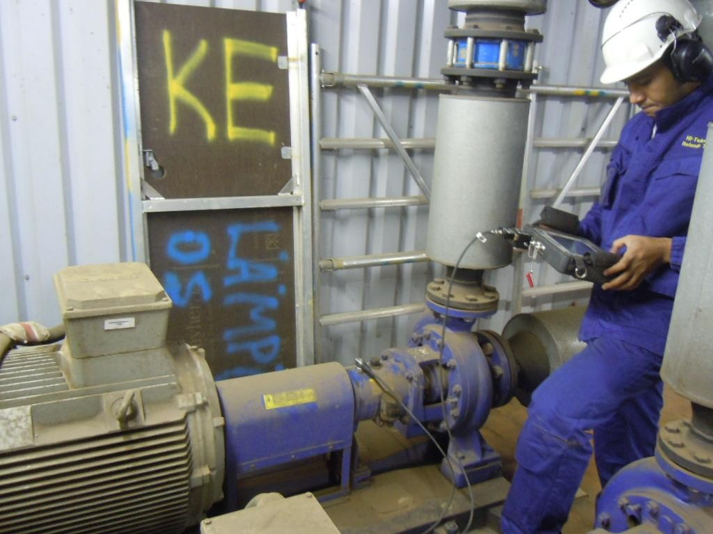

Figure 19 Vibration Measurements performed by the author.

Evaluating the data

To evaluate the information obtained by the data collector I used the AMS suite machinery Health Manager made by Emerson.

AMS Machinery Manager provides:

    - Machine health diagnostics from multiple, integrated predictive maintenance technologies for a complete picture of the condition of machinery.

    - Analysis tools for diagnosis and prognosis of machinery health.

    - AMS Suite: Asset Performance Management and other business systems to disseminate machinery health information throughout the enterprise.

    - Real-time asset health integration with control automation systems (Emerson.com/products/AMS Suite: Machinery Health Manager )

Summary

The existence of non-synchronous components in a vibration spectrum is a red flag to the analyst that bearing problems may exist. Figure 20 shows letters B and C in the spectrum. This automatically means that there is a problem concerning the ball pass outer rate of the bearing because started to wear. A problem with bearings is mainly a lubrication problem, maybe the wrong lubricant was used or the amount of lubricant used was not enough.
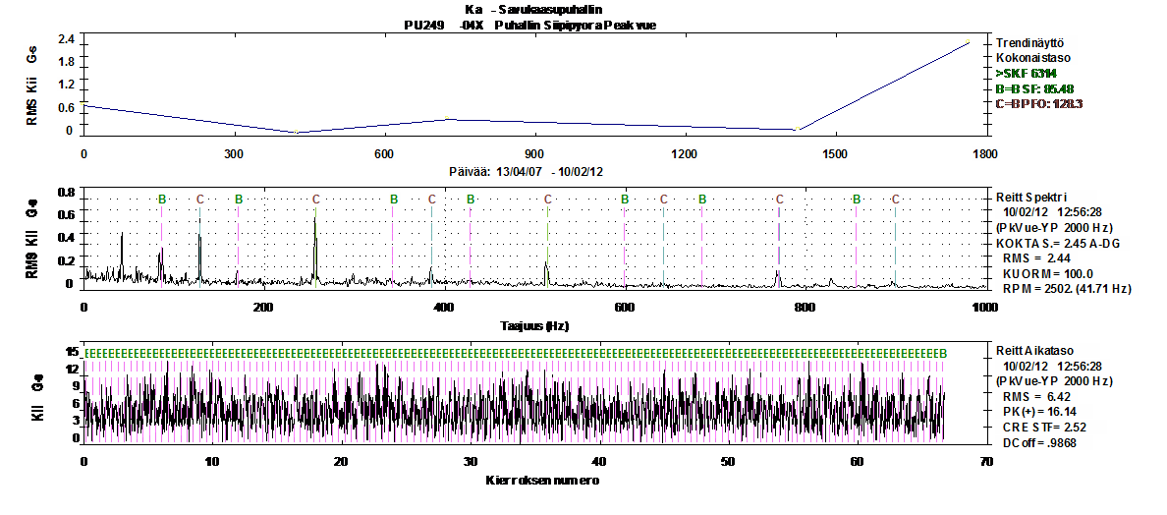
Figure 20 AMS manager – Vibration measurement recording 1

When the outer race of the bearing start to wear the balls have more space to move and the bearing does not work properly, creating a looseness problem. This creates harmonics in the spectrum (Figure 21).

As the bearing wear grows worse, the level of the peak in the fault fre- quency will increase. The harmonics in the spectrum will indicate the amount of impact that is occurring internally. The trend in Figure 21 shows that there is a change in the vibration level indicating that a prob- lem is occurring.
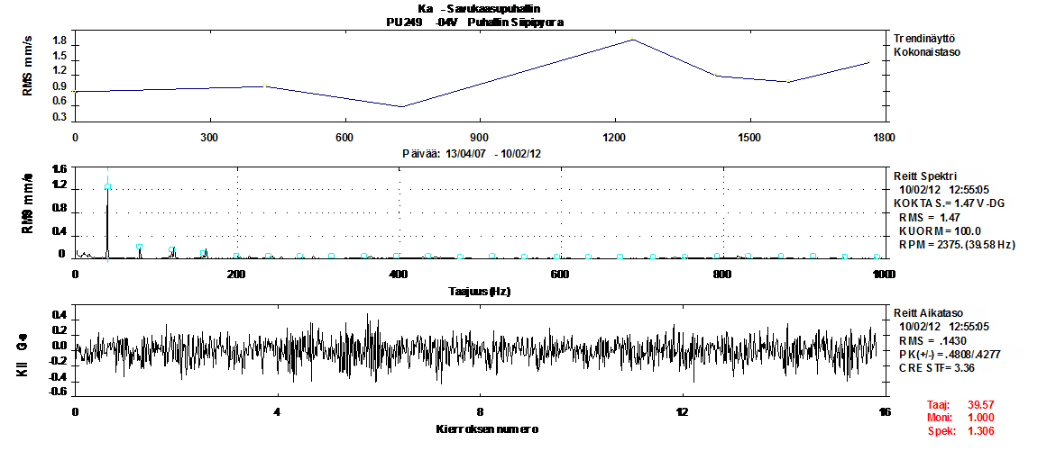

Figure 21 AMS manager – Vibration measurement recording 2

Also after a bearing fault has began the level of noise will increase propor- tionally to the magnitude of the fault. The Figure 22 shows that there has been a change in the level of noise generated by the bearing, it is possible to compare the actual noise level to the previous ones obtained two years ago.

Max Amp
.63

Ka - Savukaasupuhallin
PU249 -04X Puhallin Siipipyora Peak vue

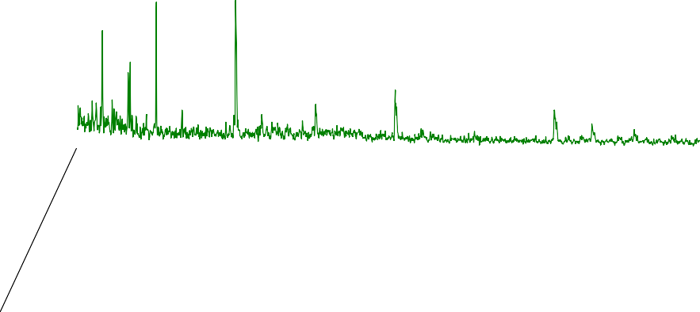0.7
0.6

0.5

0.4

0.3

0.2
RM S Kiiht y v y y s G- s

0.1

0
10/02/12
12:56:28

08/03/11
12:53:17

0 200 400 600 800 1000
Taajuus (Hz)

08/04/09
09:14:28

Figure 22 AMS manager – Vibration measurement recording 3

Because the bearing is a rolling element, every time that the balls pass the damage area of the outer rate a hit is generated. The peak values have changed since 2011, from 1.0 G to 15.8 G. The peaks represent the amount of energy in every hit, that the bearings make (Figure 23).

Ka - Savukaasupuhallin
PU249 -04X Puhallin Siipipyora Peak vue

15.8
.0

10/02/12 12:56

1.04
.0

08/03/11 12:53

2.96
.0

08/04/09 09:14

0 4 8 12 16 20 24 28 32

Figure 23 AMS manager – Vibration measurement outcome 4

The Figure 24 shows how bad the damage in the inner race of the bearing can become because of wearing problems.

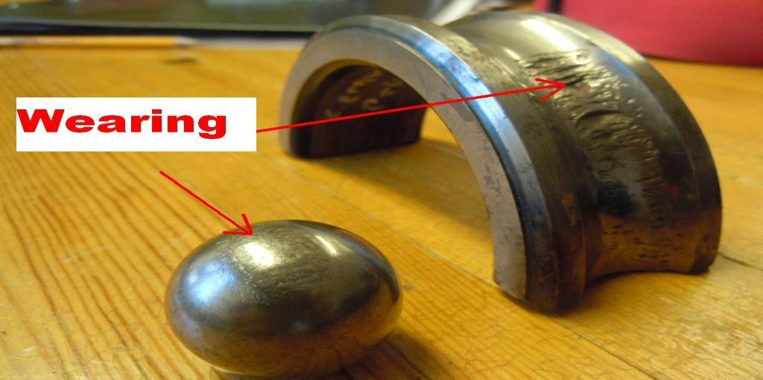

Figure 24 Wearing in bearings

After my visit to the hot water plant the person in charge received a full report containing graphics an explanation of the problem. They decided to keep the flue gas fan running because the bearing problem was not severe and also because it was in the middle of the winter season when shutting down the fan for maintenance service would have left the city without hot water.

10 MACHINERY FAULT DIAGNOSIS
This step is one of the most important when it comes to vibration meas- urements. Experience plays a big role here because when conducting the diagnostic process the user should have a good understanding of what it happening inside the machine.

When the user is starting the fault diagnosis phase, the most likely faults to be found are:

- Imbalance
- Misalignment
- Rolling element bearing faults
- Looseness
- Resonance

Imbalance

Imbalance is a condition where the center of the mass does not lie on the axis of rotation. This means that there is a heavy spot (mass) somewhere along the shaft. So if the machine is out of balance the user will see a sinu- soidal time waveform. It is up to the user to determine whether the imbal- ance actually represents a problem that is serious on the amplitude levels. (Mobius Institute 2005, 169.)

In practice machinery with a balancing fault is very common because the increased rotational forces put excessive stress on the bearings and seals.

Figure 25 shows an imbalance problem in a machine. There is a strong peek in the rotating speed. The trend shows that there is a change in the vibration level from 4.0 mm/s to 10.82 mm/s.
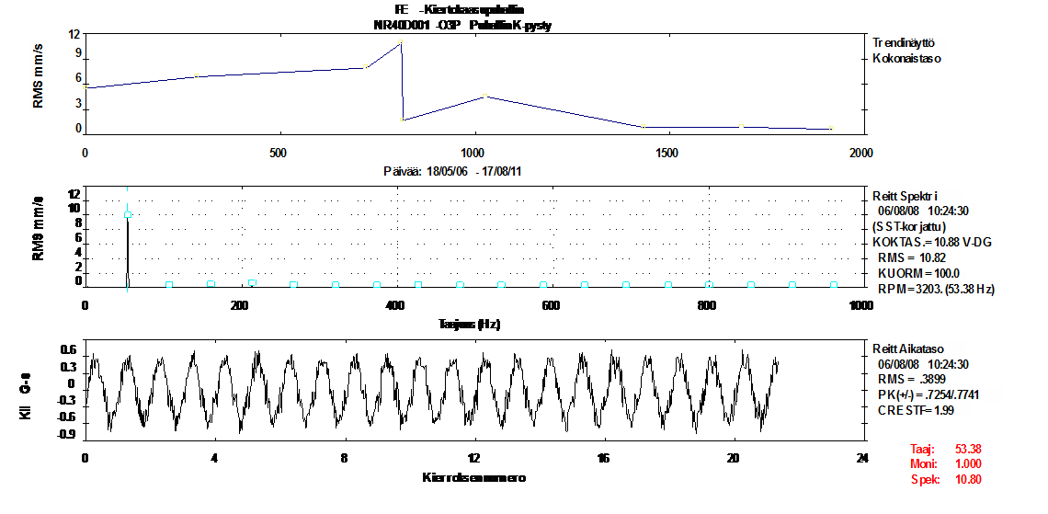
Figure 25 Imbalance diagnosis base on vibration levels

Figure 26 shows that with the same machine the vibration level has been reduced to 1.5 mm/s meaning that the imbalance problem has been solved.
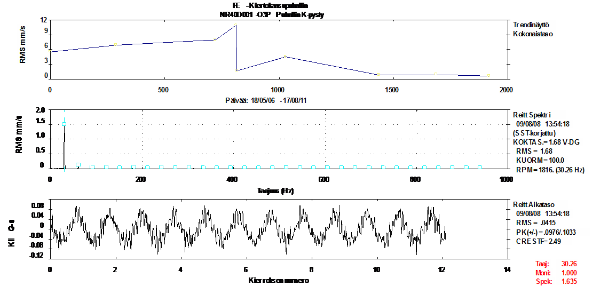
Figure 26 Imbalance diagnosis based on vibration levels

Causes for Imbalance

The following conditions can result in an imbalance problem:

      - Cracked rotor
      - Machining errors
      - Uneven mass distribution in electrical windings
      - Missing balance weights

Misalignment

Misalignment is a condition where the centrelines of coupled shafts do not coincide. There are two types of misalignments: parallel misalignment and angular misalignment.

The user should also distinguish between misalignment and imbalance when performing the machinery fault diagnosis. The vibration level due to imbalance will increase in proportion to the square of the speed whereas vibration due to misalignment will not change.

Parallel misalignment

In this case the misaligned centrelines are parallel but not coincident (Fig- ure 27). (If the machine speed can be varied, the vibration due to imbal- ance will vary with the square of the speed)
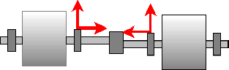
Figure 27 Parallel misalignment between two shafts.

Angular misalignment

In this case the misalignment shafts meet at one point but they are not in parallel (Figure 28).

Figure 28 Angular Misalignment between two shafts

Causes for misalignment

      - Incorrect assembly of components
      - Temperature induced growth of machine structure
      - Soft food, sometimes the hold down bolts are loose

10.3 Looseness

There are two types of looseness: rotating looseness and non rotating looseness. Rotating looseness is caused by excessive clearance between the rotating and stationary elements of the machine such as in a bearing, while non-rotating looseness is looseness between two normally stationary parts, such as a foot and a foundation or a bearing housing and machine. (Mobius Institute 2005, 186.)

Figure 29 shows the vibration measurement for a fan. The huge amount of harmonics in the spectrum tell us that there is a looseness problem.
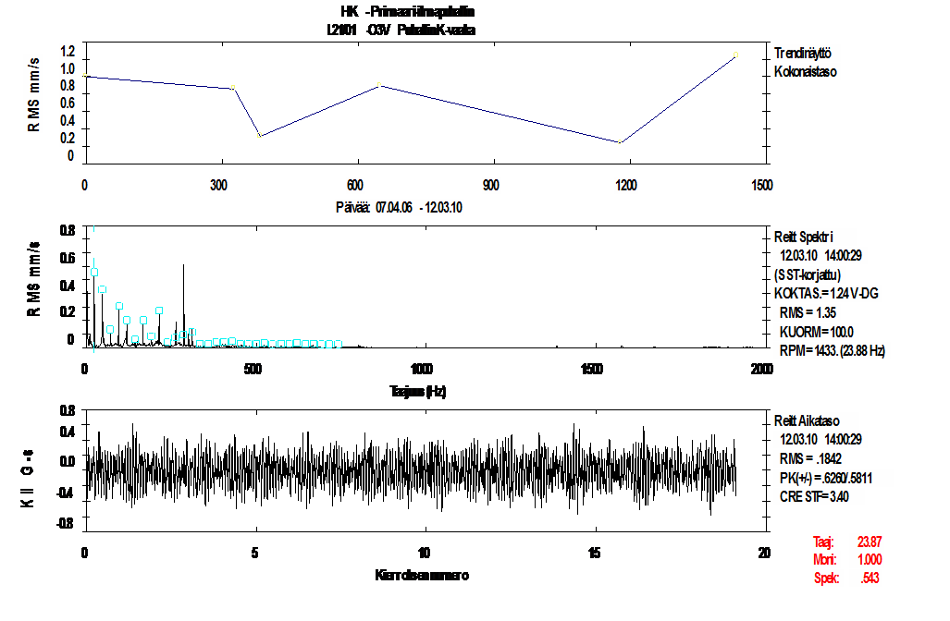

Figure 29 Looseness diagnosis based on vibration levels

10.3.1 Rotating looseness

When the bearing of the machine start to wear there is a high probability that rotating looseness can occur. By studying the spectrum of the vibra- tion measurement the user will detect a potential looseness problem. As the looseness problem becomes worse, the number and amplitude of the harmonics will increase. (Mobius Institute 2005, 186.)

Rolling element bearing faults

Rolling elements bearings can be found in almost all rotatory machines and somehow they are responsible for many faults inside the machine. Around 10% of all the bearings will run for their desired lifetime, other 40% will fail due to improper lubrication and almost 30% of the failures are generated because of bad mounting or misalignment. The rest 20% are faults because of other reasons. (Mobius Institute 2005, 194.)

Of course if a machine is properly lubricated and well balanced, it will be- come more reliable. In many of the industries around the world this is not the case and bearings fail prematurely. A vibration analysis is a perfect so- lution to detect bearing problems with machinery.

When analysing bearings the user must take into consideration the follow- ing forcing frequencies:

    - Ball Spin- BS
    - Ball Pass inner Race- BPI
    - Ball pass outer Race- BPO
    - Fundamental Train – FT

Calculating these frequencies can be complicated, but most of the vibra- tion measurements software packages will offer the user a huge database for different types of bearings. Depending on the type of bearing the user will find the four forcing frequencies.

Bearing failure comes at different stages. At the beginning the vibration spectrum will not give much information to the user because the fault will produce only ultrasonic frequencies. Later on the bearing wears grow worse and the frequencies will begin to appear in the spectrum. With time the fault will get worse and the vibration level will definitely increase, at this stage higher harmonics will appear in the spectrum. At the last stage the user definitely will be able to hear the bearings, meaning that the time is running out and imminent failure is approaching.

The most important thing to learn is that vibration measurements will help the user to detect problems with bearings when they are in the early stages, so the user can prevent any bigger losses because of bearing failures.

Pump Faults

There are many types of pumps in the market and the vibration pattern for each of them may vary. It is always important when performing vibration measurements for pumps that the operating conditions are consistent from one measurement to the next to assure consistent vibration patterns. (Mo- bius Institute 2005, 217.)

When analysing centrifugal pumps it is important to notice if the vibration amplitude increases considerably. This can be a sign of misalignment problems.

In conclusion, most of the pumps will generate a peak in the spectrum (number of rotating elements multiplied by the speed of the pump), if this peak level increases during a certain period of time probably the user will detect that a problem exists in the pump.

Fan faults

Most fans are either axial flow propeller-type, or centrifugal. Fans are prone to uneven build-up of debris on the blades, especially when they are handling particle-laden air or gas. This causes imbalance, and should be corrected as soon as it is diagnosed. (Mobius Institute 2005, 219).

If any blades become deformed, cracked, or broken, the blade pass fre- quency vibration peak will increase in level, and if there are many blades, sometime 1X sidebands will appear around the blade pass frequency. If there is a clearance problem, harmonics of blade pass will also be present. (Mobius Institute 2005, 219).

CONCLUSION
With this thesis work my objective was to inform people about the impor- tance of vibration measurements for maintenance services. Vibration measurement is the most integral test that will give the user and accurate idea of the machine’s condition internally.

For example with energy plants and paper mills it is easier to schedule the maintenance work when the user knows which machines will need more attention and not waste time and money on non-critical machines.

Companies will lose a lot of money when a failure occurs. A vibration measurement will give the user an option to save money in spare parts and to avoid any downtime. A vibration measurement will cost probably 2000 or 3000 Euros for a company, but at the same time millions of Euros can be saved avoiding downtime and acquisition of spare parts.

In Finland big companies such as paper mills or Energy plants are aware of the importance of vibration measurements, they have the equipment and specialised personnel for these purposes, but smaller industries with low budgets prefer to outsource the vibration services.

It is still not easy to sell the vibration measurement service to industries because they do not realize the high amount of money that can be saved just by knowing the health status of their machinery.

I predict that in the future the technology of vibration measurement will be well known by engineers, and the number of people that can understand this technology and perform a vibration measurement will not be many.

SOURCES

- AMS Suite: Machinery Health Manager. Accessed March 2012. http://www2.emersonprocess.com/enUS/brands/amssuite/amsmach inerymanager/Pages/MachineryManager.aspx

- Mobius Institute, Vibration Training Book course. 2005.

- PSK 6201. Maintenance. Terms and definitions. Part 4: Mainten- ance objectives. 2011-08-15 3rd edition. Accessed March 2012. http://www.pskstandardisointi.fi.proxy.hamk.fi:2048/Standard/Ryh ma62/psk6201.pdf

- PSK Standardisointi 2009 Vibration Measurement in Condition Monitoring. PSK Standardisointiyhdistys ry Helsinki. Accessed March 2012.

- Portable Data collector CSi 2130. Accessed March 2012. http://www2.emersonprocess.com/enUS/brands/csitechnologies/pv a/csi2130/Pages/CSI2130MachineryHealthAnalyzer.asp

- Scandinavian Center for Maintenance Management, Keep it run- ning Industrial Asset Management. 1998. Finland: Scandinavian Center for Maintenance Management Finland ry and Management System Oy

- Touru Tapio. 2011. Maintenance lecture series. HAMK University of Applied Sciences September-December 2011.

