Vibration Measurement Techniques: Basics

Introduction:

Vibration is the back and forth or repetitive motion of an object from its point of rest. When a force is applied to the mass, it stretches the spring and moves the weight to the lower limit. When the force is removed, the stored energy in the spring causes the weight to move upward through the position of rest to its upper limit. Here, the mass stops and reverses direction traveling back through the position of rest to the lower limit. In a friction-free system the mass would continue this motion indefinitely. All real systems are damped, that is they will gradually come to their rest position after several cycles of motion, unless acted upon by an external force. The characteristics of this vibratory motion are period, frequency, displacement, velocity, acceleration, amplitude and phase. Continued vibration of this spring mass system would only repeat the characteristics shown in this single cycle.

All rotating machines produce vibrations that are a function of the machine dynamics, such as the alignment and balance of the rotating parts. Measuring the amplitude of vibration at certain frequencies can provide valuable information about the accuracy of shaft alignment and balance, the condition of bearings or gears, and the effect on the machine due to resonance from the housings, piping and other structures. Vibration measurement is an effective, non-intrusive method to monitor machine condition during start-ups, shutdowns and normal operation. Vibration analysis is used primarily on rotating equipment such as steam and gas turbines, pumps, motors, compressors, paper machines, rolling mills, machine tools and gearboxes. Vibration analysis is used to determine the operating and mechanical condition of equipment. A major advantage is that vibration analysis can identify developing problems before they become too serious and cause unscheduled downtime. This can be achieved by conducting regular monitoring of machine vibrations either on continuous basis or at scheduled intervals. Regular vibration monitoring can detect deteriorating or defective bearings, mechanical looseness and worn or broken gears. Vibration analysis can also detect misalignment and unbalance before these conditions result in bearing or shaft deterioration. Trending vibration levels can identify poor maintenance practices, such

as improper bearing installation and replacement, inaccurate shaft alignment or imprecise rotor balancing.

Basic Characteristics of Vibrations:

Modern vibration monitoring has its genesis in the mid-1950s with the development and application of basic vibration sensors, which are the heart of modern computerized condition monitoring systems. Figure 9.1 shows the traditional fundamental use of vibration monitoring in rotating machinery, i.e., to provide warning of gradually approached or suddenly encountered excessively high vibration levels that could potentially damage the machinery. Trending a machine’s vibration levels over an extended period of time can potentially provide early warning of impending excessive vibration levels and/or other problems and thus provide plant operators with valuable information for critical decision making to schedule a timely shutdown of a problem machine for corrective action, e.g., rebalancing the rotor. For evaluating the machine vibrations, it is usually desirable to express frequency in terms of cycles per minute, since we measure the rotational speed of machinery in revolutions per minute. This allows examination of the vibration frequency in terms of multiples of the rotational speed. Rotational speed is also known as the fundamental frequency and the multiples of the fundamentals frequencies are known as its higher harmonics or super harmonics.
Trip level

Alarm level
Vibration Amplitude (m/s²)

Sudden increase

Time

Fig. 9.1 Vibration signature as Indicator

There are three main parameters are measured to evaluate the vibration characteristics of any dynamic system as displacement, velocity and acceleration. The peak-to-peak distance is measured from the upper limit to the lower limit, measured in mm to micron level. The velocity of a vibrating object is continually changing. At the upper and lower limits, the object stops and reverses its direction of travel, thus its velocity at these two points is zero.
While passing through the neutral or position of rest, the velocity is at its maximum. Since, the velocity is continually changing with respect to time, the peak or maximum velocity is always measured and commonly expressed in mm-per-second peak. When expressing the vibration characteristic in terms of velocity, both the displacement and frequency are considered. Since, the vibrating object must reverse course at the peak displacements, this is where the maximum acceleration occurs. Like velocity, acceleration is constantly changing, and the peak acceleration is usually measured.
Displacement measurements can be important, especially in low frequency vibrations on machines that have brittle components. That is, the stress that is applied is sufficient to snap the component. Many machines have cast iron frames or cases that are relatively brittle and are subject to failure from a single large stress. Acceleration measurements are also important in that they directly measure force. Excessive force can lead to improper lubrication in journal bearings, and result in failure. The dynamic force created by the vibration of a rotating member can directly cause bearing failure. Generally a machine can withstand up to eight times its designed static load before bearing failure occurs. However, overloads as little as 10% can cause damage over an extended period of time. Although this seems insignificant, it can be shown that small unbalances can easily create sufficient dynamic forces to overload the bearings.
The International Standards Organization (ISO), who establishes internationally acceptable units for measurement of machinery vibration, suggested the velocity – root mean square (rms) as the standard unit of measurement. This was decided in an attempt to derive criteria that would determine an effective value for the varying function of velocity. Velocity – rms tends to provide the energy content in the vibration signal, whereas the velocity peak correlated better with the intensity of vibration. Higher velocity – rms is generally more damaging than a similar magnitude

of velocity peak. The crest factor of a waveform is the ratio of the peak value of the waveform to the rms value of the waveform. It is also sometimes called the ‘peak-to- rms ratio’. The crest factor of a sine wave is 1.414, i.e. the peak value is 1.414 times the rms value. The crest factor is one of the important features that can be used to trend machine condition. In discussing vibration velocity, it was pointed out that the velocity of the mass approaches zero at extreme limits of travel. Each time it comes to a stop at the limit of travel, it must accelerate to increase velocity to travel to the opposite limit. Acceleration is defined as the rate of change in velocity. Referring to the spring-mass body, acceleration of the mass is at a maximum at the extreme limit of travel where velocity of the mass is zero. As the velocity approaches a maximum value, the acceleration drops to zero and again continues to rise to its maximum value at the other extreme limit of travel.
Significance of Dynamic parameters

The displacement, velocity and acceleration characteristics of vibration are measured to determine the severity of the vibration and these are often referred to as the ‘amplitude’ of the vibration. In terms of the operation of the machine, the vibration amplitude is the first indicator to indicate how good or bad the condition of the machine may be. Generally, greater vibration amplitudes correspond to higher levels of machinery defects. The relationship between acceleration, velocity and displacement with respect to vibration amplitude and machinery health redefines the measurement and data analysis techniques that should be used. Motion below 10 Hz (600 cpm) produces very little vibration in terms of acceleration, moderate vibration in terms of velocity and relatively large vibrations in terms of displacement. Hence, displacement is used in this range. In the high frequency range, acceleration values yield more significant values than velocity or displacement. Hence, for frequencies over 1000 Hz (60 kcpm) or 1500 Hz (90 kcpm), the preferred measurement unit for vibration is acceleration. It is generally accepted that between 10 Hz (600 cpm) and 1000 Hz (60 kcpm) velocity gives a good indication of the severity of vibration, and above 1000 Hz (60 kcpm), acceleration is the only good indicator. Since, the majority of general rotating machinery (and their defects) operates in the 10–1000 Hz range, velocity is commonly used for vibration measurement and analysis. In recent time, there is a concerted effort to utilize vibration monitoring in an extended role, mainly

in what is now commonly called predictive maintenance, which is an extension and/or replacement of traditional preventive maintenance. [Scheffer & Girdher]
An additional benefit of a model-based diagnostic approach is the ability to combine measured vibration signals with vibration computer model outputs to make real-time determinations of rotor vibration signals at locations where no sensors are installed. Typically, vibration sensors are installed at or near the bearings where sensor access to the rotor and survivability of sensors dictate. However, midspan locations between the bearings are where operators would most like to measure vibration levels but cannot because of inaccessibility and the hostile environment for vibration sensors. Thus, the model-based approach provides “virtual sensors” at inaccessible rotor locations.

Measured vibration using sensors:

The nature of sound and vibrations to be measured can vary widely. Sound can be “noisy” (roar or hiss-like), like that from a heavily trafficked highway, while vibrations of a machine are often dominated by the rotational frequency and its multiples. A machine under constant loading gives off a stationary noise, while the noise at an airport tends to be intermittent. Moreover, the purpose of measurements varies. The commonly monitored vibration signals are displacement, velocity, and acceleration. The basic operational principles of each of these are presented in this section. The measurement systems that are marketed today are primarily digital, i.e., sound pressure and vibrations are converted into digital values for later treatment in more or less advanced signal processors. While digital technology offers ever more sophisticated possibilities, measurement systems are nevertheless often adapted to be able to compare measurement results with those obtained in the past using analog technology. Digital measurement systems have a more complicated structure than analog ones.

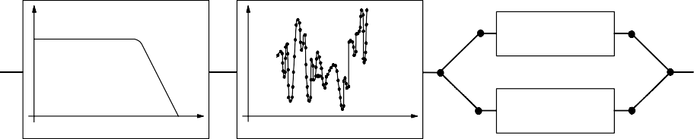S ound or vibra t io n s igna l T ra n s duc e r E lectrical s ig n a l S igna l c o nditio ning
S igna l
A ccelero m ete r

Tim e
M ic ropho ne
A n a log f ilte r
A n a log - d ig ita l c o nve rs ion
F re que nc y a n a ly s is
A m plific a t ion
S igna l
1
D ig ita l
f ilte r in g
Im pe da nc e m a tc hing

A m p lific a tio n

F a s t F ourie r
F re q ue n c y Tim e Tra n s fo rm L o w pa s s f ilte r ing
M eas u rem e n t d a ta Gra p h
p ro c e ssin g |  |  | A m p litu d e  F re que nc y
E x am p le:
A v erag in g
R M S a m plitu de
A - , B - , C - w e ig hting

Fig. 9.2 Flow chart of a digital, single-channel measurement system [1]

The types of transducers that are most commonly used in vibroacoustics are microphones to measure sound pressure, accelerometers to measure accelerations of solid structures, and force transducers to measure forces on solid structures. The principles behind force transducers are not described here, but are very similar to those for accelerometers.
A number of characteristics are common to all types of transducers:

Sensitivity: Indicates the ratio of electrical output to mechanical input. Example: A microphone’s sensitivity is given in mV/Pa.
Frequency band: Indicates the upper and lower frequency limits, between which the transducer sensitivity varies within a given (small) tolerance range.

Dynamic range: Indicates the upper and lower amplitude limits between which
the transducer sensitivity varies within a given (small) tolerance
range. The dynamic range is commonly given in dB with respect to a reference value. The lower dynamic boundary is often determined by the transducer’s electrical noise, and the upper boundary by when the transducer is loaded beyond its mechanical linear region.

Accelerometer

An accelerometer is composed of an internal mass compressed in contact with a

relatively stiff
force-measuring load
cell (usually a piezoelectric crystal) by a

relatively soft preload spring. For an accelerometer, the system damping is a
negligible effect and thus for explanation purposes the damping is assumed here to be zero.
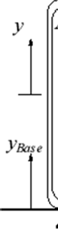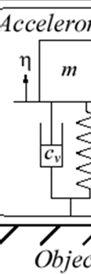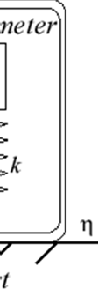

Fig. 9.3 Uni-axial accelerometer

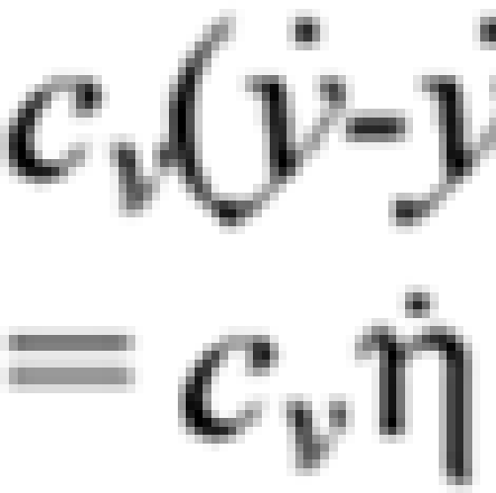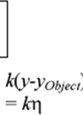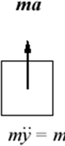

Fig. 9.4 FBD for force balance

The equation of motion then becomes,
⋅⋅ ⋅ ⋅⋅
mη + cv η + kη = −m y object

(9.1)

The accelerometer load cell is usually a piezoelectric crystal and thus registers only compressive loads, necessitating a preload spring to keep it in compression. However, the piezoelectric crystal is inherently quite stiff in comparison to the preload spring. Therefore, the load cell essentially registers “all” the dynamic force required to accelerate the internal mass.
- Velocity Transducers:

The velocity pickup is a very popular transducer or sensor for monitoring the vibration of rotating machinery. This type of vibration transducer installs easily on machines, and generally costs less than other sensors. For these two reasons, this type of transducer is ideal for general purpose machine applications. Velocity pickups have been used as vibration transducers on rotating machines for a very long time, and they are still utilized for a variety of applications today. Velocity pickups are available in many different physical configurations and output sensitivities. When a coil of wire is moved through a magnetic field, a voltage is induced across the end wires of the coil. The induced voltage is caused by the transferring of energy from the flux field of the magnet to the wire coil. As the coil is forced through the magnetic field by vibratory motion, a voltage signal representing the vibration is produced. The velocity pickup is a self-generating sensor requiring no external devices to produce a vibration signal as shown in Fig. 3. This type of sensor is made up of three components: a permanent magnet, a coil of wire, and spring supports for the coil of wire. The pickup is filled with an oil to dampen the spring action.
Due to gravity forces, velocity transducers are manufactured differently for horizontal or vertical axis mounting. With this in mind, the velocity sensor will have a sensitive axis that must be considered when applying these sensors to rotating machinery. Velocity sensors are also susceptible to cross axis vibration, which if great enough may damage a velocity sensor. The higher output sensitivity is useful in situations where induced electrical noise is a problem. The larger signal for a given vibration level will be less influenced by the noise level. Velocity pickups will have differing

frequency responses depending on the manufacturer. However, most pickups have a

frequency response range in the order of 10 to
1000 Hz.
This is an
important

consideration when selecting a velocity pickup for a rotating machine application. The pickup's frequency response must be within the expected vibration frequencies of the machine. A velocity transducer has internal moving parts, its use is less popular in

hostile environments where
relatively
higher ruggedness is
demanded,
as more

inherent with an accelerometer.

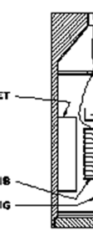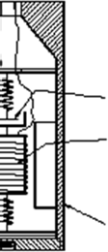

Fig. 9.5 Velocity Transducer

- Displacement Transducers:

The displacement transducer, in its most elementary form, consists of a fixed part and a mobile part. The mobile part is attached to the mobile contact of the breaker under test, and moves with the contacts, while the fixed part acts as a reference as shown in Fig. 9.6. The internals of many types of rotating machinery have a number of quite
small annular radial clearance gaps between the rotor and the stator, e.g., journal
bearings, annular seals, balance drums, and blade-tip clearances. Therefore, one

obvious potential consequence of excessive rotor
vibration is
rotor-stator rubbing

contact or, worse, impacting. Both accelerometers and velocity transducers measure
vibration of non-rotating parts of a machine and thus cannot provide any direct
information on rotor motion relative to the stator. Two types of non-contacting
transducers that emerged in the 1950s are the capacitance type and the inductance

type.
The capacitance-type
displacement transducer works
on the principle of

measuring the electrical capacitance of the gap between transducer tip and the target whose position is measured. The capacitance method is well suited for highly precise laboratory measurements, but its high sensitivity to material (e.g., oil) variations or contaminants within the clearance gap would make it a calibration “nightmare” for industrial applications. In contrast, inductance-type displacement transducer systems have proved to be the optimum rotor-to-stator position measurement method and are now installed on nearly all major rotating machines in power plants, petrochemical and process plants, naval vessel propulsion drive systems, and many others.

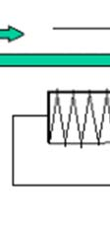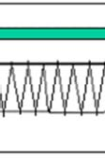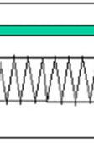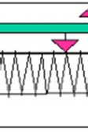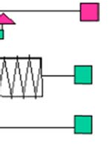

Fig. 9.6 Displacement Transducers

Calibration of transducers and measurement systems:
In order to maintain a high standard of measurement quality, transducers and the rest of the measurement system should be calibrated regularly. An important concept in that regard is traceability. That is affected by a network of national and international

laboratories that
guarantee
the precision of their
own respective instruments and

ensure that that precision is traceable to the next level in the network. In practice, this means that individual laboratories must regularly calibrate their equipment, and have their calibration equipment itself calibrated at the next level in the network.
In order to obtain calibrated measurement values on a day-to-day basis, two methods are used:
  - Calibration based on a transducer’s sensitivity, and knowledge of the
amplification of the rest of the measurement system.

  - The entire measurement chain is calibrated simultaneously. The transducer is subjected to a known vibration or sound signal, and the system’s output display is adjusted to show the correct value. That is the most common and convenient method to calibrate instrumentation prior to a measurement.

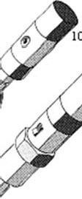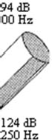

Figure 9.7 Piston phones and microphone calibrators are battery driven portable units for the calibration of acoustic measurement systems. Microphones are put into one end of a small cavity. In the other end, there is a piston or a membrane that is excited by an electrical motor or a piezoelectric element. The excitation gives a tone with a known frequency and sound level. (Source: Brüel & Kjær.)
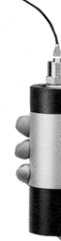
Figure 9.8 To calibrate a vibration measurement system, there are portable, battery- driven electrodynamic vibrators, that generate vibrations of a known frequency and amplitude. (Photo: Brüel & Kjær.)

