UNIT-I

BASICS OF VIBRATION: Basic motion: amplitudes, period, frequency, basic parameters: displacement,

velocity, acceleration, units (including dB scales) and conversions, Mass, spring and damper concept,

Introduction to SDOF and MDOF systems, Natural frequencies and resonance, Forced response.

Vibration is a mechanical phenomenon whereby [oscillations](https://en.wikipedia.org/wiki/Oscillation) occur about an [equilibrium point](https://en.wikipedia.org/wiki/Equilibrium_point). The word comes from Latin *vibrationem* ("shaking, brandishing"). The oscillations may be [periodic](https://en.wikipedia.org/wiki/Periodic_function), such as the motion of a pendulum—or [random](https://en.wikipedia.org/wiki/Random), such as the movement of a tire on a gravel road.

Vibration can be desirable: for example, the motion of a [tuning fork](https://en.wikipedia.org/wiki/Tuning_fork), the [reed](https://en.wikipedia.org/wiki/Reed_(music)) in a [woodwind instrument](https://en.wikipedia.org/wiki/Woodwind_instrument) or [harmonica](https://en.wikipedia.org/wiki/Harmonica), a [mobile phone](https://en.wikipedia.org/wiki/Mobile_phone), or the cone of a [loudspeaker](https://en.wikipedia.org/wiki/Loudspeaker).

In many cases, however, vibration is undesirable, wasting [energy](https://en.wikipedia.org/wiki/Energy) and creating unwanted [sound](https://en.wikipedia.org/wiki/Sound). For example, the vibrational motions of [engines](https://en.wikipedia.org/wiki/Engine), [electric motors](https://en.wikipedia.org/wiki/Electric_motor), or any [mechanical device](https://en.wikipedia.org/wiki/Machine) in operation are typically unwanted. Such vibrations could be caused by [imbalances](https://en.wikipedia.org/wiki/Engine_balance) in the rotating parts, uneven [friction](https://en.wikipedia.org/wiki/Friction), or the meshing of [gear](https://en.wikipedia.org/wiki/Gear) teeth. Careful designs usually minimize unwanted vibrations.

The studies of sound and vibration are closely related. Sound, or pressure [waves](https://en.wikipedia.org/wiki/Wave), are generated by vibrating structures (e.g. [vocal cords](https://en.wikipedia.org/wiki/Vocal_cords)); these pressure waves can also induce the vibration of structures (e.g. [ear drum](https://en.wikipedia.org/wiki/Ear_drum)). Hence, attempts to reduce noise are often related to issues of vibration.

VIBRATIONS (OSCILLATIONS)

•        Anything that moves back and forth, to or fro, side to side, in-out-in, or up or down is said to be vibrating or oscillating.

•        Time variations that repeat themselves at regular intervals: periodic or cyclic behavior.

A vibration is a periodic “wiggle” in time.

A wave is a periodic “wiggle” in both space and time.

The source of all waves is something that is vibrating.

Light and sound are both vibrations that propagate through space as a wave, but are two very different types of waves.

VIBRATIONS (OSCILLATIONS)

When an object is disturbed from its equilibrium position, a restoring force acts on it to restore it back to the equilibrium position. If the object over shoots the equilibrium position and oscillates to and fro, the object is said to be vibrating. For example, if you suspend a stone from a piece of string (simple pendulum), the stone will vibrate back and forth when disturbed. When the stone is attached to the end of a spring and held vertically, the stone will bounce up and down when disturbed. Pendulums swing to and frowith such regularity, they were used for a long time to control the motion of most clocks.

SIMPLE HARMONIC MOTION  (SHM)

To model vibrations, we need to setup a simple model using approximations and simplifications. The simplest model to describe vibrations is called simple harmonic motion. In this model, the object will move backward and forward in a straight line about an equilibrium position with a period which is independent of the magnitude of the disturbance and the displacement of the object from its equilibrium position can be described by a sinusoidal function. For the vertical oscillations of an object, the frame of reference has the +Y axis pointing upwards and the equilibrium position corresponds to the Origin. The position of the object at any time t is given by the displacement http://www.physics.usyd.edu.au/teach_res/hsp/sp/mod31/m31_wavesA_files/image024.png.

Displacement           http://www.physics.usyd.edu.au/teach_res/hsp/sp/mod31/m31_wavesA_files/image028.png

Velocity                  http://www.physics.usyd.edu.au/teach_res/hsp/sp/mod31/m31_wavesA_files/image030.png

Acceleration                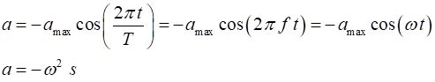

Displacement amplitude http://www.physics.usyd.edu.au/teach_res/hsp/sp/mod31/m31_wavesA_files/image037.png is the maximum extent of a vibration or oscillation, measured from the position of equilibrium.

Velocity amplitude  http://www.physics.usyd.edu.au/teach_res/hsp/sp/mod31/m31_wavesA_files/image046.png is the maximum speed of the oscillating object.

Acceleration amplitude  http://www.physics.usyd.edu.au/teach_res/hsp/sp/mod31/m31_wavesA_files/image047.png is the maximum acceleration of the oscillating object.

•        The amplitude is always a positive number. The symbol http://www.physics.usyd.edu.au/teach_res/hsp/sp/mod31/m31_wavesA_files/image048.png is often used for the amplitude.

•        For SHM the acceleration is proportional to the displacement and it direction is opposite to the displacement.

Period  http://www.physics.usyd.edu.au/teach_res/hsp/sp/mod31/m31_wavesA_files/image049.png is the time for one cycle of motion  [s].

Frequency http://www.physics.usyd.edu.au/teach_res/hsp/sp/mod31/m31_wavesA_files/image050.png is the number of cycles in one second  [hertz Hz   1 Hz = 1 s-1]

      1 kHz = 103 Hz (kilo)     1 MHz = 106 Hz (mega)     1GHz = 109 Hz (giga)

Angular frequency  http://www.physics.usyd.edu.au/teach_res/hsp/sp/mod31/m31_wavesA_files/image051.png         [ rad.s-1]

http://www.physics.usyd.edu.au/teach_res/hsp/sp/mod31/m31_wavesA_files/image052.png

Phase angle  http://www.physics.usyd.edu.au/teach_res/hsp/sp/mod31/m31_wavesA_files/image053.png         [ rad ]     angle http://www.physics.usyd.edu.au/teach_res/hsp/sp/mod31/m31_wavesA_files/image054.png must be measured in radians and time http://www.physics.usyd.edu.au/teach_res/hsp/sp/mod31/m31_wavesA_files/image055.png in seconds

|  |
| --- |
| The displacement http://www.physics.usyd.edu.au/teach_res/hsp/sp/mod31/m31_wavesA_files/image024.png, velocity http://www.physics.usyd.edu.au/teach_res/hsp/sp/mod31/m31_wavesA_files/image057.png and acceleration http://www.physics.usyd.edu.au/teach_res/hsp/sp/mod31/m31_wavesA_files/image059.png are all sinusoidal functions of time.  http://www.physics.usyd.edu.au/teach_res/hsp/sp/mod31/m31_wavesA_files/image061.png |

|  |
| --- |
| http://www.physics.usyd.edu.au/teach_res/hsp/sp/mod31/m31_wavesA_files/image063.png |

A periodic signal is the recording of an ECG.

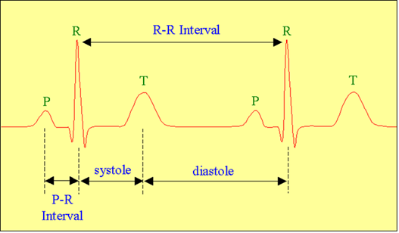

Mass, spring and damper concept,

The mass-spring-damper model consists of [discrete mass nodes](https://en.wikipedia.org/wiki/Point_mass) distributed throughout an object and interconnected via a network of [springs](https://en.wikipedia.org/wiki/Spring_(device)) and [dampers](https://en.wikipedia.org/wiki/Dashpot). This model is well-suited for modelling object with complex material properties such as [nonlinearity](https://en.wikipedia.org/wiki/Nonlinear) and [viscoelasticity](https://en.wikipedia.org/wiki/Viscoelasticity). Packages such as [MATLAB](https://en.wikipedia.org/wiki/MATLAB) may be used to run [simulations](https://en.wikipedia.org/wiki/Simulation) of such models.[[1]](https://en.wikipedia.org/wiki/Mass-spring-damper_model#cite_note-1) Objects may be described as [volumetric meshes](https://en.wikipedia.org/w/index.php?title=Volumetric_mesh&action=edit&redlink=1) for simulation in this manner. As well as [engineering simulation](https://en.wikipedia.org/w/index.php?title=Engineering_simulation&action=edit&redlink=1), these systems have applications in [computer graphics](https://en.wikipedia.org/wiki/Computer_graphics) and [computer animation](https://en.wikipedia.org/wiki/Computer_animation)[[2]](https://en.wikipedia.org/wiki/Mass-spring-damper_model#cite_note-2)

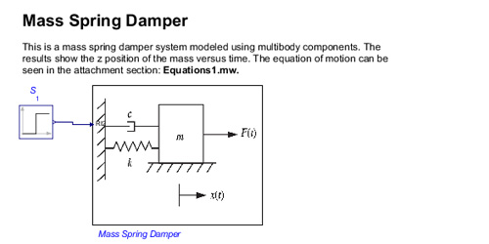

A tuned mass damper (TMD) is a device consisting of a mass, a spring, and a damper that is attached to a structure in order to reduce the dynamic response of the structure. The frequency of the damper is tuned to a particular structural frequency so that when that frequency is excited, the damper will resonate out of phase with the structural motion. Energy is dissipated by the damper inertia force acting on the structure. The TMD concept was first applied by Frahm in 1909 (Frahm, 1909) to reduce the rolling motion of ships as well as ship hull vibrations. A theory for the TMD was presented later in the paper by Ormondroyd and Den Hartog (1928), followed by a detailed discussion of optimal tuning and damping parameters in Den Hartog’s book on mechanical vibrations (1940). The initial theory was applicable for an undamped SDOF system subjected to a sinusoidal force excitation. Extension of the theory to damped SDOF systems has been investigated by numerous researchers. Significant contributions were made by Randall et al. (1981), Warburton (1981, 1982), Warburton and Ayorinde (1980), and Tsai and Lin (1993). This chapter starts with an introductory example of a TMD design and a brief description of some of the implementations of tuned mass dampers in building structures. A rigorous theory of tuned mass dampers for SDOF systems subjected to harmonic force excitation and harmonic ground motion is discussed next. Various cases, including an undamped TMD attached to an undamped SDOF system, a damped TMD attached to an undamped SDOF system, and a damped TMD attached to a damped SDOF system, are considered. Time history responses for arange of SDOF systems connected to optimally tuned TMD and subjected to harmonic and seismic excitations are presented. The theory is then extended to MDOF systems, where the TMD is used to dampen out the vibrations of a specific mode. An assessment of the optimal placement locations of TMDs in building structures is included. Numerous examples are provided to illustrate the level of control that can be achieved with such passive devices for both harmonic and seismic excitations.







|  |
| --- |
| Definition |
| https://www.efunda.com/images/section_bar_1.png |
|  |
| The simplest vibratory system can be described by a single mass connected to a spring (and possibly a dashpot). The mass is allowed to travel only along the spring elongation direction. Such systems are called *Single Degree-of-Freedom* (SDOF) systems and are shown in the following figure,  https://www.efunda.com/formulae/vibrations/sdof_images/SDOF_plot.gif |
|  |
|  |
| Equation of Motion for SDOF Systems |
| https://www.efunda.com/images/section_bar_1.png |
|  |
| SDOF vibration can be analyzed by Newton's second law of motion, F = m*a. The analysis can be easily visualized with the aid of a [free body diagram](https://www.efunda.com/formulae/vibrations/vib_glossary.cfm?ref=fbd#fbd),  https://www.efunda.com/formulae/vibrations/sdof_images/SDOF_FreeBodyDiagram.gif  The resulting equation of motion is a [second order](https://www.efunda.com/math/ode/generalterms.cfm" \l "order), [non-homogeneous](https://www.efunda.com/math/ode/generalterms.cfm" \l "homogeneous), [ordinary differential equation](https://www.efunda.com/math/ode/ode.cfm):  https://www.efunda.com/formulae/vibrations/sdof_images/SDOF_eq1.gif  with the initial conditions,  https://www.efunda.com/formulae/vibrations/sdof_images/mck_ic.gif  The solution to the general SDOF equation of motion is shown in the [damped SDOF](https://www.efunda.com/formulae/vibrations/sdof_free_damped.cfm) discussion. |

Vibration of Multiple Degree of Freedom Systems

In this chapter, some of the basic concepts of vibration analysis for multiple degree of freedom (MDoF) discrete parameter systems will be introduced, as there are some significant differences to a single degree of freedom (SDoF) system. The term ‘discrete (or sometimes lumped) parameter’ implies that the system in question is a combination of discrete rigid masses (or components) interconnected by flexible stiffness and damping elements. Note that the same approaches may be employed when a modal coordinate system is used (see later). On the other hand, ‘continuous’ systems, considered later in [Chapters 3](https://www.oreilly.com/library/view/introduction-to-aircraft/9780470858400/13_chap03.html#chap03)and [4](https://www.oreilly.com/library/view/introduction-to-aircraft/9780470858400/14_chap04.html#chap04), are those where all components of the system are flexible/elastic and deform in some manner.

The focus of this chapter will be in setting up the equations of motion, finding natural frequencies and mode shapes for free vibration and determining the forced vibration response with various forms of excitation relevant to aircraft loads. Some of the core solution methods introduced in [Chapter 1](https://www.oreilly.com/library/view/introduction-to-aircraft/9780470858400/11_chap01.html#chap01) will be considered for MDoF systems. For simplicity, the ideas will be illustrated for only two degrees of freedom. The general form of equations will be shown in matrix form to cover any number of degrees of freedom, since matrix algebra unifies all MDoF systems. Further treatment may be found in Tse *et al*. (1978), Newland (1989), Rao (1995), Thomson (1997) and Inman (2006).

Free vibrations are oscillations where the total energy stays the same over time. This means that the amplitude of the vibration stays the same. This is a theoretical idea because in real systems the energy is dissipated to the surroundings over time and the amplitude decays away to zero, this dissipation of energy is called damping.

Free vibration

[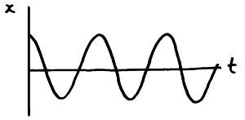](http://physicsnet.co.uk/wp-content/uploads/2010/05/free-vibration-graph.jpg)

Light damping

[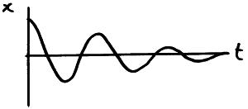](http://physicsnet.co.uk/wp-content/uploads/2010/05/light-damping-graph.jpg)

Heavy damping

[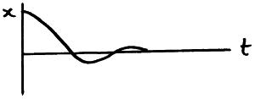](http://physicsnet.co.uk/wp-content/uploads/2010/05/heavy-damping-graph.jpg)

Critical damping

[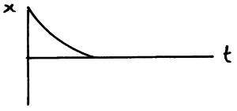](http://physicsnet.co.uk/wp-content/uploads/2010/05/critical-damping-graph.jpg)

Overdamped

[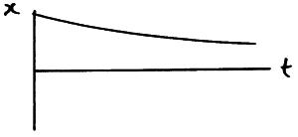](http://physicsnet.co.uk/wp-content/uploads/2010/05/overdamped-graph.jpg)

 Forced vibrations occur when the object is forced to vibrate at a particular frequency by a periodic input of force.

Objects which are free to vibrate will have one or more natural frequency at which they vibrate,

If an object is being forced to vibrate at its natural frequency, resonance will occur and you will observe large amplitude vibrations. The resonant frequency is fo.

[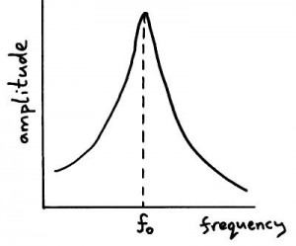](http://physicsnet.co.uk/wp-content/uploads/2010/05/resonance-graph.jpg)

Effect of damping on resonance graph.

The amplitude of the resonance peak decreases and the peak occurs at a lower frequency.

[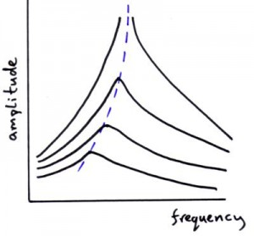](http://physicsnet.co.uk/wp-content/uploads/2010/05/resonance-damping-graph.jpg)

Phase and resonance

The phase relationship between the driving oscillation and the the oscillation of the object being driven is different at different frequencies.

* Below resonance they are in phase with each other.
* At resonance the phase relationship is 90o or /2 rad.
* Above resonance the phase relationship is 180o or  rad.