- HYDRO POWER:
- Components of Hydro electric power plant:
- pumped storage systems,
- Estimation of water power potential;
- Estimation of load on turbines: load curve, load factor
- capacity factor, utilization factor,
- diversity factor, load – duration curve,
- firm power,
- secondary power, prediction of load

HOW HYDROPOWER WORKS:
Hydroelectric power comes from water at work, water in motion. It can be seen as a form of solar energy, as the sun powers the hydrologic cycle which gives the earth its water. In the hydrologic cycle, atmospheric water reaches the earth=s surface as precipitation. Some of this water evaporates, but much of it either percolates into the soil or becomes surface runoff. Water from rain and melting snow eventually reaches ponds, lakes, reservoirs, or oceans where evaporation is constantly occurring.
Generating Power:
In nature, energy cannot be created or destroyed, but its form can change. In generating electricity, no new energy is created. Actually one form of energy is converted to another form. To generate electricity, water must be in motion. This is kinetic (moving) energy. When flowing water turns blades in a turbine, the form is changed to mechanical (machine) energy. The turbine turns the generator rotor which then converts this mechanical energy into another energy form -- electricity. Since water is the initial source of energy, we call this hydroelectric power or hydropower for short. At facilities called hydroelectric powerplants, hydropower is generated. Some powerplants are located on rivers, streams, and canals, but for a reliable water supply, dams are needed. Dams store water for later release for such purposes as irrigation, domestic and industrial use, and power generation. The reservoir acts much like a battery, storing water to be released as needed to generate power.
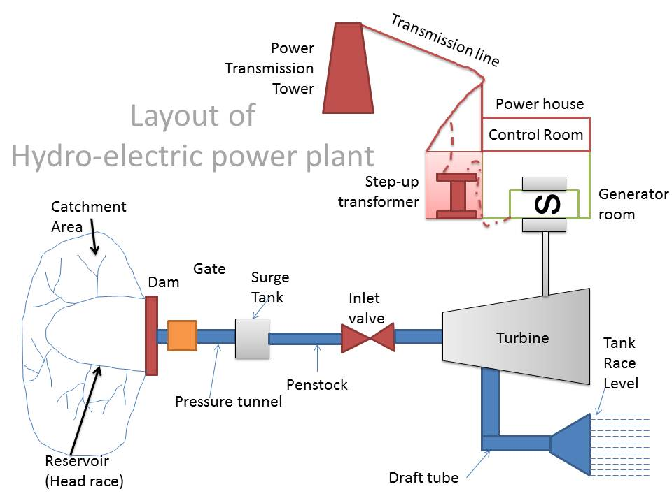
Pumped Storage:
Like peaking, pumped storage is a method of keeping water in reserve for peak period power demands. Pumped storage is water pumped to a storage pool above the powerplant at a time when customer demand for energy is low, such as during the middle of the night. The water is then allowed to flow back through the turbine-generators at times when demand is high and a heavy load is place on the system.
The reservoir acts much like a battery, storing power in the form of water when demands are low and producing maximum power during daily and seasonal peak periods. An advantage of pumped storage is that hydroelectric generating units are able to start up quickly and make rapid adjustments in output. They operate efficiently when used for one hour or several hours.
Because pumped storage reservoirs are relatively small, construction costs are generally low compared with conventional hydropower facilities.
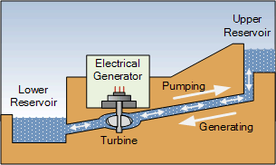
Hydropower potential:
Electricity from water is usually referred to as Hydro-Power, where the term ‘hydro’ is the Greek word for water and hydropower is the energy contained in water. It can be converted in the form of electricity through hydroelectric power plants. All that is required is a continuous inflow of water and a difference of height between the water level of the upstream intake of the power plant and its downstream outlet. In order to evaluate the power of flowing water, we may assume a uniform steady flow between two cross-sections of a river, with H (metres) of difference in water surface elevation between two sections for a flow of Q (m3 /s), the power (P) can be expressed as 2 2 1 2 2 v v P QH g γ ⎛ ⎞ − = + ⎜ ⎟ ⎝ ⎠ [Nm/s] where v1 and v2 are the mean velocities in the two sections. Neglecting the usually slight difference in the kinetic energy and assuming a value of γ as 9810N/m2 , one obtains the expression of power as P Q = 9810 H [Nm/s] Since an energy of 1000Nm/s can be represented as 1kW (1kilo-Watt), one may write the following: P = 9.81QH [kW] The above expression gives the theoretical power of the selected river stretch at a specified discharge. In order to evaluate the potential of power that may be generated by harnessing the drop in water levels in a river between two points, it is necessary to have knowledge of the hydrology or stream flow of the site, since that would be varying everyday. Even the average monthly discharges over a year would vary. Similarly, these monthly averages would not be the same for consecutive years. Hence, in order to evaluate the hydropower potential of a site, the following criteria are considered: 1. Minimum potential power is based on the smallest runoff available in the stream at all times, days, months and years having duration of 100 percent. This value is usually of small interest 2. Small potential power is calculated from the 95 percent duration discharge 3. Medium or average potential power is gained from the 50 percent duration discharge 4. Mean potential power results by evaluating the annual mean runoff. Since it is not economically feasible to harness the entire runoff of a river during flood (as that would require a huge storage), there is no reason for including the entire magnitude of peak flows while calculating potential power or potential annual energy.
Hence, a discharge-duration curve may be prepared (Figure 4) which plots the daily discharges at a location in the decreasing order of magnitude starting from the largest daily discharge observed during the year and going upto the minimum daily discharge.
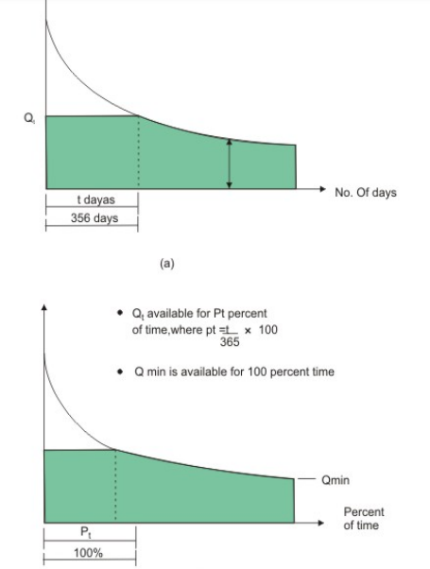
From this annual discharge curve, a truncation is made at a discharge Qt which is the discharge corresponding to a time of ‘t’ days, where t can be the median (say, 182 days or 50 percent duration, denoted by (Q182 or Q50%), or a higher Qt (t less than 182 days) can be selected by specialists who are familiar with the local conditions and future plans for power supply. Accordingly, the annual magnitude of potential (theoretical) energy can be computed in KWh as below and referring to Figure 4: 365 24 9.81 p t i E HQ Qi ⎛ ⎞ =× + ⎜ ⎟ ⎝ ⎠ ∑ ≈ 235H ⋅ A (in kWh) Where Qi denotes the daily mean flow during the period 365-t days and A, the hatched area cut by Qt , where the area under the curve has a unit m3 ×day/s. The massive influx of water in the hydrologic cycle has an estimated potential for generating, on a continuous basis, 40,000 billion units (TWh) of power annually for the whole world (CBIP, 1992). Hydropower potential is commonly divided into three categories:
Pumped-Storage schemes:
Hydropower schemes of the pumped-storage type are those which utilize the flow of water from a reservoir at higher potential to one at lower potential (Figure 6d). A typical schematic view of such a plant is shown in Figure 9. The upper reservoir (also called the head-water pond) and the lower reservoir (called the tail-water pond) may both be constructed by providing suitable structure across a river (Figure 10). During times of peak load, water is drawn from the head-water pond to run the reversible turbine-pump units in the turbine mode. The water released gets collected in the tail-water pond. During off-peak hours, the reversible units are supplied with the excess electricity available in the power grid which then pumps part of the water of the tail-water pond back into the head-water reservoir. The excess electricity in the grid is usually the generation of the thermal power plants which are in continuous running mode. However, during night, since the demand of electricity becomes drastically low and the thermal power plants can not switch off or start immediately, there a large amount of excess power is available at that time.
The Requirements for the Site:
As the name implies the power plant is meant for generating power which obviously means that it will consume huge quantities of fuel. The exact quantity would depend on the size of the plant and its capacity but it is a general fact that ample quantities of fuel must be available either in the vicinity or it should be reasonably economical to transport the fuel till the power plant. Since most thermal power plants use coal (they can use other fuels as well) it must be ensured that sufficient coal is available round the clock. Just to give you a rough idea a power plant with 1000 MW capacity approximately would require more than ten thousand tons of coal per day hence the necessity for continuous supply and storage capability of coal in the power station. Ash if the main byproduct of combustion and since the amount of coal used is huge, you can intuitively imagine the amount of ash generated and it is certainly in the region of thousand tons per day. Ash is much more difficult to handle as compared to coal since it comes out hot from the boiler and is very corrosive in nature. Disposing of such huge quantities of ash requires a large amount of empty space where it can be safely dumped. There must be ample space for the storage of coal, disposal of ash, building of the power plant, and residential colony of workers, markets and so forth. An approximate analysis suggests that for every MW of power generated there must be at least 3 acres of land available for the purpose. Hence the power plant site needs to have good amount of land and this land should have good bearing capacity in order to survive the static and dynamic loads during the operation of the plant.

Load Duration Curve:
It is the curve for a plant showing the total time within a specified period, during which the load equaled or exceeded the values shown
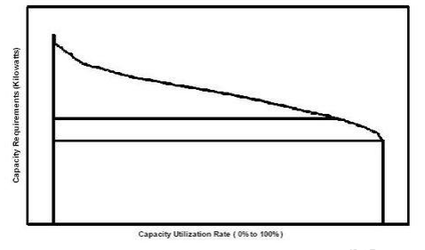
Plant Capacity Factor :
It is the ratio of the average loads on a machine or equipment to the rating of the machine or equipment, for a certain period of time considered. Since the load and diversity factors are not involved with „reserve capacity‟ of the power plant, a factor is needed which will measure the reserve, likewise the degree of utilization of the installed equipment. For this, the factor “Plant factor, Capacity factor or Plant Capacity factor” is defined as, Plant Capacity Factor = (Actual kWh Produced)/(Maximum Possible Energy that might have produced during the same period) Thus the annual plant capacity factor will be, = (Annual kWh produced)/[Plant capacity (kW) × hours of the year] The difference between load and capacity factors is an indication of reserve capacity.
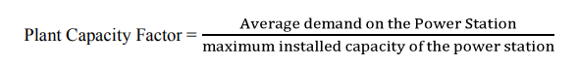
Load Factor :
It is defined as the ratio of the average load to the peak load during a certain prescribed period of time. The load factor of a power plant should be high so that the total capacity of the plant is utilized for the maximum period that will result in lower cost of the electricity being generated. It is always less than unity. High load factor is a desirable quality. Higher load factor means greater average load, resulting in greater number of power units generated for a given maximum demand. Thus, the fixed cost, which is proportional to the maximum demand, can be distributed over a greater number of units (kWh) supplied. This will lower the overall cost of the supply of electric energy.
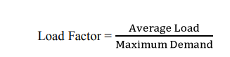
Utility Factor:
It is the ratio of the units of electricity generated per year to the capacity of the plant installed in the station. It can also be defined as the ratio of maximum demand of a plant to the rated capacity of the plant. Supposing the rated capacity of a plant is 200 mW. The maximum load on the plant is 100 MW at load factor of 80 per cent, then the utility will be = (100 × 0.8)/(200) = 40% Plant Operating Factor It is the ratio of the duration during which the plant is in actual service, to the total duration of the period of time considered.
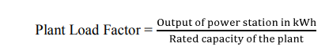
Demand Factor :
The actual maximum demand of a consumer is always less than his connected load since all the appliances in his residence will not be in operation at the same time or to their fullest extent. This ratio of' the maximum demand of a system to its connected load is termed as demand factor. It is always less than unity.
Diversity Factor:
Supposing there is a group of consumers. It is known from experience that the maximum demands of the individual consumers will not occur at one time. The ratio of the sum of the individual maximum demands to the maximum demand of the total group is known as diversity factor. It is always greater than unity. High diversity factor (which is always greater than unity) is also a desirable quality. With a given number of consumers, higher the value of diversity factor, lower will be the maximum demand on the plant, since, Diversity factor = Sum of the individual maximum Demands/Maximum demand of the total Group So, the capacity of the plant will be smaller,
resulting in fixed charges.
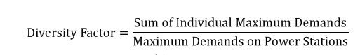
Load Curve:
It is a curve showing the variation of power with time. It shows the value of a specific load for each unit of the period covered. The unit of time considered may be hour, days, weeks, months or years.
Load Duration Curve :
It is the curve for a plant showing the total time within a specified period, during which the load equaled or exceeded the values shown.
Dump Power :
This term is used in hydro plants and it shows the power in excess of the load requirements and it is made available by surplus water.
Firm Power :
It is the power, which should always be available even under emergency conditions. Prime Power It is power, may be mechanical, hydraulic or thermal that is always available for conversion into electric power.
For Example: In Case of hydro power plant with reservoir, the firm power is that power which a hydro electric plant supplies for 95% of the time. However, it is not necessary that firm power should be produces throughout the year & available under emergency conditions.
Cold Reserve :
It is that reserve generating capacity which is not in operation but can be made available for service. Hot Reserve It is that reserve generating capacity which is in operation but not in service.
Spinning Reserve:
It is that reserve generating capacity which is connected to the bus and is ready to take the load.
Plant Use Factor :
This is a modification of Plant Capacity factor in that only the actual number of hours that the plant was in operation is used. Thus Annual Plant Use factor is, = (Annual kWh produced) / [Plant capacity (kW) × number of hours of plant operation]

Load Curve:
The Load Curve is a Graph, which represents load on the generation station (the load is in kW/MW) recorded at the interval of half hour or hour (time) against the time in chronological order.
The Load Curve gives following Information:
The daily load curve shows the variation of load on the power station during different hours of the day.
The area under the daily load curve gives the number of unit generated in the day.
Unit generated/day= Area (in kWh) under daily load curve.
The highest point on the daily load curve represents the maximum demand on the station on that day.
The area under the daily load curve divided by the total number of hours gives the average load on the station in that day.

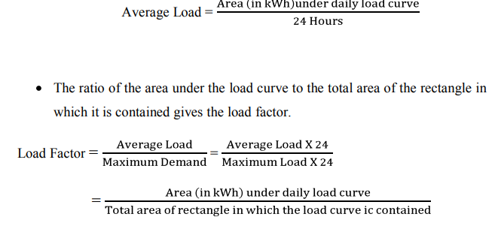
The load curves helps in selecting the size & number of generating units.
The load curve helps in preparing the operation schedule of the station.
The curve which gives idea of load of a whole day with respect to time (24 Hours or 12 Hours of the day) is known as daily load curve. T
he monthly load curve can be obtained from the daily load curve of the month. For this purpose, average values of power over a month at different times of the day are calculated.
The yearly load curve is obtained by considering the monthly load curve of that particular year.
The yearly load curve is generally used to determine annual load factor.
Load Duration Curve:
Definition: When the load elements of a load curve are arranged in the order of descending magnitudes, the curve thus obtained is called a load duration curve. The load duration curve is obtained from the same data as load curve but the ordinate representing the maximum load is represented to the left and the decreasing loads are represented to the right in the descending order.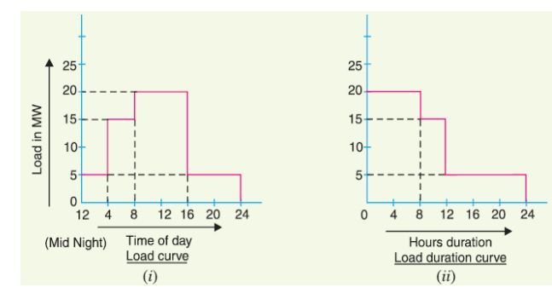
From the above figure (i) shows the daily load curve, the daily load duration curve can be readily obtained from it.
From fig (ii), it is clear from the daily load duration curve that the magnitudes of load elements are in descending order. The magnitudes are 20MW for 8 Hours, 15MW for 4 hours & remaining 5 MW from 12 hours.
The Load Duration Curve gives following information:
The load duration curve readily shows the number of hours during which the given load has prevailed.
The area under daily load duration curve (in kWh) will give the units generated on that day.
The load duration curve, which helps to give information about annual load duration curve.

Average Demand or Load:
Definition: The average of loads occurring on the power station in a given period (day or month or year) is known as average load or average demand.

The Average Demand is Calculated by using given formula:
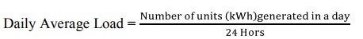
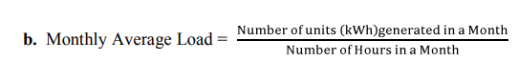
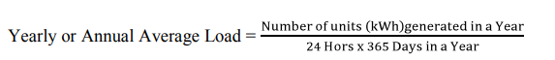
Maximum Demand (MD)
Definition: It is the greatest demand of load on the Power Station during a giving period is known as Maximum Demand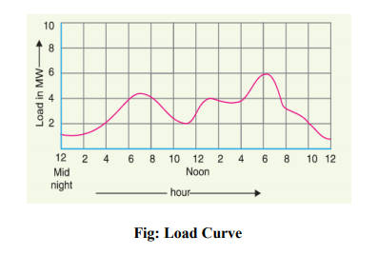
We know that, the load on every power station in not constant. The load varies from time to time. The variation of load on the power station is depends upon the demand of load with respect to time. Consider, the above figure, the figure X-axis Represents Time in Hours & Y-axis represents Load in MW. In this figure, at every two hours give information about how much load generated. Out of the 6MW load generated during evening period. So that maximum Demand is 6MW. The Knowledge of Maximum Demand is very important as it helps in determining the installed capacity of the power station.

