UNIT-II

Properties of Steam and use of Steam Tables
T-S and H-S Diagrams.
Analysis of Various Thermodynamic Processes under gone by Steam.
Vapor Power Cycles: Carnot Cycle-
Rankine Cycle- T
hermodynamic Variables Effecting
Efficiency and output of Rankine Cycle-.
Analysis of simple Rankine Cycle and
Re-heat cycle
Steam Turbines: Schematic layout of steam power plant Classification of Steam Turbines-
Impulse Turbine and Reaction Turbine-
Compounding in Turbines-
Velocity Diagrams for
simple Impulse
and Reaction Turbines-
Work done & efficiency

FORMATION OF STEAM AND PROPERTIES:
Imagine unit mass of ice below the freezing point, enclosed in a cylinder by a piston under a constant load of 1 atmosphere (1 atm. = 1.01325 bar = 101.325 kPa). If heat is added to the cylinder while keeping the pressure constant, the temperature rises and ice expands until a temperature of 273.15 K (00C) is reached (AB) as shown in Fig. Further heating does not raise the temperature of ice but causes a change to the liquid phase (BC). The change of phase occurs at a constant temperature and by reduction of specific volume. The heat required for this process is known as latent heat of fusion. Further heating results in a rise of temperature of liquid and a further contraction in volume until the temperature is about 40C and subsequent expansion until a temperature of 373.15 K (1000C) is reached (point D). At this point a second phase change occurs at constant temperature with a large increase in volume until the liquid has been vaporised (point E). The heat required in this case is called the latent heat of vaporisation. When vaporisation is complete, the temperature rises again on heating (line EF). The heat transferred to a substance while the temperature changes is sometimes referred to assensible heat. This constant pressure lines are called isobars.

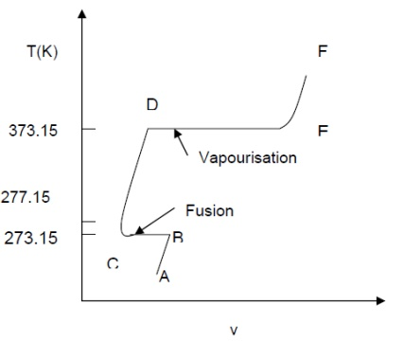

If the pressure is reduced, there is a slight rise in the melting point and also there is a marked drop in the boiling point of water and a marked increase in the change in volume, which accompanies evaporation. When the pressure is reduced to 0.006113 bar (0.6113 kPa), the melting point and boiling point temperatures become equal and change of phase, ice-water-steam, are represented by a single line. The temperature at which this occurs has been accepted internationally as a fixed point for the absolute temperature scale and is by definition 273.16 K. Only at this temperature and pressure of 0.6112 kPa, can ice, water and steam coexists in thermodynamic equilibrium in a closed vessel and is known as triple point. If the pressure is reduced further, the ice, instead of melting, sublimes directly into steam.
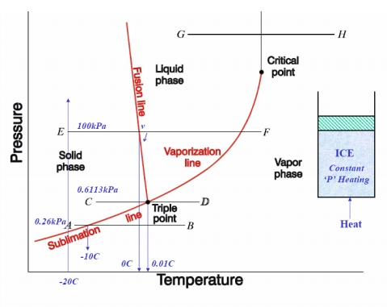
p-v, p-T, T-v, T-s, h-s DIAGRAMS:
Consider now the behaviour at pressure above atmospheric. The shape of the curve is similar to that of the atmospheric isobar, but there is a marked reduction in the change in volume accompanying evaporation. At a sufficiently high pressure, this change in volume falls to zero and the horizontal portion of the curve reduces to a point of inflexion. This is referred to critical point. The values pressure and temperature of water at which critical point reached are

pc = 221.2 bar = 22.12 MPa ; Tc = 647.3 K ; vc = 0.00317 m3/kg.
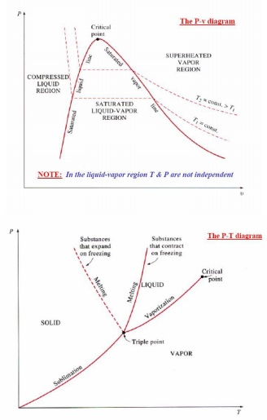
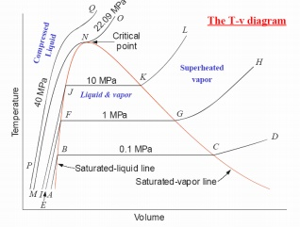
The pressure at which liquid vaporises or condenses is called saturation pressurecorresponding to a given temperature. Alternately, the temperature at which this phenomena occur is called saturation temperature corresponding to the given pressure. A vapour in a state lying along the saturated vapour line is also called dry saturated vapour and the vapour lying right of this line is called superheated vapour.
DEFINITION AND APPLICATIONS:
Saturation temperature: Temperature at which a pure substance changes phase at a

given pressure.

•Saturation pressure: Pressure at which a pure substance changes phase at a given

temperature.

•Latent heat: The amount of energy absorbed or released during a phase-change.Melting/freezing: Latent heat of fusion.
Evaporation/condensation: Latent heat of vaporization.

•Temperature at which water starts boiling depends on the pressure => if thepressure is fixed, so is the boiling temperature.

SLOVED PROBLEMS

1. A vessel of volume 0.04 m³ contains a mixture of saturated water and steam at a temperature of 250°C. The mass of the liquid present is 9 kg. Find the pressure, mass, specific volume, enthalpy, entropy and internal energy. [April/May 2012,2015]

Given Data:

Volume, V = 0.04 m³

Temperature, T = 250°C

Mass, m = 9 kg

To find:

1) p, 2) m, 3) v, 4) h, 5) S,6) ΔU

Solution:

From the Steam tables corresponding to 250°C, v_{f =} v₁ = 0.001251 m³/kg

v_{g =} v_{s} = 0.050037 m³/kg p = 39.776 bar
Total volume occupied by the liquid,

V₁ = m₁ × v₁

= 9 × 0.001251

= 0.0113 m³.

Total volume of the vessel,

V = Volume of liquid + Volume of steam

= V₁ + V_{S}

0.4 = 0.0113 + V_{S}

V_{S} = 0.0287 m³.

Mass of steam, m_{s} = V_{S} / v_{s}

= 0.0287 / 0.050037

= 0.574 kg.

Mass of mixture of liquid and steam, m = m₁ + m_{s}

= 9 + 0.574

= 9.574 kg.

Total specific volume of the mixture,

v =

= 0.04 / 9.574

= 0.00418 m³ / kg.

We know that,

v = v_{f} + x v_{fg}

0.00418 = 0.001251 + x (0.050037 –0.001251) x = 0.06

From Steam table corresponding to 250 °C, h_{f} = 1085.8 KJ / kg

h_{fg} = 1714.6 KJ / kg

s_{f} = 2.794 KJ / kg K

s_{fg} = 3.277 KJ / kg K.

Enthalpy of mixture,

h = h_{f} + x h_{fg}

= 1085.8 + 0.06 × 1714.6

= 1188.67 KJ / kg Entropy of mixture,
s = s_{f} + x s_{fg}

= 2.794 + 0.06 × 3.277

= 2.99 kJ / kg K. Internal energy, u = h –p v

= 1188.67 –39.776×10² × 0.00418

= 1172 KJ / kg.

Result:

1) p = 39.776 bar

2) m = 9.574 kg

3) v = 0.00418 m³ / kg
4) h = 1188.67 KJ / kg

5) S = 2.99 KJ /kg K

6) ΔU= 1172 KJ / kg.

2). A steam power plant uses steam at boiler pressure of 150 bar and temperature of 550°C with reheat at 40 bar and 550 °C at condenser pressure of 0.1 bar. Find the quality of steam at turbine exhaust, cycle efficiency and the steam rate. [May/June 2014]

Given Data:

p₁ = 150 bar

T₁ = 550°C
p₂ = 40 bar

T₃ = 550 °C

p₃ = 0.1 bar

To find:

1. The quality of steam at turbine exhaust, (x₄)

2. cycle efficiency and

3. The steam rate.

Solution:

1. The quality of steam at turbine exhaust, (x₄):

Properties of steam from steam tables at 150 bar & 550°C h₁ = 3445.2 KJ/kg.

S₁= 6.5125 KJ/kg K At 40 bar & 550°C
h₃ = 3558.9 KJ/kg.

S₃= 7.2295 KJ/kg K

At 40 bar

T_{sat} = 250.3°C = 523.3 K
h_{f} =1087.4 KJ/kg.
h_{fg} = 1712.9 KJ/kg.
S_{f}= 2.797 KJ/kg K
S_{fg}= 3.272 KJ/kg K
At 0.1 bar
h_{f} =191.8 KJ/kg.
h_{fg} = 2392.9 KJ/kg.
S_{f}= 0.649 KJ/kg K
S_{fg}= 7.502 KJ/kg K
1-2 = isentropic
S₁ = S = 6.5125 KJ/kg K

S₂ = S_{g} at 40 bar

Therefore,
Exit of HP turbine is superheat

T_{sup} = 332°C

h₂ = 3047.18 KJ/kg

S₃ = S_{g} at 0.1 bar

Steam is at wet condition.

S₄ = S₃ = 7.2295 KJ/kg K

S4 = Sf4 + x4 Sfg4

7.2295 = 0.649 + x₄ × 7.502

x₄ = 0.877

h4 = hf4 + x4 hfg4

= 191.8 + 0.877 × 2392.9

h₄ = 2290.37 KJ/kg K

2) Cycle efficiency:

D = (h₁ –h₂) + (h₃ –h₄) / (h₁ –h_{f4}) + (h₃ –h₂)

= (3445.2 –3047.15) + (3558.9 –2290.37) / (3445.2 –191.8) + (3558.9 –3047.18)
= 0.4426 × 100
= 44.26%

3) Steam rate:
= 3600 / (h₁ –h₂) + (h₃ –h₄)
= 3600 / (3445.2 –3047.15) + (3558.9 –2290.37)
= 2.16 kg/Kw–hr.

Result:

1. The quality of steam at turbine exhaust, (x₄) = 0.877

2. cycle efficiency = 44.26%

3. The steam rate = 2.16 kg/Kw–hr.

3). Ten kg of water 45 °C is heated at a constant pressure of 10 bar until it becomes superheated vapour at 300°C. Find the change in volume, enthalpy, internal energy and entropy.

Given Data:

m= 10 kg

p₁ = p₂ = 10 bar

T₂ = 300°C

To find:

1) Change in volume,
2) Change in Enthalpy,
3) Change in Internal energy,

4) Change in Entropy.

Solution:

From steam tables, corresponding to 45°C,
v₁₌v_{f1}=0.001010 m³ / kg;
h₁ ₌ h_{f1} = 188.4 KJ/kg;
s1 = sf1 = 0.638 KJ/kg K
From steam tables, corresponding to 10 bar and 300°C,
h2 = 3052.1 KJ/kg;
s2 = 7.125 KJ/kg K;
v2 = 0.258 m3 /kg;
Change in Volume,2–v1)
V = m (v = 10 (0.258 –0.001010)
= 2.5699 m³.
Change in Enthalpy,₂–₁)
h = m (h
= 10 (3052.1 –188.4)

= 28637 KJ.

Change in Entropy,₂–s₁) S = m (s

= 10 (7.125 –0.638)

= 64.87 KJ/K.

Change in Internal₂–u₁) energy, U = m (u

= m [(h₂ - h₁) –(p₂v₂ –p₁v₁)]

= m [(h₂ - h₁) –p₁ (v₂ –v₁)

= 10 [(3052.1 –188.4) –1000 (0.258 –0.001010)]

= 26067.1 KJ.

Result:
1) Change in volume, ΔV= 2.5699 m³.
2) Change in Enthalpy,=h28637 KJ.
3) Change in Internal energy, ΔU = 26067.1 KJ.
4) Change in Entropy, ΔS = 64.87 KJ/K.

1. A vessel of volume 0.04 m3 contains a mixture of saturated water and steam at a temperature of 250°C. The mass of the liquid present is 9 kg. Find the pressure, mass, specific volume, enthalpy, entropy and internal energy. [April/May 2012,2015]

Given Data:

Volume, V = 0.04 m3

Temperature, T = 250°C

Mass, m = 9 kg

To find:

1) p, 2) m, 3) v, 4) h, 5) S,6) ΔU

Solution:

From the Steam tables corresponding to 250°C, vf = v1 = 0.001251 m3/kg

vg = vs = 0.050037 m3/kg p = 39.776 bar
Total volume occupied by the liquid,

V1 = m1 × v1

= 9 × 0.001251

= 0.0113 m3.

Total volume of the vessel,

V = Volume of liquid + Volume of steam

= V1 + VS

0.4 = 0.0113 + VS

VS = 0.0287 m3.

Mass of steam, ms = VS / vs

= 0.0287 / 0.050037

= 0.574 kg.

Mass of mixture of liquid and steam, m = m1 + ms

= 9 + 0.574

= 9.574 kg.

Total specific volume of the mixture,

v =

= 0.04 / 9.574

= 0.00418 m3 / kg.

We know that,

v = vf + x vfg

0.00418 = 0.001251 + x (0.050037 –0.001251) x = 0.06

From Steam table corresponding to 250 °C, hf = 1085.8 KJ / kg

hfg = 1714.6 KJ / kg

sf = 2.794 KJ / kg K

sfg = 3.277 KJ / kg K.

Enthalpy of mixture,

h = hf + x hfg

= 1085.8 + 0.06 × 1714.6

= 1188.67 KJ / kg Entropy of mixture,
s = sf + x sfg

= 2.794 + 0.06 × 3.277

= 2.99 kJ / kg K. Internal energy, u = h –p v

= 1188.67 –39.776×102 × 0.00418

= 1172 KJ / kg.

Result:

1) p = 39.776 bar

2) m = 9.574 kg

3) v = 0.00418 m3 / kg
4) h = 1188.67 KJ / kg

5) S = 2.99 KJ /kg K

6) ΔU= 1172 KJ / kg.

2). A steam power plant uses steam at boiler pressure of 150 bar and temperature of 550°C with reheat at 40 bar and 550 °C at condenser pressure of 0.1 bar. Find the quality of steam at turbine exhaust, cycle efficiency and the steam rate. [May/June 2014]

Given Data:

p1 = 150 bar

T1 = 550°C
p2 = 40 bar

T3 = 550 °C

p3 = 0.1 bar

To find:

1. The quality of steam at turbine exhaust, (x4)

2. cycle efficiency and

3. The steam rate.

Solution:

1. The quality of steam at turbine exhaust, (x4):

Properties of steam from steam tables at 150 bar & 550°C h1 = 3445.2 KJ/kg.

S1= 6.5125 KJ/kg K At 40 bar & 550°C
h3 = 3558.9 KJ/kg.

S3= 7.2295 KJ/kg K

At 40 bar

Tsat = 250.3°C = 523.3 K
hf =1087.4 KJ/kg. hfg = 1712.9 KJ/kg.
Sf= 2.797 KJ/kg K Sfg= 3.272 KJ/kg K
At 0.1 bar
hf =191.8 KJ/kg. hfg = 2392.9 KJ/kg.
Sf= 0.649 KJ/kg K Sfg= 7.502 KJ/kg K
1-2 = isentropic
S1 = S = 6.5125 KJ/kg K

S2 = Sg at 40 bar

Therefore,
Exit of HP turbine is superheat

Tsup = 332°C

h2 = 3047.18 KJ/kg

S3 = Sg at 0.1 bar

Steam is at wet condition.

S4 = S3 = 7.2295 KJ/kg K

S4 = Sf4 + x4 Sfg4

7.2295 = 0.649 + x4 × 7.502

x4 = 0.877

h4 = hf4 + x4 hfg4

= 191.8 + 0.877 × 2392.9

h4 = 2290.37 KJ/kg K

2) Cycle efficiency:

D = (h1 –h2) + (h3 –h4) / (h1 –hf4) + (h3 –h2)

= (3445.2 –3047.15) + (3558.9 –2290.37) / (3445.2 –191.8) + (3558.9 –3047.18)
= 0.4426 × 100
= 44.26%

3) Steam rate:
= 3600 / (h1 –h2) + (h3 –h4)
= 3600 / (3445.2 –3047.15) + (3558.9 –2290.37)
= 2.16 kg/Kw–hr.

Result:

1. The quality of steam at turbine exhaust, (x4) = 0.877

2. cycle efficiency = 44.26%

3. The steam rate = 2.16 kg/Kw–hr.

3). Ten kg of water 45 °C is heated at a constant pressure of 10 bar until it becomes superheated vapour at 300°C. Find the change in volume, enthalpy, internal energy and entropy.

Given Data:

m= 10 kg

p1 = p2 = 10 bar

T2 = 300°C

To find:

1) Change in volume,
2) Change in Enthalpy,
3) Change in Internal energy,

4) Change in Entropy.

Solution:

From steam tables, corresponding to 45°C,
v1=vf1=0.001010 m3 / kg; h1 = hf1 = 188.4 KJ/kg;
s1 = sf1 = 0.638 KJ/kg K
From steam tables, corresponding to 10 bar and 300°C,
h2 = 3052.1 KJ/kg; s2 = 7.125 KJ/kg K;
v2 = 0.258 m3 /kg;
Change in Volume,2–v1) V = m (v
= 10 (0.258 –0.001010)
= 2.5699 m3.
Change in Enthalpy,2–1) h = m (h

= 10 (3052.1 –188.4)

= 28637 KJ.

Change in Entropy,2–s1) S = m (s

= 10 (7.125 –0.638)

= 64.87 KJ/K.

Change in Internal2–u1) energy, U = m (u

= m [(h2 - h1) –(p2v2 –p1v1)]

= m [(h2 - h1) –p1 (v2 –v1)

= 10 [(3052.1 –188.4) –1000 (0.258 –0.001010)]

= 26067.1 KJ.

Result:
1) Change in volume, ΔV= 2.5699 m3.
2) Change in Enthalpy,=h28637 KJ.
3) Change in Internal energy, ΔU = 26067.1 KJ.
4) Change in Entropy, ΔS = 64.87 KJ/K.

RANKINE CYCLE:
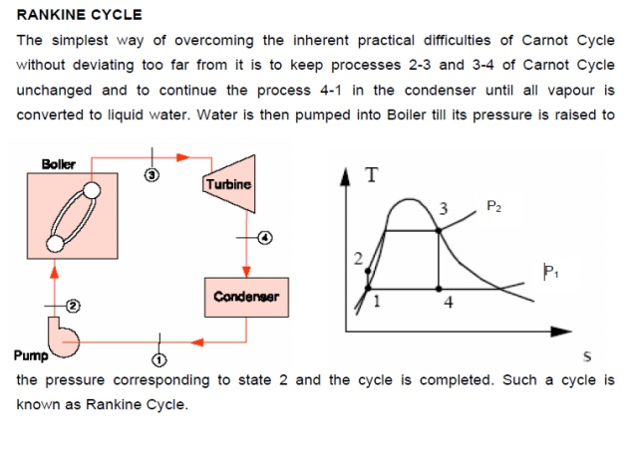
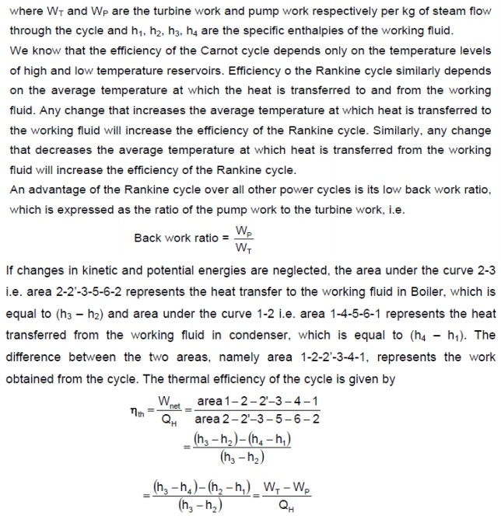
STEAM TURBINE:
Impulse Turbine:
Impulse turbines (single-rotor or multirotor) are simple stages of the turbines. Here the impulse blades are attached to the shaft. Impulse blades can be recognized by their shape. They are usually symmetrical and have entrance and exit angles respectively, around 20 ° . Because they are usually used in the entrance high-pressure stages of a steam turbine, when the specific volume of steam is low and requires much smaller flow than at lower pressures, the impulse blades are short and have constant cross sections.

he Single-Stage Impulse Turbine:
The single-stage impulse turbine is also called the de Laval turbine after its inventor. The turbine consists of a single rotor to which impulse blades are attached. The steam is fed through one or several convergent-divergent nozzles which do not extend completely around the circumference of the rotor, so that only part of the blades is impinged upon by the steam at any one time. The nozzles also allow governing of the turbine by shutting off one or more them.
The velocity diagram for a single-stage impulse has been shown in Fig. 22.1. Figure 22.2 shows the velocity diagram indicating the flow through the turbine blades.
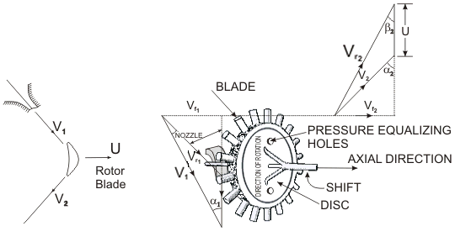
V1 and = Inlet and outlet absolute velocity
and = Inlet and outlet relative velocity (Velocity relative to the rotor blades.)
U = mean blade speed
= nozzle angle, = absolute fluid angle at outlet
It is to be mentioned that all angles are with respect to the tangential velocity ( in the direction of U )
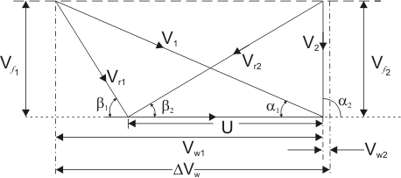
Figure 22.2 Velocity diagram of an Impulse Turbine
and = Inlet and outlet blade angles
and = Tangential or whirl component of absolute velocity at inlet and outlet
and = Axial component of velocity at inlet and outlet
Tangential force on a blade,
(22.1)
(mass flow rate X change in velocity in tangential direction)
or,
(22.2)

Power developed = | (22.3)
Blade efficiency or Diagram efficiency or Utilization factor is given by
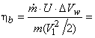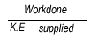
or,
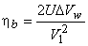 | (22.4)
stage efficiency | (23.1)

or, | (23.2)

or, | (23.3)
Optimum blade speed of a single stage turbine

(23.4)
where, = friction coefficient
 |  | = Blade speed ratio | (23.5)
is maximum when 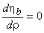 also 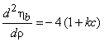
or,

or, | (23.6)
is of the order of 18⁰ to 22⁰
Now, 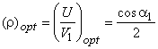 (For single stage impulse turbine)
The maximum value of blade efficiency
(23.7)
For equiangular blades,
(23.8)
If the friction over blade surface is neglected
(23.9)
Compounding in Impulse Turbine
If high velocity of steam is allowed to flow through one row of moving blades, it produces a rotor speed of about 30000 rpm which is too high for practical use.
It is therefore essential to incorporate some improvements for practical use and also to achieve high performance. This is possible by making use of more than one set of nozzles, and rotors, in a series, keyed to the shaft so that either the steam pressure or the jet velocity is absorbed by the turbine in stages. This is called compounding. Two types of compounding can be accomplished: (a) velocity compounding and (b) pressure compounding
Either of the above methods or both in combination are used to reduce the high rotational speed of the single stage turbine.
The Velocity - Compounding of the Impulse Turbine
The velocity-compounded impulse turbine was first proposed by C.G. Curtis to solve the problems of a single-stage impulse turbine for use with high pressure and temperature steam. The Curtis stage turbine, as it came to be called, is composed of one stage of nozzles as the single-stage turbine, followed by two rows of moving blades instead of one. These two rows are separated by one row of fixed blades attached to the turbine stator, which has the function of redirecting the steam leaving the first row of moving blades to the second row of moving blades. A Curtis stage impulse turbine is shown in Fig. 23.1 with schematic pressure and absolute steam-velocity changes through the stage. In the Curtis stage, the total enthalpy drop and hence pressure drop occur in the nozzles so that the pressure remains constant in all three rows of blades.

Velocity is absorbed in two stages. In fixed (static) blade passage both pressure and velocity remain constant. Fixed blades are also called guide vanes. Velocity compounded stage is also called Curtis stage. The velocity diagram of the velocity-compound Impulse turbine is shown in Figure 23.2.
The fixed blades are used to guide the outlet steam/gas from the previous stage in such a manner so as to smooth entry at the next stage is ensured.
K, the blade velocity coefficient may be different in each row of blades

Work done = | (23.10)

End thrust = | (23.11)
The optimum velocity ratio will depend on number of stages and is given by 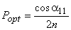
• Work is not uniformly distributed (1st >2nd )
• The fist stage in a large (power plant) turbine is velocity or pressure compounded impulse stage.
Reaction Turbine
A reaction turbine, therefore, is one that is constructed of rows of fixed and rows of moving blades. The fixed blades act as nozzles. The moving blades move as a result of the impulse of steam received (caused by change in momentum) and also as a result of expansion and acceleration of the steam relative to them. In other words, they also act as nozzles. The enthalpy drop per stage of one row fixed and one row moving blades is divided among them, often equally. Thus a blade with a 50 percent degree of reaction, or a 50 percent reaction stage, is one in which half the enthalpy drop of the stage occurs in the fixed blades and half in the moving blades. The pressure drops will not be equal, however. They are greater for the fixed blades and greater for the high-pressure than the low-pressure stages.
The moving blades of a reaction turbine are easily distinguishable from those of an impulse turbine in that they are not symmetrical and, because they act partly as nozzles, have a shape similar to that of the fixed blades, although curved in the opposite direction. The schematic pressure line (Fig. 24.2) shows that pressure continuously drops through all rows of blades, fixed and moving. The absolute steam velocity changes within each stage as shown and repeats from stage to stage. Figure 24.3 shows a typical velocity diagram for the reaction stage.

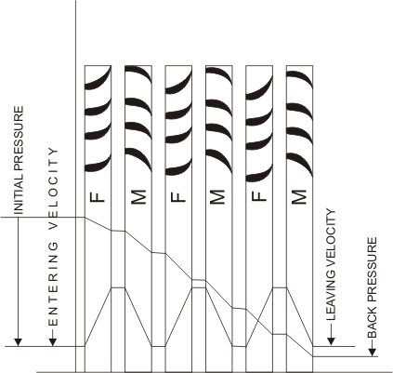
Three stages of reaction turbine indicating pressure and velocity distribution
Pressure and enthalpy drop both in the fixed blade or stator and in the moving blade or Rotor
Degree of Reaction =

or, | (24.3)
A very widely used design has half degree of reaction or 50% reaction and this is known as Parson's Turbine. This consists of symmetrical stator and rotor blades.
Figure 24.3 The velocity diagram of reaction blading
The velocity triangles are symmetrical and we have
Energy input per stage (unit mass flow per second)

(24.4)

(24.5)
From the inlet velocity triangle we have,
Work done (for unit mass flow per second)
(24.6)
Therefore, the Blade efficiency
(24.7)
Put 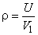 then
(25.1)
For the maximum efficiency and we get
(25.2)
from which finally it yields
(25.3)

Figure 25.1 Velocity diagram for maximum efficiency
Absolute velocity of the outlet at this stage is axial (see figure 25.1). In this case, the energy transfer
(25.4)
can be found out by putting the value of in the expression for blade efficiency
(25.5)

(25.6)
is greater in reaction turbine. Energy input per stage is less, so there are more number of stages.
Stage Efficiency and Reheat factor
The Thermodynamic effect on the turbine efficiency can be best understood by considering a number of stages between two stages 1 and 2 as shown in Figure 25.2
Figure 25.2 Different stage of a steam turbine
The total expansion is divided into four stages of the same efficiency and pressure ratio.
(25.7)
The overall efficiency of expansion is . The actual work during the expansion from 1 to 2 is

or, |  | (25.8)
Reheat factor (R.F.)= 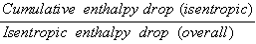
or, |  | (25.9)
R.F is 1.03 to 1.04
If remains same for all the stages or is the mean stage efficiency.
(25.10)

or, | (25.11)

We can see:
(25.12)
This makes the overall efficiency of the turbine greater than the individual stage efficiency.
The effect depicted by Eqn (25.12) is due to the thermodynamic effect called "reheat". This does not imply any heat transfer to the stages from outside. It is merely the reappearance of stage losses an increased enthalpy during the constant pressure heating (or reheating) processes AX, BY, CZ and D2.

