UNIT-I

I.C Engines: Classification,
working principles
valve and port timing diagrams
air standard cycles
Engine systems line fuel injection, carburetion,
ignition,
cooling
lubrication
Engine performance evaluation

The Concept of IC Engine
The internal combustion engine (ICE) is an engine where the combustion of a fuel (normally a fossil fuel) occurs with an oxidizer (usually air) in a combustion chamber that is an integral part of the working fluid flow circuit.
Heat Engines :- Heat engines is a device which transforms the chemical energy of a fuel into thermal energy and uses this energy to produce mechanical work. Heat engines are divided into two broad classes.
- External combustion engines
- Internal combustion engines.

The most significant improvement offered by the Concept IC Engine:

Ø The most significance of IC engine in Day to day life, It is a lightweight and reasonably compact way to get power from fuel.
Ø It is also significantly safer and more efficient than the engine it replaced - steam.
Ø Small, lightweight IC engines made personal transportation possible. It transformed how we built cities and did business.
Classification of IC Engines:
There are no standard methods or ways of classifying I.C. Engines.
They may be classified in many ways such as following:
(1) Arrangement of Engine Cylinders:
(i) Horizontal engine
(ii) Vertical engine
(iii) V engine
(iv) In-line engine
(v) Opposed cylinder engine
(vi) Opposed piston engine
(vii) Deltic engine
(viii) Y engine
(ix) Radial engine
(2) Working Cycle Employed:
(i) Four stroke cycle engine
(ii) Two stroke cycle engine
(3) Fuel Used:
(i) Petrol engine
(ii) Diesel engine
(iii) Gas engine
(iv) Bi-fuel engine
(4) Nature of Thermodynamic Cycle Used:
(i) Otto cycle engine
(ii) Diesel cycle engine
(iii) Dual combustion cycle engine.
(5) Speed:
(i) Low speed engine
(ii) Medium speed engine
(iii) High speed engine
(6) Method of Cooling:
(i) Air cooled engine
(ii) Water cooled engine
(7) Field of Application:
(i) Stationary engine
(ii) Marine engine
(iii) Automobile engine
(iv) Motor-cycle engine
(v) Aero engine
(vi) Locomotive engine, etc.
(8) Method of Ignition:
(i) Compression ignition engine
(ii) Spark ignition engine.

Components and functions of IC Engines
The cylinder block is the main body of the engine, the structure that supports all the other components of the engine. In the case of the single cylinder engine the cylinder block houses the cylinder, while in the case of multi-cylinder engine the number of cylinders are cast together to form the cylinder block. The cylinder head is mounted at the top of the cylinder block. When the vehicle runs, large amounts of heat are generated within the cylinder block. To remove this heat the cylinder block and the cylinder head are cooled by water flowing through the water jackets within larger engines such as those found in cars and trucks. For smaller vehicles like motorcycles, fins are provided on the cylinder block and on the cylinder head to cool them. The bottom portion of the cylinder block is called a crankcase. Within the crankcase is where lubricating oil, which is used for lubricating various moving parts of the engine, is stored.
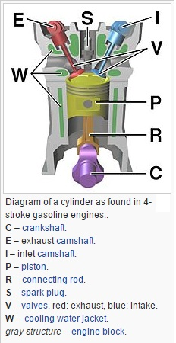
Cylinder:
As the name suggests it is a cylindrical shaped vessel fitted in the cylinder block. This cylinder can be removed from the cylinder block and machined whenever required to. It is also called a liner or sleeve. Inside the cylinder the piston moves up and down, which is called the reciprocating motion of the piston. Burning of fuel occurs at the top of the cylinder, due to which the reciprocating motion of the piston is produced. The surface of the cylinder is finished to a high finish, so that there is minimal friction between the piston and the cylinder.

Piston:
The piston is the round cylindrical component that performs a reciprocating motion inside the cylinder. While the cylinder itself is the female part, the piston is the male part. The piston fits perfectly inside the cylinder. Piston rings are fitted over the piston. The gap between the piston and the cylinder is filled by the piston rings and lubricating oil. The piston is usually made up of aluminum
Piston rings:
The piston rings are thin rings fitted in the slots made along the surface of the piston. It provides a tight seal between the piston and the cylinder walls that prevents leaking of the combustion gases from one side to the other. This ensures that that motion of the piston produces as close as to the power generated from inside the cylinder.
Combustion chamber:
It is in the combustion chamber where the actual burning of fuel occurs. It is the uppermost portion of the cylinder enclosed by the cylinder head and the piston. When the fuel is burnt, much thermal energy is produced which generates excessively high pressures causing the reciprocating motion of the piston.
Inlet manifold:Through the inlet manifold the air or air-fuel mixture is drawn into the cylinder.
Exhaust manifold:All the exhaust gases generated inside the cylinder after burning of fuel are discharged through the exhaust manifold into the atmosphere.
Inlet and exhaust valves:The inlet and the exhaust valves are placed at the top of the cylinder in the cylinder head. The inlet valve allows the intake of the fuel during suction stroke of the piston and to close thereafter. During the exhaust stroke of the piston the exhaust valves open allowing the exhaust gases to release to the atmosphere. Both these valves allow the flow of fuel and gases in single direction only.
Spark plug:The spark plug is a device that produces a small spark that causes the instant burning of the pressurized fuel.
Connecting rod:It is the connecting link between the piston and the crankshaft that performs the rotary motion. There are two ends of the connecting rod called the small end and big end. The small end of the connecting rod is connected to the piston by gudgeon pin, while the big end is connected to crankshaft by crank pin

Crankshaft:The crankshaft performs the rotary motion. It is connected to the axle of the wheels which move as the crankshaft rotates. The reciprocating motion of the piston is converted into the rotary motion of the crankshaft with the help of connecting rod. The crankshaft is located in the crankcase and it rotates in the bushings.
Camshaft:It takes driving force from crankshaft through gear train or chain and operates the inlet valve as well as exhaust valve with the help of cam followers, push rod and rocker arms.
WORKING PRINCIPLES O F FOUR-STROKE CYCLE ENGINES
- Four Stroke Petrol engine
- Four Stroke Diesel engine
FOUR STROKE PETROL ENGINE
The four stroke-cycles refers to its use in petrol engines, gas engines, light, oil engine and heavy oil engines in which the mixture of air fuel are drawn in the engine cylinder. Since ignition in these engines is due to a spark, therefore they are also called spark ignition engines.
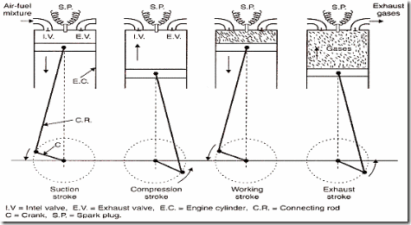
SUCTION STROKE: In this Stroke the inlet valve opens and proportionate fuel-air mixture is sucked in the engine cylinder. Thus the piston moves from top dead centre (T.D.C.) to bottom dead centre (B.D.C.). The exhaust valve remains closed through out the stroke.
COMPRESSION STROKE: In this stroke both the inlet and exhaust valves remain closed during the stroke. The piston moves towards (T.D.C.) and compresses the enclosed fuel-air mixture drawn. Just before the end of this stroke the operating plug initiates a spark which ignites the mixture and combustion takes place at constant pressure.
POWER STROKE OR EXPANSION STROKE: In this stroke both the valves remain closed during the start of this stroke but when the piston just reaches the B.D.C. the exhaust valve opens. When the mixture is ignited by the spark plug the hot gases are produced which drive or throw the piston from T.D.C. to B.D.C. and thus the work is obtained in this stroke.
EXHAUST STROKE: This is the last stroke of the cycle. Here the gases from which the work has been collected become useless after the completion of the expansion stroke and are made to escape through exhaust valve to the atmosphere. This removal of gas is accomplished during this stroke. The piston moves from B.D.C. to T.D.C. and the exhaust gases are driven out of the engine cylinder; this is also called SCAVENGING.
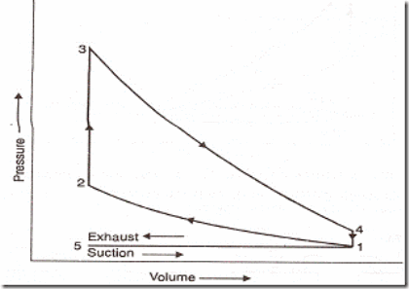
Theoretical P-V diagram of a four-stroke engine

FOUR STROKE DIESEL ENGINE

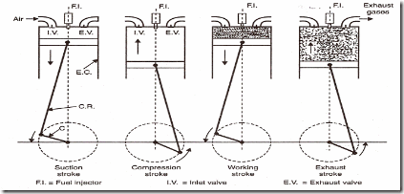
SUCTION STROKE: With the movement of the piston from T.D.C. to B.D.C. during this stroke, the inlet valve opens and the air at atmospheric pressure is drawn inside the engine cylinder; the exhaust valve however remains closed. This operation is represented by the line 5-1
COMPRESSION STROKE: The air drawn at atmospheric pressure during the suction stroke is compressed to high pressure and temperature as the piston moves from B.D.C. to T.D.C. Both the inlet and exhaust valves do not open during any part of this stroke. This operation is represented by 1-2
POWER STROKE OR EXPANSION STROKE: As the piston starts moving from T.D.C to B.D.C, the quantity of fuel is injected into the hot compressed air in fine sprays by the fuel injector and it (fuel) starts burning at constant pressure shown by the line 2-3.
At the point 3 fuel supply is cut off. The fuel is injected at the end of compression stroke but in actual practice the ignition of the fuel starts before the end of the compression stroke. The hot gases of the cylinder expand adiabatically to point 4. Thus doing work on the piston.
EXHAUST STROKE: The piston moves from the B.D.C. to T.D.C. and the exhaust gases escape to the atmosphere through the exhaust valve. When the piston reaches the T.D.C. the exhaust valve closes and the cycle is completed. This stroke is represented by the line 1-5.
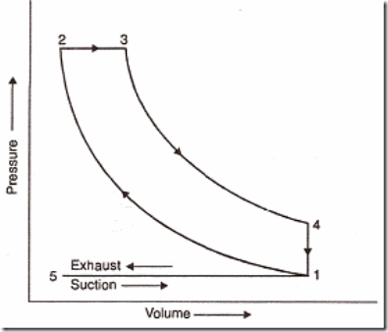
Theoretical p- V diagram of a four-stroke Diesel Engine
WORKING PRINCIPLE OF I.C. ENGINE:TWO STROKE CYCLE ENGINE
A mixture of fuel with correct amount of air is exploded in an engine cylinder which is closed at one end. As a result of this explosion, heat is released and this heat causes the pressure of the burning gases to increase. This pressure forces a close fitting piston to move down the cylinder. The movement of piston is transmitted to a crankshaft by a connecting rod so that the crankshaft rotates and turns a flywheel connected to it. Power is taken from the rotating crank shaft to do mechanical work. To obtain continuous rotation of the crankshaft the explosion has to be repeated continuously
TWO STROKE CYCLE ENGINE (PETROL ENGINE) In two stroke cycle engines, the whole sequence of events i.e., suction, compression, power and exhaust are completed in two strokes of the piston i.e. one revolution of the crankshaft. There is no valve in this type of engine. Gas movement takes place through holes called ports in the cylinder. The crankcase of the engine is air tight in which the cra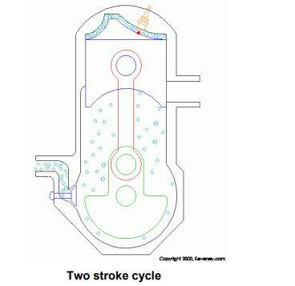
Upward stroke of the piston (Suction + Compression): When the piston moves upward it covers two of the ports, the exhaust port and transfer port, which are normally almost opposite to each other. This traps the charge of air- fuel mixture drawn already in to the cylinder. Further upward movement of the piston compresses the charge and also uncovers the suction port. Now fresh mixture is drawn through this port into the crankcase. Just before the end of this stroke, the mixture in the cylinder is ignited by a spark plug (Fig 2 c &d). Thus, during this stroke both suction and compression events are completed.
Downward stroke (Power + Exhaust) :Burning of the fuel rises the temperature and pressure of the gases which forces the piston to move down the cylinder. When the piston moves down, it closes the suction port, trapping the fresh charge drawn into the crankcase during the previous upward stroke. Further downward movement of the piston uncovers first the exhaust port and then the transfer port. Now fresh charge in the crankcase moves in to the cylinder through the transfer port driving out the burnt gases through the exhaust port. Special shaped piston crown deflect the incoming mixture up around the cylinder so that it can help in driving out the exhaust gases . During the downward stroke of the piston power and exhaust events are completed
COMPARISON OF DIESEL ENGINE WITH PETROL ENGINE
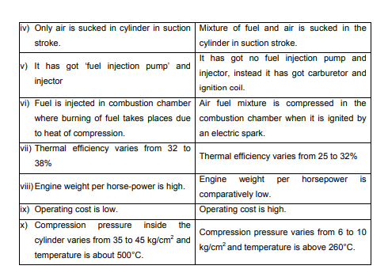
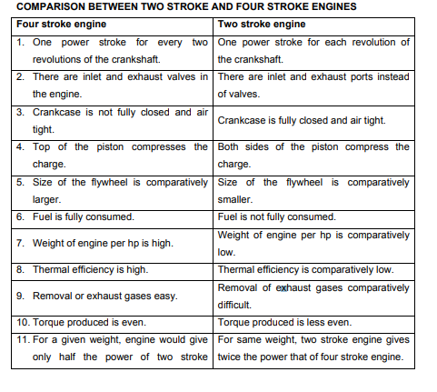

Valve Timing Diagram for 4-Stroke Engine (petrol and diesel)
As we all know in 4-stroke engine the cycle completes in 4-strokes that are suction, compression, expansion and exhaust , The relation between the valves (inlet and outlet) and piston movement from TDC to BDC is represented by the graph known as valve timing diagram.

Theoretical
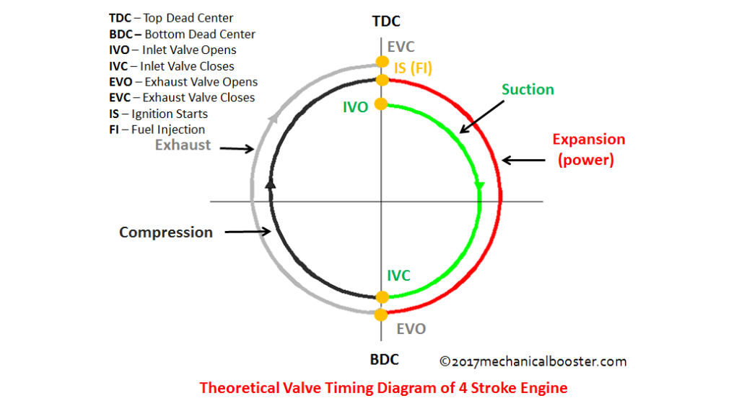
Suction Stroke- The engine cycle starts with this stroke, Inlet valve opens as the piston which is at TDC starts moving towards BDC and the air-fuel mixture in case of petrol and fresh air in case of diesel engine starts entering the cylinder,till the piston moves to BDC.
Compression Stroke- After the suction stroke the piston again starts moving from BDC to TDC in order to compress the air-fuel (petrol engine) and fresh air (diesel engine) which in turn raises the pressure inside the cylinder which is essential for the combustion of the fuel.
- The inlet valve closes during this operation to provide seizure of the chamber for the compression of the fuel.
Expansion Stroke- After compressing the fuel, The combustion of the fuel takes place which in turn pushes the piston which is at TDC towards BDC in order to release the pressure developed by the combustion and output is obtained .
Note – In petrol engine combustion takes place due to the spark produced by the spark plug.
- In petrol engine the air and fuel charge enters the cylinder during suction stroke.
- In diesel engine combustion occurs due to the high compression provided by the compression stroke which is responsible for raising the temperature inside cylinder upto auto-ignition temperature of the diesel and air charge.
- In diesel engine the fresh air enters inside the cylinder during suction stroke and the fuel is sprayed by the fuel injectors over the air.
- Exhaust Stroke- After expansion stroke the piston which is at BDC starts moving towards TDC followed by the opening of exhaust valve for the removal of the combustion residual
- Exhaust valve closes after the piston reaches TDC.

Actual or Practical Process

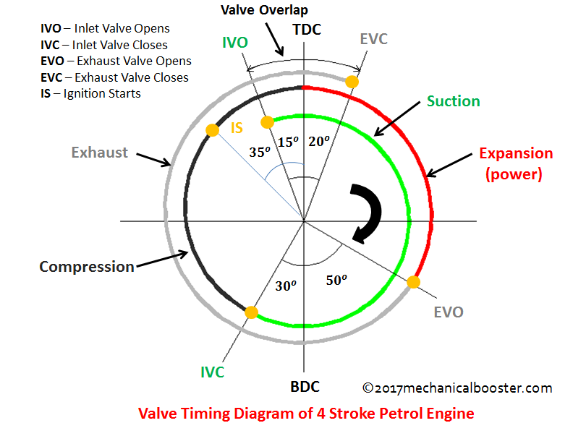Actual or Practical Process

In suction stroke of 4-stroke engine the inlet valve opens 10-20 degree advance to TDC for the proper intake of air-fuel(petrol) or air (diesel) ,which also provides cleaning of remaining combustion residuals in the combustion chamber.When the piston reaches BDC the compression stroke starts and again the piston starts moving towards TDC ,The inlet valve closes 25-30 degree past the BDC during the compression stroke,which provide complete seizure of the combustion chamber for the compression of air-fuel(petrol engine)and air(diesel engine).
During the compression stroke as the piston moves towards TDC ,combustion of fuel takes place 20-35 degree before TDC which provides the proper combustion of fuel and proper propagation of flame.The expansion strokes starts due to the combustion of fuel which in turn releases the pressure inside the combustion chamber and provide rotation to the crank shaft,The piston moves from TDC to BDC during expansion stroke which continuous 30-50 degree before BDC.The exhaust valve opens 30-50 degree before BDC which in turn starts the exhaust stroke and the exhaust of the combustion residual takes place with movement of the piston from BDC toTDC which continues till the 10-20 degree after the piston reaches TDC.
As we can see in the entire cycle of engine valves overlap 2 times i.e. closing of both valves during compression stroke and opening of both valves during exhaust stroke.How does a Four Stroke Diesel Engine (Compression Ignition Engine) Work?
Valve Timing Diagram for 2-Stroke Engine:
In 2-stroke petrol engine as we all know the engine cycle completes in 2-strokes i.e expansion stroke and compression stroke, The fuel intake and combustion residual exhaust occurs respectively during these 2 strokes.
Theoretical valve timing:
Expansion stroke- At the beginning of the expansion stroke the piston which is at TDC starts moving towards BDC due to the combustion of compressed air-fuel (petrol engine) and (diesel sprayed charge in diesel engine) during compression stroke and the power output is obtained. The air-fuel(petrol engine) and air (diesel diesel) enters through the inlet port during the expansion strokes as the piston moves from TDC to BDC during this stroke.The expansion stroke continuous till the piston reaches BDC.
Compression Stroke- At the end of the expansion stroke the piston which is at BDC starts moving towards TDC and the compression of air-fuel(petrol engine) and diesel sprayed charge(diesel engine) starts along with the exhaust of combustion residual through exhaust port due to the movement of piston from BDC to TDC.The piston closes both inlet port and exhaust port due to its movement from BDC to TDC which in turn raises the pressure inside the combustion chamber.At the end of the compression stroke i.e. when the piston reaches TDC combustion of the air-fuel (petrol engine) due to spark and diesel sprayed charge (diesel engine) due to the high pressure takes place, And the cycle repeats again.
Actual or practical process
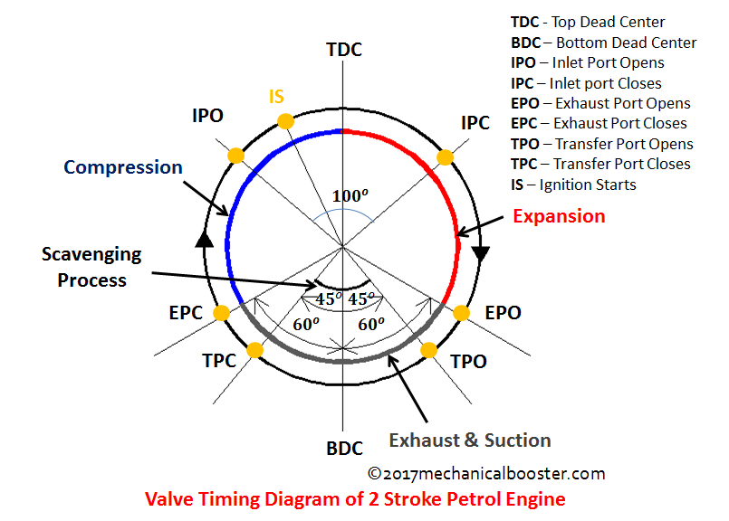
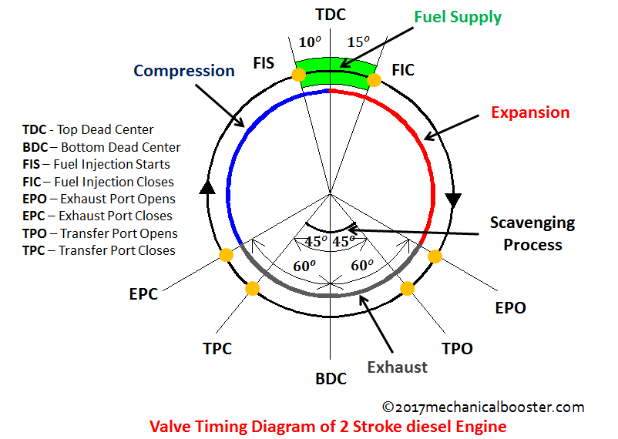

- Before the expansion stroke i.e. completion of the compression stroke, the inlet port open 10-20 degree before the piston reaches the TDC which in turn starts the expansion stroke due to the combustion of air-fuel (petrol engine) from the crankcase and air (diesel engine) entered from the inlet port which in turn pushes the piston towards BDC.
The inlet port closes 15-20 degree after TDC during the expansion stroke of the 2-stroke engine.Due to the movement of piston from TDC to BDC during expansion stroke exhaust port opens 35-60 degree before the piston reaches BDC which in turn starts the exhaust of the combustion residual.. Transfer port open 30-45 degree before BDC for scavenging process.
- When the piston moves towards TDC from BDC the transfer port closes 30-45 degree after BDC which in turn stops the scavenging process. During the movement of piston from BDC to TDC exhaust valve closes 35-60 degree after BDC which seizes the combustion chamber and pressure inside the combustion chamber increases due to the start of compression stroke.and the cycle starts again.
- The air fuel mixture (petrol engine) and air ( diesel engine) is transported to the cylinder during the opening of the transfer port.

Derivation of air-standard efficiency of Otto Cycle:

p-V and T-s Diagrams of Otto Cycle:
p-V Diagram | T-s Diagram
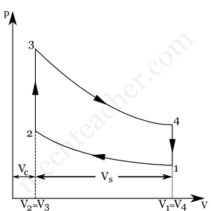 | 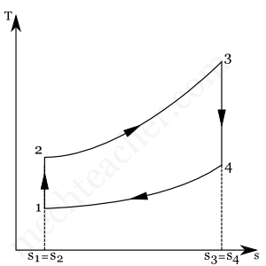

Basic terms used in derivation of air-standard efficiency of Otto cycle:

Total Cylinder Volume:
It is the total volume (maximum volume) of the cylinder in which Otto cycle takes place. In Otto cycle,
Total cylinder volume = V₁ = V₄ = V_{c} + V_{s} (Refer p-V diagram above)
where,
V_{c} → Clearance Volume
V_{s} → Stroke Volume

Clearance Volume (V_{c}):
At the end of the compression stroke, the piston approaches the Top Dead Center (TDC) position. The minimum volume of the space inside the cylinder, at the end of the compression stroke, is called clearance volume (V_{c}). In Otto cycle,
Clearance Volume, V_{c} = V₂ (See p-V diagram above)

Stroke Volume (V_{s}): In Otto cycle, stroke volume is the difference between total cylinder volume and clearance volume.
Stroke Volume, V_{s} = Total Cylinder Volume – Clearance Volume = V₁ – V₂ = V₄ – V₃

Compression Ratio:
Compression ratio (r) is the ratio of total cylinder volume to the clearance volume.
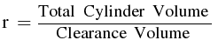
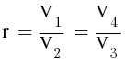Now that we know the basic terms, let us derive expressions for T₂ and T₃. These expressions will be useful for us to derive the expression for air-standard efficiency of otto cycle. For finding T₂, we take process 1-2 and for finding T₃, we take process 3-4.
Process 1-2:
This process is an isentropic (reversible adiabatic) process. For this process, the relation between T and V is as follows:
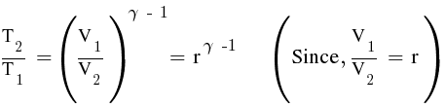
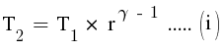
Process 3-4:
This is also an isentropic process. The relation between T and V in this process is similar to the relation between T and V in process 1-2: Here,
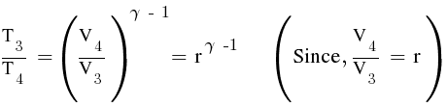
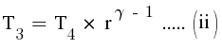

Air-standard efficiency of Otto cycle:
It is defined as the ratio between work done during Otto cycle to the heat supplied during Otto cycle.
Air-Standard Efficiency (thermal efficiency) of Otto cycle,
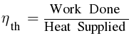
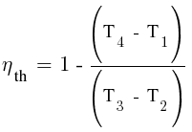
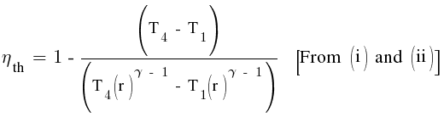
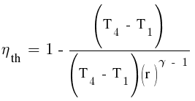
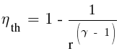
Derive an expression for efficiency of diesel cycle:

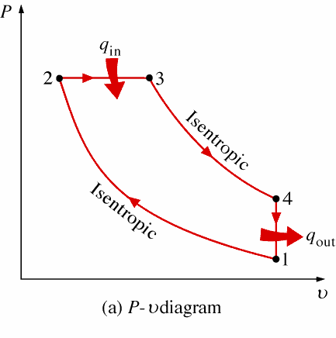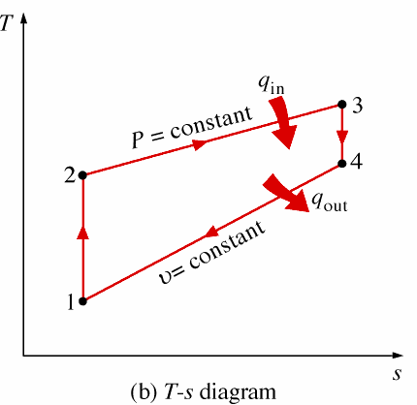

Diesel cycle has four processes. They are:
- Process 1-2: Isentropic (Reversible adiabatic) Compression
- Process 2-3: Constant Pressure (Isobaric) Heat Addition
- Process 3-4: Isentropic Expansion
- Process 4-1: Constant Volume (Isochoric) Heat Rejection

Process 1-2: Isentropic Compression
In this process, the piston moves from Bottom Dead Centre (BDC) to Top Dead Centre (TDC) position. Air is compressed isentropically inside the cylinder. Pressure of air increases from p₁ to p₂, temperature increases from T₁ to T₂, and volume decreases from V₁ to V₂. Entropy remains constant (i.e., s₁ = s₂). Work is done on the system in this process (denoted by W_{in} in the diagrams above).

Process 2-3: Constant Pressure Heat Addition
In this process, heat is added at constant pressure from an external heat source. Volume increases from V₂ to V₃, temperature increases from T₂ to T₃ and entropy increases from s₂ to s₃.
Heat added in process 2-3 is given by
Q_{in} = mC_{p}(T₃ − T₂) kJ ………… (i)
where, m → Mass of air in kg C_{p} → Specific heat at constant pressure in kJ/kgK
T₂ → Temperature at point 2 in K,T₃ → Temperature at point 3 in K
Process 3-4: Isentropic Expansion:Here the compressed and heated air is expanded isentropically inside the cylinder. The piston is forced from TDC to BDC in the cylinder. Pressure of air decreases from p₃ to p₄, temperature decreases from T₃ to T₄, and volume increases from V₃ to V₄. Entropy remains constant (i.e., s₃ = s₄). Work is done by the system in this process (denoted by W_{out} in the p-V and T-s diagrams above).
Process 4-1: Constant Volume Heat RejectionIn this process, heat is rejected at constant volume (V₄ = V₁). Pressure decreases from P₄ to P₁, temperature decreases from T₄ to T₁ and entropy decreases from s₄ to s₁.

Heat rejected in process 4-1 is given by
Q_{out} = mC_{v}(T₄ − T₁) kJ ………… (ii)
where,m → Mass of air in kg,C_{v} → Specific heat at constant volume in kJ/kgK
T₂ → Temperature at point 2 in K,T₃ → Temperature at point 3 in K

Air-standard Efficiency of Diesel Cycle:
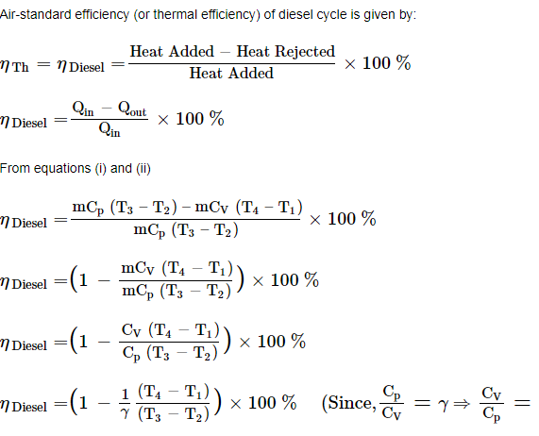

IGNITION SYSTEM

Basically Convectional Ignition systems are of 2 types : (a) Battery or Coil Ignition System, and (b) Magneto Ignition System. Both these conventional, ignition systems work on mutual electromagnetic induction principle. Battery ignition system was generally used in 4-wheelers, but now-a-days it is more commonly used in 2-wheelers also (i.e. Button start, 2- wheelers like Pulsar, Kinetic Honda; Honda-Activa, Scooty, Fiero, etc.). In this case 6 V or 12 V batteries will supply necessary current in the primary winding. Magneto ignition system is mainly used in 2-wheelers, kick start engines. (Example, Bajaj Scooters, Boxer, Victor, Splendor, Passion, etc.). In this case magneto will produce and supply current to the primary winding. So in magneto ignition system magneto replaces the battery.
Battery or Coil Ignition System:Figure shows line diagram of battery ignition system for a 4-cylinder petrol engine.It mainly consists of a 6 or 12 volt battery, ammeter, ignition switch, auto-transformer (step up transformer), contact breaker, capacitor, distributor rotor, distributor contact points, spark plugs, etc. Note that the Figure 4.1 shows the ignition system for 4-cylinder petrol engine, here there are 4-spark plugs and contact breaker cam has 4-corners. (If it is for 6-cylinder engine it will have 6-spark plugs and contact breaker cam will be a hexagon).The ignition system is divided into 2-circuits: i. Primary Circuit :a. It consists of 6 or 12 V battery, ammeter, ignition switch, primary winding it has 200-300 turns of 20 SWG (Sharps Wire Gauge) gauge wire, contact breaker, capacitor.
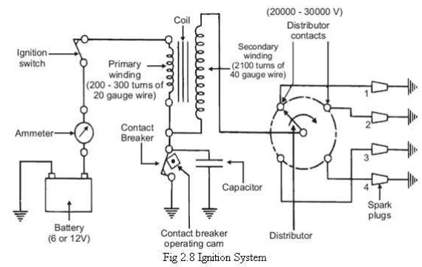
(ii) Secondary Circuit:

It consists of secondary winding. SecondaryIgnition Systems winding consists of about 21000 turns of 40 (S WG) gauge wire. Bottom end of which is connected to bottom end of primary and top end of secondary winding is connected to centre of distributor rotor. Distributor rotors rotate and make contacts with contact points and are connected to spark plugs which are fitted in cylinder heads (engine earth).
(iii) Working : When the ignition switch is closed and engine in cranked, as soon as the contact breaker closes, a low voltage current will flow through the primary winding. It is also to be noted that the contact beaker cam opens and closes the circuit 4-times (for 4 cylinders) in one revolution. When the contact breaker opens the contact, the magnetic field begins to collapse. Because of this collapsing magnetic field, current will be induced in the secondary winding. And because of more turns (@ 21000 turns) of secondary, voltage goes unto 28000-30000 volts. This high voltage current is brought to centre of the distributor rotor. Distributor rotor rotates and supplies this high voltage current to proper stark plug depending upon the engine firing order. When the high voltage current jumps the spark plug gap, it produces the spark and the charge is ignited-combustion starts-products of combustion expand and produce power.
Magneto Ignition System: In this case magneto will produce and supply the required current to theprimary winding. In this case as shown, we can have rotating magneto with fixed coil or rotating coil with fixed magneto for producing and supplying current to primary, remaining arrangement is same as that of a battery ignition system.

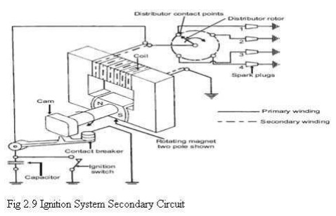

Lubrication System: The lubrication and cooling system of an internal- combustion engine is very important. If the lubricating system should fail, not only will the engine stop, but many of the parts are likely to be damage beyond repair. Coolant protects your engine from freezing or overheating.
Purpose of Lubrication System
Lubricate
➢ Reduces Friction by creating a thin film(Clearance) between moving parts (Bearings and journals)
Seals
➢ The oil helps form a gastight seal between piston rings and cylinder walls (Reduces Blow-By)
➢ Internal oil leak (blow-by) will result in blue smoke at the tale pipe.
Cleans
➢ As it circulates through the engine, the oil picks up metal particles and carbon, and brings them back down to the pan.
Absorbs shock
➢ When heavy loads are imposed on the bearings, the oil helps to cushion the load.
Viscosity:
➢ Viscosity is a measure of oil’s resistance to flow.
➢ A low viscosity oil is thin and flows easily
➢ A high viscosity oil is thick and flows slowly.
➢ As oil heats up it becomes more viscous (Becomes thin)

1 Splash:
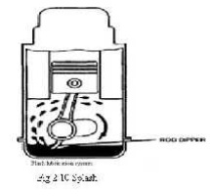
The splash system is no longer used in automotive engines. It is widely used in small four-cycle engines for lawn mowers, outboard marine operation, and so on. In the splash lubricating system , oil is splashed up from the oil pan or oil trays in the lower part of the crankcase. The oil is thrown upward as droplets or fine mist and provides adequate lubrication to valve mechanisms, piston pins, cylinder walls, and piston rings.

In the engine, dippers on the connecting-rod bearing caps enter the oil pan with each crankshaft revolution to produce the oil splash. A passage is drilled in each connecting rod from the dipper to the bearing to ensure lubrication. This system is too uncertain for automotive applications. One reason is that the level of oil in the crankcase will vary greatly the amount of lubrication received by the engine. A high level results in excess lubrication and oil consumption and a slightly low level results in inadequate lubrication and failure of the engine.

Combination of Splash and Force Feed:
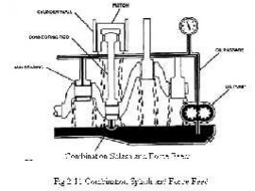
In a combination splash and force feed , oil is delivered to some parts by means of splashing and other parts through oil passages under pressure from the oilpump. The oil from the pump enters the oil galleries.From the oil galleries, it flows to the main bearings and camshaft
bearings. The main bearings have oil-feed holes or grooves that feed oil into drilled passages in the crankshaft. The oil flows through these passages to the connecting rod bearings. From there, on some engines, it flows through holes drilled in the connecting rods to the piston- pin bearings. Cylinder walls are lubricated by splashing oil thrown off from the connecting-rod bearings. Some engines use small troughs under each connecting rod that are kept full by small nozzles which deliver oil under pressure from the oil pump. These oil nozzles deliver an increasingly heavy stream as speed increases.
At very high speeds these oil streams are powerful enough to strike the dippers directly. This causes a much heavier splash so that adequate lubrication of the pistons and the connecting-rod bearings is provided at higher speeds. If a combination system is used on an overhead valve engine, the upper valve train is lubricated by pressure from the pump.
2.Force Feed :

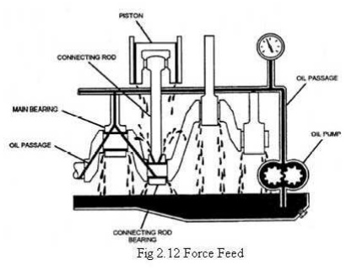

A somewhat more complete pressurization of lubrication is achieved in the force-feed lubrication system. Oil is forced by the oil pump from the crankcase to the main bearings and the camshaft bearings. Unlike the combination system the connecting-rod bearings are also fed oil under pressure from the pump. Oil passages are drilled in the crankshaft to lead oil to the connecting-rod bearings.
The passages deliver oil from the main bearing journals to the rod bearing journals. In some engines, these opening are holes that line up once for every crankshaft revolution. In other engines, there are annular grooves in the main bearings through which oil can feed constantly into the hole in the crankshaft. The pressurized oil that lubricates the connecting-rod bearings goes on to lubricate the pistons and walls by squirting out through strategically drilled holes. This lubrication system is used in virtually all engines that are equipped with semi floating piston pins.
3.Full Force Feed:
In a full force-feed lubrication system, the main bearings, rod bearings,camshaft bearings, and the complete valve mechanism are lubricated by oil under pressure. In addition, the full force-feed lubrication system provides lubrication under pressure to the pistons and the piston pins. This is accomplished by holes drilled the length of the connecting rod, creating an oil passage from the connecting rod bearing to the piston pin bearing. This passage not only feeds the piston pin bearings but also provides lubrication for the pistons and cylinder walls. This system is used in virtually all engines that are equipped with full-floating piston pins.

Cooling System:
Air Cooled System:Air cooled system is generally used in small engines say up to 15-20 Kw and in aero plane engines. In this system fins or extended surfaces are provided on the cylinder walls, cylinder head, etc. Heat generated due to combustion in the engine cylinder will be conducted to the fins and when the air flows over the fins, heat will be dissipated to air. The amount of heat dissipated to air depends upon : (a) Amount of air flowing through the fins. (b) Fin surface area. I Thermal conductivity of metal used for fins.
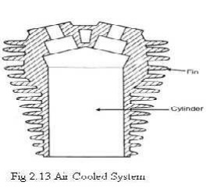
Advantages of Air Cooled System Following are the advantages of air cooled system:
(a) Radiator/pump is absent hence the system is light. (b) In case of water cooling system there are leakages, but in this case there are no leakages. I Coolant and antifreeze solutions are not required. (d) This system can be used in cold climates, where if water is used it may freeze.
Disadvantages of Air Cooled System(a) Comparatively it is less efficient. (b) It is used only in aero planes and motorcycle engines where the engines are exposed to air directly.
Water Cooling System:
In this method, cooling water jackets are provided around the cylinder, cylinder head, valve seats etc. The water when circulated through the jackets, it absorbs heat of combustion. This hot water will then be cooling in the radiator partially by a fan and partially by the flow developed by the forward motion of the vehicle. The cooled water is again recirculated through the water jackets
Thermo Syphon System:In this system the circulation of water is due to difference in temperature (i.e.difference in densities) of water. So in this system pump is not required but water is circulated because of density difference only.
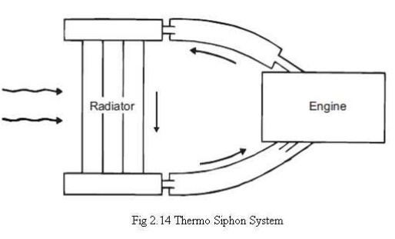

Pump Circulation System: In this system circulation of water is obtained by a pump. This pump is driven by means of engine output shaft through V-belts.

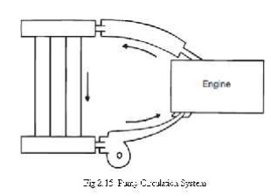
TECHNICAL TERMS

Alternator: A generator producing alternating current used for recharging the vehicle battery.
BMEP: Pressure in I.C engine cylinder during the work stroke.
Cam shaft: A shaft having number of cams at appropriate angular position for opening the valves at timing relative to the piston movement.
Carburation: Air fuel mixing of correct strength
Catalytic converter: Convert toxic gases produced by I.C engines
Clearance volume: volume of engine cylinder above the piston when it is in the TDC position.
Combustion chamber: The small space in the engine cylinder head and or piston into which air fuel mixture(petrol engine) or air (diesel engine) is compressed and burnt.
Connecting rod: it converts the linear motion of the piston into the rotary motion of the crank shaft.
EGR system: Exhaust gas recirculation
Fly wheel: A heavy metallic wheel attached to the engine crankshaft to smoothen out the power surges from the engine power strokes.
Governer: A mechanical or electronic device to restrict the performance of an engine usually for reason of safety.
Idle screw: A screw on the carburetor for adjusting the idling speed of the engine.
Detonation: An uncontrolled explosion of the unburnt air fuel mixture in the engine cylinder.

Pre-ignition: Ignition of air-fuel mixture earlier than the spark plug.

Engine performance Calculation:
Engine performance is an indication of the degree of success of the engine performs its assigned task, i.e. the conversion of the chemical energy contained in the fuel into the useful mechanical work. The performance of an engine is evaluated on the basis of the following :
(a) Specific Fuel Consumption.
(b) Brake Mean Effective Pressure.
I Specific Power Output.
(d) Specific Weight.
(e) Exhaust Smoke and Other Emissions.
The particular application of the engine decides the relative importance of these performance parameters. For Example : For an aircraft engine specific weight is more important whereas for an industrial engine specific fuel consumption is more important.

Indicated Power: It is the power developed in the cylinder and thus, forms the basis of evaluation of combustion efficiency or the heat release in the cylinder. Where, I.P= PmLANK/60 pm = Mean effective pressure, N/m2, L = Length of the stroke, m, A

= Area of the piston, m2, N
Frictional horse power (FHP): - It is the power required to run the engine at a given speed without producing any useful work. It represents the friction and pumping losses of an engine. IHP = BHP + FHP
PROBLESMS:

//ALL THE BEST//

