UNIT – 6
GAS POWER CYCLES
Discussion of this gas power cycles will involve the study of those heat engines in which the working fluid remains in the gaseous state throughout the cycle. We often study the ideal cycle in which internal irreversibilities and complexities (the actual intake of air and fuel, the actual combustion process, and the exhaust of products of combustion among others) are removed. We will be concerned with how the major parameters of the cycle affect the performance of heat engines. The performance is often measured in terms of the cycle efficiency.
INTRODUCTION
- The cycle is defined as the repeated series of operation or processes performed on a system, so that the system attains its original state.
- The cycle which uses air as the working fluid is known as Gas power cycles.
- In the gas power cycles, air in the cylinder may be subjected to a series of operations which causes the air to attain to its original position.
- The source of heat supply and the sink for heat rejection are assumed to be external to the air.
- The cycle can be represented usually on p-V and T-S diagrams.
POWER CYCLES
- Ideal Cycles, Internal Combustion
- Otto cycle, spark ignition
- Diesel cycle, compression ignition
- Sterling & Ericsson cycles
- Brayton cycles
- Jet-propulsion cycle
- Ideal Cycles, External Combustion
- Rankine cycle
IDEAL CYCLES
- Idealizations & Simplifications
- Cycle does not involve any friction
- All expansion and compression processes are quasi-equilibrium processes
- Pipes connecting components have no heat loss
- Neglecting changes in kinetic and potential energy (except in nozzles & diffusers)

GAS POWER CYCLES

Working fluid remains a gas for the entire cycle
Examples:

    - Spark-ignition engines
    - Diesel engines
    - Gas turbines
Air-Standard Assumptions
- Air is the working fluid, circulated in a closed loop, is an ideal gas
- All cycles, processes are internally reversible
- Combustion process replaced by heat-addition from external source
- Exhaust is replaced by heat rejection process which restores working fluid to initial state
ENGINE TERMS
- Top dead center
- Bottom dead cente
- Bore
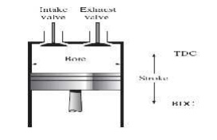
- Clearance volume
- Displacement volume
- Compression ratio
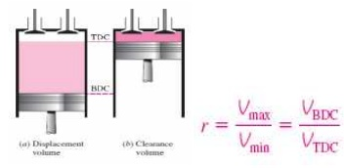
Mean effective pressure (MEP)
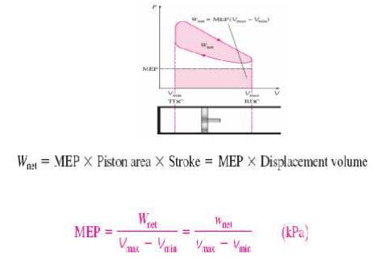
CYCLES AND THEIR CONCEPTS
OTTO CYCLE
An Otto cycle is an idealized thermodynamic cycle that describes the functioning of a typical spark ignition piston engine. It is the thermodynamic cycle most commonly found in automobile engines. The idealized diagrams of a four-stroke Otto cycle Both diagrams
  - Petrol and gas engines are operated on this cycle
  - Two reversible isentropic or adiabatic processes
  - Two constant volume process
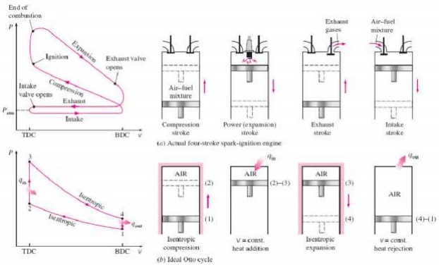
PROCESS OF OTTO CYCLE
➢ Ideal Otto Cycle
➢ Four internally reversible processes
1-2 Isentropic compression
2-3 Constant-volume heat addition
3-4 Isentropic expansion
4-1 Constant-volume heat rejection
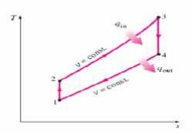
Thermal efficiency of ideal Otto cycle:
Since V2= V3 and V4 = V 1
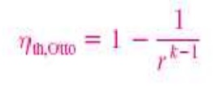
Diesel cycle
The Diesel cycle is a co mbustion process of a reciprocating internal combustion engine. In it, fuel is ignited by hea t generated during the compression of air in the combustion chamber, into which fuel is t hen injected.
It is assumed to have constant pressure during the initial part of the "combustion" phase The Diesel engine is a heat engine: it converts heat into work. During the bottom isentropic processes (blue), energy is transferred into the system in the form of work , W_{in} but by definition (isentropic) no ene rgy is transferred into or out of the system in the form of heat. During the constant pressure ( red, isobaric) process, energy enters the syste m as heat . During the top isentropic processes (yellow), energy is transferred out of the sy stem in the form of W_{out}, but by definition (isen tropic) no energy is transferred into or out of the system in the form of heat. During the constan t volume (green,isochoric) process, some of energy flows out of the system as heat through the right depressurizing process Q_{out} . The wor k that leaves the system is equal to the work that enters the system plus the difference between the heat added to the system and the heat that lea ves the system; in other words, net gain of wo rk is equal to the difference between the heat adde d to the system and the heat that leaves the system.
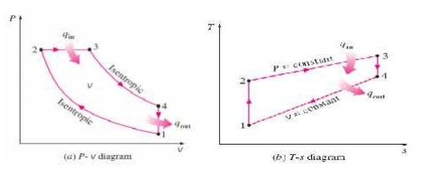

PROCESSES OF DIESEL CYCLE:
➢ 1-2 Isentropic com pression
➢ 2-3 Constant-Pres sure heat addition
➢ 3-4 Isentropic expansion
➢ 4-1 Constant-volume heat rejection
For ideal diesel cycle
Cut off ratio r_{c}
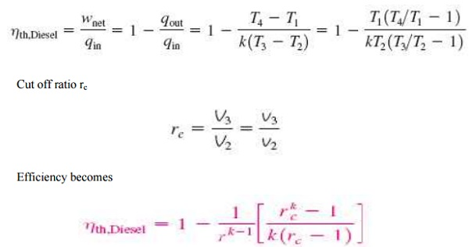

DUAL CYCLE
The dual combustion cycle (also known as the limited pressure or mixed cycle) is a thermal cycle that is a combination of the Otto cycle and the Diesel cycle. Heat is added partly at constant volume and partly at constant pressure, the advantage of which is that more time is available for the fuel to completely combust. Because of lagging characteristics of fuel this cycle is invariably used for diesel and hot spot ignition engines.
➢ Heat addition takes place at constant volume and constant pressure process .
➢ Combination of Otto and Diesel cycle.
➢ Mixed cycle or limited pressure cycle.
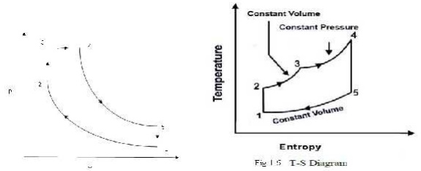
Isentropic compression

➢ Constant-volume heat rejection
➢ Constant-pressure heat addition
➢ Isentropic expansion
➢ Constant-volume heat rejection

The cycle is the equivalent air cycle for reciprocating high speed compression ignition engines. The P-V and T-s diagrams are shown in Figs.6 and 7. In the cycle, compression and expansion processes are isentropic; heat addition is partly at constant volume and partly at constant pressure while heat rejection is at constant volume as in the case of the Otto and Diesel cycles.

STERLING CYCLE
Sterling cycle is a thermodynamic cycle consists of two isothermal and two isochoric processes. Heat rejection and heat addition takes place at constant temperature.
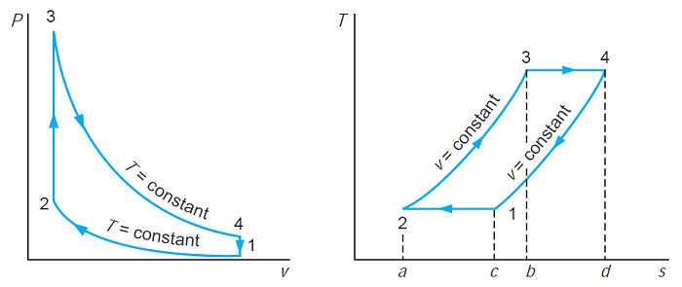
Pressure-volume and Temperature-entropy diagram
Where,
1-2: Isothermal compression
2-3: Constant volume cooling
3-4: Isothermal exoansion
4-1: Contant volume heating
From the p-V and T-s diagram of stirling cycle it is clear that the amount of heat addition and heat rejection during constant volume is same.
Heat supplied = Work done during isothermal expansion
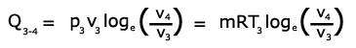
Heat rejected by the air during isothermal compression
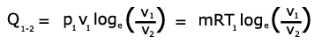
Work done = heat supplied – heat rejected
Thermal efficiency can be given by the equation
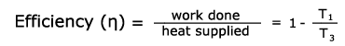

ATKINSON CYCLE:
Atkinson cycle is an ideal cycle for Otto engine exhausting to a gas turbine. In this cycle the isentropic expansion (3-4) of an Otto cycle (1-2-3-4) is further allowed to proceed to the lowest cycle pressure so as to increase the work output. With this modification the cycle is known as Atkinson cycle. The cycle is shown on p-v and T-s diagrams in Fig.4.8. Processes involved are:
- Process 1-2: Reversible adiabatic compression (v1 to v2).
- Process 2-3: Constant volume heat addition.
- Process 3-4: Reversible adiabatic expansion (v3 to v4).
- Process 4-1: Constant pressure heat rejection
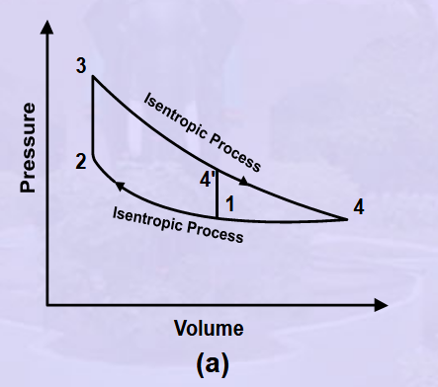
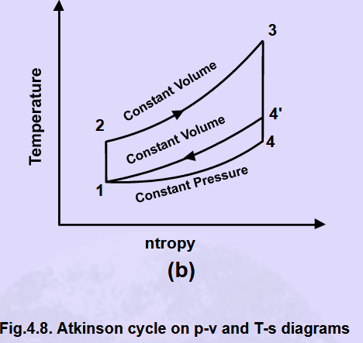

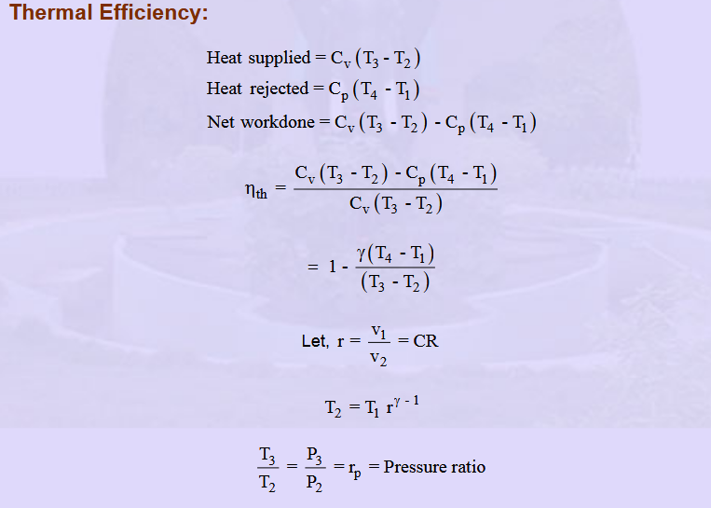
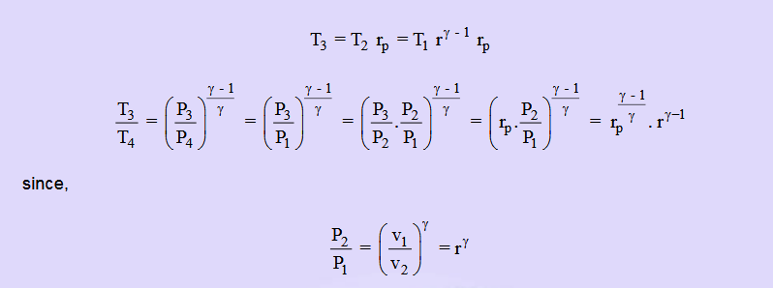
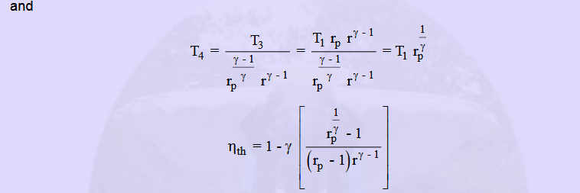
ERICCSON CYCLE

The Ericsson cycle consists of two isothermal and two constant pressure processes.

The processes are:
Process 1-2: Reversible isothermal compression.
Process 2-3: Constant pressure heat addition.
Process 3-4: Reversible isothermal expansion.
Process 4-1: Constant pressure heat rejection.
The heat addition and rejection take place at constant pressure as well as isothermal processes. Since the process 2-3 and 3-4 are parallel to each other on the T-s diagram, the net effect is that the heat need to be added only at constant temperature T3=T4 and rejected at the constant temperature T1=T2. The cycle is shown on p-v and T-s diagrams in Fig.4.3. The advantage of the Ericsson cycle over the Carnot and Stirling cycles is its smaller pressure ratio for a given ratio of maximum to minimum specific volume with higher mean effective pressure.
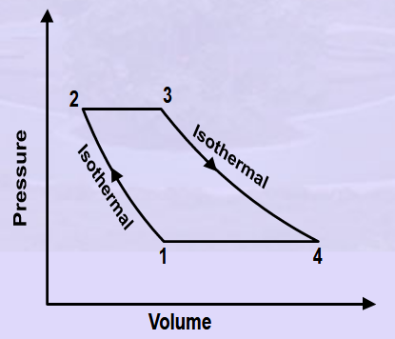
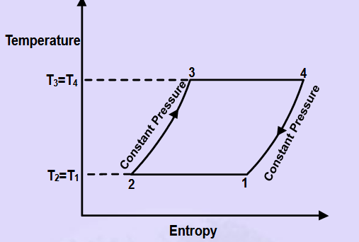
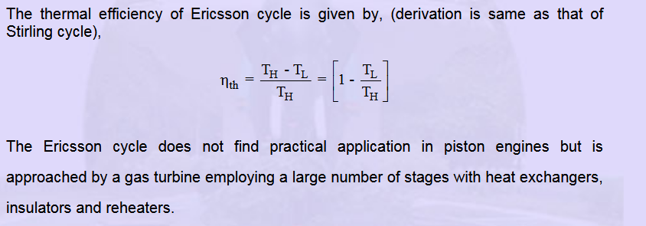

LENOIR CYCLE
