UNIT – 5
Mixture of ideal gases
Basic assumption is that the gases in the mixture do not interact with each other.
Consider a mixture with components l = 1,2,3... with masses m₁, m₂, m₃ ...m_{i} and with number of moles.
The total mixture occupies a volume V, has a total pressure P and temperature T (which is also the temperature of each of the component species)
The total mass
(5.1)
Total number of mole N
(5.2)
Mass fraction of species i
(5.3)
Mole fraction of species i
(5.4)
The mass and number of moles of species i are related by
(5.5)
is the number of moles of species i and is the molar mass of species i
Also to be noted
and | (5.6)
We can also define a molar mass of the mixture as
(5.7)
or,
or,
(5.8)

Dalton’s Law of partial pressure
Total pressure of an ideal gas mixture is equal to the sum of the partial pressures of the constituent components, That is
(5.9)
P is the total pressure of the mixture
P_{i} is the partial pressure of species i
= pressure of the species if it existed alone in the given temperature T and volume V
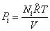 | (5.10)
is the universal gas constant = 8.314 kJ/k mol K
Dalton 's Law
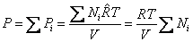
or
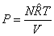 | (5.11)
The pressure function of species i
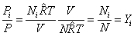 | (5.12)
Therefore,
Pressure fraction = Mole fraction

Amagat's Law:
Volume of an ideal gas mixture is equal to the sum of the partial volumes
(5.13)
V = total volume of the mixture
V_{i} = partial volume of the species i
= volume of the species if it existed alone in the given temperature T and pressure P
For an ideal gas
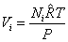 | (5.14)
Amagat's Law
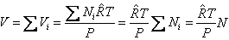
or
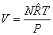 | (5.15)
The volume fraction of species i
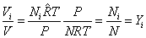
or,
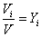 | (5.16)

Volume fraction = Mole fraction
Mass based analysis is known as gravimetric analysis
Mole based analysis is known as molar analysis

PSYCHROMETRY

INTRODUCTION
The psychrometric is that branch of engineering science which deals with the study of moist air i.e., dry air mixed with water vapour or humidity. It also includes the study of behavior of dry air and water vapour mixture under various sets of conditions. Though the earth’s atmosphere is a mixture of gases including nitrogen (N2), oxygen (O2), argon (Ar) and carbon dioxide (CO2), yet for the purpose of psychrometric, it is considered to be a mixture of dry air and water vapour only.

PSYCHOMETRIC TERMS

Though there are many psychometric terms, yet the following are important from the subject point of view :
    - Dry air. The pure dry air is a mixture of a number of gases such as nitrogen, oxygen, carbon dioxide, hydrogen, argon, neon, helium etc. But the nitrogen and oxygen have the major portion of the combination. The dry air is considered to have the composition as given in the following table:

Table .1 Composition of dry air

S.No. | Constituent | By volume | By mass | Molecular Mass
1  2  3  4  5 | Nitrogen (N2) Oxygen (O2) Argon (Ar)  Carbon dioxide (CO2)  Hydrogen (H2) | 78.03%  20.99%  0.94%  0.03%  0.01% | 75.47%  23.19%  1.29%  0.05%  - | 28  32  40  44  2
The molecular mass of dry air is taken as 28.966 and the gas constant of air (Ra) is equal 0.287 kJ / kg K or 287 J/kg K.
The molecular mass of water vapour is taken as 18.016 and the gas constant for water vapour (k) is equal to 0.461-kJ/kg K or 461 J/kg K.
Notes: (a) The pure dry air does not ordinarily exist in nature because it always contains some water vapour
- The term air, wherever used in this text, means dry air containing moisture in the vapour form.
- Both dry air and water vapour can be considered as perfect gases because both exist in the atmosphere at low pressure. Thus all the perfect gas terms can be applied to them individually.
- The density of dry air is taken as 1.293 kg/m3 at pressure 1.0135 bar or 101.35 1(11/m2 and at temperature 0°C (273 K).

    - Moist air. It is a mixture of dry air and water vapour. The amount of water vapour present. in the air depends upon the absolute pressure and temperature of the mixture.
    - Saturated air. It is mixture of dry air and water vapour, when the air has diffused the maximum amount of water vapour into it. The water vapours, usually, occur in the form of superheated steam as an invisible gas. However, when the saturated air is cooled, the water vapour in the air starts condensing, and the same may be visible in the form of moist, fog or condensation on cold surfaces.
    - Degree of saturation. It is the ratio of actual mass of water vapour in a unit mass of dry air to the mass of water vapour in the same mass of dry air when it is saturated at the same temperature.
    - Humidity. It is the mass of water vapour present in 1 kg of dry air, and is generally expressed in terms of gram per kg of dry air (g / kg of dry air). It is also called specific humidity or humidity ratio.
    - Absolute humidity. It is the mass of water vapour present in 1 m3 of dry air, and is generally expressed in terms of gram per cubic metre of dry air (g /m3 of dry air). It is also expressed in terms of grains per cubic metre of dry air. Mathematically, one kg of water vapour is equal to 15 430 grains.
    - Relative humidity. It is the ratio of actual mass of water vapour in a given_volume of moist air to the mass of water vapour in the same volume of saturated air at the same temperature and pressure. It is briefly written as RH.
    - Dry bulb temperature. It is the temperature of air recorded by a thermometer, when it is not affected by the moisture present in the air. The dry bulb temperature (briefly written as DBT) is generally denoted by td or tdb.
    - Wet bulb temperature. It is the temperature of air recorded by a thermometer, when its bulb is surrounded by a wet cloth exposed to the air. Such a thermometer is called *wet bulb thermometer. The wet bulb temperature (briefly written as WBT) is generally denoted by tw or twb.
    - Wet bulb depression. It is the difference between dry bulb temperature and wet bulb temperature at any point. The wet bulb depression indicates relative humidity of the air.

    - Dew point temperature. It is the temperature of air recorded by a thermometer, when the moisture (water vapour) present in it begins to condense. In other words, the dew point temperature is the saturation temperature (tsat). corresponding to the partial pressure of water vapour (Pv) It is, usually, denoted by tdp. Since pv. is very smaIl, therefore the saturation temperature by water vapour at pv is also low (less than the atmospheric or dry bulb temperature). Thus the water vapour in air exists in the superheated state and the moist air containing moisture in such a form (i.e., superheated state) is said to be unsaturated air. This condition is shown by point A on temperature-entropy (T-s) diagram as shown in Fig.1. When the partial pressure of water vapour (Pv) is equal to the saturation pressure (Ps) the water vapour is in dry condition and the air will be saturated air
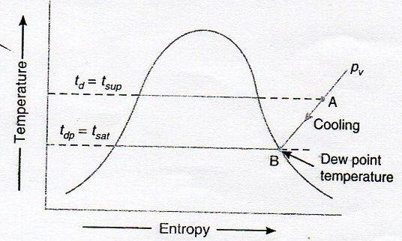
Fig.1. T-s diagram

If a sample of unsaturated air, containing superheated water vapour, is cooled at constant pressure, the partial pressure (pr) of each constituent remains constant until the water vapour reaches the saturated state as shown by point B in Fig.1. At this point 8, the first drop of dew will' be formed and hence the temperature at point B is called dew paint temperature. Further cooling will cause condensation of water vapour.
From the above we see that the dew point temperature is the temperature at which the water vapour begins to condense.
Note: For saturated air, the dry bulb temperature, wet bulb temperature and dew point temperature is same.
    - Dew point depression. It is the difference between the dry bulb temperature and dew point temperature of air.
    - Psychrometer. There are many types of psychrometers, but the sling psychrometer, as shown in Fig..2, is widely used. It consists of a dry bulb thermometer and a wet bulb thermometer mounted side by side in a protective case that is attached to a handle by a swivel connection so that the case can be easily rotated. The dry bulb thermometer is directly exposed to air and measures the actual temperature of the air. The bulb of the wet bulb thermometer is covered; by a wick thoroughly wetted by distilled water. The temperature measured by this wick covered bulb of a thermometer is the temperature of liquid water in the wick and is called wet Nib j temperature.

The sling psychrometer is rotated in the air for approximately one minute after which HO readings from both the thermometers are taken. This process is repeated several times to assure': that the lowest possible wet bulb temperature is recorded.
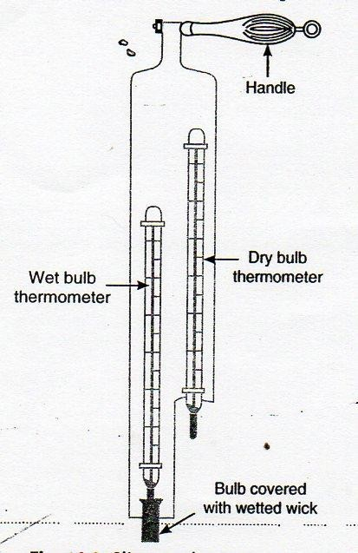
Fig.2, Sling psychrometer

DALTON'S LAW OF PARTIAL PRESSURES

It states, The total pressure exerted by the mixture of air and water vapour is equal to the sum of the pressures, which each constituent Fould exert, if it occupied the same space by itself. In other words, the total pressure exerted by air and water vapour mixture is equal to the barometric pressure. Mathematically, barometric pressure of the mixture,
Pb = Pa+ Pv,

where Pa = Partial pressure of dry air, and

Pv= Partial pressure of water vapour.

PSYCHROMETRIC RELATIONS

We have already discussed some psychrometric terms in Art. These terms have some relations between one another. The following psychrometric relations are important from the subject point of view:
- Specific humidity, humidity ratio or moisture content. It is the mass of water vapour present in 1 kg of dry air (in the air-vapour mixture) and is generally expressed in g /kg of dry air. It may also be defined as the ratio of mass of water vapour to the mass of dry air in a given volume of the air-vapour mixture.
Let Pa, Va, Ta, ma and Ra = Pressure, volume, absolute temperature, mass and gas constant

air,
respectively for dry air, and

Pv, Vv, mv and Rv = Corresponding values for the water vapour.

Assuming that the dry air and water vapour behave as perfect gases, we have for dry

Pa va = ma RaTa

and for water vapour, Pv vv = mv Rv Tv,

Also va = vv

and Ta = Tv,= Td ... (where Td is dry bulb temperature) From equations (i) and (ii), we have
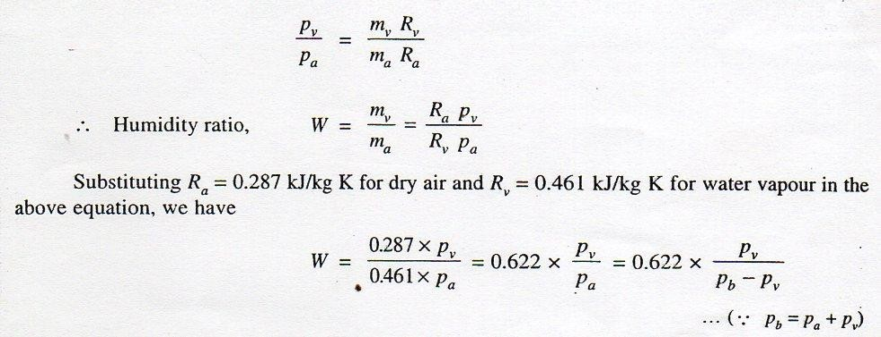
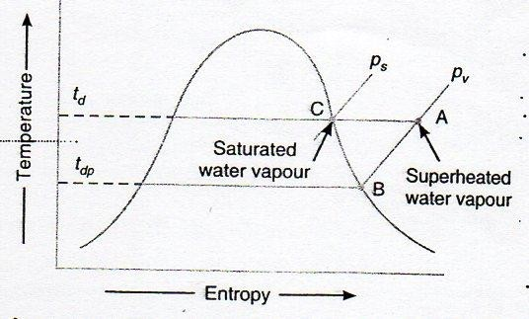
Fig.3 T-s diagram

Consider unsaturated air containing superheated vapour at dry bulb temperature td and partial pressure pv as shown by point A on the T-s diagram in Fig. 3. If water is added into this unsaturated air, the water will evaporate which will increase the moisture content (specific humidity) of the air and the partial pressure pv increases. This will continue until the water vapour becomes saturated at that temperature, as shown by point C in Fig.3, and there will be more evaporation of water. The partial pressure pv, increases to the saturation pressure ps and it is maximum partial pressure of water vapour at temperature td. The air containing moisture in such a state

(point C) is called saturated air.

For saturated air (i.e. when the air is holding maximum amount of water vapour), the humidity ratio or maximum specific humidity,
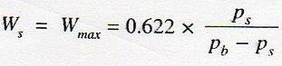
where Ps = Partial pressure of air corresponding to saturation temperature (i.e. dry bulb temperature td).
- Degree of saturation or percentage humidity. We have already discussed that the degree of saturation is the ratio of vapour in a unit mass of water air to the mass of water vapour in the same mass of dry air when it is saturated at the same temperature (dry bulb temperature), it may be defined as the ratio of actual specific humidity to the specific humidity of saturated air at the same dry bulb temperature. It is, usually, denoted by 𝜇. Mathematically, degree of saturation,
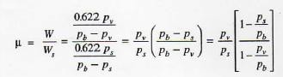
Notes: (a) The partial pressure of saturated air (Ps) is obtained from the steam tables corresponding to dry bulb temperature td.
- If the relative humidity,∅) = Pv / Ps is equal to zero, then the humidity ratio, W = 0, i.e. for dry air, 𝜇 = 0.
- If the relative humidity, ∅) Pv / Ps is equal to 1, then W = Ws and 𝜇 = 1. Thus p. varies between 0 and 1.
- Relative humidity. We have already discussed that the relative humidity is the ratio of actual mass of water vapour (mv) in a given volume of moist air to the mass of water vapour (ms) in the same volume of saturated air at the same temperature and pressure. It is usually denoted by ∅. Mathematically, relative humidity,
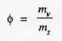
Let pv, vv , Tv , mv and Rv = Pressure, volume, temperature, mass and gas constant respectively for

water vapour in actual conditions, and

ps, vs, Ts, ms and Rs = Corresponding values for water vapour in saturated air.

We know that for water vapour in actual conditions,

Pv vv = mv Rv Tv …..(i) Similarly, for water vapour in saturated air,
Ps vs = ms Rs Ts …(ii)

According to the definitions,

vv = vs

Tv = Ts

Also Rv = Rs = 0.461 kJ/kg K

∴ From equations (i) and (ii), relative humidity,
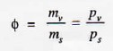
Thus, the relative humidity may also be defined as the ratio of actual partial pressure of water vapour in moist air at a given temperature (dry bulb temperature) to the saturation pressure of water vapour (or partial pressure of water vapour in saturated air) at the same temperature.
The relative humidity may also be obtained as discussed below: We know that degree of saturation,
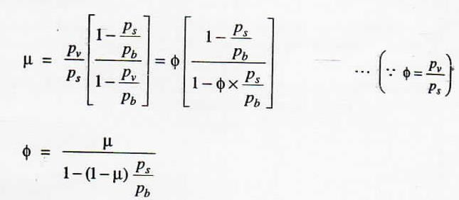

- Pressure of water vapour. According to Carrier's equation, the partial pressure of water vapours,
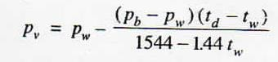
Where pw, = Saturation pressure corresponding to wet bulb temperature (from steam tables),
Pb = Barometric pressure,

td = Dry bulb temperature, and

tw = Wet bulb temperature.

- Vapour density or absolute humidity. We have already discussed that the vapour density or absolute humidity is the mass of water vapour present in 1 m3 of dry air.
Let vv = Volume of water vapour in m³/kg of dry air at its partial pressure,
va = Volume of dry air in m³/kg of dry air at its partial pressure,
𝜌v, = Density of water vapour in kg/m³ corresponding to its partial pressure and dry bulb
temperature td, and

𝜌a = Density of dry air in kg/m³ of dry air.
We know that mass of water vapour,
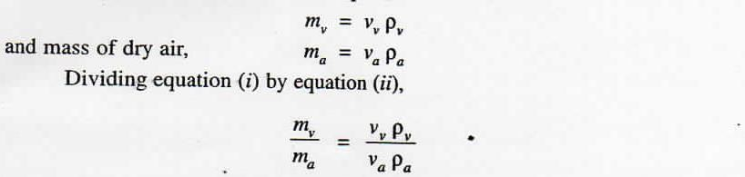
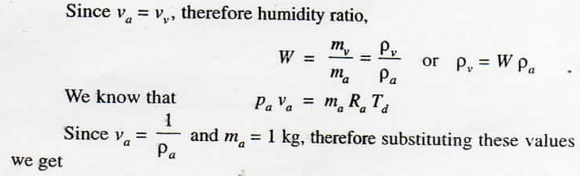
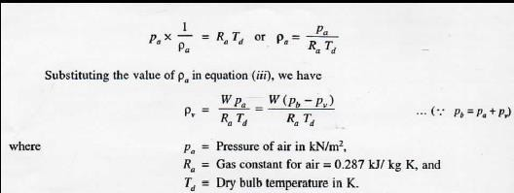

THERMODYNAMIC WET BULB TEMPERATURE OR ADIABATIC SATURATION TEMPERATURE
The thermodynamic wet bulb temperature or adiabatic saturation temperature is the temperature at which the air can be brought to saturation state, adiabatically, by the evaporation of water into the flowing air.
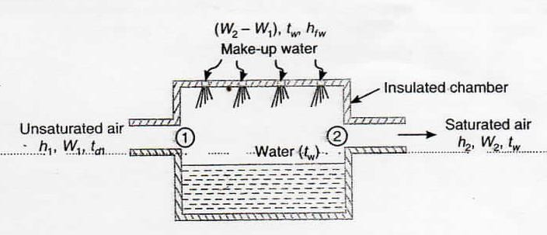
Fig.4 Adiabatic saturation of air.

The equipment used for the adiabatic saturation of air, in its simplest form, consists of an insulated chamber containing adequate quantity of water. There is also an arrangement for extra water (known as make-up water) to flow into the chamber from its top, as shown in Fig.4.
Let the unsaturated air enters the chamber at section 1. As the air passes through the chamber over a long sheet of water, the water evaporates which is carried with the flowing stream of air, and the specific humidity of the air increases. The make-up water is added to the chamber at this temperature to make the water level constant. Both the air and water are cooled as the evaporation takes place. This process continues until the energy transferred from the air to the water is equal to the energy required to vaporize the water. When steady conditions are reached, the air flowing at section 2 is saturated with water vapour. The temperature of the saturated air at section 2 is known as thermodynamic wet bulb temperature or adiabatic saturation temperature.
The adiabatic saturation process can be represented on T-s diagram as shown by the curve 1-2 in Fig.5.
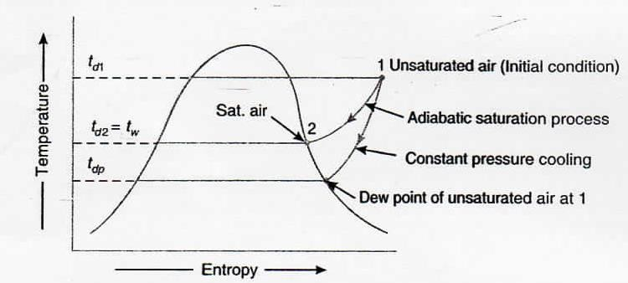
Fig.5. T-s diagram for adiabatic saturation process

During the adiabatic saturation process, the partial pressure of vapour increases, although the total ressure of the air-vapour mixture. The unsaturated air initially at dry bulb temperature td2, is coo e adiabatically to dry bulb temperature td, which is equal to the adiabatic saturation temperature tw. It may be noted that the adiabatic saturation temperature is taken equal to the wet bulb temperature for all practical purposes.
Let h1 = Enthalpy of unsaturated air at section 1,

W1 = Specific humidity of air at section 1,

h2,W2 = Corresponding values of saturated air at section 2, and

hfw= Sensible heat of water at adiabatic saturation temperature.

Balancing the enthalpies of air at inlet and outlet (i.e. at sections 1 and 2),

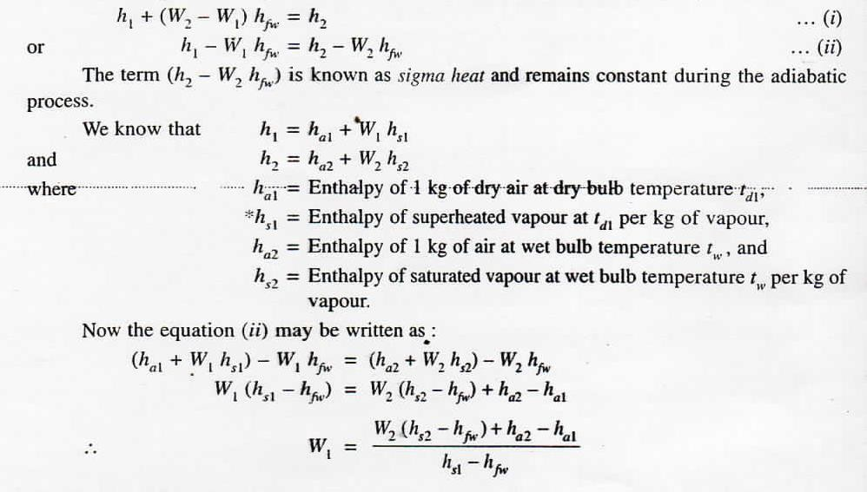

PSYCHROMETRIC CHART

It is a graphical representation of the various thermodynamic properties of moist air. The psychrometric chart is very useful for finding out the properties of air (which are required in the field of air conditioning) and eliminate lot of calculations. There is a slight variation in the charts prepared by different air-conditioning manufactures but basically they are all alike. The psychrometric chart is normally drawn for standard atmospheric pressure of 760 mm of Hg (or 1.01325 bar).
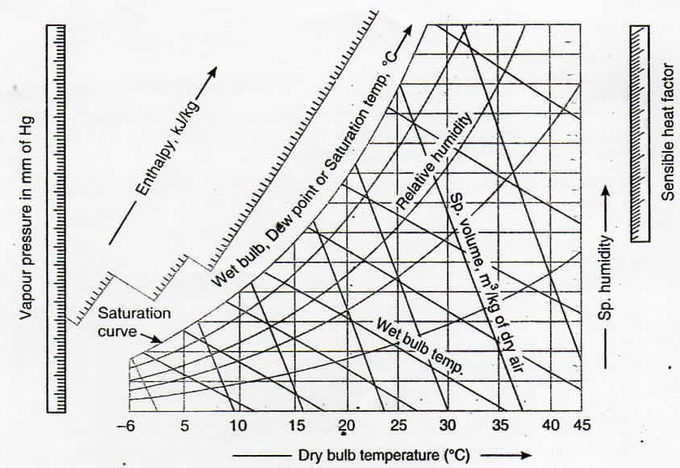
Fig. 6 Psychrometric chart.

In a psychrometric chart, dry bulb temperature is taken as abscissa and specific humidity i.e. moisture contents as ordinate, as shown in Fig. 6. Now the saturation curve is
drawn by plotting the various saturation points at corresponding dry bulb temperatures. The saturation curve represents 100% relative humidity at various dry bulb temperatures. It also represents the wet bulb and dew point temperatures.
Though the psychrometric chart has a number of details, yet the following lines are important frpm the subject point of view :
    - Dry bulb temperature lines. The dry bulb temperature lines are vertical i.e. parallel to the ordinate and uniformly spaced as shown in Fig. 7. Generally the temperature range of these lines on psychrometric chart is from - 6° C to 45° C. The dry bulb temperature lines are drawn with difference of every 5°C and up to the saturation curve as shown in the figure. The values of dry bulb temperatures are also shown on the saturation curve.
    - Specific humidity or moisture content lines. The specific humidity (moisture content) lines are horizontal i.e. parallel to the abscissa and are also uniformly spaced as shown in Fig. 16.8. Generally, moisture content range of these lines on psychrometric chart is from 0 to 30 g / kg of dry air (or from 0 to 0.030 kg / kg of dry air). The moisture content lines are drawn with a difference of every 1 g (or 0.001 kg) and up to the saturation curve as shown in the figure.
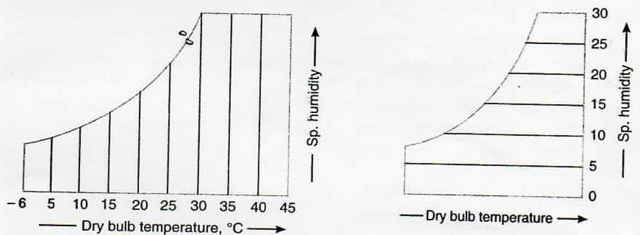
Fig.7. Dry bulb temperature lines. Fig. 8. Specific humidity lines.

    - Dew point temperature lines. The dew point temperature lines are horizontal i.e. parallel to the abscissa and non-uniformly spaced as shown in Fig. 16.9. At any point on the saturation curve, the dry bulb and dew point temperatures are equal.
The values of dew point temperatures are generally given along the saturation curve of the chart as shown in the figure.

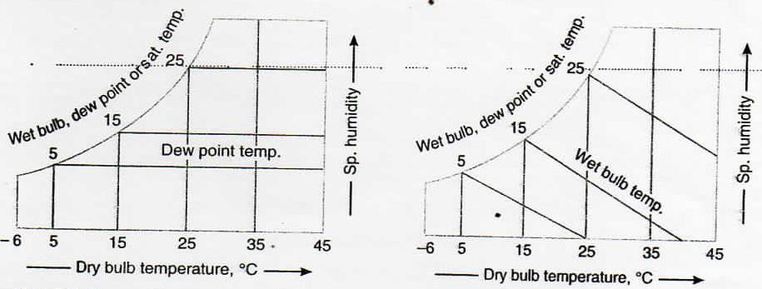

Fig. 9 Dew point temperature lines. Fig.10 Wet bulb temperature lines.

    - Wet bulb temperature lines. The wet bulb temperature lines are inclined straight lines and non-uniformly spaced as shown in Fig.10. At any point on the saturation curve, the dry bulb and wet bulb temperatures are equal.
The values of wet bulb temperatures are generally given along the saturation curve of the chart as shown in the figure.
    - Enthalpy (total heat) lines. The enthalpy (or total heat) lines are inclined straight lines and uniformly spaced as shown in Fig.11. These lines are parallel to the wet bulb temperature lines, and are drawn up to the saturation curve. Some of these lines coincide with the wet bulb temperature lines also.
The values of total enthalpy are given on a scale above the saturation curve as shown in the figure.
    - Specific volume lines. The specific volume lines are obliquely inclined straight lines and uniformly spaced as shown in Fig.12. These lines are drawn up to the saturation curve. The values of volume lines are generally given at the base of the chart.
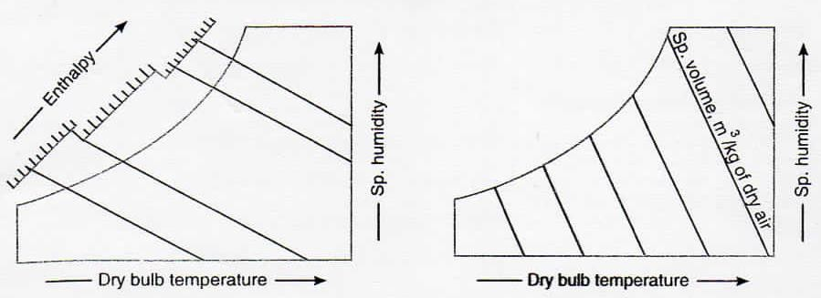
Fig. 11. Enthalpy lines. Fig. 12. Specific volume lines.

    - Vapour pressure lines. The vapour pressure lines are horizontal and uniformly spaced. Generally, the vapour pressure lines are not drawn in the main chart. But a scale showing vapour pressure in mm of Hg is given on the extreme left side of the chart as shown in Fig.13.
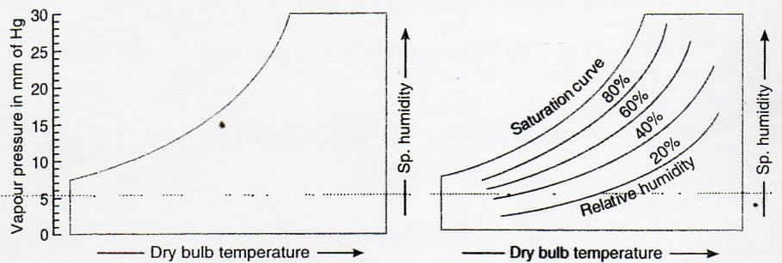

lines.
Fig. 13. Vapour pressure lines. Fig. 14. Relative humidity

    - Relative humidity lines. The relative humidity lines are curved lines and follow the
saturation curve. Generally, these lines are drawn with values 10%, 20%, 30% etc. and up to 100%. The saturation curve represents 100% relative humidity. The values of relative humidity lines are generally given along the lines themselves as shown in Fig. 14.

saturation curve. Generally, these lines are drawn with values 10%, 20%, 30% etc. and up to 100%. The saturation curve represents 100% relative humidity. The values of relative humidity lines are generally given along the lines themselves as shown in Fig. 14.

