UNIT – 4
PURE SUBSTANCE
A pure substance is one that has homogeneous and invariable chemical composition. It may exist in more than one phase, but chemical composition is same for all the phases. Thus, water, mixture of water and ice and water and steam are all examples of pure substance. Sometimes a mixture of gases e.g. air is considered as pure substance.
We have seen that two independent properties are sufficient to determine thermodynamic state of a fluid when it is in equilibrium. Any other thermodynamic property is a function of the chosen pair of independent properties. We shall first consider the relation between the primary properties p, v and T, the equation expressing this relation for any particular fluid being called the equation of state or characteristic equation of the fluid.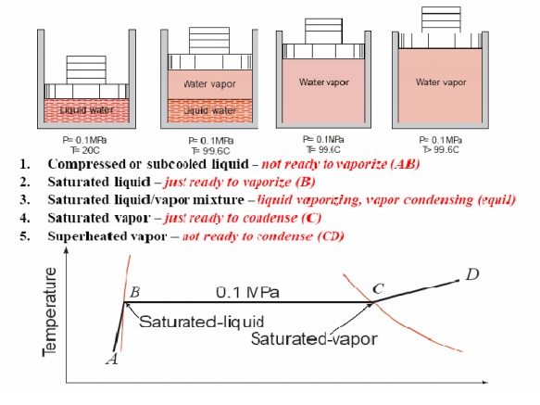
FORMATION OF STEAM AND PROPERTIES
Imagine unit mass of ice below the freezing point, enclosed in a cylinder by a piston under a constant load of 1 atmosphere (1 atm. = 1.01325 bar = 101.325 kPa). If heat is added to the cylinder while keeping the pressure constant, the temperature rises and ice expands until a temperature of 273.15 K (00C) is reached (AB) as shown in Fig. Further heating does not raise the temperature of ice but causes a change to the liquid phase (BC). The change of phase occurs at a constant temperature and by reduction of specific volume. The heat required for this process is known as latent heat of fusion. Further heating results in a rise of temperature of liquid and a further contraction in volume until the temperature is about 40C and subsequent expansion until a temperature of 373.15 K (1000C) is reached (point D). At this point a second phase change occurs at constant temperature with a large increase in volume until the liquid has been vaporised (point E). The heat required in this case is called the latent heat of vaporisation. When vaporisation is complete, the temperature rises again on heating (line EF). The heat transferred to a substance while the temperature changes is sometimes referred to as sensible heat. This constant pressure lines are called isobars.
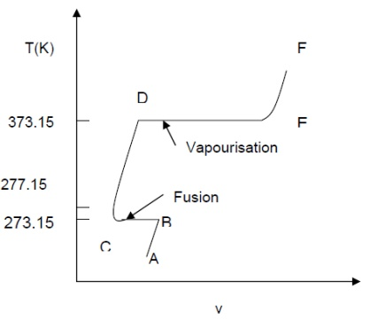
If the pressure is reduced, there is a slight rise in the melting point and also there is a marked drop in the boiling point of water and a marked increase in the change in volume, which accompanies evaporation. When the pressure is reduced to 0.006113 bar (0.6113 kPa), the melting point and boiling point temperatures become equal and change of phase, ice-water-steam, are represented by a single line. The temperature at which this occurs has been accepted internationally as a fixed point for the absolute temperature scale and is by definition 273.16 K. Only at this temperature and pressure of 0.6112 kPa, can ice, water and steam coexists in thermodynamic equilibrium in a closed vessel and is known as triple point. If the pressure is reduced further, the ice, instead of melting, sublimes directly into steam.
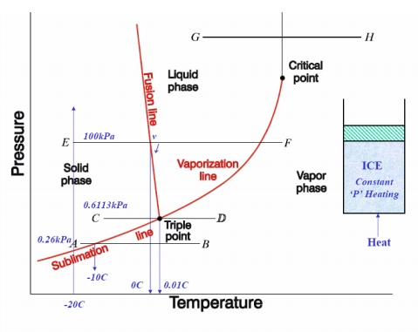

p-v, p-T, T-v, T-s, h-s DIAGRAMS

Consider now the behaviour at pressure above atmospheric. The shape of the curve is similar to that of the atmospheric isobar, but there is a marked reduction in the change in volume accompanying evaporation. At a sufficiently high pressure, this change in volume falls to zero and the horizontal portion of the curve reduces to a point of inflexion. This is referred to critical point. The values pressure and temperature of water at which critical point reached are
P_{c} = 221.2 bar = 22.12 MPa ;
Tc = 647.3 K ;
Vc = 0.00317 m3/kg.

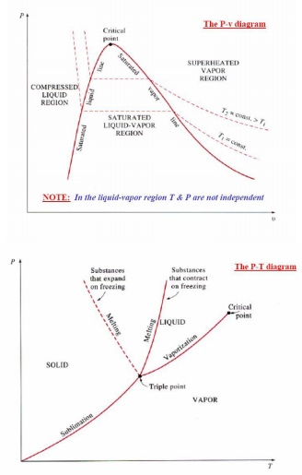
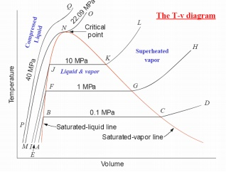
The pressure at which liquid vaporises or condenses is called saturation pressure corresponding to a given temperature. Alternately, the temperature at which this phenomena occur is called saturation temperature corresponding to the given pressure. A vapour in a state lying along the saturated vapour line is also called dry saturated vapour and the vapour lying right of this line is called superheated vapour.
DEFINITION AND APPLICATIONS
•Saturation temperature: Temperature at which a pure substance changes phase at a given pressure.
Saturation pressure: Pressure at which a pure substance changes phase at a given temperature.
•Latent heat: The amount of energy absorbed or released during a phase-change. Melting/freezing: Latent heat of fusion.
Evaporation/condensation: Latent heat of vaporization.
Temperature at which water starts boiling depends on the pressure => if the pressure is fixed, so is the boiling temperature.

CLAUSIUS–CLAPEYRON RELATION
The Clausius–Clapeyron relation, named after Rudolf Clausius and Émile Clapeyron, who defined it sometime after 1834, is a way of characterizing the phase transition between two phases of matter, such as solid and liquid. On a pressure–temperature (P–T) diagram, the line separating the two phases is known as the coexistence curve. The Clausius–Clapeyron relation gives the slope of this curve. Mathematically,
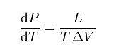
where dP / dT is the slope of the coexistence curve, L is the latent heat, T is the temperature,Visthevolumeandchange of the phase transition.
Pressure Temperature Relations
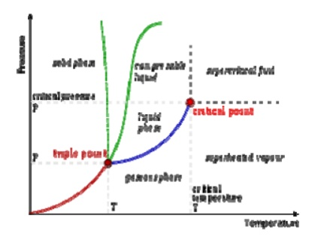
A typical phase diagram. The dotted line gives the anomalous behavior of water. The Clausius–Clapeyron relation can be used to (numerically) find the relationships between pressure and temperature for the phase change boundaries. Entropy and volume changes (due to phase change) are orthogonal to the plane of this drawing
Derivation
Using the state postulate, take the specific entropy, s, for a homogeneous substance to be a function of specific volume, v, and temperature, T.
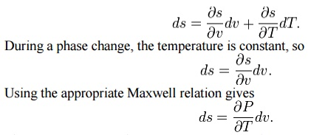
Since temperature and pressure are constant during a phase change, the derivative of pressure with respect to temperature is not a function of the specific volume. Thus the partial derivative may be changed into a total derivative and be factored out when taking an integral from one phase to another,
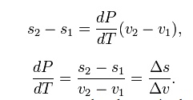
Del is used as an operator to represent— final (2) minus initial (1) For a closed system undergoing an internally reversible process, the first law is
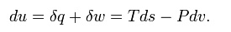
This leads to a version of the Clausius–Clapeyron equation that is simpler to integrate:
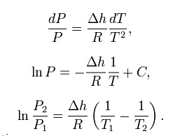
C is a constant of integration
These last equations are useful because they relate saturation pressure and saturation temperature to the enthalpy of phase change, without requiring specific volume data. Note that in this last equation, the subscripts 1 and 2 correspond to different locations on the pressure versus temperature phase lines. In earlier equations, they corresponded to different specific volumes and entropies at the same saturation pressure and temperature.

Dryness Fraction (Quality of steam)
It is the fraction of steam that is in the vapour form in the mixture.
Let, m_{g} = mass of dry steam/kg of mixture
m_{f} = mass suspended liquid/kg of mixture x = dryness fraction of steam
Therefore
x = mg
mg +mf

or wet steam, x < 1

For dry steam, x = 1
THE MEASUREMENTS OF DRYNESS FRACTION
Dryness fraction of wet steam, representing the fraction of steam in the mixture of water and steam can be measured by using (i) Throttling calorimeter and (ii) Separating and Throttling calorimeter.
(i) Throttling calorimeter:
Let us consider a wet steam as represented by state 1 in the h-s diagram. When it undergoes a throttling process to state 2, it enters into the superheated region. By measuring the temperature and pressure after throttling the specific enthalpy can be obtained. As mentioned earlier during throttling enthalpy remains constant. Therefore the initial state can be completely fixed since the pressure before throttling and the corresponding specific enthalpy are known.
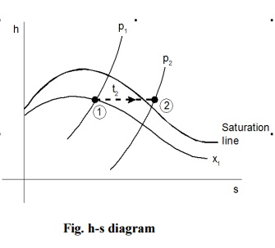
Steam from the main is extracted through a perforated tube projecting into it as shown in the Figure. Pressure of the steam is measured. It is then throttled into a chamber where the necessary pressure and temperature measurements are made. From the chamber the expanded steam is then condensed by circulating cooling water and discharged.
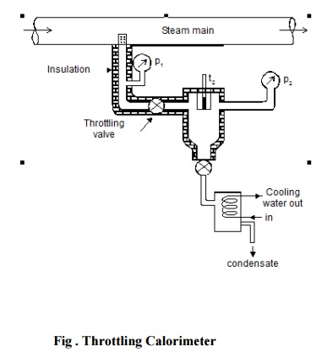
(ii) Separating and Throttling calorimeter:
When the dryness fraction of the steam is very low, it becomes superheated vapour only at very low end pressure on throttling. In general, the pressure after throttling for dryness fraction measurement is preferred to be above atmospheric. In such applications, separating and throttling calorimeters are used for dryness fraction measurement.

Wet steam, when subjected to sudden change in the direction of flow, a portion of the liquid falls due to gravity and gets separated from the main stream. Thus the remaining steam becomes rich in vapour, which upon throttling will become superheated vapour even at a pressure higher than atmospheric pressure. This principle is employed in the separating and throttling calorimeter.
The wet steam from the steam main is extracted through a perforated tube and sent to the separator where a portion of the liquid is separated due to sudden change in the direction. The remaining steam is throttled into a chamber where the required pressure and temperature measurements are made. Mass flow rate of liquid separated in the separator is collected and measured. Mass of the remaining steam is also measured by condensing the throttled steam and collecting it. Let be the mass of liquid separated in the separator and be the mass of steam throttled
