UNIT – 3
Limitations of First Law of Thermodynamics

If a well insulated tank of fluid is stirred by a rotating paddle wheel, the energy of the fluid increases. If the stirrer is stopped, however the energy of the fluid will not decrease and cause the stirrer to rotate in the opposite direction. The possibility of this process proceeding in the opposite direction is not excluded by the first law of Thermodynamics. Hence first law of thermodynamics does not allow us to predict whether a proposed conceived energy conversion is possible or not.
In all the internal combustion engines fuel and air mixture is supplied at room temperature. This mixture undergoes combustion inside the engine and gives out work. Exhaust gases coming out of the engine are always at higher temperature, indicating that some heat is taken away into atmosphere. Hence, in all the IC engines only a part of the heat is converted into work. From our experience we know that if any attempt is made to convert all the heat into work, our effort will go in vain. This limitation in the extent of energy conversion has also not been addressed in first law of thermodynamics.

The first law of thermodynamics tells us that energy can be changed from one form to another but can be neither created nor destroyed in any process. The mathematical expression which is used to represent the first law of thermodynamics is DE = q-w, where DE refers to the internal energy change of the system when 'w' amount of work is done by the system when it absorbs 'q' amount of heat and carries out 'w' amount of work. However, this law possesses many limitations such as given below.

1. The first law of thermodynamics merely indicates that in any process there is a transformation between the various forms of energy involved in the process but provides no information regarding the feasibility of such transformation.
2. First law does not provide any information regarding the direction a processes will take whether it is a spontaneous or a non spontaneous process.

The Second law of Thermodynamics
Kelvin Planck’s: It is impossible statement to constructa device that, operating continuously, will produce no effect other than transfer of heat from a single thermal reservoir and performance of an equal amount of work.
The term thermal reservoir refers to a very large system in stable equilibrium, to which or from which, any amount of heat can be transferred at constant temperature.
A thermal reservoir supplying heat continuously at constant temperature is known as source. (Example : Sun)
A thermal resevoir receiving heat continuously at constant temperature is known as sink. (Examples : River, Sea)
From Kelvin-Planck statement it is clear that for any system to operate in a cycle and to give out work continuously it should interact with a minimum of two reservoirs at different temperatures. The system will receive heat from the high temperature reservoir and reject heat to the low temperature reservoir. Such devices are known as heat engines. Performance (or) Efficiency of a heat engine can be expressed as the ratio of desired output to the required input. In a heat engine the desired output is net work output and the required input is total heat input.
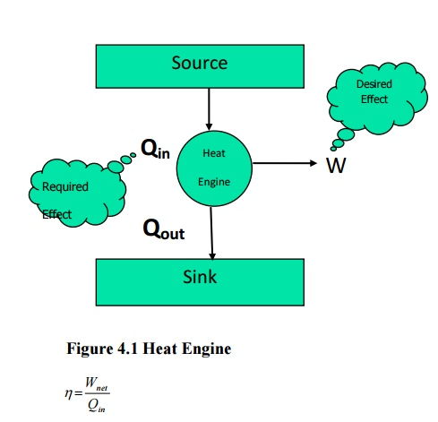
From first law of thermodynamics
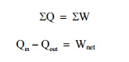
Clausius statement : Unaided by an external agency heat can not be transferred from a body at lower temperature to a body at higher temperature.

Devices that are used to transfer heat from a body at lower temperature to a body at higher temperature are known as refrigerators (or) heat pumps. If the high temperature side is atmosphere it is a refrigerator. If the low temperature side is atmosphere it is known as a heat pump. The performance index here is called coefficient of performance (COP). In refrigerator (and heat pumps) the performance is the ratio of two independent parameters and hence the possibility of getting the value more than unity is always there. But the term efficiency is restricted to a maximum of unity. Hence the term efficiency is not used here.
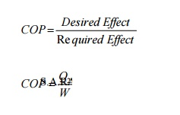
COP=Q/W
Taking work as external agency, for refrigerators (Figure 4.2)
From first law
QΣ= €ΣW
Q₁ −Q₂ €=W
COP = Q₂ / Q₁ – Q₂
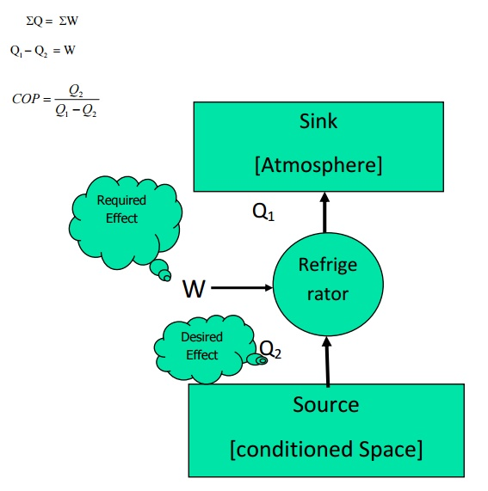
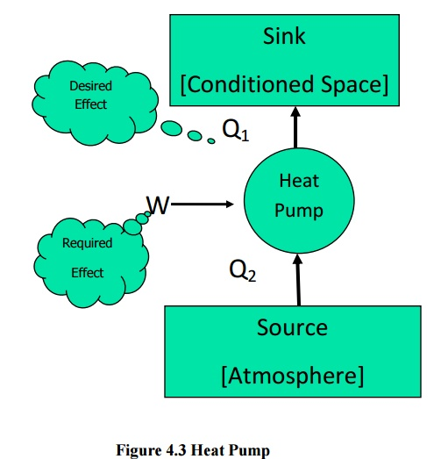
Similarly for a heat pumps (Figure 4.3)
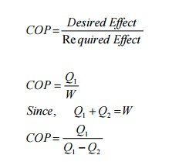

Equivalence of Kelvin-Planck and Clausius Statements
The Clausius and Kelvin-Planck statements of the second law are entirely equivalent. This equivalence can be demonstrated by showing that the violation of either statement can result in violation of the other one.
Referring to Figure 4.4(a) the device marked Clausius violator is pumping Q₁ amount of heat from a low temperature reservoir at T₁ to a high temperature reservoir at T₂ without the aid of any external agency. This is an impossible arrangement.
If such an arrangement is possible it would also violate Kelvin-Planck statement. Let a heat engine operating between the same reservoirs at T₂ and T₁ take in Q₂ as heat input at T₂. It converts a part of this heat into work and rejects heat Q₃to the sink at T₁. Since the Clausius violator is rejecting the same quantity Q₂at T₂, it can be supplied directly into the heat engine so that the reservoir at T₂ can be eliminated. This combination as shown in Figure 4.4 (b) is producing continuous work with a single reservoir at T₁. Hence it violates the Kelvin-Planck statement.
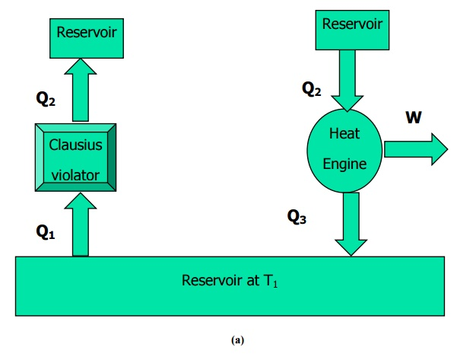
Figure 4.4 Illustration of the equivalence of Clausius and Kelvin-Planck’s statemen
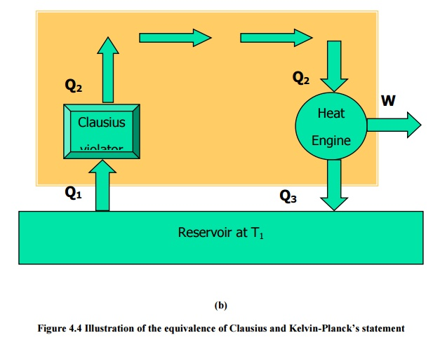
Referring to Figure 4.5 a Kelvin-planck violator is converting all heat Q_{H} taken from the reservoir at T_{H} into work. If such an impossible heat engine is assumed to exist it will violate the Clausius statement. Consider a refrigerator pumping Q_{L} heat from the low temperature reservoir at T_{L} to the reservoir at higher temperature T_{H}. Combined with the Kelvin-Planck violator, the arrangement is pumping Q_{L} heat from T_{L} to T_{H}, without any external agency. Hence it violate the Clausius statement.
ENTROPY
The first law of thermodynamics deals with the property energy and the conservation of energy. The second law introduced in the previous chapter, leads to the definition of a new property called entropy. Entropy is defined in terms of a calculus operation, and no direct physical picture of it can be given. In this chapter, Clausius inequality, which forms the basis for the definition of entropy will be discussed first. It will be followed by the discussion of entropy changes that take place during various processes for different working fluids. Finally, the reversible steady-flow work and the isentropic efficiencies of various engineering devices such as turbine and compressors will be discussed.
The Clausius Inequality
Consider two heat engines operating between two reservoirs kept at temperature T_{H} and T_{L} as shown in the Figure 5.1. Of the two heat engines, one is reversible and the other is irreversible.
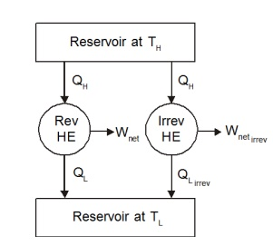
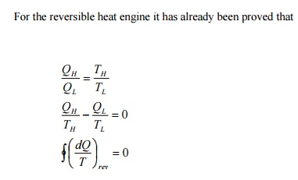
As discussed earlier, the work output from the irreversible engine should be less than that of the reversible engine for the same heat input Q_{H}. Therefore Q_{L,Irrev} will be greater than Q_{L,Rev} . Let us define
Q_{L, Irrev} =Q_{L, Rev} +Dq
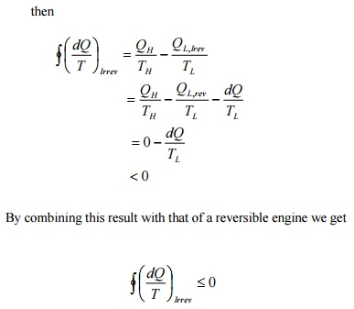
This is known as Clausius inequality.
Clausius inequality forms the basis for the definition of a new property known as entropy.
Consider a system taken from state 1 to state 2 along a reversible path A as shown in Figure 5.2. Let the system be brought back to the initial state 1 from state 2 along a reversible path B. Now the system has completed one cycle. Applying Clausius inequality we get

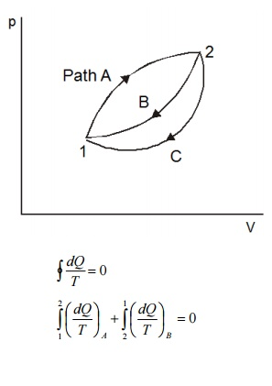
Instead of taking the system from state2 to state1 along B, consider another reversible path C. Then for this cycle 1-A-2-C-1, applying Clausius inequality :
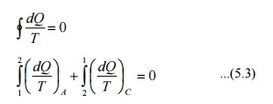
Comparing 5.2 & 5.3
Hence, it can be concluded that the quantity is a point function, independent of the path followed. Therefore it is a property of the system. Using the symbol S for entropy we can write
upon integration we get
For a reversible process.
Temperature - Entropy diagram
In a T-s diagram consider a strip of thickness ds with mean height T as shown in Figure 5.4. Then Tds gives the area of the strip.
For a reversible process the elemental heat transfer
dQ =Tds =Area of the strip
To get the total heat transfer the above equation should be integrated between the limits 1 and 2, so that, we get
This is equivalent to the area under a curve representing the process in a T-S diagram as shown in the Fig 5.4.
Note: For an isothermal process S₂ −S₁ =.
For reversible adiabatic process S₂ −S₁ =0.
Change in Entropy
a) Solids and Liquids
Change in entropy
Where dq =du + pdv
For solids and liquids
pdv = 0
Where c- is the specific heat
b) For ideal gases change in entropy
Substituting
du =C_{v} dT
We get ,Upon integration
Substituting dh €=C_{p} dT
and We get Upon integration
Principle of Increase in Entropy
Applying Clausius inequality,
For an isolated system undergoing a process
Consider a system interacting with its surroundings. Let the system and its surroundings are included in a boundary forming an isolated system. Since all the reactions are taking place within the combined system, we can express
or
Whenever a process occurs entropy of the universe (System plus surroundings) will increase if it is irreversible and remain constant if it is reversible. Since all the processes in practice are irreversible, entropy of universe always increases
ie., (Δs)_{universe}>0
This is known as principle of increase of entropy.
Adiabatic Efficiency of Compressors and Turbines
In steady flow compressors and turbines reversible adiabatic process is assumed to be the ideal process. But due to the irreversibilities caused by friction between the flowing fluid and impellers, the process is not reversible though it is adiabatic. Percentage deviation of this process from the ideal process is expressed in terms of adiabatic efficiency.
(a) Compressors :
Since compressors are work consuming devices actual work required is more than ideal work. For compressors handling ideal gases
(b) Turbines :
In turbine due to irreversibilities the actual work output is less than the isentropic work.
AVAILABLE ENERGY, AVAILABILITY AND IRREVERSIBILITY
From second law of thermodynamics we found that complete conversion of heat into work is not possible in a continuous process. Also it has been proved that the most efficient cycle to produce work is a reversible power cycle (Carnot cycle). Even in carnot cycle, the efficiency of conversion can never be
unity and hence to establish a comparison of the work-energy conversion in actual processes, the maximum theoretical work obtainable with respect to some datum must be determined. This chapter is dedicated for this objective.
Available and Unavailable Energy
The energy content of a system can be divided into two parts
• Available energy, which under ideal conditions may be completely converted into work
• Unavailable energy which is usually rejected as waste.
Consider Q units of heat energy available at a temperature T. Available part of energy can be obtained by assuming that the heat is supplied to a Carnot engine. Work obtained from the carnot engine
quantities can be represented as shown in the fig 6.1. The term T₀ is the ambient temperature. Hence it can be concluded that the available and unavailable part of energy content of a system depends on the ambient conditions also.
Reversible Work In A Non-flow Process
From first law of thermodynamics
Q_{sys} −W=U₂−U₁ ...6.1
From second law of thermodynamics for a reversible process
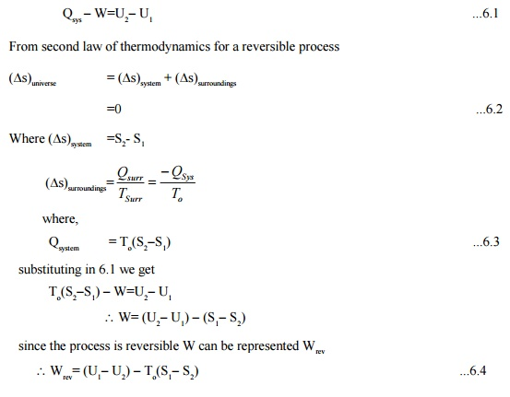
This is also the maximum work in the process.
For a closed system, when undergoing change in volume, the work done against the atmospheric pressure:
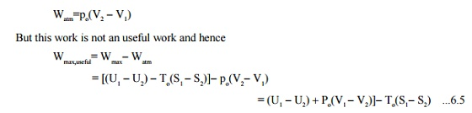
Reversible Work In A Steady-state Control Volume
Steady flow energy equation for a constant volume is
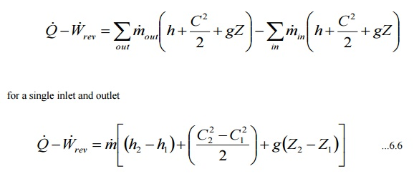
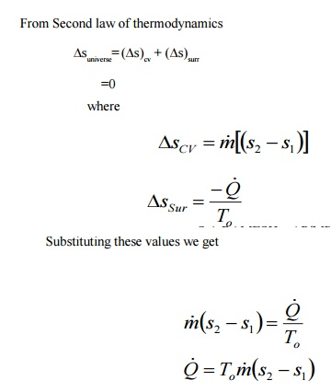
From eqn 6.6 neglecting kinetic and potential energy changes
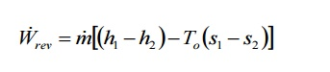
Availability
The maximum useful work that can be obtained from the system such that the system comes to a dead state, while exchanging heat only with the surroundings, is known as availability of the system. Here the term dead state means a state where the system is in thermal and mechanical equilibrium with the surroundings.
Therefore for a closed system availability can be expressed as
φ=(U −U_{o} )+p_{o} (V −V_{o} )−T_{o} (S−S_{o} )
similarly for an open system
ψ=(H −H_{o} )−T_{o} (S−S_{o} )
In steady flow systems the exit conditions are assumed to be in equilibrium with the surroundings. The change in availability of a system when it moves from one state to another can be given as:
or a closed system
φ₁−φ₂ =(U₁ −U ₂ )+p_{o} (V₁ −V₂ )−T_{o} (S₁ −S₂ ₎ ...6.10
for an open system
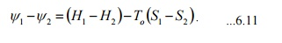
Availability Change Involving Heat Exchange with Reservoirs
Consider a system undergoing a change of state while interacting with a reservoir kept at T_{R} and atmosphere at pressure p_{o} and temperature T_{o}. Net heat transfer to the system
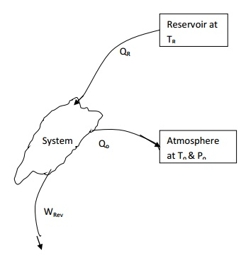
Q_{net}= QR-QO.
From first law of thermodynamics
Q_{net}- W_{rev}=U2-U1 ...6.12
From second law of thermodynamics, assuming the process to be reversible
(Δs)_{Res}+(Δs)_{atm}+(Δs)_{sys}=0
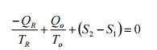
The negative sign for Q_{R} shows that the heat is removed from the reservoir.
By rearranging We get
Net heat transferred
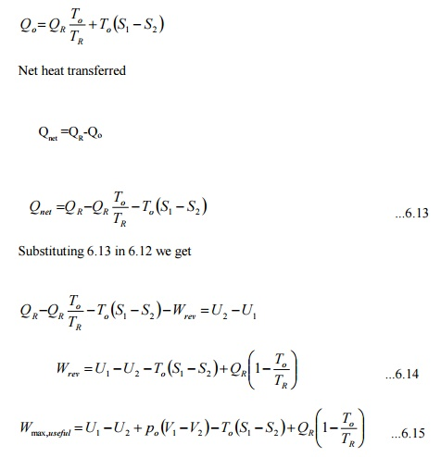
Irreversibility

Work obtained in an irreversible process will always be less than that of a reversible process. This difference is termed as irreversibility (i.e) the difference between the reversible work and the actual work for a given change of state of a system is called irreversibility.

I=W_{rev} − W_{act}
Let a stationary closed system receiving Q kJ of heat is giving out W_{act} kJ of work. From first law of thermodynamics.

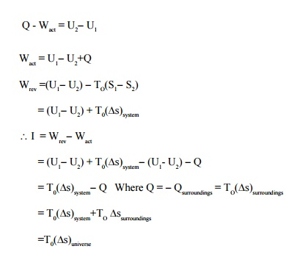
Since (Δs)_{universe} will be positive for an irreversible flow, irreversibility will be zero for a reversible process and will never be negative
I ≥0 .
Similarly for a steady flow system
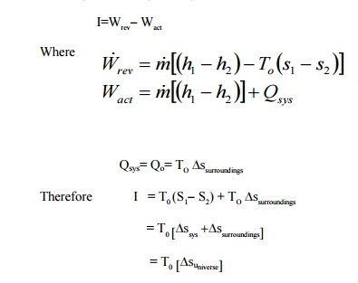
REAL GAS
Real gas, as opposed to a Perfect or Ideal Gas, effects refers to an assumption base where the following are taken into account:
•Compressibility effects
•Variable heat capacity
•Van der Waals forces
•Non-equilibrium thermodynamic effects
•Issues with molecular dissociation and elementary reactions with variable composition.
For most applications, such a detailed analysis is "over-kill" and the ideal gas approximation is used. Real-gas models have to be used near condensation point of gases, near critical point, at very high pressures, and in several other less u
VAN DER WAALS MODELISATION
Real gases are often modeled by taking into account their molar weight and molar volume
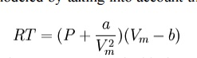
Where P is the pressure, T is the temperature, R the ideal gas constant, and Vm the molar volume. a and b are parameters that are determined empirically for each gas, but are sometimes estimated from their critical temperature (Tc) and critical pressure (Pc) using these relations:
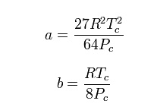
REDLICH–KWONG MODELISATION
The Redlich–Kwong equation is another two-parameters equation that is used to modelize real gases. It is almost always more accurate than the Van der Waals equation, and often more accurate than some equation with more than two parameters. The equation is
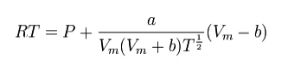
THERMODYNAMICS RELATIONS
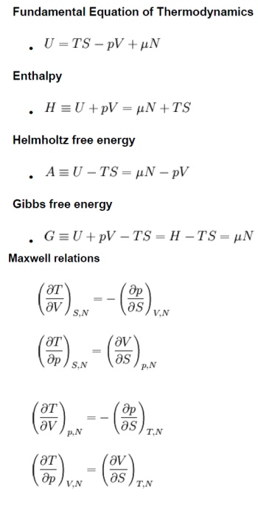
Maxwell relations.
The Maxwell’s equations relate entro properties p,v and T for pure simple compressible substances.
From first law of thermodynamics,
Q = W + U
Rearranging the parameters
Q = U + W since [ds = , W = pdv ]
Tds = du +pdv
du = Tds –pdv ----------- (1)
We know that, h = u + pv
dh = du + d(pv)
= du + vdp + pdv ----------- (2)
Substituting the value du in equation (2),
dh = Tds + pdv + vdp –pdv
dh = Tds + vdp ----------- (3)
By Helmotz’s function,
a = u –Ts
da = du –d(Ts)
= du –Tds –sdT ----------- (4)
Substituting the values of du in equation (4),
da = Tds –pdv –Tds –sdT
T = –pdv –sdT ----------- (5)
By Gibbs functions,
G = h –Ts
dg = dh –d(Ts)
dg = dh –Tds –sdT ----------- (6)
Substituting the value of dh in equation (6),
So, dg becomes
dg = Tds + vdp –Tds –sdT
dg = vdp –sdT ----------- (7)
By inverse exact differential we can write equation (1) as, du = Tds –pdv
----------- (8)
Similarly, equation (3) can be written as, dh = Tds + vdp
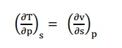
Similarly, equation (5) can be written as,
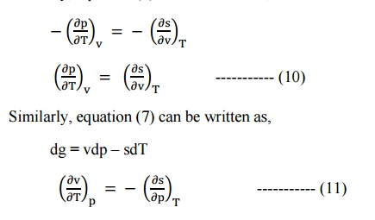
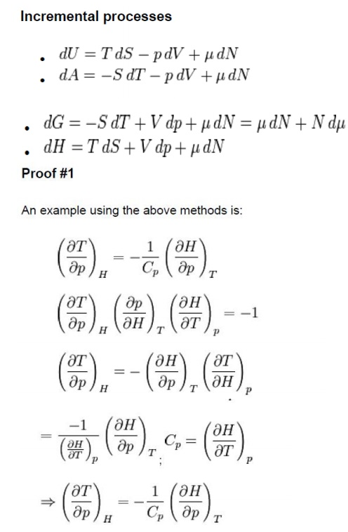
Tds relations in terms of temperature and pressure changes and temperature and volume changes.
The entropy (s) of pure substance can be expressed as a function of temperature (T) and pressure (p).
We know that,
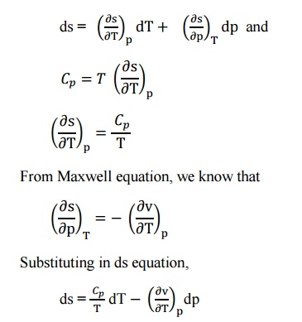
This is known as the first form of entropy equation or the first Tds equation. By considering the entropy of a pure substance as a function of temperature and specific volume,
i.e. s = f(T,v)
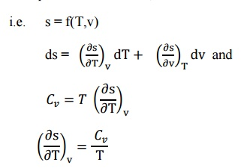
From the Maxwell Equations, we know that
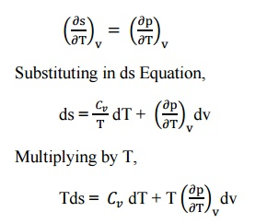
This is known as the second form of entropy equation or the second Tds equation
The third law of thermodynamics states that:
“The entropy of all the perfect crystalline solids is zeros at absolute zero temperature”. The third law of thermodynamics is also referred to as Nernst law. It provides the basis for the calculation of absolute entropies of the substances.
Mathematically,
Lim_{T –>0} S = 0
If the entropy is zero at temperature T = o, then this law states that the absolute entropy S_{ab} of a substance at temperature T and pressure P is expressed by the followingexpression:
S_{ab}T∫₀ (δQ) _{rev} / T
Importance of third law of thermodynamics is given below:
1) It helps in calculating the thermodynamic properties.
2) It is helpful in measuring chemical affinity. Because of this it is known as Nernst theorem.
3) It explains the behavior of solids at very low temperature.
4) It helps in analyzing chemical and phase equilibrium.

