UNIT - II
JOULES EXPERIMENT:

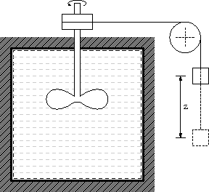

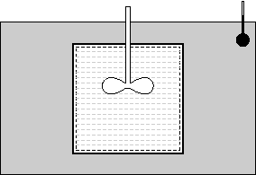

It is well known that heat and work both change the energy of a system. Joule conducted a series of experiments which showed the relationship between heat and work in a thermodynamic cycle for a system. He used a paddle to stir an insulated vessel filled with fluid. The amount of work done on the paddle was noted (the work was done by lowering a weight, so that work done = mgz). Later, this vessel was placed in a bath and cooled. The energy involved in increasing the temperature of the bath was shown to be equal to that supplied by the lowered weight. Joule also performed experiments where electrical work was converted to heat using a coil and obtained the same result.
THE FIRST LAW OF THERMODYNAMICS
Energy interactions between a system and its surroundings across the boundary in the form of heat and work have been discussed separately in the previous chapter. So far, no attempt has been made to relate these interactions between themselves and with the energy content of the system.
First law of thermodynamics, often called as law of conservation of energy, relating work, heat, and energy content of the system will be discussed in detail in this chapter.
First Law of Thermodynamics
In its more general form, the first law may be stated as follows
“When energy is either transferred or transformed, the final total energy present in all forms must precisely equal the original total energy”.
It is based on the experimental observations and can not be proved mathematically. All the observations made so far, confirm the correctness of this law.

First Law of Thermodynamics for a Closed System Undergoing a Process
First law can be written for a closed system in an equation form as
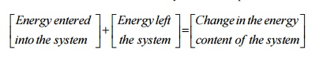
For a system of constant mass, energy can enter or leave the system only in two forms namely work and heat.
Let a closed system of initial energy E₁ receives Q units of net heat and gives out W units of work during a process. If E₂ is energy content at the end of the process as given in Figure 3.1, applying first law we get
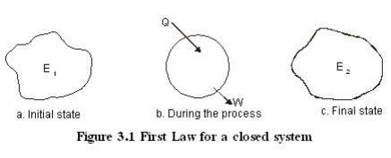
Q −W =(E2 €−E1 )
Where the total energy content
Internal Energy Ε + Kinetic= energy + Potential energy
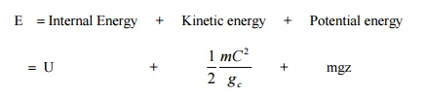
The term internal energy usually denoted by the letter U is the energy due to such factors as electron spin and vibrations, molecular motion and chemical bond.
Kinetic energy term is due to the system movement with a velocity C. For stationary systems this term will be zero. The term g_{c} is a constant of value 1 in SI unit. It will be dropped here after since SI unit is followed throughout the book.
Potential energy term is due to the location of the system in the gravitational field. It remains constant for a stationary system. The unit of energy in SI is kJ.
The Thermodynamic Property Enthalpy
Consider a stationary system of fixed mass undergoing a quasi-equilibrium constant pressure process
Applying first law
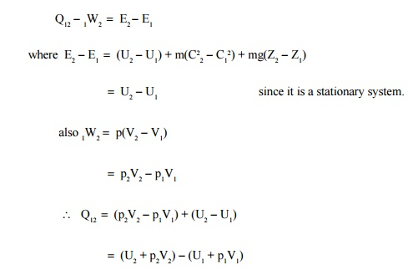
The terms within brackets are all properties depending on the end states. This combination of properties may be regarded as a single property known as enthalpy. It is usually denoted by the letter H.
ie H -U + pV
(or) h -u + pv
Where h is specific enthalpy in kJ/kg
u is specific internal energy in kJ/kg and
v is specific volume in m³/kg

Flow Energy
Flow energy is defined as the energy required to move a mass into the a control volume against a pressure. Consider a mass of volume V entering into a control volume as given in the Figure 3.2 against a pressure p.
The Flow energy =Work done in moving the mass
=Force ×distance
=pA ×dx
=p ×(Adx)
=pV
Therefore, Enthalpy =Internal energy + Flow energy
First Law of Thermodynamics for a Control Volume
Mass simultaneously entering and leaving the system is a very common phenomenon in most of the engineering applications. Control volume concept is applied to these devices by assuming suitable control surfaces.
To analyze these control volume problems, conservation of mass and energy concepts are to be simultaneously considered.
Energy may cross the control surface not only in the form of heat and work but also by total energy associated with the mass crossing the boundaries. Hence apart from kinetic, potential and internal energies, flow energy should also be taken into account.
Conservation of mass
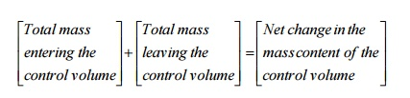
Conservation of energy
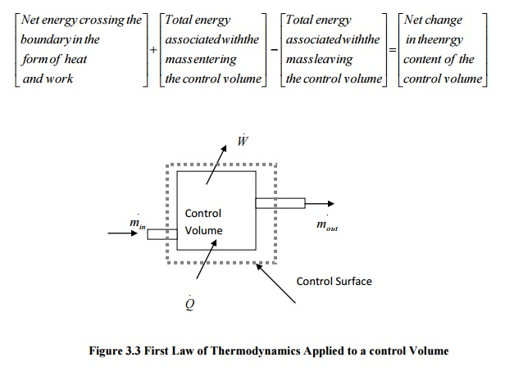
As a rate equation, it becomes
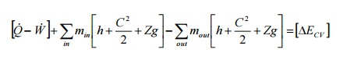
The Steady-state Flow Process
When a flow process is satisfying the following conditions, it is known as a steady flow process.
1. The mass and energy content of the control volume remains constant with time.
2. The state and energy of the fluid at inlet, at the exit and at every point within the control volume are time independent.
3. The rate of energy transfer in the form of work and heat across the control surface is constant with time.
Therefore for a steady flow process
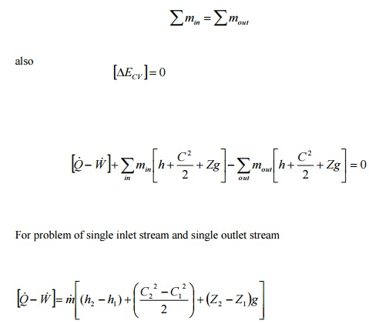
This equation is commonly known as steady flow energy equation (SFEE).
Application of SFEE
SFEE governs the working of a large number of components used in many engineering practices. In this section a brief analysis of such components working under steady flow conditions are given and the respective governing equations are obtained.
Turbines
Turbines are devices used in hydraulic, steam and gas turbine power plants. As the fluid passes through the turbine, work is done on the blades of the turbine which are attached to a shaft. Due to the work given to the blades, the turbine shaft rotates producing work.
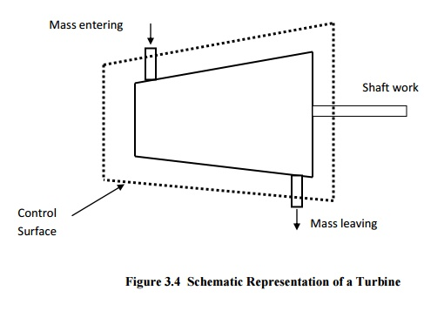

General Assumptions
1. Changes in kinetic energy of the fluid are negligible
2. Changes in potential energy of the fluid are negligible.
[Q−W ]=m[(h₂ −h₁ )]
Compressors
Compressors (fans and blowers) are work consuming devices, where a low-pressure fluid is compressed by utilising mechanical work. Blades attached to the shaft of the turbine imparts kinetic energy to the fluid which is later converted into pressure energy.
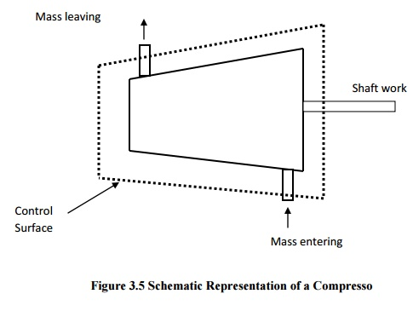

General Assumptions
1. Changes in the kinetic energy of the fluid are negligible
2. Changes in the potential energy of the fluid are negligible
Governing Equation
Applying the above equations SFEE becomes
[Q−W ]=m[(h₂ −h₁ )]
Pumps
Similar to compressors pumps are also work consuming devices. But pumps handle incompressible fluids, whereas compressors deal with compressible fluids.
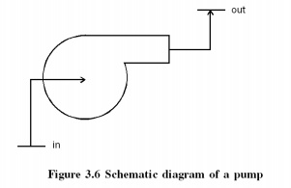
General Assumptions
1. No heat energy is gained or lost by the fluids;
2. Changes in kinetic energy of the fluid are negligible.

Governing Equation
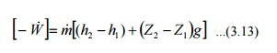
As the fluid passes through a pump, enthalpy of the fluid increases, (internal energy of the fluid remains constant) due to the increase in pv (flow energy). Increase in potential energy of fluid is the most important change found in almost all pump applications.
Nozzles

Nozzles are devices which increase the velocity of a fluid at the expense of pressure. A typical nozzle used for fluid flow at subsonic* speeds is shown in Figure 3.7.

General Assumptions
1. In nozzles fluids flow at a speed which is high enough to neglect heat lost or gained as it crosses the entire length of the nozzle. Therefore, flow through nozzles can be regarded as adiabatic. That is =0.
2. There is no shaft or any other form of work transfer to the fluid or from the fluid; that is =0.
Changes in the potential energy of the fluid are negligible.
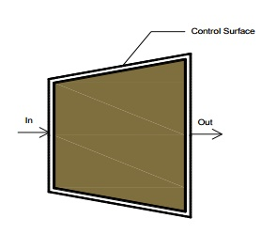
Governing Equation
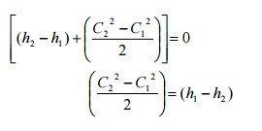
Diffusers
Diffusers are (reverse of nozzles) devices which increase the pressure of a fluid stream by reducing its kinetic energy.
General Assumptions
Similar to nozzles, the following assumptions hold good for diffusers.
1. Heat lost or gained as it crosses the entire length of the nozzle. Therefore, flow through nozzles can be regarded as adiabatic. That is Q = 0
2. There is no shaft or any other form of work transfer to the fluid or from the fluid; that is = 0.
3. Changes in the potential energy of the fluid are negligible.
Governing Equation
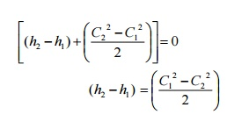
Heat Exchangers
Devices in which heat is transferred from a hot fluid stream to a cold fluid stream are known as heat exchangers.
Throttling
A throttling process occurs when a fluid flowing in a line suddenly encounters a restriction in the flow passage. It may be
• a plate with a small hole as shown in Figure 3.10 (a)
• a valve partially closed as shown in Figure 3.10 (b)
• a capillary tube which is normally found in a refrigerator as shown in Figure 3.10 (c)
a porous plug as shown in Figure 3.10 (d)
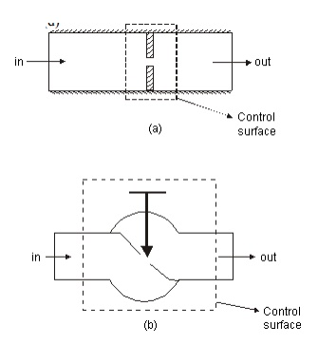
First Law for a Cyclic Process
In a cyclic process the system is taken through a series of processes and finally returned to its original state. The end state of a cyclic process is identical with the state of the system at the beginning of the cycle. This is possible if the energy level at the beginning and end of the cyclic process are also the same. In other words, the net energy change in a cyclic process is zero.
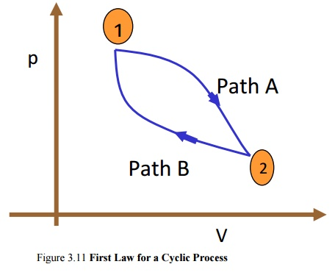

Figure 3.11 First Law for a Cyclic Process
Consider a system undergoing a cycle consisting of two processes A & B as shown in Figure 3.11 Net energy change
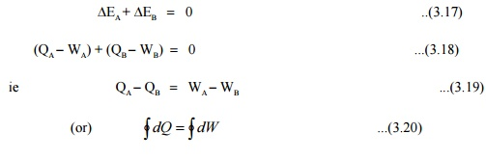
Hence for a cyclic process algebraic sum of heat tranfers is equal to the algebraic sum of work transfer.
This was first proved by Joule, based on the experiments he conducted between 1843 and 1858, that were the first quantitative analysis of thermodynamic systems.

Energy is a property of a system
Consider a system undergoing a process from state1 to state2 along path A as shown in Figure 3.12. Let the system be taken back to the initial state 1 along two possible paths B and C. Process A, combined separately with process B and C forms two possible cycles.
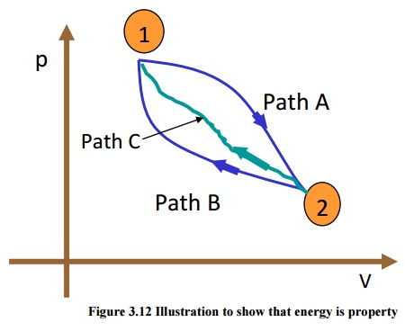
Cycle 1A2B1
Q_{A} +Q_{B} =[W_{A} +W_{B}]
Q_{A} −W_{A} =−[Q_{B} −W_{B}]
E = − ΔE Δ...(3.21)
Cycle 1A2C1
Q_{A} +Q_{C} =[W_{A} +W_{C}]
Q_{A} −W_{A} =−[Q_{C} −W_{C}]
ΔE_{A} = - ΔE_{C} ...(3.22)
From Equation (3.21) and (3.22) it can be concluded that energy change in path B and path C are equal and hence energy is a point function depending only on the end states.
It has been already shown that all the properties are point functions and hence energy is also a property of the system.
Specific Heat at Constant Volume and at Constant Pressure
Specific heat at constant volume of a substance is the amount of heat added to rise the temperature of unit mass of the given substance by 1 degree at constant volume
From first law for a stationary closed system undergoing a process
dQ =pdV + dU or dq =pdv + du
For a constant volume process
dQ =dU or dq =du
du =C dT ...(3.23)
Similarly specific heat at constant pressure is the quantity of heat added to rise the temperature of unit mass of the given substance by 1 degree at constant pressure
Where dQ =pdV + dU
=pdV + d(H −PV)

dQ = €pdV + dH −Vdp −pdV dQ =dH −Vdp

For a constant pressure process dp =0
Hence dQ =dH or dq =dh
or dh =C_{p}dT
• The difference in specific heats C_{p} −C_{v} =R €
• The ratio of sp. heat γ =C_{p}/C_{v}
• Since h and u are properties of a system, dh =C_{p}dT and du=C_{v}dT, for all processes.
Work Interaction in a Reversible Steady Flow Process
In a steady flow process the work interaction per unit mass between an open system and the surroundings can be expressed in differential form as
dq - dw - dh + CdC + gdz
dw - dq - (dh + CdC +gdz)
dq - du + pdv (or) dh - vdp
dw - dh - vdp - (dh + CdC + gdz)
- vdp - (CdC + gdz)
For a stationary
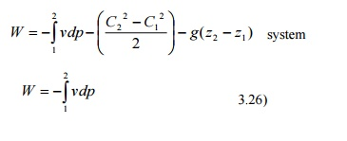
First law for an open system under unsteady flow conditions
Many processes of engineering interest involve unsteady flow, where energy and mass
content of the control volume increase or decrease.
Example for such conditions are:
1) Filling closed tanks with a gas or liquid.
2) Discharge from closed vessels.
3) Fluid flow in reciprocating equipments during an individual cycle.
To develop a mathematical model for the analysis of such systems the following assumptions are made.instant of time the state is uniform throughout the entire control volume.
3) The state of the mass crossing each of the areas of flow on the control surface is constant with time although the mass flow rates may be time varying.
Unlike in steady flow system, duration of observation Δt plays an important role in transient analysis. Let mass of the working fluid within the control volume before and after the observation be m₁ and m₂ respectively. Applying mass balance we get,
(m₂ −m₁)_{CV} =Σm_{i} −Σm₀ ...(3.27)
Where €∑m_{i} is the mass entered the control volume during the interval Δt seconds.
∑m₀ is the mass left the control volume during the interval Δt seconds.
By applying energy balance we get,
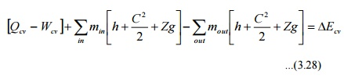
Where ECV is the change in energy content of the control volume in Δt seconds.
Q_{CV} is the heat energy entered into the control volume in Δt seconds.
W_{CV} is the work energy left the control volume in Δt seconds.
h_{i} & h₀ are specific enthalpy of the inlet and outlet streams respectively.
are the kinetic energy of the inlet and outlet streams respectively.
Z_{i}g & Z₀g are the potential energy of inlet and outlet streams respectively.
Perpetual Motion Machine – I
An engine which could provide work transfer continuously without heat transfer is known as perpetual motion machine of first kind. It is impossible to have such an engine as it violates first law of thermodynamics.

