UNIT - 1
BASIC CONCEPTS AND DEFINITIONS

Thermodynamics is the science of energy transfer which deals with the relations among heat, work and properties of systems.

The name ‘thermodynamics’ is derived from the Greek words therme, meaning ‘heat’ and dynamis meaning power. Thus, thermodynamics is basically the study of heat and power.

Application Area of Thermodynamics

Energy transfer is present in almost all the engineering activities. Hence, the principles of thermodynamics are playing vital role in designing all the engineering equipments such as internal combustion engines, rockets, jet engines, thermal and nuclear power plants, refrigerators etc.

Statistical and Classical Thermodynamics

Statistical Thermodynamics is microscopic approach in which, the matter is assumed to be made of numerous individual molecules. Hence, it can be regarded as a branch of statistical mechanics dealing with the average behaviour of a large number of molecules.

Classical thermodynamics is macroscopic approach. Here, the matter is considered to be a continuum without any concern to its atomic structure.

Consider a gas in a container. Pressure exerted at the wall of the container is the average force per unit area due to the collision of the gas molecules on the wall surface. To determine this pressure, we need not know the behaviour of individual molecules of the gas. This approach is macroscropic approach. However, the results obtained from macroscopic and statistical study of matter.

Thermodynamic Systems and Surroundings

A Thermodynamic system is defined as a quantity of matter or a region in space whose behaviour is being investigated.

Everything external to the system is defined as surroundings. In its usual context the term‘surroundings’ is restricted to the regions in the immediate vicinity which has a detectable influence on the system.

Boundary is the surface which separates the system from its surroundings. It may be fixed or moving and real or imaginary.

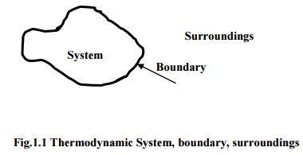
Types of Thermodynamic Systems

There are three types of thermodynamic systems :

a) Closed System

b) Open System and

c) Isolated System

In closed system, attention is focused on a fixed mass. Energy in the form of heat and work (The terms heat and work will be defined in the chapter 2.) can cross the boundary of the system. But there is no mass flow across the boundary. Hence, the possibility of change in volume is always there in the closed systems.
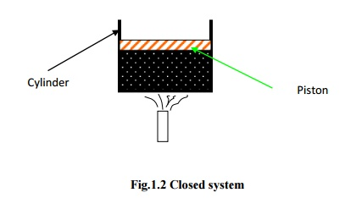
In open system, both matter and energy can cross the boundary. Here, the behaviour of a fixed region in space called control volume is investigated and hence, there is no change in volume. The surface of the control volume is known as control surface.
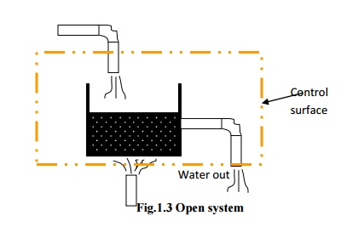
A system that exchanges neither energy nor matter with its surroundings is known as an isolated system.
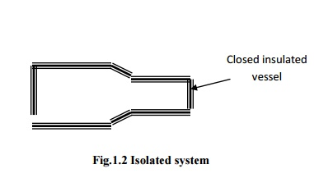
BASIC CONCEPTS AND DEFINITIONS

Thermodynamics is the science of energy transfer which deals with the relations among heat, work and properties of systems.

The name ‘thermodynamics’ is derived from the Greek words therme, meaning ‘heat’ and dynamis meaning power. Thus, thermodynamics is basically the study of heat and power.

Application Area of Thermodynamics

Energy transfer is present in almost all the engineering activities. Hence, the principles of thermodynamics are playing vital role in designing all the engineering equipments such as internal combustion engines, rockets, jet engines, thermal and nuclear power plants, refrigerators etc.
Thermodynamic Properties

In all thermodynamic problems energy transfer to or from the system is observed. To receive, store and deliver energy a working substance is present within the system. The characteristics which can be used to describe the condition of the system are known as properties.

Thermodynamic properties are classified into two categories : intensive and extensive. Intensive properties are independent of quantity of matter or mass whereas extensive properties are dependent on mass
Consider a vessel containing air. If a membrane is assumed to be introduced into the vessel, such that it is divided into two equal parts. The properties remaining unchanged such as pressure and temperature are intensive properties. Volume of air will be reduced to half of its initial value. Hence, it is an extensive property.
BASIC CONCEPTS AND DEFINITIONS

Thermodynamics is the science of energy transfer which deals with the relations among heat, work and properties of systems.
The name ‘thermodynamics’ is derived from the Greek words therme, meaning ‘heat’ and dynamis meaning power. Thus, thermodynamics is basically the study of heat and power.

Application Area of Thermodynamics

Energy transfer is present in almost all the engineering activities. Hence, the principles of thermodynamics are playing vital role in designing all the engineering equipments such as internal combustion engines, rockets, jet engines, thermal and nuclear power plants, refrigerators etc.

Thermodynamic State and Equilibrium

When a system does not undergo any change, all the properties have fixed values. This condition is known as a thermodynamic state.
The word equilibrium means balance. An equilibrium state of a thermodynamic system is a state that can not be changed without any interaction with its surroundings. The factors that cause a change without any interactions with its surroundings are:

1. Pressure difference
2. Temperature difference
3. Chemical reaction

If a system is balanced in all respects, it is in a state of thermodynamic equilibrium. Balanced in all respects means :

• There should not be any temperature difference within the system, so that the system is thermally balanced.
• No pressure difference exists between any two points within the system (Neglecting gravitational effects) and between the system and surroundings, so that it is mechanically balanced.
• No chemical reaction is taking place, so that it is chemically balanced.
• If two phases are involved, mass of each phase remains constant so that phase equilibrium is achieved.

Hence, for a system in a state of thermodynamic equilibrium, there is no change in any macroscopic property.

Processes and Cycles

When a system is taken from one equilibrium state to another, the change is known as process. The series of intermediate states through which a system passes during a process is called the path of the process. If all these intermediate states are equilibrium states, the process is known as quasi equilibrium or quasi-static process.

Consider a certain quantity of gas taken in a frictionless piston cylinder arrangement as shown in Fig 1.5. The system is in thermodynamic equilibrium so that there is no unbalanced force acting on piston.
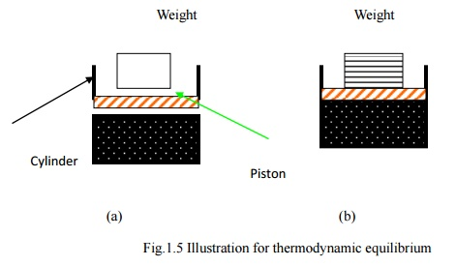
Fig.1.5 Illustration for thermodynamic equilibrium
The moment the weight is removed from the piston, mechanical equilibrium does not exist and as a result the piston is moved upward until mechanical equilibrium is restored again. Therefore the actual process occurs only when equilibrium does not exist.

As shown in Fig.1.5.a, if the entire weight on the piston is removed at once, the deviation from the equilibrium is high and the expansion is rapid. For such a process the intermediate states are not equilibrium states and hence the process would be non-quasi-equilibrium.

If the weight is assumed to be made of a large number of small pieces as shown in Fig.1.5.b and taken off one by one, the deviation from equilibrium is less. The process could be considered quasi-equilibrium.

A thermodynamic system is said to undergo a cycle, if it is taken through a number of processes such that, the final state of the last process is identical with the initial state of the first process in all respects. For cycles net change in any property is zero.

Point and Path Functions

Thermodynamic functions are classified into two categories namely point and path functions. Point functions are those for which the change depends on only the end states and not on the path followed. Hence point functions are inexact differentials

Path functions are those for which the change depends not only on the end states but also on the path followed. Hence path functions are exact differentials

In can be observed the change in any property during a process depends only on end states. Therefore all the properties are point functions.
.
To demonstrate path and point functions, let us consider two stations A and B on a hill as shown in the Fig.1.6. While moving from station A to station B, let the distance traveled and increase in height from the mean sea level are observed. Distance traveled in path 1 is different from that in path 2. Hence it may be regarded as path function. But the change in height is same in both path 1 and path 2, therefore it is a point function.
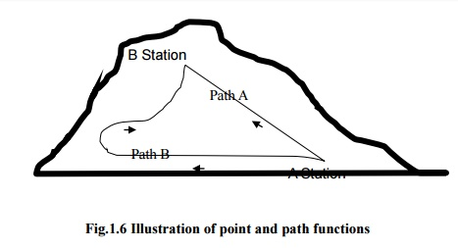
State Postulate and Property Diagrams
As mentioned earlier, properties are meant for describing the state of a system. To fix a state, all the properties need not be specified. If any two independent intensive properties are specified, rest of the properties automatically assumes certain values. This is known as state postulate.
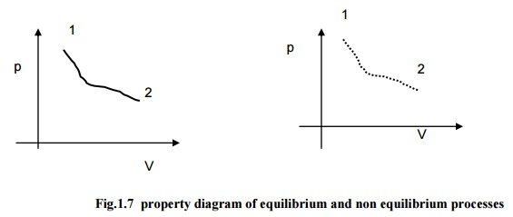
Fig.1.7 property diagram of equilibrium and non equilibrium processes
Consider pressure and specific volume (Volume per unit mass) are the two independent, intensive properties, describing the state of a compressible system. On a p-V diagram the state will assume a point as represented in the Fig.1.7(a). Let the system be taken to another state such that all the intermediate states are equilibrium states. The curve connecting the initial state and final state, passing through all the intermediate states is indicating the path of the process. In non-quasi-equilibrium process as the intermediate status can not be defined, the path is denoted by dashed line as given in Fig.1.7(b)
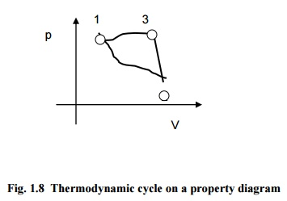
Fig.1.8 indicates a system undergoing a cycle consisting of three quasi-equilibrium processes.

Temperature and Zeroth Law

Maxwell defined the temperature of a system as its Thermal state considered with reference to its ability to communicate heat to other bodies.

When a hot body is brought into contact with a cold body, the hot body becomes cooler and the cold body becomes hotter. After sufficient time, the temperature of both the bodies will be equal. At that point, the two bodies are said to have reached thermal equilibrium.

Consider three bodies A, B and C. If the bodies A and B are in thermal equilibrium with C when brought into contact separately, they are also in thermal equilibrium with each other. This concept is known as zeroth law of thermodynamics.
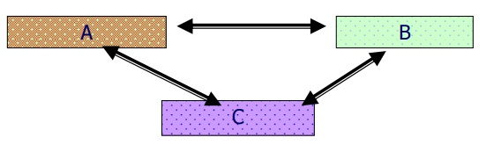
Several properties of materials are found to be varying with temperature in a predictable way. This variation is used to measure temperature. In mercury thermometers, expansion of mercury with temperature is used for temperature measurement.
Temperature Scales

Freezing point of water known as ice point and boiling point of water known as steam point are taken as the reference states for all types of temperature scales.

The various types as temperature scales in use are :

a) Celsius scale
b) Fahrenheit scale
c) Kelvin scale
d) Rankine scale

Reference state Celsius Kelvin Fahrenheit Rankine

Steam point 100 373 212 672

Ice point 0 273 32 492

Absolute Zero -273 0 -460 0

Homogeneous and Heterogeneous Systems

Matter can exist in any one of the three phases namely solid, liquid and gas. A system consisting of a single phase is known as homogeneous systems. If the matter exists in more than one phase, the system is known as heterogeneous system.
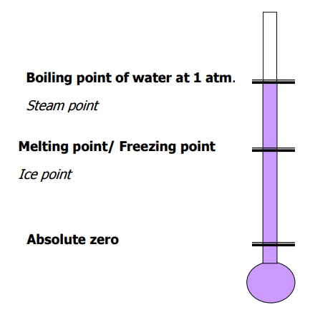
Concept of continuum

In microscopic approach the substance is assumed to be continuously distributed, ignoring the space between the molecules. This is known as continuum hypothesis.

Since the matter is treated as continuous, the density at a point can be defined as
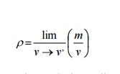
Where v’is the smallest volume for which a definite value of the ratio exists. Below the limiting value of v’, the fluctuation in average density will be high and a definite value for the ratio becomes impossible, with the mean free path* of the molecules approaching the order of magnitude of the dimension of the vessel

WORK AND HEAT

The different thermodynamic systems and their characteristics were discussed. To undergo a change of state, the system has to interact with its surroundings. Work and heat transfers across the boundaries cause these changes.

Work as Defined in Mechanics

work is done when the point of application of a force moves in the direction of the force. The product of the force and the distance moved in the direction of the force is equal to the amount of the work done.

This simple definition of work confines only to the area of mechanics and can not be extended to the more complex problems in thermodynamics. Hence a new definition should be introduced to cover mechanical as well as the other forms of work.

The Thermodynamic Definition of Work

Positive work is done by a system, during a given process, when sole effect external to the system could be reduced to the lifting of a mass.

Consider a gas expanding in a piston cylinder arrangement as given in Figure 2.1. Here no mass is actually lifted against gravity. But if the existing surroundings is fitted with an arrangement as given in the Figure 2.2, there is a possibility of lifting the mass. Hence work is said to be done by the system.
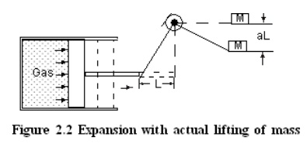
While exploring the possibility of lifting a mass the effects that are external to the system alone must be taken into account. For example, a lift with a person and a suitcase is considered as a system. If the person lifts the suitcase, it should not be taken into account, because this event occurs within the system.
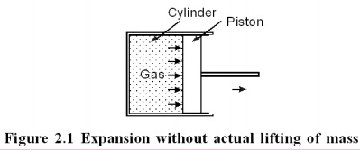
Units of Work and Power
In the international system (SI), the unit of force is Newton (N) and that of distance is metre (m). Hence the unit of work is Nm which is also given a special name Joule. In most of the applications large quantity of work is involved. Therefore kJ is commonly used.

Rate of doing work is known as power. Hence its unit is Nm/S or J/S which is again given a special name Watts(W).

Sign Convention of Work

- Work done by the system on the surroundings is considered as positive work.
- Work done on the system by the surroundings is taken as negative work.
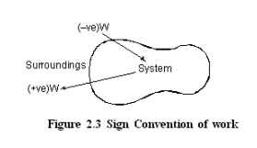
Displacement Work

Consider a piston cylinder arrangement as given in the Figure 2.4. If the pressure of the fluid is greater than that of the surroundings, there will be an unbalanced force on the face of the piston. Hence, the piston will move towards right.
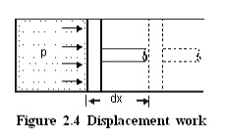

Force acting on the piston = Pressure×Area
= pA
∴ Work done = Force ×distance
= pA ×dx
= pdV
where dV - change in volume.

This work is known as displacement work or pdV work corresponding to the elemental displacement dx. To obtain the total work done in a process, this elemental work must be added from the initial state to the final state. Mathematically, .

Evaluation of Displacement Work

Constant Pressure Process

Figure 2.5 shows a piston cylinder arrangement containing a fluid. Let the fluid expands such that the pressure of the fluid remains constant throughout the process. Figure 2.6 shows the process in a p-V diagram.
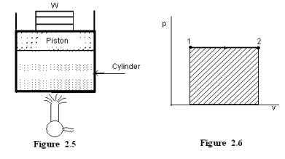
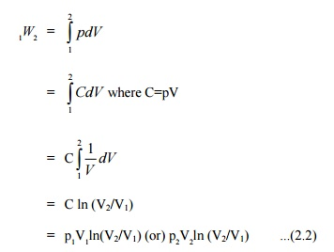
The mathematical expression for displacement work can be obtained as follows:
=p(V₂ –V₁) ...(2.1)

This expression shows that the area under a curve in a p-V diagram gives work done in the process.

Constant volume process

Consider a gas contained in a rigid vessel being heated. Since there is no change in volume, the displacement work .

Hyperbolic process

Let the product of pressure and volume remains constant at all the intermediate states of a process. In the p-V diagram it will be a hyperbola as given in Figure 2.7.
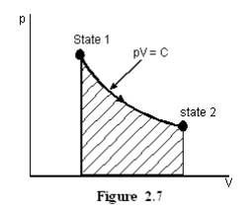
For Ideal gases when temperature remains constant, pV will be constant i.e., isothermal process are hyperbolic processes for an ideal gas.
Polytropic Process

Any process can be represented by the general form pV^{n} =constant. Based on the valve of n, the process differs as given below;For other values of n, the process is known as polytropic process. Figure 2.8 shows the polytropic processon-V coordinatesofvarious.Expression possi for displacements work for a polytropic process can be obtained as follows :
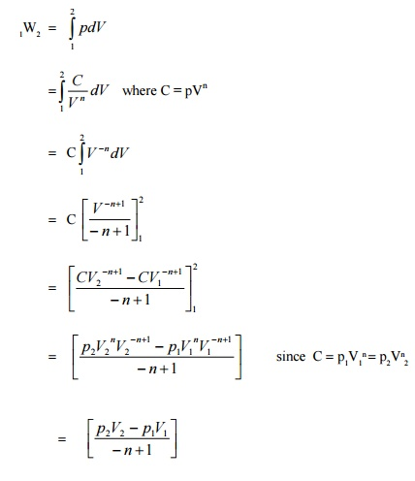
Work is a Path Function

Consider a working substance initially occupying 0.2 m³ at 1 bar as represented by state 1 in the Figure 2.9. Let the system changes its state such that the final volume is 0.05m³ and pressure 2 bar. The change of state may occur along the paths 1A2,1B2 or 1C2. As mentioned earlier, area under the curve representing the process in a p-V diagram gives the work done in the process. Comparing the area under the paths 1A2, 1B2 and 1C2, it is clear that the work done in these paths are different. Hence it can be concluded that the amount of work done is not only a function of the end states of a process, but also the path followed between the states. Therefore work is a path function.

Additivity of Work Over Processes

If a system is taken through two or more number of processes, the total work done is the sum of work done in the individual processes.

Let a system executes three processes as shown in Figure 2.10. The total work done,
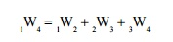

Heat

Heat is the interaction between systems which occurs by virtue of their temperature difference when they communicate.

If a system, at a given temperature is brought in contact with another system (or surroundings) at a lower temperature, it can be observed that heat is transferred from the system at the higher temperature to the system at lower temperature. This heat transfer occurs solely because of the temperature difference between the two systems. Another important aspect of the definition of heat is that a body never contains heat. Rather, heat can be identified only as it crosses the boundary. Similar to work, heat is also a form of energy transfer occurring at the boundary of the system and is a path function.

Sign Convention of Heat

▪ •Heat given into a system is positive
▪ •Heat coming out of the system is negative
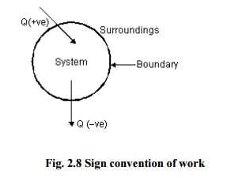
Modes of Heat Exchange

Conduction, convection and radiation are the three possible modes of heat transfer between systems and between system and its surroundings.

Conduction occurs without bulk movement of molecules. Energy transfer in conduction is due to lattice vibration and free electron movement. It is the predominant mode of heat transfer in solids.

Convection occurs with bulk movement of molecules and therefore, occurs in gases and liquids. If the bulk movement or flow is due to an external device, it is known as forced convection. In the absence of an external device the flow is due to the difference in density caused by the temperature difference. This mode is known as natural convection.

Bodies separated by a distance may exchange heat in the form of electromagnetic waves without the participation of the intervening medium. It is known as radiation. It is generally a surface phenomenon. Sometimes as in the case of gas mixtures containing carbon dioxide and water vapour it is a volume phenomenon.

ensible and Latent Heat

It is known that a substance can exists in three phases namely solid, liquid and gas. When a substance is heated or cooled temperature of the substance increases or decreases respectively unless there is any phase change. Quantity of heat added or removed to change the temperature by unit degree is known as specific heat. For solids and liquids same quantity of heat is required to cause unit degree rise for both constant pressure heating as well as constant volume heating as they are incompressible. But for gases there is appreciable difference in the quantity of heat required to cause unit difference in temperature between constant volume and constant pressure processes. Accordingly, they are known as specific heat at constant volume (C_{V}) and specific heat at constant pressure (C_{P}). Thus to increase the
temperature of m kg of the given substance by ΔT degree, amount of heat required is given by
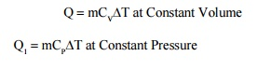
Q =mCvΔT at Constant Volume ...(2.5)
Q₁ =mC_{P}ΔT at Constant Pressure …(2.6)
If a certain single component system is undergoing phase change at constant pressure, temperature of the system remains constant during heating or cooling. Quantity of heat removed or added to cause the change of phase of unit mass of the substance is known as latent heat. For example latent heat of fusion of water is the amount of heat to be removed to solidify 1 kg of water into 1 kg of ice at a given temperature.

Let us consider a process of converting 1 kg of ice at −30°C to system to steam at 250°C at atmospheric pressure. We know that ice melts at 0°C and water evaporates at 100°C at atmospheric pressure.

For a constant rate of heating, if temperature at different instants are plotted we will get a graph as shown in Figure 2.9.
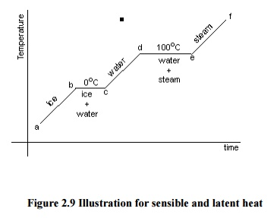
Figure 2.9 Illustration for sensible and latent heat
The total heat required can be obtained as follows:
Q = Qab + Qbc + Qcd + Qde + Qef ...(2.7)
Q_{ab} = mCice (t_{b} - t_{c}) ...(2.8)
Qbc = Latent heat of melting of ice at 0ºC
Q_{cd} = mC_{water} (t_{d} - t_{c}) ...(2.9)
Qde = Latent heat of evaporation of water at 100ºC
Qef = mC_{PSteam} (t_{f} - t_{e}) ...(2.10)
Where C_{ice} =Specific heat of ice
C_{water} = Specific heat of water

C_{PSteam} =Specific heat of steam at constant pressure

Reversible Adiabatic Process

A reversible process during which, the system and the surroundings do not exchange any heat across the boundary is known as reversible adiabatic process. For such a process, pressure and volume variation is governed by the law :
pV =constant . ..(2.11)
Where

C_{p} is the specific heat at constant pressure

C_{V} is the specific heat at constant volume

Detailed discussion on these specific heats is presented in the next chapter.

A wall which does not permit the heat flow across it is known as adiabatic wall, whereas the wall that permits the heat is known as diathermic wall. In an adiabatic process the only possible energy interaction across the boundary of the system is work transfer to or from the system.

Displacement work involved in a reversible adiabatic process can be expressed as
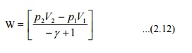
Comparison between work and heat

 Both heat and work are boundary phenomena, that is, they occur only at the boundary.

● The interaction due to the temperature difference is heat and all other interactions are to be taken as work.
▪
● Both work and heat are path functions, that is, they are inexact differentials.

