UNIT – V:
DC–AC Converters
What is an inverter
The word ‘inverter’ in the context of power-electronics denotes a class of power conversion (or power conditioning) circuits that operates from a dc voltage source or a dc current source and converts it into ac voltage or current.
Some examples where voltage source inverters are used are: uninterruptible power supply (UPS) units, adjustable speed drives (ASD) for ac motors, electronic frequency changer circuits etc. Most of us are also familiar with commercially available inverter units used in homes and offices to power some essential ac loads in case the utility ac supply gets interrupted.

Classification of Voltage Source Inverters
Voltage source inverters can be classified according to different criterions. They can be classified according to number of phases they output. Accordingly there are single-phase or three-phase inverters depending on whether they output single or three-phase voltages. It is also possible to have inverters with two or five or any other number of output phases. Inverters can also be classified according to their ability in controlling the magnitude of output parameters like, frequency, voltage, harmonic content etc. Some inverters can output only fixed magnitude (though variable frequency) voltages whereas some others are capable of both variable voltage, variable frequency (VVVF) output. Output of some voltage source inverters is corrupted by

significant amount of many low order harmonics like 3
rd th th
, 5 , 7
th
, 11
th
, 13
order of the desired

(fundamental) frequency voltage. Some other inverters may be free from low order harmonics but may still be corrupted by some high order harmonics. Inverters used for ac motor drive applications are expected to have less of low order harmonics in the output voltage waveform, even if it is at the cost of increased high order harmonics. Higher order harmonic voltage distortions are, in most ac motor loads, filtered away by the inductive nature of the load itself.
Inverters may also be classified according to their topologies. Some inverter topologies are suitable for low and medium voltage ratings whereas some others are more suitable for higher voltage applications

Single-Phase Voltage Source Inverters
Single-phase voltage source inverters (VSIs) can be found as half-bridge and full-bridge topologies. Although the power range they cover is the low one, they are widely used in power supplies, single-phase UPSs, and currently to form elaborate high-power static power topologies

Half-Bridge VSI
Figure 6.1 shows the power topology of a half-bridge VSI, where two large capacitors are required to provide a neutral point N, such that each capacitor maintains a constant voltage
Vi/2. Because the current harmonics injected by the operation of the inverter are low-order harmonics, a set of large capacitors (C+ and C-) is required. It is clear that both switches S+ and S- cannot be on simultaneously because a short circuit across the dc link voltage source vi would be produced. There are two defined (states 1 and 2) and one undefined (state 3) switch state as shown in Table 6.1. In order to avoid the short circuit across the dc bus and the undefined ac output voltage condition, the modulating technique should always enure that at any instant either the top or the bottom switch of the inverter leg is on.

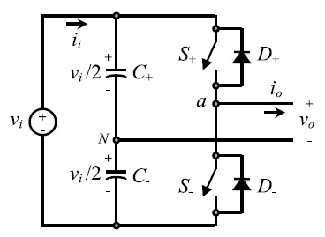
FIGURE 6.1 Single-phase half-bridge VSI.

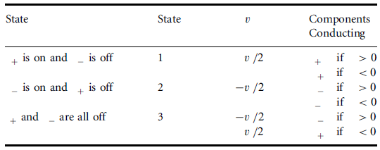

TABLE 6.1 Switch states for a half-bridge single-phase VSI

Figure 6.2 shows the ideal waveforms associated with the half-bridge inverter shown in Fig. 6.1. The states for the switches S+ and S- are defined by the modulating technique, which in this case is a carrier-based PWM.

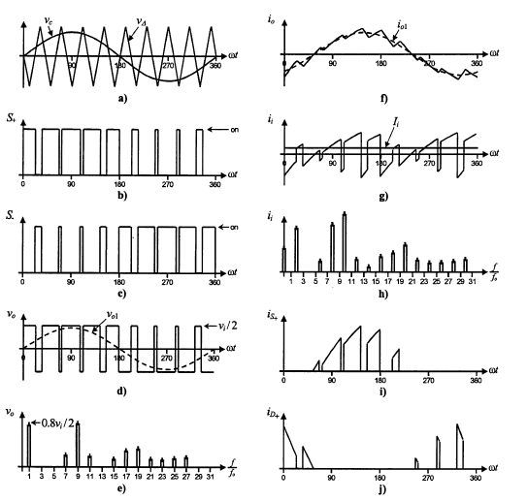

FIGURE 6.2 The half-bridge VSI. Ideal waveforms for the SPWM (ma = 0:8, mf = 9): (a) carrier and modulating signals; (b) switch S+ state; (c) Switch S- state; (d) ac output voltage; (e) ac output voltage spectrum; (f) ac output current; (g) dc current; (h) dc current spectrum; (i) switch S+ current; (j) diode D+ current.

The Carrier-Based Pulsewidth Modulation (PWM) Technique
As mentioned earlier, it is desired that the ac output voltage vo = vaN follow a given waveform (e.g., sinusoidal) on a continuous basis by properly switching the power valves. The carrier- based PWM technique fulfils such a requirement as it defines the on and off states of the switches of one leg of a VSI by comparing a modulating signal vc (desired ac output voltage) and a triangular waveform vΔ (carrier signal). In practice, when vc > vΔ the switch S+ is on and the switch S- is off; similarly, when vc < vΔ the switch S+ is off and the switch S- is on.
A special case is when the modulating signal vc is a sinusoidal at frequency fc and amplitude ^vc
, and the triangular signal vD is at frequency fD and amplitude ^vD. This is the sinusoidal PWM (SPWM) scheme. In this case, the modulation index ma (also known as the amplitude- modulation ratio) is defined as
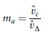
and the normalized carrier frequency mf (also known as the frequency-modulation ratio) is
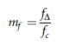
Figure 6.2(e) clearly shows that the ac output voltage vo = vaN is basically a sinusoidal waveform plus harmonics, which features: (a) the amplitude of the fundamental component of the ac output voltage ^vo1 satisfying the following expression:
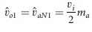
Full-Bridge VSI
Figure 6.3 shows the power topology of a full-bridge VSI. This inverter is similar to the half- bridge inverter; however, a second leg provides the neutral point to the load. As expected,
both switches S1+ and S1- (or S2+ and S2 -) cannot be on simultaneously because a short circuit across the dc link voltage source vi would be produced. There are four defined (states 1, 2, 3, and
4) and one undefined (state 5) switch states as shown in Table 6.2. The undefined condition should be avoided so as to be always capable of defining the ac output voltage. In order to
avoid the short circuit across the dc bus and the undefined ac output voltage condition, the modulating technique should ensure that either the top or the bottom switch of each leg is
on at any instant. It can be observed that the ac output voltage can take values up to the dc link value vi , which is twice that obtained with half-bridge VSI topologies. Several modulating techniques have been developed that are applicable to full-bridge VSIs. Among them are the PWM (bipolar and unipolar) techniques.
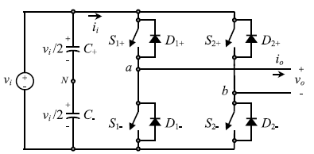
FIGURE 6.3 Single-phase full-bridge VSI.
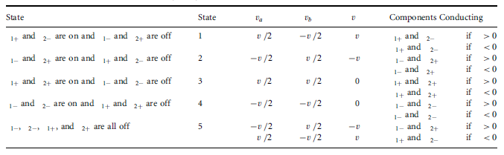
TABLE 6.2 Switch states for a full-bridge single-phase VSI

Bipolar PWM Technique
States 1 and 2 (Table 6.2) are used to generate the ac output voltage in this approach. Thus, the ac output voltage waveform features only two values, which are vi and ÿvi. To generate the states, a carrier-based technique can be used as in half-bridge configurations (Fig. 6.2), where only one sinusoidal modulating signal has been used. It should be noted that the on state in switch S+ in the half-bridge corresponds to both switches S1+ and S2- being in the on state in the full-bridge configuration. Similarly, S- in the on state in the half-bridge corresponds to both switches S1- and S2+ being in the on state in the full-bridge configuration. This is called bipolar carrier-based SPWM. The ac output voltage waveform in a full-bridge VSI is basically a sinusoidal waveform that features a fundamental component of amplitude ^vo1 that satisfies the expression
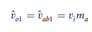
in the linear region of the modulating technique (ma < 1), which is twice that obtained in the half-bridge VSI. Identical conclusions can be drawn for the frequencies and amplitudes of the harmonics in the ac output voltage and dc link current, and for operations at smaller and larger values of odd mf (including the overmodulation region (ma > 1)), than in halfbridge VSIs, but considering that the maximum ac output voltage is the dc link voltage vi . Thus, in the overmodulation region the fundamental component of amplitude ^vo1 satisfies the expression
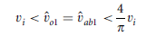
Unipolar PWM Technique
In contrast to the bipolar approach, the unipolar PWM technique uses the states 1, 2, 3, and 4 (Table 6.2) to generate the ac output voltage. Thus, the ac output voltage waveform can instantaneously take one of three values, namely, vi, -vi , and 0. To generate the states, a carrier- based technique can be used as shown in Fig. 6.4, where two sinusoidal modulating signals (vc and -vc) are used. The signal vc is used to generate vaN, and -vc is used to generate vbN ; thus vbN1= -vaN1. On the other hand, vo1= vaN1 -vbN1=2.vaN1; thus ^vo1 = ^vaN1 =ma . vi . This is called unipolar carrier-based SPWM.
Identical conclusions can be drawn for the amplitude of the fundamental component and harmonics in the ac output voltage and dc link current, and for operations at smaller and larger values of mf , (including the overmodulation region (ma > 1)), than in full-bridge VSIs modulated by the bipolar SPWM. However, because the phase voltages (vaN and vbN ) are identical but 180_ out of phase, the output voltage (vo = vab = vaN -vbN ) will not contain even harmonics. Thus, if mf is taken even, the harmonics in the ac output voltage appear at normalized odd frequencies fh centered around twice the normalized carrier frequency mf and its multiples. Specifically,
where k =1; 3; 5; . . . and the harmonics in the dc link current appear at normalized frequencies fp centered around twice the normalized carrier frequency mf and its multiples. Specifically,
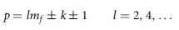
where k = 1; 3; 5; . . .. This feature is considered to be an advantage because it allows the use of smaller filtering components to obtain high-quality voltage and current waveforms while using the same switching frequency as in VSIs modulated by the bipolar approach.

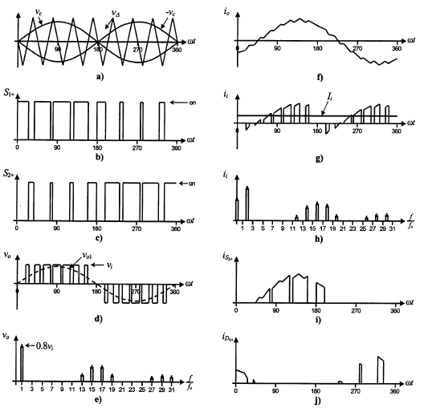

FIGURE 6.4 The full-bridge VSI. Ideal waveforms for the unipolar SPWM (ma =0:8, mf = 8):
(a) carrier and modulating signals; (b) switch S1+ state; (c) switch S2+ state; (d) ac output voltage; (e) ac output voltage spectrum; (f) ac output current; (g) dc current; (h) dc current spectrum; (i) switch S1+ current; (j) diode D1+ current

.

THREE-PHASE VSI PWM INVERTER
Three phase inverter is used to provide adjustable frequency power for industrial applications. Three phase inverter is more common than single phase inverters. DC supply for three phase inverters is taken from a battery or usually from a rectifier. In industrial application, VSI is mostly used, because a wide range of speed control is possible. Three phase VSI is operated at two modes i) 180 degree mode operation and ii) 120 degree mode operation. In 180 degree mode of operation three switches conduct at one cycle, each IGBT is operated at 60 degree delay angle. In this mode of operation, one can easily get the pure sine wave using a filter. So it is otherwise called as a quasi square wave mode or switched mode . In 120 degree mode operation is pair of switch conduct at 120 degree delay angle. In this mode a shoot through fault occurs.
A six step bridge is used for three phase inverter by using six switches, with two switches for each phase. Each step is defined as a change in the time of operation for each IGBT to the next IGBT in proper sequence. For one cycle of 3600, each step would be of 600 intervals for a six step inverter. Figure 6.5 shows the power circuit diagram of a three phase bridge inverter using

six IGBTs. The source voltage Vs fed from three phase uncontrolled rectifier. Large capacitors (C1=Vs /2 and C2=Vs /2) are connected at the input terminal to make the DC input constant and also to suppress the harmonics fed back to the source . T1, T2, T3, T4, T5 and T6 are the IGBTs switch. In figure 6.5 shows a, b, and c are the output terminals of the switched mode PWM inverter. This output terminals fed by three phase induction motor, where n is three phase induction motor neutral terminal.
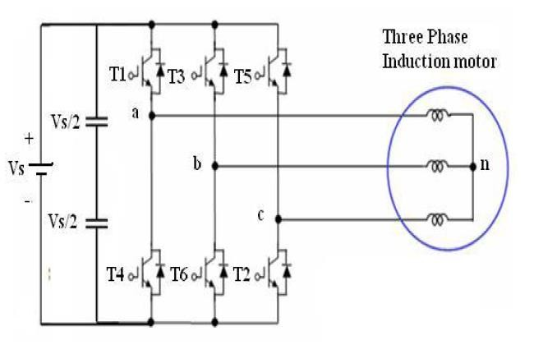
Figure 6.5 Power Circuit Diagram of a Three Phase Bridge Inverter using Six IGBTs

There are two patterns of gating the transistors. In one pattern, each transistor conducts for 180 degree and in the other, each transistor conducts for 120 degree. But in both the patterns gating signals are applied and removed at 60 degree intervals of the output voltage waveform. Both modes require a six step bridge inverter.

Three-Phase 180 Degree Mode VSI
By referring to figure 6.5, three switch conducts for 180 degree mode of operation. The conduction sequence can be written as follows T6T1T2, T1T2T3, T2T3T4, T3T4T5, T4T5T6, and T5T6T1. For consider one switching sequence T1T2T3, T1T3 are upper group and T2 is lower group. T1 operated delay at t =00, T3 operated delay at t =1200, and T2 operated delay at t
= 600. Transistors in the upper group i.e. T1, T3, and T5 conduct at an interval of 1200. It implies that if T1 is operated delay at t =00, then T3 must be operated delay at t =1200 and T5 delay at t
=2400, the same thing for lower group of transistors. Table 6.3 shows the switching states for six switches and also phase to phase Vab, Vbc and Vca voltages are obtained. Figure 6.6 shows the voltage waveforms for 180 degrees mode three phase VSI.

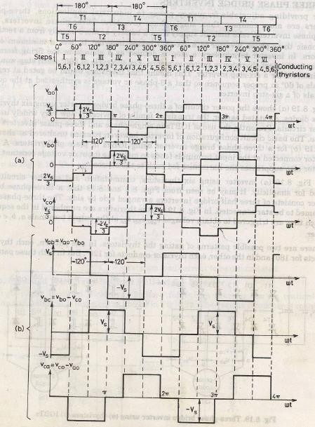
FIGURE6.6 :Voltage waveforms for 180 degrees mode 3- phase VSI
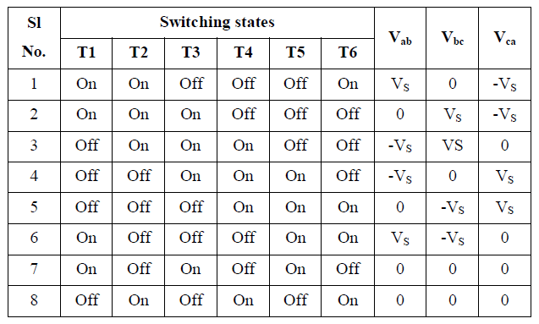
Table 6.3 Switching States for Three-Phase Voltage Source Inverter for 180 Degree Conduction

Three-Phase 120 Degree Mode VSI
The power circuit diagram of this inverter is the same as shown in Figure 6.5. In 120 degree mode VSI, each transistor conducts for 120 degree of a cycle. Like 180 Degree mode, 120 Degree mode inverter also requires six steps, each of 60 Degree duration, for completing one cycle of the output AC voltage. During the first 120 degree, T1 conducts with T6 for 60 degree, and then conducts with T2 for another 60 degree. The T3 will conduct for 120 degree (from 120 to 240 ) for 60 (from 120 to 180 ) with T2 and then conduct another 60 (from 180 to 240 ) with T4. The T5 will conducts 120 (from 240 to 360 ) with T4 for 60 (from 240 to 300 ) and then conducts for another 60 (from 300 to 360 ) with T6. The conduction sequence can be written as follows: T6T1, T1T2, T2T3, T3T4, T4T5, T5T6, and T6T1. The disadvantage of 1200 mode VSI is shoot through fault will occur during the conduction period. Figure 6.7 shows the voltage waveforms for 120 degrees mode six-step 3-phase inverter.
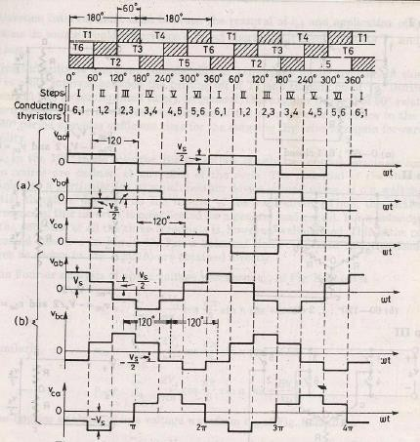
FIGURE6.7: voltage waveforms for 120 degrees mode six-step 3-phase inverter

PWM SWITCHING FREQUENCY EFFECTS
The VSI output voltage has PWM voltage pulses, which causes PWM ripple in the output current. The current ripple decreases with increasing output inductance. When the AC motor is directly connected to the VSI output, since the leakage inductance of the motor acts as a low- pass filter, it partially suppresses the PWM current ripple and the motor current is nearly sinusoidal. However, when the switching frequency is low or inverter output inductance is small, the ripple current becomes high, which results in higher losses, thermal stresses, and acoustic noise in the motor. Also when the ripple current is high, inverter current reaches high peak values, which increases current stresses on the inverter switches. Thus, in such cases additional filters are needed to reduce the PWM ripple.

CONCEPT OF PULSE WIDTH MODULATION
Higher order harmonics in the load current could be easily filtered out using a series Inductor. A selected range of lower order harmonics can be reduced or eliminated by choosing the number of pulses per half cycle. When number of pulses increases then the order of harmonics is also increased and that can be easily eliminated by means of filters. In this method, a fixed AC voltage is given to the converter and controlled DC output voltage is obtained by adjusting the ON and OFF periods of the pulses. This is the most popular method of controlling the output voltage and this method is termed as pulse width modulation control.

ADVANTAGES OF PWM
- The advantages possessed by PWM technique are as under: The output voltage control can be obtained without any additional components.
- Lower order harmonics can be eliminated or minimized along with its output voltage control. As higher order harmonics can be filtered easily, the filtering requirements are minimized.

DIFFERENT PWM TECHNIQUES
PWM techniques are characterized by constant amplitude pulses. The width of these pulses is, however, modulated to obtain output voltage control and to reduce its harmonic content. Different PWM techniques are as under.
Single-pulse modulation Multiple-pulse modulation Sinusoidal-pulse modulation

Single-Pulse Width Modulation
In single pulse-width modulation control, there is only one pulse per half-cycle and the width of the pulse is varied to control the inverter output voltage.

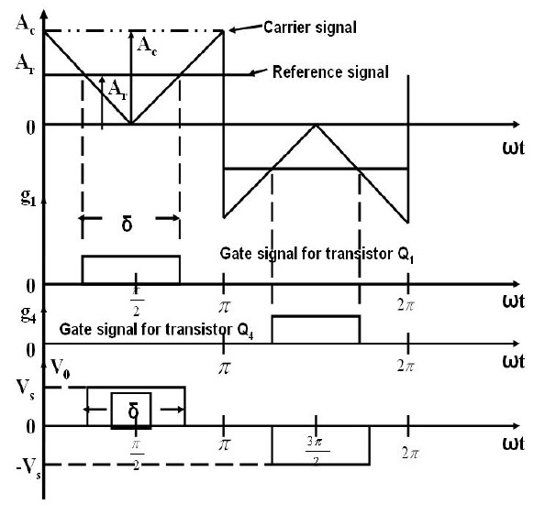
Figure 6.8 Single Pulse Width Modulation
Figure 6.8 shows the generation of gating signals. The gating signals are generated by comparing a rectangular reference signal of amplitude, Ar, with a triangular carrier wave of amplitude; Ac
.The frequency of the reference signal determines the fundamental frequency of the output voltage. The ratio of Ar to Ac is the control variable and defined as the amplitude modulation index.
The amplitude modulation index or simply modulation index is
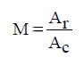
The RMS output voltage can be found from
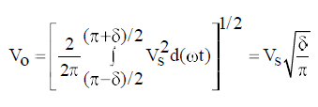

Multiple -Pulse-Width Modulation
The harmonic content can be reduced using several pulses in each half-cycle of output voltage. The generation of gating signals for turning on and off of transistors is shown in figure 6.9 by comparing a reference signal with a triangular carrier wave. The frequency of reference signal sets the output frequency, fo, and the carrier frequency, fc, determines the number of pulses per half-cycle. The modulation index controls the output voltage. This type of modulation is also known as uniform pulse-width modulation (UPWM).
The number of pulses per half-cycle is found from
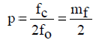
where mf = f0/fc is defined as the frequency modulation ratio.
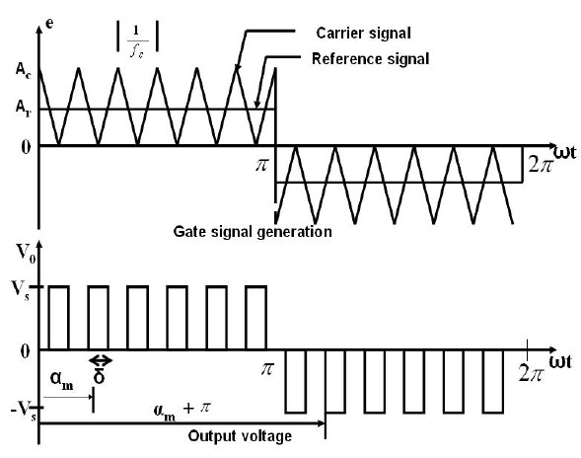
Figure 6.9 Multiple Pulse Width Modulation
If δ is the width of each pulse, the RMS output voltage can be found from
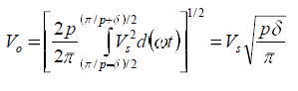

Sinusoidal Pulse Width Modulation
Instead of maintaining the width of all pulses the same as in the case of multiple-pulse modulation, the width of each pulse is varied in proportion to the amplitude of a sine wave evaluated at the centre of the same pulse. The distortion factor and lower-order harmonics are reduced significantly. The gating signals as shown in figure 6.10 are generated by comparing a sinusoidal reference signal with a triangular carrier wave of frequency, fc. This type of modulation is commonly used in industrial applications and abbreviated as SPWM. The frequency of the reference signal, fr, determines the output frequency fo, and its peak amplitude, Ar, controls the modulation index m, and then in turn the RMS output voltage, Vo. The number of pulses per half cycle depends on the carrier frequency. The RMS output voltage can be varied by varying the modulation index m. If δm is the width of the pulse, the RMS output voltage can be found from the waveforms.

The three PWM techniques listed above differ from each other in the harmonic content in their respective output voltages. Thus the choice of a particular PWM technique depends upon the permissible harmonic content in the converter output voltage. The devices are switched on and off several times within each half cycle to control the output voltage which has low harmonic content.

