**UNIT–IV:**

**DC–DC Converters**

**Introduction To Commuration Circuits:**

A thyristor can be turned ON by applying a positive voltage of about a volt or a current of a few tens of milliamps at the gate-cathode terminals. However, the amplifying gain of this regenerative device being in the order of the 108, the SCR cannot be turned OFF via the gate terminal. It will turn-off only after the anode current is annulled either naturally or using forced commutation techniques. These methods of turn-off do not refer to those cases where the anode current is gradually reduced below Holding Current level manually or through a slow process. Once the SCR is turned ON, it remains ON even after removal of the gate signal, as long as a minimum current, the Holding Current, Ih, is maintained in the main or rectifier circuit.

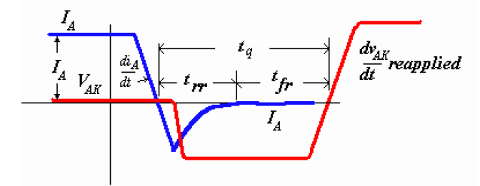

**Fig. 5.1 Turn-off dynamics of the SCR**

In all practical cases, a negative current flows through the device. This current returns to zero only after the reverse recovery time *trr*, when the SCR is said to have regained its reverse blocking capability. The device can block a forward voltage only after a further *tfr*, the forward recovery time has elapsed. Consequently, the SCR must continue to be reverse-biased for a minimum of *tfr* + *trr* = *tq*, the rated turn-off time of the device. The external circuit must therefore reverse bias the SCR for a time *toff* > *tq*. Subsequently, the reapplied forward biasing voltage must rise at a dv/dt < dv/dt (reapplied) rated. This dv/dt is less than the static counterpart. General Electric has suggested six classification methods for the turn-off techniques generally adopted for the SCR. Others have chosen different classification rules.

SCRs have turn-off times rated between 8 - 50 μsecs. The faster ones are popularly known as 'Inverter grade' and the slower ones as 'Converter grade' SCRs. The latter are available at higher current levels while the faster ones are expectedly costlier.

**The six distinct classes by which the SCR can be turned off are:**

Class A Self commutated by a resonating load

Class B Self commutated by an L-C circuit

Class C C or L-C switched by another load carrying SCR

Class D C or L-C switched by an auxiliary SCR

Class E An external pulse source for commutation

Class F AC line commutation

These examples show the classes as choppers. The commutation classes may be used in practice in configurations other than choppers.

**Class A, Self commutated by resonating the load:**



**Fig. 5.2 A resonant load commutated SCR and the corresponding waveforms**

When the SCR is triggered, anode current flows and charges up C with the dot as positive. The L-C-R form a second order under-damped circuit. The current through the SCR builds up and completes a half cycle. The inductor current will then attempt to flow through the SCR in the reverse direction and the SCR will be turned off.

The current may be expressed as

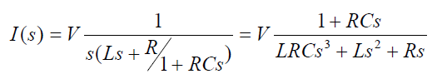

The solution of the above equation is of the form

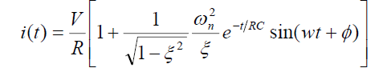

Where

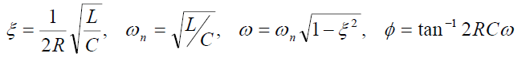

And

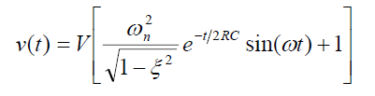

The capacitor voltage is at its peak when the SCR turns off and the capacitor discharges into the resistance in an exponential manner. The SCR is reverse-biased till the capacitor voltages returns to the level of the supply voltage V.

Class B, Self commutated by an L-C circuit

The Capacitor C charges up in the dot as positive before a gate pulse is applied to the SCR. When SCR is triggered, the resulting current has two components.

The constant load current Iload flows through R - L load. This is ensured by the large reactance in series with the load and the freewheeling diode clamping it. A sinusoidal current flows through the resonant L-C circuit to charge-up C with the dot as negative at the end of the half cycle. This current will then reverse and flow through the SCR in opposition to the load current for a small fraction of the negative swing till the total current through the SCR becomes zero. The SCR will turn off when the resonant–circuit (reverse) current is just greater than the load current.

The SCR is turned off if the SCR remains reversed biased for tq > toff, and the rate of rise of the reapplied voltage < the rated value.

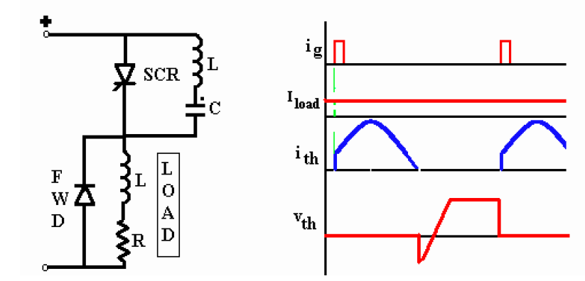

**Fig. 5.3 Class B, L-C turn-off**

Class C, C or L-C switched by another load–carrying SCR

This configuration has two SCRs. One of them may be the main SCR and the other auxiliary. Both may be load current carrying main SCRs. The configuration may have four SCRs with the load across the capacitor, with the integral converter supplied from a current source. Assume SCR2 is conducting. C then charges up in the polarity shown. When SCR1 is triggered, C is switched across SCR2 via SCR1 and the discharge current of C opposes the flow of load current in SCR2. **Fig. 5.4**



**Fig. 5.4 Class C turn-off, SCR switched off by another load-carring SCR**

Class D, L-C or C switched by an auxiliary SCR

**Example 1**

The circuit shown in Figure 5.3 (Class C) can be converted to Class D if the load current is carried by only one of the SCR’s, the other acting as an auxiliary turn-off SCR. The auxiliary SCR would have a resistor in its anode lead of say ten times the load resistance.



**Fig. 5.5 Class D turn-off. Class D commutation by a C (or LC) switched by an Auxiliary SCR.**

**Example 2**

SCR*A* must be triggered first in order to charge the upper terminal of the capacitor as positive. As soon as C is charged to the supply voltage, SCR*A* will turn off. If there is substantial inductance in the input lines, the capacitor may charge to voltages in excess of the supply voltage. This extra voltage would discharge through the diode-inductor-load circuit.

When SCR*M* is triggered the current flows in two paths: Load current flows through the load and the commutating current flows through C- SCR*M* -L-D network. The charge on C is reversed and held at that level by the diode D. When SCRA is re-triggered, the voltage across C appears across SCR*M* via SCR*A* and SCR*M* is turned off. If the load carries a constant current as in Fig. 5.4, the capacitor again charges linearly to the dot as positive.

**Class E – External pulse source for commutation:**

The transformer is designed with sufficient iron and air gap so as not to saturate. It is capable of carrying the load current with a small voltage drop compared with the supply voltage.

When SCR1 is triggered, current flows through the load and pulse transformer. To turn SCR1 off a positive pulse is applied to the cathode of the SCR from an external pulse generator via the pulse transformer. The capacitor C is only charged to about 1 volt and for the duration of the turn-off pulse it can be considered to have zero impedance. Thus the pulse from the transformer reverses the voltage across the SCR, and it supplies the reverse recovery current and holds the voltage negative for the required turn-off time.

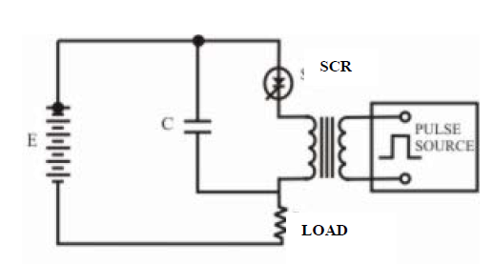

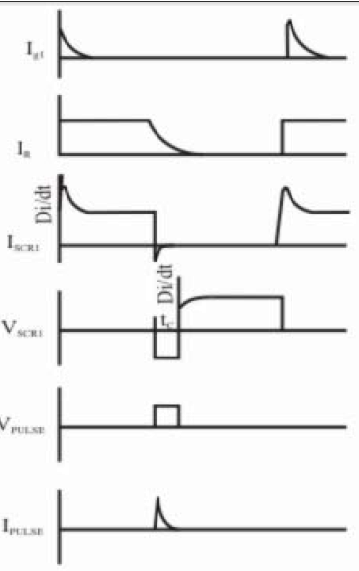

**Fig. 5.6 Class E, External pulse commutation**

**5.7 DC-DC Converters :**

There are three basic types of dc-dc converter circuits, termed as buck, boost and buck-boost. In all of these circuits, a power device is used as a switch. This device earlier used was a thyristor, which is turned on by a pulse fed at its gate. In all these circuits, the thyristor is connected in series with load to a dc supply, or a positive (forward) voltage is applied between anode and cathode terminals. The thyristor turns off, when the current decreases below the holding current, or a reverse (negative) voltage is applied between anode and cathode terminals. So, a thyristor is to be force-commutated, for which additional circuit is to be used, where another thyristor is often used. Later, GTO’s came into the market, which can also be turned off by a negative current fed at its gate, unlike thyristors, requiring proper control circuit. The turn-on and turn-off times of GTOs are lower than those of thyristors. So, the frequency used in GTO-based choppers can be increased, thus reducing the size of filters. Earlier, dc-dc converters were called ‘choppers’, where thyristors or GTOs are used. It may be noted here that buck converter (dc-dc) is called as ‘step-down chopper’, whereas boost converter (dc-dc) is a ‘step-up chopper’. In the case of chopper, no buck-boost type was used.

With the advent of bipolar junction transistor (BJT), which is termed as self-commutated device, it is used as a switch, instead of thyristor, in dc-dc converters. This device (NPN transistor) is switched on by a positive current through the base and emitter, and then switched off by withdrawing the above signal. The collector is connected to a positive voltage. Now-a-days, MOSFETs are used as a switching device in low voltage and high current applications. It may be noted that, as the turn-on and turn-off time of MOSFETs are lower as compared to other switching devices, the frequency used for the dc-dc converters using it (MOSFET) is high, thus, reducing the size of filters as stated earlier. These converters are now being used for applications, one of the most important being Switched Mode Power Supply (SMPS). Similarly, when application requires high voltage, Insulated Gate Bi-polar Transistors (IGBT) are preferred over BJTs, as the turn-on and turn-off times of IGBTs are lower than those of power transistors (BJT), thus the frequency can be increased in the converters using them. So, mostly self-commutated devices of transistor family as described are being increasingly used in dc-dc converters.

**Buck Converters (dc-dc)**

A buck converter (dc-dc) is shown in Fig. 5.7.1a. Only a switch is shown, for which a device as described earlier belonging to transistor family is used. Also a diode (termed as free wheeling) is used to allow the load current to flow through it, when the switch (i.e., a device) is turned off. The load is inductive (R-L) one. In some cases, a battery (or back emf) is connected in series with the load (inductive). Due to the load inductance, the load current must be allowed a path, which is provided by the diode; otherwise, i.e., in the absence of the above diode, the high induced emf of the inductance, as the load current tends to decrease, may cause damage to the switching device. If the switching device used is a thyristor, this circuit is called as a step-down chopper, as the output voltage is normally lower than the input voltage.

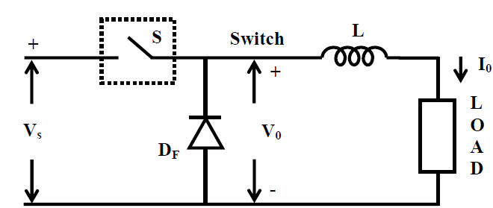

**Fig. 5.7.1(a): Buck converter (dc-dc)**

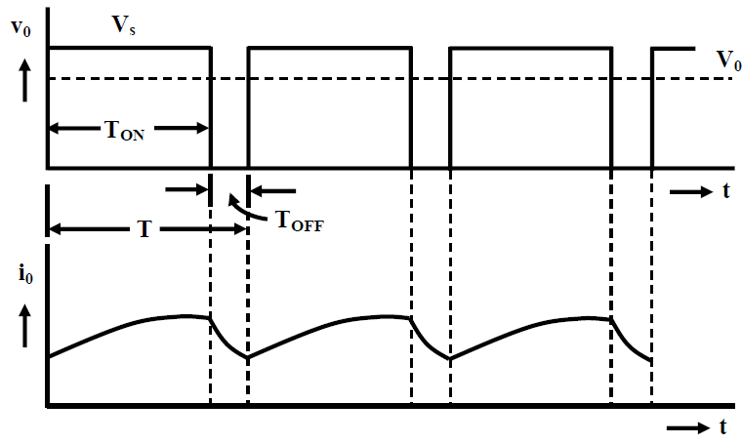

**Fig. 5.7.1(b): Output voltage and current waveforms**

The output voltage and current waveforms of the circuit (Fig. 5.7.1a) are shown in Fig. 5.7.1b. The output voltage is same as the input voltage, i.e., V0= VS, when the switch is ON, during the period, . The switch is turned on at TON > t > 0 and then turned off at . This is called ON period. During the next time interval, the output voltage is zero, i.e., as the diode, now conducts. The OFF period is TOFF = T- TON. with the time period being T= TON + TOFF. The frequency is f=1 /T. With T kept as constant, the average value of the output voltage is,

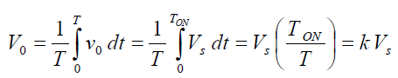

Normally due to turn-on delay of the device used, the duty ratio (k) is not zero, but has some positive value. Similarly, due to requirement of turn-off time of the device, the duty ratio (k) is less than 1.0. So, the range of duty ratio is reduced. It may be noted that the output voltage is lower than the input voltage. Also, the average output voltage increases, as the duty ratio is increased. So, a variable dc output voltage is obtained from a constant dc input voltage. The load current is assumed to be continuous as shown in Fig. 5.7.1b. The load current increases in the ON period, as the input voltage appears across the load, and it (load current) decreases in the OFF period, as it flows in the diode, but is positive at the end of the time period, T.

**Boost Converters (dc-dc)**

A boost converter (dc-dc) is shown in Fig. 5.7.2a. Only a switch is shown, for which a device belonging to transistor family is generally used. Also, a diode is used in series with the load. The load is of the same type as given earlier. The inductance of the load is small. An inductance, L is assumed in series with the input supply. The position of the switch and diode in this circuit may be noted, as compared to their position in the buck converter (Fig. 5.7.1a).

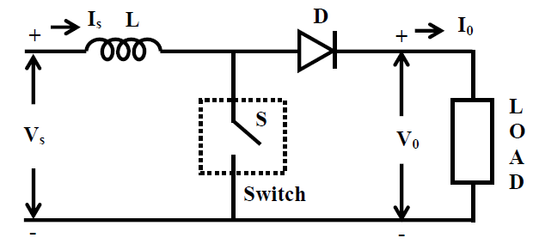

**Fig. 5.7.2(a): Boost converter (dc-dc)**

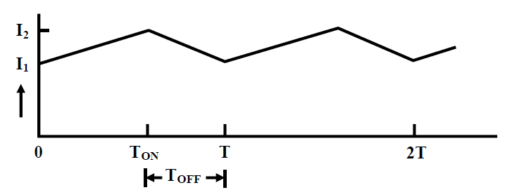

**Fig. 5.7.2(b): Waveforms of source current (is)**

The operation of the circuit is explained. Firstly, the switch, S (i.e., the device) is put ON (or turned ON) during the period, 0< t< TON , the ON period being . The output voltage is zero , if no battery (back emf) is connected in series with the load, and also as stated earlier, the load inductance is small. The current from the source flows in the inductance L. The value of current increases linearly with time in this interval, with (di/dt) being positive. As the current through L increases, the polarity of the induced emf is taken as say, positive, the left hand side of L being +ve. The equation for the circuit is,

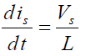

The switch, S is put OFF during the period, TON < t < T , the OFF period being TOFF = T-TON, where T is the time period. As the current through L decreases, with its direction being in the same direction as shown (same as in the earlier case), the induced emf reverses, the left hand side of L being -ve. So, the induced emf (taken as –ve in the equation given later) is added with the supply voltage, being of the same polarity, thus, keeping the current (is=io) in the same direction. The current (is=io) decreases linearly in the time interval, , as the output voltage is assumed to be nearly constant at with (*didt*) being negative, as VS < V0.

The equation for the circuit is,

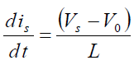

Equating the above two equations from which the average value of the output voltage is,

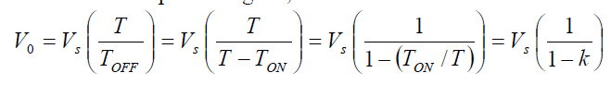

Here



**5.8 Buck Converter (DC-DC) with RLE –LOAD:**

The circuit of the buck converter (dc-dc) or step-down chopper using thyristor, with inductive (R-L) and battery (or back emf = E) load, is shown in Fig. 18.1. The switch in Fig. 5.8.1a is replaced by a thyristor here, where the components of the load, such as R, L & E, are also shown. The output (load) voltage and current waveforms for both (a) discontinuous, and (b) continuous conduction are shown in Fig. 5.8.2.

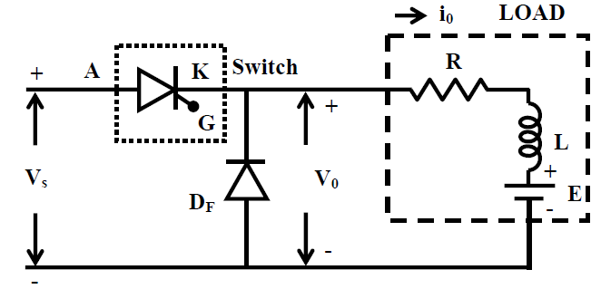

**Fig. 5.8.1: Step-down chopper circuit using thyristor.**

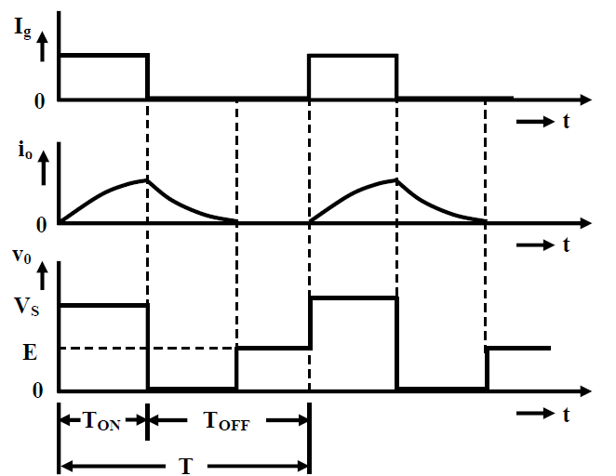

**a) Discontinuous load current**

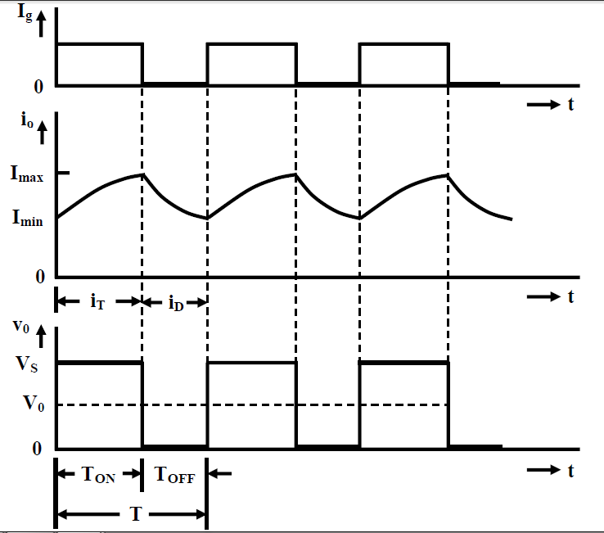

**b) Continuous load current**

**Fig. 5.8.2: Two modes operation of the chopper.**

Maximum and Minimum Values of the Load Current

The procedure for finding the maximum and minimum of the load current, assuming continuous conduction, is described. The operation of the chopper circuit has been discussed in the earlier lesson. There are two modes of operation. Mode 1 starts at t=0, when the thyristor is turned ON, with the diode, being OFF at that time, and continues till . During this time period, the load current increases. The induced emf in the load inductance L, is positive, i.e., having the same polarity as that of the input voltage, opposing it. Mode 2 starts at t > Ton when the thyristor is turned OFF by auxiliary circuit (not shown in Fig. 5.8.1), and the diode, turns ON at that time, as the load current starts decreasing, and the induced emf in the load inductance, L changes polarity, with the voltage across the diode now being positive. This continues till , end of the time period. Then the cycle repeats.

**Mode 1:** The equation for the load (output) current in the circuit during this time interval,

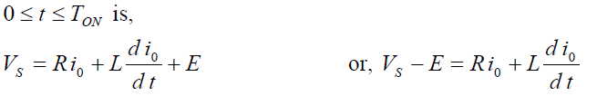

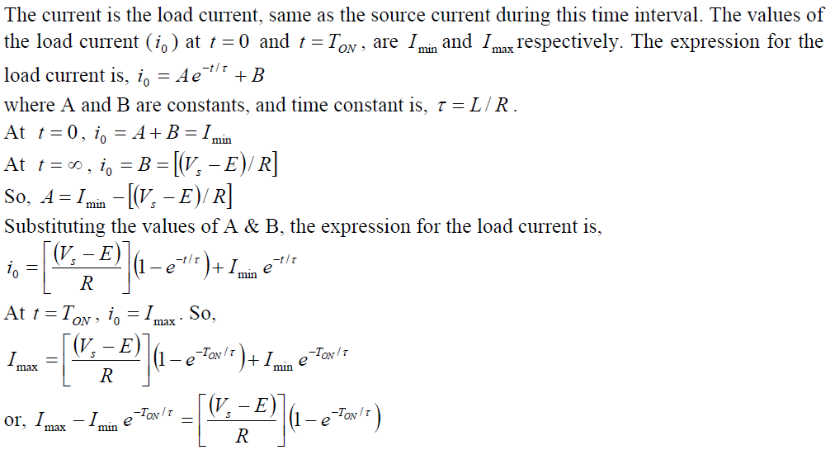

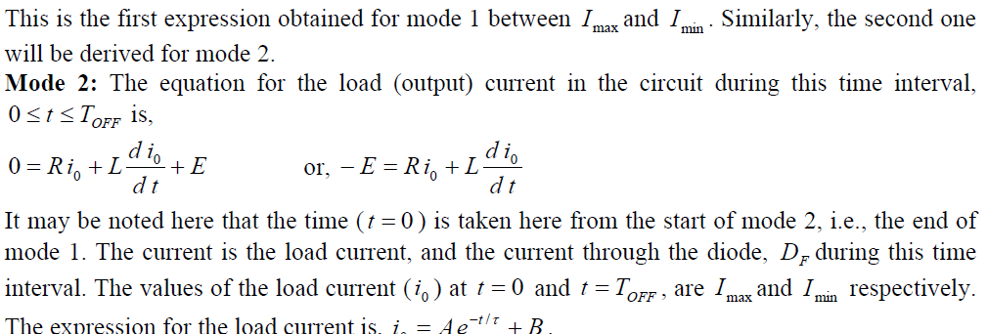

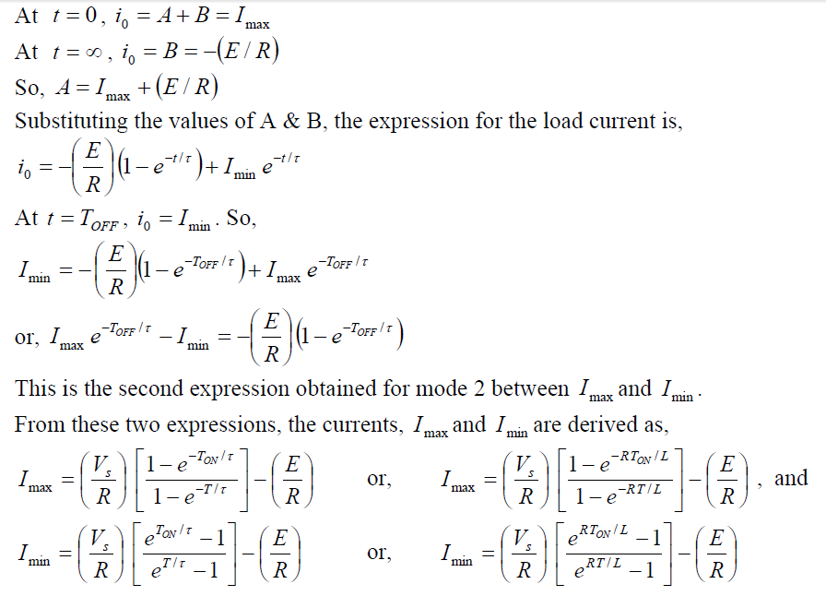

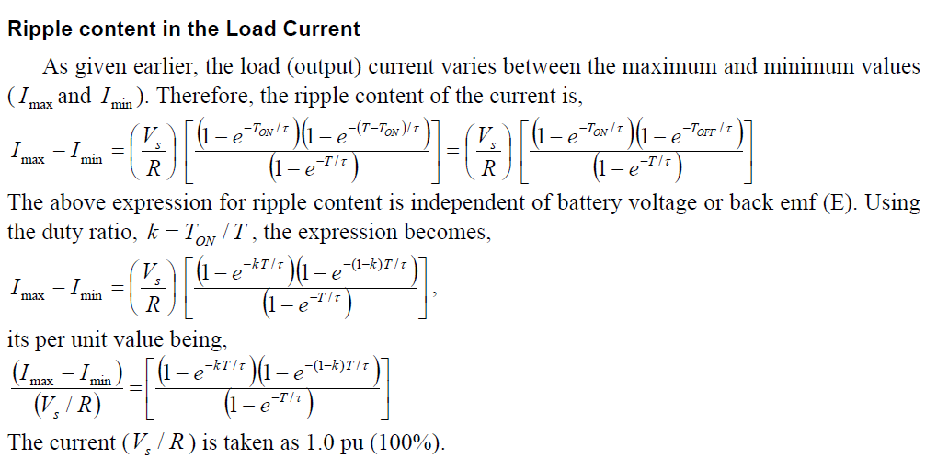

**5.9Control Strategies**

In all cases, it is shown that the average value of the output voltage can be varied. The two types of control strategies (schemes) are employed in all cases. These are:

(a) Time-ratio control, and (b) Current limit control.

Time-ratio Control

In the time ratio control the value of the duty ratio, *k*= TON/ T is varied. There are two ways, which are constant frequency operation, and variable frequency operation.

Constant Frequency Operation

In this control strategy, the ON time, is varied, keeping the frequency (), or time period *ONTTf*/1=*T* constant. This is also called as *pulse width modulation control* (PWM). Two cases with duty ratios, as (a) 0.25 (25%), and (b) 0.75 (75%) are shown in Fig. 5.9.1. Hence, the output voltage can be varied by varying ON time, TON.

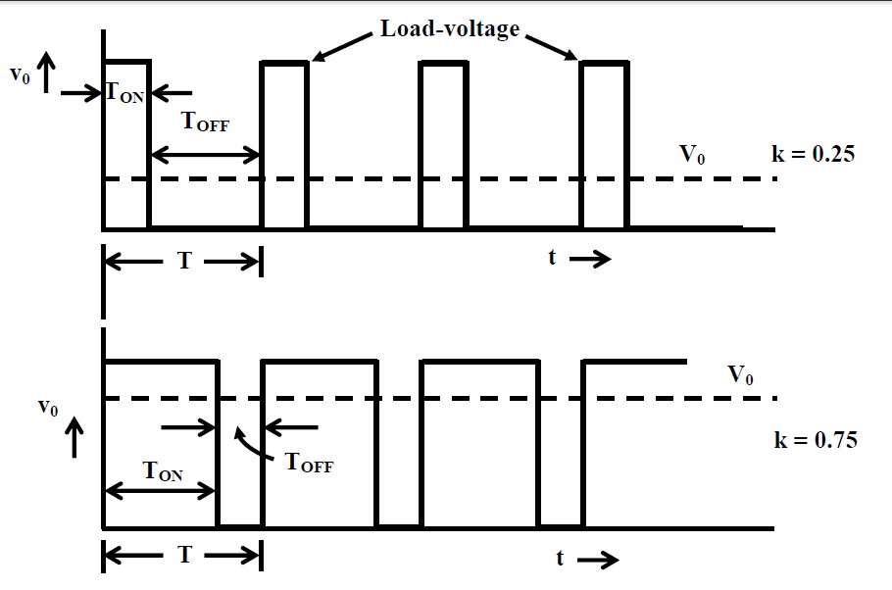

**Fig. 5.9.1: Pulse-width modulation control (constant frequency)**

Variable Frequency Operation

In this control strategy, the frequency (*T=1/f*), or time period *T* is varied, keeping either (a) the ON time, constant, or (b) the OFF time, constant. This is also called as *frequency modulation control*. Two cases with (a) the ON time, constant, and (b) the OFF time, constant, with variable frequency or time period are shown in Fig. 5.9.2. The output voltage can be varied in both cases, with the change in duty ratio.

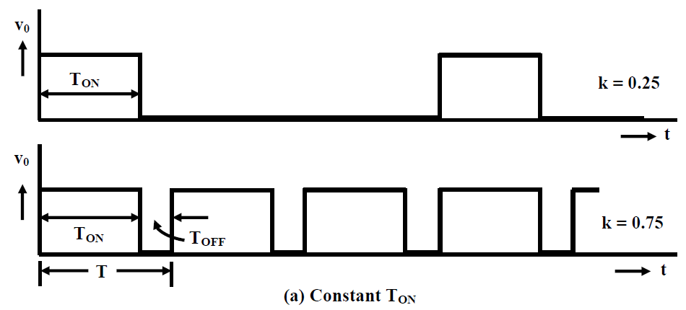

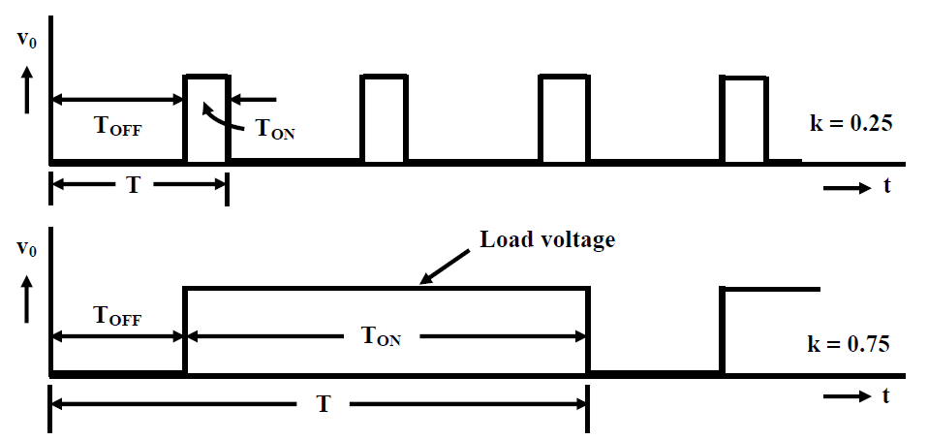

**b) Constant TOFF**

**Fig. 5.9.2: Output voltage waveforms for variable frequency system**

There are major disadvantages in this control strategy. These are:

(a) The frequency has to be varied over a wide range for the control of output voltage in frequency modulation. Filter design for such wide frequency variation is, therefore, quite difficult.

(b) For the control of a duty ratio, frequency variation would be wide. As such, there is a possibly of interference with systems using certain frequencies, such as signaling and telephone line, in frequency modulation technique.

(c) The large OFF time in frequency modulation technique, may make the load current discontinuous, which is undesirable.

Thus, the constant frequency system using PWM is the preferred scheme for dc-dc converters (choppers).

**Current Limit Control**

As can be observed from the current waveforms for the types of dc-dc converters described earlier, the current changes between the maximum and minimum values, if it (current) is continuous. In the current limit control strategy, the switch in dc-dc converter (chopper) is turned ON and OFF, so that the current is maintained between two (upper and lower) limits. When the current exceed upper (maximum) limit, the switch is turned OFF. During OFF period, the current freewheels in say, buck converter (dc-dc) through the diode,D , and decreases exponentially. When it reaches lower (minimum) limit, the switch is turned ON. This type of control is possible, either with constant frequency, or constant ON time, TON. This is used only, when the load has energy storage elements, i.e. inductance, L. The reference values are load current or load voltage. This is shown in Fig. 5.9.3. In this case, the current is continuous, varying between and , which decides the frequency used for switching. The ripple in the load current can be reduced, if the difference between the upper and lower limits is reduced, thereby making it minimum. This in turn increases the frequency, thereby increasing the switching losses.

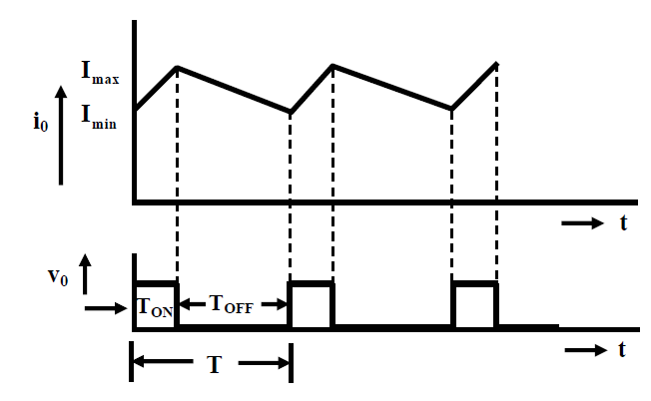

**Fig. 5.9.3: Current limit control**