UNIT–III:
AC-DC 3-Phase Converters
Introduction :
Single phase half controlled bridge converters & fully controlled bridge converters are used extensively in industrial applications up to about 15kW of output power.
The output ripple frequency is equal to the twice the ac supply frequency. The Single phase full wave controlled rectifiers provide two output pulses during every input supply cycle and hence are referred to as two pulse converters. Three phase converters are 3-phase controlled rectifiers which are used to convert ac input power supply into dc output power across the load.
devices.
Pre requisite: Students should have the knowledge of Single phase rectifiers.

Reason for going to 3 phase rectifiers:
(i) Higher dc voltage
(ii) Better TUF
(iii) Better input pf
(iu) Less ripple content in output current; therefore better load performance and
(v) lower size of filter circuit parameters because of higher ripple frequency.
Three phase controlled rectifiers are extensively used in high power variable speed industrial dc drives.

Three phase three pulse uncontrolled/diode rectifier:
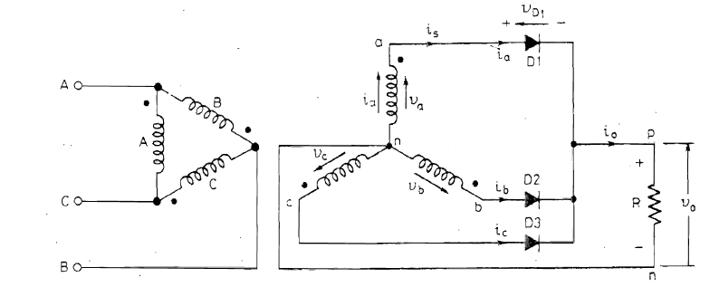
Fig.1: Three phase full wave diode rectifier with common cathode arrangement
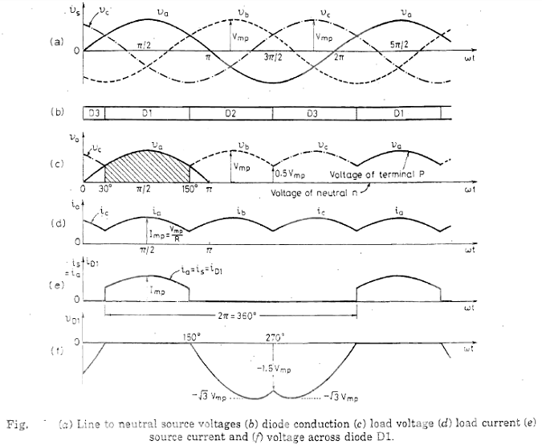
.2

The three diodes D1, D2 and D3, one in each phase, have their cathodes connected together to common load R. Neutral is used to complete the path for the return of load current. As the cathodes of three diodes are connected together, circuit is also known as common-cathode circuit for a 3-phase half-wave rectifier. The three-phase supply voltage is shown as va (= Van' voltage between a and n), Vb Vc in Fig. (a).

The rectifier element connected to the line at the highest positive instantaneous voltage can only conduct. In Fig. a diode with the highest positive voltage will begin to conduct at the cross-over points of the three-phase supply. It is seen from Fig.(a) that diode Dl will conduct for wt = 30° to wt = 150⁰ as this diode senses the most positive voltage Va as compared to the other two diodes, during the interval. Diode D2 will conduct from wt = 150° to 270⁰ and diode D3 from 270° to 390°. The conduction of diodes in proper sequence is shown in Fig. (b). When a diode is conducting, the common cathode terminal P rises to the highest positive voltage of that phase and the other two blocking diodes are reverse biased. The voltage Vo across the load follows the positive supply voltage envelope and has the waveform as shown in Fig. (c). It should be noted that voltage of the neutral point 'n' is taken as zero and is given by the reference line wt. The voltage of point P in Fig. is shown by Va, Vb, Vc etc above the reference line in Fig.(c). The dc load voltage V0 varies between Vmp ( = maximum phase voltage) and 0.5 Vmp, It is observed that for one cycle of supply voltage, output voltage has three pulses, the circuit of Fig. can therefore be called a 3-phase 3-pulse diode rectifier or 3-phase half-wave diode rectifier.
$$V_{0}= \frac{1}{2π/3}\int_{π/6}^{5π/6}{V_{mp}sinωt dωt= \frac{3}{2π}V_{ml}}$$
Vmp = maximum value of phase voltage.
Vml = maximum value of line voltage
Following observations can be made from the above analysis.
(i) Each diode conducts for 120⁰ only.
(ii) These are three pulses of output voltage, or output current, during one cycle of input voltage. It is, therefore, called 3-phase three-pulse diode rectifier.
(iii) Current in the transformer secondary is unidirectional, therefore, dc exists in the transformer secondary current. As a result , transformer core gets saturated leading to more iron losses and reduced efficiency.

Three-phase 6 pulse diode / uncontrolled Bridge Rectifier:
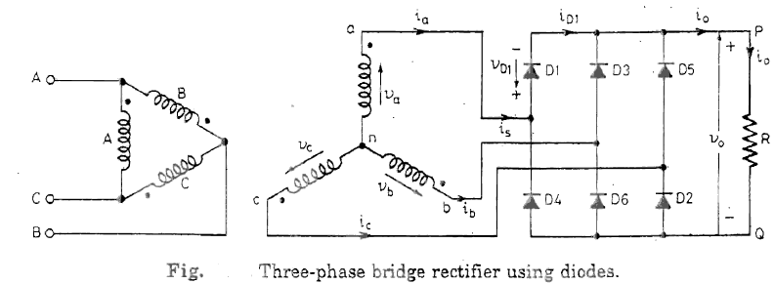
3
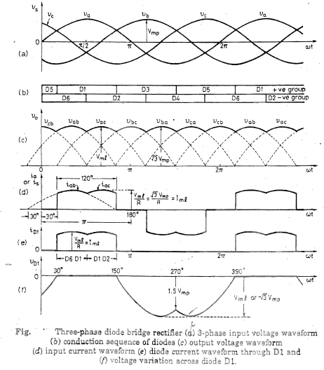
4

Power circuit diagram for a 3~phase bridge rectifier using six diodes in shown in Fig. The diodes are arranged in three legs. Each leg has two series-connected diodes. Upper diodes Dl, D3, D5 constitute the positive group of diodes. The lower diodes D2, D4, D6 form the negative group of ·diodes. The three-phase transformer feeding, the bridge is connected in delta-star. This rectifier is also called 3~phase 6~pulse diode rectifier, 3-phase full-wave diode rectifier, or three-phase B-6 diode rectifier.

Positive group of diodes conduct when these have the most positive anode . Similarly, . negative group of diodes would conduct if these have the most negative anode. In other words, diodes D1, D3, D5, forming positive group, would conduct when these experience the highest positive voltage. Likewise, diodes D2, D4, D6 would conduct when these are subjected to the most negative voltage.

It is seen from the source voltage waveform Vs of Fig. (a ) that from rot = 30° to 150⁰ , voltage va is more positive than the voltages vb, vc, Therefore, diode D1 connected to line 'a' (as per subscript 'a' in va) conducts during the interval wt = 30° to 150°. Likewise, from wt = 150° to 270°, voltage vb is more positive as compared to va) Vc; therefore, diode D3 connected to line 'b' (as per the subscript 'b' in Vb) conducts during this interval. Similarly, diode D5 from the positive group co .ducts from cut = 270⁰ to 3900 and so on. Note also that from (. 0 to 30° , Vc is the most positive, therefore, diode D5 from the positive group conducts for this interval. Conduction of positive group diodes is shown in Fig. 3.40 (b) as D5, Dl, D3, D5,Dl etc.

Voltage vc is the most negative from rot =90⁰ to 210⁰ • Therefore, negative group diode D2 connected to line 'c' (as per subscript 'c' in vc) conducts during this interval. Similarly, diode D4 conducts from 210⁰ to 330⁰ and diode D6 from 330⁰ to 450⁰ and so on. Note also that from wt = 0⁰ to 90⁰ , Vb is the most negative, therefore diode D6 conducts during this interval. Conduction of negative group diodes is shown as D6, D2, D4, D6, etc in Fig. 3.40 (b).

$$V_{0}= \frac{1}{π/3}\int_{π/3}^{2π/3}{V_{ml}sinωt dωt= \frac{3}{π}V_{ml}}$$
Three Phase Three pulse converters with R load:
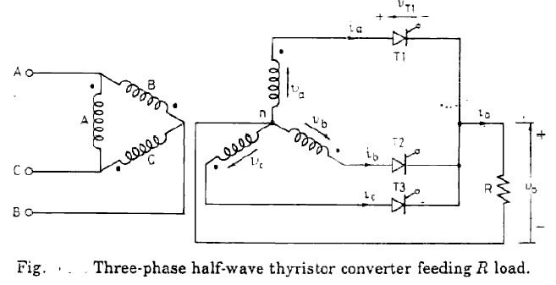
5

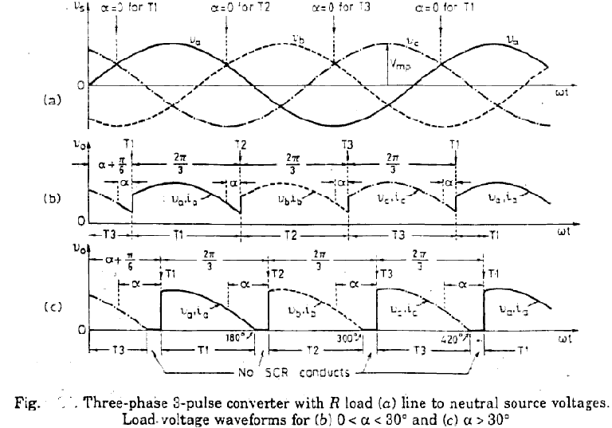
6
Power circuit diagram of this converter is shown in Fig. with resistive load R.. If firing angle is zero degree, SCR T1 would begin conducting from wt = 30⁰ to 150⁰ , T2 from wt = 150⁰ to 270⁰ and T3 from rot = 270⁰ to 390⁰ and so on. In other words, firing angle for this controlled converter would be measured
from wt = 30⁰ for T1, from wt = 150⁰ for T2 and from wt = 270⁰ for T3 as indicated in Fig. (a). For zero degree firing angle delay, thyristor behaves as a diode and the voltage output waveform Vo is as shown in Fig. (c). The operation of this converter is now described for α < 30⁰ and for α > 30⁰.

Firing angle < 30°:
$$V_{0}= \frac{1}{2π/3}\int_{\frac{π}{6}+α}^{\frac{5π}{6}+α}{V_{ml}sinωt dωt= \frac{3}{2π}V_{ml}cosα}$$

Firing angle > 30°:
$$V_{0}= \frac{1}{2π/3}\int_{\frac{π}{6}+α}^{π}{V_{ml}sinωt dωt= \frac{3}{2π}V_{mp}[1+\cos\left(α+30\right)]}$$

Three Phase Three pulse converters with RL load:
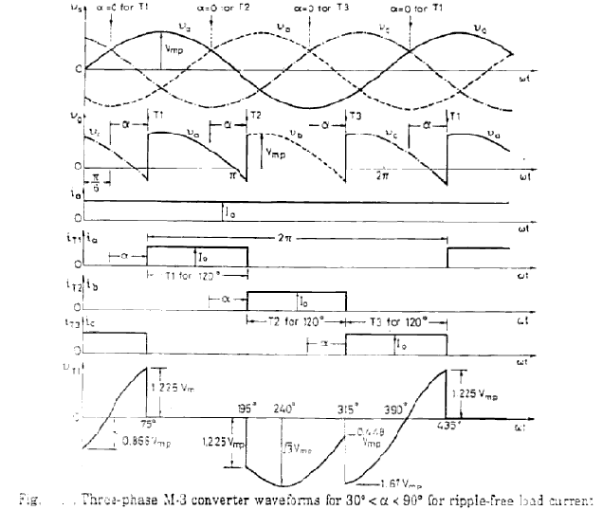
7

In power circuit, load R is now replaced by load RL. The load inductance L is large so that load current is continuous and constant at 1o as shown in Fig.. For firing angle < 30⁰ , Vo is given by Equation derived for R load. For the firing angle range of 30° < α < 90⁰ and 90⁰ < α < 180⁰, this converter behaves differently as described here. 30⁰ < α < 90⁰ • For firing angle in this range, let the firing angle be, say, 45⁰ for which the various waveforms in Fig. are drawn. Note that T1 conducts from 30 + α to 150 + α, T2 from 150 + α to 2700+ α, T3 from 270 + α to 390 and so on. Thus, each SCR conducts for 120⁰.

At wt = 180⁰, phase voltage va is zero, but i_{T1} (or i_{a}) is not zero because of RL load. Therefore. T1 would continue conducting beyond wt = 180⁰. As such , vo = va goes negative beyond wt = 180⁰. When T2 is turned on at wt = 150⁰ + α , load current shifts from T1 to T2 and a voltage Va - Vb appears as reverse bias across T1 to aid its commutation. SCR T2 conducts from (150 + α to (270+ α) and so on. The waveform for ia, ib and ic are as shown in Fig

Average value of output voltage are the same as derived for R load.

Three Phase Full converter:

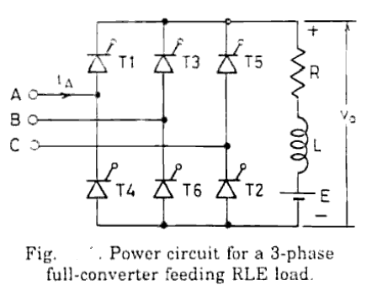
8

A three-phase full ·converter bridge as shown in Fig. For α = 0°, SCRs TI, T2, .... T6 behave as diodes and the output voltage waveform is as shown in Fig. (a ) by Vab, Vac, Vbc etc. In this figure, for α = 0°, Tl is turned on at wt = 600 , T2 at wt = 120°, T3 at wt = 180° and so on. In Fig. (a), therefore, firing angle is measured from wt = 60° for T1, from wt = 120⁰ for T2, from wt = 180⁰ for T3 and so on.

For α = 60°, T1 is turned on at wt = 60 + 60 = 120°, T2 at wt = 180, T3 at wt = 240° and so on. When T1 is turned on at wt 120°, T5 is turned off. T6 is already conducting. As T1 and T6 are connected toA and B respectively, load voltage must be Vab as shown in Fig. (b). When T2 is turned on, T6 is commutated. As T1 and T2 are now conducting, the load voltage is Vac Fig. (b). In this manner, load voltage waveform can be drawn with the turning on or off of other SCRs in sequence. For a = 90°, the load voltage is symmetrical about the reference line wt, therefore its average value is zero. In Fig. (c), load current waveform io is drawn on the assumption that load is pure L. Average output voltage is
$$V_{0}= \frac{1}{π/3}\int_{\frac{π}{3}+α}^{\frac{2π}{3}+α}{V_{ml}sinωt dωt= \frac{3}{π}V_{ml}cosα}$$

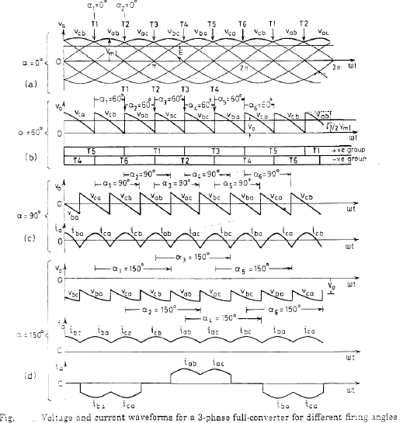
9

Effect of source inductance:
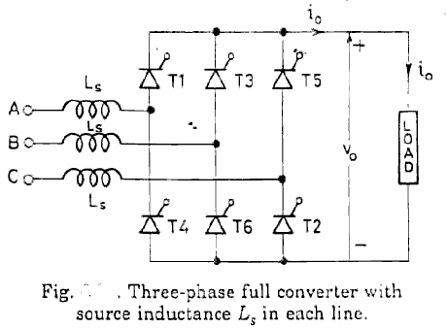
10
Fig. shows a three-phase full-converter bridge with a source inductance Ls in each line. The load current is assumed constant as the analysis with pulsating current is quite complicated.

In Fig. (b) is shown the conduction of various SCRs with firing angle α = 0⁰ and overlap angle μ = 0. In this figure ; T5, T6 conduct up to wt=30• From wt=30 to 90° (i .e. for 60°), T1 , T6 conduct. From wt = 90 to 150°; T1, T2 conduct and so on. It is seen that only two SCRs conduct at a time, one from the positive group and the other from the negative group.

Fig. (c) shows the effect of overlap. From wt = 0° to 30 ; T5, T6 conduct. At wt = 30°, T5 is outgoing SCR and T1 is incoming SCR and both T5 T6 belong to the positive group. As T1 is triggered, current through T5 starts decaying while through T1 current begins to build up. At wt = 30+ μ, I5 is Zero while I1 = I0, Therefore, from wt = 30° to 30+ μ, three SCRs T5, T6, T1 conduct. After wt = 30° + μ T6, T1 conduct. At wt = 90°, as T2 is triggered, I5 begins to decrease and I2 starts to build up. Therefore, from wt = 90 to 90+ μ. three SCRs T6, T1, T2 conduct. At wt = 90° + μ .I6 = 0 and 12 = I0, After wt = 90+ μ. only two SCRs Tl, T2 conduct. This sequence of operation repeats with other SCRs of the full converter. It may be observed from this that when positive group of SCRs are undergoing commutation two SCRs from the positive group and one SCR from the negative group conduct. After the commutation of positive group is completed ; only two SCRs conduct, one from the positive group and the other from the negative group. Similarly, when negative group of SCRs are undergoing commutation, three SCRs conduct, two from the negative group and one from the
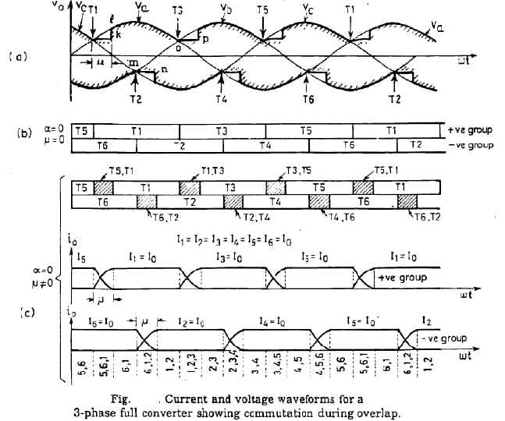
11

positive group and these are followed by two SCRs, one from negative group and one from positive
group and so on. Conduction of various thyristors as shown in Fig. (c) is as follows:
5-6,5-6-1,6-1,6-1-2,1- 2,1-2-3,2-3,2-3-4,3-4, 3-4-5, 4-5, ,4-5- 6, 5-6 and so on.
The effect of source inductance Ls is to reduce the average dc output voltage. Thus, average value of fall in output voltage due to overlap
$$= \frac{3}{π}\int_{0}^{μ}{V_{L}dωt=\frac{3}{π}\int_{0}^{μ}{L_{s}\frac{di}{dt}dωt=\frac{3}{π}\int_{0}^{μ/ω}{ωL_{s}\frac{di}{dt}dt= } } \frac{3ωL_{s}}{π}\int_{0}^{I_{0}}{di= }}\frac{3ωL_{s}}{π}I_{0}$$

Output voltage with overlap, Vox = $\frac{3V_{ml}}{π} cosα- \frac{3ωL_{s}}{π}I_{0}$

Dual Converters:
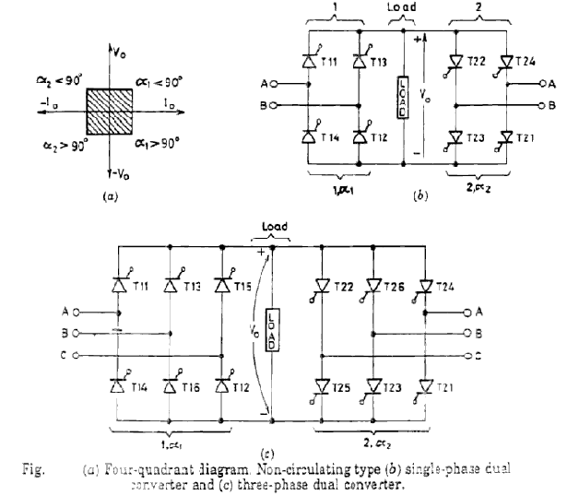
12

Semi-converters are single quadrant converters. This means that over the entire firing angle range, load
voltage and current have only one polarity as shown in Fig. (a ). In this figure, Vo and I0 represent, respectively, the average positive voltage and current of the semi-converter indicating rectification mode and power flow from a source to the de load. In full converters, direction of current cannot reverse because of the unidirectional properties of SCRs but polarity of output voltage can be reversed as shown in Fig. (b). Thus, a full converter operates as a rectifier in first quadrant (both Vo, I0 positive) from α = 0° to 90 and as an inverter (Vo negative but I0 positive) from a = 90° to 180 in the fourth quadrant. This shows that a full converter can operate as a two quadrant converter, Fig. (b ). In the first quadrant, power flows from ac source to the dc load and in fourth quadrant, power flows from dc circuit to the ac source.

There are two functional modes of a dual converter, one is non-circulating-current mode and the other is circulating-current mode. Non-circulating types of dual converters using single-phase and three-phase configurations are shown in Fig. (b) and (c) respectively. If full converter marked I, to the left of load circuit in Fig. (b) and (c), is working alone, operation in first and fourth quadrants can be obtained. With full converter marked 2 working alone in Fig. (b) and (c), polarity of load voltage as well as direction of load current, with respect to converter I , can be reversed. Hence, full converter marked 2 can operate in both second and third quadrants. Thus, a dual converter using two full converters can give four quadrant operation as shown in Fig. (a ).
Dual Converter without Circulating Current:
With non circulating current dual converter, only one converter is in operation at a time and it alone carries the entire load current. Only this converter receives the firing pulses from the trigger control. The other converter is blocked from conduction; this is achieved by removing the firing pulses from this converter. Thus, only one converter is in operation at a time whereas the other converter is idle. Such an arrangement for the dual' converters is shown in Fig. where there is no reactor in· between the two converters.

Suppose converter 1 is in operation and is supplying the load current. For blocking convertor 1 and switching on converter 2, first firing pulse to converter 1 are immediately removed or the firing angle of converter 1 is increased to maximum value and then its firing pulses are blocked. With this, load current would decay to zero and then only converter 2 is made to conduct by applying the firing pulses to it. Now the current in converter 2 would build up through the load in the reverse direction. So long as converter 2 is in operation, converter 1 is idle as firing pulses are withdrawn from it. It should be ensured that during changeover from one converter to the other, the load current must decay to zero. After the outgoing converter has stopped conducting, a delay time of 10 to 20 m sec is introduced before the firing pulses are applied to switch on the incoming converter. This time delay ensures reliable commutation of SCRs in the outgoing converter. If the incoming converter is triggered before the outgoing converter has been completely turned off. a large circulating current would flow between the two converters.

With non-circulating current mode of dual converter. the load current may be continuous or discontinuous. The control circuitry for the dual converter is so designed as to give satisfactory operation during continuous as well as discontinuous load current.
Dual converter with circulating current:
In the circulating current mode of dual converter. a reactor is inserted in-between converters 1 and 2 as shown in Fig. This reactor limits the magnitude of circulating current to a reasonable value.

The firing pulses of the two converters are so adjusted that α1+ α2 = 180". As for example. if firing angle of converter 1 is 60°. then firing angle of converter 2 must be 120°. Therefore, for these firing angles. converter 1 is working as rectifier and converter 2 as an inverter. Though the output voltage at the terminals of both converters 1 and 2 has the same average value and also has the same polarity. their instantaneous output voltage waveforms, however are not similar as shown by Vo1 and Vo2 in Fig. (b). As a consequence of it, circulating current flows between the two converters. This circulating current is limited by the reactor. If the load current is to be reversed. the role of two converters is interchanged. This means that converter1 is now made to act as inverter by making its firing angle greater than 90° and converter 2 is made to work as rectifier by making its firing angle less than 90 such that α1+ α2 = 180• The normal delay period of 10 to 20 m.sec, as required in circulating-current free operation, is not needed here. This makes the dual converter with circulating current operation faster. The main disadvantages of this dual converter are as under :
(i) A reactor is required to limit the circulating current. The size and cost of this reactor may be quite significant at high power levels.
(ii) Circulating current gives rise to more losses in the converters. hence the efficiency and power factor are low.
(iii ) As the converters have to handle load as well as circulating currents, the thyristors for the two converters are rated for higher currents.
In spite of these drawbacks, a dua1 converter with circulating current mode is preferred if load current is to be reversed quite frequently and a fast response is desired in the four-quadrant operation of the dual converter.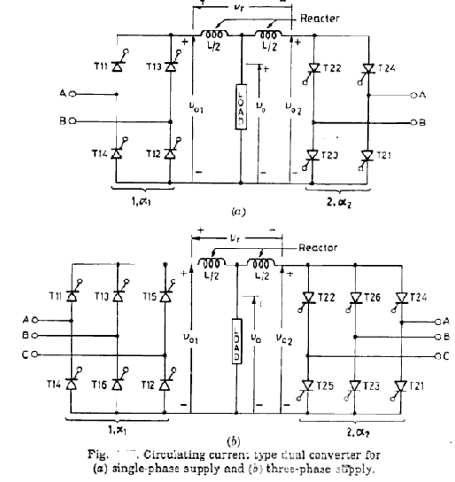
73

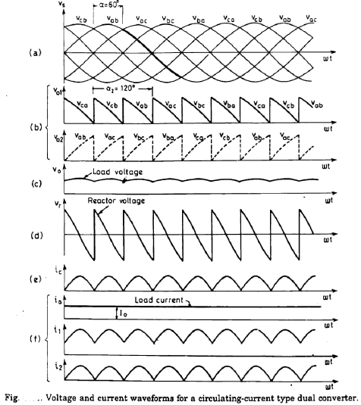
14

ACADEMIC YEAR 2017-2018 – I SEMESTER

Class: III B.Tech. - I sem, EEE (A, B & C) Sub: POWER ELECTRONICS Unit-III
Name of the staff: E.Vargil Kumar/B.Mahesh Babu/K.Santhosh Kumar
Three Phase Converters
Assignment-Cum-Tutorial Questions

SECTION-A
Questions testing the remembering / understanding level of students

- In a three phase half wave controlled rectifier each SCR conduct for maximum of _________ radians.
a) 2π/6 b) 2π c) 2π/3 d) π/3.
- The range of firing angles of a three phase bridge converter with a freewheeling diode is_____
- 0⁰< α < 180⁰ b) 0⁰< α < 150⁰ c) 30⁰< α < 120⁰ d) 0⁰< α < 120⁰
- In a dual converter, under circulating mode_____
- One acts as inverter and other acts as rectifier.
- Both operate as rectifier
- Both operate as Inverter
- None of the above
- The minimum frequency of the output voltage ripple in a three phase half wave uncontrolled rectifier is _________ times the input voltage frequency.
- 1 b) 2 c) 3 d) 6.
- In circulating current type of dual converter, the nature of voltage across inductor is ____
- Alternating b) pulsating c) direct d) Triangular.
- In a Three phase full converter, the number of SCR’s conducting during overlap is____
- 1 b) 2 c) 3 d) 6.
- A three phase ac to dc converter which requires neutral point connection is _____
- Three phase semi converter c) Three phase full converter.
- Three phase half wave converter d) Three phase full converter with diodes
Question testing the ability of students in applying the concepts.
8. The frequency of the ripple in the output voltage of 3-phase semi-converter depends on:
a) Firing angle and load resistance b) Firing angle and load inductance
c) The load circuit parameters d) Firing angle and the supply frequency.
9. A four quadrant operation requires
a)two full converters in series b)two full converters connected in parallel
c)two full converters connected in back to back d)two semi converters connected in back to back.
10. In circulating current mode of dual converter ________ is used to limit current
a) resistor b) capacitor c) reactor d) diode.
11. In non circulating current mode of dual converter α₁ ₊ α₂ is equal to
a) 90 b)120 c)180 d) 360.
12. A three phase semi-converter can work as______
- Converter for α = 0⁰ to 180⁰ c) Converter for α = 0⁰ to 90⁰
- Inverter for α = 0⁰ to 180⁰ d) Inverter for α = 0⁰ to 90⁰.

13. In a three phase semi converter, for firing angle less than equal to 60⁰, freewheeling diode conducts for_________
- 30⁰ b) 60⁰ c) 90⁰ d) 0⁰.

SECTION-B

Questions testing the remembering / understanding level of students

1. A 3-phase full converter is connected to a resistive load. Show that average output voltage
is given by
$V_{o}= \frac{3V_{ml}}{ᴨ}*cosα$ for 0 < α < $\frac{ᴨ}{3}$
$V_{o}= \frac{3V_{ml}}{ᴨ}*(1+\left(\cos\left(α+\frac{ᴨ}{3}\right)\right)$ for $\frac{ᴨ}{3}$< α < $\frac{2ᴨ}{3}$
Where $V_{ml}$is the maximum line voltage.
2. Describe the operation of three phase Half wave controlled rectifier feeding R- load with associated waveforms
3. Compare 3-phase midpoint converter and Bridge type converters and bring out the important features?
4. Describe the operation of 3- phase Half wave controlled rectifier connected to RL-load with the help of necessary circuit diagram and waveforms?
5. Describe the operation of three phase full bridge converter with RL-load?
6. Define Dual converter? Describe the operation of Dual converter?
7. Describe the difference between circulating mode and non- circulating mode operations of Dual converter?
8. Describe the effect of source inductance on the operation of three phase full converter?
9. Describe the operation of Three phase semi converter and also derive the expression for load voltages for firing angle α < 60⁰ and α > 60⁰.

Question testing the ability of students in applying the concepts.

1. A three phase fully controlled thyristor bridge converter supplies a dc voltage source of 400V having an internal resistance of 1.8Ω. Assume highly inductive load with a constant load current of 20A. The supply rms load voltage per phase is 230V and source inductance in each phase is 0.005H. compute the following by ignoring the source resistance.
(a) firing angle for an output voltage of 436V
(b) overlap angle.

2. A three phase half controlled rectifier is supplied at 150V/ph, 50Hz, the source inductance and resistance being 1.2mH and 0.07Ω per phase respectively. Assuming the thyristor voltage drop of 1.5V and continuous load current of 30A, compute the average load voltage at firing angles of 0⁰,30⁰,60⁰.

3. A three phase full converter is supplied from a three phase 230V, 60Hz supply. The load current is continuous and has a negligible ripple. If the average load current is 150A and commutating inductance L_{c} = 0.1mH, determine the overlap angle for firing angles of 0⁰,30⁰,60⁰.
4. A three phase half wave rectifier is supplied at 400V(line). The load current is constant at 40A and is independent of firing angle. Find the average load voltage for the voltage waveform at firing angles of 0⁰ and 30⁰. Given that thyristor has a forward voltage drop of 2V. Find the value of current and peak reverse voltage rating required by the thyristor and what will be the average power dissipation in each thyristor.
[Ans: 23.1A, 565.68V, 26.6W]
5. A three phase half wave controlled rectifier has a supply voltage of 230V/ phase, the thyristors having a voltage drop of 2V and continuous load current. Then calculate the average load voltage for firing angle of 0⁰, 30⁰, 45⁰.
[Ans:266.995V, 230.956V, 188.208V]
6. The three phase half wave controlled rectifier is operated from a three phase Y- connected 230V and 50Hz supply, the load Resistance is 12Ω. if the average output voltage is 30% of maximum possible average voltages, determine:
(a) delay angle (b) average load current [Ans: 88.7115⁰, 3.8825A]
7. A three phase half Wave converter is operated from a 400V and 50Hz supply. The load current is maintained constant at 30A over the firing angle range of 0⁰ and 80⁰. At these two firing angles, compute the power delivered. [Ans: 8.102kW, 1.407kW].
8. A three phase half controlled rectifier is supplied from 140V/ ph and 50Hz supply mains. The source inductance and Resistances are 1.5mH and 0.05Ω respectively. Assume continuous load current of 32A and the thyristor voltage drop of 2V. Determine the average load voltage at firing angles of 30⁰, 45⁰, 60⁰.
[Ans: 132.99V, 106.978V, 73.068V]
9. A three phase full wave converter is operated from 430V and 50Hz supply, the load current is maintained constant at 3000A, neglecting source impedance, then determine the following.
a) firing angle (b) power delivered to load in MW for the output voltage of 560V.
[Ans: 15.345⁰, 1.68MW]
10. A three phase fully controlled bridge converter is connected to 400V, 50Hz supply having a reactance of 0.5Ω / phase and resistance of 0.07Ω/ phase. The converter is working in the inversion mode at a firing advance angle of 35⁰. compute the average generator voltage. assume i_{d} = 70a and the thyristor drop = 2v.
[Ans: 489.96V]
11. A three phase full converter is fed from 400V, 50Hz three phase supply. The load is highly inductive and the average load current is 140A, the firing angle is 45⁰. Determine the
(a) output power (b) Average, rms and peak current through thyristors
(c) peak inverse voltage.
[Ans: 53476.06W, 46.67A, 46.667A, 565.68V]
12. A three phase fully controlled bridge converter is connected to three phase ac supply of 440V, 50Hz and operates with a firing angle of 45⁰. The load current is maintained constant at 9A and the load voltage is 3650V. Determine
(a) source inductance (b) Load resistance (c) overlap angle.
[Ans: 22.29mH, 40Ω, 14.69⁰]
Questions testing the analyzing / evaluating ability of students
1. Draw the load voltage and input current waveforms of Three phase full converter with resistive load, if one of the thyristors in the middle leg stopped working.
2. Find the reduction in load voltage in the above problem.
SECTION-C

previous questions asked in GATE examination:

- A three-phase diode bridge rectifier is feeding a constant DC current of 100 A to a highly inductive load. If three-phase, 415 V, 50 Hz AC source is supplying to this bridge rectifier then the rms value of the current in each diode, in ampere, is _____________.
Ans : 57 to 58 [GATE2016]
- A solar cell of 350V is feeding power to an ac supply of 440V, 50Hz through a three phase fully controlled Bridge converter. A large inductance is connected in the dc circuit to maintain the dc current of 20A. if the solar cell resistance is 0.5Ω, then each thyristor will be reverse biased for a period of ___________ [GATE2006]
a)125⁰ b) 120⁰ c) 60⁰ d) 55⁰.
3. A three phase diode bridge rectifier is fed from a 400V RMS, 50Hz, Three phase AC source, If the load is purely resistive, the peak instantaneous output voltage is equal to
________ 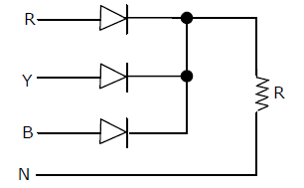
- 400V b) 400*$\sqrt{2}$ V c) 400* $\sqrt{\frac{2}{3}}$ V d) 400* $\sqrt{\frac{1}{3}}$ V.

4. In the given circuit, if the supply frequency is 400Hz, then ripple frequency at the output voltage is _______________ [GATE2004]
a) 400Hz b) 800Hz c) 1200Hz d) 2400Hz

INSTRUCTORS
E.Vargil Kumar (Associate professor)
B. Mahesh Babu (Assistant professor)
K. Santhosh Kumar (Assistant professor)

ACADEMIC YEAR 2017-2018 – I SEMESTER

Class: III B.Tech. - I sem, EEE (A, B & C) Sub: POWER ELECTRONICS Unit-IV
Name of the staff: E.Vargil Kumar/B.Mahesh Babu/K.Santhosh Kumar
AC Voltage Controllers & Cyclo converters
Assignment-Cum-Tutorial Questions

SECTION-A
Questions testing the remembering / understanding level of students
1. In a voltage controller feeding RL load, the rms value of load voltage depends on
a) Firing angle b) impedance angle only c) both a and b d) firing angle, impedance angle and value of the impedance.
2. A single phase A.C. voltage controller feeds an pure resistive load. The thyristors are fired at an angle of α in the range of 0⁰ to 180⁰. The circuit turn off time of the thyristor corresponds to an angle of _________
a) 180⁰ b) α⁰ c) 180⁰- α⁰ d) α⁰- 180⁰.
3. The output frequency of cyclo-converter is less than the input frequency for____
a) containing commutation failure. b) preventing commutator failure
c) reducing switching failure d) reducing distortion.
4. A single phase voltage controller using two SCRs in anti-parallel is found to be operating as controlled rectifier. This is because
a) load is R and pulse gating is used.
b) load is R and high frequency carrier gating is used.
c) load is RL and pulse gating is used.
d) load is RL and continuous gating is used.
5. The disadvantage of a cycloconverter is that it has______
a) a very low power factor b) a distorted load current
c) no regeneration capability d) increased harmonic effects at low frequencies.
6. In a single phase A.C. voltage controller, the angle of extinction β which extends beyond ᴨ depends on ___________
a) on the load inductance b) on the current through the circuit
c) on the energy stored in the inductor till ωt= ᴨ.
d) on the maximum instantaneous current in the circuit.
7. The purpose of intergroup reactor in a cyclo converter is to _______________
a) limit the distortion of output voltage.
b) limit the circulating currents.
c) improve the transient behaviour of the load converter.
d) facilitate voltage control.

Question testing the ability of students in applying the concepts.
7. The cyclo converter is a frequency converter from
a. higher to lower frequency with one stage conversion.
b. higher to lower frequency with two stage conversion
c. lower to higher frequency with one stage conversion.
d. ac at one frequency to dc and then dc to ac at different frequency.
From these , the correct statements are_____
- 2,4 b) 1only c) 2,3 d) 1,3.
8. The cyclo converter requires natural and forced commutation as under:
- Natural commutation in both step up and step down.
- Forced commutation in both step up and step down.
- Forced commutation in step up.
- Forced commutation in step down.
9. A 3-phase to 3-phase cycloconverter requires
a. 18SCRs for 3-pulse device.
b. 18SCRs for 6-pulse device
c. 36SCRs for 3-pulse device
d. 36SCRs for 6-pulse device.
From these the correct statements are_______
- 1,3 b) 2,3 c) 2,4 d) 1,4.
9. In a single phase voltage controller with RL-Load, ac output power can be controlled if,
a) firing angle α > Φ(load angle) and conduction angle γ = ᴨ.
b) α > Φ and γ < ᴨ
c) α < Φ and γ = ᴨ
d) α < Φ and γ > ᴨ.
10. In a single phase voltage controller feeding an RL- load, when
1. firing angle α < Φ , load voltage V₀ is sinusoidal.
2. firing angle α > Φ , load voltage V₀ is non- sinusoidal.
3. firing angle α < Φ , load voltage V₀ is non- sinusoidal.
4. firing angle α = Φ , load voltage V₀ is sinusoidal.
From these the correct statements are_______
a) 2,3,4 b) 1,3,4 c) 1,2,4 d) 1,4.
11. A purely inductive load is controlled by a single phase ac voltage controller using back to back connected SCRs. If firing angle of each SCR is 75⁰, the current through two SCRs will flow for________
a) 180⁰ and 180⁰. B) 160⁰ and 160⁰ c) 100⁰ and 100⁰ d) 160⁰ and 0⁰.
12. When a single phase ac voltage controller supplies power to an inductive load, control is lost if:
a) α < β - ᴨ b) α = β c) α > β - Φ d) α = β – Φ.
SECTION-B

Questions testing the remembering / understanding level of students

- With relevant waveforms Describe the operation of single phase full wave voltage controllers for Resistive load?
- Derive the expressions for RMS output voltage and input power factor for a full wave voltage controller with R and RL- load?
- For a Single phase full wave voltage controller with both R and RL load, Draw the load and source current wave forms?
- Describe different control strategies for regulating power flow in ac voltage controller?
- Describe the operation of Integral cycle control of AC voltage regulators? Derive the expressions for RMS value of load voltage , input power factor, average and RMS values of Thyristor currents?
- What is cycloconverter? Describe about different types of cycloconverters?
- With relevant diagrams Describe about Bridge type Step down cyclo converter with R and RL- Load?
- With relevant diagrams Describe the Mid- point Step down cyclo converter with R and RL- Load?
- Enumerate the merits and demerits of AC voltage controllers and cyclo converters?

Question testing the ability of students in applying the concepts.
1. A single phase full wave AC voltage controller feeds a load of R = 20Ω with input voltage of 230V, 50Hz. Firing angle for both the thyristors is 45⁰. Calculate the rms value of output voltage , load power factor, input power factor, average and RMS values of thyristor current.
[Ans: 219.304V, 2404.71W,0.9535 lag 4.418A, 7.736A]
2. A single phase voltage controller has input voltage of 230V, 50Hz and a load of R= 15Ω. For 6 cycles ON and 4 cycles OFF, determine
(a) rms output voltage (b) input powerfactor (c) average and rms thyristor currents.
[Ans: 178.157V, 0.7746 lag, 4.1407A, 8.397A]
3. A single phase AC voltage controller, fed from 230V, 50Hz source, is feeding an RL load with R= 4Ω and X_{L} = 6Ω. For a firing angle of 120⁰ , calculate the extinction angle and rms value of output voltage?
[Ans: 220⁰, 117.482V]
4. A single phase bridge type cycloconverter has input voltage of 230V, 50Hz and load of R=10Ω. Output frequency is one third of input frequency. For a firing angle delay of 30⁰, calculate (a) rms output voltage (b) rms current of each converter (c) rms current of each thyristor (d) input powerfactor.
[Ans: 266.66V, 16.03A, 11.335A, 0.9856 lag]
5. A single phase mid- point cycloconverter has a source voltage of 230V, 50Hz and load is 20Ω. Find the power delivered to load for firing angles of 0⁰ and 30⁰ [Ans: 5290W, 5136.01W]

Questions testing the analyzing / evaluating ability of students
1. A single phase full wave AC voltage controller is supplying R – load. Draw the load voltage and current waveforms if one of the thyristors stopped working suddenly.
2. In the above case, find the reduction in power delivered to load.
3. Draw the input and load current waveforms if freewheeling diode is connected across a load in single phase full wave AC voltage controller supplying RL-load.

SECTION-C

previous questions asked in GATE examination:

- A single-phase SCR based ac regulator is feeding power to a load consisting of 5W
resistance and 16 mH inductance. The input supply is 230 V, 50 Hz ac. The maximum firing
angle at which the voltage across the device becomes zero all throughout and the rms value of
current through SCR, under this operating condition, are [GATE 2014]
(A) 300 and 46 A (B) 300 and 23 A (C) 450 and 23 A (D) 450 and 32 A

INSTRUCTORS
E.Vargil Kumar (Associate professor)
B. Mahesh Babu (Assistant professor)
K. Santhosh Kumar (Assistant professor)

Class: III B.Tech. - I sem, EEE (A, B & C) Sub: POWER ELECTRONICS Unit-V
Name of the staff: E.Vargil Kumar/B.Mahesh Babu/K.Santhosh Kumar
Choppers and Commutation Circuits
Assignment-Cum-Tutorial Questions

SECTION-A
Questions testing the remembering / understanding level of students

1. A step up chopper has input voltage 110 V and output voltage 150 V. The value of duty
cycle is
a) 0.32 b) 0.67 c) 0.45 d) 0.27.
2. In DC chopper input and output voltages are ___________
a) continuous and discontinuous b) continuous and continuous
c) discontinuous and discontinuous d) discontinuous and continuous
3. In frequency modulation method of controlling the average output voltage in a chopper,
1. T_{ON} is kept constant and time period is varied
2. T_{OFF} is kept constant and time period is varied
3. T_{ON} is kept constant and T_{OFF} is varied
4. T_{OFF} is kept constant and T_{ON} is varied.
From the above statements which is right.
a) 1,3,4 b) 2,3,4 c) 1,2,3,4 d) 1,2,3.
4. A step down chopper has V_{s} is the source voltage, R is the load resistance and α is the duty cycle. The average output voltage of the chopper is ____
a) α* V_{s} b)(1- α)* V_{s} c) V_{s} /(1-α) d) V_{s} *$\sqrt{α}$
5. A chopper can be used on
a) pulse width modulation only b) frequency modulation only
c) amplitude modulation only d) both PWM and FM.
6. Other name for class- C commutation is_____________
a) complementary commutation b) impulse commutation
c) resonant pulse commutation d) Load commutation
7. Other name for class- B commutation is_____________
a) complementary commutation b) impulse commutation
c) resonant pulse commutation d) Load commutation.
Question testing the ability of students in applying the concepts.
8. A step up chopper has V_{s} is the source voltage, R is the load resistance and α is the duty cycle. The average output voltage of the chopper is ____
a) α* V_{s} b)(1- α)* V_{s} c) V_{s} /(1-α) d) V_{s} *$\sqrt{α}$
9. A step down chopper has V_{s} is the source voltage, R is the load resistance and α is the duty cycle. The RMS output voltage of the chopper is ____
a) α* V_{s} b)(1- α)* V_{s} c) V_{s} /(1-α) d) V_{s} *$\sqrt{α}$
10. when a series LC circuit is connected to DC supply of V volts through a thyristor, then peak current through thyristor is __________
a) V.$\sqrt{LC}$ b) V.$\sqrt{L/C}$ c) V.$\sqrt{C/L}$ d) V/.$\sqrt{LC}$.
11. In DC chopper, the load voltage is governed by______
a) number of switches used in the circuit.
b) duty cycle of the circuit
c) DC voltage applied to the circuit.
d) none of the above.
SECTION-B

Questions testing the remembering / understanding level of students

1. Explain about different control strategies employed in chopper circuits?
2. Define chopper? Explain the principle of operation of chopper and derive the expression for its average output voltage?
3. Define commutation? Explain about different types of commutation circuits?
4. With relevant diagrams explain the operation of Voltage commutated chopper?
5. For a Type- A chopper with RLE load, derive the expressions for average voltage, ripple in the load current, maximum and minimum load current.
6. Explain the operation of step up chopper. Derive the expression for load voltage, load current, equivalent Resistance seen by the source?
7. For a Type- A chopper with R and RL load, derive the expressions for average voltage, average and rms values of load current.
Question testing the ability of students in applying the concepts.
1. A step down chopper, fed from 220V dc, is connected to RL load with R= 10Ω and L= 150mH. Chopper frequency is 1250Hz and duty cycle is 0.5. Calculate the (a) maximum and minimum values of load current (b) ripple current.
[Ans : 12.478A, 9.56A, 2.918A]
2. A step up/ step down chopper has DC voltage of 220V and output voltage of 660V. If the conduction time of thyristor is 120μsec. Compute the pulse width of load voltage.
In case pulse width of load voltage is increased to three times of its previous width, for constant frequency operation, calculate the new value of average output voltage?
[Ans : 40μsec, 73.33V]

4. A DC battery is to be charged from a constant DC source of 220V. The DC battery is to be charged from its internal emf 90V to 122V. The battery has internal resistance of 1Ω. For a constant charging current of 10A, compute the range of duty cycle.
[Ans : 0.4545 to 0.6]
5. For a basic step down DC- DC converter, express the following variables as function of V_{S} , R and duty cycle α in case of load resistive:
a) Average output voltage and current
b) output current at the time of commutation.
c) average and RMS value of freewheeling diode currents.
d) RMS value of the output voltage.
e) RMS and average thyristor currents.
f) Effective output input resistance of the chopper.

6. For Type- A chopper DC source voltage is 230V, load resistance is 10Ω. Take the voltage drop of 2V across chopper when it is ON. For a duty cycle of 0.4, calculate
a) average and RMS value of output voltage.
b) chopper efficiency. [Ans : 91.2V, 144.2V, 99.13% ]

7. A type – A chopper has input voltage of 200V and a load of 10Ω in series with inductance of 80mH. If load current varies linearly between 12A and 16A, find the time ratio T_{ON}/ T_{OFF} for this chopper.
[Ans : 2.333]

8. For a type –A chopper, source voltage is 220V, chopping frequency f= 500Hz, T_{ON} = 500μsec, R= 1Ω, L= 1mH, E= 72V.
a) Find the values of average output voltage and average output current.
b) Find whether load current is continuous or not.
c) compute the maximum and minimum of values of steady state output current.
d) sketch the time variations of gate signal i_{g} , load current i_{o}, load voltage V_{o}, thyristor current i_{T}, free wheeling diode current i_{fd}, and voltage across thyristor V_{T}.
[Ans : 103.95V,31.95A,0A, 81.5A]

Questions testing the analyzing / evaluating ability of students
1. Draw the load voltage and Load current waveforms when Duty ratio of switch becomes unity in step down converter? Compare theoretical and practical waveforms.
2. What happens if freewheeling diode fails in step down converter?
3. A current commutated chopper is fed from a dc source of 230V, Its commutating components are L= 20μH and C= 50μF. If load current is 200A and constant during the commutating process, then compute (a) Turn off time of main thyristor (b) Total commutation interval (c) Turn off time of auxillary thyristor.
[Ans : 62.52μsec, 239.427μsec, 80.931μsec]
4. In the following figure, suppose capacitor C is charged to 50V with lower plate positive, switch S is closed at t=0. The final voltage across C is _____. [Ans: 250V]
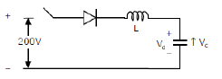
SECTION-C

previous questions asked in GATE examination:

1. For the switching converter shown in the following figure, assume steady-state operation. Also assume that the components are ideal, the inductor current is always positive and continuous and switching period is T5. If the voltage VL is as shown, the duty cycle of the Switch is ___________[GATE 2015]
Ans: 0.75.
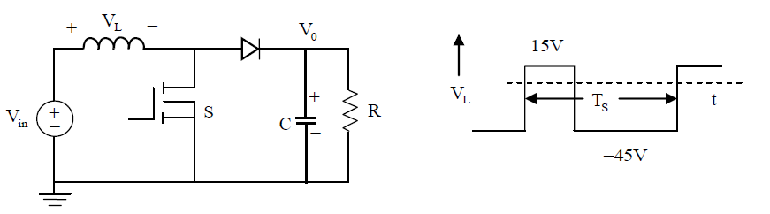
2. A buck converter feeding a variable resistive load is shown in the figure. The switching frequency of the switch S is 100 kHz and the duty ratio is 0.6. The output voltage V0 is 36V. Assume that all the components are ideal, and that the output voltage is ripple-free. The value of R (in Ohm) that will make the inductor current (i_{L}) just continuous is_______________ [GATE 2015]
Ans: 1250
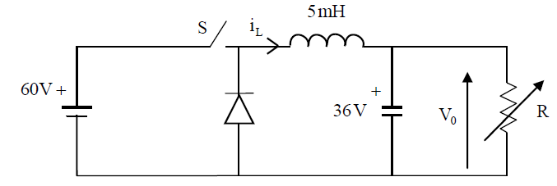
3. A step-up chopper is used to feed a load at 400 V dc from a 250 V dc source. The inductor current is continuous. If the ‘off’ time of the switch is 20μs, the switching frequency of the chopper is kHz is __________.
Ans : 31.25

4. A voltage commutation circuit is shown in Figure. If the Turn off time of SCRs is 50μs and safety margin of 2 is considered, then what will be the approximate minimum value of capacitor is required for proper commutation?
Ans: [GATE 2006]

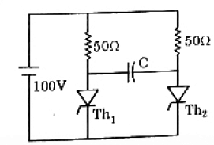

5. A voltage commutated chopper operating at 1KHz is used to control the speed of dc motor as shown in Figure. The load current is assumed to be constant at 10A.
[GATE 2006]

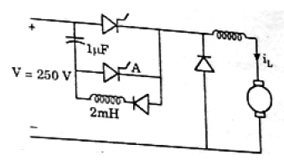
Find the minimum time in μsec for which SCR M should be ON is_____
- 280 b) 140 c) 70 d) 0.

Find the average output voltage of chopper?
- 70V b) 47.5V c) 35V d) 0V

6. A self commutating switch SW, operated at duty cycle δ is used to control the load voltage as shown in the figure. Under steady state operating conditions, the average voltage across the inductor and the capacitor respectively, are [GATE 2015]
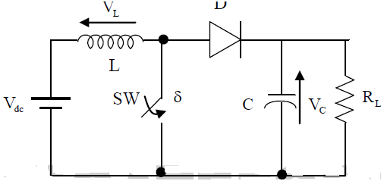
- V_{L}= 0 and V_{C} = $\frac{V_{dc}}{1- δ}$ c) V_{L}= 0 and V_{C} = $\frac{δ*V_{dc}}{1- δ}$
- V_{L}= $\frac{δ}{2}*$ V_{dc} and V_{C} = $\frac{V_{dc}}{1- δ}$ d) V_{L}= $\frac{δ}{2}*$ V_{dc} and V_{C} = $\frac{{δ*V}_{dc}}{1- δ}$

INSTRUCTORS
E.Vargil Kumar (Associate professor)
B. Mahesh Babu (Assistant professor)
K. Santhosh Kumar (Assistant professor)

Class: III B.Tech. - I sem, EEE (A, B & C) Sub: POWER ELECTRONICS Unit-VI
Name of the staff: E.Vargil Kumar/B.Mahesh Babu/K.Santhosh Kumar
Inverters
Assignment-Cum-Tutorial Questions

SECTION-A
Questions testing the remembering / understanding level of students
1. In a single pulse modulation, third harmonics can be eliminated only when pulse width is ______
a) 30⁰ b) 60⁰ c) 120⁰ d) 150⁰
2. If V_{r} and V_{c} are the magnitudes of reference and control signal(carrier signal), then modulation index is given as ______________
a) $\sqrt{\frac{V_{c}}{V_{r}}}$ b) $\sqrt{\frac{V_{r}}{V_{c}}}$ c) $\frac{V_{c}}{V_{r}}$ d) $\frac{V_{r}}{V_{c}}$
3. The output voltage waveform of square wave inverter consist of __________
a) odd harmonics b) even harmonics c) both even and odd harmonics d) triplen harmonics.
4. The main drawback of series inverter is _____________
5. The purpose of freewheeling diode in voltage source inverter is ____________
a) to provide the path for current when no thyristor is conducting or the conducting thyristor is turned off
b) to provide path for excess commutating current.
c) to effectively provide reverse bias to the thyristor.
d) All the above.
6. A parallel inverter feeds a pure inductor load. The load current and load voltage waveforms are__________
a) both square waves
b) the former is triangular wave whereas the latter is a square wave.
c) the former is square wave whereas the latter is a triangular.
d) both are triangular.
Question testing the ability of students in applying the concepts.
7. A single phase voltage source square wave inverter feeds pure inductive load, the waveform of the load current will be _________
a) Sinusoidal b) rectangular c) Trapezoidal d) triangular.
8. Inverter gain is given by____________
a) $\frac{DC output voltage }{AC input voltage}$ b) $\frac{DC output voltage }{DC input voltage}$ c) $\frac{AC output voltage }{AC input voltage}$ d) $\frac{AC output voltage }{DC input voltage}$
9. A single phase full bridge inverter operates in Load commutation mode in case load consist of ______________
a) RL b) RLC under damped c) RLC over damped d) RLC critically damped
10. A time margin for series inverter ensures
a) low power loss b) safety of the device c) improved power factor d) absence of harmonics.

11. A voltage source is normally employed
a) when the load and source has very low inductance.
b) when the load has small inductance and source has large inductance.
c) when the load has large inductance and source has small inductance.
d) when the load and source has large low inductance.
12. In a voltage source inverter________
a) both load current and load voltage depends on load impedance.
b) the load voltage independent of load impedance whereas load current depends on load
impedance.
c) both load current and load voltage independent of load impedance.
d) the load current independent of load impedance whereas load voltage depends on load impedance.

SECTION-B

Questions testing the remembering / understanding level of students

1. What is an inverter? List a few applications of inverter?
2. Describe the working of a single phase half bridge inverter. What is its main drawback?
3. Describe the working of single phase Full bridge inverter. List the merits and demerits of
Full bridge inverter over Half bridge inverter?
4. Describe the operation of series inverter? Enumerate its drawbacks?
5. Describe the operation of parallel inverter?
6. Describe about internal control of inverter?
7. Describe different control strategies used in PWM inverter?
8. Describe 120⁰ mode operation of three phase inverter? Draw the line and phase voltage waveforms?
9. Describe 180⁰ mode operation of three phase inverter? Draw the line and phase voltage waveforms?
Question testing the ability of students in applying the concepts.
1. A single phase half bridge inverter has a load of 2Ω and DC source of V_{S} is 230V. Calculate the rms value of load voltage and power delivered to load?
2. A single phase Full bridge inverter has a load of 10Ω and DC source of V_{S} is 220V. Calculate the rms value of load voltage and power delivered to load? Repeat the same problem for Half bridge inverter.
Questions testing the analyzing / evaluating ability of students
1. What happens if two switches in the same leg of inverter operate simultaneously. Explain the significance of dead time ?
2. Enumerate the merits and demerits of 120⁰ mode operation over 180⁰ mode. Identify the dominant harmonic in pole, phase, line voltages by using Fourier series.

SECTION-C

previous questions asked in GATE examination:

- In a Three phase Inverter as shown below, the load is balanced and firing scheme is 180⁰ mode. All the Switches are ideal. DC input voltage is 300V.
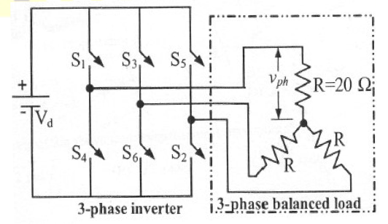
The R.M.S value of the load phase voltage is __________________
- 106.1V b) 141.4V c) 212.2V d) 282.8V

- Find the power consumed by load is ____________
- 1500W b) 2000W c) 2500W d) 3000W.

- A single-phase voltage source inverter shown in figure is feeding power to a load. The
triggering pulses of the devices are also shown in the figure.
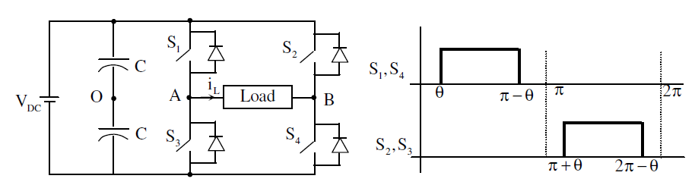
If the load current is sinusoidal and is zero at 0, x, 2x...., the node voltage VAO has the
Waveform [GATE2014]
Ans: D
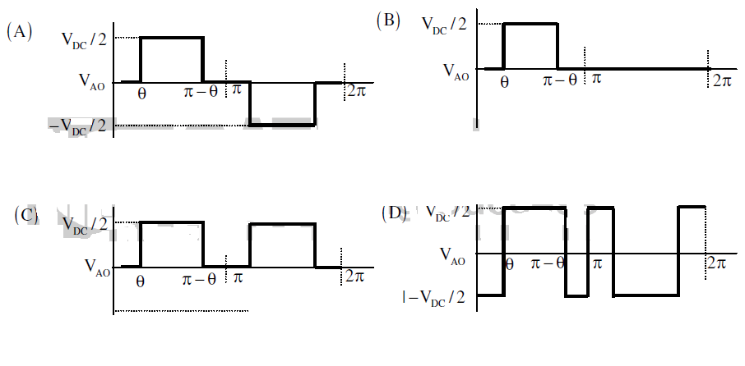
- A single-phase full-bridge voltage source inverter (VSI) is fed from a 300 V battery. A pulse of 120o duration is used to trigger the appropriate devices in each half-cycle. The rms value of the fundamental component of the output voltage, in volts, is
[GATE2014]
(A) 234 (B) 245 (C) 300 (D) 331.

- A three-phase Voltage Source Inverter (VSI) as shown in the figure is feeding a delta connected resistive load of 30 Ω/phase. If it is fed from a 600 V battery, with 180o conduction of solid-state devices, the power consumed by the load, in kW, is __________.
Ans : 24 [GATE2016]
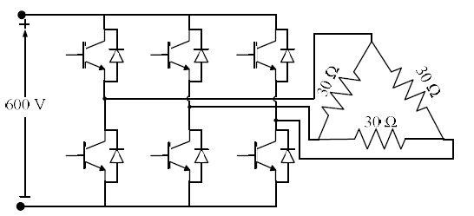

- A single phase inverter is operated in PWM mode generating a single pulse of width 2d in the centre of each half cycle as shown in figure. It is found that the output voltage is free from 5th harmonic for pulse width of 1440. What will be the percentage of 3rd harmonic present in the output voltage (V03/ V01max) ? [GATE 2006]
- 0.0 % b) 19.6% c) 31.7% d) 53.9%
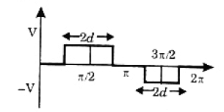

- The output voltage waveform of a three phase square wave inverter contains___________
[GATE2005]
- Only even harmonics c) both odd and even harmonics
- Only odd harmonics d) only triplen harmonics.

INSTRUCTORS
E.Vargil Kumar (Associate professor)
B. Mahesh Babu (Assistant professor)
K. Santhosh Kumar (Assistant professor)

