UNITV-I
3-Phase Transformers

Three Phase Transformers
Usually power is generated and distributed in three phase system, and therefore it is obvious that we would need three phase transformers to step up and step down voltages. Although, it is practically possible to use three suitably interconnected 'single phase transformers' instead of one 'three phase transformer', the following advantages of three phase transformers encourage their use -
- One 'three phase transformer' occupies less space than a gang of three 'single phase transformers'.
- Single 'three phase' unit is more economical
- The overall bus-bar structure, switchgear and installation of 'three phase transformer' is simpler.

Construction of three phase transformer
Three phase transformers can be of core type or shell type (just like single phase transformers). The constructional details of core type as well as shell type three phase transformers are as follows.

Core type construction
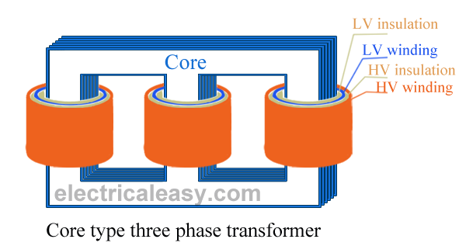
The construction of a core type three phase transformer is as shown in the figure. The core consists of three legs or limbs. As usual, the core is made up of thin laminated sheets to reduce eddy current losses. Each limb has primary and secondary windings in cylindrical shape (former wound) arranged concentrically. The construction is well illustrated in the figure.

Shell type construction
In a shell type three phase transformer, three phases are more independent than they are in core type. Each phase has its individual magnetic circuit. The construction of shell type three phase transformer is illustrated in the figure at right. The construction is similar to that of three single phase shell type transformers kept on the top of each other.
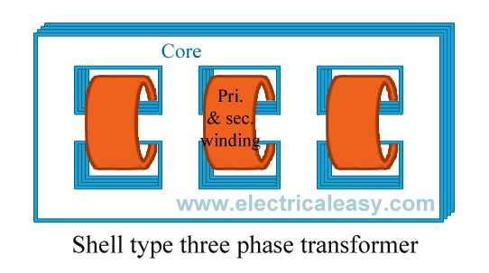
The basic working principle of a three phase transformer is similar to the working principle of a single phase transformer. Power from primary is transferred to the secondary by the phenomenon of mutual induction.
The main drawback in a three phase transformer is that, even if fault occurs in one phase, the whole transformer is removed from service for repairs.

Three Phase Transformer Connections
Three phase transformer connections In three phase system, the three phases can be connected in either star or delta configuration. In case you are not familiar with those configurations, study the following image which explains star and delta configuration. In any of these configurations, there will be a phase difference of 120° between any two phases.

Three phase transformer connections
Windings of a three phase transformer can be connected in various configurations as (i) star-star, (ii) delta-delta, (iii) star-delta, (iv) delta-star, (v) open delta and (vi) Scott connection. These configurations are explained below.

Star-star (Y-Y)
- Star-star connection is generally used for small, high-voltage transformers. Because of star connection, number of required turns/phase is reduced (as phase voltage in star connection is 1/√3 times of line voltage only). Thus, the amount of insulation required is also reduced.
- The ratio of line voltages on the primary side and the secondary side is equal to the transformation ratio of the transformers.
- Line voltages on both sides are in phase with each other.
- This connection can be used only if the connected load is balanced.

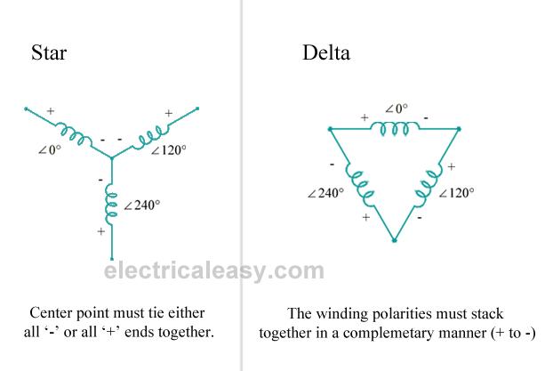

Delta-delta (Δ-Δ)
- This connection is generally used for large, low-voltage transformers. Number of required phase/turns is relatively greater than that for star-star connection.
- The ratio of line voltages on the primary and the secondary side is equal to the transformation ratio of the transformers.
- This connection can be used even for unbalanced loading.
- Another advantage of this type of connection is that even if one transformer is disabled, system can continue to operate in open delta connection but with reduced available capacity.

Star-delta OR wye-delta (Y-Δ)
- The primary winding is star star (Y) connected with grounded neutral and the secondary winding is delta connected.
- This connection is mainly used in step down transformer at the substation end of the transmission line.
- The ratio of secondary to primary line voltage is 1/√3 times the transformation ratio.
- There is 30° shift between the primary and secondary line voltages.

Delta-star OR delta-wye (Δ-Y)
- The primary winding is connected in delta and the secondary winding is connected in star with neutral grounded. Thus it can be used to provide 3-phase 4-wire service.
- This type of connection is mainly used in step-up transformer at the beginning of transmission line.
- The ratio of secodary to primary line voltage is √3 times the transformation ratio.
- There is 30° shift between the primary and secondary line voltages.
Above transformer connection configurations are shown in the following figure.

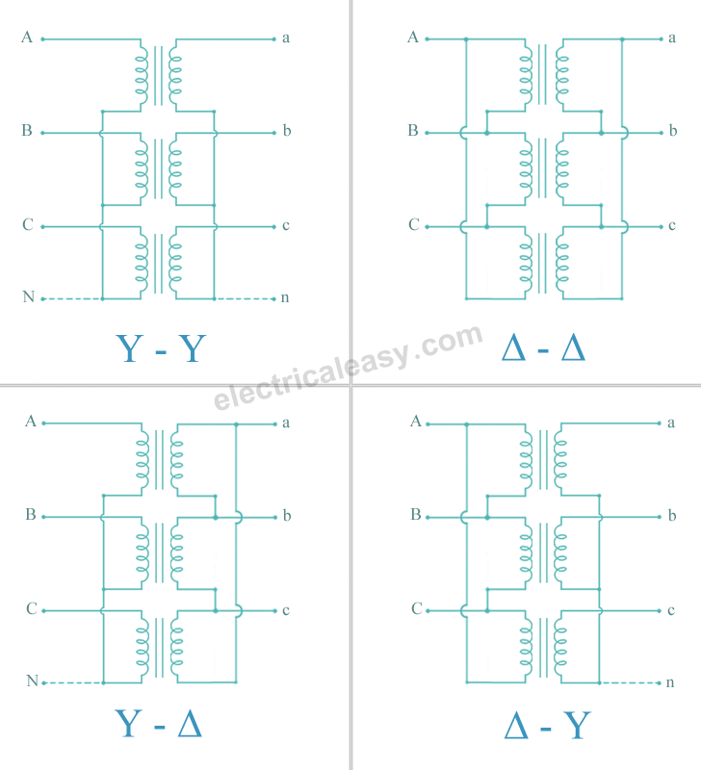

Open Delta or V-Connection
As seen previously in connection of three single phase transformers that if one of the transformers is unable to operate then the supply to the load can be continued with the remaining tow transformers at the cost of reduced efficiency. The connection that obtained is called V-V connection or open delta connection.
Consider the Fig. 1 in which 3 phase supply is connected to the primaries. At the secondary side three equal three phase voltages will be available on no load.
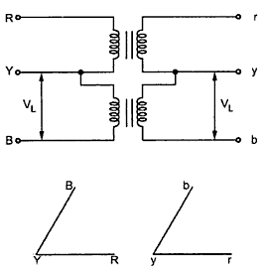
Fig. 1
The voltages are shown on phasor diagram. The connection is used when the three phase load is very very small to warrant the installation of full three phase transformer.
If one of the transformers fails in ∆ - ∆ bank and if it is required to continue the supply even though at reduced capacity until the transformer which is removed from the bank is repaired or a new one is installed then this type of connection is most suitable.
When it is anticipated that in future the load increase, then it requires closing of open delta. In such cases open delta connection is preferred.
Key point : It can be noted here that the removal of one of the transformers will not give the total load carried by V - V bank as tow third of the capacity of ∆ - ∆ bank.
The load that can be carried by V - V bank is only 57.7% of it. it can be proved as follows.
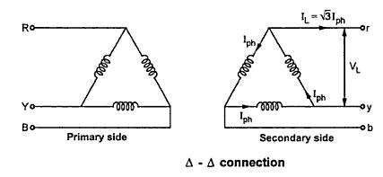
Fig. 2(a)

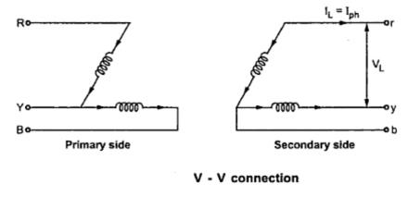
Fig. 2(b)
It can be seen from the Fig. 2(a)
∆ - ∆ capacity = √3 V_{L} I_{L} = √3 V_{L} (√3 I_{ph} )
∆ - ∆ capacity = 3 V_{L} I_{ph} ............(i)
It can also be noted from the Fig. 2(b) that the secondary line current I_{L} is equal to the phase current I_{ph}.
V- V capacity = √3 V_{L} I_{L} = √3 V_{L} I_{ph} ...............(ii)
Dividing equation (ii) by equation (i)
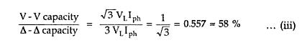
Thus the three phase load that can be carried without exceeding the ratings of the transformers is 57.5 percent of the original load. Hence it is not 66.7 % which was expected otherwise.
The reduction in the rating can be calculated as {(66.67 - 57.735)/(57.735)}x 100 = 15.476
Suppose that we consider three transformers connected in ∆ - ∆ fashion and supplying their rated load. Now one transformer is removed then each of the remaining tow transformers will be overloaded. The overload on each transformer will be given as,
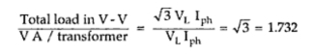

Key point : This overload can be carried temporarily if provision is made to reduce the load otherwise overheating and breakdown of the remaining tow transformers would take place.

Third Harmonics in 3-Phase Transformer Operation
It was shown in Section 5-3 that the sinusoidal flux in iron cores requires a third-harmonic component in the exciting current, which, although small in relation to the rated current, may produce undesirable effects in 3-phase transformer operation.
Consider three identical unloaded, single-phase transformers connected wye-wye to a 3-phase generator with their primary neutral connected to the generator neutral as shown in Fig. 6-32. The sum of the instantaneous currents flowing in the primary must equal zero, i.e.
The fundamental components, as well as harmonics - not including the third and multiples thereof, are 120° apart, and, being of equal amplitudes, their sum is
where the subscript h stands for the order of the harmonics 1, 5, 7, 11, but not for 3, 9, 15, etc. It should be remembered that harmonics in the exciting current of an iron-core transformer are odd for sinusoidal flux when there is no d-c component of flux. It follows from Eqs. 6-94 and 6-95 that the neutral current in the unloaded transformers, or in such as deliver balanced sinusoidal 3-phase currents, is comprised of third-harmonic current, which is the sum of the third harmonics in the three phases, thus
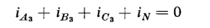
or
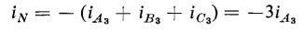
Figures 6-33(a), 6-33(b), and 6-33(c) show balanced 3-phase waves that are comprised of a fundamental and a third harmonic. The sum of the three
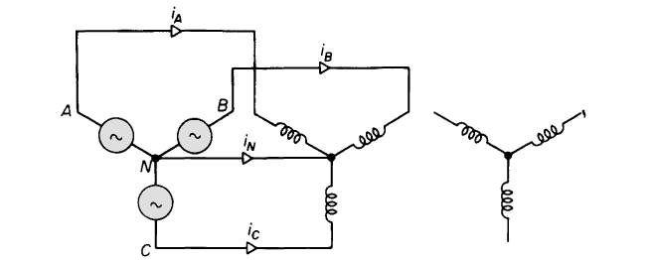
. Exciting currents and neutral current in wye-wye transformer connection.

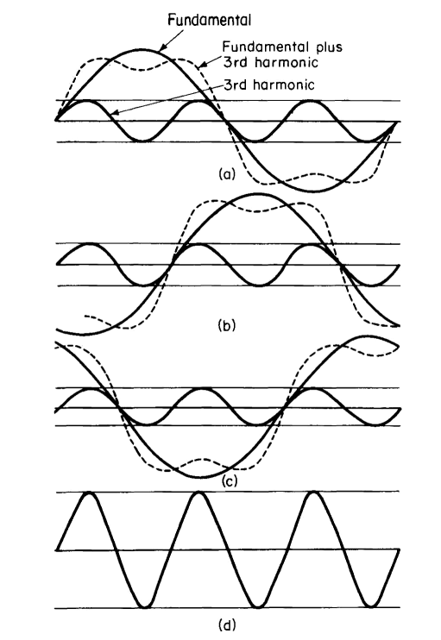
Balanced 3-phase waves containing a fundamental and a third harmonic component, (d) Sum of the three waves of (a), (b), and (c).
balanced waves is shown in Fig. (d) and is a pure third harmonic having an amplitude equal to three times that of the third harmonic in any one phase.
If the neutral connection between the transformer primaries and the generator is broken, then the path for the third-harmonic currents is interrupted and the third harmonics in the exciting current will be suppressed. As a result, the flux cannot be sinusoidal, as it will contain a third harmonic, which in turn produces a third harmonic in the transformer voltages. These third harmonics show up only in the line-to-neutral voltage if the transformers are identical, and will not appear in the line-to-line voltages because the line-to-line voltages are the phasor difference between the line-to-neutral voltages, i.e.
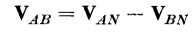
The third harmonics in the line-to-neutral voltages of all three phases are equal and in phase with each other and, therefore, cancel in the line-to-line
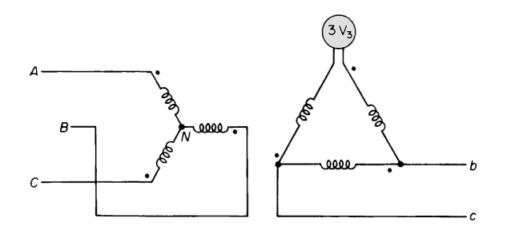
Third-harmonic voltage across an open corner in the delta on the secondary of a wye-delta connection with the primary neutral isolated.
voltages. This becomes evident when the difference is taken between any two of three waves a, b, and c of Fig.. Since
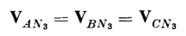
and
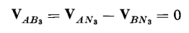
When the primaries are connected in delta, the third-harmonic components in the current are free to flow, but will not show up in the line currents because the line currents are the differences between the currents flowing in the delta as shown in Fig. 6-21. The delta connection on the secondary side of a wye-delta arrangement also provides a path for the third-harmonic components in the exciting mmf. Figure 6-34 shows the primaries of a wye-delta arrangement connected in wye with the neutral isolated. One corner of the delta is shown open. Since the neutral is isolated, there is no return path on the primary side for the third harmonics in the exciting current, causing third harmonics to appear in the voltage across each primary winding. There will be corresponding third harmonics in the voltages across each secondary winding if one or more corners of the delta are open. The voltage appearing across the open corner of the delta in Fig. 6-34 is the sum of the voltages in the three secondary windings, and, if the exciting characteristics of the three phases are identical, the sum of the fundamentals, as well as that of all harmonics - except the third and its multiples - will be zero since these are all equal and 120° apart. The multiples of the third harmonics are usually negligible. The third harmonics are equal and in phase with each other. And the voltage across the open corner of the delta is three times the third-harmonic voltage in one phase of the secondary. Thus, if V₃ is the third harmonic voltage per phase in the delta, then 3V₃ is the voltage across the open corner of the delta.
Closing the open corner of the delta in Fig. 6-34, for normal operation, short circuits the third-harmonic emf 3 V₃, causing a third-harmonic current to circulate in the delta, thus producing a substantially sinusoidal flux. If, in addition, the primary neutral is closed, the third-harmonic components of the mmf required by the sinusoidal flux divide between the primary and secondary, depending upon their relative third-harmonic leakage impedances.
Since the delta connection provides a path for the third-harmonic current, and because it assures balanced voltages, most 3-phase transformations include a delta winding, which makes the wye-delta or delta-wye arrangement very common. Where wye-wye transformation is required, it is quite common to incorporate a third winding, known as a tertiary, connected in delta. Generally, the rating of the delta-connected tertiary is considerably lower than that of the primary and secondary wye-connected windings.
Scott connection
With the help of Scott connection, proposed by C.F. Scott, it is possible to obtain 2phase supply which is required for furnaces or even three phase load can be driven from the available 2phase supply source. The Scott connection which is serving this purpose is shown in the Fig.1.
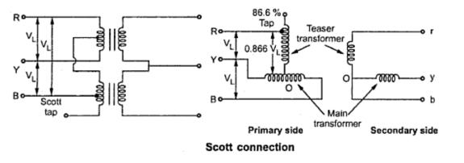
Fig. 1
This connection uses tow transformers with different rating. But identical transformers with suitable tapping may also be used for the interchangeability and provision of spares. One of the transformers having 50% taping is called main transformer and other one having 86.6% tapping is called teaser transformer. If the secondaries of the tow transformers are connected as shown in the Fig. 1 then tow phase, three wire system is obtained.
One end of the primary winding of the teaser transformer is connected to the centre tapping provided on the primary winding of the main transformer.The tow ends of the primary winding of the main transformer and 86.6 tapping point on the teaser transformer is connected to a balanced three phase supply. The voltage per turn is same both in primary of both main and teaser transformer. With the equal number of turns on secondaries of both the transformers, the secondary voltage will be equal in magnitude which results in symmetrical 2phase system.

The same connection drawn slight differently is shown in the Fig. 2.
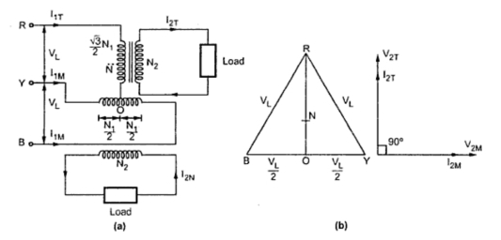
Fig. 2
The main transformer primary winding consists of N₁ turns connected between lines Y and B of a symmetrical three phase supply. V_{RY,} V_{YB} and V_{BR} are all line voltages. Hence VRY= V_{YB} = V_{BR} = V_{L} . But RO being the altitude of the equilateral triangle, the voltage V_{RO} is (√3/2)V_{L}. The voltage per turn will be same in primaries of both the transformers if number of turns between R and O are (√3/2)N₁. With this then the terminal voltages on the secondary windings having same turns will be equal in magnitude and have a same difference of between them.
The point O is not the neutral point of 3 phase supply voltage as its voltage with respect to any line is not V_{L}/√3. N is the neutral point shown in Fig. 3. Voltage V_{RN} is nothing but V_{L}/√3 whereas V_{RO} is (√3/2)V_{L}. Hence the voltage between N and O will be

(√3/2)V_{L} - (1/√3)V_{L} = 0.288 V_{L} ~ 0.29V_{L}
Since 0.29 is one third of 0.866, N divides the teaser winding RO in the ratio 2 :1. Now let us consider the unity power factor load. The teaser secondary is supplying a current of I_{2T} . Neglecting the magnetizing current we have I_{O} we have,
Transformation ratio, K = I_{1T}/I_{2T} = N₂ /N₁
Consider, I_{1T}/I_{2T} = N₂/N₁
I_{1T} = I_{2T} x (N₂ /((√3/2)N₁)) = (2/√3) (N₂/N₁) I_{2T}
=1.15 ( N₂/N₁) I_{2T}
... I_{1T} = 1.15 K I_{2T} ..................(i)
Each half on the primary winding of the main transformer carries current of consisting of I1mtow parts.
i) First part balances the main secondary current
I_{1M} = ( N₂/N₁) I_{2M} = K I_{2M}
ii) The second part is equal to one half of the teaser primary current i.e. 0.5 I1T
The main transformer primary winding forms a return path for the teaser primary current which is divided into two halves at point O in either direction.
The current in each half is equal to (I1T/2)=((1.15 K I2T ) /2) = 0.58 K I2T
This current is shown in the Fig. 3
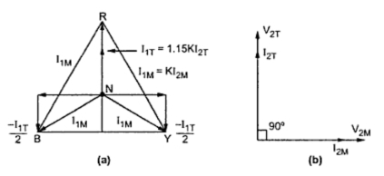
Fig. 3
Thus the phase R supplies current I_{1T} which is divided into equal parts and is flowing in the main transformer in the opposite directions. Thus the line currents on the primary side are vectorially given by,
Ī_{R} = Ī_{1T}
Ī_{Y} = Ī_{1M} - 0.5 Ī_{1T} = Ī_{1M} - 0.5 Ī_{1T}
Ī_{B} = -Ī_{1M} - 0.5 Ī_{1T} = - Ī_{1M} - 0.5 Ī_{1T}
The magnitude of these line currents are given by,
I_{R} = I_{1T}
I_{Y} = I_{B} = √(( I_{1M} )² + (0.5 I_{1T} )²)
The currents in the lines Y and B are obtained vectorially. The teaser transformer currents flowing in the tow halves of the primary winding of the main transformer in the opposite direction and have no magnetic effect on the core and does not take part in balancing the secondary ampere turns of the main transformer. Thus when tow phase load of unity power factor is balanced then three phase side is also balanced.
Now let us consider balanced row phase load at a lagging p.f. of cosΦ. The corresponding phasor diagram is shown in the Fig. 4. The three phase side is again balanced as the currents drawn from the three phase system are equal balanced and lag by angle Φ with respect to their respective phase voltages. This can be shown mathematically.
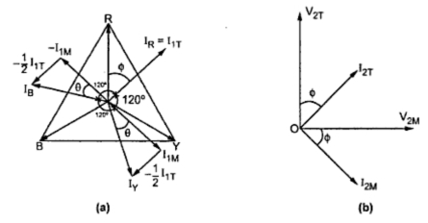
Fig. 4
Let us consider the equal currents at a power factor of cos Φ lagging from secondary side
... I_{2T} = I_{2M} = I₂
From the phasor diagram we have
I_{R} = I_{1T}
I_{Y} = I_{B} = √(( I_{1M})² + ( 0.5 I_{1T})²)
Now, I_{1M} = K I_{2M} = K I₂
I_{1T} = 1.16 K I_{2T} = 1.16 K I₂
Substituting I_{R} = 1.16 K I₂
I_{Y} = I_{B} = √((K I₂)²+(0.5 x1.16 I₂)²)
= 1.16 K I₂
Thus all the currents in the primary side are equal in magnitude.
We have from the phasor diagram
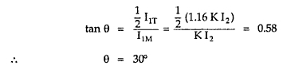

Since the power factors of the load for the main transformer and the teaser transformer are equal, the phase angle between the secondary currents is also 90°. The angle between the primary currents I_{1T} and I_{1M} is also 90°. Thus the three line currents I_{R} ,I_{Y} and I_{B} are displaced from each other by 120° and lag the respective phase voltages by an angle Φ. This proves that if the tow phase load is balanced then the loading on the three phase side is also balanced.
Now we will consider the case of unbalanced tow phase load having different currents and different power factors. The phasor diagram for this case can be constructed in a similar manner. It is shown in the Fig. 5.
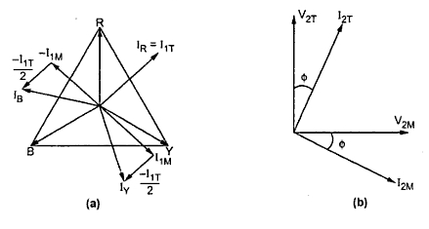
Fig. 5

Off load and on load tap changers

Tap Changing Transformer -Voltage variation in power systems is a normal phenomenon owing to the rapid growth of industries and distribution network. System voltage control is therefore essential for:
- Adjustment of consumers’ terminal voltage within prescribed limits.
- Control of real and reactive power flow in the network.
- Periodical adjustment (1-10%) to check off-set load variations.
Adjustment is normally carried out by off-circuit tap changing, the common range being 5% in 2.5% steps. Daily and short-time control or adjustment is carried out by means of on-load tap changing gear.
Besides the above, tapping are also provided for one of the following purposes:
- For varying the secondary voltage.
- For maintaining the secondary voltage constant with a varying primary voltage.
- For providing an auxiliary secondary voltage for a special purpose
- For providing a low voltage for starting rotating machines.
- For providing a neutral point, e.g. for earthing.
The principal tapping is one to which the rating of the winding is related. A positive tapping means more, and a negative tapping implies less turns than those of the principal tap. Tap Changing Transformer may be achieved in one of the three conditions, viz.
voltage variation with constant flux and
constant voltage turn,
with varying flux, a mix of (i) and (ii). In (i) the percentage tapping range is same as the voltage Location
The taps may be placed on the primary or secondary side which partly depends on construction. If tappings are near the line ends, fewer bushing insulators are required.
If the tappings are placed near the neutral ends, the phase-to-phase insulation conditions are eased.
For achieving large voltage variation, tappings should be placed near the centres of the phase windings to reduce magnetic asymmetry. However, this arrangement cannot be put on LV windings placed next to the core (as in core type transformer) because of accessibility and insulation considerations. The HV winding placed outside the LV winding is easily accessible and can, thus, be tapped easily.
It is not possible to tap other than an integral number of turns and this may not be feasible with LV side tappings. For example 250 V phase winding with 15 V/turn cannot be tapped closer than 5%. It is therefore essential to tap the HV windings which is advantageous in a step-down transformer.

Some of the methods of locating tappings are depicted in Fig. 3.67(a) and (b).

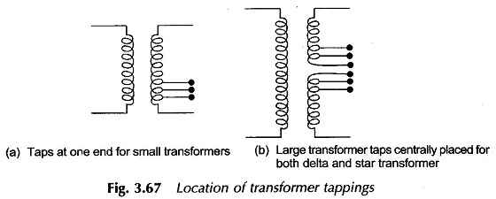
Axial mmf unbalance is minimized by thinning out the LV winding or by arranging parts of the winding more symmetrically. For very large tapping ranges a special tapping coil may be employed.
Tap Changing Transformer causes changes in leakage reactance, core loss, /2R loss and perhaps some problems in parallel operation of dissimilar transformers.
No-load (off-load or off-circuit) tap changing
The cheapest method of changing the turn ratio of a transformer is the use of off-circuit tap changer. As the name indicates, it is required to deenergize the transformer before changing the tap. A simple no-load tap changer is shown in Fig. 3.68. It has eight studs marked one to eight. The winding is tapped at eight points. The face plate carrying the suitable studs can be mounted at a convenient place on the transformer such as upper yoke or located near the tapped positions on the windings. The movable contact arm A may be rotated by hand wheel mounted externally on the tank.
If the winding is tapped at 2% intervals, then as the rotatable arm A is moved over to studs 1, 2; 2, 3; 6, 7; 7, 8 the winding in circuit reduces progressively by it from 100% with arm at studs (1, 2) to 88% at studs (7, 8). The stop F which fixes the final position of the arm A prevents further anticlockwise rotation so that stud 1 and 8 cannot be bridged by the arm. Adjustment of tap setting is carried out with transformer deenergized. For example, for 94% tap the arm is brought in position to bridge studs 4 and 5. The transformer can then be switched on

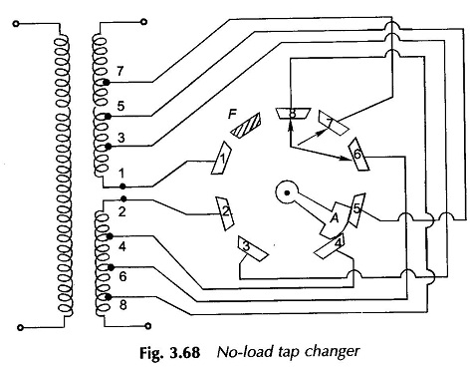
To prevent unauthorized operation of an off-circuit tap changer, a mechanical lock is provided. Further, to prevent inadvertent operation, an electromagnetic latching device or microswitch is provided to open the circuit breaker so as to deenergize the transformer as soon as the tap changer handle is moved; well before the contact of the arm with the stud (with which it was in contact) opens.
On–load Tap Changing
On-load tap changers are used to change the turn ratio of transformer to regulate system voltage while the transformer is delivering load. With the introduction of on-load tap changer, the operating efficiency of electrical system gets considerably improved. Nowadays almost all the large power transformers are fitted with on-load tap changer. During the operation of an on-load tap changer the main circuit should not be opened to prevent (dangerous) sparking and no part of the tapped winding should get short-circuited. All forms of on-load tap changing circuits are provided with an impedance, which is introduced to limit short-circuit current during the tap changing operation. The impedance can either be a resistor or centre-tapped reactor. The on-load tap changers can in general be classified as resistor or reactor type. In modem designs the current limiting is almost invariably carried out by a pair of resistors.
On-load Tap Changing Transformer gear with resistor transition, in which one winding tap is changed over for each operating position, is depicted in Fig. 3.69. The figure also shows the sequence of operations during the transition from one tap to the next (adjoining) (in this case from tap 4 to tap 5). Back-up main contractors are provided which short-circuit the resistor for normal operation. To ensure that the transition once started gets completed, an energy (usually a spring device) storage is provided which acts even if the auxiliary power supply
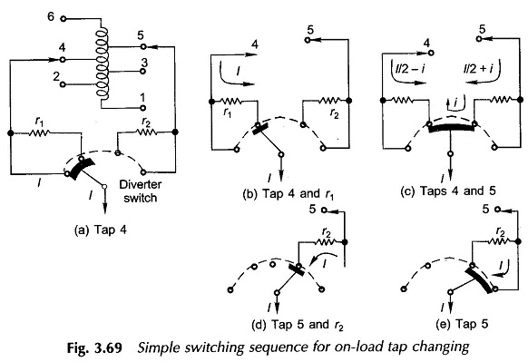happens to fail. In resistor-aided Tap Changing Transformer the current break is made easier by the fact that the short-circuit resistor causes the current to be opened to have unity power factor. On-load tap changer control gear can be from simple push-button initiation to complex automatic control of several transformers operating in parallel. The aim is to maintain a given voltage level within a specified tolerance or to raise it with load to compensate for the transmission line voltage drop. The main components are an automatic voltage regulator, a time delay relay, and compounding elements. The time delay prevents unwanted initiation of a tap change by a small transient voltage fluctuation. It may be set for a delay unto 1 min. At present tap changers are available for the highest insulation level of 1475 kV (peak) impulse and 630 kV power frequency voltage. Efforts are underway to develop tap changers suitable for still higher insulation levels. More compact tap changers with high reliability and performance are being made by employing vacuum switches in the diverter switch. Also, now thyristorized tap changers are available for special applications where a large number of operations are desired.

