UNIT-V
Single-phase Transformers Testing

Testing of Transformer

The testing of transformer means to determine efficiency and regulation of a transformer at any load and at any power factor condition.

There are two methods

- Direct loading test

- Indirect loading test
a.Open circuit test
b.Short circuit test

i) Load test on transformer

This method is also called as direct loading test on transformer because the load is directly connected to the transformer. We required various meters to measure the input and output reading while change the load from zero to full load. Fig. 2.22 shows the connection of transformer for direct load test. The primary is connected through the variac to change the input voltage as we required. Connect the meters as shown in the figure below.
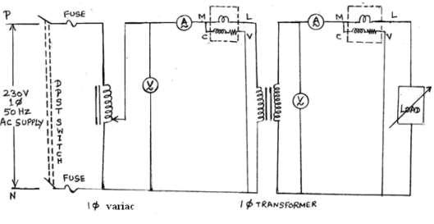

Fig: 2

The load is varied from no load to full load in desired steps. All the time, keep primary voltage V1 constant at its rated value with help of variac and tabulated the reading. The first reading is to be noted on no load for which I2 = 0 A and W2 = 0W.

Calculation
From the observed reading

W1 = input power to the transformer

W2 = output power delivered to the load
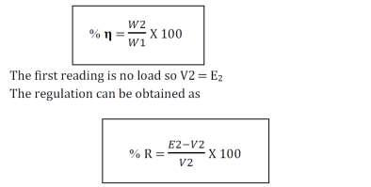

The graph of % η and % R on each load against load current IL is plotted as shown in fig. 2.23.
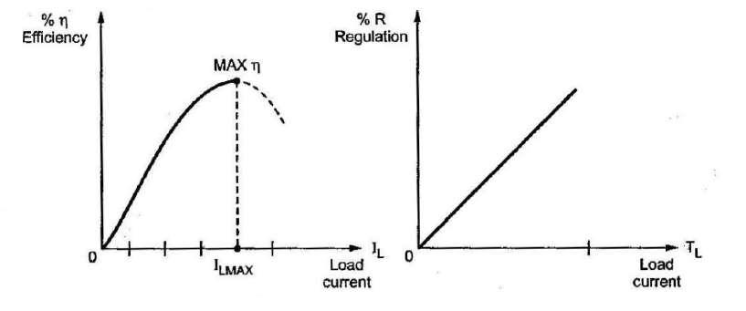

Fig: 2.23

Advantages:

- This test enables us to determine the efficiency of the transformer accurately at any load.

- The results are accurate as load is directly used.

Disadvantages:

- There are large power losses during the test.

- Load not avail in lab while test conduct for large transformer.

a. Open-Circuit or No-Load Test

This test is conducted to determine the iron losses (or core losses) and parameters R0 and X0 of the transformer. In this test, the rated voltage is applied to the primary (usually low-voltage winding) while the secondary is left open circuited. The applied primary voltage V1 is measured by the voltmeter, the no load current I0 by ammeter and no-load input power W0 by wattmeter as shown in Fig.2.24.a. As the normal rated voltage is applied to the primary, therefore, normal iron losses will occur in the transformer core. Hence wattmeter will record the iron losses and small copper loss in the primary. Since no-load current I0 is very small (usually 2-10 % of rated current). Cu losses in the primary under no-load condition are negligible as compared with iron losses. Hence, wattmeter reading practically gives the iron losses in the transformer. It is reminded that iron losses are the same at all loads.
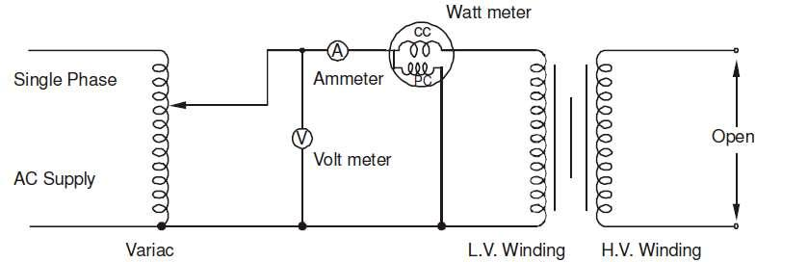

Fig: 2.24.a

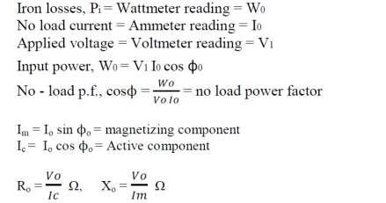

Under no load conditions the PF is very low (near to 0) in lagging region. By using the above data we can draw the equivalent parameter shown in Figure 2.24.b.
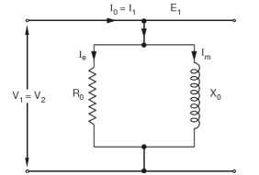

Thus open-circuit test enables us to determine iron losses and parameters R0 and X0 of the transformer.

b. Short-Circuit or Impedance Test

This test is conducted to determine R1e (or R2e), X1e (or X2e) and full-load copper losses of the transformer. In this test, the secondary (usually low-voltage winding) is short-circuited by a thick conductor and variable low voltage is applied to the primary as shown in Fig.2.25. The low input voltage is gradually raised till at voltage VSC, full-load current I1 flows in the primary. Then I2 in the secondary also has full-load value since I1/I2 = N2/N1. Under such conditions, the copper loss in the windings is the same as that on full load. There is no output from the transformer under short-circuit conditions. Therefore, input power is all loss and this loss is almost entirely copper loss. It is because iron loss in the core is negligibly small since the voltage VSC is very small. Hence, the wattmeter will practically register the full load copper losses in the transformer windings.
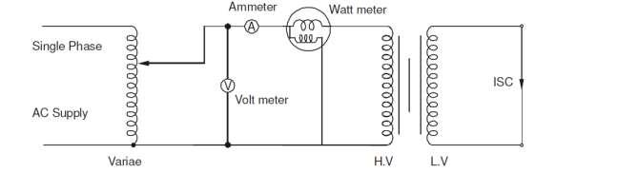

Fig: 2.25.a
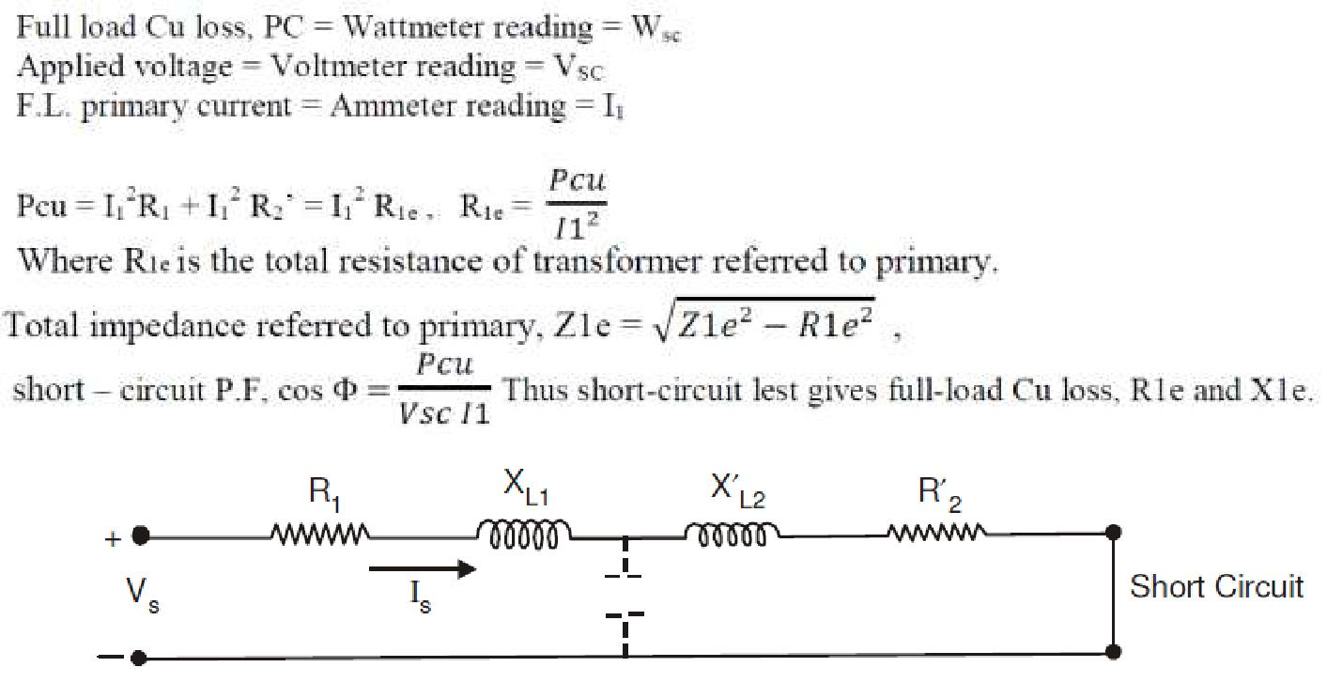

Fig: 2.25.b

From fig: 2.25.b we can calculate,
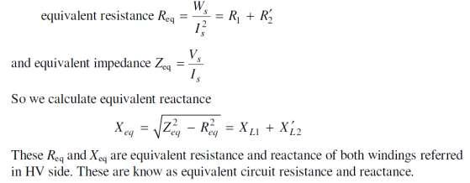

Voltage Regulation of Transformer

Under no load conditions, the voltage at the secondary terminals is E2 and
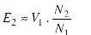

(This approximation neglects the drop R1 and Xl1 due to small no load current). As load is applied to the transformer, the load current or the secondary current increases. Correspondingly, the primary current I1also increases. Due to these currents, there is a voltage drop in the primary and secondary leakagereactances, and as a consequence the voltage across the output terminals or the load terminals changes. In quantitative terms this change in terminal voltage is called Voltage Regulation.

Voltage regulation of a transformer is defined as the drop in the magnitude of load voltage (or secondary terminal voltage) when load current changes from zero to full load value. This is expressed as a fraction of secondary rated voltage.

The secondary rated voltage of a transformer is equal to the secondary terminal voltage at no load (i.e. E2), this is as per IS.

Voltage regulation is generally expressed as a percentage.
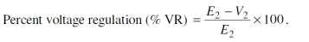

Note that E2, V2 are magnitudes, and not phasor or complex quantities. Also note that voltage regulation depends not only on load current, but also on its power factor. Using approximate equivalent circuit referred to primary or secondary, we can obtain the voltage regulation. From approximate equivalent circuit referred to the secondary side and phasor diagram for the circuit.
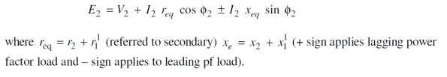

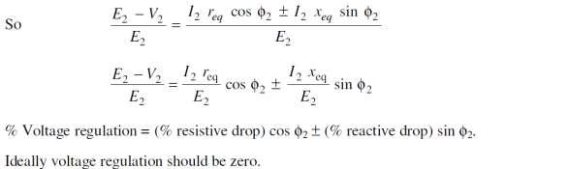

Auto-transformers

The transformers we have considered so far are two-winding transformers in which the electrical circuit connected to the primary is electrically isolated from that connected to the secondary. An auto-transformer does not provide such isolation, but has economy of cost combined with increased efficiency. Fig.2.26 illustrates the auto-transformer which consists of a coil of NA turns between terminals 1 and 2, with a third terminal 3 provided after NB turns. If we neglect coil resistances and leakage fluxes, the flux linkages of the coil between 1 and 2 equals NAфm while the portion of coil between 3 and 2 has a flux linkage NBфm. If the induced voltages are designated as EA and EB, just as in a two winding transformer,

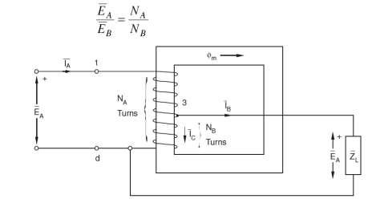

Fig: 2.26

Neglecting the magnetizing ampere-turns needed by the core for producing flux, as in an ideal transformer, the current IA flows through only (NA – NB) turns. If the load current is IB, as shown by Kirchhoff’s current law, the current IC flowing from terminal 3 to terminal 2 is (IA - IB). This current flows through NB turns. So, the requirement of a net value of zero ampere-turns across the core demands that

Consequently, as far as voltage, current converting properties are concerned, the autotransformer of Figure: 26 behaves just like a two-winding transformer. However, in the autotransformer we don’t need two separate coils, each designed to carry full load values of current.

Parallel Operation of Transformers

It is economical to install numbers of smaller rated transformers in parallel than installing a bigger rated electrical power transformers. This has mainly the following advantages,

To maximize electrical power system efficiency: Generally electrical power transformer gives the maximum efficiency at full load. If we run numbers of transformers in parallel, we can switch on only those transformers which will give the total demand by running nearer to its full load rating for that time. When load increases, we can switch none by one other transformer connected in parallel to fulfil the total demand. In this way we can run the system with maximum efficiency.

To maximize electrical power system availability: If numbers of transformers run in parallel, we can shut down any one of them for maintenance purpose. Other parallel transformers in system will serve the load without total interruption of power.

To maximize power system reliability: if any one of the transformers run in parallel, is tripped due to fault of other parallel transformers is the system will share the load, hence power supply may not be interrupted if the shared loads do not make other transformers over loaded.
To maximize electrical power system flexibility: There is always a chance of increasing or decreasing future demand of power system. If it is predicted that power demand will be increased in future, there must be a provision of connecting transformers in system in parallel to fulfil the extra demand because, it is not economical from business point of view to install a bigger rated single transformer by forecasting the increased future demand as it is unnecessary investment of money. Again if future demand is decreased, transformers running in parallel can be removed from system to balance the capital investment and its return.

2.10.1 Conditions for Parallel Operation of Transformers

When two or more transformers run in parallel, they must satisfy the following conditions for satisfactory performance. These are the conditions for parallel operation of transformers.

- Same voltage ratio of transformer.
- Same percentage impedance.
- Same polarity.
- Same phase sequence.

- Same Voltage Ratio

Same voltage ratio of transformer.

If two transformers of different voltage ratio are connected in parallel with same primary supply voltage, there will be a difference in secondary voltages. Now say the secondary of these transformers are connected to same bus, there will be a circulating current between secondaries and therefore between primaries also. As the internal impedance of transformer is small, a small voltage difference may cause sufficiently high circulating current causing unnecessary extra I2R loss.

Same Percentage Impedance

The current shared by two transformers running in parallel should be proportional to their MVA ratings. Again, current carried by these transformers are inversely proportional to their internal impedance. From these two statements it can be said that, impedance of transformers running in parallel are inversely proportional to their MVA ratings. In other words, percentage impedance or per unit values of impedance should be identical for all the transformers that run in parallel.
Same Polarity

Polarity of all transformers that run in parallel, should be the same otherwise huge circulating current that flows in the transformer but no load will be fed from these transformers. Polarity of transformer means the instantaneous direction of induced emf in secondary. If the instantaneous directions of induced secondary emf in two transformers are opposite to each other when same input power is fed to both of the transformers, the transformers are said to be in opposite polarity. If the instantaneous directions of induced secondary e.m.f in two transformers are same when same input power is fed to the both of the transformers, the transformers are said to be in same polarity.

Same Phase Sequence

The phase sequence or the order in which the phases reach their maximum positive voltage, must be identical for two parallel transformers. Otherwise, during the cycle, each pair of phases will be short circuited.

The above said conditions must be strictly followed for parallel operation of transformers but totally identical percentage impedance of two different transformers is difficult to achieve practically, that is why the transformers run in parallel may not have exactly same percentage impedance but the values would be as nearer as possible.

Why Transformer Rating in kVA?

An important factor in the design and operation of electrical machines is the relation between the life of the insulation and operating temperature of the machine. Therefore, temperature rise resulting from the losses is a determining factor in the rating of a machine. We know that copper loss in a transformer depends on current and iron loss depends on voltage. Therefore, the total loss in a transformer depends on the volt-ampere product only and not on the phase angle between voltage and current i.e., it is independent of load power factor. For this reason, the rating of a transformer is in kVA and not kW.

Sumpner's test or Back-to-Back test on Transformer
Sumpner's test or back to back test on transformer is another method for determining transformer efficiency, voltage regulation and heating under loaded conditions. Short circuit and open circuit tests on transformer can give us parameters of equivalent circuit of transformer, but they cannot help us in finding the heating information. Unlike O.C. and S.C. tests, actual loading is simulated in Sumpner's test. Thus the Sumpner's test gives more accurate results of regulation and efficiency than O.C. and S.C. tests.

Sumpner's test
Sumpner's test or back to back test can be employed only when two identical transformers are available. Both transformers are connected to supply such that one transformer is loaded on another. Primaries of the two identical transformers are connected in parallel across a supply. Secondaries are connected in series such that emf's of them are opposite to each other. Another low voltage supply is connected in series with secondaries to get the readings, as shown in the circuit diagram shown below.

.
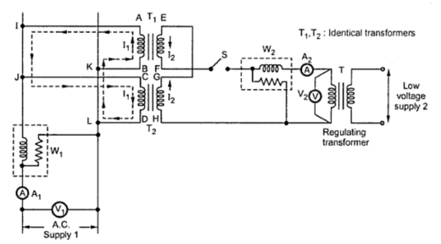
In above diagram, T₁ and T₂ are identical transformers. Secondaries of them are connected in voltage opposition, i.e. E_{EF} and E_{GH}. Both the emf's cancel each other, as transformers are identical. In this case, as per superposition theorem, no current flows through secondary. And thus the no load test is simulated. The current drawn from V₁ is 2I₀, where I₀ is equal to no load current of each transformer. Thus input power measured by wattmeter W₁ is equal to iron losses of both transformers.
i.e. iron loss per transformer Pi = W₁/2.
Now, a small voltage V₂ is injected into secondary with the help of a low voltage transformer. The voltage V₂ is adjusted so that, the rated current I₂ flows through the secondary. In this case, both primaries and secondaries carry rated current. Thus short circuit test is simulated and wattmeter W₂ shows total full load copper losses of both transformers.
i.e. copper loss per transformer P_{Cu} = W₂/2.
From above test results, the full load efficiency of each transformer can be given as -
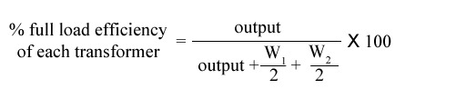

Differences Between Autotransformer and Transformer
- An autotransformer has only one winding which acts both as a primary and the secondary whereas the conventional transformer has a two separate windings, i.e., the primary and the secondary winding.
- The auto-transformer works on the principle of self-induction i.e. induce the electromagnetic force in the circuit due to variation in current. The conventional transformer works on the principle of mutual induction in which the emf induces in the coil by changing the current in the adjacent coil.
- The auto-transformer is smaller in size, whereas the conventional transformer is larger in size.
- The autotransformer is more economical as compared to a conventional transformer.
- In an autotransformer, electrical power is transferred from primary to secondary partly by the process of transformation and partly by the direct current. The conventional transformer transfers the electrical power through the electric transformation due to which power loss occurs.
- The voltage regulation of an auto-transformer is much better than the conventional transformer
  - The voltage regulation is the change in the secondary terminal voltage from no load to full load.
- The autotransformer has only one winding. Thus, less conductor is required for winding as compared to the conventional transformer.
- The primary and secondary windings of the autotransformer are not electrically insulated whereas the windings of the conventional transformer are electrically insulated from each other.
- The starting current of the auto-transformer is less than the actual current, whereas the starting current of the conventional transformer is one-third of the main current.
- The auto-transformer is more efficient as compared to the conventional transformer.
- The leakage flux and resistance of an auto-transformer are low because it has only one winding whereas it is high in the conventional transformer.
- The autotransformer has less impedance as compared to conventional current. The smaller impedance results in the large short circuit current.
- The cost of the autotransformer is very less whereas the conventional current is very costly.
- The losses in the auto-transformer are less as compared to the conventional transformer.
- The output voltage of the secondary transformer varies when the sliding contacts are used in the secondary winding whereas the output voltage of the conventional transformer always remains constant.
- The autotransformer is used as a voltage regulator, in the laboratory, in the railway stations, as a stator in an induction motor, etc., whereas the conventional transformer is used to step-up and step-down the voltage in the power grid.

