UNIT-IV
Single-phase Transformers

Introduction

The transformer is a device that transfers electrical energy from one electrical circuit to another electrical circuit. The two circuits may be operating at different voltage levels but always work at the same frequency. Basically transformer is an electro-magnetic energy conversion device. It is commonly used in electrical power system and distribution systems. It can change the magnitude of alternating voltage or current from one value to another. This useful property of transformer is mainly responsible for the widespread use of alternating currents rather than direct currents i.e., electric power is generated, transmitted and distributed in the form of alternating current. Transformers have no moving parts, rugged and durable in construction, thus requiring very little attention. They also have a very high efficiency as high as 99%.

Single Phase Transformer

A transformer is a static device of equipment used either for raising or lowering the voltage of an a.c. supply with a corresponding decrease or increase in current. It essentially consists of two windings, the primary and secondary, wound on a common laminated magnetic core as shown in Fig 1. The winding connected to the a.c. source is called primary winding (or primary) and the one connected to load is called secondary winding (or secondary). The alternating voltage V1 whose magnitude is to be changed is applied to the primary.

Depending upon the number of turns of the primary (N1) and secondary (N2), an alternating e.m.f. E2 is induced in the secondary. This induced e.m.f. E2 in the secondary causes a secondary current I2. Consequently, terminal voltage V2 will appear across the load.

If V2> V1, it is called a step up-transformer.

If V2< V1, it is called a step-down transformer.
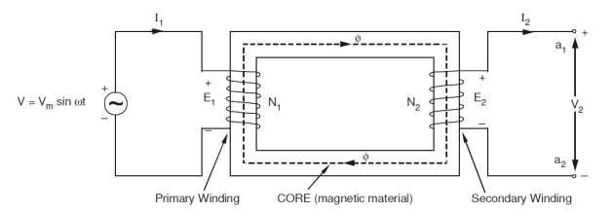

Constructional Details

Depending upon the manner in which the primary and secondary windings are placed on the core, and the shape of the core, there are two types of transformers, called (a) core type, and (b) shell type.

1 Core-type and Shell-type Construction

In core type transformers, the windings are placed in the form of concentric cylindrical coils placed around the vertical limbs of the core. The low-voltage (LV) as well as the high-voltage (HV) winding are made in two halves, and placed on the two limbs of core. The LV winding is placed next to the core for economy in insulation cost. Figure 2.1(a) shows the cross-section of the arrangement. In the shell type transformer, the primary and secondary windings are wound over the central limb of a three-limb core as shown in Figure 2.1(b). The HV and LV windings are split into a number of sections, and the sections are interleaved or sandwiched i.e. the sections of the HV and LV windings are placed alternately.

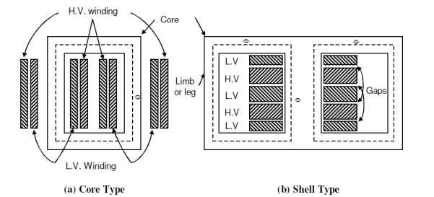

Core

The core is built-up of thin steel laminations insulated from each other. This helps in reducing the eddy current losses in the core, and also helps in construction of the transformer. The steel used for core is of high silicon content, sometimes heat treated to produce a high permeability and low hysteresis loss. The material commonly used for core is CRGO (Cold Rolled Grain Oriented) steel. Conductor material used for windings is mostly copper. However, for small distribution transformer aluminium is also sometimes used. The conductors, core and whole windings are insulated using various insulating materials depending upon the voltage.

Insulating Oil

In oil-immersed transformer, the iron core together with windings is immersed in insulating oil. The insulating oil provides better insulation, protects insulation from moisture and transfers the heat produced in core and windings to the atmosphere.

The transformer oil should possess the following qualities:

- High dielectric strength,

- Low viscosity and high purity,

- High flash point, and

(d) Free from sludge.

Transformer oil is generally a mineral oil obtained by fractional distillation of crude oil.

Tank and Conservator

The transformer tank contains core wound with windings and the insulating oil. In large transformers small expansion tank is also connected with main tank is known as conservator. Conservator provides space when insulating oil expands due to heating. The transformer tank is provided with tubes on the outside, to permits circulation of oil, which aides in cooling. Some additional devices like breather and Buchholz relay are connected with main tank. Buchholz relay is placed between main tank and conservator. It protect the transformer under extreme heating of transformer winding. Breather protects the insulating oil from moisture when the cool transformer sucks air inside. The silica gel filled breather absorbs moisture when air enters the tank. Some other necessary parts are connected with main tank like, Bushings, Cable Boxes, Temperature gauge, Oil gauge, Tappings, etc.

2.4 Principle of Operation

When an alternating voltage V1 is applied to the primary, an alternating flux ϕ is set up in the core. This alternating flux links both the windings and induces e.m.f.s E1 and E2 in them according to

Faraday’s laws of electromagnetic induction. The e.m.f. E1 is termed as primary e.m.f. and e.m.f. E2 is termed as secondary e.m.f.

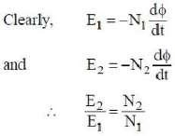

Note that magnitudes of E2 and E1 depend upon the number of turns on the secondary and primary respectively.

If N2> N1, then E2> E1 (or V2>V1) and we get a step-up transformer. If N2< N1, then E2< E1

(or V2< V1) and we get a step-down transformer.
If load is connected across the secondary winding, the secondary e.m.f. E2 will cause a current I2 to flow through the load. Thus, a transformer enables us to transfer a.c. power from one circuit to another with a change in voltage level.

The following points may be noted carefully:

- The transformer action is based on the laws of electromagnetic induction.

- There is no electrical connection between the primary and secondary.

- The a.c. power is transferred from primary to secondary through magnetic flux.

- There is no change in frequency i.e., output power has the same frequency as the input power.

- The losses that occur in a transformer are:

  - core losses—eddy current and hysteresis losses

  - copper losses—in the resistance of the windings

In practice, these losses are very small so that output power is nearly equal to the input primary power. In other words, a transformer has very high efficiency.

2.4.1 E.M.F. Equation of a Transformer

Consider that an alternating voltage V1 of frequency f is applied to the primary as shown in Fig.2.3. The sinusoidal flux ϕ produced by the primary can be represented as:

ϕ=ϕmsinωt

When the primary winding is excited by an alternating voltage V1, it is circulating alternating current, producing an alternating flux ϕ.

ϕ - Flux

ϕm - maximum value of flux

N1 - Number of primary turns

N2 - Number of secondary turns

f - Frequency of the supply voltage

E1 - R.M.S. value of the primary induced e.m.f

E2 - R.M.S. value of the secondary induced e.m.f

The instantaneous e.m.f. e1 induced in the primary is -
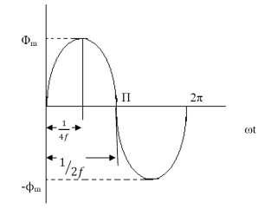

Fig. 2.3

From Faraday’s law of electromagnetic induction -
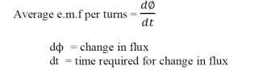

The flux increases from zero value to maximum value ϕm in 1/4f of the time period that is in 1/4f seconds.

The change of flux that takes place in 1/4f seconds = ϕm - 0 = ϕmwebers

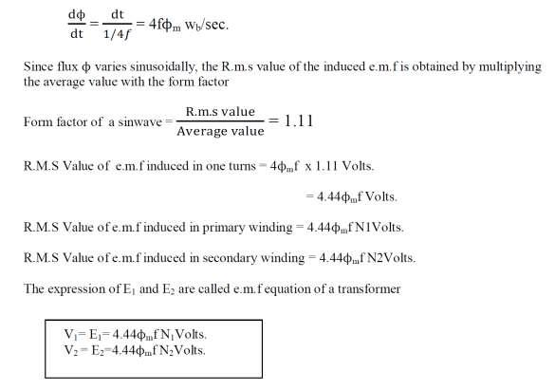

2 Voltage Ratio

Voltage transformation ratio is the ratio of e.m.f induced in the secondary winding to the e.m.f induced in the primary winding.
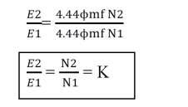

This ratio of secondary induced e.m.f to primary induced e.m.f is known as voltage transformation ratio
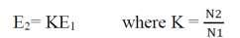

- If N2>N1 i.e. K>1 we get E2>E1 then the transformer is called step up transformer.

- If N2< N1 i.e. K<1 we get E2< E2 then the transformer is called step down transformer.

- If N2= N1 i.e. K=1 we get E2= E2 then the transformer is called isolation transformer or 1:1 transformer

Current Ratio

Current ratio is the ratio of current flow through the primary winding (I1) to the current flowing through the secondary winding (I2). In an ideal transformer -

Apparent input power = Apparent output power.

V1I1 = V2I2
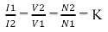

Volt-Ampere Rating
- The transformer rating is specified as the products of voltage and current (VA rating).

- On both sides, primary and secondary VA rating remains same. This rating is generally expressed in KVA (Kilo Volts Amperes rating).
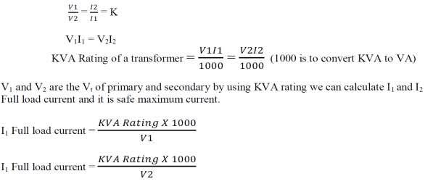

Transformer on No-load

- Ideal transformer

- Practical transformer

a) Ideal Transformer

An ideal transformer is one that has

(i) No winding resistance

- No leakage flux i.e., the same flux links both the windings

- No iron losses (i.e., eddy current and hysteresis losses) in the core

Although ideal transformer cannot be physically realized, yet its study provides a very powerful tool in

the analysis of a practical transformer. In fact, practical transformers have properties that approach very

close to an ideal transformer.
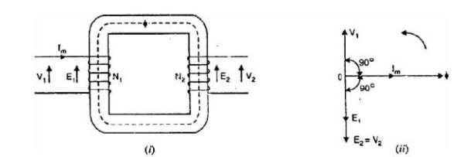

Fig: 2.4

Consider an ideal transformer on no load i.e., secondary is open-circuited as shown in Fig.2.4 (i). under such conditions, the primary is simply a coil of pure inductance. When an alternating voltage V1 is applied to the primary, it draws a small magnetizing current Im which lags behind the applied voltage by 90°. This alternating current Im produces an alternating flux ϕ which is proportional to and in phase with it. The alternating flux ϕ links both the windings and induces e.m.f. E1 in the primary and e.m.f. E2 in the secondary. The primary e.m.f. E1 is, at every instant, equal to and in opposition to V1 (Lenz’s law). Both e.m.f.s E1 and E2 lag behind flux ϕ by 90°.However, their magnitudes depend upon the number of primary and secondary turns. Fig. 2.4 (ii) shows the phasor diagram of an ideal transformer on no load. Since flux ϕ is common to both the windings, it has been taken as the reference phasor. The primary e.m.f. E1 and secondary e.m.f. E2 lag behind the flux ϕ by 90°. Note that E1 and E2 are in phase. But E1 is equal to V1 and 180° out of phase with it.
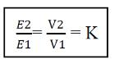

2.4.5 Phasor Diagram

- Φ (flux) is reference

- Im produce ϕ and it is in phase with ϕ, V1 Leads Im by 90˚

- E1 and E2 are in phase and both opposing supply voltage V1, winding is purely inductive

So current has to lag voltage by 90˚. iv) The power input to the transformer

P = V1.I1.cos (90˚) ……….. (cos90˚ = 0)

P= 0 (ideal transformer)

b)i) Practical Transformer on no load

A practical transformer differs from the ideal transformer in many respects. The practical transformer

has (i) iron losses (ii) winding resistances and (iii) Magnetic leakage

- Iron losses. Since the iron core is subjected to alternating flux, there occurs eddy current andhysteresis loss in it. These two losses together are known as iron losses or core losses. The iron losses depend upon the supply frequency, maximum flux density in the core, volume of the core etc. It may be noted that magnitude of iron losses is quite small in a practical transformer.

- Winding resistances. Since the windings consist of copper conductors, it immediately follows thatboth primary and secondary will have winding resistance. The primary resistance R1 and secondary resistance R2 act in series with the respective windings as shown in Fig. When current flows through the windings, there will be power loss as well as a loss in voltage due to IR drop. This will affect the power factor and E1 will be less than V1 while V2 will be less than E2.
Consider a practical transformer on no load i.e., secondary on open-circuit as Shown in Fig 2.5.

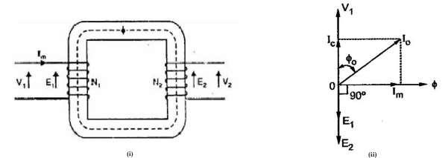

Fig: 2.5 Phasor diagram of transformer at noload

Here the primary will draw a small current I0 to supply -

(i) the iron losses and
(ii) a very small amount of copper loss in the primary.

Hence the primary no load current I0 is not 90° behind the applied voltage V1 but lags it by an angle ϕ0

< 90° as shown in the phasor diagram. No load input power, W0 = V1 I0cos ϕ0

As seen from the phasor diagram in Fig.2.5 (ii), the no-load primary current I0

(i) The component Ic in phase with the applied voltage V1. This is known as active or working or iron loss component and supplies the iron loss and a very small primary copper loss.

Ic = I0cosϕ0

The component Im lagging behind V1 by 90° and is known as magnetizing component. It is this component which produces the mutual flux ϕ in the core.

Im = I0 sin ϕ0

Clearly, Io is phasor sum of Im and Ic,
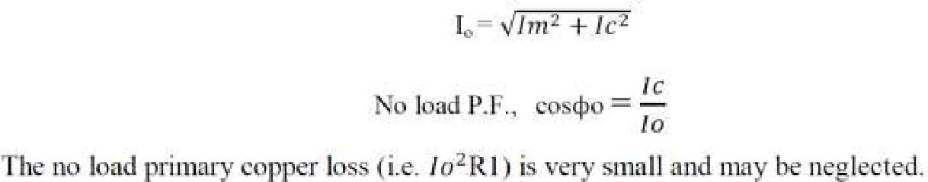

Therefore, the no load primary input power is practically equal to the iron loss in the transformer i.e., No load input power, W0 = V1Iocosϕo = Pi = Iron loss

b) ii)Practical Transformer on Load

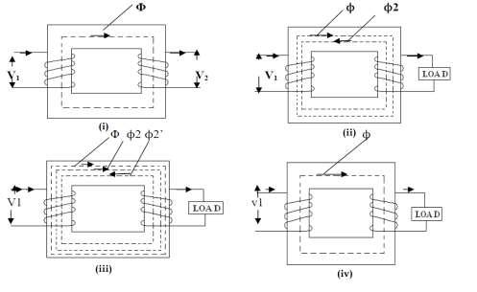

At no load, there is no current in the secondary so that V2 = E2. On the primary side, the drops in R1 and X1, due to I0 are also very small because of the smallness of I0. Hence, we can say that at no load, V1 = E1.

- When transformer is loaded, the secondary current I2 is flows through the secondary winding.

- Already Im magnetizing current flow in the primary winding fig. 2.6(i).

- The magnitude and phase of I2 with respect to V2 is determined by the characteristics of the load. a) I2 in phase with V2 (resistive load)

b) I2 lags with V2 (Inductive load) c) I2 leads with V2 (capacitive load)

- Flow of secondary current I2 produce new Flux ϕ2 fig.2.6 (ii)

- Φis main flux which is produced by the primary to maintain the transformer as constant magnetising component.

vi) Φ2 opposes the main flux ϕ, the total flux in the core reduced. It is called demagnetising Ampere-

turns due to this E1 reduced.

vii) To maintain the ϕ constant primary winding draws more current (I2’) from the supply (load component of primary) and produce ϕ2’ flux which is oppose ϕ2 (but in same direction as ϕ), to maintain flux constant flux constant in the core fig.2.6 (iii).

- The load component current I2’ always neutralizes the changes in the load.

- Whatever the load conditions, the net flux passing through the core is approximately the same as at no-load. An important deduction is that due to the constancy of core flux at all loads, the core loss is also practically the same under all load conditions fig.2.6 (iv).
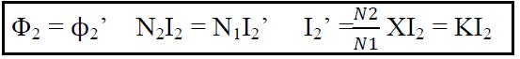

2.4.6 Phasor Diagram

- Take (ϕ) flux as reference for all load

- The load component I2’, which is in anti-phase with I2 and phase of I2 is decided by the load.

- Primary current I1 is vector sum of Io and I2’
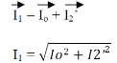

- If load is Inductive, I2 lags E2 by ϕ2, shown in phasor diagram fig 2.7 (a).

- If load is resistive, I2 in phase with E2 shown in phasor diagram fig. 2.7 (b).

- If load is capacitive load, I2 leads E2 by ϕ2 shown in phasor diagram fig. 2.7 (c).

For easy understanding at this stage here we assumed E2 is equal to V2 neglecting various drops.

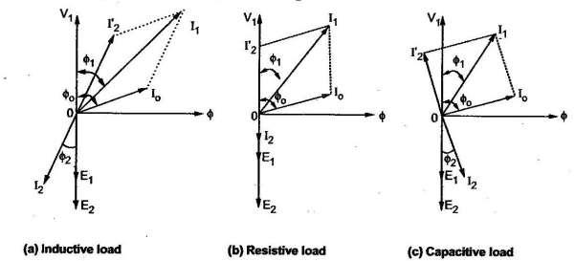

Fig: 2.7.a
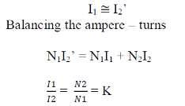

Now we going to construct complete phasor diagram of a transformer (shown in Fig: 2.7.b)

Effect of Winding Resistance

In practical transformer it process its own winding resistance causes power loss and also the voltage drop.

R1 – primary winding resistance in ohms.

R2 – secondary winding resistance in ohms.

The current flow in primary winding make voltage drop across it is denoted as I1R1 here supply voltage V1 has to supply this drop primary induced e.m.f E1 is the vector difference between V1 and I1R1.

Similarly the induced e.m.f in secondary E2, The flow of current in secondary winding makes voltage drop across it and it is denoted as I2R2 here E2 has to supply this drop.
The vector difference between E2 and I2R2

(Assuming as purely resistive drop here.)

Equivalent Resistance

- It would now be shown that the resistances of the two windings can be transferred to any one of the two winding.

- The advantage of concentrating both the resistances in one winding is that it makes calculations very simple and easy because one has then to work in one winding only.

- Transfer to any one side either primary or secondary without affecting the performance of the transformer.

The total copper loss due to both the resistances.
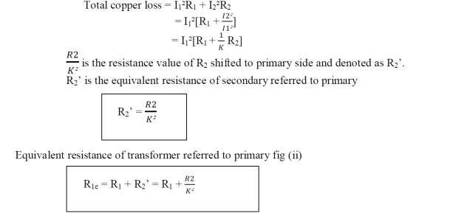

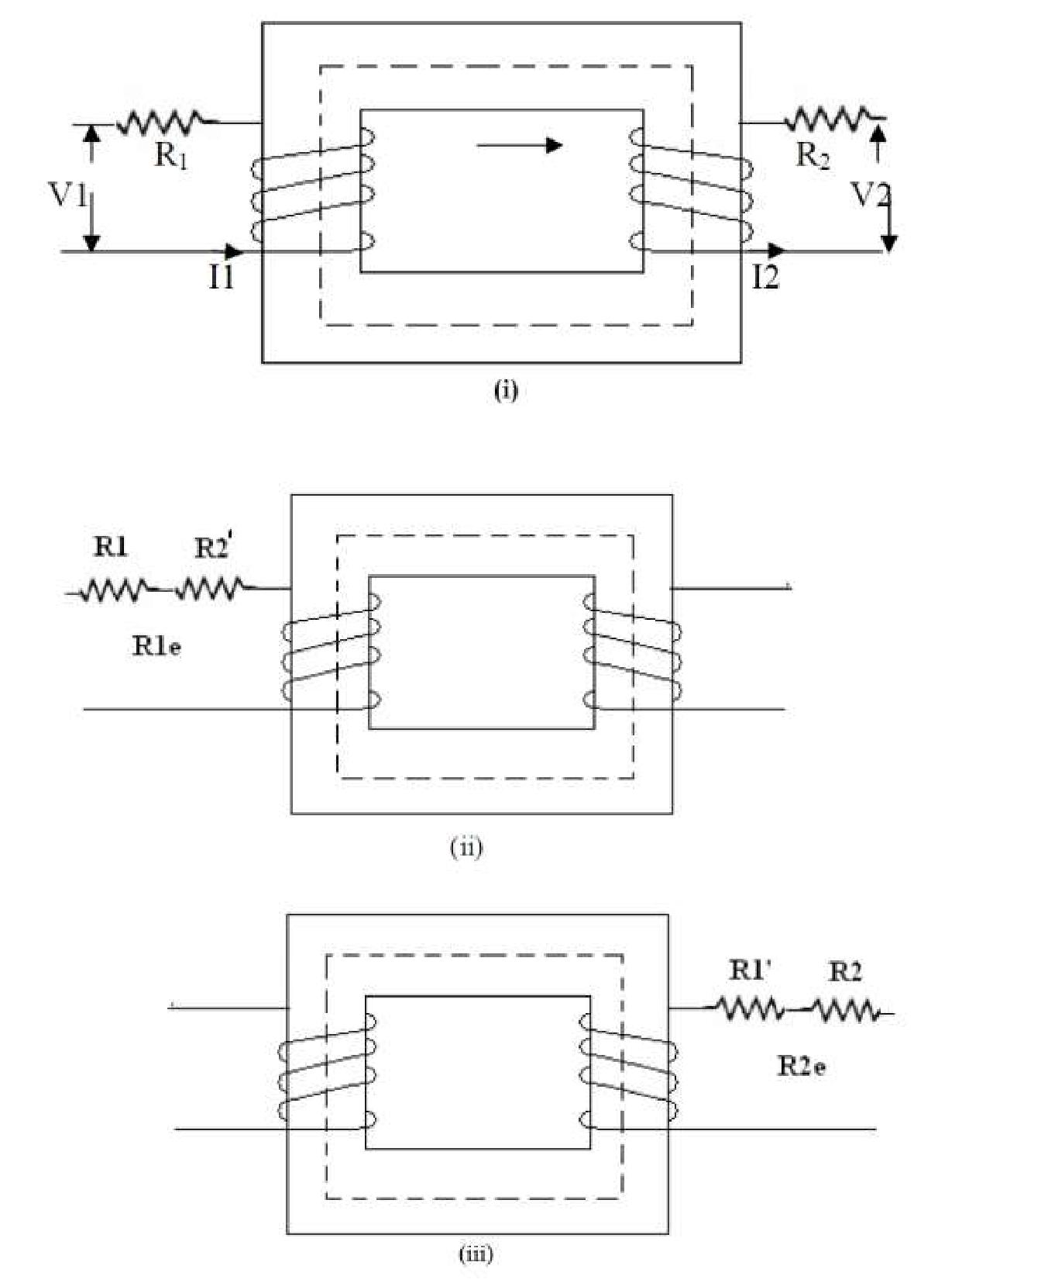

Similarly it is possible to refer the equivalent resistance to secondary winding.

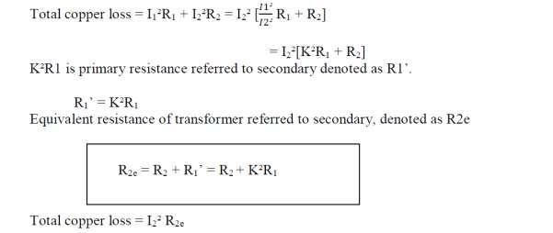

Note:

i) When a resistance is to be transferred from the primary to secondary, it must be multiplied by K², it must be divided by K² while transferred from the secondary to primary.

High voltage side low current side high resistance side Low voltage side high current side low resistance side

Effect of Leakage Reactance

- It has been assumed that all the flux linked with primary winding also links the secondary winding. But, in practice, it is impossible to realize this condition.

- However, primary current would produce flux ϕ which would not link the secondary winding. Similarly, current would produce some flux ϕ that would not link the primary winding.

- The flux ϕL1 complete its magnetic circuit by passing through air rather than around the core, as shown in fig.2.9. This flux is known as primary leakage flux and is proportional to the primary ampere

– turns alone because the secondary turns do not links the magnetic circuit of ϕL1. It induces an e.m.f eL1 in primary but not in secondary.

iv) The flux ϕL2 complete its magnetic circuit by passing through air rather than around the core, as shown in fig. This flux is known as secondary leakage flux and is proportional to the secondary ampere

– turns alone because the primary turns do not links the magnetic circuit of ϕL2. It induces an e.m.f eL2 in secondary but not in primary.

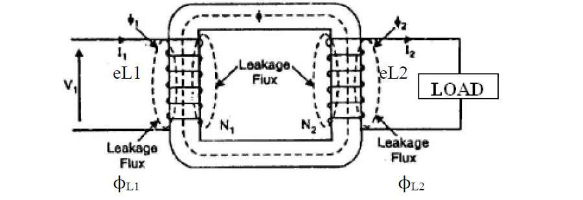

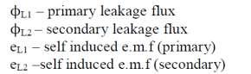

Equivalent Leakage Reactance
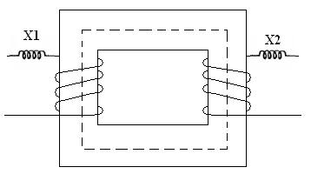

Similarly to the resistance, the leakage reactance also can be transferred from primary to secondary. The relation through K² remains same for the transfer of reactance as it is studied earlier for the resistance

X1 – leakage reactance of primary.
X2 - leakage reactance of secondary.

Then the total leakage reactance referred to primary is X1e given by
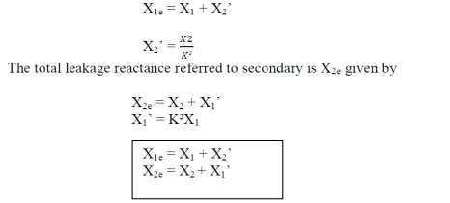

Equivalent Impedance

The transformer winding has both resistance and reactance (R1, R2, X1,X2).Thus we can say that the total impedance of primary winding isZ1 which is,

Z1 = R1 + jX1 ohms

On secondary winding,

Z2 = R2 + jX2 ohms
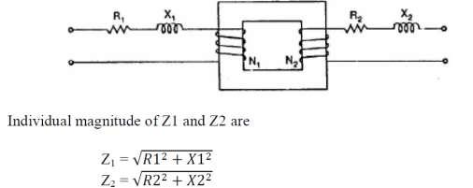

Similar to resistance and reactance, the impedance also can be referred to any one side,

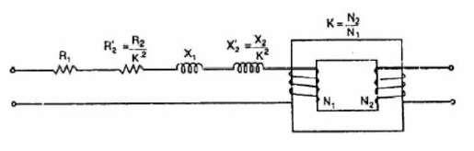

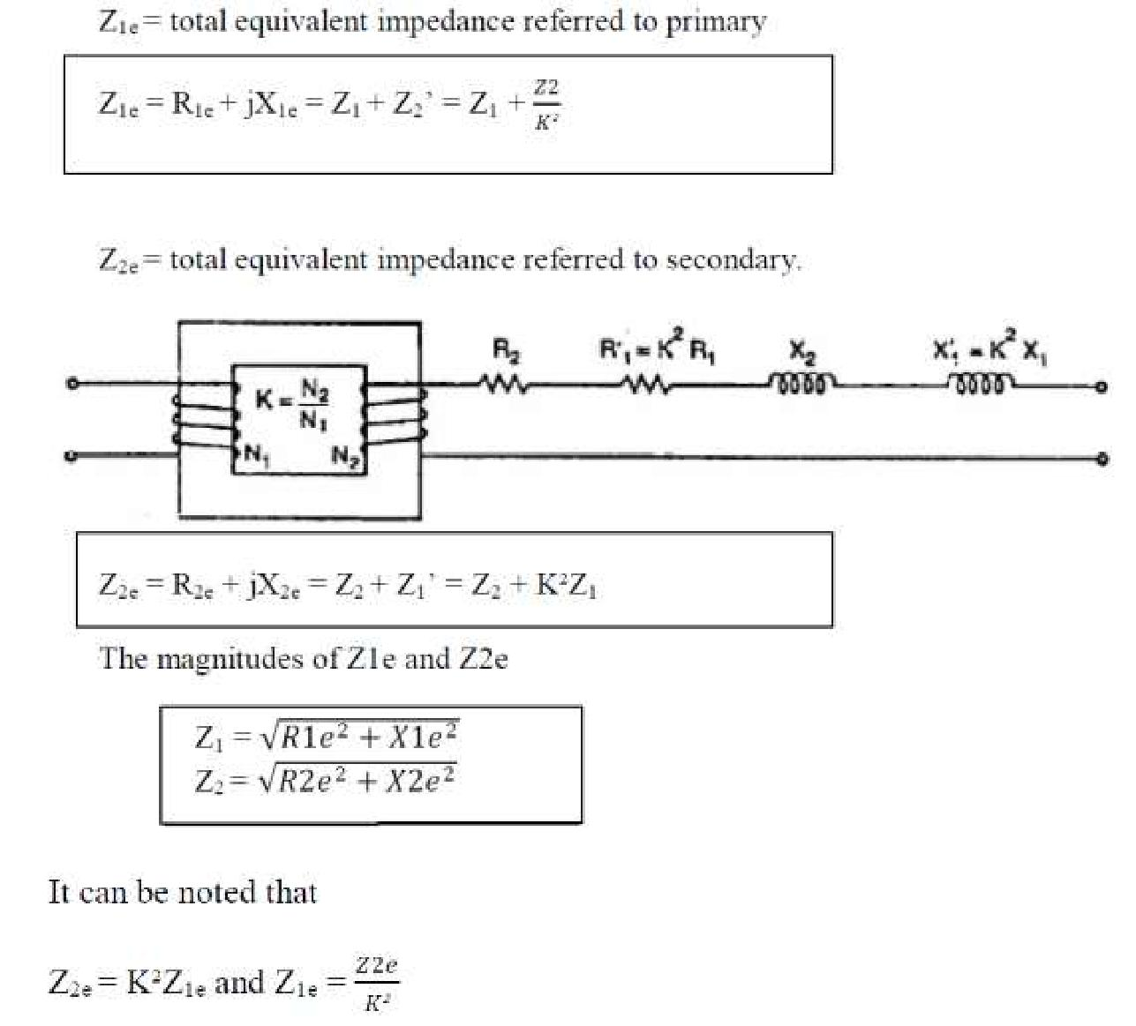

Complete Phasor Diagram of a Transformer (for Inductive Load or Laggingpf)

We now restrict ourselves to the more commonly occurring load i.e. inductive along with resistance,
which has a lagging power factor.

For drawing this diagram, we must remember that
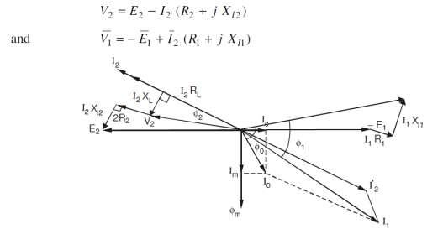

Equivalent Circuit of Transformer

No load equivalent circuit
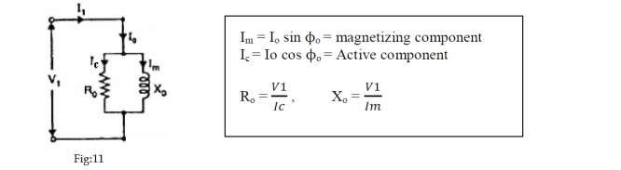

- Im produces the flux and is assumed to flow through reactance Xo called no load reactance while Ic is active component representing core losses hence is assumed to flow through the resistance R0

- Equivalent resistance is shown in fig.2.12.

- When the load is connected to the transformer then secondary current I2flows causes voltage drop across R2 and X2. Due to I2, primary draws an additional current.

I1 is the phasor addition of Io and I2’. This I1 causes the voltage drop across primary resistance R1 and reactance X1.
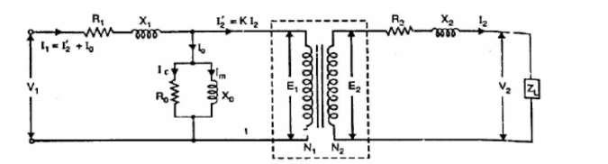

Fig: 2.12

To simplified the circuit the winding is not taken in equivalent circuit while transfer to one side.
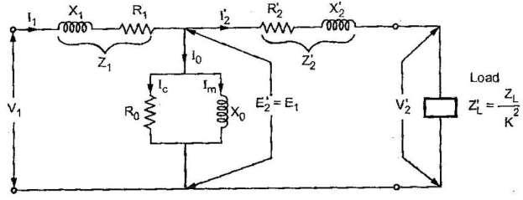

Fig: 2.13

Exact equivalent circuit referred to primary

Transferring secondary parameter to primary -

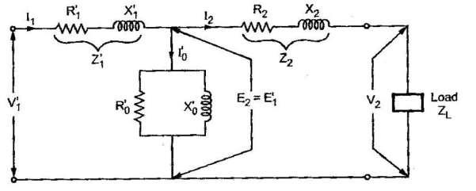

Exact equivalent circuit referred to secondary
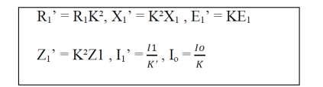

Now as long as no load branch i.e. exciting branch is in between Z1 and Z2’, the impedances cannot be combined. So further simplification of the circuit can be done. Such circuit is called approximate equivalent circuit.

Approximate Equivalent Circuit

i) To get approximate equivalent circuit, shift the no load branch containing Ro and Xo to the left of R1 and X1.

- By doing this we are creating an error that the drop across R1 and X1 to Io is neglected due to this circuit because simpler.

- This equivalent circuit is called approximate equivalent circuit Fig: 2.15 & Fig: 2.16.

In this circuit new R1 and R2’ can be combined to get equivalent circuit referred to primary R1e,similarly
X1 and X2’ can be combined to get X1e.
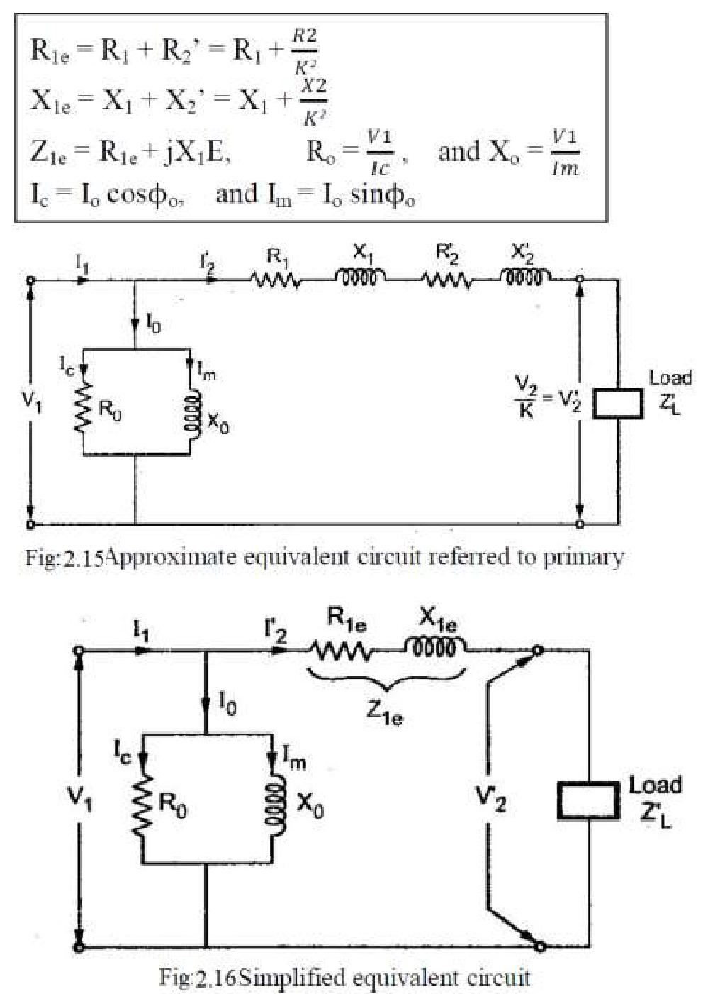

Approximate Voltage Drop in a Transformer

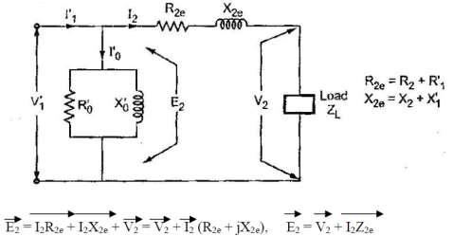

Fig. 2.17

Primary parameter is referred to secondary there are no voltage drop in primary. When there is no load,

I2 = 0 and we get no load terminal voltage drop in

V2o = E2 = no load terminal voltage

V2 = terminal voltage on load

1 For Lagging P.F.

- The current I2 lags V2 by angle ϕ2

- Take V2 as reference

- I2R2e is in phase with I2 while I2 X2e leads I2 by 90˚

- Draw the circle with O as centre and OC as radius cutting extended OA at M. as OA = V2 and now OM = E2.

- The total voltage drop is AM = I2Z2e.

- The angle α is practically very small and in practice M&N are very close to each other. Due to this the approximate voltage drop is equal to AN instead of AM

AN – approximate voltage drop
To find AN by adding AD& DN AD = AB cosϕ = I2R2ecosϕ DN = BL sinϕ = I2X2esinϕ

AN = AD + DN = I2R2e cosϕ2 + I2X2e sinϕ2

Assuming: ϕ2 = ϕ1 = ϕ

Approximate voltage drop = I2R2e cosϕ+I2X2esinϕ (referred to secondary) Similarly: Approximate voltage drop = I1R1e cosϕ+I1X1esinϕ (referred to primary)
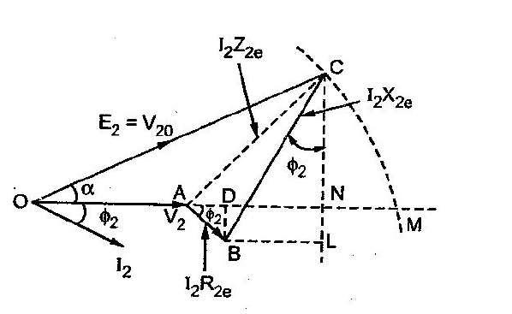

Fig:2.18

2 For Leading P.F Loading

I2 leads V2 by angle ϕ2

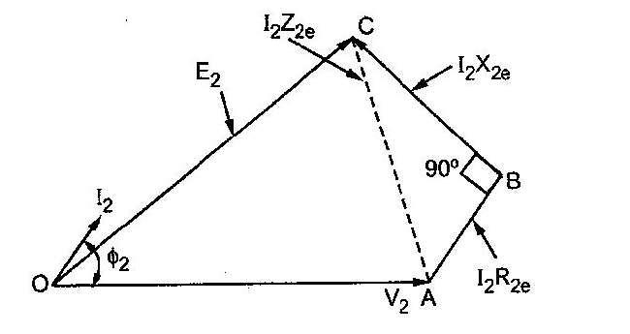
Approximate voltage drop = I2R2ecosϕ - I2X2esinϕ (referred to secondary) Similarly: Approximate voltage drop = I1R1ecosϕ - I1X1esinϕ (referred to primary)

Fig: 2.19

3 For Unity P.F. Loading

Approximate voltage drop = I2R2e (referred to secondary) Similarly: Approximate voltage drop = I1R1e (referred to primary)
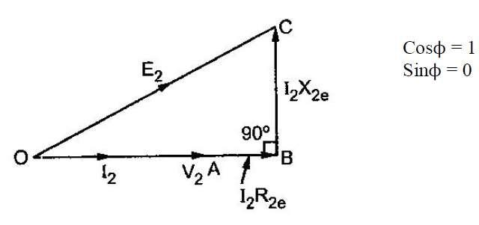

Fig: 2.20

Approximate voltage drop = E2 – V2

= I2R2ecosϕ ± I2X2esinϕ (referred to secondary)

  - I1R1ecosϕ ± I1X1esinϕ (referred to primary)

Losses in a Transformer

The power losses in a transformer are of two types, namely;
- Core or Iron losses

- Copper losses

These losses appear in the form of heat and produce (i) an increase in Temperature and (ii) a drop in efficiency.

2.7.1 Core or Iron losses (Pi)

These consist of hysteresis and eddy current losses and occur in the transformer core due to the alternating flux. These can be determined by open-circuit test.

Hysteresis loss = kh f Bm^{1.6} watts /m³

Kh– hysteresis constant depend on material

f - Frequency

Bm – maximum flux density

Eddy current loss = Ke f² Bm²t² watts /m³

Ke – eddy current constant

t - Thickness of the core

Both hysteresis and eddy current losses depend upon

- Maximum flux density Bm in the core

- Supply frequency f. Since transformers are connected to constant-frequency, constant voltage supply, both f and Bm are constant. Hence, core or iron losses are practically the same at all loads.

Iron or Core losses, Pi = Hysteresis loss + Eddy current loss = Constant losses (Pi)

The hysteresis loss can be minimized by using steel of high silicon content .Whereas eddy current loss can be reduced by using core of thin laminations.

Copper losses (Pcu)
These losses occur in both the primary and secondary windings due to their ohmic resistance. These can be determined by short-circuit test. The copper loss depends on the magnitude of the current flowing through the windings.
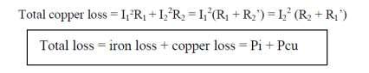

Efficiency of a Transformer

Like any other electrical machine, the efficiency of a transformer is defined as the ratio of output power (in watts or kW) to input power (watts or kW) i.e.

Power output = power input – Total losses

Power input = power output + Total losses

= power output + Pi + Pcu
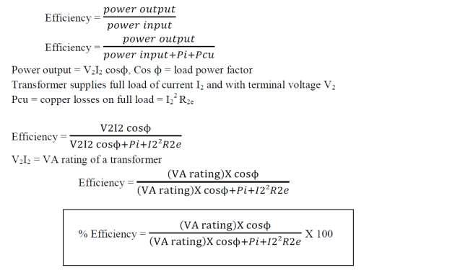

This is full load efficiency and I2 = full load current.

We can now find the full-load efficiency of the transformer at any p.f. without actually loading the transformer.

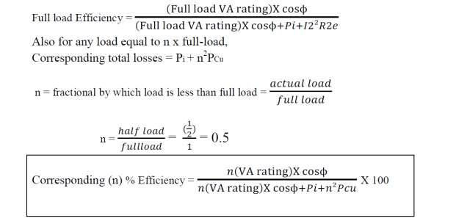

Condition for Maximum Efficiency

Voltage and frequency supply to the transformer is constant the efficiency varies with the load. As load increases, the efficiency increases. At a certain load current, it loaded further the efficiency start decreases as shown in fig. 2.21.
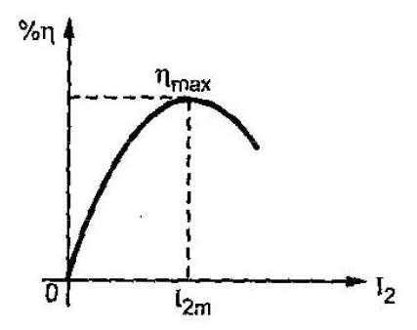

Fig: 2.21

The load current at which the efficiency attains maximum value is denoted as I_{2m}a n d maximum efficiency is denoted as ηmax, now we find -
- condition for maximum efficiency

- load current at which ηmax occurs

- KVA supplied at maximum efficiency Considering primary side,

Load output = V₁I₁ cosϕ1
Copper loss = I | ² R | 1e | or I | 2 | R | 2e
1 |  |  | 2

Iron loss = hysteresis + eddy current loss = Pi
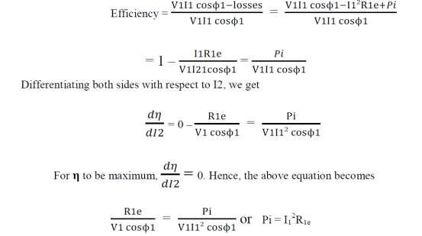

Pcu loss = Pi iron loss

The output current which will make Pcu loss equal to the iron loss. By proper design, it is possible to make the maximum efficiency occur at any desired load.

Load current I2m at maximum efficiency

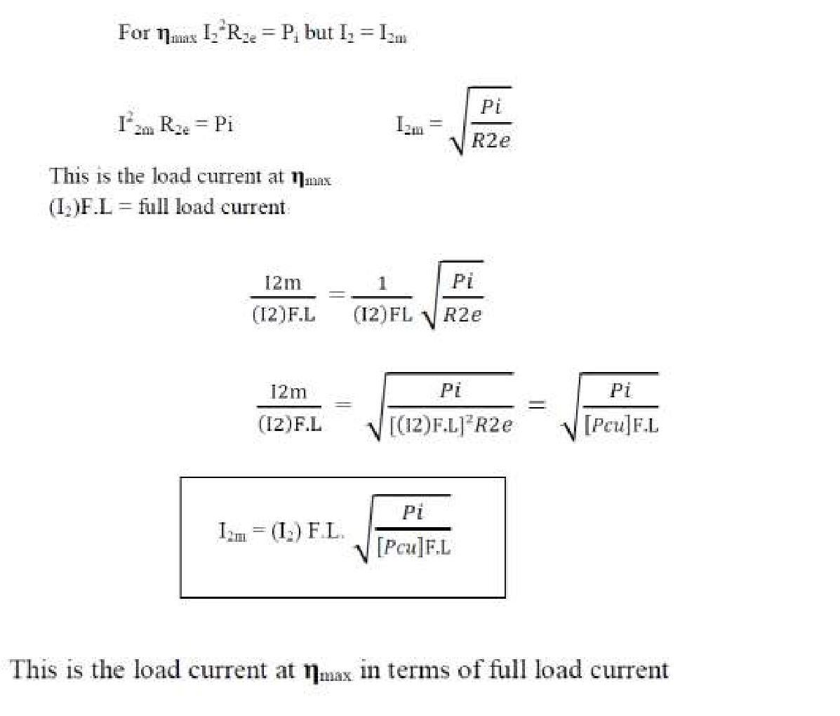

KVA Supplied at Maximum Efficiency
For constant V2 the KVA supplied is the function of load current.
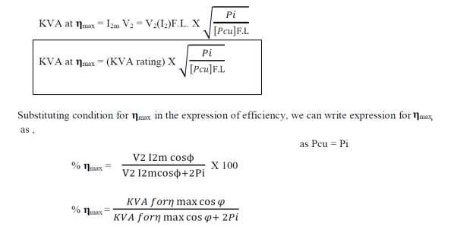

All Day Efficiency (Energy Efficiency)

In electrical power system, we are interested to find out the all-day efficiency of any transformer because the load at transformer is varying in the different time duration of the day. So all day efficiency is defined as the ratio of total energy output of transformer to the total energy input in 24 hours.

Here, kWh is kilowatt hour.

