UNIT-III
Starting, Speed Control and Testing of D.C. Machines

Necessity of starter
- At starting, heavy current is drawn by the dc motor from the supply as some time is required by the motor to gain speed and hence to built up back emf. If the starter is not present then there will be overheating of armature and voltage drop in supply takes place. So starters are required to limit this initial heavy inrush current to stop the overheating of the armature.
- Hence the main functions of starter are to limit functions of starter is to limit the starting current in armature circuit during starting.
The necessity of starter: -we know that in case of dc motor
l _{a}=(V-E_{b})/(R_{a}) and E_{b}=(∅ZNP)/60
So during starting, speed(N) is zero. Hence back emf E _{b} is zero.
- If the armature resistances is very small then armature current will be very large. This excess armature current may damage the winding. To avoid this excessive starting current, the starter is needed in the circuits of the armature.
- In the starter, additional resistance is connected in series with armature at the time of starting.
- When motor attains its full speed, this resistance gets disconnected.
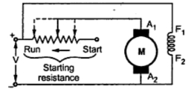

Starter
Three Point Starter
The arrangement is shown in the figure 3.14 shows a three point starter for shunt motor.
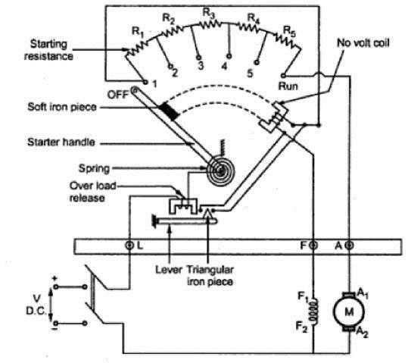

Fig. 3.14 Internal view of three point starter

It consists of resistances arranged in steps, R1 to R5 connected in series with the armature of the shunt motor. Field winding is connected across the supply through a protective device called ‘NO – Volt

Coil’. Another protection given to the motor in this starter is ‘over load release coil’. To start the motorthe starter handle is moved from OFF position to Run position gradually against the tension of a hinged spring. An iron piece is attached to the starter handle which is kept hold by the No-volt coil at Run position. The function of No volt coil is to get de-energized and release the handle when there is failure or disconnection or a break in the field circuit so that on restoration of supply, armature of the motor will not be connected across the lines without starter resistance. If the motor is over loaded beyond a certain predetermined value, then the electromagnet of overload release will exert a force enough to attract the lever which short circuits the electromagnet of No volt coil. Short circuiting of No volt coil results inde-energisation of it and hence the starter handle will be released and return to its off position due to the tension of the spring.
Four Point Starter

One important change is the No Volt Coil has been taken out of the shunt field and has been connected directly across the line through a Protecting resistance ‘R’. When the arm touches stud one. The current divides into three paths, 1. Through the starter resistance and the armature, 2. Through shunt field and the field rheostat and 3.Through No-volt Coil and the protecting resistance ‘R’. With this arrangement, any change of current in shunt field circuit does not affect the current passing though the NO-volt coil because, the two circuits are independent of each other. Thus the starter handle will not be released to its off position due to changes in the field current which may happen when the field resistance is varied. Fig 3.15 shows internal view of 4-point starter.

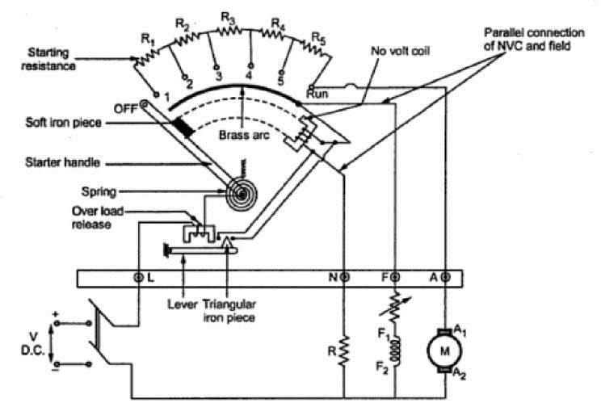

Fig. 3.15 Internal view of three point starter

Speed Control of DC Motor (Shunt, Series, and Compound)

Often we want to control the speed of a DC motor on demand. This intentional change of drive speed is known as speed control of a DC motor.
Speed control of a DC motor is either done manually by the operator or by means of an automatic control device. This is different to speed regulation – where the speed is trying to be maintained (or ‘regulated’) against the natural change in speed due to a change in the load on the shaft.
The speed of a DC motor (N) is equal to:
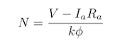
Therefore speed of the 3 types of DC motors – shunt, series and compound – can be controlled by changing the quantities on the right-hand side of the equation above.
Hence the speed can be varied by changing:
- The terminal voltage of the armature, V.
- The external resistance in armature circuit, R_{a}.
- The flux per pole, φ.

Terminal voltage and external resistance involve a change that affects the armature circuit, while flux involves a change in the magnetic field. Therefore speed control of DC motor can be classified into:
- Armature Control Methods
- Field Control Methods
We will discuss how both of these methods control the speed of DC series motors and DC shunt motors.

Speed Control of DC Series Motor
Speed control methods for a DC series motor can be classified as:
- Armature Control Methods
- Field Control Methods

Armature Controlled DC Series Motor
Speed adjustment of a DC series motor by armature control may be done by:
- Armature Resistance Control Method
- Shunted Armature Control Method
- Armature Terminal Voltage Control

Armature Resistance Control Method
This is the most common method employed. Here the controlling resistance is connected directly in series with the supply of the motor as shown in the fig.
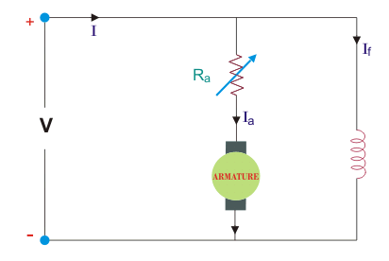
The power loss in the control resistance of DC series motor can be neglected because this control method is utilized for a large portion of time for reducing the speed under light load condition. This method of speed control is most economical for constant torque. This method of speed control is employed for DC series motor driving cranes, hoists, trains etc.

Shunted Armature Control
The combination of a rheostat shunting the armature and a rheostat in series with the armature is involved in this method of speed control. The voltage applied to the armature is varies by varying series rheostat R₁. The exciting current can be varied by varying the armature shunting resistance R₂. This method of speed control is not economical due to considerable power losses in speed controlling resistances. Here speed control is obtained over wide range but below normal speed.
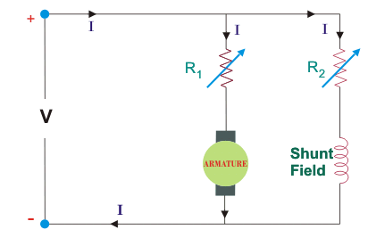

Armature Terminal Voltage Control
The speed control of DC series motor can be accomplished by supplying the power to the motor from a separate variable voltage supply. This method involves high cost so it rarely used.

Field Controlled DC Series Motor

Armature Terminal Voltage Control
The speed control of DC series motor can be accomplished by supplying the power to the motor from a separate variable voltage supply. This method involves high cost so it rarely used.

Field Controlled DC Series Motor

Speed adjustment of a DC series motor by field control may be done by:
- Field Diverter Method
- Tapped Field Control

Field Diverter Method
This method uses a diverter. Here the field flux can be reduced by shunting a portion of motor current around the series field. Lesser the diverter resistance less is the field current, less flux therefore more speed. This method gives speed above normal and the method is used in electric drives in which speed should rise sharply as soon as load is decreased.
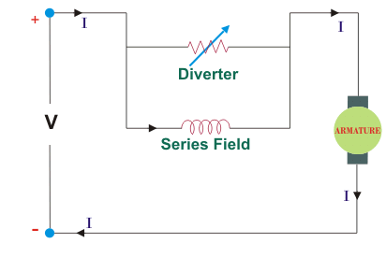

Tapped Field Control
This is another method of increasing the speed by reducing the flux and it is done by lowering number of turns of field winding through which current flows. In this method a number of tapping from field winding are brought outside. This method is employed in electric traction.
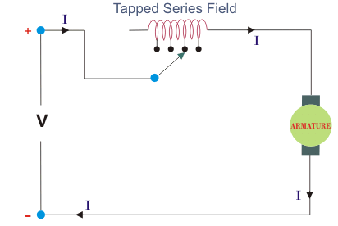

Speed Control of DC Shunt Motor
The classification of speed control methods for a DC shunt motor are similar to those of a DC series motor. These two methods are:
- Armature Control Methods
- Field Control Methods

Armature Controlled DC Shunt Motor
Armature controlled DC shunt motor can be performed in two ways:
- Armature Resistance Control
- Armature Voltage Control

Armature Resistance Control
In armature resistance control a variable resistance is added to the armature circuit. Field is directly connected across the supply so flux is not changed due to variation of series resistance. This is applied for DC shunt motor. This method is used in printing press, cranes, hoists where speeds lower than rated is used for a short period only.

Armature Voltage Control
This method of speed control needs a variable source of voltage separated from the source supplying the field current. This method avoids disadvantages of poor speed regulation and low efficiency of armature-resistance control methods.
The basic adjustable armature voltage control method of speed d control is accomplished by means of an adjustable voltage generator is called Ward Leonard System. This method involves using a motor-generator (M-G) set. This method is best suited for steel rolling mills, paper machines, elevators, mine hoists, etc. This method is known as Ward Leonard System.

Advantages of Armature Controlled DC Shunt Motor
- Very fine speed control over whole range in both directions
- Uniform acceleration is obtained
- Good speed regulation
- It has regenerative braking capacity

Disadvantages of Armature Controlled DC Shunt Motor
- Costly arrangement is needed, floor space required is more
- Low efficiency at light loads
- Drive produced more noise.

Field Controlled DC Shunt Motor
By this method a DC Shunt motor’s speed is controlled through a field rheostat.

Field Rheostat Controlled DC Shunt Motor
In this method, speed variation is accomplished by means of a variable resistance inserted in series with the shunt field. An increase in controlling resistances reduces the field current with a reduction in flux and an increase in speed. This method of speed control is independent of load on the motor. Power wasted in controlling resistance is very less as field current is a small value. This method of speed control is also used in DC compound motor.

Disadvantages of Field Rheostat Controlled DC Shunt Motor
- Creeping speeds cannot be obtained.
- Top speeds only obtained at reduced torque.
- The speed is maximum at minimum value of flux, which is governed by the demagnetizing effect of armature reaction on the field.

Testing of DC machines can be broadly classified as

- Direct method of Testing
- Indirect method of testing

DIRECT METHOD OF TESTING:

In this method, the DC machine is loaded directly by means of a brake applied to a water cooled pulley coupled to the shaft of the machine. The input and output are measured and efficiency is
output
determined by η= input . It is not practically possible to arrange loads for machines of large
capacity.

INDIRECT METHOD OF TESTING:

In this method, the losses are determined without actual loading the machine. If the losses are known, then efficiency can be determined. Swinburne’s test and Hopkinson’s test are commonly used on shunt motors. But, as series motor cannot be started on No-load,these tests cannot be conducted on DC series motor.
- BRAKE TEST: is a direct method of testing.
R
W₂
S

In this method of testing motor shaft is coupled to a Water cooled pulley which is loaded by means of weight

W₁= suspended weight in kg
W₂ = Reading in spring balance in kg R = radius of pulley
N = speed in rps

V = Supply voltage

I = Full Load Current

Net pull due to friction = (W₁ − W₂) kg
= 9.81 (W₁ − W₂) Newton 1
Shaft torque T_{ch} = (W₁ − W₂)R kg − mt.
Shaft torque T_{ch} =9.81 (W₁ − W₂)R N − mt.
Motor output power = T_{ch} X 2 n N Watt
= (W₁ − W₂)R X 2 n N watts 3
Or 9.81 (W₁ − W₂)R X 2 n N watt.
= 61.68 N (W₁ − W₂)R Watt 4
Input power = VI watts 5
Therefore efficiency = output = 61.68 N (M1– M2)R 6
input VI

This method of testing can be used for small motors only because for a large motor it is difficult to arrange for dissipation of heat generated at the brake.

Swinburne’s Test:
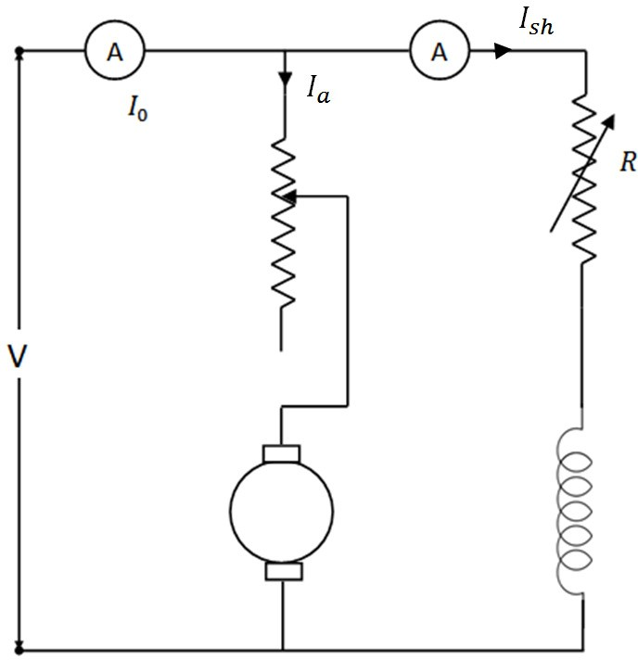

Figure 4.2
This test is a no load test and hence cannot be performed on series motor. The circuit connection is shown in Figure 4.2. The machine is run on no load at rated speed which is adjusted by the shunt field resistance.

ADVANTAGES

  - Economical, because no load input power is sufficient to perform the test
  - Efficiency can be pre-determined
  - As it is a no load test, it cannot be done on a dc series motor

DISVANTAGES
1.Change in iron loss from no load to full load is not taken into account. (Because of armature reaction, flux is distorted which increases iron losses).
2.Stray load loss cannot be determined by this test and hence efficiency is over estimated.
3.Temperature rise of the machine cannot be determined.
4.The test does not indicate whether commutation would be satisfactory when the machine is loaded.

I_{O} = No load current;
I_{sh} = shunt field current
I_{ao} = No load armature current = (I_{o} - I_{sh})
V= Supply Voltage

No load input =VI_{o} watts.

No load power input supplies
- Iron losses in the core
- Friction and windings loss and
- Armature copper loss.
Let I = load current at which efficiency is required

I_{a} = I – I_{sh} if machine is motoring; I + I_{sh} if machine is generating Efficiency as a motor:
Input = VI; I_{a}²r_{a} = (I- I_{sh})²r_{a}
Constant losses W_{c} = VI_{o} – (I_{o} – I_{sh})²r_{a} 7
Total losses = (I- I_{sh})²r_{a} + W_{c}

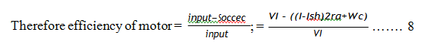
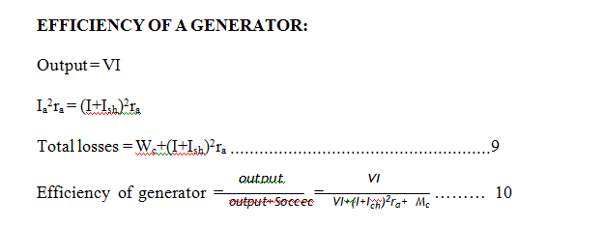
Regenerative Or Back To Back Test:
This is a regenerative test in which two identical DC shunt machines are coupled mechanically and tested simultaneously. One of the machines is run as a generator while the other as motor supplied by the generator. The set therefore draws only losses in the machines. The circuit connection is shown in Figure 4.3. The machine is started as motor and its shunt field resistance is varied to run the motor at its rated speed. The voltage of the generator is made equal to supply voltage by varying the shunt field resistance of the generator which is indicated by the zero reading of the voltmeter connected across the switch. By adjusting the field currents of the machines, the machines can be made to operate at any desired load with in the rated capacity of the machines

ADVANTAGES:

  - The two machines are tested under loaded conditions so that stray load losses are accounted for.
  - Power required for the test is small as compared to the full load powers of the two machines. Therefore economical for long duration tests like “Heat run tests”.
  - Temperature rise and commutation qualities can be observed.
  - By merely adjusting the field currents of the two machines the two machines can be loaded easily and the load test can be conducted over the complete load range in a short time.

DISADVANTAGES:

- Availability of two identical machines
- Both machines are not loaded equally and this is crucial in smaller machines.
- There is no way of separating iron losses of the two machines which are different because of different excitations.
- Since field currents are varied widely to get full load, the set speed will be greater than rated values.
The efficiency can be determined as follows:

