UNIT-II
Performance of D.C. Machines

Principle of Operation

DC motor operates on the principle that when a current carrying conductor is placed in a magnetic field, it experiences a mechanical force given by F = BIL newton. Where ‘B’ = flux density in wb, ‘I’ is the current and ‘L’ is the length of the conductor. The direction of force can be found by Fleming’s left hand rule. From the point of construction, there is no difference between a DC generator and DC motor. Figure 3.1 shows a multipolar DC motor. Armature conductors are carrying current downwards under North Pole and upwards under South Pole. When the field coils are excited, with current carrying armature conductors, a force is experienced by each armature conductor whose direction can be found by Fleming’s left hand rule. This is shown by arrows on top of the conductors. The collective force produces a driving torque which sets the armature into rotation. The function of a commutator in DC motor is to provide a continuous and unidirectional torque.

In DC generator the work done in overcoming the magnetic drag is converted into electrical energy. Conversion of energy from electrical form to mechanical form by a DC motor takes place by the work done in overcoming the opposition which is called the ‘back emf’.
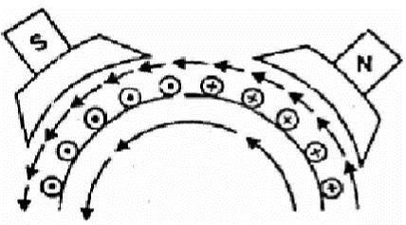

Fig. 3.1 Generation of force in DC motor

Back EMF

It is the dynamically induced emf in the armature conductors when the armature rotates following principle of DC motor. The direction of this induced emf can be determined using Fleming’s right hand rule. This emf act in opposition to the supply voltage of the armature. It opposes the supply voltage that is why it is called back emf. The value of this induced emf is same as the value of the emf induced in dc generator. The work done in overcoming this opposition is converted into mechanicalenergy.
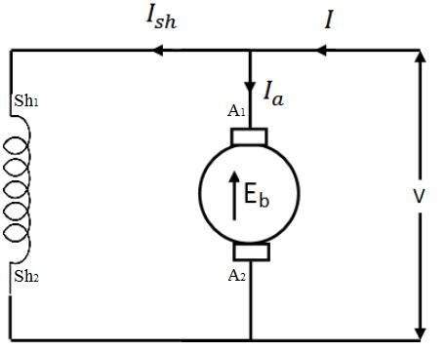

Fig. 3.2 Schematic diagram of DC shunt motor

Fig shown 3.2 a DC shunt motor the rotating armature generating the back emfEb. The armature current can be written as
I_{a} = V-E_{b}/R_{a}
Where ra is armature resistance,
E_{b}= PØNZ / 60 A

Armature current is proportional to back emf. So back emf is a controlling factor of armature current.

Torque Equation

Let Ta = armature torque in N –m developed by the armature of a motor running at N.rps.
Therefore P = Ta X ^{2πN} Watts
60
Electrical equivalent of mechanical power developed P_{m} =E_{b}I_{a}

^{P}m ^{=E} b ^{I} a ^{=P=T}a ×
T_{a} = | E _{b}I_{a} | ×60 Also, on substituting for Eb i.e., E_{b} | = | PφZN
 | 2πN |  |  | 60A
Therefore,
_{Ta=}

From the above equation for torque, it is seen that

  - T_{a} =kφI_{a}

  - T_{a}∝I_{a}² - For series motor (becauseφ∝I_{a} ) before saturation. After saturation T_{a}∝I_{a}

  - T_{a}∝I_{a} - For shunt motor. (because φ is constant in a shunt motor)

Characteristics of DC Motors

There are three important characteristics-

- Armature torque vs armature current Tavsla(Electrical characteristics)

- Speed vs armature current characteristic N vsIa

- Speed vs torque N vsTa (Mechanical characteristics)

Characteristics of DC shunt motor

1 Armature torque vs armature current TavsIa characteristics

For a shunt motor flux can be assumed practically constant (at heavy loads, decreases, due to increased armature reaction)

T_{a} =kφI_{a}

φ is constant,T_{a}∝I_{a}

Therefore electrical characteristic of a shunt motor is a straight line through origin shown by dotted line in figure 3.3. Armature reaction weakens the flux hence Tays la characteristic bends as shown by dark line in figure 3.3, Shunt motors should never be started on heavy loads, since it draws heavy current under such condition.

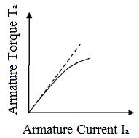

Fig. 3.3 Torque Current Characteristic of DC shunt motor

2 Speed vs armature current NavsIa characteristics

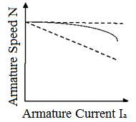

V is constant and in dc shunt motor φ is also constant. Thus with armature current speed drops and the If Ia increases, speed decreases. This characteristic is shown in figure 3.7. Therefore the speed is inversely proportional to armature current Ia. When load is heavy Iaia heavy thus speed is low. When load is low Ia is low thus speed becomes dangerously high. Hence series motor should never started without load on it.
speed current characteristics is drooping in nature is shown in figure 3.4.
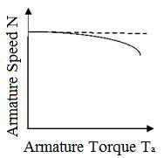

4 Speed vs armature current characteristics of DC shunt motor

Thus with increase with torque the speed of DC shunt motor decreases. The nature of the characteristics is drooping in nature shown in figure 3.5.

3 Speed vs armature torque Navs Ta characteristics

∴ N= |  |  |  |  |  | V |  |  |  |  |  | - |  |  |  |  | I_{a}r_{a}
 |  |  | kk₁I_{a} |  |  |  |  |  |  |  |  |  |  |  | kk₁I_{a}
⇒ N= |  |  |  |  |  |  | V |  |  |  |  |  |  | - |  |  | r_{a}
 |  |  |  | kk₁I_{a} |  |  |  |  |  |  |  |  |  |  |  |  | kk₁
Now, T =kI²∴I |  |  |  |  |  |  |  |  |  |  |  |  |  |  |  |  |  |  |  |  | = |  | T_{a}
 |  |  |  |  |  |  |  |  |  |  |  |  |  |  |  |  |  |  |  | a
 |  |  |  |  |  | a |  |  |  |  |  |  |  | a |  |  |  |  |  |  |  |  | k
Substituting I_{a}
 |  |  |  |  |  |  |  |  |  |  |  |  |  |  |  |  | r_{a}
N= |  | V |  |  |  |  |  | k |  |  |  |  | -
 |  | kk₁ |  |  |  |  |  |  |  |  |  |  |  |  |  | kk₁
 |  |  |  |  |  |  |  |  | T_{a}
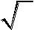
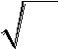
⇒ N= ^{Const.} -Const.
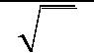
T_{a}

Thus with increase with torque the speed of DC shunt motor decreases. The nature of the characteristics is drooping in nature shown in figure 3.5.

Speed vs armature torque characteristics of DC shunt motor

2 Characteristics of DC series motor

1 Armature torque vs armature current TavsIa characteristics

T_{a} =kφI_{a}

T_{a}∝I_{a}² - For series motor (becauseφ∝I_{a} ) before saturation After saturation φ becomes constant thus T_{a}∝I_{a}

At light loads, Ia and hence φ is small. But as Ia increases Ta increases as the square of the current up-to saturation. After saturation φ becomes constant, the characteristic becomes a
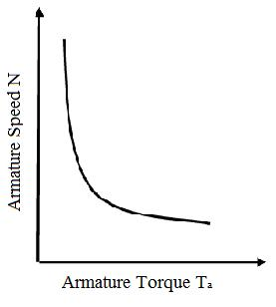

straight line as shown in Figure 3.6. Therefore a series motor develops a torque proportional to the square of the armature current. This characteristic is suited where huge starting torque is required for accelerating heavy masses.

Speed vs armature torque characteristics of DC series motor

3 Characteristics of DC compound motor

There are two different types of compound motors in common use, they are the cumulative compound motor and the differential compound motor. In the cumulative compound motor, the field produced by the series winding aids the field produced by the shunt winding. The speed of this motor falls more rapidly with increasing current than does that of the shunt motor because the field increases. In the differential compound motor, the flux from the series winding opposes the flux from the shunt winding. The field flux, therefore, decreases with increasing load current. Because the flux decreases, the speed may increases with increasing load. Depending on the ratio of the series-to-shunt field ampere-turns, the motor speed may increases very rapidly.
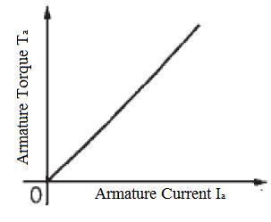

Armature torque vs armature current characteristics of DC compound motor
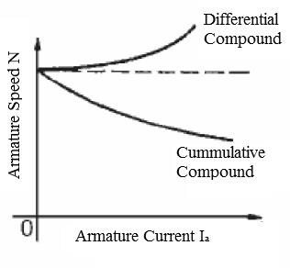

Speed vs armature current characteristics of DC compound motors

1The torque-speed (c/s) of a cumulatively compound D.C motor

In the cumulative compounded D.C. motor, there is a component of flux which is constant and another component which is proportional to its armature current (and thus to its load). Therefore, the cumulatively compounded motor has a higher starting torque than a shunt motor (whose flux is constant) but a lower starting torque than a series motor (whose entire flux is proportional to armature current). At light loads, the series field has a very small effect, so the motor behaves approximately as a shunt D.C. motor. As the load gets very large, the series flux becomes quite important and the torque-speed curve begins to look like a series motor's (c/s). A comparison of the torque-speed (c/s) of
each of these type of machines is shown in figure 3.11.
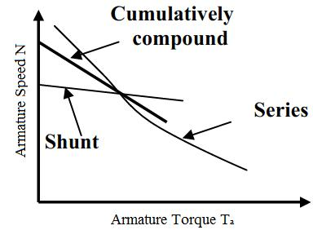

Speed vs armature torque characteristics of DC motors

2 The torque-speed (c/s) of a differentially compound D.C motor

In a differentially compound D.C. motor, the shunt magneto motive force and series magneto motive force subtract from each other. This means that as the load on the motor increases, Ia increases and the flux in the motor decreases. But as the flux decreases, the speed of the motor increases. This speed increases causes anther increases in load, which further increases Ia, further decreasing the flux, and increasing the speed again. The result is that a differentially compounded motor is unstable and tends to run away. It is so bad that a differentially compounded motor is unsuitable for any application. The torque speed characteristics is shown in figure 3.12.

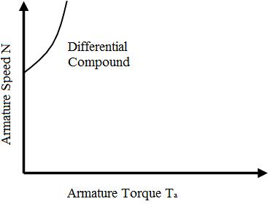

Speed vs armature torque characteristics of DC differential compound motor

5 Application of DC motors

1 Application of DC shunt motor

The characteristics of a DC shunt motor give it a very good speed regulation, and it is classified as a constant speed motor, even though the speed does slightly decrease as load is increased. Shunt wound motors are used in industrial and automotive applications where precise control of speed and torque are required.
2 Application of DC series motor

For a given input current, the starting torque developed by a DC series motor is greater than that developed by a shunt motor. Hence series motors are used where huge starting torques are necessary. Ex. Cranes, hoists, electric traction etc. The DC series motor responds by decreasing its speed for the increased in load. The current drawn by the DC series motor for the given increase in load is lesser than DC shunt motor. The drop in speed with increased load is much more prominent in series motor than that in a shunt motor. Hence series motor is not suitable for applications requiring a constant speed.

3 Application of DC compound motor

Cumulative compound wound motors are virtually suitable for almost all applications like business machines, machine tools, agitators and mixers etc. Compound motors are used to drive loads such as shears, presses and reciprocating machines.

Differential compound motors are seldom used in practice (because of rising speed characteristics).

Armature Reaction

The action of magnetic field set up by armature current on the distribution of flux under main poles of a DC machine is called armature reaction.

When the armature of a DC machines carries current, the distributed armature winding produces its own mmf. The machine air gap is now acted upon by the resultant mmf distribution caused by the interaction of field ampere turns (ATf) and armature ampere turns (ATa). As a result the air gap flux density gets distorted.

Figure shows a two pole machine with single equivalent conductor in each slot and the main field mmf (Ff) acting alone. The axis of the main poles is called the direct axis (d-axis) and the interpolar axis is called quadrature axis (q-axis). It can be seen from the Figure b that armature mmf (Fa) is along the interpolar axis. Fa which is at 90⁰ to the main field axis is known as cross magnetizing mmf.
Figure c shows the practical condition in which a DC machine operates when both the Field flux and armature flux are existing. Because of both fluxes are acting simultaneously, there is a shift in brush axis and crowding of flux lines at the trailing pole tip and flux lines are weakened or thinned at the leading pole tip. (The pole tip which is first met in the direction of rotation by the armature conductor is leading pole tip and the other is trailing pole tip).

If the iron in the magnetic circuit is assumed unsaturated, the net flux/pole remains unaffected by the armature reaction though the air gap flux density distribution gets distorted. If the main pole excitation is such that the iron is in the saturated region of magnetization (practical case) the increase in flux density at one end of the poles caused by armature reaction is less than the decrease at the other end, so that there is a net reduction in the flux/pole. This is called the demagnetizing effect. Thus it can be summarized that the nature of armature reaction in a DC machine is

- Cross magnetizing with its axis along the q-axis.

- It causes no change in flux/pole if the iron is unsaturated but causes reduction in flux/pole in the presence of iron saturation. This is termed as demagnetizing effect. The resultant mmf ‘F’ is shown in figure d.
Cross Magnetizing Ampere Turns/pole(ATc)

If the brush is shifted by an angle θ as shown in figure 1.23 then the conductors lying in between the angles BOC and DOA are carrying the current in such a way that the direction of the flux is downwards i.e., at right angles to the main flux. This results is the distortion in the main flux. Hence, these conductors are called cross magnetizing or distorting ampere conductors.

Total armature conductors/pole=Z / P
Demagnetizing conductors / pole = Z * 2θ / 360
Therefore cross magnetizing conductors/pole= |  |  |  | Z |  | − Z |  |  | 2θ
 |  |  |  | P |  |  |  | 360
Cross magnetizing ampere turns/pole ATc= | ZI_{a} |  | ⎛ |  |  | 1 | − |  | θ |  | ⎞
 | a |  | ⎜ |  |  |  |  | 360 |  |  | ⎟
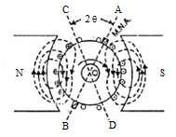 |  |  | ⎝ 2 P |  |  |  |  |  |  |  | ⎠

Fig. 1.23 Cross-magnetizing ampere conductors

Demagnetizing Ampere Turns /pole (ATd)

The exact conductors which produce demagnetizing effect are shown in Fig 1.24, Where the brush axis is given a forward lead of θ so as to lie along the new axis of M.N.A. The flux produced by the current carrying conductors lying in between the angles AOC and BOD is such that, it opposes the main flux and hence they are called as demagnetizing armature conductors.
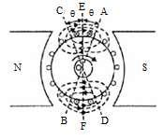

Fig. 1.24 Demagnetizing ampere conductors

Z= total no of armature conductors

Current in each armature conductors=Ia / A
θ =Forward lead in mechanical or angular deg.
Total no of armature conductors in between angles AOC & BOD =Z * 4θ / 360

Demagnetizing amp turns/poles ATd = Z * (θ / 360) * Ia / A

Compensating Winding

Due to armature reaction flux density wave get distorted and reduced. Due to distortion of flux wave the peak flux density increases to such a high value that it creates high induced emf. If this emf is higher than the breakdown voltage across adjacent segments, a spark over could result which can easily spread over the whole commutator, and there will be a ring of fire, resulting in the complete short circuit of the armature.

To protect armature from such adverse condition armature reaction must be neutralized. To neutralize the armature reaction ampere-turns by compensating winding placed in the slots cut
out in pole face such that the axis of the winding coincides with the brush axis as shown figure 1.25.

Compensating conductors in field poles and the connection of compensating conductors with armature

The compensating windings neutralize the armature mmf directly under the pole which is the major portion because in the interpole region the air gap will be large. Compensating windings are connected in series with armature so that it will create mmf proportional to armature mmf.

The number of ampere-turns required in the compensating windings is given by

ATc = Total Armature Ampere Turns ×^{Pole Arc}
Pole Pitch

Commutation

The process of reversal of current in the short circuited armature coil is called ‘Commutation’. This process of reversal takes place when coil is passing through the interpolar axis (q-axis), the coil is short circuited through commutator segments and brush.
The process of commutation of coil ‘CD’ is shown Fig. 1.26. In sub figure ‘c’ coil ‘CD’ carries 20A current from left to right and is about to be short circuited in figure ‘d’ brush has moved by a small width and the brush current supplied by the coil are as shown. In figure ‘e’ coil ‘CD’ carries no current as the brush is at the middle of the short circuit period and the brush current in supplied by coil ‘AB’ and coil ‘EF’. In sub figure ‘f’ the coil ‘CD’ which was carrying current from left to right carries current from right to left. In sub fig ‘g’ spark is shown which is due to the reactance voltage. As the coil is embedded in the armature slots, which has high permeability, the coil possess appreciable amount of self inductance. The current is changed from +20 to –20. So due to self inductance and variation in the current from +20 to –20, a voltage is induced in the coil which is given by L dI/dt. This emf opposes the change in current in coil ‘CD’ thus sparking occurs.
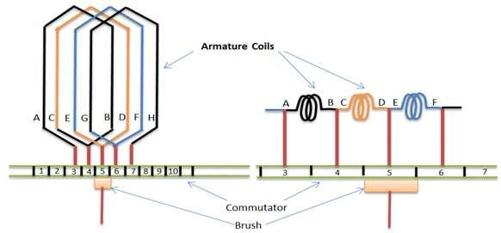

Fig a Fig b

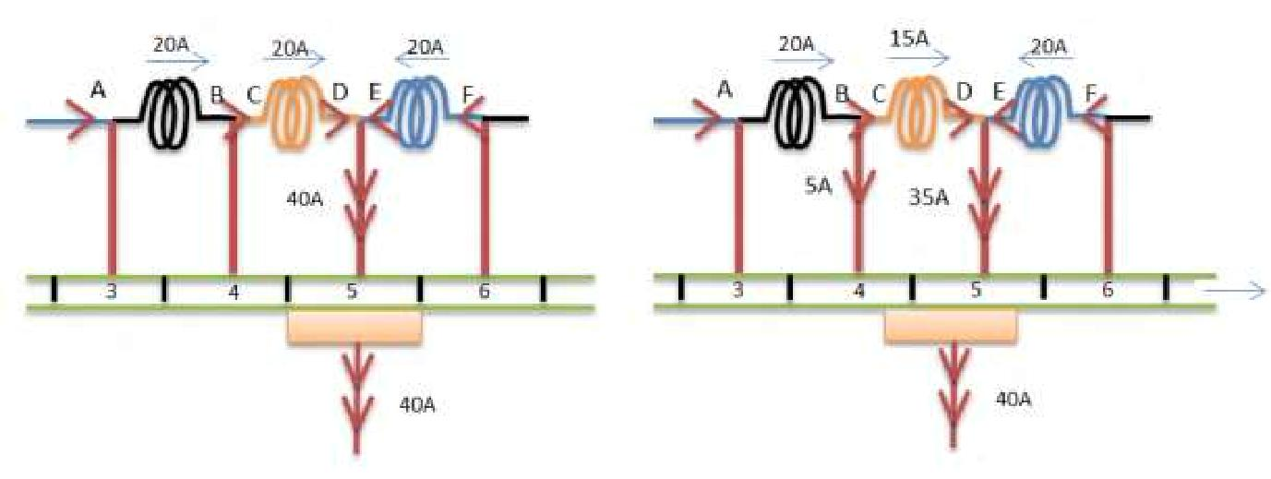

Fig.c Fig.d

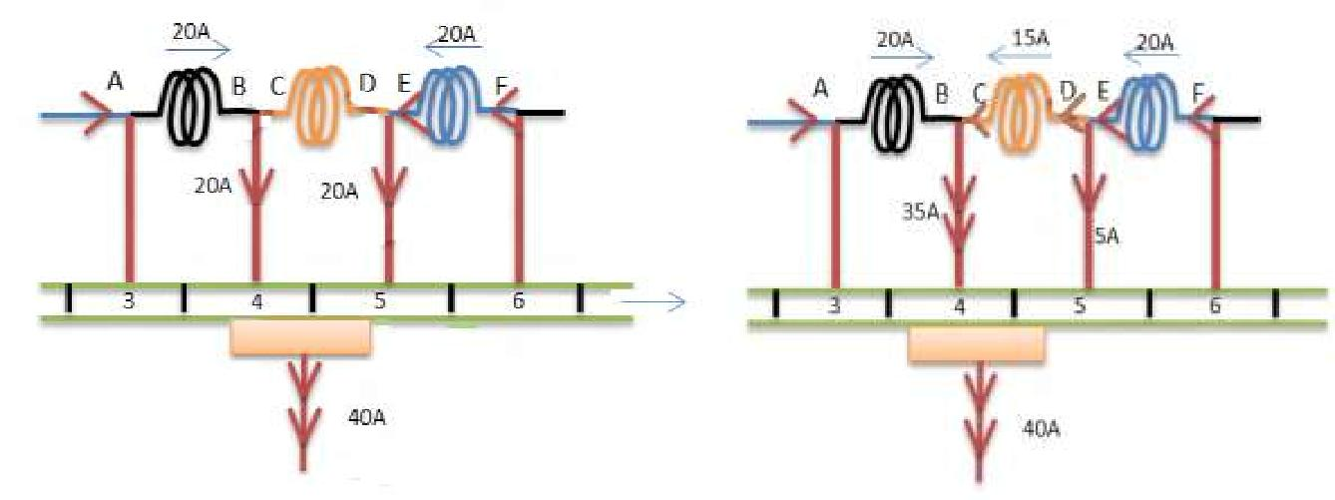

Fig.e Fig.f

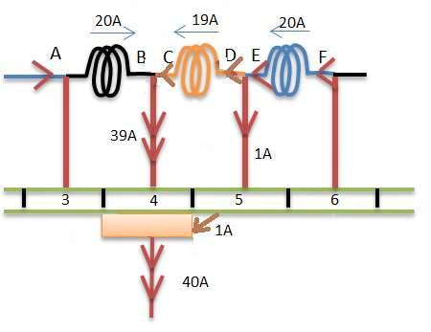

Fig.1.26 a-g shows the process of commutation

Reactance Voltage

During commutation sparking occurs in the commutator segment and brush due to presence of reactance voltage. This voltage is generated due to change of current in the commutating coil for its self-inductance and also due to mutual inductance of the adjacent coils. This voltage is called reactance voltage and according to Lenz’s law this induced voltage oppose its cause of production. Here the cause of production is the change in current in the coil under commutation. Thus the commutation becomes poorer.

Reactance voltage = co-efficient of self-inductance X rate of change of current= L di/ dt

Time of short circuit = Tc = (time required by commutator to move a distance equal to the circumferential thickness of brush)–(one mica insulating strip) = Time of commutation

Let Wb= brush width in cm

Wi = width of mica insulation in cm

Vc = peripheral velocity of commutator segments in cm/sec.
Then T =^{Wb-Wi}sec
c | V_{c}
Total change in current = I - (-I) = 2I
Therefore self-induced or reactance voltage = L |  | 2I | for linear commutation
 |  | T_{c}

= 1.11 L 2I / T_{C}

If brush width is given in terms of commutator segments, then commutator velocity should be converted in terms of commutator segments/seconds.

Method of Improving Commutation

Commutation can be improved in two ways by (i) Resistance commutation

Resistance Commutation
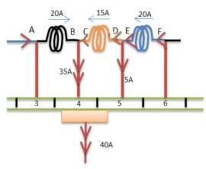

Fig. 1.27

In this method the resistance of the brushes are increased by changing then from copper brush to carbon brush. From the above figure 1.27 it is seen that when current ‘20A’ from coil ‘EF’ reaches the commutator segment ‘5’, it has two parallel paths opened to it. The first path is straight from bar ‘5’ to the brush and the other is via short circuited coil ‘CD’ to bar ‘4’ and then to brush. If copper brushes are used the current will follow the first path because of its low contact resistance. But when carbon brushes having high resistance are used, then current ‘20A’ will prefer the second path because the resistance r1 of first path will increase due to reducing area of contact with bar ‘5’ and the resistance r2 of second path decreases due to increasing area of contact with bar ‘4’. Hence carbon brushes help in obtaining sparkles commutation. Also, carbon brushes lubricate and polish commutator. But, because of high resistance the brush contact drop increases and the commutator has to be made larger to dissipate the heat due to loss. Carbon brushes require larger brush holders because of lower current density.

E.M.F commutation:

To neutralize sparking caused by reactance voltage in this method an emf is producedwhich acts in opposite direction to that of reactance voltage, so that the reactance voltage is completely eliminated. The neutralization of emf may be done in two ways (i) by giving brush a forward lead sufficient enough to bring the short circuited coil under the influence of next pole of opposite polarity or (ii) by usinginterpoles or compoles. The second method is commonly employed.
Interpoles or Compoles

These are small poles fixed to the yoke and placed in between the main poles as shown in figure 1.28. They are wound with few turns of heavy gauge copper wire and are connected in series with the armature so that they carry full armature current. Their polarity in case of generator is that of the main pole ahead in the direction of rotation. Their polarity in case of motor is that of the main pole behind in the direction of rotation.
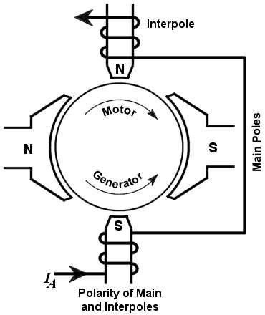

Fig. 1.28 Inter-poles of DC machines

The function of interpoles is (i) to induce an emf which is equal and opposite to that of the reactance voltage. Interpoles neutralize the cross magnetizing effect of armature reaction.

Losses and efficiency of DC Machines

It is convenient to determine the efficiency of a rotating machine by determining the losses than by direct loading. Further it is not possible to arrange actual load for large and medium sized machines. By knowing the losses, the machine efficiency can be found by

η = | Output | (for Generator)
 | Output+Losses
_{η=}Input-losse
input for motor

In the process of energy conversion in rotating machines-current, flux and rotation are involved which cause losses in conductors, ferromagnetic materials and mechanical losses respectively.

Various losses occurring in a DC machine are listed below-

Total losses can be broadly divided into two types.

- Constant losses

- Variable losses

These losses can be further divided as 1) Constant losses –

- Core loss or iron loss

  - Hysteresis loss

  - Eddy current loss

- Mechanical loss

  - Windage loss

  - Friction loss – brush friction loss and Bearing friction loss.

- Variable losses –

- copper loss (I² r)

    - Armature copper loss

    - Field copper loss

    - Brush contact loss

  - Stray load loss

    - Copper stray load loss

    - Core stray load loss

Core loss or iron loss occurs in the armature core is due to the rotation of armature core in the magnetic flux produced by the field system. Iron loss consists of a) Hysteresis loss and b) Eddy current loss.

Hysteresis loss: This loss is due to the reversal of magnetization of armature core as the core passesunder north and south poles alternatively. This loss depends on the volume and grade of iron, maximum value of flux density and frequency. Hysteresis loss is given by Steinmetz formula.

W_{h}= K _{h} B_{m}^{1.6} f V Joule/sec or watt

Where Kh = Constant of proportionality- depends on core material.

Bm = Maximum flux density in Wb/m²

f = Frequency in Hz

V = Volume of the armature core in m³

Eddy Current Loss: Eddy currents are the currents set up by the induced emf in the armature corewhen the core cuts the magnetic flux. The loss occurring due to the flow of eddy current is known as eddy current loss. To reduce this loss the core is laminated, stacked and riveted. These laminations are insulated from each other by a thin coating of varnish. The effect of lamination is to reduce the current path because of increased resistance due to reduced cross section area of laminated core. Thus the magnitude of eddy current is reduced resulting in the reduction of eddy current loss.

Eddy Current loss is given by
W_{e}= K _{e} B_{m}² f ²t ²V Watt

Where Ke = Constant of proportionality

Bm = Maximum flux density in Wb/m²

f = Frequency in Hz

V = Volume of the armature core in m³

t = Thickness of the lamination in meters

ii) Mechanical loss: these losses include losses due to windage, brush friction and bearing friction

losses.

2) Variable losses: Variable losses consist of

(i) Copper loss:

- Armature copper loss: This loss occurs in the armature windings because of the resistance of armature windings, when the current flows through them. The loss occurring is termed as copper loss or r loss. This loss varies with the varying load.

- Field copper loss: This is the loss due to current flowing in the field windings of the machine. c) Brush contact drop: This is due the contact resistance between the brush and the commutator. This loss remains constant with load.

(ii) Stray load loss: The additional losses which vary with the load but cannot be related to current in a simple manner are called stray load loss. Stray load losses are.

Copper stray load loss: the loss occurring in the conductor due to skin effect and loss due to the eddy currents in the conductor set up by the flux passing through them are called copper stray load loss.

Core stray load loss: When the load current flows through the armature conductors, the flux densitydistribution gets distorted in the teeth and core. The flux density decreases at one end of the flux density wave and increases at the other. Since the core loss is proportional to the square of the flux density, the decrease in flux density will be less than the increase due to the increase in flux density, resulting in a net increase in the core loss predominantly in the teeth, is known as stray load loss in the core.

Further under highly saturated conditions of teeth, flux leaks through the frame and end shields causing eddy current loss in them. This loss is a component of stray load loss. Stray load loss is difficult to calculate accurately and therefore it is taken as 1 % of the output of a DC machine.

EFFICIENCY OF A DC GENERATOR:

Power flow in a DC generator is shown in figure 3.19.
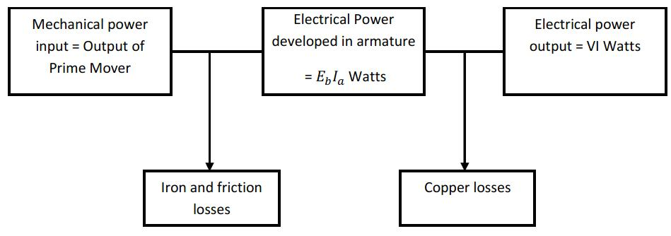

Fig. 3.19 Power flow in a DC generator

CONDITION FOR MAXIMUM EFFICIENCY

Generator output = VI;

Generator input = VI + losses.

I n p u t =VI+I_{a}²r_{a}+w_{c}

If the shunt field current is negligible, then Ia =I

For maximum efficiency _{dI}^{d}(η)=0

I _{a}²r_{a}=w_{c}

Hence efficiency is maximum when variable loss = constant loss.
The load current corresponding to maximum efficiency is | I = |  | w_{c}
 |  |  | r_{a}

