UNIT-I
Electromechanical Energy Conversion

Electromechanical-Energy-Conversion Principles

The electromechanical-energy-conversion process takes place through the medium of the electric or magnetic field of the conversion device of which the structures depend on their respective function
- Transducers: microphone, pickup, sensor, loudspeaker
- Force producing devices: solenoid, relay, and electromagnet
- Continuous energy conversion equipment: motor, generator
Forces and Torques in Magnetic Field Systems

The Lorentz Force Law gives the force F on a particle of charge q in the presence of electric and magnetic fields.

F=q(E+v×B)
Where, F :newtons, q: coulombs, E: volts/meter, B : telsas, v: meters/second

In a pure electric-field system,F=qE

In pure magnetic-field systems, F=q(v×B
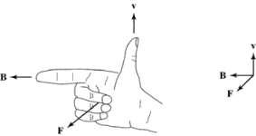

Fig 1.1 Right-hand rule for F=q(v×B)
- For situations where large numbers of charged particles are in motion,

Fv=ρ(E+v×B)

J =ρv
Fv= J V

ρcharge dencity:coulmbs/m³

Fv(force density): newtons/m³

J=ρv(current density): amperes/m²

Most electromechanical-energy-conversion devices contain magnetic material.

- Forces act directly on the magnetic material of these devices which are constructed of rigid, non-deforming structures.

- The performance of these devices is typically determined by the net force, or torque, acting on the moving component. It is rarely necessary to calculate the details of the internal force distribution.

- Just as a compass needle tries to align with the earth’s magnetic field, the two sets of fields associated with the rotor and the stator of rotating machinery attempt to align, and torque is associated with their displacement from alignment.

- In a motor, the stator magnetic field rotates ahead of that of the rotor, pulling on it and performing work.

o For a generator, the rotor does the work on the stator.
The Energy Method

- Based on the principle of conservation of energy: energy is neither created nor destroyed; it is merely changed in form.

- Fig. 1.2 shows a magnetic-field-based electromechanical-energy-conversion device.

- A lossless magnetic-energy-storage system with two terminals

- The electric terminal has two terminal variables: e (voltage), i (current).

- The mechanical terminal has two terminal variables: ffld (force), x (position)

- The loss mechanism is separated from the energy-storage mechanism.

– Electrical losses: ohmic losses...

– Mechanical losses: friction, windage...
>Fig. 1.3: a simple force-producing device with a single coil forming the electric terminal, and a movable plunger serving as the mechanical terminal.

- The interaction between the electric and mechanical terminals, i.e. the electromechanical energy conversion, occurs through the medium of the magnetic stored energy.
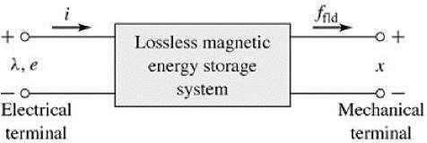

Fig 1.2 Schematic diagram of magnetic- | field
electromechanical-energy-conversion | device

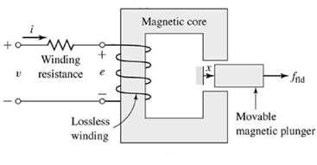

Fig. 1.3 Schematic diagram of simple force-producing device

- Wfld: the stored energy in the magnetic field

^{dW}fld | =ei−f_{fld} | dx
dt |  | dt

e=dλ / dt
dW_{fld}= id λ− f _{fld} dx

- From the above equation force can be solved as a function of the flux λ and the mechanical terminal position x.

- The above equations form the basis for the energy method

Energy Balance

Consider the electromechanical systems whose predominant energy-storage mechanism is in magnetic fields. For motor action, the energy transfer can be accounted as

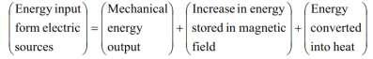

The ability to identify a lossless-energy-storage system is the essence of the energy method.

- This is done mathematically as part of the modeling process.

- For the lossless magnetic-energy-storage system of Fig. 1.2 can be rearranged and gives

dWelec=dWmech+dWfld
where

dWelec= idλ= differential electric energy input

dWmech=fflddx= differential mechanical energy outputdWfld= differential change in magnetic stored energy

>Here e is the voltage induced in the electric terminals by the changing magnetic stored energy. It is through this reaction voltage that the external electric circuit supplies power to the coupling magnetic field and hence to the mechanical output terminals.

dWelec=eidt
- The basic energy-conversion process is one involving the coupling field and its action and reaction on the electric and mechanical systems.

- Combining above two equation –

dW_{elec}=eidt=dW_{mech}+dW_{fld}

Energy in Singly-Excited Magnetic Field Systems

In energy-conversion systems the magnetic circuits have air gaps between the stationary and moving members in which considerable energy is stored in the magnetic field.

This field acts as the energy-conversion medium, and its energy is the reservoir between the electric and mechanical system.

Fig. 1.4 shows an electromagnetic relay schematically. The predominant energy storage occurs in the air gap, and the properties of the magnetic circuit are determined by the dimensions of the air gap.

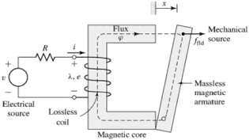

Fig.1.4 Schematic of an electromagnetic relay

λ= L (x )i
^{dW}mech^{=f}fld^{dx}

dW_{fld}= id λ− f _{fld} dx

Wfldis uniquely specified by the values ofλ and x. Therefore ,λand x are referred to as state variables.Since the magnetic energy storage is lossless, it is conservative system. Wfld is the same regardless of how λandx are brought to their final values. Fig 1.5 shows where two separate the paths.
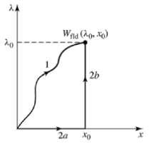

Fig. 1.5 Integration paths for Wfld

On path 2a, dλ=0 and ffld =0. Thus dffld =0 on path 2a. On path 2b, dx= 0. Therefore the following equation can be written
W_{fld}(λ₀, x₀)=∫ i (λ, x₀)dλ0

For a linear system in which λ is proportional to i the equation will change and can be written as-

 | λ |  |  |  |  |  |  |  | λ | λ | ' |  | 1 λ |  |  | 2
W (λ, x )= i (λ', x )d λ' |  |  |  |  |  |  | = |  |  |  |  | dλ'=
fld | ∫ |  |  |  |  |  |  |  | ∫ | L ( x ) |  |  | 2 L ( x)
 | 0 |  |  |  |  |  |  |  | 0
 | V: the volume of the magnetic field
 |  |  |  | ⎛ | B |  |  |  |  | ⎞
 | W |  | = | ∫⎜ | ∫ | H .dB 'dV
 |  | fld |  |  |  |  |  |  |  | ⎟
 |  |  |  | V ⎝ | 0 |  |  |  |  | ⎠
 | If B =μH , then
 |  |  |  | ⎛ | B² |  |  | ⎞
 | W |  | = | ∫⎜ |  |  |  | dV
 |  | fld |  |  | 2μ |  |  | ⎟
 |  |  |  | V ⎝ |  |  |  | ⎠

Determination of Magnetic Force and Torque form Energy

The magnetic stored energy is a state function, determined uniquely by the values of the Wfld independent state variables λ and x.
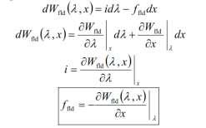

Energy and Co-energy:

It is that energy from which the force can be obtained directly as a function of the current. The selection of energy or co-energy as the state function is purely a matter of convenience.

The co-energy W' (i , x) is defined as a function of I and x such that
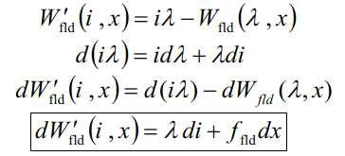

From the above equation co-energy W'_{fld} (i ,x) can be seen to be a state function of the two independent variables i and x.
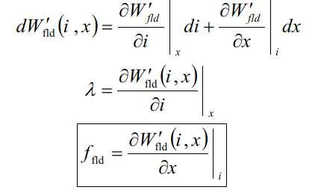

For a system with a rotating mechanical displacement,
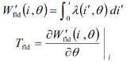

If the system is magnetically linear,
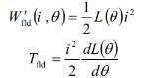

In field-theory terms, for soft magnetic materials
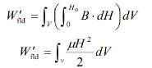

For permanent-magnet (hard) materials

For a magnetically-linear system, the energy and co-energy (densities) are numerically equal:
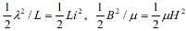

For a nonlinear system in which λ and i or B and H are not linearly proportional, the two functions are not even numerically equal.
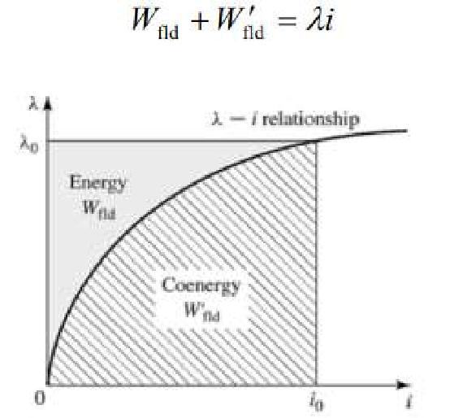

Fig.1.6 Graphical interpretation of energy and co-energy in a singly-excited system

Multiply-Excited Magnetic Field Systems

Many electromechanical devices have multiple electrical terminals.

Measurement systems: torque proportional to two electric signals; power as the product of voltage and current.

Energy conversion devices: multiply-excited magnetic field system.

A simple system with two electrical terminals and one mechanical terminal:

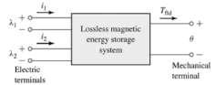

Fig. 1.7 Multiply-excited magnetic energy storage system
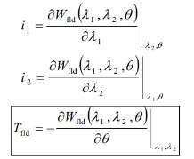

To find Wfld, use the path of integration as shown in Fig 1.8.

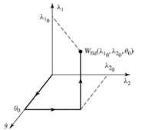

Fig. 1.8 Integration path to obtain Wfld(λ10 ,λ20 ,θ0)

In a magnetically-linear system,
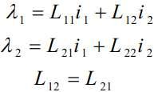

Note that Lij=Lij (θ )

The energy for this linear system is
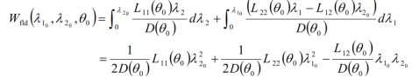

Co-energy function for a system with two windings can be defined as
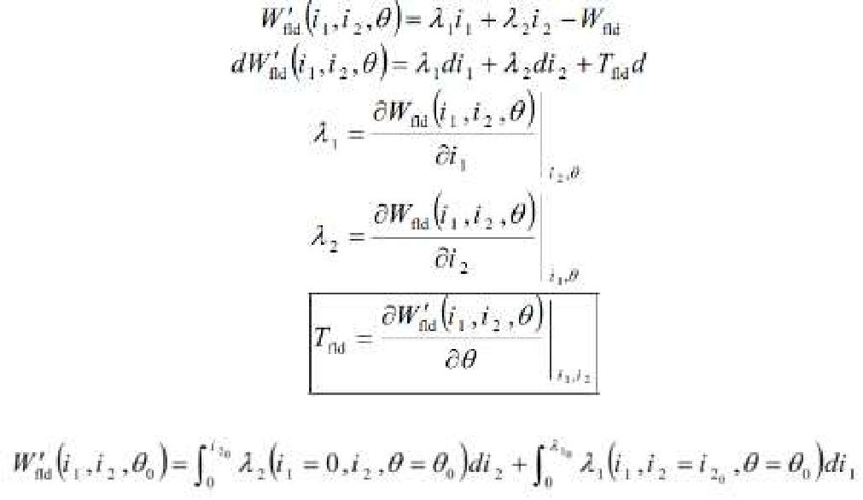

For a linear system
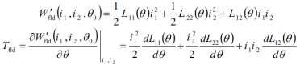

- Note that the co-energy function is a relatively simple function of displacement.

- The use of a co-energy function of the terminal currents simplifies the determination of torque or force.
- Systems with more than two electrical terminals are handled in analogous fashion.

UNIT-I
DC Generators

Principle of operation of DC Generator

A D.C generator as shown in figure below the armature be driven by a prime mover in the clock wise direction and the stator field is excited to produce the field poles as shown. There will be induced voltage in each armature conductor. The direction of the induced voltage can be determined by applying Fleming'sright hand rule. All the conductors under the influence of North Pole will have directed induced voltage, while the conductors under the influence of South Pole will have induced voltage in them. For a loaded generator the direction of the armature current will be same as that of the induced voltages. Thus and also represent the direction of the currents in the conductors. We know, a current carrying conductor placed in a magnetic field experiences force, the direction of which can be obtained by applying

Fleming's left hand rule.Applying this rule to the armature conductors in fig 1.9, the rotor experiences atorque (Te) in the counter clockwise direction (i.e., opposite to the direction of rotation) known as back torque. For steady speed operation back torque is equal to the machines input torque (Tpm) i.e. the torque supplied by prime mover.
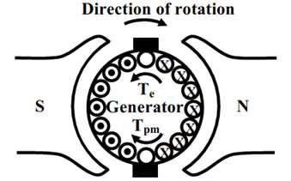

Fig. 1.9 Action of DC generator

Action of Commutator

In DC machines the current in each wire of the armature is actually alternating, and hence a device is required to convert the alternating current generated in the DC generator by electromagnetic induction into direct current, or at the armature of a DC motor to convert the input direct current into alternating current at appropriate times, as illustrated in Fig. 1.10.

DC generator: induced AC emf is converted to DC voltage;

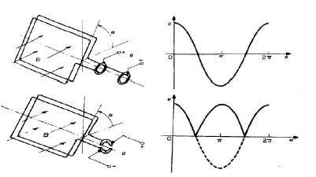
DC motor: input direct current is converted to alternating current in the armature at appropriate times to produce a unidirectional torque. The commutator consists of insulated copper segments mounted on an insulated tube. Armature coils are connected in series through the commutator segments. Two brushes are pressed to the commutator to permit current flow. The brushes are placed in the neutral zone, where the magnetic field is close to zero, to reduce arcing. The commutator switches the current from one rotor coil to the adjacent coil. The switching requires the interruption of the coil current. The sudden interruption of an inductive current generates high voltages. The high voltage produces flashover and arcing between the commutator segment and the brush.

Fig. 1.10Action of Commutator
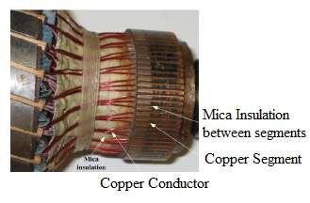

Fig. 1.11 Mechanical view of commutator
Constructional Features

The stator of the dc machine has poles, which are excited by dc current to produce magnetic fields. In the neutral zone, in the middle between the poles, commutating poles or interpoles are placed to reduce sparking of the commutator due to armature reaction. The commutating poles are supplied by dc current. Compensating windings are mounted on the main poles. Field poles are mounted on an iron core that provides a closed magnetic circuit. The motor housing supports the iron core, the brushes and the bearings. The rotor has a ring-shaped laminated iron core with slots. Coils with several turns are placed in the slots. The distance between the two legs of the coil is about 180 electric degrees for full pitch. The coils are connected in series through the commutator segments. The ends of each coil are connected to a commutator segment.
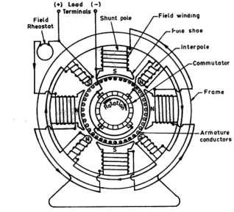

Fig. 1.12 Cross sectional view of DC Machine
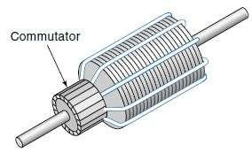

Fig. 1.13 Armature of DC Machine

Armature Winding

DC machines armature consists of armature conductors. The conductors distributed in slots provided on the periphery of the armature is called armature winding. Depending on the way in which the coils are interconnected at the commutator end of the armature, the windings can be classified as lap and wave windings. Further they can be classified as simplex and multiplex.

Coil Span/Coil Pitch:

It represents the span of the coil. For full pitched winding, the span is 180⁰ electrical or number of slots per pole. Coil pitch can be represented in terms of electrical degrees, slots or conductor. A full pitched coil leads to maximum voltage per coil.

Back Pitch (Yb):

It is the distance measured in between the two coil sides of the same coil at the back end of the armature, the commutator end being the front end of armature. It can be represented in terms of number of slots or coil sides. Back pitch also represents the span of coil.

Front Pitch (Yf):

The distance between the two coil sides of two different coils connected in series at the front end of the armature is called front pitch.

Lap Winding

Lap winding is suitable for low voltage high current machines because of more number of parallel paths. The number of parallel path in lap winding is equal to number of poles.

A=P

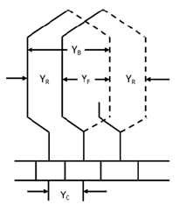
Equalizing rings are connected in lap winding.

Fig. 1.14 Winding diagram of lap winding

Wave Winding

Wave winding is used for high voltage low current machines. In case of wave winding, the number of parallel path (A) = 2 irrespective of number of poles. Each path will have conductors connected in series.

Equalizing rings are not required in wave winding.
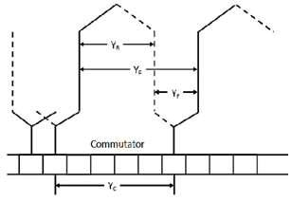

Fig. 1.15 Winding diagram of wave winding

Simplex and Multiplex Winding

Fig 1.14 and Fig. 1.15 shows simplex lap and simplex wave winding.

The degree of multiplicity of a multiplex winding indicates the relative number of parallel paths with respect to the number of parallel paths in the corresponding simplex winding. For example a duplex lap or wave winding is a lap or wave winding having twice as many as parallel paths as a simplex lap or wave winding respectively. The winding can be triplex or quadruplex winding in similar manner.

Use of Laminated Armature

The armature winding of DC machine should be laminated to reduce eddy current losses. The armature body (rotor) rotates in the field magnetic field. Thus in the core of the armature voltage induced which inturn causes current to flow in the body. This current is known as eddy current. This current causes loss and thus heat will be generated. This loss depends on the amount of current flow. To reduce the amount of current flow the resistance of the body should be increased. Thus using lamination the resistance of the path through which current flows will be increased. The amount of eddy current will be reduced and thus eddy current loss can be minimized.
EMF Equation

Let φ = flux per pole in weber
Z = number of armature conductors = Number of slots X conductors per slot.
P = Number of poles; A= Number of parallel paths in armature.
A= P for lap wound armature; A=2 for wave wound armature
N = speed of armature in rpm;
E = induced emf in each parallel path.
Average emf generated/conductor in one revolution = dφ / dt
Flux cut by a conductor in one revolution = dφ = Pφ weber.
Since Number of revolutions/second= _{N/60}
Time taken for one revolution = dt= 60/N seconds
dφdt
EMF generated/conductor = Pφ / 60/N)
Since each path has _{Z/A}conductors in series
EMF generated in each path is E= Pφ / (60/N) * _{Z/A}
_{E =} φΖΝ / 60 ∗ ( P /A)

Construction of a DC machine:
A DC generator can be used as a DC motor without any constructional changes and vice versa is also possible. Thus, a DC generator or a DC motor can be broadly termed as a DC machine. These basic constructional details are also valid for the construction of a DC motor. Hence, let's call this point as construction of a DC machine instead of just 'construction of a dc generator'.
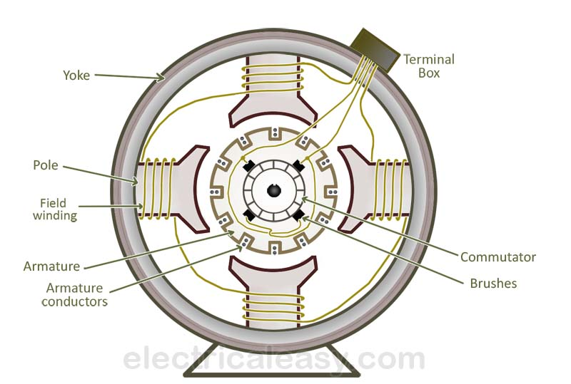
The above figure shows the constructional details of a simple 4-pole DC machine. A DC machine consists two basic parts; stator and rotor. Basic constructional parts of a DC machine are described below.
- Yoke: The outer frame of a dc machine is called as yoke. It is made up of cast iron or steel. It not only provides mechanical strength to the whole assembly but also carries the magnetic flux produced by the field winding.
- Poles and pole shoes: Poles are joined to the yoke with the help of bolts or welding. They carry field winding and pole shoes are fastened to them. Pole shoes serve two purposes; (i) they support field coils and (ii) spread out the flux in air gap uniformly.
- Field winding: They are usually made of copper. Field coils are former wound and placed on each pole and are connected in series. They are wound in such a way that, when energized, they form alternate North and South poles.
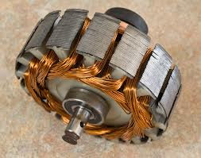
Armature core (rotor)
- Armature core: Armature core is the rotor of the machine. It is cylindrical in shape with slots to carry armature winding. The armature is built up of thin laminated circular steel disks for reducing eddy current losses. It may be provided with air ducts for the axial air flow for cooling purposes. Armature is keyed to the shaft.
- Armature winding: It is usually a former wound copper coil which rests in armature slots. The armature conductors are insulated from each other and also from the armature core. Armature winding can be wound by one of the two methods; lap winding or wave winding. Double layer lap or wave windings are generally used. A double layer winding means that each armature slot will carry two different coils.
- Commutator and brushes: Physical connection to the armature winding is made through a commutator-brush arrangement. The function of a commutator, in a dc generator, is to collect the current generated in armature conductors. Whereas, in case of a dc motor, commutator helps in providing current to the armature conductors. A commutator consists of a set of copper segments which are insulated from each other. The number of segments is equal to the number of armature coils. Each segment is connected to an armature coil and the commutator is keyed to the shaft. Brushes are usually made from carbon or graphite. They rest on commutator segments and slide on the segments when the commutator rotates keeping the physical contact to collect or supply the current.

The main parts of DC Machine (motor or generator) are as follows:
  - Yoke
  - Pole core and pole shoes
  - Pole coil and field coil
  - Armature core
  - Armature winding or conductor
  - Commutator
  - Brushes and bearings
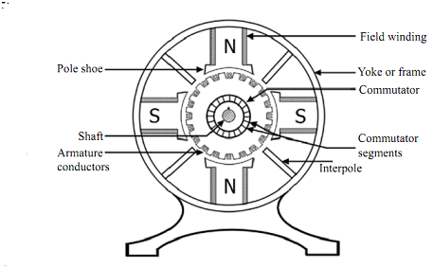
Construction of DC Machine

1. Yoke
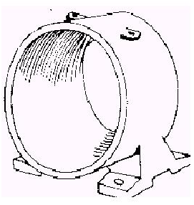
1 Yoke
- Function
  - It provide mechanical Support for poles
  - It also provide protection to whole machine from dust, moisture etc.
  - It also carries magnetic flux produced by the poles
  - Yoke is also called as frame.
- Material used
  - For small M/C yoke is made of cast iron.
  - For large M/C it is made of cast steel or rolled steel.2. Pole & Pole core
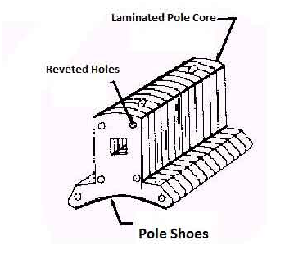
2 Pole & Pole core
- Function
  - Pole of a generator is an electromagnet.
  - The field winding is winding over pale.
  - Pole provides magnetic flux when field winding is excited.
- Material used
  - Pole core or pole made of cast iron or cast steel.
  - It built of these laminations of annealed steel. The laminations is done to reduce the power lose due to eddy currents.

3. Pole Shoe
Function
  - It is extended part of pole. It enlarge area of pole
  - Due to this enlarged area, flux is spread out in the air gap and more flux can pass through the air gap to armature.
  - Material used
  - It is made of cast iron or cast steed.
  - It built of this lamination of annealed steel. the lamination is done to reduce power loss due to eddy currents

4. Pole coil or field windings
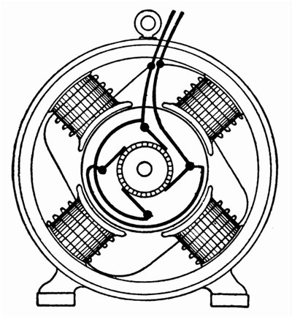
Pole coil or field windings
- Function
  - It is wound around pole core and called as field coil
  - it is connected in series to from field winding
  - When Current is passed through field winding it electro magnetize the poles which produce necessary flux.
- Material used
  - The material used for field conductor is copper.

5. Armature Core
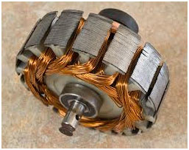
Armature Core
- Function
  - It has large number of slots in its periphery
  - Armature conductor, are placed in this slots
  - It is also provide path of low reluctance to the flux produced by field winding
- Material used
  - High permeability low reluctance materials such as cast or iron are used for armature core.
  - The lamination is provided so as to reduce the loss due to eddy current.

6. Armature Winding
- Function
  - Armature conductor are inter connected to form armature Winding
  - When armature winding is rotated using prime mover. the magnetic flux and voltage gets induced in it
  - Armature winding is connected to external circuit
- Material used
  - It is made of conducting material such as coppers.

7. Commutator
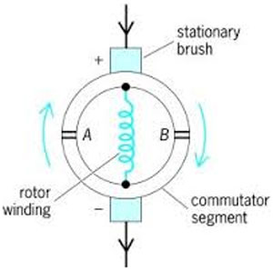
Commutator
- Function
  - It Convert alternating current induce in the current in a unidirectional current
  - It collects the current form armature conductor and pass it load with the help of brushes
  - It also provide unidirectional torque for dc motor
- Material used
  - It is made of a large number of edge shaped segments of hard drawn copper.
  - The Segments are insulated from each other by thin layer of mica.
OR
  - The Segment of commutator is made of copper and insulating material between segments is mica.

8. Brushes
- Function
  - Brushes collect the current from commutator and apply it to external load.
  - Brushes wear with time and it is should be inspected regularly.
- Material used
  - Brushes are made of carbon or graphite it is rectangular in shape.

COMPARISION BETWEEN LAP,WAVE WINDING:
Lap Winding | Wave Winding
1. In this winding all the pole groups of the coils generating  e.m.f in the same direction at any instant of time are  connected in parallel by the brushes. | 1. In this winding all the coils carrying current in the  same direction are connected in series i.e., coils  carrying current in one direction are connected in one  series circuit and coils carrying current in opposite  direction are connected in other series circuit.
2. Lap winding is also known as parallel windings. | 2. Wave winding is also known as series winding.
3. The number of parallel path is equal to the number  of poles i.e., A = P. | 3. The number of parallel paths is always equal to 2  i.e., A = 2.
4. The number of brush required by this windingis always  equal to the number of poles. | 4. The number of brushes required by this winding  is always equal to 2.
5. The machine using lap winding requires equalizer rings  for obtaining better commutation. | 5. The machine using wave winding does require dummy  coils to provide the mechanical balance for the armature.
6. Lap windings are used for low voltage and high current  machines. | 6. Wave windings are used for high voltage and low  current machines.
7. Lap windings are generally used for machines of ratings  above 500 kW. | 7. Wave windings are generally used for machines of  ratings below 560 kW

Methods of excitation

DC machines are excited in two ways-

1Separate excitation:
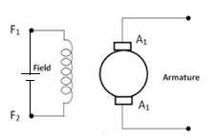
When the field winding is connected to an external source to produce field flux. According to the type of excitation this machines are called separately excited dc machine.

Fig. 1.16 Schematic diagram of separately excited dc machine

2 Self-excitation:

When the field winding is connected with the armature to produce field flux. A self-excited machine requires residual magnetism for operation. According to the type of excitation this machines are called self-excited dc machine.

Depending on the type of field winding connection DC machines can be classified as:

1 Shunt machine:

The field winding consisting of large number of turns of thin wire is usually excited in parallel with armature circuit and hence the name shunt field winding. This winding will be having more resistance and hence carries less current.
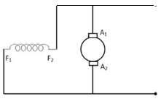

Fig. 1.17 Schematic diagram of dc shunt machine

2 Series machine:

The field winding has a few turns of thick wire and is connected in series with armature.
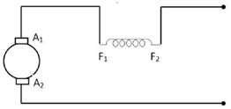

3 Compound machine:

Compound wound machine comprises of both series and shunt windings and can be either short shunt or long shunt, cumulative, differential or flat compounded.
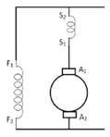
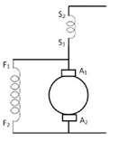

A B

Fig. 1.19 A A Schematic diagram of short -shunt compound machine

Fig.1.19 B Schematic diagram of long-shunt compound machine

Build-up of E.M.F

When the armature is rotating with armature open circuited, an emf is induced in the armature because of the residual flux. When the field winding is connected with the armature, a current flows through the field winding ( in case of shunt field winding, field current flows even on No-load and in case of series field winding only with load) and produces additional flux. This additional flux along with the residual flux generates higher voltage. This higher voltage circulates more current to generate further higher voltage. This is a cumulative process till the saturation is attained.

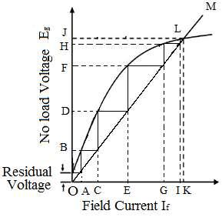

Process of voltage build-up in DC generator

Here OM is the field resistance curve in Fig. 1.20. Initially there will be residual voltage which will create OA field current. This field current will increase the existing magnetic field and the induced voltage will increase up-to OB. This OB voltage will further applied to the field winding and increase the field current to OC. This process will continue upto the point L where the emf curve intersect with field resistance and finally the induced voltage will be OJ. This way voltage builds-up in dc generator.

Critical Resistance:-

The voltage to which it builds is decided by the resistance of the field winding as shown in the figure

If field circuit resistance is increased such that the resistance line does not cut OCC like ‘OP’ in the figure1.21, then the machine will fail to build up voltage to the rated value. The slope of the air gap line drawn as a tangent (OQ) to the initial linear portion of the curve represents the maximum resistance that the field circuit can have beyond which the machine fails to build up voltage. This value of field circuit resistance is called critical field resistance. The field circuit is generally designed to have a resistance value less than this so that the machine builds up the voltage to the rated value.

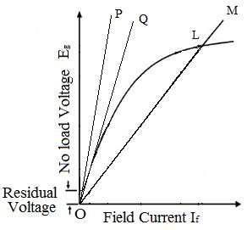

Field current vs No-load voltage for different field resistances

Critical field resistance is defined as the maximum field circuit resistance for a given speed with which the shunt generator would excite. The shunt generator will build up voltage only if field circuit resistance is less than critical field resistance.
Critical Speed:

Voltage of a dc generator is proportional to its speed. Thus when speed will be reduced then the induced voltage will reduced. There can be such situation occur when the speed will be so low that the existing field winding resistance voltage bulid up will not occur. The speed of the generator can be lowered upto a certain level. This minimum value of the speed of the generator for which the generator can excite is called critical speed. It can also define as that speed of a generator for which the existing field resistance of generator becomes its critical field resistance.
Critical Speed:

Voltage of a dc generator is proportional to its speed. Thus when speed will be reduced then the induced voltage will reduced. There can be such situation occur when the speed will be so low that the existing field winding resistance voltage bulid up will not occur. The speed of the generator can be lowered upto a certain level. This minimum value of the speed of the generator for which the generator can excite is called critical speed. It can also define as that speed of a generator for which the existing field resistance of generator becomes its critical field resistance.

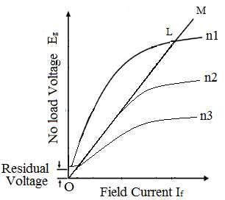

Field current vs No-load voltage for different speed

In the above figure it is showing that when speed of the generator changes from n1 to n2 and then n3 emf production changes accordingly. Here n1>n2>n3. For speed n3 voltage build-up is not possible. The speed n2 is the critical speed. As shown in the figure at speed n2 generator field resistance become its critical field resistance.

Causes for failure to self-excite and its remedial

- The field poles may not have residual magnetism. Then the generator will fail to excite.

Then to restore residual magnetism field winding should be connected to an external dc voltage source. This is called flashing of field.

- When the direction of rotation is not proper such that flux produced by the field current reinforces the residual magnetism.

The rotation of the machine has to be reversed.

- The field winding resistance is more than critical resistance then the machine will fail to excite. The field winding resistance should be less than critical field resistance.

- When the speed of the machine is less than critical speed. The machine’s speed should be more than critical speed.
- If the field winding connections are such that newly generated field flux is working in opposite to the existing residual magnetism. Then the generator will fail to excite.

Then the field winding connection should be reversed.

