UNIT - VI

Two port Networks

Objectives:

To study the relationship between the input and output voltages and currents

and define different sets of two port parameters.

To study the relationship between different two port networks and interconnection of two port networks.

Syllabus:

Introduction to Two port networks- Z, Y, ABCD and hybrid parameters and their relations. Cascaded networks.

Outcomes:

On completion, the student should be able to:

Determine Z, Y, ABCD & h parameters for two port networks. Derive the relationship between different two port parameters.

Interconnect different two port networks and obtain the relation between the input and output quantities of the combined two-port network.

6.1 Introduction:

A two-port network has two pairs of terminals, one pair at the input known as input port and one pair at the output known as output port as shown in figure: 6.1.

There are four variables | V ₁ | ,V ₂ | ,I ₁∧I ₂ | associated with a two port network. Two of

these variables can be expressed in terms of the other two variables. Thus, there will be two dependent variables and two independent variables. The number of
possible combinations generated by four variables taken two at a time is ⁴ ^{C}2 , i.e., six. There are six possible sets of equations describing a two-port network.

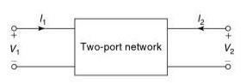

Figure: 6.1 Two-port network

6.2 Two-Port Parameters:

Parameter |  |  | Variables
 | Express |  | In terms of
Open-Circuit
Impedance | ^{V} 1 , | V ₂ | ^{I}1 , ^{I}2

Short-Circuit | ^{I}1 , ^{I}2 | ^{V} 1 , ^{V} 2
Admittance

Transmission | ^{V} 1 , ^{I}1 | ^{V} 2 , ^{I}2

Equation

- ₁=Z₁₁ I ₁ +Z₁₂ I ₂

- ₂=Z₂₁ I₁ + Z₂₂ I₂

- 1 ^{=Y} 11 ^{V} 1^{+Y} 12 ^{V} 2

- 2 ^{=Y} 21 ^{V} 1 ^{+Y} 22 ^{V} 2
^{V} 1 _{= A} ^{V} 2^{−¿} _{B}

- ₂
^{I}1 _{= C} ^{V} 2^{−¿} _{D}

- ₂

Inverse | ^{V} 2 , ^{I}2 | ^{V} 1 , ^{I}1
Transmission

Hybrid | V ₁ | , | I₂ | I₁ | , | V ₂

V ₂ | = | A ' V ₁ | -
 | B ' I ₁
I₂ | = | C ' V ₁ | -
 | D' I ₁

- ₁=h₁₁ I ₁+ h₁₂ V ₂

- ₂ =h₂₁ I ₁+ h₂₂ V ₂

Inverse |  |  |  | ^{I}1 ^{=g}11 ^{V} 1⁺ ^{g}12 ^{I}2
 | I₁ | , ^{V} 2 | ^{V} 1 , | I₂
Hybrid |  |  |  | ^{V} 2^{=g}21 ^{V} 1⁺ ^{g}22 ^{I} 2

6.3 Open-Circuit Impedance Parameters (Z Parameters)

The Z parameters of a two-port network may be defined by expressing two-port

voltages ^{V} 1 | and |  | ^{V} 2 in terms of two-port currents^{I}1 and ^{I}2 .
(V ₁ | ,V ₂ ) | = | f ( I ₁ , I ₂ )

- ₁=Z₁₁ I ₁ +Z₁₂ I ₂

- ₂=Z₂₁ I₁ + Z₂₂ I₂

In matrix form, we can write | [V^{V} | ₂¹] | = | [Z^{Z} | 21¹¹ | Z^{Z} | ₂₂¹² ][I^{I} | ₂¹]
 | [V ] |  | = | [Z ] [I ]

The individual Z parameters for a given network can be defined by setting each of the port currents equal to zero.

Case 1: When the output port is open-circuited, i.e., I2 =0

Z₁₁=^{V} ¹ / I₂ =0
I ₁

Where ^{Z}11 is the driving-point impedance with the output port open-circuited. It is also called open-circuit input impedance.

Similarly, |  | ^{Z}21⁼ | V ₂ | /I ₂=0
 |  |  | I 1
Where | ^{Z}21 | is the transfer impedance with the output port open-circuited. It is also
called open-circuit forward transfer impedance.
Case 2: When the input port is open-circuited, i.e., I1 =0
 |  |  | Z₁₂= |  | V ₁ | / I ₁=0
 |  |  |  |  | I 2
Where | ^{Z}12 | is the transfer impedance with the input port open-circuited. It is also
called open-circuit reverse transfer impedance.
Similarly, |  |  |  |  | Z₂₂= |  | V ₂ | /I ₁=0
 |  |  |  |  |  |  | I ₂
Where | ^{Z}22 | is the open-circuit driving-point impedance with the input port open-
circuited. It is also called open-circuit output impedance.

As these impedance parameters are measured with either the input or output port open-circuited, these are called open-circuit impedance parameters.

The equivalent circuit of the two-port network in terms of Z parameters is shown in figure: 6.3
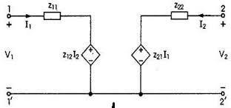

Figure: 6.3 Equivalent circuit of the two-port network in terms of Z parameter.

Condition for Reciprocity:

If | ^{Z}12 | = | ^{Z}21 | ,the network is said to be reciprocal network.
Condition for Symmetry:
If | ^{Z}11 | = | ^{Z}22 | , the network is said to be symmetrical network.

6.4 Short-Circuit Admittance Parameters (Y Parameters)

The Y parameters of a two-port network may be defined by expressing two-port

currents | ^{I}1_{and} ^{I}2 | in terms of the two-port voltages ^{V} 1^{∧V} 2 .
 | ( I ₁ | , I₂ ) | = | f (V ₁ , V ₂ )
 |  |  |  | I₁ =Y ₁₁ V ₁+Y ₁₂ V ₂
I₂ =Y ₂₁ V ₁ +Y ₂₂ V ₂
In matrix form, we can write |  |  |  | [I^{I} | ₂¹ ] = [Y^{Y} | 21¹¹ | Y^{Y} | ₂₂¹²][V^{V} | ₂¹ ]
[I ] ₌ | [Y ][V ]

The individual Y parameters for a given network can be defined by setting each of the port voltages equal to zero.

Case 1: When the output port is short-circuited, i.e., V2 =0

 |  | Y | = | ^{I} 1 | /V |  | =0
 |  |  | 11 | V 1 |  | 2
Where | ^{Y} 11 | is the | driving-point admittance with the output port short-

circuited. It is also called short-circuit input admittance.

Similarly, | Y | = | I₂ | /V ₂=0
 |  | 21 | V 1

Where | ^{Y} 21 | is the transfer admittance with the output port short-circuited. It is

also called short-circuit forward transfer admittance. Case 2: When the input port is short-circuited, i.e., V1 =0
Y ₁₂= ^{I1} /V ₁=0
V ₂

Where | ^{Y} 12 | is the transfer admittance with the input port short-circuited. It is also
called short-circuit reverse transfer admittance.
 |  |  | I₂
Similarly, ^{Y} |  | 22⁼ |  | / V ₁=0
 |  |  | V ₂
Where | ^{Y} 22 | is the short-circuit driving-point admittance with the input port short-
circuited. It is also called short-circuit output admittance.

As these admittance parameters are measured with either input or output port short-circuited, these are called short-circuit admittance parameters.

The equivalent circuit of the two-port network in terms of Y parameters is shown in figure: 6.4
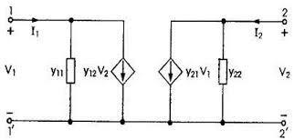

Figure: 6.4 Equivalent circuit of the two-port network in terms of Y-parameters

Condition for Reciprocity:

If ^{Y} 12 = ^{Y} 21 ,the network is said to be reciprocal network.

Condition for Symmetry:

If ^{Y} 11 = ^{Y} 22 , the network is said to be symmetrical network.

6.5 Transmission Parameters (ABCD Parameters)

The transmission parameters or chain parameters or ABCD parameters serve to relate the voltage and current at the input port to voltage and current at the output port.

In equation form,
 |  | (V ₁ , I ₁ ) |  | = | f (V ₂ ,−I ₂ )
 |  |  | V ₁ | _{= A}^{V} 2^{−¿} _{B} ^{I}2
I₁ |  | _{= C}^{V} 2^{−¿} _{D} ^{I}2
Here, the negative sign is used with |  |  | I₂ |  | and not for parameters B and D. The
reason the current | I₂ | carries a negative sign is that in transmission field, the

output current is assumed to be coming out of the output port instead of going into the port.
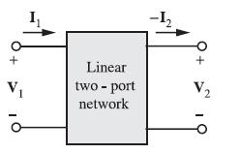

Figure: 6.5 Terminal variables used

to define ABCD parameters
 | [ | V ₁ | ] | A | B | [ | V ₂ | ]
In matrix form, we can write |  | I₁ |  | = [C | D] −I ₂

Where matrix [_{C}^{A} _{D}^{B}] is called transmission matrix.

For a given network, these parameters are determined as follows:

Case 1 When the output port is open-circuited, i.e., ^{I}2 =0

A= | V ₁ | ^{/I} ₂=0
 | V ₂

Where A is the reverse voltage gain with the output port open-circuited.

Similarly, | C= | I ₁ | / I₂ =0
 |  | V ₂

Where C is the transfer admittance with the output port open-circuited. Case 2 When the output port is short-circuited, i.e., ^{V} 2 =0
B=−^{V} ¹ _{/V} ₂₌₀
I ₂

Where B is the transfer impedance with the output port short-circuited.

Similarly, | ¿− | I ₁ | /V =0
 | D | I ₂ | 2

Where D is the reverse current gain with the output port short-circuited.

Condition for Reciprocity:

If AD-BC=1, the network is said to be reciprocal network.

Condition for Symmetry:

If A=D, the network is said to be symmetrical network.

6.6 Hybrid Parameters (h Parameters)

The hybrid parameters of a two-port network may be defined by expressing the voltage of input port ^{V} 1 and current of output port ^{I}2 in terms of current of input port ^{I}1 and voltage of output port ^{V} 2 .

₍ ^{V} 1 , ^{I}2 _{) = f (} ^{I}1 , ^{V} 2 ₎

- ₁=h₁₁ I ₁+ h₁₂ V ₂ I₂ =h₂₁ I ₁+ h₂₂ V ₂

In matrix form, we can write [^{V}I₂¹] = [^{h}h¹¹₂₁ ^{h}h¹²₂₂ ][V^{I1}₂ ]

These parameters are particularly important in transistor circuit analysis. Case 1 When the output port is short-circuited, i.e., ^{V} 2 =0

- ₁
h₁₁₌V ^{I} ¹ 0
2 ⁼
Where | ^{h}11 | is called as short-circuit input impedance.
 |  |  |  | I ₂
Similarly, |  |  |  | I₁
 |  | ^{h}21⁼ _{V} ₂₌₀
Where | ^{h}21 | is called as short-circuit forward current gain.
Case 2 | When the input port is open-circuited, i.e., ^{I}1 =0

- ₁

h₁₂= |  | V 2
 | I₁=0
Where |  | ^{h}12is called as open circuit reverse voltage gain.

 |  |  | I ₂
Similarly, | h₂₂= |  | V 2
 |  | I₁ =0
Where ^{h}22 | is called as open-circuit output admittance.
Since h parameters represent dimensionally impedance, admittance, voltage gain and current gain, these are called hybrid parameters.

The equivalent circuit of the two-port network in terms of hybrid parameters is shown in figure: 6.6
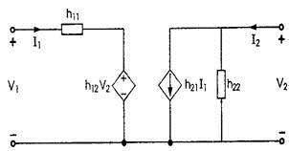

Figure: 6.6 Equivalent circuit of the two-port network in terms of h-parameters

Condition for Reciprocity:
If | ^{h}21 ^{¿−h}12 , the network is said to be reciprocal network.
Condition for Symmetry:
If | ^{h}11 ^{h}22 ^{−h}12 ^{h}21^{=1(∆ h=1)} , the network is said to be symmetrical network.

6.7 Inter-Relationships between the Parameters:

When it is required to find out two or more parameters of a particular network then finding each parameter will be tedious. But if we find a particular parameter then the other parameters can be found if the inter-relationship between them is known.

1. Z-parameters in terms of other parameters:

- Z-parameters in terms of Y-parameters:

We known that
^{I}1 ^{=Y} 11 ^{V} 1^{+Y} 12 ^{V} 2
I₂ =Y ₂₁ V ₁ +Y ₂₂ V ₂

 |  | By Cramer’s rule, |  |  | V | = | |I^{I} ₂¹ |  | Y^{Y} ₂₂¹²| |  |  |  | = |  |  |  | ^{Y} 22 ^{I}1 ^{−Y} 12 ^{I} 2 ₌ ^{Y} 22 |  |  | I | ₋ ^{Y} 12 |  | I
 |  |  |  |  | 1 |  | |Y^{Y} | 21¹¹ | Y^{Y} | ₂₂¹²| |  |  |  |  |  |  | Y 11 Y 22⁻Y 12 Y 21 |  | ΔY | 1 |  | ΔY |  | 2
 |  | Where |  |  |  |  |  |  | ΔY =Y ₁₁ Y ₂₂−Y ₁₂ Y ₂₁
 |  | Comparing with |  |  |  |  |  |  | ^{V} 1^{=Z}11 ^{I} 1 ^{+Z}12 ^{I} 2
^{Z}11 | = | ^{Y} 22
 |  | ΔY
Z₁₂= |  | −Y ₁₂
 |  | Y
 |  |  |  |  | Also, |  |  | V ₂= |  |  | |Y^{Y} |  | 21¹¹ | I^{I} | ₂¹|
 |  |  |  |  |  |  |  |  |  |  |  |  | ΔY

- ^{Y}_{ΔY}¹¹ I ₂− ^{Y}_{ΔY}²¹ I ₁

Comparing with | V ₂=Z₂₁ I₁ + Z₂₂ I₂

- ₂₂= ^{Y}_{ΔY}¹¹

  - ₌^{−Y} 21 ²¹ ΔY

- Z-parameters in terms of ABCD parameters:

We know that |  |  |  |  |  |  |  |  |  |  |  |  |  |  |  |  |  | ^{V} 1_{= A} ^{V} 2^{−¿} _{B} ^{I}2
 |  |  |  |  |  |  |  |  |  | I₁ |  |  |  | _{= C}^{V} 2^{−¿} _{D} ^{I}2
Rewriting the second equation,
V |  | = |  | 1 |  | I |  |  | + | D | I
 | 2 |  |  | C ¹ |  |  |  |  |  | C |  |  | 2
Comparing with |  |  |  |  |  |  |  |  |  |  |  |  |  |  |  |  |  | ^{V} 2^{=Z}21 ^{I}1 ⁺ ^{Z}22 ^{I}2
Z | 21 |  | = |  | 1
 |  |  |  |  | C
Z | 22 |  | = |  | D
 |  |  |  |  | C
Also, |  |  |  |  | ^{V} 1= ^{A} [ |  |  |  |  |  |  | 1 |  |  | I ₁ + | D | ^{I}2 ]^{−B I} 2
 |  |  |  |  |  |  |  |  |  |  |  | C |  |  |  | C

- _{C}^{A} I₁ +[ ^{AD}_{C} −B]I ₂

- _{C}^{A} I₁ +[ ^{AD−}_{C}^{BC} ]I ₂

Comparing with | V ₁=Z₁₁ I ₁ +Z₁₂ I ₂

- ₁₁= _{C}^{A}

_{Z} ₌ AD −BC
12 _{C}

c) Z-parameters in terms of A’B’C’D’ parameters:

We know that | V ₂ | ₌^{A ' V} 1 ₋ ^{B ' I} 1
 | I₂ | ₌^{C ' V} 1 ₋ ^{D' I} 1

Rewriting the second equation,

V ₁= _{C}^{D'}' I ₁+ _{C}¹' I₂

Comparing with | V ₁=Z₁₁ I ₁ +Z₁₂ I ₂

^{Z}11 |  | = | D '
 |  |  | C '
Z | 12 | = | 1
 |  |  | C '
 |  |  | ' |  |  |  | D ' | 1 |  | ' |  |  | A' D' −B' C' |  | A'
Also, |  |  |  | V ₂= A |  | [ |  | I ₁ + |  | ^{I} 2]−^{B} |  | ^{I} 1=[ |  | ]^{I} 1 + |  | I ₂
 |  |  |  |  |  |  | C' |  | C' |  |  |  | C' |  | C'
Comparing with |  |  |  |  |  |  |  |  |  |  | V ₂=Z₂₁ I₁ + Z₂₂ I₂

- ₂₁=[^{A'} ^{D'}_{C}⁻'^{B'} ^{C'} ]

- ₂₂= _{C}^{A'}'

  - Z-parameters in terms of Hybrid parameters:

We know that

- ₁=h₁₁ I ₁+ h₁₂ V ₂

- ₂ =h₂₁ I ₁+ h₂₂ V ₂

Rewriting second equation,
- ₂=^{−h21} I ₁ + ¹ I₂

h22h22

Comparing with

Z₂₁= |  |  |  |  | −h₂₁
 |  |  |  |  |  | h22
Z | 22 |  | = |  | 1
 |  |  |  |  | ^{h}22
Also, |  |  |  |  |  |  | ^{V} 1^{=h}11 ^{I} 1⁺ ^{h}12 [ |  |  |  |  |  |  |  | −h₂₁ | I ₁+ | 1 | ^{I} 2]
 |  |  |  |  |  |  |  |  |  |  |  |  |  |  | ^{h}22 |  | ^{h}22
¿ h |  |  |  | I |  | + | ^{h}12 |  |  | I | − | ^{h}12 ^{h}21 | I
 |  |  |  |  |  |  | h22
 |  | 11 |  |  | 1 |  |  |  |  | 2 |  | h22 |  | 1

- [^{h11} ^{h22}_{h}⁻₂₂^{h12} ^{h21} ]I ₁+ ^{h}_{h}¹²₂₂ I ₂

Comparing with

- ₌ ^{h}11 ^{h}22^{−h}12 ^{h}21 ₌ ∆ h
¹¹h₂₂h₂₂

- ₌ ^{h}12 ¹² h₂₂

- 2^{=Z}21 ^{I}1 ⁺ ^{Z}22 ^{I}2

- 1^{=Z}11 ^{I} 1 ^{+Z}12 ^{I} 2

2. Y-parameters in terms of other parameters:

a) Y-parameters in terms of Z-parameters:

We known that | V ₁=Z₁₁ I ₁ +Z₁₂ I ₂

- ₂=Z₂₁ I₁ + Z₂₂ I₂

By Cramer’s rule,

I = | |V^{V} ₂¹ |  | Z^{Z}₂₂¹²|
¹ |_{Z}Z |  | 21¹¹ | Z^{Z} | ₂₂¹²|

¿ ^{Z}22 ^{V} 1^{−Z}12 ^{V} 2
Z11 Z22⁻Z12 Z21

¿ ∆^{Z22}_{Z} V ₁− ∆^{Z12}_{Z} V ₂

Where

∆ Z=Z₁₁ Z₂₂−Z₁₂ Z₂₁

Comparing with | ^{I}1 ^{=Y} 11 ^{V} 1^{+Y} 12 ^{V} 2

- ₁₁= ∆^{Z22}_{Z}

- ₁₂=^{−Z12}_{∆Z}

Also, | I₂ | |Z^{Z} |  | 21¹¹ | V^{V} | ₂¹|
 |  | = |  | ∆ Z

- ^{Z}11 ^{V} 2^{−Z}12 ^{V} 1
  - Z

¿− ∆^{Z21}_{Z} V ₁ + ∆^{Z11}_{Z} V ₂

Comparing with | I₂ =Y ₂₁ V ₁ +Y ₂₂ V ₂

- ₌^{−Z}21 ²¹ ∆ Z
- ₂₂= ∆^{Z11}_{Z}

  - Y-parameters in terms of ABCD parameters:

We know that | V ₁= A V ₂−B I₂

I₁ =C V ₂−D I₂

 | −1 |  | A
Rewriting the first equation, ^{I}2 ⁼ |  | V ₁ + |  | ^{V} 2
 | B |  | B

Comparing with |  |  | ^{I}2 ^{=Y} 21 ^{V} 1 ^{+Y} 22 ^{V} 2
^{Y} 21⁼ | −1
 | B

Y ₂₂= ^{A}_{B}

_{Also,} ^{I}1 ^{=C V} 2^{−D}[⁻_{B}¹ ^{V} 1⁺ _{B}^{A V} 2 ]

- ^{D}_{B} V ₁+[^{BC} ⁻_{B}^{AD} ]V ₂

Comparing with | I₁ =Y ₁₁ V ₁+Y ₁₂ V ₂

- ₁₁= ^{D}_{B}
_{Y} ₌ BC −AD
12 _{B}

c) Y-parameters in terms of A’B’C’D’ parameters:

We know that |  |  |  |  |  |  | V ₂ |  | = A' |  |  | V ₁ |  |  | -B' |  |  | I₁
 |  |  |  |  |  |  | I₂ | = C' |  |  |  | V ₁ |  |  | - D' |  |  |  | I₁
 |  |  |  |  |  |  |  |  |  |  | I₁ | = | A | ' | V ₁ − |  | 1 |  | V
Rewriting the first equation, |  |  |  |  |  |  |  |  |  |  |  |  |  |  |  |  |  |  |  | 2
 |  |  |  |  |  |  |  |  |  |  |  |  | B | ' |  |  | B | '
Comparing with |  |  |  |  |  |  |  |  |  | I₁ =Y ₁₁ V ₁+Y ₁₂ V ₂
Y = |  | A '
11 |  | B '
^{Y} 12⁼ |  | −1
 |  | B '
_{Also,}^{I}2 ^{=C'} ^{V} 1^{−D'} [ |  |  |  |  | A | ' | V ₁− |  | 1 |  | ^{V} 2 ]
 |  |  |  |  | B | ' |  |  | B | '

¿−[^{A'} ^{D'}_{B}⁻' ^{B'} ^{C'} ]V ₁ + ^{D}_{B'}' V ₂

Comparing with | ^{I}2 ^{=Y} 21 ^{V} 1 ^{+Y} 22 ^{V} 2

_{Y} ₂₁₌−A' D_{B}'−'B' C'

Y ₂₂= ^{D '}
B '

d) Y-parameters in terms of Hybrid parameters:

We know that,

- ₁=h₁₁ I ₁+ h₁₂ V ₂ I₂ =h₂₁ I ₁+ h₂₂ V ₂

Rewriting the first equation,
I | = | 1 | V | − | ^{h}12 |  |  | V
 |  | h11 |  |  | h11
1 |  |  | 1 |  |  |  |  |  |  |  | 2
 |  |  | Comparing with |  |  |  |  |  |  |  |  |  |  |  |  |  |  | ^{I}1 ^{=Y} 11 ^{V} 1^{+Y} 12 ^{V} 2
 |  |  |  | Y |  | = |  |  |  |  | 1
 |  |  |  |  |  |  |  |  |  | ^{h}11
 |  |  |  |  |  | 11
 |  |  |  | Y ₁₂= |  |  |  |  |  | −h₁₂
 |  |  |  |  |  |  |  |  |  |  | h11
 |  |  | Also, |  |  |  |  |  |  |  |  | ^{I}2 ^{=h}21 [ |  | 1 | V ₁− | h | 12 | ^{V} 2 ]^{+h}22 ^{V} 2
 |  |  |  |  |  |  |  |  |  |  |  |  |  | ^{h}11 |  | h | 11

- ^{h}_{h}²¹₁₁ V ₁+[^{h11} ^{h22}_{h}⁻₁₁^{h12} ^{h21} ]V ₂

Comparing with | I₂ =Y ₂₁ V ₁ +Y ₂₂ V ₂

- ₌ ^{h}21 ²¹ h₁₁

- ₌ ^{h}11 ^{h}22^{−h}12 ^{h}21
²²h₁₁

- ABCD parameters in terms of other parameters:

  - ABCD parameters in terms of Z-parameters:

We know that

- ₁=Z₁₁ I ₁ +Z₁₂ I ₂

- 2^{=Z}21 ^{I}1 ⁺ ^{Z}22 ^{I}2

Rewriting the second equation,
I | = | 1 |  | V | − | ^{Z}22 |  | I
 |  | Z21 |  |  |  | Z21
1 |  |  | 2 |  |  |  |  |  |  | 2
Comparing with, |  |  |  |  |  |  |  |  |  |  | I₁ =C V ₂−D I₂
C= |  | 1
 |  | ^{Z}21
D= |  | ^{Z}22
 |  | Z21
Also, |  |  |  | V ₁=Z₁₁ |  |  |  | [ | 1 |  | V ₂ − | Z | 22 | ^{I} 2 ]⁺ ^{Z}12 ^{I}2
 |  |  |  |  |  |  |  |  | ^{Z}21 |  |  | Z | 21
- ^{Z11} V ₂− ^{Z22} ^{Z11} I ₂+ Z₁₂ I ₂
Z21Z21

- ^{Z}_{Z}¹¹₂₁ V ₂−[^{Z11} ^{Z22}_{Z}⁻₂₁^{Z12} ^{Z21} ]I ₂

Comparing with, | V ₁= A V ₂−B I₂

_{A=} ^{Z}11
Z21

_{B=} ^{Z}11 ^{Z}22^{−Z}12 ^{Z}21
Z21

b) ABCD parameters in terms of Y-parameters:

We know that

- ₁ =Y ₁₁ V ₁+Y ₁₂ V ₂

- 2 ^{=Y} 21 ^{V} 1 ^{+Y} 22 ^{V} 2

Rewriting the second equation,

- ₁=^{−Y} ²² V ₂ + ¹

Y 21Y 21

Comparing with

_{A=}^{−Y} 22
Y 21
B=⁻¹

^{Y} 21

- [^{Y} 12 ^{Y} 21^{−Y} 11 ^{Y} 22 ]_{V} ₂ ₊ ^{Y} 11 _{I} ₂

^{Y} 21^{Y} 21

- ₂

V ₁= A V ₂−B I₂

_{Also,}^{I}1 ^{=Y} 11[ | −Y ₂₂ | V ₂ + | 1 | ^{I} 2 ]^{+Y} 12 ^{V} 2
 | ^{Y} 21 |  | ^{Y} 21

Comparing with, |  |  |  |  |  |  |  |  |  |  |  | I₁ =C V ₂−D I₂
C=[ |  | Y | 12 | Y |  | −Y | 11 | Y | 22 | ]= | −∆ Y
 |  |  |  |  |  | 21
 |  |  |  |  |  | ^{Y} 21 |  |  |  |  | ^{Y} 21
D= | −Y ₁₁
 |  | Y 21

c) ABCD parameters in terms of hybrid parameters:

We know that, | V ₁=h₁₁ I ₁+ h₁₂ V ₂

- ₂ =h₂₁ I ₁+ h₂₂ V ₂

 | −h₂₂ | 1
Rewriting the second equation, ^{I}1 ⁼ |  | V ₂ + |  | I₂
 | h21 |  | h21

Comparing with, | I₁ =C V ₂−D I₂
- ₌^{−h}22 h21
D=⁻¹

^{h}21

_{Also,} ^{V} 1^{=h}11 [_{h}¹₂₁ ^{I} 2⁻ ^{h}_{h}²²₂₁ ^{V} 2 ]^{+h}12 ^{V} 2

- [^{h12} ^{h21}_{h}⁻₂₁^{h11} ^{h22} ]V ₂ + ^{h}_{h}¹¹₂₁ I₂

Comparing with | V ₁= A V ₂−B I₂

_{A=} ^{h}12 ^{h}21^{−h}11 ^{h}22
h21

_{B=}^{−h}11
h21

- Hybrid parameters in terms of other parameters:

  - Hybrid parameters in terms of Z-parameters:

We know that | V ₁=Z₁₁ I ₁ +Z₁₂ I ₂

- ₂=Z₂₁ I₁ + Z₂₂ I₂

 |  |  |  |  |  |  |  |  |  |  |  |  | −Z₂₁ | 1
Rewriting the second equation, ^{I}2 ⁼ |  |  |  |  |  |  |  |  |  |  |  |  |  |  | I ₁+ |  |  |  | V ₂
 |  |  |  |  |  |  |  |  |  |  |  |  | Z22 |  |  |  | Z22
Comparing with |  |  |  |  |  |  |  |  |  | ^{I}2 ^{=h}21 ^{I} 1⁺ ^{h}22 ^{V} 2
h₂₁= |  |  |  | −Z₂₁
 |  |  |  | Z22
h | 22 |  | = | 1
 |  |  |  | ^{Z}22
 |  |  |  |  |  | _{Also,}^{V} 1^{=Z}11 ^{I} 1 ^{+Z}12 [ |  |  |  |  |  | −Z₂₁ |  | I ₁+ |  | 1 |  |  | ^{V} 2 ]
 |  |  |  |  |  |  |  |  |  |  |  | ^{Z}22 |  |  |  | ^{Z}22
¿[ |  | ^{Z}11 ^{Z}22^{−Z}12 ^{Z}21 |  |  |  |  | ]^{I} 1+ | ^{Z}12 | V ₂
 |  | ^{Z}22 |  |  |  |  |  | ^{Z}22
Comparing with |  |  |  |  |  |  |  |  |  | V ₁=h₁₁ I | 1⁺ ^{h}12 ^{V} |  |  | 2
- ₌ ^{Z}11 ^{Z}22^{−Z}12 ^{Z}21 ₌ ∆ Z

¹¹Z₂₂Z₂₂

- ₌ ^{Z}12 ¹² Z₂₂

  - Hybrid parameters in terms of Y-parameters:

We know that

I₁ =Y ₁₁ V ₁+Y ₁₂ V ₂

I₂ =Y ₂₁ V ₁ +Y ₂₂ V ₂

1 |  |  | ^{Y} 12
Rewriting the first equation, ^{V} 1⁼ |  | I ₁− |  | V ₂
 | Y 11 |  | Y 11

Comparing with |  |  |  | V ₁=h₁₁ I ₁+ h₁₂ V ₂
h | = | 1
 |  | ^{Y} 11
11
- ₌^{−Y} 12 ¹² Y ₁₁

_{Also,} ^{I}2 ^{=Y} 21 [_{Y}¹₁₁ ^{I} 1⁻ ^{Y}_{Y} ¹²₁₁ ^{V} 2]⁺ ^{Y} 22 ^{V} 2

- [^{Y} 11^{Y} 22^{−Y} 12 ^{Y} 21 ]_{V} ₂ ₊ ^{Y} 21 _{I} ₁

^{Y} 11^{Y} 11

Comparing with | I₂ =h₂₁ I ₁+ h₂₂ V ₂

- ₌ ^{Y} 11 ^{Y} 22^{−Y} 12 ^{Y} 21 ₌ ∆ Y
²²Y ₁₁Y ₁₁

- ₌ ^{Y} 21 ²¹ Y ₁₁

c) Hybrid parameters in terms of ABCD parameters:

We know that |  |  | V ₁= A V ₂−B I₂
 |  |  | I₁ =C V ₂−D I₂
 |  |  |  | −1 |  | C
Rewriting the second equation, ^{I}2 ⁼ |  |  |  |  | I ₁+ |  | V ₂
 |  |  |  | D |  | D
Comparing with |  |  | I₂ =h₂₁ I ₁+ h₂₂ V ₂
h₂₁= | −1
 | D

h₂₂= ^{C}_{D}

_{Also,} ^{V} 1⁼ ^{A V} 2^{−B}[⁻_{D}¹ ^{I} 1 ⁺ ^{C}_{D} ^{V} 2 ]

- _{D}^{B} I ₁ +[^{AD} ⁻_{D}^{BC} ]V ₂

Comparing with | ^{V} 1^{=h}11 ^{I} 1⁺ ^{h}12 ^{V} 2

h₁₁= _{D}^{B}

_{h} ₌ AD −BC ₌ ∆T
12 _{D} _{D}

Inter-relationship between parameters:

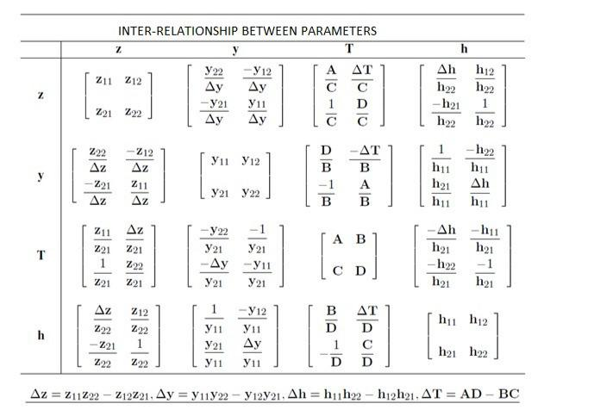

6.8 Interconnection of two-port networks:

Interconnection of two-port networks, namely, cascade, parallel, series-parallel and parallel-series are discussed below and the relation between the input and output quantities of the combined two-port networks is derived.

6.8.1 Cascade Connection:

Transmission Parameter Representation:

Figure: 6.8.1 shows two-port networks connected in cascade. In the cascade connection, the output port of the first network becomes the input port of the second network. Since it is assumed that input and output currents are positive when they enter the network, we have

I'₁ =−I ₂

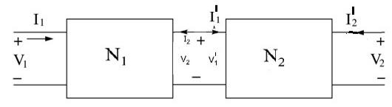

 | Figure: 6.8.1 Cascade Connection
_{Let}^{A}1 ^{,B}1 ^{,C}1 ^{, D}1 | be the transmission parameters of the network ^{N}1 and
^{A}2 ^{,B}2 ^{, C}2 ^{, D}2be the transmission parameters of the network ^{N}2 .
For the network | ^{N}1 ,
 | V ₁ | A₁ B₁ | V ₂
 | [I₁ | ]⁼[C₁ D₁ | ][−I₂ ] __________ (i)

For the network ^{N}2 ,
[ | V ₁' | ] | = | A₂ B₂ | [ | V ₂' | ]
 | I₁ |  |  | [C₂ D₂ | ] −I ₂
 | ' |  |  |  |  | '
Since |  |  |  | V ₁'=V ₂ |  | _{and} I2' ⁼⁻I 2 _{, we can write}
 |  |  |  |  |  |  | V ₂ | A₂ B₂ V ₂' | ] _________ (ii)
 |  |  |  |  |  |  | [−I ₂ | ]⁼[C₂ D₂][−I ₂'
Combining equations (i) and (ii),
[I₁ | ]⁼[C₁ D₁ | ][C₂ D₂ | ][−I₂' | ]⁼[CD ][₋I ₂' | ]
V ₁ | A₁ B₁ | A₂ B₂ | V ₂' | AB V ₂'

AB | A₁ B₁ | A₂ B₂ | ] __________ (iii)
Hence, [CD | ]⁼[C₁ D₁ | ][C₂ D₂

Equation (iii) shows that the resultant ABCD matrix of the cascade connection is the product of the individual ABCD matrices.

6.8.2 Parallel Connection:

Figure: 6.8.2 shows two-port networks connected in parallel. In the parallel connection, the two networks have the same input voltages and the same output voltages.
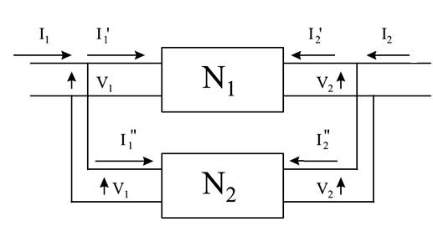

Figure: 6.8.2 Parallel Connection

Let | Y ₁₁' , Y ₁₂' , Y ₂₁' , Y ₂₂' | be the Y-parameters of the network |  |  |  | N₁ | and | Y ₁₁'' | , Y ₁₂'' | , Y ₂₁'' , Y ₂₂''
be the Y-parameters of the network |  |  |  |  | ^{N}2 .
For the network ^{N}1 |  | I ₁' | Y ₁₁' | Y ₁₂' | V ₁
 |  | , [I ₂' | ]⁼[Y ₂₁' | Y ₂₂' | ][V ₂ ]

I ₁'' | Y ₁₁'' | Y ₁₂'' | V ₁ | ]
For the network ^{N}2 , [_{I} ₂'' | ]⁼[Y ₂₁'' | Y ₂₂'' | ][V ₂

For the combined network, |  |  | I₁ =I ₁' + I ₁'' _{and} I₂ =I₂' |  |  |  |  |  | + I ₂'' |  | ]
Hence, | [I ₂ | ]⁼[_{I2}' | + I ₂'' | ]⁼[Y ₂₁' | + Y ₂₁'' | Y ₂₂' | + Y ₂₂'' | ][V | ₂]⁼[Y ₂₁ Y ₂₂][V ₂
 | I ₁ | I₁' | + I ₁'' | Y ₁₁' | +Y ₁₁'' | Y ₁₂' | +Y ₁₂'' | V | 1 | ^{Y} 11 ^{Y} 12 ^{V} 1

Thus, the resultant Y-parameter matrix for parallel connected networks is the sum of Y matrices of each individual two-port networks.

6.8.3 Series Connection:

Figure: 6.8.3 shows two-port networks connected in series. In a series connection, both the networks carry the same input current. Their output currents are also equal.
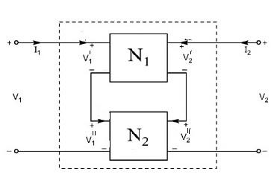

Figure: 6.8.3 Series Connection

Let | Z₁₁' , Z₁₂' , Z₂₁' , Z₂₂' |  | be the Z-parameters of the network |  |  |  | N₁ | and | Z₁₁'' | , Z₁₂'' | , Z₂₁'' , Z₂₂''
be the Y-parameters of the network |  |  |  | ^{N}2 .
 |  |  |  | V ₁' | Z₁₁' Z₁₂' | I ₁
For the network |  | N₁ | , | [V ₂' | ]⁼[Z₂₁' Z₂₂' | ][I ₂]
 |  |  |  | V ₁' ' | Z₁₁'' Z₁₂'' | I ₁
For the network |  | N₂ | , | [V ₂'' | ]⁼[Z₂₁'' Z₂₂'' | ][I ₂]

For the combined network |  |  |  | V ₁=V ₁' +V ₁'' |  |  | _{and} V 2⁼V 2' |  |  | +V ₂'' |  | ][I ₂ | ]
Hence, | [V ₂]⁼[_{V} |  | 2' | +V ₂'' | ]⁼[Z₂₁' | + Z₂₁'' Z₂₂' |  | + Z₂₂'' | ][I ₂]⁼[Z₂₁ |  | ^{Z}22
 | V ₁ | V | 1' | +V ₁'' | Z₁₁' | + Z₁₁'' | Z₁₂' | + Z₁₂'' | I ₁ | ^{Z}11 ^{Z}12 |  | I ₁

Thus, the ersultant Z-parameters matrix for the series-connected networks is the sum of Z matrices of each individual two-port network.

Assignment cum tutorial questions

SECTION-A

- A voltage of 10V applied at port-1 results in I1=5A and V2=5V when port 2 is

open circuited. The open circuit transfer impedance is____ a) 2Ω b) 1Ω c) 3Ω

d) 4Ω

- For a two port network, Z11 and Z22 are equal and also Z12=Z21.Then the two

port network is

a) Symmetric only

b) Reciprocal but not symmetrical

c) Symmetric and Reciprocal

d) Symmetrical but not reciprocal

- The parameter Y11 in terms of Z parameters is...........

a) | Z 22 | b) | – Z 12 | c) | Z 11 | d) | – Z 21
 | Dz |  | Dz |  | Dz |  | Dz

- With port 1 short circuited, a voltage of 10V is applied at port 2 results in I2=4A and I1=-2A.The short circuit driving point admittance at port 2 is__

a) -0.4 |  |  | b)0.2 |  |  | c)-0.2 |  |  | d)0.4
5. For |  | a given | two |  | port | network, |  |  | the S/C | parameters are
Y11=10 ,Y12=Y21=2 ,Y22=5.The value of Z21 is___
10 |  |  | 5 |  |  | −1 |  |  |  | 1
a) |  | Ω | b) |  | Ω | c) |  | Ω | d) |  | Ω
 | 23 |  |  | 23 |  |  | 23 |  |  | 23

- For a given two port network,Z11=10Ω;Z22=8Ω;Z12=Z21=3Ω.A resistance of 5Ω

is connected at port 2.Then the driving point impedance at port 1 is__
121 |  |  |  | 134 |  |  | 108
a) |  | Ω | b)7 Ω | c) |  | Ω | d) |  | Ω
 | 3 |  |  |  | 13 |  |  | 13

- In a two port network, the parameters A=D=2 and B=3Ω.Then value of

parameter C is_
1 |  | 1
a) 2 b) 1 mho c) |  | mho d) |  | mho
 | 2 |  | 3

- In a two port network, the expression for Z11 in terms of ABCD parameters is

 | D | 1 |  |  | B |  | A
a) |  | b) |  | c) |  | d)
 | C |  | C |  | C |  | C

- For a two port symmetrical network, the relation in transmission parameters is

1 |  | 1
a) A= |  | b) CA=BD c) A= |  | d) A=D
 | CD |  | D

- Two identical two port networks (having same port parameters) are connected

in cascade. The parameters A of the combined network is
- A
a) A+BC b) A2+BC c) A+ C d) 2

- When port 1 of a two-port circuit is short-circuited, I1 = 4I2 and V2 = 0.25I2. Which of the following is true?

(a) y11 = 4 (b) y12 = 16 | (c) y21 = 16 | (d) y22 = 0.25

12. A two-port is described by the following equations:

V1 = 50I1 + 10I2 V2 = 30I1 + 20I2

which of the following is not true?

(a) z12 = 10 (b) y12 = -0.0143 (c) h12 = 0.5 (d) A = 50

13. If two-port is reciprocal, which of the following is not true?

(a) z21 = z12 (b) y21 = y12 (c) h21 = h12 (d) AD = BC + 1

- A passive 2 port network is in a steady-state compared to its input, the steady stay output can never offer

      - Better regulation.

      - Higher voltage.

      - Greater Power

      - Lower impedance.

    - Which elements act as an independent variables in Y-parameters?

        - Current

        - Voltage

        - Both (a&b)

        - None of the above

  - If the two ports are connected in cascade configuration, then which arithmetic operation should be performed between the individual transmission parameter in order to determine overall transmission parameters?

a. Addition b. Subtraction c. Multiplication d. Division

SECTION-B

- Determine the Z-parameters for the network shown in fig (a).

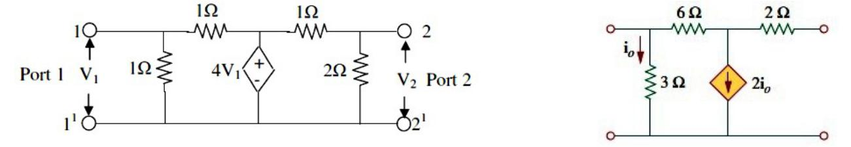

Fig.(a) Fig.(b)

- Obtain the y parameters for the circuit in Fig(b)

- The y-parameters of a two port network are y11=15 mho, y22=24 mho, y12=y21=6 mho. Determine ABCD parameters.

- Determine ABCD parameters of the network shown in fig.

- Determine the y parameters for the two-port shown in Fig.

- Find I1 and I2 in the circuit in Fig.
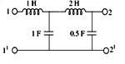
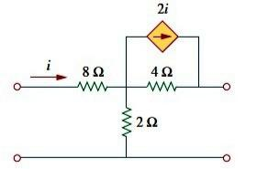
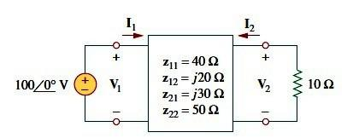

7. Find the y parameters for the circuit shown below:

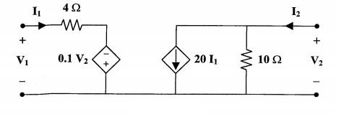

8. Obtain T-parameters for the circuit shown in the figure below
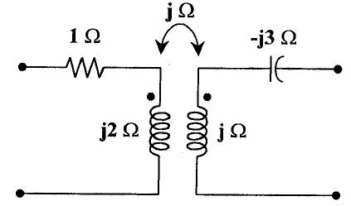

SECTION-C

1. The open circuit impedance matrix of the two-port network shown in figure is:
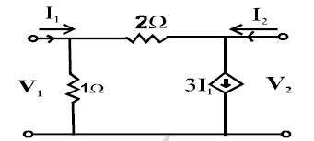

a) [⁻₋²₈ ¹₃] b) [⁻₁² ⁻₃⁸ ] c) [⁰₁ ¹₀ ] d) [⁻₋²₁ ⁻₃¹]

- Two two-port networks are connected in cascade. The combination is to represented as a single two-port networks. The parameters of the network are

obtained by multiplying the individual:
a) z-parameter matrix |  |  |  | b) h-parameter matrix
c) y-parameter matrix |  |  |  | d) ABCD parameter matrix
3. For a two-port network to be reciprocal
a) | ^{z}11^{=z}22 | b) | ^{y}21⁼ ^{y}12 | c) | h₁₂=−h₂₁ | d) AD-BC=0

- The condition that a z-port network is reciprocal, can be expressed in terms of its ABCD parameters as:

a) AD-BC=1 b) AD-BC=0 c) AD-BC>1 d) AD-BC<1

- The short-circuit admittance matrix of a two-port network is:

[₁⁰_{/2} ⁻¹₀^{/2}]

The two-port network is:

a) Non-reciprocal and passive b) Non-reciprocal and active

c) Reciprocal and passive d) Reciprocal and active

- A two-port network is shown in figure. The parameter h21 for this network can be given by:
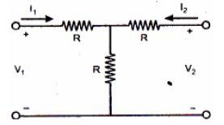

a) –1/2 b) +1/2 c) –3/2 d) +3/2

7. The Z parameters Z11 and Z21 for the 2-port network in figure are:

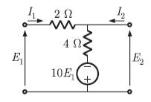

a) | Z₁₁= | −6 |  |  | ΩZ₂₁= |  | 16 | Ω |  | b) | Z₁₁= | 6 | ΩZ₂₁= | 4 | Ω
 |  |  | 11 |  |  |  | 11 |  |  |  |  | 11 |  | 11
c) | Z₁₁= | 6 |  | ΩZ₂₁= |  | −16 |  |  | Ω | d) | Z₁₁= | 4 | ΩZ₂₁= | 4 | Ω
 |  | 11 |  |  |  |  | 11 |  |  |  |  | 11 |  | 11

8. The admittance parameter Y12 in the two-port network in figure is:
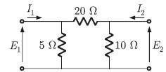

a) –0.2 mho b) 0.1 mho c) –0.05 mho d) 0.05 mho

9. The impedance parameters Z11 and Z12 of the two-port network in figure are:
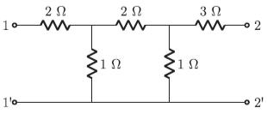

a) Z11 = 2.75 Ω and Z12 = 0.25 Ω b) Z11 = 3 Ω and Z12 = 0.5 Ω

c) Z11 = 3 Ω and Z12 = 0.25 Ω d) Z11 = 2.25 Ω and Z12 = 0.5 Ω

10. For the lattice shown in figure, | Z_{a} = j 2Ω |  |  | and | Z_{b} =2Ω | . The values of the
open
circuit impedance parameters ^{Z} ⁼[z^{z} |  | 21¹¹ | z^{z}₂₂¹² ] | are
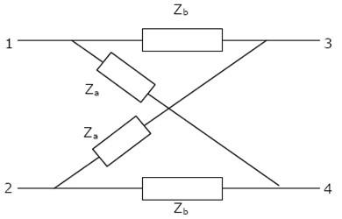

[1− j 1+ j ] [ 1− j 1+ j ] [1+ j 1+ j ] [ 1+ j −1+ j]
a) 1+ j 1+ j b) −1+ j 1− j c) 1− j 1− j d) −1+ j 1+ j

- The h parameters of the circuit in figure are:
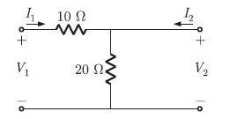

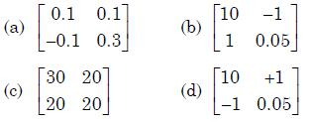

- The ABCD parameters of an ideal n:1 transformer shown in the figure are

[^{n}₀ ⁰_{x}]
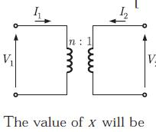

 | 1 |  | _{c)} n² | 1
a) n | b) |  |  | d)
 |  | n |  |  | n²

- In the two port network shown in the figure below, Z12and Z21and respectively
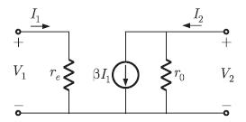

a) reand βr0 b) 0 and -βr0 c) 0 and βr0 d) re and -βr0

- A two-port network is represented by ABCD parameters given by
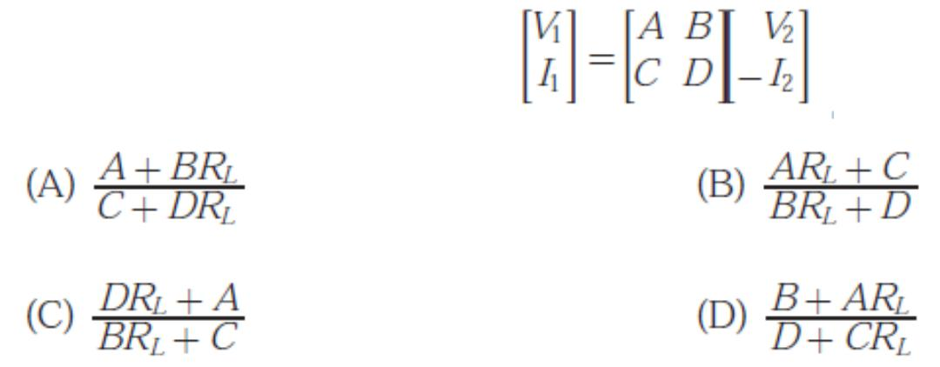

15.A two-port network shown below is excited by external DC source. The voltage and the current are measured with voltmeters V1, V2and ammeters. A1, A2(all assumed to be ideal), as indicated
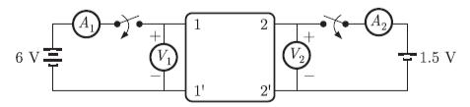

Under following conditions, the readings obtained are:

- S1 -open, S2 - closed A1 = 0,V1 = 4.5 V,V2 = 1.5 V,A2 = 1 A

- S1 -open, S2 - closed A1 = 4 A,V1 = 6 V,V2 = 6 V,A2 = 0

- The z -parameter matrix for this network is

[1.5 1.5] [1.5 4.5 ] [1.5 4.5 ]
a) 4.5 1.5 b) 1.5 4.5 c) 1.5 1.5 d)

  - ⁴₁..⁵₅ ¹₄..⁵₅]

- The h-parameter matrix for this network is

a) [⁻₋³_{1 0.}³₆₇] b) [⁻₃³ _{0.}¹₆₇] c) [³_{1 0.}³₆₇] d)

[₋³₃ ₋₀¹_{.67}]

- For the two-port network shown below, the short-circuit admittance parameter matrix is
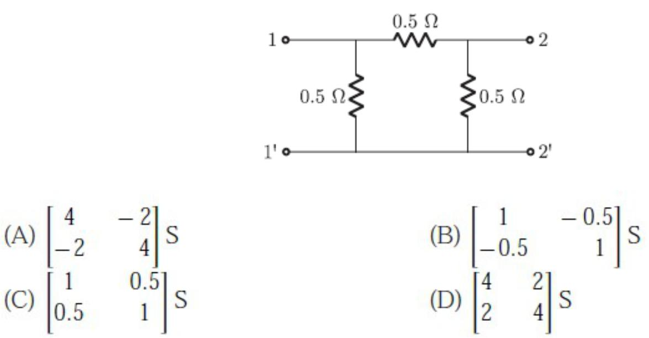

- With 10 V dc connected at port A in the linear nonreciprocal two-port network shown below, the following were observed :

  - 1 Ω connected at port B draws a current of 3A

(ii) 2.5 Ω connected at port B draws a current of 2A

- With 10 V dc connected at port A, the current drawn by 7 Ω connected at port B is

a) 3/7 A b) 5/7 A c) 1A d) 9/7 A

- For the same network, with 6 V dc connected at port A, 1 Ω connected at port B draws 7/3 A. If 8 V dc is connected to port A, the open circuit voltage at port B is

a) 6 V b) 7 V c) 8 V d) 9 V

- In the h – parameter model of 2 – port network given in the figure shown,
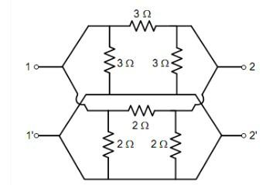

The value of h22 (in Siemens) is _____________

22. The 2 – port Admittance matrix of the circuit shown is given by____________

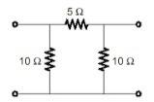

[0.3 0.2] [15 5 ] [3.33 5 ]
a) 0.2 0.3 b) 5 15 c) 5 3.33 d)

[⁰₀..³₄ ⁰₀..⁴₃]

