UNIT - II

Unbalanced Three Phase Circuits

Objectives:

To analyze three phase Unbalanced systems

To Measure active and reactive power in Three Phase Unbalanced systems.

Syllabus:

Analysis of three phase Unbalanced circuits- Loop method-Application of Millman’s theorem-Star Delta transformation Technique-Measurement of power

Outcomes:

On completion the student should be able to:

Describe the reasons for, and the generation of the Unbalanced Voltages and Circulating currents.

Solve three-phase circuits in terms of phase and line quantities, and the power developed in three-phase Unbalanced loads.
Measure power dissipation in Unbalanced three-phase loads.

3.1 Introduction:

An unbalanced three-phase circuit is one that contains at least one source or load that does not possess three-phase symmetry. A source with the three source-function magnitudes unequal and/or the successive phase displacements different from 120° can make a circuit unbalanced. Similarly, a three-phase load with unequal phase impedance values can make a circuit unbalanced.

The single-phase equivalent circuit technique of analysis does not work for unbalanced three-phase circuits. General circuit analysis techniques like

mesh analysis or nodal analysis will have to be employed for analyzing such circuits.

3.2 Analysis of Three phase unbalanced circuits:

3.2.1 Unbalanced delta connected load

Let us consider an unbalanced delta connected load fed from a 3-phase 3 wire balanced supply. Since the terminals are fixed, the voltage drop across each load impedance is known. Hence the current in each load impedance can be computed and then apply KCL at junctions to obtain the line currents.

- The method of solution is similar to that of a balanced delta connected load.

- But the phase currents will neither be equal in magnitude nor have a phase difference of 120⁰.
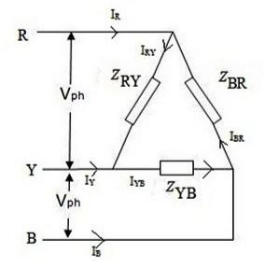

Fig 3.1 Unbalanced Delta Load Determination of phase voltages:

VAB = V ∠ 0⁰, VBC = V ∠ -120⁰, VCA = V ^{∠−24} 0⁰= V ^{∠12} 0⁰ Phase currents are computed as
IAB= | ^{V} AB | ; IBC = | ^{V} BC | ; ICA = | ^{V} CA
 | Z AB |  | ZBC |  | ZCA

Determination of Line currents:

By applying KCL at junction R, Y, B we get,

IA =IAB – IBC; IB =IBC – ICA; IC =ICA – IAB;

Check: IA + IB + IC = 0

- The sum of the line currents in a 3-phase 3-wire system is zero.

3.2.2 Unbalanced star connected load with neutral

Let us consider an unbalanced star connected load which is fed from a 3-phase 4 wire supply. The neutral of the supply is connected to the star point of the load i.e., the star point of the load and neutral are at the same potential (ground potential). The voltage across each of the load impedance is known and is equal to the line to neutral voltage (phase voltage). The currents in each of the load impedances can be computed and they will be line currents and they are unbalanced.
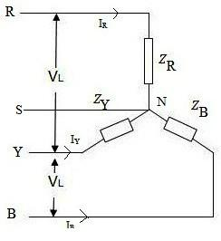

Fig.3.2 Unbalanced Star Load with Neutral

- Hence in an unbalanced system the neutral wire will carry current and forms the return path for the phase currents.
- The analysis of 3-phase 4-wire star connected unbalanced load is simple compared to 3-phase 3 wire star or delta connected loads.

Determination of phase voltages

 | V | ∠0 | 0 |  |  |  | V | ∠−12 0 |  |  | 0 |  |  | V | ∠120 | 0
VRS= |  |  |  | ; VYS = |  |  |  |  |  |  | ; VBS = |  |  |  |  | ;
 | √ 3 |  |  |  |  |  | √ 3 |  |  |  |  |  |  | √ 3
Determination of line currents
 |  | IR= |  | ^{V} RS |  | ; IY = |  |  | ^{V} YS | ; IB = |  | ^{V} BS |  | ;
 |  |  |  | Z _{R} |  |  |  |  | Z_{Y} |  |  | Z_{B}

Neutral current IN = -( IR + IY + IB)

3.2.3 Unbalanced star connected load without neutral:

An unbalanced star connected load is supplied from a balanced 3-phase 3 wire supply. Since the load is unbalanced, the voltages across each load impedance are not equal to phase voltage but it is different. The voltages across each load impedance if it is determined, then we can determine the line currents.

- Since the voltage across ZA, ZB, ZC are different the voltage of the star point S of the 3-phase load, and of the neutral point of the supply are different.

- The potential difference between the neutral point of the supply N and star point S of the load is called Neutral displacement or Neutral shift.
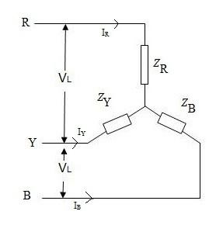

Fig.3.3 Unbalanced star connected load without neutral

3.3 Loop Method:

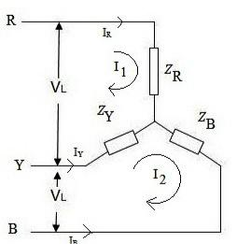

Fig.3.4 Unbalanced Star Load for Loop Analysis

The voltage VAN is taken as reference. Applying KVL for each of the loops.

Loop 1:

I1ZR + (I1 - I2)ZY= VRY

I1(ZR + ZY) – I2(ZY) =VRY

Loop 2:

(I2 – I1) ZY + I2ZB = VYB

-I1(ZY) + I2(ZY + ZB) = VYB

Writing down the above equations in matrix form

[^{Z}−^{R+}Z^{Z}_{Y} ^{Y} Z⁻_{Y}+^{Z}Z^{Y} _{B} ][^{I}I ¹₂ ][^{V}V ^{RY}_{YB} ]

By using cramer’s rule we will get I1 and I2

The line currents IR, IY and IB are given by

IR = I1 ; IY = I2 – I1 ; IB = -(I2)

The voltage across each load impedance

VRN = IR * ZR; VYS = IY * ZY ; VBS = IB* ZB ; The neutral displacement voltage VNS

VNS = VRN – VRS

3.4 Milliman’s Theorem:

Fig.3.5 Star Connected Load

In this method, the neutral shift voltage (VNS) is determined by using the following expression derived below:
VNS =- | (V _{RN} Y _{R} +V _{YN} Y _{Y} +V _{BN} Y _{B} )
 | Y _{R} +Y _{Y} +Y _{B}

- The line to neutral voltages VRN , VYN , and VBN are the balanced phase voltages obtained from the supply.
- YR , YY and YB are the star connected load admittances.

The voltages across the load impedances

VRS = VRN + VNS

VYS = VYN + VNS

VBS = VBN + VNS

The line currents are given by

IR= | ^{V} RS | ; IY = | ^{V} YS | ; IB = | ^{V} BS | ;
 | Z _{R} |  | Z_{Y} |  | Z_{B}

Applying KCL at the star point S,

IR + IY + IB =0

^{V} RS | + | ^{V} YS | + | ^{V} BS | =0
Z _{R} |  | Z_{Y} |  | Z_{B}

3.5 Star / Delta Conversion:

For solving an unbalanced star connected load, we will replaced it by an equivalent delta connected load and solve the delta connected load. The principle to get an equivalent delta connected load is to equate the impedances between corresponding terminals of the two loads as shown below.
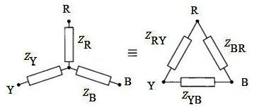

Fig.3.6 Star Delta Equivalents For delta to star conversion
ZR = |  | ^{Z}RY ^{Z}BR
 |  | ZRY ⁺ ZYB⁺ZBR
ZY = |  | ^{Z}RY ^{Z}YB
 |  | ZRY ⁺ ZYB⁺ ZBR
ZB = |  | ^{Z}YB ^{Z}BR
 |  | ZRY ⁺ ZYB⁺ ZBR

Z _{RY} _{= Z + Z +} ^{ZR ZY}
R Y Z _{B}

^{ZYB} = ZY + ZB + |  | Z_{Y} Z_{B}
 |  |  | Z R
Z _{BR}=¿ | ZB + ZR + |  | Z_{B} Z _{R} |  | .
 |  |  | Z_{Y}

we can replace a star connected load by an equivalent delta connected load ( λ−Δconversion ₎

Phase currents are computed as
IRY= | ^{V} RY | ; IYB = | ^{V} YB | ; IBR = | ^{V} BR
 | ZRY |  | ZYB |  | ZBR

Determination of Line currents:

By applying KCL at junction R, Y, B we get,

IR =IRY – IBR; IY =IYB – IRY ; IB =IBR – IYB ;

Check: IR + IY + IB = 0

3.6 Measurement of Power:

3.6.1 Two wattmeter method:

- This is the most common method of measurement of power in 3-phase circuits.
- This method can be employed for balanced or unbalanced, star or delta connected 3-phase circuits.

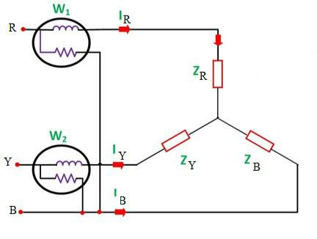

Fig.1.17 Two Wattmeter method to measure Active Power in unbalanced Load Let us consider a 3-phase star connected load of impedances ZR , ZY, and

ZB and the two watt meters are connected to measure total power.

The current coils of the two watt meters W1 and W2 are connected in two lines R and Y, the potential coils W1 and W2 are connected between lines R-B and Y-B.

Let VRS, VYS and VBS be the instantaneous values of voltage drops across

the load impedances.

Let iR, iY and iB be the instantaneous values of currents in the load

impedances.
The total instantaneous power in the 3-phase load
= VRS iR+VYSiY+VBSiB | (1.1)
From Fig., we see that instantaneous current through W1 is iR and the instantaneous voltage across the pressure coil of W1 is VRB and hence the

instantaneous power measured by W1 is
W1 = iRVRB= iR[VRS-VBS] | (1.2)
Similarly the instantaneous power measured by W2 is
W2 = iYVYB= iY[VYS-VBS] | (1.3)
Sum of the instantaneous power read by W1 and W2 is
W1+W2= iR[VRS-VBS] +iY[VYS-VBS]
= iRVRS+iYVYS-VBS[iR+iY] | (1.4)
Applying KCL to node s, i.e., star point, we get,
iR+iY+iB = 0

iR+iY = - iB | (1.5)
substituting equation (1.5) in equation (1.4) we get,
W1 +W2 = iRVRS+ iYVYS+ iB VBS | (1.6)
- Since equation (1.1) and (1.6) are identical, the sum of the two watt meter readings given the total instantaneous power.
- Actually the power measured by each watt meter varies from instant to instant. But inertia of the moving systems makes the pointer to read the average power.

- The above proof does not assume a balanced load or a sinusoidal wave form hence is applicable under all conditions.

Assignment-Cum-Tutorial Questions

SECTION-A

- An unbalanced system is caused by

  - The source voltages are not equal in magnitude

  - Difference in phase by angles that are unequal

  - Load impedances are unequal.

  - All the above

- A 400 V, 3-phase, 4 wire, star-connected system supplies three resistive loads of 15 kW, 20 kW and 25 kW in the red, yellow and blue phases respectively. Determine the current flowing in each of the four conductors.

- For the unbalanced circuit in Figure below, Find the generator current Ica, the line current IcC, and the phase current IAB.

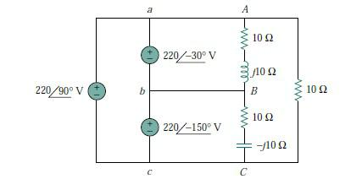

- For the circuit in Figure shown below, Za = 6 − j8, Zb = 12 + j9 , and Zc = 15 . Find the line currents Ia , Ib, and Ic.
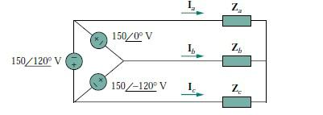

- A delta-connected load whose phase impedances are ZAB = 50 , ZBC = −j50 , and ZCA = j50 is fed by a balanced wye-connected three-phase source with Vp = 100 V. Find the phase currents.

- A balanced three-phase wye-connected generator with Vp = 220 V supplies an unbalanced wye-connected load with ZAN = 60 + j80 , ZBN = 100 − j120, and ZCN = 30 + j40 . Find the total complex power absorbed by the load.

- In Figure, two wattmeters are properly connected to the unbalanced load supplied by a balanced source such that Vab = 208 V with positive phase sequence.

(a) Determine the reading of each wattmeter. (b) Calculate the total apparent power absorbed by the load.

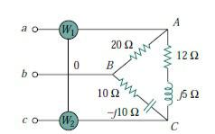

SECTION-B

- The unbalanced ∆ load of Fig. is supplied by balanced line-to-line voltages of 440 V in the positive sequence. Find the line currents. Take Vab as reference.
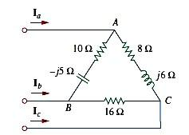

- The unbalanced Y-load of Fig has balanced voltages of 100 V and the acb sequence. Calculate the line currents and the neutral current. Take ZA=15Ω, ZB=(10+j5)Ω, ZC=(6-j8)Ω
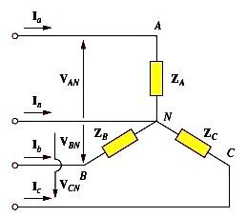

- For the phase sequence indicator as shown in Figure find the equivalent
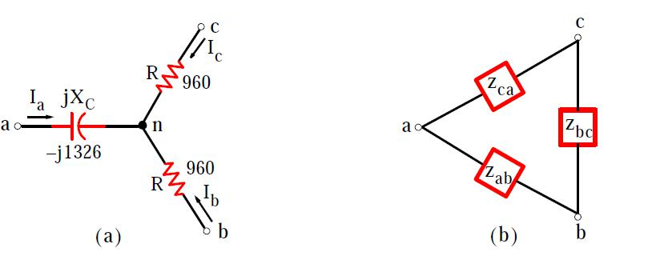

- Find the line currents in the unbalanced three-phase circuit of Figure and the real power absorbed by the load.
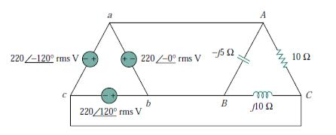

- For the unbalanced circuit in Figure find:

  - the line currents,

  - the total complex power absorbed by the load, and

  - the total complex power supplied by the source.
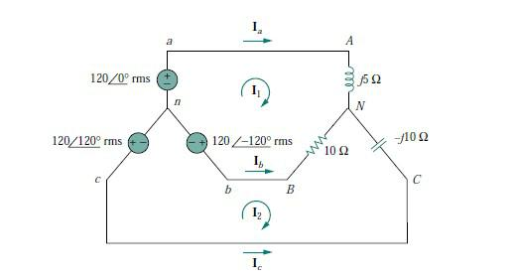

- Consider the unbalanced circuit shown in Figure below. Find the generator current Iab, the line current IbB, and the phase current IBC.
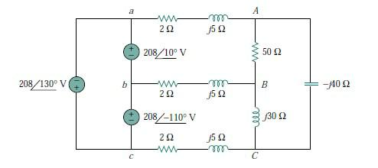

- Three watt meters W1, W2, and W3 are connected, respectively, to phases a, b, and c to measure the total power absorbed by the unbalanced wye connected load.

  - Predict the wattmeter readings. (b) Find the total power absorbed.
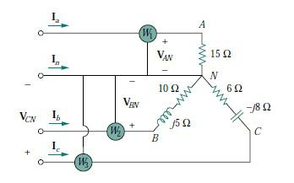

- Refer to the unbalanced circuit of Figure. Calculate:
  - the line currents

  - the real power absorbed by the load

  - the total complex power supplied by the source

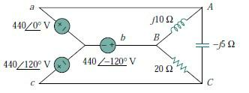

SECTION-C

- A good phase sequence indicator operates with one lamp very bright and the other very dim. Using the same lamps as in figure but with a capacitor of different value, can you design a better indicator?
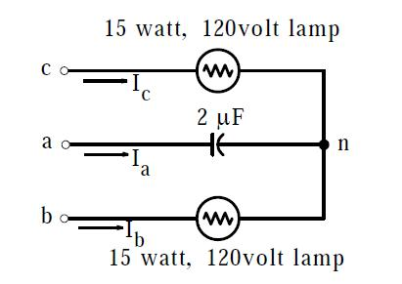

Figure shows a typical phase indicator consisting of two resistors representing two light bulbs each rated 15 watts, 120 volts at 60Hz frequency, and a capacitor connected to a120 volt three phase system.

- An unbalanced star connected load is connected across a 3-φ, 400V balanced supply of phase sequence RYB as shown in fig. Two wattmeters are connected to measure the total power supplied as shown in fig. Find the readings of the wattmeters.

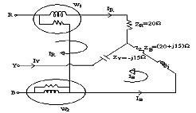

- Given an unbalanced delta connected load, obtain the respective phase currents.
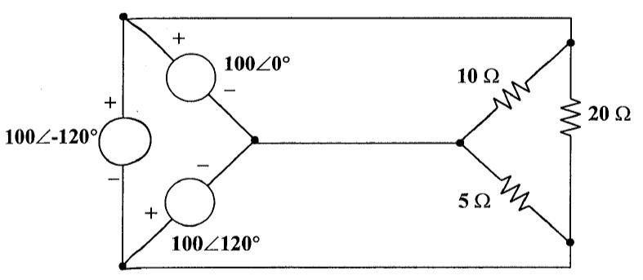

- Find out the equivalent capacitance when the following transformation is used
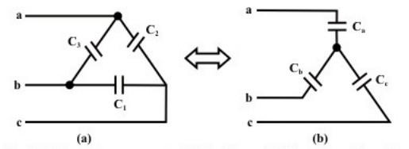

- A 230V (phase), 50 Hz, three phase, 4-wire system has a phase sequence ABC. A unity power factor load of 4 kW is connected between phase A and neutral N. It is desired to achieve zero neutral current through the use of a pure inductor and a pure capacitor in the other two phases. The values of inductor and capacitor are

  - 72.95 mH in phase C and 139.02 µF in phase B.

  - 72.95 mH in phase B and 139.02 µF in phase C.

  - 42.12 mH in phase C and 240.79 µF in phase B.

  - 42.12 mH in phase B and 240.79 µF in phase C.

- For the three phase system in Figure, compute the generator voltages Vab, Vbc , and Vca . Assume that each transformer impedance on the high side is

j30 and the transformer resistances are negligible. Assume also that the lines are very short and thus their impedances can are also negligible.
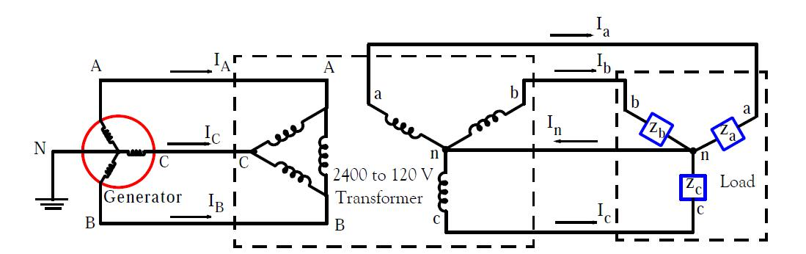

- As shown in Figure a three-phase four-wire line with a phase voltage of 120 V supplies a balanced motor load at 260 kVA at 0.85 pf lagging. The motor load is connected to the three main lines marked a, b, and c. In addition, incandescent lamps (unity pf) are connected as follows: 24 kW from line a to the neutral, 15 kW from line b to the neutral and 9 kW from line a to the neutral.

- If three watt meters are arranged to measure the power in each line, calculate the reading of each meter.

- Find the current in the neutral line.

