UNIT - II

Balanced Three Phase circuits

Objectives:

To introduce the concept of three phase electrical supply. To analyze three phase balanced systems

To Measure three phase active and reactive power.

Syllabus:

Phase sequence-Star and Delta connection-Relation between line and phase voltages and currents in balanced systems-Analysis of balanced three phase circuits-Analysis -Star Delta transformation Technique-Measurement of Active and Reactive power in balanced three phase systems-Two wattmeter method of measurement of three phase power.

Outcomes:

On completion the student should be able to:

Describe the reasons for, and the generation of the three-phase supply. Distinguish between star (3 and 4-wire) and delta connections.

State the relative advantages of three-phase systems compared with single-phase-systems.
Solve three-phase circuits in terms of phase and line quantities, and the power developed in three-phase balanced loads.

Measure power dissipation in balanced three-phase loads, using the 1, 2 and 3-wattmeter methods, and hence determine load power factor.

1.1 Introduction:

There are two types of systems available in electrical circuits, single phase and three phases. In single phase circuits, there will be only one phase, i.e the current will flow through only one wire and there will be one return path called neutral line to complete the circuit.

- In 1882, new invention has been done called polyphase system, that more than one phase can be used for generating, transmitting and for load system.

- Three phase circuit is the polyphase system where three phases are sent together from generator to the load.
- Each phase are having a phase difference of 120⁰, i.e 120⁰ angle electrically. So from the total of 360⁰, three phases are equally divided into 120⁰ each.

The sinusoidal waves for 3 phase system are shown below.
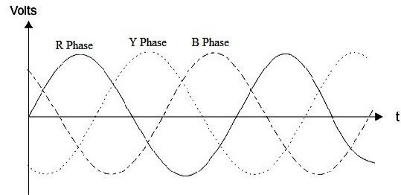

Fig.1.1 Three Phase Voltages

- The three phase can be used as three individual single phases. So if the load is single phase, then one phase can be taken from the three phase circuit and the neutral can be used as ground to complete the circuit.

1.1.1 Why three phase is preferred over single phase?

- There are number of advantages over single phase circuit.

  - The three phase system can be used as three single phase line so it can act as three single phase system.
    - The three phase generation and single phase generation is same in the

generator except the arrangement of coil in the generator to get 120⁰ phase difference.
      - The conductor needed in three phase circuit is 75% that of conductor needed in single phase circuit.

A 3-phase system has the following advantages over single phase system.

- For a given frame size of a machine a 3-phase machine will have large capacity than a single phase machine.
- The torque produced in a 3-phase motor will be more uniform where as in a 1-phase motor it is pulsating.
- The amount of copper required in a certain amount of power over a particular distance, is less compared to a single phase system.

1.1.2 Phase sequence:

- It is the order in which the phase voltages will attain their maximum values.

- From the fig 1.1 it is seen that the voltage in R phase will attain maximum value first and followed by Y and B phases. Hence three phase sequence is RYB.

- This is also evident from phasor diagram in which the phasors with its positive direction of anti-clockwise rotation passes a fixed point is the order RYB, YBR and so on.

- The phase sequence depends on the direction of rotation of the coils in the magnetic field.
- If the coils rotate in the opposite direction then the phase voltages attains maximum value in the order RBY. The phase sequence gets reversed with direction of rotation.
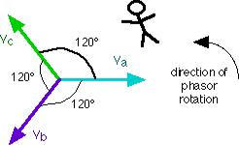

Fig.1.2 Phasor Representation of Three Phase Voltages Then the voltage for this sequence can be represented as

- _{R}=v_{m} sin ωt

- _{Y} =v_{m} sin (ωt−120⁰ )

- _{B}=v_{m}sin (ωt−240⁰ )=v_{m} sin (ωt +120⁰)

The RMS values of voltage can be expressed as

- _{R} =V _{m} ∠0⁰

- _{Y} =V _{m} ∠−12 0⁰

- _{B} =V _{m} ∠−24 0⁰=V _{m} ∠+12 0⁰

1.1.3 Star and Delta connection

- The three phase windings have six terminals i.e., R,Y,B are starting end of the windings and R',Y' and B' are finishing ends of windings.
- For 3 phase systems two types of common interconnections are employed.

1.1.3(a) Star connection:

- The finishing ends or starting ends of the three phase windings are connected to a common point as shown in. R', Y', B' are connected to a common point called neutral point.

- The other ends R, Y, B are called line terminals and the common terminal neutral are brought outside.
- Then it is called a 3 phase 4 wire star connected system.

- If neutral point is not available, then it is called 3 phase 3 wire star connection.
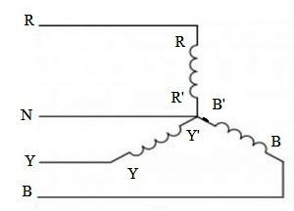

Fig.1.3 Star Connection

1.1.3(b) Delta connection:

- Here the dissimilar ends of the three coils i.e R and Y', Y and B', and B

and R' are connected to form a closed circuit (starting end of one phase is connected to finishing end of the next phase).
- The three ends are brought outside as line terminal R, Y, B. Three phase windings are connected in series and form a closed path.
- The sum of the voltages in the closed path for balanced system of voltages at any instant will be zero.
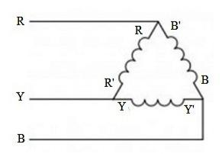

Fig.1.4 Delta Connection

- The main advantage of star connection is that we can have two different 3-phase voltages.
- The voltages between R & Y, Y & B, and B & R are called line voltages and form a balanced three phase voltage.
- The voltages between the terminals R & N, Y & N, and B & N are called phase voltage and form another balanced three phase voltage (line to neutral voltage or wye voltage).

1.2 Relation between line and phase voltage and currents in balanced systems:

In this section we will derive the relation between line and phase values of voltages and currents of 3-phase star connected and delta connected systems.

1.2.1 Star connection:

- Here, we employ double subscript notation to represent voltages and currents.

- The terminal corresponding to first subscript is assumed to be at a higher potential with respect to the terminal corresponding to second subscript.

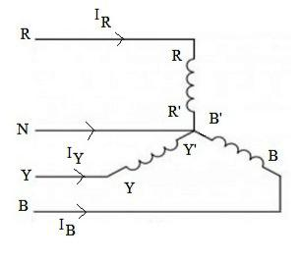

Fig.1.5 Star Connected Syatem

- The voltage across each coil, i.e., the voltage between R & R', Y & Y', and B & B' are called phase voltages(acting from finishing end to starting end).
- VRR’ , VYY’ , VBB’ or VRN, VYN, VBN represent phase voltages.

- The voltages across line terminals R & Y, Y & B, B & R are called line voltages.

- The connection diagram and the corresponding phasor diagram of voltages is shown in fig.
- From the star connected 3 phase system, it is clearly observed that whatever currents flow through the lines R, Y, B also flow through the respective phase windings.

- Hence in star connected system, the phase currents and line currents are identical.

Phase current (Iph) = Line currents (IL)

Iph= ILine
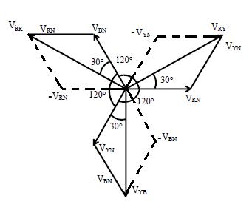

Fig.1.6 Phasor Diagram of Star System

The voltage VRY between lines R and Y is obtained by adding VRN and VNY respectively.

 | VRY = VRN+VNY = VRN – VYN
Similarly | VYB = VYN+VNB = VYN – VBN
 | VBR = VBN+VNR = VBN – VRN

The line voltage VRY is obtained by adding VRN with reversed vector of VYN.VRY bisects the angle between VRN and –VYN
VRY² = VL²= Vph² + Vph² + 2 VphVphcos 60⁰= 3Vph²

VRY = √3 Vph

Line voltage = √3 phase voltage

- The line voltages VRY, VYB, VBR are equal in magnitude and differ in phase by 120⁰.
- Hence they form a balanced 3-phase voltage of magnitude √3 Vph.

- The two voltages differ in phase by 30⁰.

- When the system is balanced, the three phase currents IR, IY, IB are

balanced.

- The magnitude and phase angle of current is determined by circuit

parameters.

- IR, IY, IB are line or phase currents.

- The current in the neutral wire is IN and is by applying kirchoff’s current law at star point, we get

IN = -( IR+ IY+ IB)

- If the currents are balanced, then the neutral current is zero.

1.2.2 Delta connection or MESH connection:

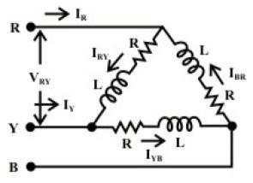

Fig.1.7 Delta Connected System

- The currents flowing through the phase windings IRR’, IYY’, and IBB’ or IRY, IYB, and IBR are called phase currents and are balanced as shown in phasor diagram Fig.1.8.
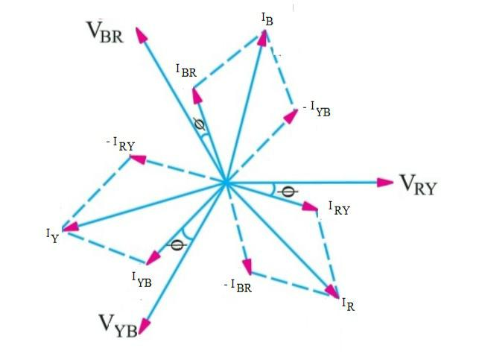

Fig.1.8 Phasor Diagram of Delta System By applying KCL at node R

IA+IBR = IRY, IR = IRY - IBR

Similarly by applying KCL at nodes Y and B

IY = IYB - IBR

IB = IBR - IYB

The line current IR is obtained by adding IRY and –IBR vectorially. IR bisects the angle between IRY and –IBR
IR² = ILine²= Iph² + Iph² + 2 IphIphcos 60⁰

- 3Iph²

IL = √3 Iph

- Line current(IL) = √3 phase voltage(Iph)

- The line current IR, IY, IB and also equal and differ in phase by 120⁰. They form a balanced system of currents.
- The line and phase currents differ in phase by 30⁰.

1.3 Analysis of balanced three phase circuits

A set of three impedances interconnected in the form of a star or delta form a 3-phase star or delta connected load.

- If the three impedances are identical and equal then it is a balanced 3-phase load, otherwise it is an unbalanced 3-phase load.

The analysis of balanced 3-phase circuits is illustrated as follows 1.3.1 Balanced delta connected load:
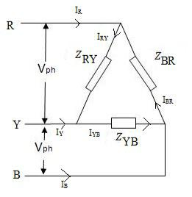

Fig.1.9 Balanced Delta Connected Load

Let us consider a balanced 3-phase delta connected load

Determination of phase voltages:

VRY = V ∠ 0⁰, VYB = V ∠ -120⁰, VBR = V ^{∠−24} 0⁰= V ^{∠12} 0⁰

Determination of phase currents:

Phase current = Phase voltage/ Load impedance
IRY= | ^{V} RY | ; IYB= | ^{V} YB | ; IBR= | ^{V} BR
 | Z |  | Z |  | Z

Determination of line currents:

Line currents are calculated by applying KCL at nodes R,Y,B IR = IRY – IBR ; IY = IYB – IRY ; IB = IBR – IYB

• Note: Line currents are also balanced and equal to ^{√ 3} phase current.

1.3.2 Balanced star connected load:

Let us consider a balanced 3-phase star connected load.

For star connection, phase voltage= Line voltage/( √ ³ )

For RYB sequence, the phase voltage is polar form are taken as

VRN = Vph ^{∠−900} ; VYN = Vph ^{∠1500} ; VBN = Vph ^{∠300}
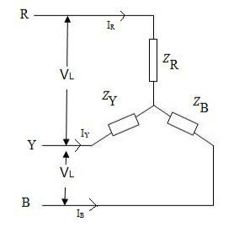

Fig.1.10 Balanced Star Connected Load For star connection line currents and phase currents are equal
IR = | ^{V} RN | ; IY = | ^{V} YN | ; IB = | ^{V} BN | ;
 | Z |  | Z |  | Z

To determine the current in the neutral wire apply KVL at star point IN + IR + IY + IB =0

IN = -( IR + IY + IB) (since they are balanced)

- In a balanced system the neutral current is zero.

- Hence if the load is balanced, the current and voltage will be same whether neutral wire is connected or not.

- Hence for a balanced 3-phase star connected load, whether the supply is

3-phase 3 wire or 3-phase 4 wire, it is immaterial.

- In case of unbalanced load, there will be neutral current.

1.4 Power calculation in three phase balanced system:

- In a balanced 3-phase load, the currents and voltages are balanced.

- Hence the power in each phase is same and hence power calculations

are based on per phase basis.

- The total power is given by 3 times the power in each phase.

- If Vph – voltage/ph, Iph – current/phase and the angle between voltage Vph

and current Iph is θ then,

Active power/phase = VphIphcosθ watts/ph Total active power = 3 VphIphcosθ watts

Similarly,

Reactive power/phase = VphIphsinθ VAR/ph Total reactive power = 3 VphIphsinθ VAR

Total volt amps = 3 * volt amps/ph =3 VphIph volt amps

1.4.1 Expression for power in terms of Line Voltages & Line Currents:

- Star connected system:

Total power = 3 VphIphcosθ

For star connected systems VL = √3 Vph ;

 |  | Vph = | V _{L} | and IL = Iph
 |  |  | √ 3
Total power = 3( | V _{L} | )ILcos θ
 | √ 3

    - √3 VLILcos θ

Total reactive power = √3 VLIL sin θ Total volt amps = √3 VLIL

b. Delta connected system:

Total power = 3 VphIphcosθ

For delta connected systems IL = √3 Iph ;

 |  | Iph = | I _{L} | and VL = Vph
 |  |  | √ 3
Total power = 3( | I _{L} | )VLcos θ
 | √ 3

    - √3 VLILcos θ

Total reactive power = √3 VLIL sin θ Total volt amps = √3 VLIL

- For either balanced star or delta connected systems, the total active power is given by total reactive power = √3 VLIL sin θ.Where θ angle between phase voltage and phase current.

- The power factor of balanced 3-phase load (either star or delta connected) is the cosine of the angle between phase voltage and phase current.
- In unbalanced circuit, the power, reactive power and apparent power in each phase is different. Hence they have to be calculated separately and to be added to get total power in 3-phase system.

1.5.1 Two watt meter method applied to balanced loads:

In this section, we derive the expression for the readings of watt meters W1 and W2 used to measure power in a balanced 3 phase load connected to a

balanced 3-phase supply.

Consider a balanced star connected load of impedance Z∟θ ohms/ph as shown in Fig1.11.
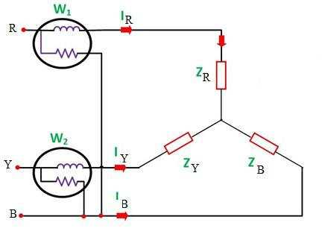

Fig.1.11 Two Wattmeter method to measure Active Power The phasor diagram of voltage and currents are shown in Fig.1.12
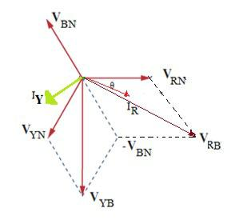

Fig.1.12

The phasor diagram is drawn for the RYB sequence is as shown.

Watt meter W1:

- Current through current coil = IR

- Voltage across pressure coil = VRB= VRS – VBS

- Phase difference between VRB and IR = 30- θ

- Power measured by W1 = VRBIR cos(30- θ)

- Since the load is balanced, and the supply is also balanced VRB and IR represent line voltage and line currents respectively.
- Reading of W1= VLILcos(30 - θ)

Watt meter W2:

- Current through current coil = IY

- Voltage across pressure coil = VYB = VYS – VBS

- Phase difference between VYB and IY = 30+ θ

- Power measured by W2 = VYBIY cos(30+θ)

= VLILcos(30+ θ) | (1)
- The total power is given by algebraic sum of the watt meter readings.

- W1+W2= VLIL[cos(30 - θ) + cos(30+ θ)]

= VLIL 2 cos 30⁰cos θ = √3 VLILcos θ
• W1+W2= √3 VLILcos θ = total power | (2)
• The difference in the wattmeter reading:
W1-W2= VLIL [cos(30 - θ) -cos(30+ θ)]
= VLIL 2 sin 30⁰ sin θ = VLILsin θ
• Total reactive power = √3(W1-W2)= √3 VLIL sin θ | (3)
• Dividing (3) by (2) we get,

tanθ = √3(W1-W2)/W1+W2 | (4)
From the above equation (4) we can calculate phase angle θ and hence power factor cos θ can be determined from the watt meter readings. θ is considered +ve for lagging p.f and –ve for leading p.f.

1.5.2. Measurement of Reactive Power:

Reactive Power can be measured only for balanced Loads.

To measure Reactive Power Wattmeter current coil will be placed in one of the line and Pressure coil between the remaining two line terminals as shown in figure1.13
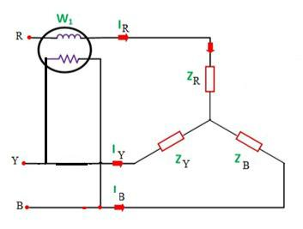

Fig.1.13 Single Wattmeter method to measure Reactive Power

Power measured by the wattmeter W1 can be obtained from the product of current through current coil(IR) and voltage measured by the pressure coil(VYB)

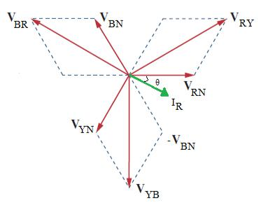

Fig.1.14 Phasor Diagram

From the phasor diagram angle between VYB and IR is ^{90−θ} Power measured by wattmeter W1is given by W1 = ^{V} YB ^{I} R ^{cos} ^{(90−θ)}
= | V _{YB} I _{R} sin θ
= | V _{L} I _{L} sinθ

_{Reactive Power =} √3V L IL sin θ ₌ √3W 1

By using this method one can measure reactive Power as ^{√3} times of wattmeter reading.

