B.Tech. Program in Artificial Intelligence and Machine Learning (AI & ML)

Faculty List
S. No. | Name of the Faculty | Designation | Qualification | Photo
1 | Dr. Gera Jaideep | Assoc Prof | Ph. D | 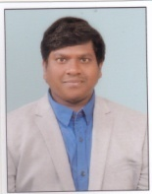
2 | M Yamuna Rani | Asst Professor | M.Tech | 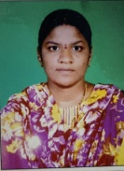
3 | P V B Sivappa | Asst Professor | M.Tech | 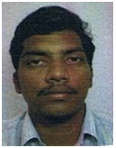
4 | Gandikota Bala Nagayya | Asst Professor | M.Tech | 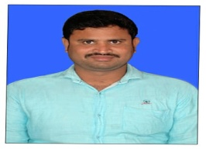
5 | Pagadala Rajesh | Asst Professor | M.Tech | 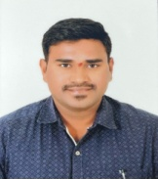
7 | Pagadala Sandhya Rani | Asst Professor | M.Tech | 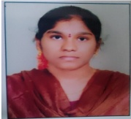
8 | N Pooja | Asst Professor | M.Tech | 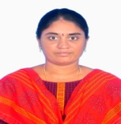
9 | Bolisetty Harika Lakshmi Manasa | Asst Professor | M.Tech | 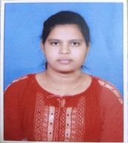
10 | Shaik Beebi | Asst Professor | M.Tech | 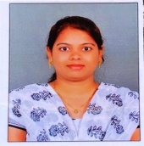
11 | Md Fareena | Asst Professor | M.Tech | 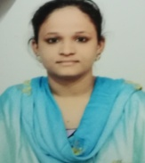
12 | M Phanindra | Asst Professor | M.Tech | 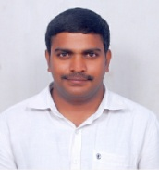
13 | Chakkiraja Sireesha | Asst Professor | M.Tech | 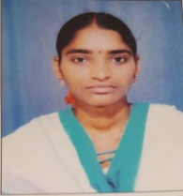
14 | Gummadi Srikanth | Asst Professor | M.Tech | 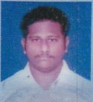
15 | T Lakshmi Sarika | Asst Professor | M.Tech | 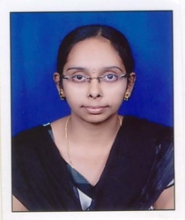
16 | D Sasikanth | Asst Professor | M.Tech | 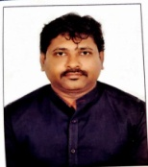
17 | Donepudi Rohini | Asst Professor | M.Tech | 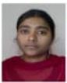
18 | M Prasanth Babu | Asst Professor | M.Tech | 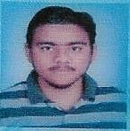
19 | S Sankeerthi | Asst Professor | M.Tech | 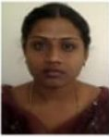
20 | M Venkata Kondala Rao | Asst Professor | M.Tech | 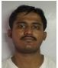
21 | Ch Vijaya Durga | Asst Professor | M.Tech | 