B.Tech. Program in Artificial Intelligence and Data Science (AI & DS)
List of Faculty:
S. No. | Name of the Faculty |  | Designation |  | Qualification |  | Photo
1 | Dr SSN Anjaneyulu |  | Assoc.Prof |  | Ph. D |  | 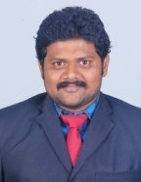
2 | Shabana Khanum |  | Asst Professor |  | M.Tech |  | 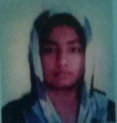
3 | Dr Riaz Shaik |  | Assoc Prof |  | Ph. D |  | 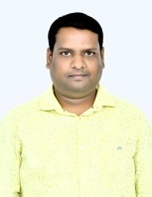
4 | P Firoze |  | Asst Professor |  | M.Tech |  | 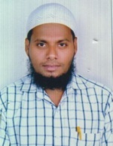
5 | S Kiran Babu |  | Asst Professor |  | M.Tech |  | 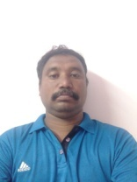
7 | P Srinivas |  | Asst Professor |  | M.Tech |  | 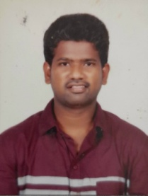
8 | P Naresh Kumar |  | Asst Professor |  | M.Tech |  | 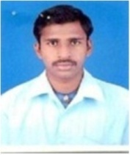
9 | V Roshan Kumar |  | Asst Professor |  | M.Tech |  | 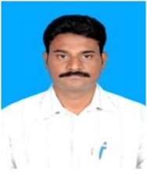
10 | M Krishna Reddy |  | Asst Professor |  | M.Tech |  | 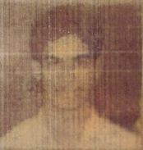
11 | P Lakshman Rao |  | Asst Professor |  | M.Tech |  | 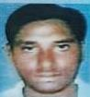
42 | V Baby Vasanthi |  | Asst Professor |  | M.Tech |  | 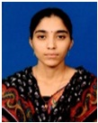
13 | Bade Gopinadh |  | Asst Professor |  | M.Tech |  | 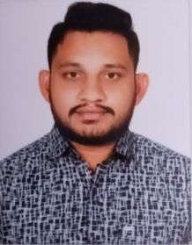
14 | Veraboina Somaiah |  | Asst Professor |  | M.Tech |  | 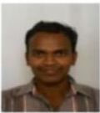
15 | P Sai Bharathi |  | Asst Professor |  | M.Tech |  | 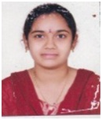
16 | G Sasikala |  | Asst Professor |  | M.Tech |  | 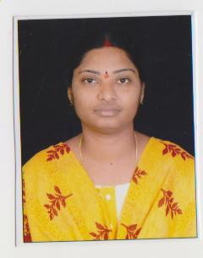
17 | G Lakshmi Swathi |  | Asst Professor |  | M.Tech |  | 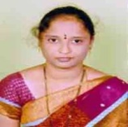
18 | Velaga Silpa Chowdary |  | Asst Professor |  | M.Tech |  | 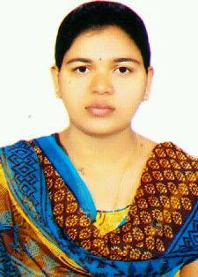
19 | Velaga Praneeth |  | Asst Professor |  | M.Tech |  | 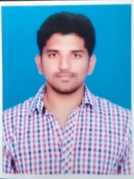
20 | Kathi Anitha |  | Asst Professor |  | M.Tech |  | 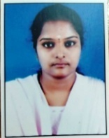
21 | G Sarath |  | Asst Professor |  | M.Tech |  | 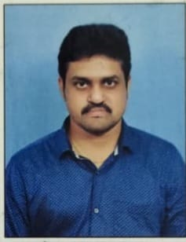
Dr E Uma Shankar Rao |  | Asst Professor |  | M.Tech |  | 