**UNIT-VI**

**Amplifier & Oscillators**

## 6.1 Feedback Amplifier

A practical amplifier has a gain of nearly one million *i.e.* its output is one million times the input. Consequently, even a casual disturbance at the input will appear in the amplified form in the output. There is a strong tendency in amplifiers to introduce *hum* due to sudden temperature changes or stray electric and magnetic fields. Therefore, every high gain amplifier tends to give noise along with signal in its output. The noise in the output of an amplifier is undesirable and must be kept to as small a level as possible. The noise level in amplifiers can be reduced considerably by the use of *negative feedback i.e*. by injecting a fraction of output in phase opposition to the input signal. The object of this chapter is to consider the effects and methods of providing negative feedback in transistor amplifiers.

Ideally an amplifier should reproduce the input signal, with change in magnitude and with or without change in phase. But some of the short comings of the amplifier circuit are

1 . Change in the value of the gain due to variation in supplying voltage, temperature or due to components.

1. Distortion in wave-form due to non linearities in the operating characters of the Amplifying device.
2. The amplifier may introduce noise (undesired signals)

The above drawbacks can be minimizing if we introduce feedback CLASSIFICATION OF AMPLIFIERS

Amplifiers can be classified broadly as,

1. Voltage amplifiers.
2. Current amplifiers.
3. Transconductance amplifiers.
4. Transresistance amplifiers.

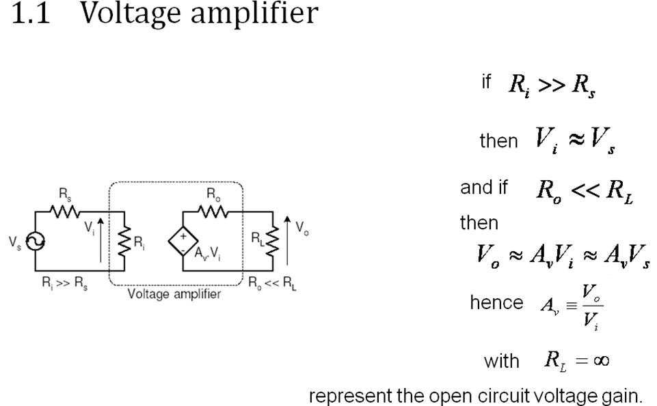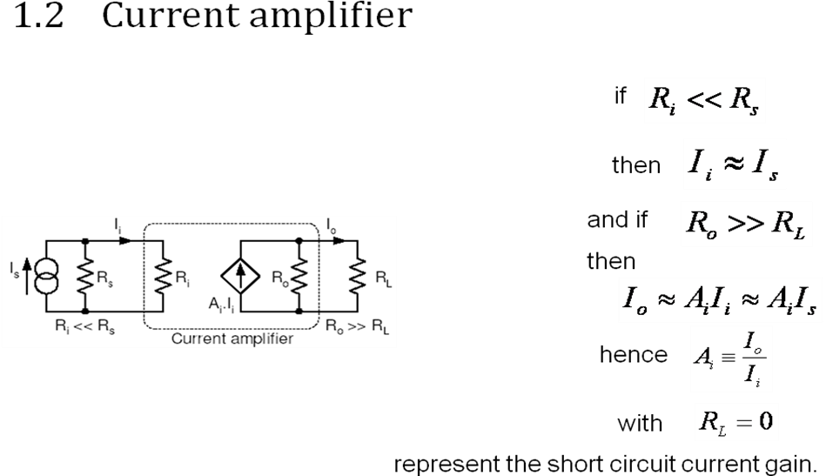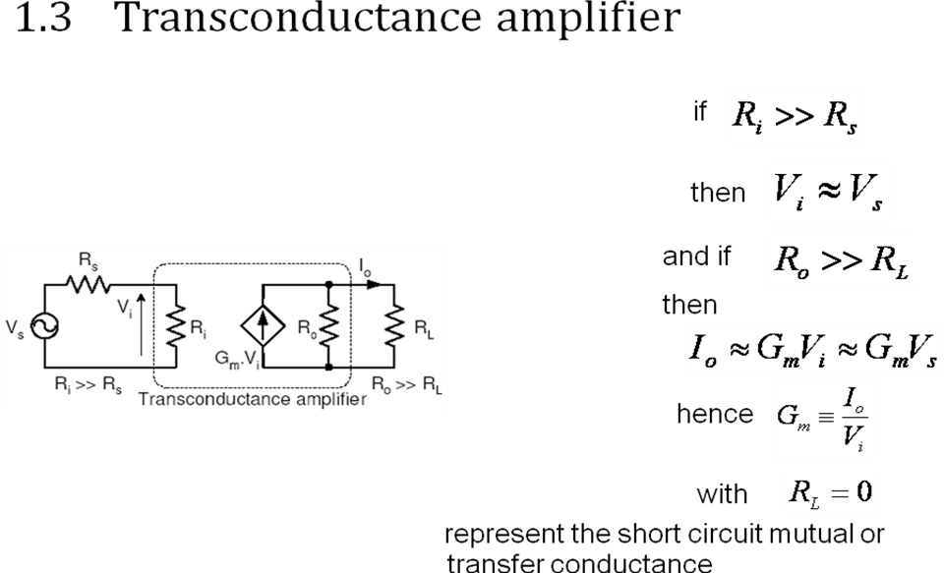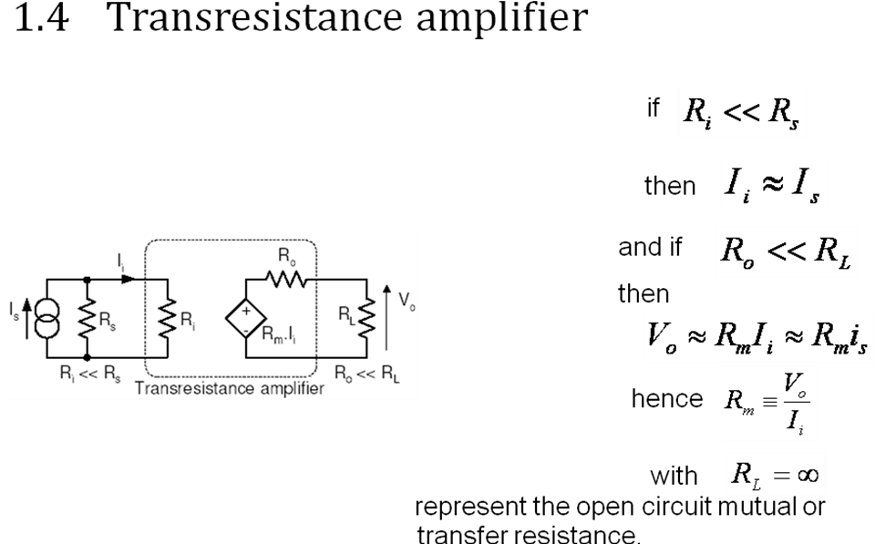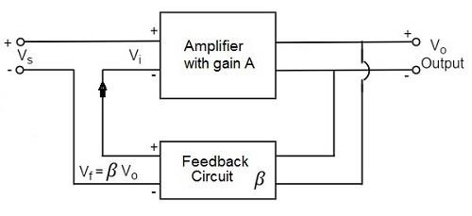

## 6.2 Concept of Feedback

An amplifier circuit simply increases the signal strength. But while amplifying, it just increases the strength of its input signal whether it contains information or some noise along with information. This noise or some disturbance is introduced in the amplifiers because of their strong tendency to introduce hum due to sudden temperature changes or stray electric and magnetic fields. Therefore, every high gain amplifier tends to give noise along with signal in its output, which is very undesirable.

The noise level in the amplifier circuits can be considerably reduced by using negative feedback done by injecting a fraction of output in phase opposition to the input signal.

## Principle of Feedback Amplifier

A feedback amplifier generally consists of two parts. They are theamplifier and the feedback circuit. The feedback circuit usually consists of resistors. The concept of feedback amplifier can be understood from the following figure.

From the above figure, the gain of the amplifier is represented as A. the gain of the amplifier is the ratio of output voltage Vo to the input voltage Vi. the feedback network extracts a voltage Vf = β Vo from the output Vo of the amplifier.

This voltage is added for positive feedback and subtracted for negative feedback, from the signal voltage Vs. Now,

Vi=Vs+Vf=Vs+βVo Vi=Vs−Vf=Vs−βVo

The quantity β = Vf/Vo is called as feedback ratio or feedback fraction.

Let us consider the case of negative feedback. The output Vomust be equal to the input voltage (Vs - βVo) multiplied by the gain A of the amplifier.

Hence,

(Vs−βVo)A=Vo Or AVs−AβVo=Vo Or AVs=Vo(1+Aβ)

Therefore,

*Vo* 

*Vs*

*A*

1  *A*

Let Af be the overall gain (gain with the feedback) of the amplifier. This is defined as the ratio of output voltage Vo to the applied signal voltage Vs, i.e.,

*Af* 

*A*

1  *A*

The equation of gain of the feedback amplifier, with positive feedback is given by

*Af* 

*A*

1  *A*

These are the standard equations to calculate the gain of feedback amplifiers.

## Typesof Feedbacks

The process of injecting a fraction of output energy of some device back to the input is known as Feedback. It has been found that feedback is very useful in reducing noise and making the amplifier operation stable.

Depending upon whether the feedback signal aids or opposes the input signal, there are two types of feedbacks used.

## Positive Feedback

The feedback in which the feedback energy i.e., either voltage or current is in phase with the input signal and thus aids it is called asPositive feedback.

Both the input signal and feedback signal introduces a phase shift of 180o thus making a 360o resultant phase shift around the loop, to be finally in phase with the input signal.

Though the positive feedback increases the gain of the amplifier, it has the disadvantages such as

* Increasing distortion
* Instability

It is because of these disadvantages the positive feedback is not recommended for the amplifiers. If the positive feedback is sufficiently large, it leads to oscillations, by which oscillator circuits are formed.

## 6.3 Negative Feedback

The feedback in which the feedback energy i.e., either voltage or current is out of phase with the input and thus opposes it, is called as negative feedback.

In negative feedback, the amplifier introduces a phase shift of 180o into the circuit while the feedback network is so designed that it produces no phase shift or zero phase shift. Thus the resultant feedback voltage Vf is 180o out of phase with the input signal Vin.

Though the gain of negative feedback amplifier is reduced, there are many advantages of negative feedback such as

* Stability of gain is improved
* Reduction in distortion
* Reduction in noise
* Increase in input impedance
* Decrease in output impedance
* Increase in the range of uniform application

It is because of these advantages negative feedback is frequently employed in amplifiers.

Negative feedback in an amplifier is the method of feeding a portion of the amplified output to the input but in opposite phase. The phase opposition occurs as the amplifier provides 180o phase shift whereas the feedback network doesn’t.

While the output energy is being applied to the input, for the voltage energy to be taken as feedback, the output is taken in shunt connection and for the current energy to be taken as feedback, the output is taken in series connection.

There are two main types of negative feedback circuits. They are −

* Negative Voltage Feedback
* Negative Current Feedback

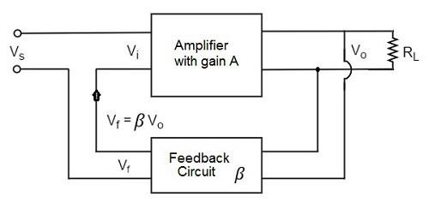

## NegativeVoltage Feedback

In this method, the voltage feedback to the input of amplifier is proportional to the output voltage. This is further classified into two types −

* Voltage-series feedback
* Voltage-shunt feedback

## Negative Current Feedback

In this method, the voltage feedback to the input of amplifier is proportional to the output current. This is further classified into two types.

* Current-series feedback
* Current-shunt feedback

Let us have a brief idea on all of them.

## Voltage-Series Feedback

In the voltage series feedback circuit, a fraction of the output voltage is applied in series with the input voltage through the feedback circuit. This is also known as shunt-driven series-fed feedback, i.e., a parallel-series circuit.

The following figure shows the block diagram of voltage series feedback, by which it is evident that the feedback circuit is placed in shunt with the output but in series with the input.

As the feedback circuit is connected in shunt with the output, the output impedance is decreased and due to the series connection with the input, the input impedance is increased.

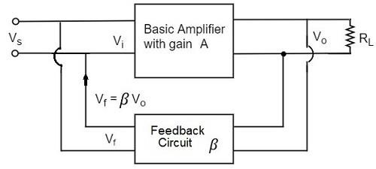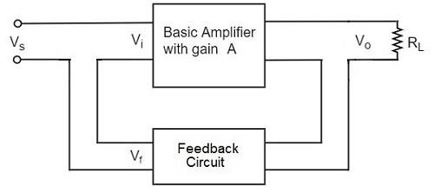

## Voltage-Shunt Feedback

In the voltage shunt feedback circuit, a fraction of the output voltage is applied in parallel with the input voltage through the feedback network. This is also known as shunt-driven shunt-fed feedback i.e., a parallel-parallel proto type.

The below figure shows the block diagram of voltage shunt feedback, by which it is evident that the feedback circuit is placed in shunt with the output and also with the input.

As the feedback circuit is connected in shunt with the output and the input as well, both the output impedance and the input impedance are decreased.

## Current-Series Feedback

In the current series feedback circuit, a fraction of the output voltage is applied in series with the input voltage through the feedback circuit. This is also known as series-driven series-fed feedback i.e., a series-series circuit.

The following figure shows the block diagram of current series feedback, by which it is evident that the feedback circuit is placed in series with the output and also with the input.

As the feedback circuit is connected in series with the output and the input as well, both the output impedance and the input impedance are increased.

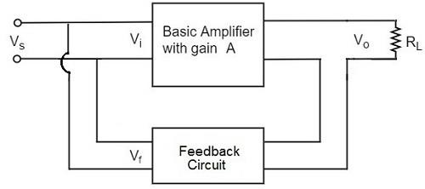

## Current-Shunt Feedback

In the current shunt feedback circuit, a fraction of the output voltage is applied in series with the input voltage through the feedback circuit. This is also known as series-driven shunt-fed feedback i.e., a series-parallel circuit.

The below figure shows the block diagram of current shunt feedback, by which it is evident that the feedback circuit is placed in series with the output but in parallel with the input.

As the feedback circuit is connected in series with the output, the output impedance is increased and due to the parallel connection with the input, the input impedance is decreased.

Let us now tabulate the amplifier characteristics that get affected by different types of negative feedbacks.

|  |  |  |  |  |
| --- | --- | --- | --- | --- |
| Characteristics | Types of Feedback | | | |
| Voltage-Series | Voltage-Shunt | Current-Series | Current-Shunt |
| Voltage Gain | Decreases | Decreases | Decreases | Decreases |
| Bandwidth | Increases | Increases | Increases | Increases |
| Input resistance | Increases | Decreases | Increases | Decreases |
| Output resistance | Decreases | Decreases | Increases | Increases |
| Harmonic distortion | Decreases | Decreases | Decreases | Decreases |
| Noise | Decreases | Decreases | Decreases | Decreases |

## EXPRESSION FOR INPUT RESISTANCE RI WITH VOLTAGE SERIES FEEDBACK

In this circuit Av represents the open circuit voltage gain taking Rs into account

Voltage series feedback

*R*  *VS*

*if I*

*i*

Apply KVL to the input side circuit Vs-IiRi-Vf=0

Vs=IiRi+Vf=IiRi+βVo

The output voltage Vo is given as

*V*  *AvVi RL*

*o*

 *A I R*  *A V*

*Ro*  *RL*

*V i i V i*

Where

*AV* 

*AV RL*

*Ro*  *RL*

Av represents the open circuit voltage gain without feedback

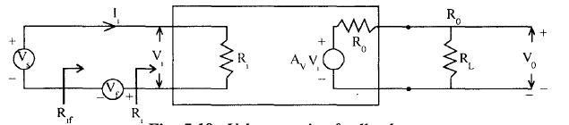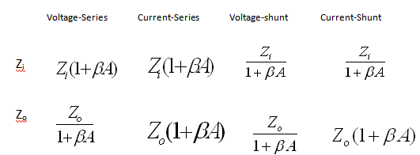

AV represents the open circuit voltage gain without feedback taking the load RL into account. Vs=IiRi+βAvIiRi

*R*  *VS* =Ri+βAvRi

*if I*

*i*

Rif=Ri(1+βAv) Similarly we can find

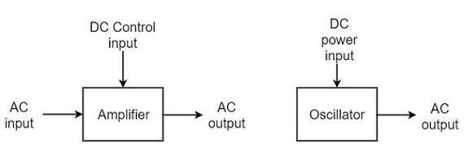

## Advantages of Negative Feedback

1. *Stabilization of gain*
   * make the gain less sensitive to changes in circuit components e.g. due to changes in temperature.
2. *Reduce non-linear distortion*
   * make the output proportional to the input, keeping the gain constant, independent of signal level.
3. *Reduce the effect of noise*
   * minimize the contribution to the output of unwanted signals generated in circuit components or extraneous interference.
4. *Extend the bandwidth of the amplifier*
   * Reduce the gain and increase the bandwidth
5. *Modification the input and output impedances*
   * raise or lower the input and output impedances by selection of the appropriate feedback topology.

## 6.4 Oscillators

An **oscillator** generates output without any ac input signal. An electronic oscillator is a circuit which converts dc energy into ac at a very high frequency. An amplifier with a positive feedback can be understood as an oscillator.

Amplifier vs. Oscillator

An **amplifier** increases the signal strength of the input signal applied, whereas an **oscillator** generates a signal without that input signal, but it requires dc for its operation. This is the main difference between an amplifier and an oscillator.

Take a look at the following illustration. It clearly shows how an amplifier takes energy from d.c. power source and converts it into a.c. energy at signal frequency. An oscillator produces an oscillating a.c. signal on its own.

The frequency, waveform, and magnitude of a.c. power generated by an amplifier, is controlled by the a.c. signal voltage applied at the input, whereas those for an oscillator are controlled by the components in the circuit itself, which means no external controlling voltage is required.

Alternator vs. Oscillator

An **alternator** is a mechanical device that produces sinusoidal waves without any input. This a.c. generating machine is used to generate frequencies up to 1000Hz. The output frequency depends on the number of poles and the speed of rotation of the armature.

The following points highlight the differences between an alternator and an oscillator −

* An alternator converts mechanical energy to a.c. energy, whereas the oscillator converts d.c. energy into a.c. energy.
* An oscillator can produce higher frequencies of several MHz whereas an alternator cannot.
* An alternator has rotating parts, whereas an electronic oscillator doesn’t.
* It is easy to change the frequency of oscillations in an oscillator than in an alternator.

Oscillators can also be considered as opposite to rectifiers that convert a.c. to d.c. as these convert d.c. to a.c.

Classification of Oscillators

Electronic oscillators are classified mainly into the following two categories −

* **Sinusoidal Oscillators** − The oscillators that produce an output having a sine waveform are called **sinusoidal** or **harmonic oscillators**. Such oscillators can provide output at frequencies ranging from 20 Hz to 1 GHz.
* **Non-sinusoidal Oscillators** − The oscillators that produce an output having a square, rectangular or saw-tooth waveform are called **non-sinusoidal** or **relaxation oscillators**. Such oscillators can provide output at frequencies ranging from 0 Hz to 20 MHz.

Sinusoidal Oscillators

Sinusoidal oscillators can be classified in the following categories −

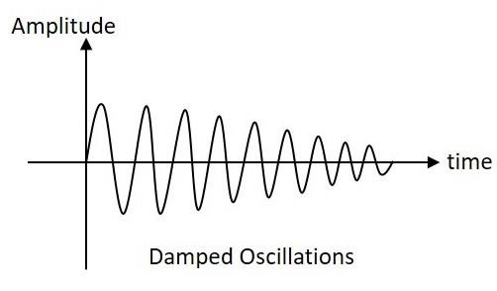

* **Tuned Circuit Oscillators** − These oscillators use a tuned-circuit consisting of inductors (L) and capacitors (C) and are used to generate high-frequency signals. Thus they are also known as radio frequency R.F. oscillators. Such oscillators are Hartley, Colpitts, Clapp-oscillators etc.
* **RC Oscillators** − There oscillators use resistors and capacitors and are used to generate low or audio-frequency signals. Thus they are also known as audio- frequency (A.F.) oscillators. Such oscillators are Phase –shift and Wein-bridge oscillators.
* **Crystal Oscillators** − These oscillators use quartz crystals and are used to generate highly stabilized output signal with frequencies up to 10 MHz. The Piezo oscillator is an example of a crystal oscillator.
* **Negative-resistance Oscillator** − These oscillators use negative-resistance characteristic of the devices such as tunnel devices. A tuned diode oscillator is an example of a negative-resistance oscillator.

Nature of Sinusoidal Oscillations

The nature of oscillations in a sinusoidal wave is generally of two types. They are **damped** and **undamped oscillations**.

Damped Oscillations

The electrical oscillations whose amplitude goes on decreasing with time are called as **Damped Oscillations**. The frequency of the damped oscillations may remain constant depending upon the circuit parameters.

Damped oscillations are generally produced by the oscillatory circuits that produce power losses and doesn’t compensate if required.

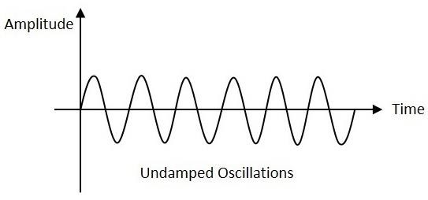

Undamped Oscillations

The electrical oscillations whose amplitude remains constant with time are called as **Undamped Oscillations**. The frequency of the Undamped oscillations remains constant.

Undamped oscillations are generally produced by the oscillatory circuits that produce no power losses and follow compensation techniques if any power losses occur.

An amplifier with positive feedback produces its output to be in phase with the input and increases the strength of the signal. Positive feedback is also called as **degenerative feedback** or**direct feedback**. This kind of feedback makes a feedback amplifier, an oscillator.

The use of positive feedback results in a feedback amplifier having closed-loop gain greater than the open-loop gain. It results in **instability** and operates as an oscillatory circuit. An oscillatory circuit provides a constantly varying amplified output signal of any desired frequency.

## The Barkhausen Criterion

With the knowledge we have till now, we understood that a practical oscillator circuit consists of a tank circuit, a transistor amplifier circuit and a feedback circuit. so, let us now try to brush up the concept of feedback amplifiers, to derive the gain of the feedback amplifiers.

Principle of Feedback Amplifier

A feedback amplifier generally consists of two parts. They are the**amplifier** and the **feedback circuit**. The feedback circuit usually consists of resistors. The concept of feedback amplifier can be understood from the following figure below.

From the above figure, the gain of the amplifier is represented as A. The gain of the amplifier is the ratio of output voltage Vo to the input voltage Vi. The feedback network extracts a voltage Vf = β Vo from the output Vo of the amplifier.

This voltage is added for positive feedback and subtracted for negative feedback, from the signal voltage Vs.

So, for a positive feedback, Vi = Vs + Vf = Vs + β Vo

The quantity β = Vf/Vo is called as feedback ratio or feedback fraction.

The output Vo must be equal to the input voltage (Vs + βVo) multiplied by the gain A of the amplifier.

Hence,

(Vs+βVo)A=Vo Or

AVs+AβVo=Vo Or

AVs=Vo(1−Aβ)

Therefore

*Af* 

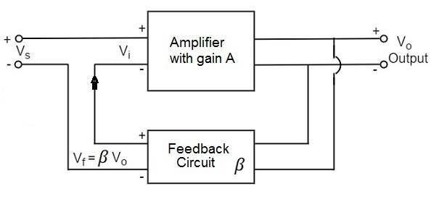

*outputvoltage inputsignalvoltage*

 *Vo Vs*

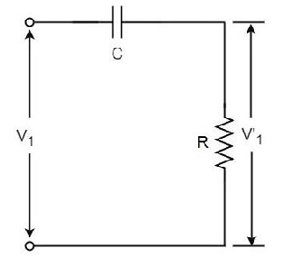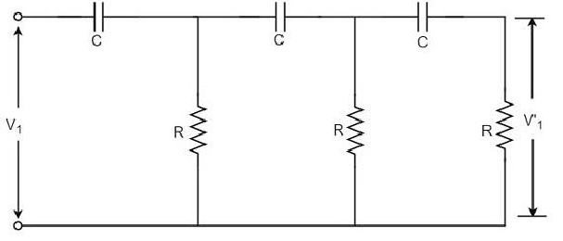

Rrom the above two equations, we can understand that, the equation of gain of the feedback amplifier with positive feedback is given by

*Af* 

*A*

1  *A*

Where **Aβ** is the **feedback factor** or the **loop gain**.

If Aβ = 1, Af = ∞. Thus the gain becomes infinity, i.e., there is output without any input. In another words, the amplifier works as an Oscillator.

The condition Aβ = 1 is called as **Barkhausen Criterion of oscillations**. This is a very important factor to be always kept in mind, in the concept of Oscillators

## 6.5 RC-Phase–shift Oscillators

Principle of Phase-shift oscilators

We know that the output voltage of an RC circuit for a sinewave input leads the input voltage. The phase angle by which it leads is determined by the value of RC components used in the circuit. The following circuit diagram shows a single section of an RC network.

The output voltage V1’ across the resistor R leads the input voltage applied input V1 by some phase angle ɸo. If R were reduced to zero, V1’ will lead the V1 by 90o i.e., ɸo = 90o.

However, adjusting R to zero would be impracticable, because it would lead to no voltage across R. Therefore, in practice, R is varied to such a value that makes V1’ to lead V1 by 60o. The following circuit diagram shows the three sections of the RC network.

Each section produces a phase shift of 60o. Consequently, a total phase shift of 180o is produced, i.e., voltage V2 leads the voltage V1 by 180o.

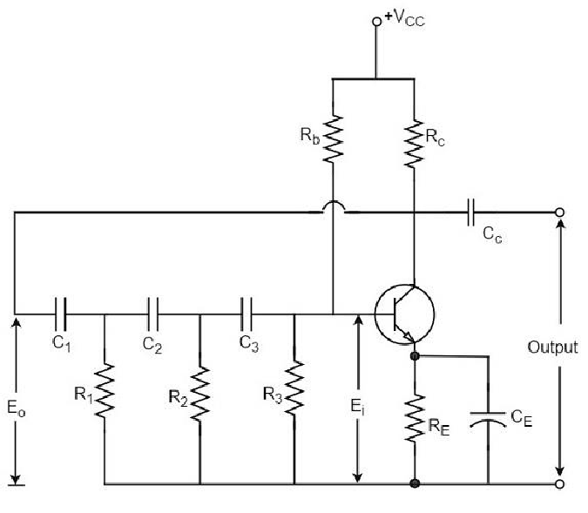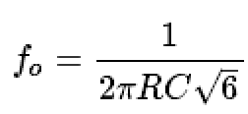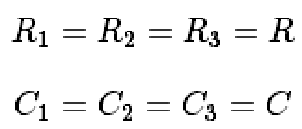

Phase-shift Oscillator Circuit

The oscillator circuit that produces a sine wave using a phase-shift network is called as a Phase-shift oscillator circuit. The constructional details and operation of a phase-shift oscillator circuit are as given below.

Construction

The phase-shift oscillator circuit consists of a single transistor amplifier section and a RC phase-shift network. The phase shift network in this circuit, consists of three RC sections. At the resonant frequency fo, the phase shift in each RC section is 60o so that the total phase shift produced by RC network is 180o.

The following circuit diagram shows the arrangement of an RC phase-shift oscillator.

The frequency of oscillations is given by

Where

Operation

The circuit when switched ON oscillates at the resonant frequency fo. The output Eo of the amplifier is fed back to RC feedback network. This network produces a phase shift of 180o and a voltage Ei appears at its output. This voltage is applied to the transistor amplifier.

The feedback applied will be m=Ei/Eo

The feedback is in correct phase, whereas the transistor amplifier, which is in CE

configuration, produces a 180o phase shift. The phase shift produced by network and the transistor add to form a phase shift around the entire loop which is 360o.

Advantages

The advantages of RC phase shift oscillator are as follows −

* It does not require transformers or inductors.
* It can be used to produce very low frequencies.
* The circuit provides good frequency stability. Disadvantages

The disadvantages of RC phase shift oscillator are as follows −

* Starting the oscillations is difficult as the feedback is small.
* The output produced is small.

Another type of popular audio frequency oscillator is the Wien bridge oscillator circuit. This is mostly used because of its important features. This circuit is free from the **circuit fluctuations** and the **ambient temperature**.

The main advantage of this oscillator is that the frequency can be varied in the range of 10Hz to about 1MHz whereas in RC oscillators, the frequency is not varied.

## 6.6 Wien bridge oscillator

Construction

The circuit construction of Wien bridge oscillator can be explained as below. It is a two- stage amplifier with RC bridge circuit. The bridge circuit has the arms R1C1, R3, R2C2 and the tungsten lamp Lp. Resistance R3 and the lamp Lp are used to stabilize the amplitude of the output.

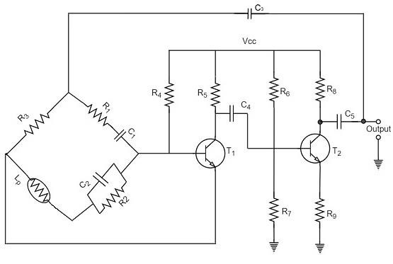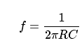

The following circuit diagram shows the arrangement of a Wien bridge oscillator.

The transistor T1 serves as an oscillator and an amplifier while the other transistor T2 serves as an inverter. The inverter operation provides a phase shift of 180o. This circuit provides positive feedback through R1C1, C2R2 to the transistor T1 and negative feedback through the voltage divider to the input of transistor T2.

The frequency of oscillations is determined by the series element R1C1 and parallel element R2C2 of the bridge.

If R1 = R2 and C1 = C2 = C

Then,

## 6.7 Crystal Oscillators

The use of piezo electric crystals in parallel resonant circuits provide high frequency stability in oscillators. Such oscillators are called as **Crystal Oscillators**.

Crystal Oscillators

The principle of crystal oscillators depends upon the **Piezo electric effect**. The natural shape of a crystal is hexagonal. When a crystal wafer is cur perpendicular to X-axis, it is called as X-cut and when it is cut along Y-axis, it is called as Y-cut.

The crystal used in crystal oscillator exhibits a property called as Piezo electric property. So, let us have an idea on piezo electric effect.

Piezo Electric Effect

The crystal exhibits the property that when a mechanical stress is applied across one of the faces of the crystal, a potential difference is developed across the opposite faces of the crystal. Conversely, when a potential difference is applied across one of the faces, a mechanical stress is produced along the other faces. This is known as **Piezo electric effect**.

Certain crystalline materials like Rochelle salt, quartz and tourmaline exhibit piezo electric effect and such materials are called as **Piezo electric crystals**. Quartz is the most commonly used piezo electric crystal because it is inexpensive and readily available in nature.

When a piezo electric crystal is subjected to a proper alternating potential, it vibrates mechanically. The amplitude of mechanical vibrations becomes maximum when the frequency of alternating voltage is equal to the natural frequency of the crystal.

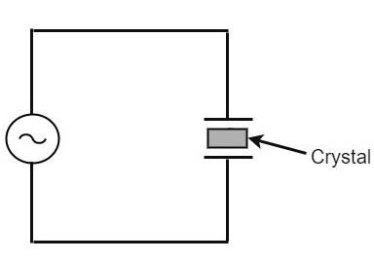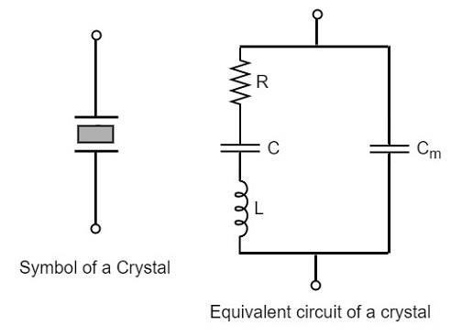

Working ofa Quartz Crystal

In order to make a crystal work in an electronic circuit, the crystal is placed between two metal plates in the form of a capacitor.**Quartz** is the mostly used type of crystal because of its availability and strong nature while being inexpensive. The ac voltage is applied in parallel to the crystal.

The circuit arrangement of a Quartz Crystal will be as shown below −

If an AC voltage is applied, the crystal starts vibrating at the frequency of the applied voltage. However, if the frequency of the applied voltage is made equal to the natural frequency of the crystal, **resonance** takes place and crystal vibrations reach a maximum value. This natural frequency is almost constant.

Equivalent circuit of a Crystal

If we try to represent the crystal with an equivalent electric circuit, we have to consider two cases, i.e., when it vibrates and when it doesn’t. The figures below represent the symbol and electrical equivalent circuit of a crystal respectively.

The above equivalent circuit consists of a series R-L-C circuit in parallel with a capacitance Cm. When the crystal mounted across the AC source is not vibrating, it is equivalent to the capacitance Cm. When the crystal vibrates, it acts like a tuned R-L-C circuit.

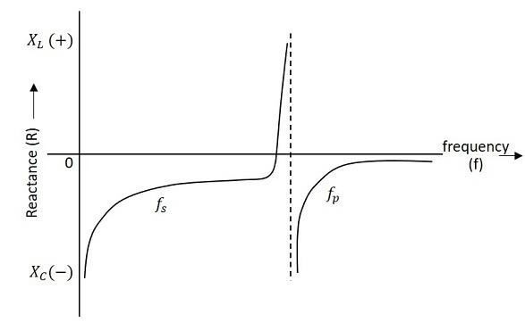

Frequency response

The frequency response of a crystal is as shown below. The graph shows the reactance (XL or XC) versus frequency (f). It is evident that the crystal has two closely spaced resonant frequencies.

The first one is the series resonant frequency (fs), which occurs when reactance of the inductance (L) is equal to the reactance of the capacitance C. In that case, the impedance of the equivalent circuit is equal to the resistance R and the frequency of oscillation is given by the relation,

The second one is the parallel resonant frequency (fp), which occurs when the reactance of R-L-C branch is equal to the reactance of capacitor Cm. At this frequency, the crystal offers a very high impedance to the external circuit and the frequency of oscillation is given by the relation.

Where

The value of Cm is usually very large as compared to C. Therefore, the value of CT is approximately equal to C and hence the series resonant frequency is approximately equal to the parallel resonant frequency (i.e., fs = fp).

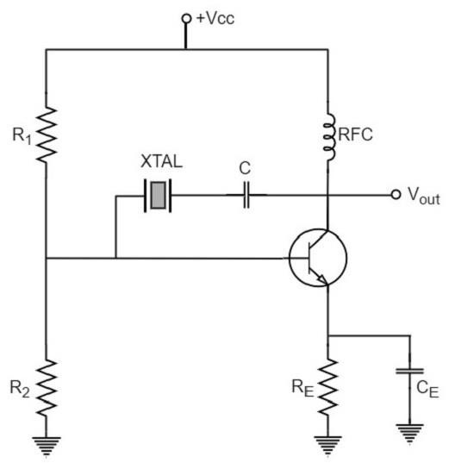

## Crystal Oscillator Circuit pierce crystal oscillator

A crystal oscillator circuit can be constructed in a number of ways like a Crystal controlled tuned collector oscillator, a Colpitts crystal oscillator, a Clap crystal oscillator etc. But the **transistor pierce crystal oscillator** is the most commonly used one. This is the circuit which is normally referred as a crystal oscillator circuit.

The following circuit diagram shows the arrangement of a transistor pierce crystal oscillator.

In this circuit, the crystal is connected as a series element in the feedback path from collector to the base. The resistors R1, R2 and RE provide a voltage-divider stabilized d.c. bias circuit. The capacitor CE provides a.c. bypass of the emitter resistor and RFC (radio frequency choke) coil provides for d.c. bias while decoupling any a.c. signal on the power lines from affecting the output signal. The coupling capacitor C has negligible impedance at the circuit operating frequency. But it blocks any d.c. between collector and base.

The circuit frequency of oscillation is set by the series resonant frequency of the crystal and its value is given by the relation,

It may be noted that the changes in supply voltage, transistor device parameters etc. have no effect on the circuit operating frequency, which is held stabilized by the crystal.

Advantages

The advantages of crystal oscillator are as follows −

* + They have a high order of frequency stability.
  + The quality factor (Q) of the crystal is very high. Disadvantages

The disadvantages of crystal oscillator are as follows −

* + They are fragile and can be used in low power circuits.
  + The frequency of oscillations cannot be changed appreciably. Frequency Stability of an Oscillator

An Oscillator is expected to maintain its frequency for a longer duration without any variations, so as to have a smoother clear sinewave output for the circuit operation. Hence the term frequency stability really matters a lot, when it comes to oscillators, whether sinusoidal or non-sinusoidal.

The frequency stability of an oscillator is defined as the ability of the oscillator to maintain the required frequency constant over a long time interval as possible. Let us try to discuss the factors that affect this frequency stability.

Change in operating point

We have already come across the transistor parameters and learnt how important an operating point is. The stability of this operating point for the transistor being used in the circuit for amplification (BJT or FET), is of higher consideration.

The operating of the active device used is adjusted to be in the linear portion of its characteristics. This point is shifted due to temperature variations and hence the stability is affected.

Variation in temperature

The tank circuit in the oscillator circuit, contains various frequency determining components such as resistors, capacitors and inductors. All of their parameters are temperature dependent. Due to the change in temperature, their values get affected. This brings the change in frequency of the oscillator circuit.

Due to power supply

The variations in the supplied power will also affect the frequency. The power supply variations lead to the variations in Vcc. This will affect the frequency of the oscillations produced.

In order to avoid this, the regulated power supply system is implemented. This is in short called as RPS.

Change in output load

The variations in output resistance or output load also affects the frequency of the oscillator. When a load is connected, the effective resistance of the tank circuit is changed. As a result, the Q-factor of LC tuned circuit is changed. This results a change in output frequency of oscillator.

Changes in inter-element capacitances

Inter-element capacitances are the capacitances that develop in PN junction materials such as diodes and transistors. These are developed due to the charge present in them during their operation.

The inter element capacitors undergo change due to various reasons as temperature, voltage etc. This problem can be solved by connecting swamping capacitor across offending inter-element capacitor.

Value of Q

The value of Q (Quality factor) must be high in oscillators. The value of Q in tuned oscillators determine the selectivity. As this Q is directly proportional to the frequency stability of a tuned circuit, the value of Q should be maintained high.

Frequency stability can be mathematically represented as, Sw=dθ/dw

Where dθ is the phase shift introduced for a small frequency change in nominal frequency

fr. The circuit giving the larger value of (dθ/dw) has more stable oscillatory frequency.

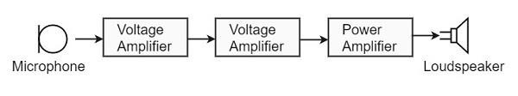

**6.8 Power Amplifiers**

In practice, any amplifier consists of few stages of amplification. If we consider audio amplification, it has several stages of amplification, depending upon our requirement.

## Power Amplifier

After the audio signal is converted into electrical signal, it has several voltage amplifications done, after which the power amplification of the amplified signal is done just before the loud speaker stage. This is clearly shown in the below figure.

While the voltage amplifier raises the voltage level of the signal, the power amplifier raises the power level of the signal. Besides raising the power level, it can also be said that a power amplifier is a device which converts DC power to AC power and whose action is controlled by the input signal.

The DC power is distributed according to the relation, DC power input = AC power output + losses

## Power Transistor

For such Power amplification, a normal transistor would not do. A transistor that is manufactured to suit the purpose of power amplification is called as a **Power transistor**.

A Power transistor differs from the other transistors, in the following factors.

* + It is larger in size, in order to handle large powers.
  + The collector region of the transistor is made large and a heat sink is placed at the collector-base junction in order to minimize heat generated.
  + The emitter and base regions of a power transistor are heavily doped.
  + Due to the low input resistance, it requires low input power.

Hence there is a lot of difference in voltage amplification and power amplification. So, let us now try to get into the details to understand the differences between a voltage amplifier and a power amplifier.

**Difference between Voltage and Power Amplifiers:**Let us try to differentiate between voltage and power amplifier.

## Voltage Amplifier

The function of a voltage amplifier is to raise the voltage level of the signal. A voltage amplifier is designed to achieve maximum voltage amplification.

The voltage gain of an amplifier is given by

*Av*=*β*(*Rc/Rin*)

The characteristics of a voltage amplifier are as follows −

* + The base of the transistor should be thin and hence the value of β should be greater than 100.
  + The resistance of the input resistor Rin should be low when compared to collector load RC.
  + The collector load RC should be relatively high. To permit high collector load, the voltage amplifiers are always operated at low collector current.
  + The voltage amplifiers are used for small signal voltages.

## Power Amplifier

The function of a power amplifier is to raise the power level of input signal. It is required to deliver a large amount of power and has to handle large current.

The characteristics of a power amplifier are as follows −

* + The base of transistor is made thicken to handle large currents. The value of β being (β > 100) high.
  + The size of the transistor is made larger, in order to dissipate more heat, which is produced during transistor operation.
  + Transformer coupling is used for impedance matching.
  + Collector resistance is made low.

The comparison between voltage and power amplifiers is given below in a tabular form.

|  |  |  |  |
| --- | --- | --- | --- |
| **S.No** | **Particular** | **Voltage Amplifier** | **Power Amplifier** |
| 1 | β | High (>100) | Low (5 to 20) |
| 2 | RC | High (4-10 KΩ) | Low (5 to 20 Ω) |
| 3 | Coupling | Usually R-C coupling | Invariably transformer coupling |
| 4 | Input voltage | Low (a few m V) | High (2-4 V) |
| 5 | Collector current | Low (≈ 1 mA) | High (> 100 mA) |
| 6 | Power output | Low | High |
| 7 | Output impendence | High (≈ 12 K Ω) | Low (200 Ω |

The Power amplifiers amplify the power level of the signal. This amplification is done in the last stage in audio applications. The applications related to radio frequencies employ radio power amplifiers. But the **operating point** of a transistor plays a very important role in determining the efficiency of the amplifier. The **main classification** is done based on this mode of operation.

The classification is done based on their frequencies and also based on their mode of operation.

## Classification Based on Frequencies

Power amplifiers are divided into two categories, based on the frequencies they handle. They are as follows.

* + **Audio Power Amplifiers** − The audio power amplifiers raise the power level of signals that have audio frequency range (20 Hz to 20 KHz). They are also known as **Small signal power amplifiers**.
  + **Radio Power Amplifiers** − Radio Power Amplifiers or tuned power amplifiers raise the power level of signals that have radio frequency range (3 KHz to 300 GHz). They are also known as **large signal power amplifiers**.

## Classification Based on Mode of Operation

On the basis of the mode of operation, i.e., the portion of the input cycle during which collector current flows, the power amplifiers may be classified as follows.

* + **Class A Power amplifier** − When the collector current flows at all times during the full cycle of signal, the power amplifier is known as **class A power amplifier**.
  + **Class B Power amplifier** − When the collector current flows only during the positive half cycle of the input signal, the power amplifier is known as **class B power amplifier**.
  + **Class C Power amplifier** − When the collector current flows for less than half cycle of the input signal, the power amplifier is known as **class C power amplifier**.

There forms another amplifier called Class AB amplifier, if we combine the class A and class B amplifiers so as to utilize the advantages of both. Before going into the details of these amplifiers, let us have a look at the important terms that have to be considered to determine the efficiency of an amplifier.

## Terms Considering Performance

The primary objective of a power amplifier is to obtain maximum output power. In order to achieve this, the important factors to be considered are collector efficiency, power dissipation capability and distortion. Let us go through them in detail.

## Collector Efficiency

This explains how well an amplifier converts DC power to AC power. When the DC supply is given by the battery but no AC signal input is given, the collector output at such a condition is observed as **collector efficiency**.

The collector efficiency is defined as

*η*=*average a*.*c poweroutput / average d*.*c powerinputtotransisto*

The main aim of a power amplifier is to obtain maximum collector efficiency. Hence the higher the value of collector efficiency, the efficient the amplifier will be.

## Power Dissipation Capacity

Every transistor gets heated up during its operation. As a power transistor handles large currents, it gets more heated up. This heat increases the temperature of the transistor, which alters the operating point of the transistor. So, in order to maintain the operating point stability, the temperature of the transistor has to be kept in permissible limits. For this, the heat produced has to be dissipated. Such a capacity is called as Power dissipation capability.

**Power dissipation capability** can be defined as the ability of a power transistor to dissipate the heat developed in it. Metal cases called heat sinks are used in order to dissipate the heat produced in power transistors.

## Distortion

A transistor is a non-linear device. When compared with the input, there occur few variations in the output. In voltage amplifiers, this problem is not pre-dominant as small

currents are used. But in power amplifiers, as large currents are in use, the problem of distortion certainly arises.

**Distortion** is defined as the change of output wave shape from the input wave shape of the amplifier. An amplifier that has lesser distortion, produces a better output and hence considered efficient.

We have already come across the details of transistor biasing, which is very important for the operation of a transistor as an amplifier. Hence to achieve faithful amplification, the biasing of the transistor has to be done such that the amplifier operates over the linear region.

## 6.9 Class B Operation

The biasing of the transistor in class B operation is in such a way that at zero signal condition, there will be no collector current. The **operating point** is selected to be at collector cut off voltage. So, when the signal is applied, **only the positive half cycle** is amplified at the output.

But during the negative half cycle of the input, the circuit is reverse biased and the collector current will be absent. Hence **only the positive half cycle** is amplified at the output.

As the negative half cycle is completely absent, the signal distortion will be high. Also, when the applied signal increases, the power dissipation will be more. But when compared to class A power amplifier, the output efficiency is increased.Well, in order to minimize the disadvantages and achieve low distortion, high efficiency and high output power, the push-pull configuration is used in this class B amplifier.

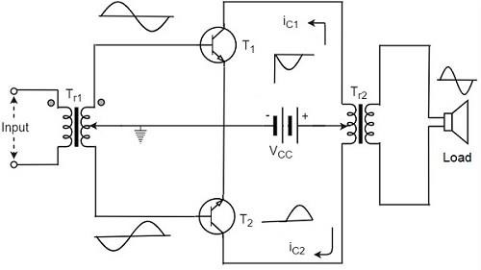

## Class B Push-Pull Amplifier

Though the efficiency of class B power amplifier is higher than class A, as only one half cycle of the input is used, the distortion is high. Also, the input power is not completely utilized. In order to compensate these problems, the push-pull configuration is introduced in class B amplifier.

## Construction:

The circuit of a push-pull class B power amplifier consists of two identical transistors T1 and T2 whose bases are connected to the secondary of the center-tapped input transformer Tr1. The emitters are shorted and the collectors are given the VCC supply through the primary of the output transformer Tr2.

The circuit arrangement of class B push-pull amplifier, is same as that of class A push-pull amplifier except that the transistors are biased at cut off, instead of using the biasing resistors. The figure below gives the detailing of the construction of a push-pull class B power amplifier.

The circuit operation of class B push pull amplifier is detailed below.

## Operation

The circuit of class B push-pull amplifier shown in the above figure clears that both the transformers are center-tapped. When no signal is applied at the input, the transistors T1 and T2 are in cut off condition and hence no collector currents flow. As no current is drawn from VCC, no power is wasted.

When input signal is given, it is applied to the input transformer Tr1 which splits the signal into two signals that are 180o out of phase with each other. These two signals are given to the two identical transistors T1 and T2. For the positive half cycle, the base of the transistor T1 becomes positive and collector current flows. At the same time, the transistor T2 has negative half cycle, which throws the transistor T2 into cutoff condition and hence no collector current flows. The waveform is produced as shown in the following figure.

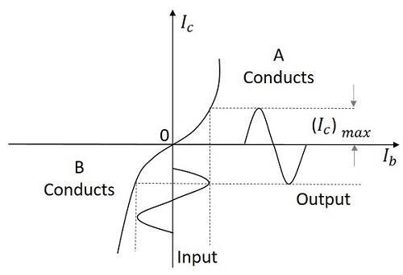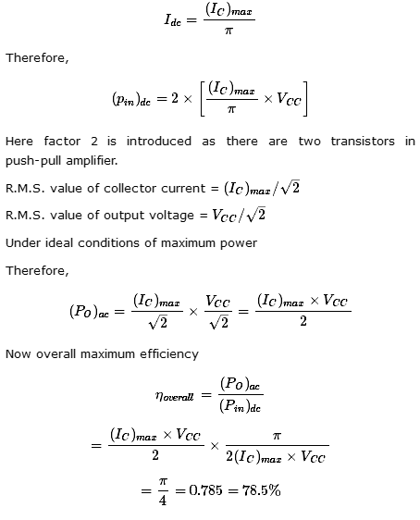

For the next half cycle, the transistor T1 gets into cut off condition and the transistor T2 gets into conduction, to contribute the output. Hence for both the cycles, each transistor conducts alternately. The output transformer Tr3 serves to join the two currents producing an almost undistorted output waveform.

## Power Efficiency of Class B Push-Pull Amplifier

The current in each transistor is the average value of half sine loop. For half sine loop, Idc is given by

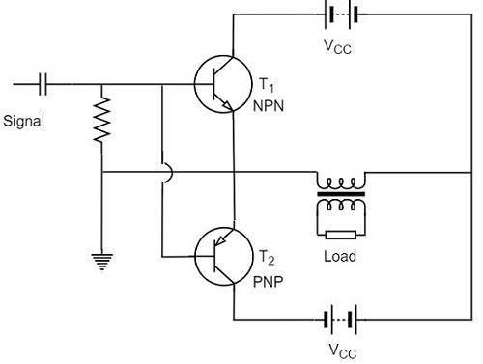

The collector efficiency would be the same.

Hence the class B push-pull amplifier improves the efficiency than the class A push-pull amplifier.

## 6.10 Complementary Symmetry Push-Pull Class B Amplifier

The push pull amplifier which was just discussed improves efficiency but the usage of center-tapped transformers makes the circuit bulky, heavy and costly. To make the circuit simple and to improve the efficiency, the transistors used can be complemented, as shown in the following circuit diagram.

The above circuit employs a NPN transistor and a PNP transistor connected in push pull configuration. When the input signal is applied, during the positive half cycle of the input signal, the NPN transistor conducts and the PNP transistor cuts off. During the negative half cycle, the NPN transistor cuts off and the PNP transistor conducts.

In this way, the NPN transistor amplifies during positive half cycle of the input, while PNP transistor amplifies during negative half cycle of the input. As the transistors are both complement to each other, yet act symmetrically while being connected in push pull configuration of class B, this circuit is termed as **Complementary symmetry push pull class B amplifier**.

## Advantages

The advantages of Complementary symmetry push pull class B amplifier are as follows.

* + As there is no need of center tapped transformers, the weight and cost are reduced.
  + Equal and opposite input signal voltages are not required.

## Disadvantages

The disadvantages of Complementary symmetry push pull class B amplifier are as follows.

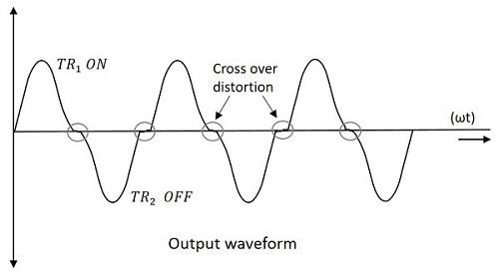

* + It is difficult to get a pair of transistors (NPN and PNP) that have similar characteristics.
  + We require both positive and negative supply voltages.

The class A and class B amplifier so far discussed has got few limitations. Let us now try to combine these two to get a new circuit which would have all the advantages of both class A and class B amplifier without their inefficiencies. Before that, let us also go through another important problem, called as **Cross over distortion**, the output of class B encounters with.

## Cross-over Distortion:

In the push-pull configuration, the two identical transistors get into conduction, one after the other and the output produced will be the combination of both.

When the signal changes or crosses over from one transistor to the other at the zero voltage point, it produces an amount of distortion to the output wave shape. For a transistor in order to conduct, the base emitter junction should cross 0.7v, the cut off voltage. The time taken for a transistor to get ON from OFF or to get OFF from ON state is called the **transition period**.

At the zero voltage point, the transition period of switching over the transistors from one to the other, has its effect which leads to the instances where both the transistors are OFF at a time. Such instances can be called as **Flat spot** or **Dead band** on the output wave shape.

The above figure clearly shows the cross over distortion which is prominent in the output waveform. This is the main disadvantage. This cross over distortion effect also reduces the overall peak to peak value of the output waveform which in turn reduces the maximum power output. This can be more clearly understood through the non-linear characteristic of the waveform as shown below.

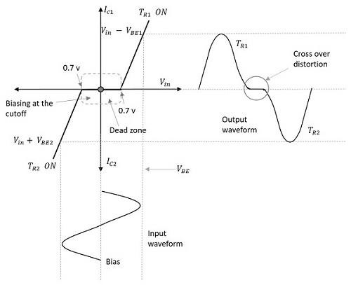

It is understood that this cross-over distortion is less pronounced for large input signals, where as it causes severe disturbance for small input signals. This cross over distortion can be eliminated if the conduction of the amplifier is more than one half cycle, so that both the transistors won’t be OFF at the same time.