IV TRANSISTOR BIASING AND STABILIZATION

4.1 NEED FOR TRANSISTOR BIASING:
If the o/p signal must be a faithful reproduction of the i/p signal, the transistor must be operated in active region. That means an operating point has to be established in this region . To establish an operating point (proper values of collector current I_{c} and collector to emitter voltage V_{CE}) appropriate supply voltages and resistances must be suitably chosen in the ckt. This process of selecting proper supply voltages and resistance for obtaining desired operating point or Q point is called as biasing and the ckt used for transistor biasing is called as biasing ckt.
There are four conditions to be met by a transistor so that it acts as a faithful ampr:
- Emitter base junction must be forward biased (V_{BE}=0.7Vfor Si, 0.2V for Ge) and collector base junction must be reverse biased for all levels of i/p signal.
- V_{ce} voltage should not fall below V_{CE (sat)} (0.3V for Si, 0.1V for Ge) for any part of the i/p signal. For V_{CE} less than V_{CE (sat)} the collector base junction is not probably reverse biased.
- The value of the signal I_{c} when no signal is applied should be at least equal to the max. collector current t due to signal alone.
- Max. rating of the transistor I_{c(max)}, V_{CE (max)} and P_{D(max)} should not be exceeded at any value of i/p signal.
Consider the fig shown in fig1. If operating point is selected at A, A represents a condition when no bias is applied to the transistor i.e, I_{c}=0, V_{CE} =0. It does not satisfy the above said conditions necessary for faithful amplification.
Point C is too close to P_{D(max)} curve of the transistor. Therefore the o/p voltage swing in the positive direction is limited.
Point B is located in the middle of active region .It will allow both positive and negative half cycles in the o/p signal. It also provides linear gain and larger possible o/p voltages and currents
Hence operating point for a transistor amplifier is selected to be in the middle of active region.

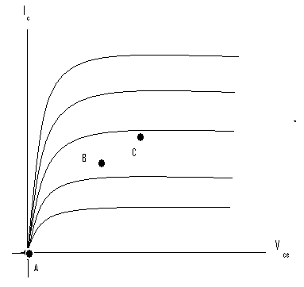 fig1
I_{C(max)} P_{D(max)}
P_{D(max)} P_{D(max)}
V_{ce(sat)} P_{D(max)}
4.2 DC LOAD LINE:
Referring to the biasing circuit of fig 4.2a, the values of V_{CC} and R_{C} are fixed and Ic and V_{CE} are dependent on R_{B}.
Applying Kirchhoff’s voltage law to the collector circuit in fig. 4.2a, we get
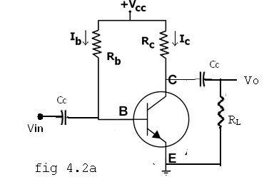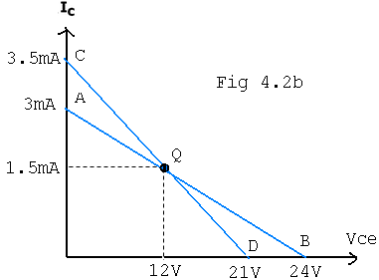
The straight line represented by AB in fig4.2b is called the dc load line. The coordinates of the end point A are obtained by substituting V_{CE} =0 in the above equation. Then . Therefore The coordinates of A are V_{CE} =0 and .
The coordinates of B are obtained by substituting Ic=0 in the above equation. Then Vce = Vcc. Therefore the coordinates of B are V_{CE} =Vcc and Ic=0. Thus the dc load line AB can be drawn if the values of Rc and Vcc are known.
As shown in the fig4.2b, the optimum POINT IS LOCATED AT THE MID POINT OF THE MIDWAY BETWEEN a AND b. In order to get faithful amplification, the Q point must be well within the active region of the transistor.
Even though the Q point is fixed properly, it is very important to ensure that the operating point remains stable where it is originally fixed. If the Q point shifts nearer to either A or B, the output voltage and current get clipped, thereby o/p signal is distorted.
In practice, the Q-point tends to shift its position due to any or all of the following three main factors.
- Reverse saturation current, Ico, which doubles for every 10ºC raise in temperature
- Base emitter Voltage ,VBE, which decreases by 2.5 mV per ºC
- Transistor current gain, h_{FE} or β which increases with temperature.
If base current I_{B} is kept constant since I_{B} is approximately equal to Vcc/RB. If the transistor is replaced by another one of the same type, one cannot ensure that the new transistor will have identical parameters as that of the first one. Parameters such as β vary over a range. This results in the variation of collector current Ic for a given I_{B}. Hence , in the o/p characteristics, the spacing between the curves might increase or decrease which leads to the shifting of the Q-point to a location which might be completely unsatisfactory.

4.3 AC LOAD LINE:
After drawing the dc load line, the operating point Q is properly located at the center of the dc load line. This operating point is chosen under zero input signal condition of the circuit. Hence the ac load line should also pas through the operating point Q. The effective ac load resistance R_{ac}, is a combination of R_{C} parallel to R_{L} i.e. ||. So the slope of the ac load line CQD will be 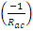. To draw the ac load line, two end points, I.e. V_{CE(max)} and I_{C(max)} when the signal is applied are required.
, which locates point D on the Vce axis.
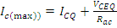, which locates the point C on the I_{C} axis.
By joining points c and D, ac load line CD is constructed. As R_{C} > R_{ac}, The dc load line is less steep than ac load line.

4.4 STABILITY FACTOR (S):
The rise of temperature results in increase in the value of transistor gain β and the leakage current Ico. So, I_{C} also increases which results in a shift in operating point. Therefore, The biasing network should be provided with thermal stability. Maintenance of the operating point is specified by S, which indicates the degree of change in operating point due to change in temperature.
The extent to which I_{C} is stabilized with varying I_{C} is measured by a stability factor S
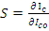 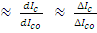 ,
For CE configuration
Differentiate the above equation w.r.t I_{C} , We get
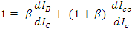
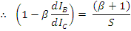
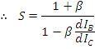
S should be small to have better thermal stability.
Stability factor S’ and S’’:
S’ is defined as the rate of change of I_{C} with V_{BE}, keeping I_{C} and V_{BE} constant.
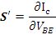
S’’ is defined as the rate of change of I_{C} with β, keeping I_{CO} and V_{BE} constant.
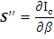

4.5 METHODS OF TRANSISTOR BIASING:

1) Fixed bias (base bias)
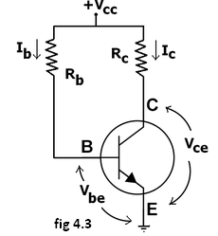
This form of biasing is also called base bias. In the fig 4.3 shown, the single power source (for example, a battery) is used for both collector and base of a transistor, although separate batteries can also be used.
In the given circuit,
V_{cc} = I_{B}R_{B} + V_{be}
Therefore, I_{B} = (V_{cc} - V_{be})/R_{B}
Since the equation is independent of current I_{C}R, dI_{B/}/dI_{C}R =0 and the stability factor is given by the equation….. reduces to
S=1+β
Since β is a large quantity, this is very poor biasing circuit. Therefore in practice the circuit is not used for biasing.
For a given transistor, V_{be} does not vary significantly during use. As V_{cc} is of fixed value, on selection of R_{B}, the base current I_{B} is fixed. Therefore this type is called fixed bias type of circuit.
Also for given circuit, V_{cc} = I_{C}R_{C} + V_{ce}
Therefore, V_{ce} = V_{cc} - I_{C}R_{C}
Merits:
- It is simple to shift the operating point anywhere in the active region by merely changing the base resistor (R_{B}).
- A very small number of components are required.
Demerits:
- The collector current does not remain constant with variation in temperature or power supply voltage. Therefore the operating point is unstable.
- Changes in V_{be} will change I_{B} and thus cause R_{E} to change. This in turn will alter the gain of the stage.
- When the transistor is replaced with another one, considerable change in the value of β can be expected. Due to this change the operating point will shift.
2) EMITTER-FEEDBACK BIAS:
The emitter feedback bias circuit is shown in the fig 4.4. The fixed bias circuit is modified by attaching an external resistor to the emitter. This resistor introduces negative feedback that stabilizes the Q-point. From Kirchhoff's voltage law, the voltage across the base resistor is
V_{Rb} = V_{CC} - I_{e}R_{e} - V_{be}.
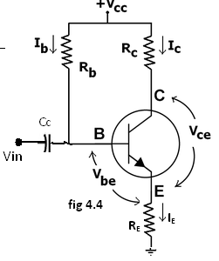
From Ohm's law, the base current is
I_{b} = V_{Rb} / R_{b}.
The way feedback controls the bias point is as follows. If V_{be} is held constant and temperature increases, emitter current increases. However, a larger I_{e} increases the emitter voltage V_{e} = I_{e}R_{e}, which in turn reduces the voltage V_{Rb} across the base resistor. A lower base-resistor voltage drop reduces the base current, which results in less collector current because I_{c} = ß I_{B}. Collector current and emitter current are related by I_{c} = α I_{e} with α ≈ 1, so increase in emitter current with temperature is opposed, and operating point is kept stable.
Similarly, if the transistor is replaced by another, there may be a change in I_{C} (corresponding to change in β-value, for example). By similar process as above, the change is negated and operating point kept stable.
For the given circuit,
I_{B} = (V_{CC} - V_{be})/(R_{B} + (β+1)R_{E}).
Merits:
The circuit has the tendency to stabilize operating point against changes in temperature and β-value.
Demerits:
- In this circuit, to keep I_{C} independent of β the following condition must be met:
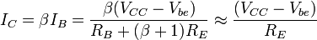
which is approximately the case if ( β + 1 )R_{E} >> R_{B}.
- As β-value is fixed for a given transistor, this relation can be satisfied either by keeping R_{E} very large, or making R_{B} very low.
- If R_{E} is of large value, high V_{CC} is necessary. This increases cost as well as precautions necessary while handling.
- If R_{B} is low, a separate low voltage supply should be used in the base circuit. Using two supplies of different voltages is impractical.
- In addition to the above, R_{E} causes ac feedback which reduces the voltage gain of the amplifier.

  - COLLECTOR TO BASE BIAS OR COLLECTOR FEED-BACK BIAS:
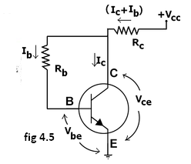
This configuration shown in fig 4.5 employs negative feedback to prevent thermal runaway and stabilize the operating point. In this form of biasing, the base resistor R_{B} is connected to the collector instead of connecting it to the DC source V_{cc}. So any thermal runaway will induce a voltage drop across the R_{C} resistor that will throttle the transistor's base current.
From Kirchhoff's voltage law, the voltage across the base resistor R_{b} is
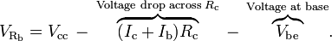
By the Ebers–Moll model, I_{c} = βI_{b}, and so
From Ohm's law, the base current , and so
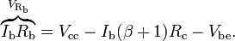
Hence, the base current I_{b} is
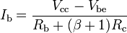
If V_{be} is held constant and temperature increases, then the collector current I_{c} increases. However, a larger I_{c} causes the voltage drop across resistor R_{c} to increase, which in turn reduces the voltage across the base resistor R_{b}. A lower base-resistor voltage drop reduces the base current I_{b}, which results in less collector current I_{c}. Because an increase in collector current with temperature is opposed, the operating point is kept stable.
Merits:
- Circuit stabilizes the operating point against variations in temperature and β (i.e. replacement of transistor)
Demerits:
- In this circuit, to keep I_{c} independent of β, the following condition must be met:
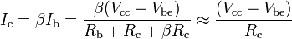
which is the case when
- As β-value is fixed (and generally unknown) for a given transistor, this relation can be satisfied either by keeping R_{c} fairly large or making R_{b} very low.
- If R_{c} is large, a high V_{cc} is necessary, which increases cost as well as precautions necessary while handling.
- If R_{b} is low, the reverse bias of the collector–base region is small, which limits the range of collector voltage swing that leaves the transistor in active mode.
- The resistor R_{b} causes an AC feedback, reducing the voltage gain of the amplifier. This undesirable effect is a trade-off for greater Q-point stability.
Usage: The feedback also decreases the input impedance of the amplifier as seen from the base, which can be advantageous. Due to the gain reduction from feedback, this biasing form is used only when the trade-off for stability is warranted.

  - COLLECTOR –EMITTER FEEDBACK BIAS:
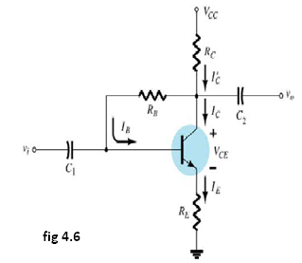
The above fig4.6 shows the collector –emitter feedback bias circuit that can be obtained by applying both the collector feedback and emitter feedback. Here the collector feedback is provided by connecting a resistance RB from the collector to the base and emitter feedback is provided by connecting an emitter Re from emitter to ground. Both feed backs are used to control collector current and base current IB in the opposite direction to increase the stability as compared to the previous biasing circuits.
  - VOLTAGE DIVIDER BIAS OR SELF BIAS OR EMITTER BIAS:
The voltage divider as shown in the fig 4.7 is formed using external resistors R₁ and R₂. The voltage across R₂ forward biases the emitter junction. By proper selection of resistors R₁ and R₂, the operating point of the transistor can be made independent of β. In this circuit, the voltage divider holds the base voltage fixed independent of base current provided the divider current is large compared to the base current. However, even with a fixed base voltage, collector current varies with temperature (for example) so an emitter resistor is added to stabilize the Q-point, similar to the above circuits with emitter resistor.
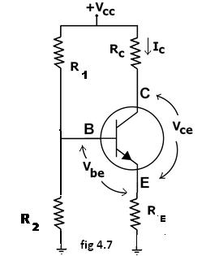
In this circuit the base voltage is given by:
voltage across 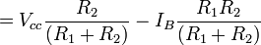
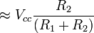provided .
Also
For the given circuit,
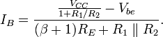
Let the current in resistor R1 is I1 and this is divided into two parts – current through base and resistor R2. Since the base current is very small so for all practical purpose it is assumed that I1 also flows through R2, so we have
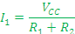
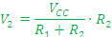
Applying KVL in the circuit, we have
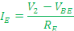
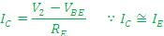
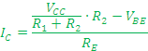
It is apparent from above expression that the collector current is independent of ? thus the stability is excellent. In all practical cases the value of VBE is quite small in comparison to the V2, so it can be ignored in the above expression so the collector current is almost independent of the transistor parameters thus this arrangement provides excellent stability.
Again applying KVL in collector circuit, we have
The resistor RE provides stability to the circuit. If the current through the collector rises, the voltage across the resistor RE also rises. This will cause VCE to increase as the voltage V2 is independent of collector current. This decreases the base current, thus collector current increases to its former value.
Stability factor for such circuit arrangement is given by
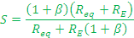
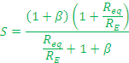
If Req/RE is very small compared to 1, it can be ignored in the above expression thus we have
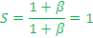
Which is excellent since it is the smallest possible value for the stability. In actual practice the value of stability factor is around 8-10, since Req/RE cannot be ignored as compared to 1.
Merits:
- Unlike above circuits, only one dc supply is necessary.
- Operating point is almost independent of β variation.
- Operating point stabilized against shift in temperature.
Demerits:
- In this circuit, to keep I_{C} independent of β the following condition must be met:
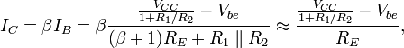
which is approximately the case if
where R₁ || R₂ denotes the equivalent resistance of R₁ and R₂ connected in parallel.
- As β-value is fixed for a given transistor, this relation can be satisfied either by keeping R_{E} fairly large, or making R₁||R₂ very low.
- If R_{E} is of large value, high V_{CC} is necessary. This increases cost as well as precautions necessary while handling.
- If R₁ || R₂ is low, either R₁ is low, or R₂ is low, or both are low. A low R₁ raises V_{B} closer to V_{C}, reducing the available swing in collector voltage, and limiting how large R_{C} can be made without driving the transistor out of active mode. A low R₂ lowers V_{be}, reducing the allowed collector current. Lowering both resistor values draws more current from the power supply and lowers the input resistance of the amplifier as seen from the base.
- AC as well as DC feedback is caused by R_{E}, which reduces the AC voltage gain of the amplifier. A method to avoid AC feedback while retaining DC feedback is discussed below.
Usage: The circuit's stability and merits as above make it widely used for linear circuits.

4.6 BIAS COMPENSATION USING DIODE AND TRANSISTOR:
The various biasing circuits considered use some type of negative feedback to stabilize the operation point. Also, diodes, thermistors and sensistors can be used to compensate for variations in current.

DIODE COMPENSATION:
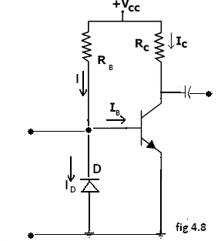
The following fig4.8 shows a transistor amplifier with a diode D connected across the base-emitter junction for compensation of change in collector saturation current I_{CO}. The diode is of the same material as the transistor and it is reverse biased by e the emitter-base junction voltage V_{BE}, allowing the diode reverse saturation current I_{O} to flow through diode D. The base current I_{B}=I-I_{O}.
As long as temperature is constant, diode D operates as a resistor. As the temperature increases, I_{CO} of the transistor increases. Hence, to compensate for this, the base current I_{B} should be decreased.
The increase in temperature will also cause the leakage current I_{O} through D to increase and thereby decrease the base current I_{B}. This is the required action to keep Ic constant.
This type of bias compensation does not need a change in Ic to effect the change in I_{C}, as both I_{O} and I_{CO} can track almost equally according to the change in temperature.
THERMISTOR COMPENSATION:
The following fig4.9 a thermistor R_{T}, having a negative temperature coefficient is connected in parallel with R₂. The resistance of thermistor decreases exponentially with increase of temperature. An increase of temperature will decrease the base voltage V_{BE}, reducing I_{B} and I_{C}.
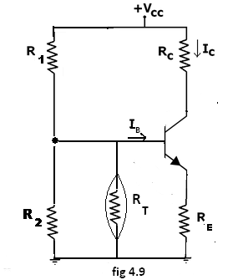
SENSISTOR COMPENSATION:
In the following fig4.10 shown a sensistor Rs having a positive temperature coefficient is connected across R₁ or R_{E}. Rs increases with temperature. As the temperature increases, the equivalent resistance of the parallel combination of R1 and Rs also increases and hence V_{BE} decreases, reducing I_{B} and Ic. This reduced Ic compensates for increased Ic caused by the increase in V_{BE}, I_{CO} and β due to temperature.
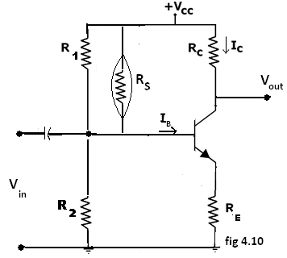

4.7 THERMAL RUNAWAY AND THERMAL STABILITY:
THERMAL RUNAWAY:
The collector current for the CE circuit is given by The three variables in the equation, β, , and increases with rise in temperature. In particular, the reverse saturation current or leakage current changes greatly with temperature. Specifically it doubles for every 10ºC rise in temperature. The collector current causes the collector base junction temperature to rise which in turn, increase , as a result will increase still further, which will further rise the temperature at the collector base junction. This process will become cumulative leading at the collector base junction. This process will become cumulative leading to “thermal runaway”. Consequently, the ratings of the transistor are exceeded which may destroy the transistor itself.
The collector is made larger in size than the emitter in order to help the heat developed at the collector junction. However if the circuit is designed such that the base current is made to decrease automatically with rise in temperature, then the decrease in will compensate for increase in the , keeping almost constant.
THERMAL RESISTANCE
Consider transistor used in a circuit where the ambient temperature of the air around the transistor is T_{A}ºC and the temperature of the collector-base junction of the transistor is T_{J}ºC.
Due to heating within the transistor T_{J} is higher than T_{A}. As the temperature difference T_{J}- T_{A} is greater, the power dissipated in the transistor, P_{D} will be greater, i.e, T_{J}- T_{A} P_{D}
The equation can be written as T_{J}- T_{A} P_{D}., where is the constant of proportionality and is called the Thermal resistance. Rearranging the above equation = T_{J}- T_{A} /P_{D}. Hence is measured in ºC/W which may be as small as 0.2 ºC/W for a high power transistor that has an efficient heat sink or up to 1000ºC/W for small signal, low power transistor which have no cooling provision.
As Θ represents total thermal resistance from a transistor junction to the ambient temperature, it is referred to as Θ_{J-A}. However, for power transistors, thermal resistance is given form junction to case, Θ_{J-C}.
The amount resistance from junction to ambience is considered to consist of 2 parts.
Θ_{J-A} = Θ_{J-C} - Θ_{C-A}.
Which indicates the heat dissipated in the junction must make its way to the surrounding air through two series paths from junction to case and from case to air. Hence the power dissipated.
P_{D} = (T_{J}- T_{A}Θ _{J-A}
=(T_{J}- T_{A}Θ _{J-C} + Θ _{C-A})
Θ_{J-C} is determined by the type of manufacture of the transistor and how it is located I the case, but Θ_{C-A} is determined by the surface area of the case or flange and its contact with air. If the effective surface area of the transistor case could be increased, the resistance to heat flows, or could be increased Θ_{C-A}, could be decreased. This can be achieved by the use of a heat sink.
The heat sink is a relatively large, finned, usually black metallic heat conducting device in close contact with transistor case or flange. Many versions of heat sink exist depending upon the shape and size of the transistor. Larger the heat sink smaller is the thermal resistance Θ_{HS-A}.
This thermal resistance is not added to Θ_{C-A} in series, but is instead in parallel with it and if
Θ_{HS-A} is much less than Θ_{C-A}, then Θ_{C-A} will be reduced significantly, thereby improving the dissipation capability of the transistor. Thus
Θ _{J-A}=Θ _{J-C} + Θ _{C-A}|| Θ_{HS-A}.

4.8 CONDITION FOR THERMAL STABILITY:
For preventing thermal runaway, the required condition I the rate at which the heat is released at the collector junction should not exceed the rate at which the heat can be dissipated under steady state condition. Hence the condition to be satisfied to avoid thermal runaway is given by
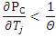
If the circuit is properly designed, then the transistor cannot runaway below a specified ambient temperature or even under any conditions.
In the self biased circuit the transistor is biased in the active region. The power generated at the junction without any signal is
Let us assume that the quiescent collector and the emitter currents are equal. Then
………………….(1)
The condition to prevent thermal runaway can be written as
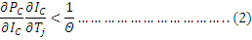
As Θ and are positive, should be negative in order to satisfy the above condition.
Differentiating equation (1) w.r.t we get
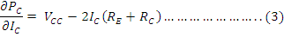
Hence to avoid thermal runaway it is necessary that
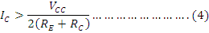
SinceVCE=VCC-IC(RE+RC) then eq(4) implies that VCE<VCC/2. IF the inequality of eq(4) is not satisfied and VCE<VCC/2, then from eq(3), is positive., and the corresponding eq(2) should be satisfied. Other wise thermal runaway will occur.

